Appendix
Article title: Framework for Patient Experience Value Elements in Rare Disease: A Case Study Demonstrating the Applicability of Combined Qualitative and Quantitative Methods
Journal name: Pharmacoeconomics Open
Author names: R. Brett McQueen, Nicholas D. Mendola, Ivett Jakab, Jeffrey Bennett, Kavita V. Nair, Bertalan Németh, András Inotai, Zoltán Kaló
Affiliation and e-mail address of the corresponding author: University of Colorado Skaggs School of Pharmacy and Pharmaceutical Sciences, robert.mcqueen@cuanschutz.edu

Conflict of Interest: RBM, NM and KVN received funding for this work through PhRMA Foundation Center of Excellence Grant – Center for Pharmaceutical Value (pValue), paid for Colorado University (CU). RBM received grant paid to CU by Eli Lilly and consulting fees from Monument Analytics and Institute for Clinical and Economic Review. KVN received grants through CU by Genentech, Biogen, Novartis, Gilead Sciences, Bristol Meyers Squibb and Rocky Mountain MS Center, received consulting fees from Biogen, Novartis and Celgene, honoraria from Sanofi and support for attending meetings from American Academy of Neurology and Consortium of Multiple Sclerosis Centers. KVN reports a leadership role as Vice Chair at Payment, Policy and Coding Subcommittee, American Academy of Neurology. IJ, BN, AI and ZK are employed by Syreon Research Institute (SRI). SRI received funding from CU for this work. IJ reports leadership positions as member of Board of Trustees, EUPATI Foundation and President of European Patients’ Forum Youth Group. JB received institutional grants or contracts from Novartis, Mallinckrodt, Alexion and NIH. JB reports both institutional and personal royalties or licenses and a patent of Aquaporumab, and consulting fees from MedImmune/Viela Bio/Horizon Therapeutics, Alexion, Chugai, Genentech, Genzyme, Mitsubishi-Tanabe, Reistone Biopharma, Roche, Beigene and Abbvie. JB reports participation on a Data Safety Monitoring Board /Advisory Board of Roche/Genentech and Clene Nanomedicine. Funding: The University of Colorado received institutional funding from PhRMA Foundation and the University of Colorado Data Science to Patient Value Initiative.

Appendix 1 – Infographics of the pre-workshop webinar
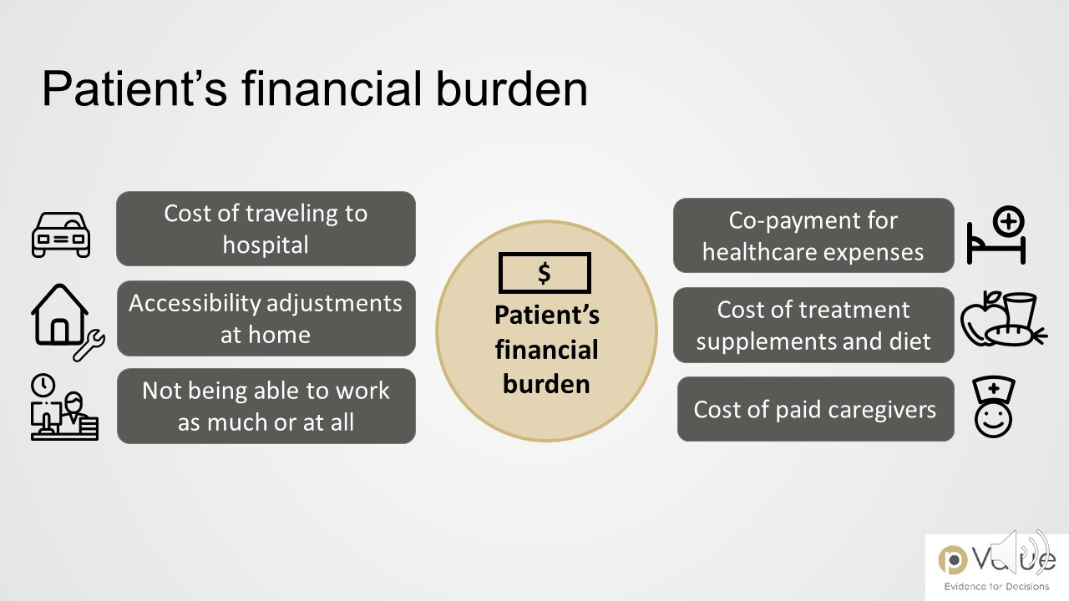
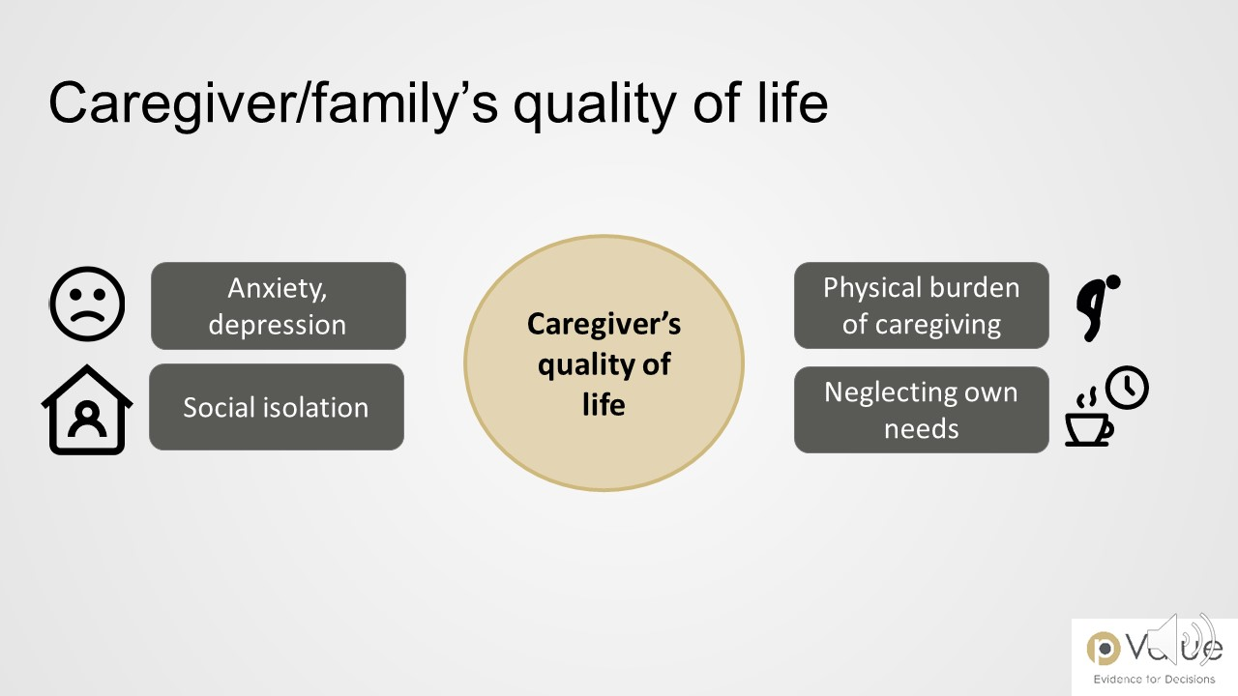
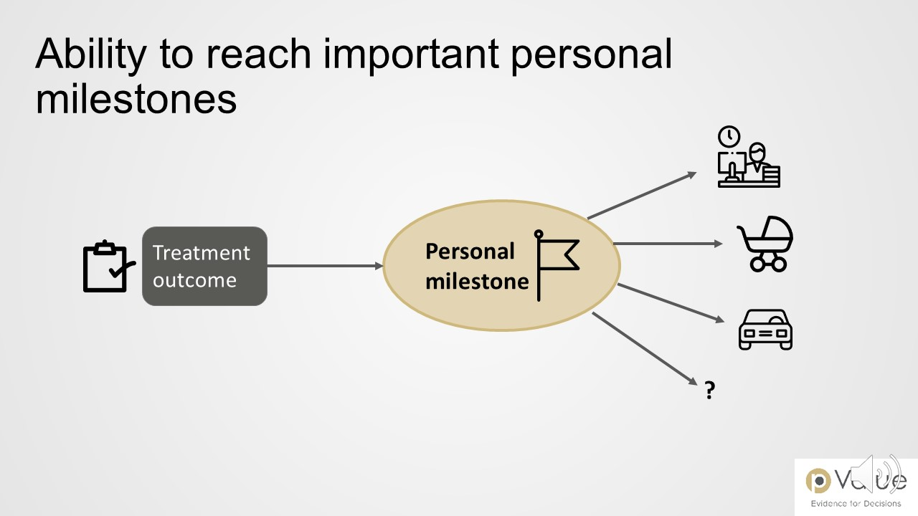
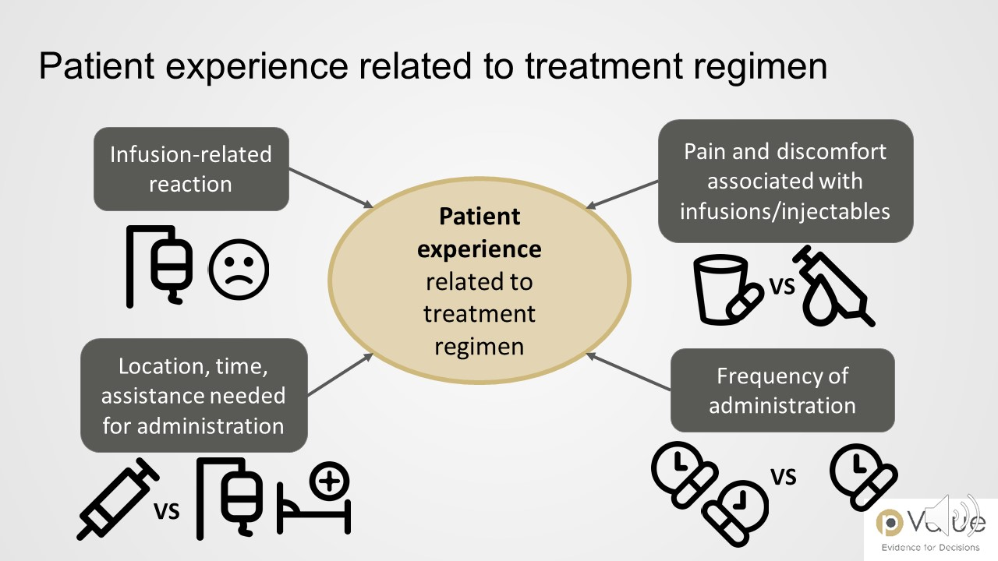

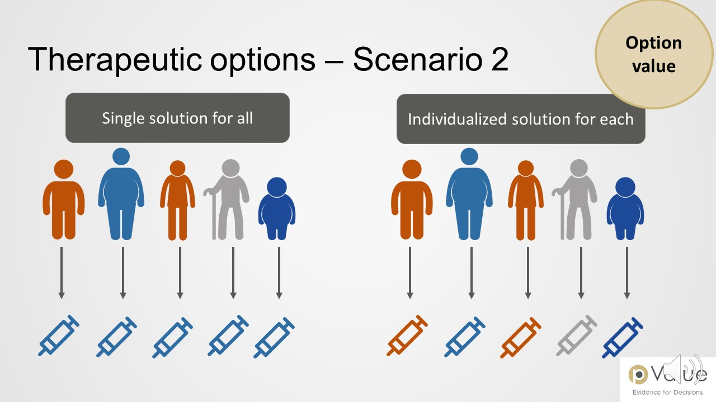
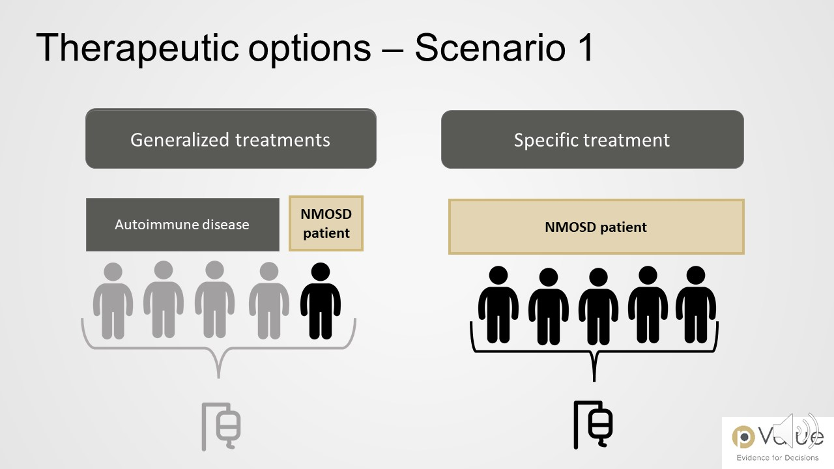
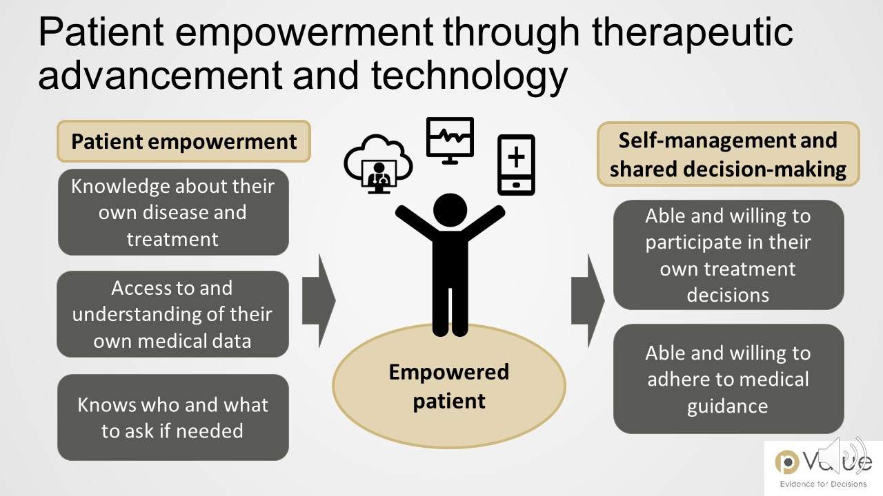
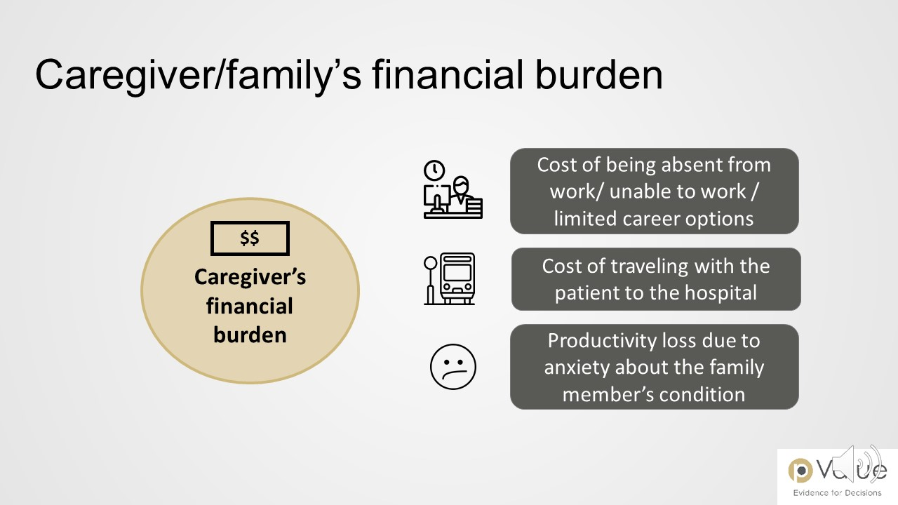
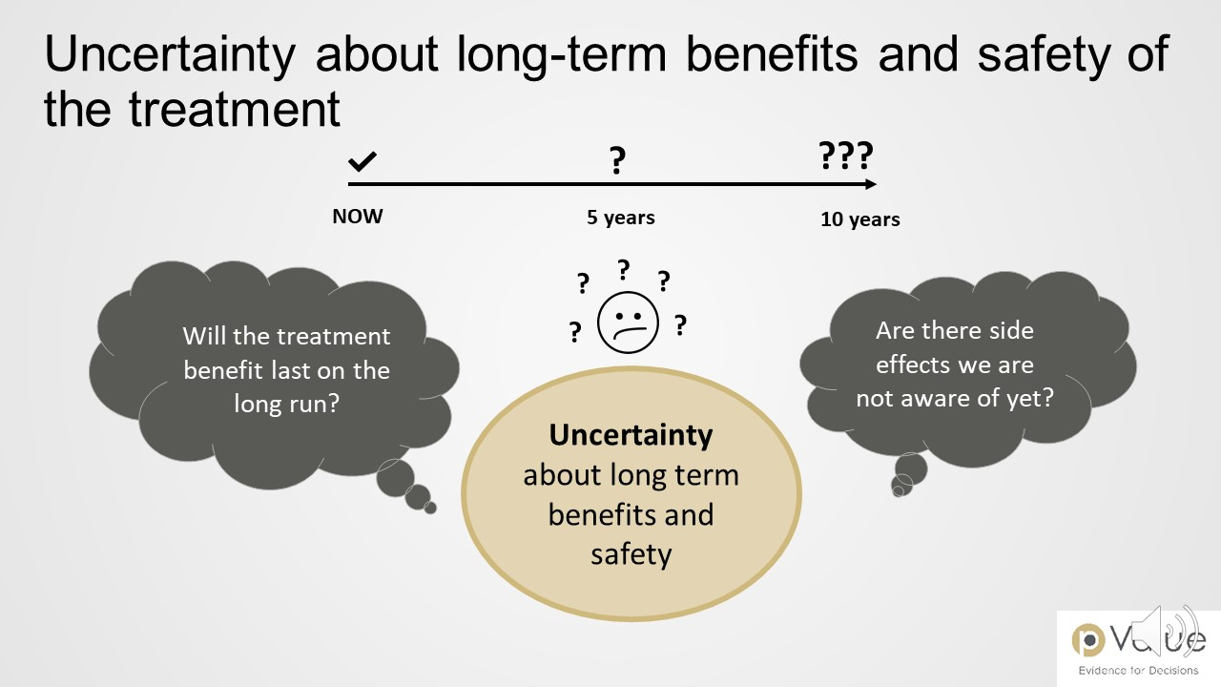

Source of icons: https://www.flaticon.com

