Appendix
PharmacoEconomics - Open
Cost-analysis of subcutaneous vs intravenous administration of natalizumab based on patient care pathway in Spain

Alonso Torres AM*¹, Arévalo Bernabé AG*², Becerril Ríos N*³, Hellín Gil MF*⁴, Martínez Sesmero JM*⁵, Meca Lallana V*⁶, Ramió-Torrentà Ll*⁷, Rodríguez-Antigüedad A*⁸, Gómez Maldonado L⁹, Triana Junco I⁹, Gómez-Barrera M¹⁰, Espinoza-Cámac N¹⁰, Oyagüez I¹⁰
*Co-first authors: TASC group
¹Neurology Dpt. Hospital Universitario de Málaga. Málaga, Spain.
²Pharmacy Dpt. Hospital Universitario Vall d’Hebron. Barcelona, Spain
³Specialized Nurse. Hospital Virgen Macarena. Sevilla, Spain.
⁴Specialized Nurse. Hospital Virgen Arrixaca. Murcia, Spain.
⁵Pharmacy Dpt. Hospital Clínico San Carlos. Madrid, Spain.
⁶Neurology Dpt. Hospital Universitario La Princesa. Madrid, Spain.
⁷Neurology Dpt. Hospital Universitario Josep Trueta. Neurodegeneration and Neuroinflammation Research Group, Medical Science Department, University of Girona. Spain
⁸Neurology Dpt. Hospital Universitario Cruces. Bilbao, Spain.
⁹Biogen, Spain.
¹⁰Pharmacoeconomics & Outcomes Research Iberia (PORIB). Madrid, Spain

Corresponding author:
Nataly Espinoza Cámac
Pharmacoeconomics & Outcomes Research Iberia
Paseo Joaquín Rodrigo 4- letra I
28224 Pozuelo de Alarcón. Madrid (Spain)
nespinoza@porib.com
Disclosure: This analysis was supported by Biogen Spain S.L.U
Conflict of interest Ana María Alonso Torres has received compensation for serving on advisory boards for Biogen Spain S.L.U, Bristol Myers Squibb (BMS), Janssen, Novartis, Roche, and Sanofi; speaker honoraria from Almirall, Biogen Spain S.L.U, BMS, Janssen, Merck, Novartis, Roche, and Sanofi; Ángel Guillermo Arévalo Bernabé has received compensation for serving on advisory boards for Biogen Spain S.L.U and Merck. Noelia Becerril Ríos has received compensation for serving on advisory boards and speaker fees from Almirall, Bayer, Biogen Spain S.L.U, BMS, Janssen, Merck, Novartis, Sanofi. María Fuensanta Hellín Gil has received compensation for serving on advisory boards and speaker event for Biogen Spain S.L.U. José Manuel Martínez Sesmero has received compensation for serving on advisory boards for Biogen Spain S.L.U, Merck, Roche, and Teva Pharmaceutical. Virginia Meca Lallana has received compensation for serving on scientific advisory boards and has received speaker honoraria from Almirall, Biogen Spain S.L.U, BMS, Genzyme, Janssen, Merck-Serono, Novartis, Roche, Sanofi-Aventis, Terumo, and Teva Pharmaceutical. Lluís Ramió-Torrentá have received compensation for serving on advisory boards and speaker honoraria from Almirall, Biogen Spain S.L.U, BMS, Merck, Novartis, Roche, Sanofi and Teva Pharmaceutical. Alfredo Rodriguez-Antigüedad Zarranz has received compensation for serving on advisory boards or speaker honoraria from Biogen, BMS, Janssen, Merck‐Serono, Novartis, Roche, and Sanofi. Laura Gómez Maldonado and Inés Triana Junco are employees of Biogen Spain S.L.U and hold shares or stocks as part of their remuneration. Manuel Gómez-Barrera, Nataly Espinoza, and Itziar Oyagüezof Pharmacoeconomics & Outcomes Research Iberia (PORIB), an independent research organisation, which received funding pursuant to a contract with Biogen Spain S.L.U.

Figure 1. Critical points diagram on starting and switching natalizumab treatment (from IV to SC)
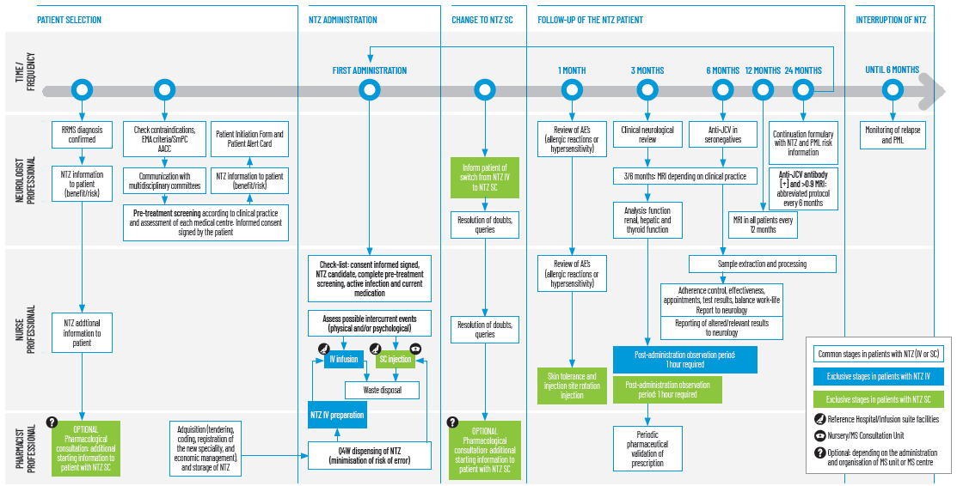
AACC: Autonomous Community, AE: Adverse events, EMA: European Medicines Agency, IV: Intravenous, JCV: John Cunningham virus, MRI: Magnetic resonance imaging, NTZ: Natalizumab, PML: Progressive multifocal leukoencephalopathy, Q4W: Every four weeks, RRMS: Relapsing-remitting multiple sclerosis, SC: Subcutaneous, SmPC: Summary of product characteristics.
Figure 2. Patient referral diagram for the administration of natalizumab SC
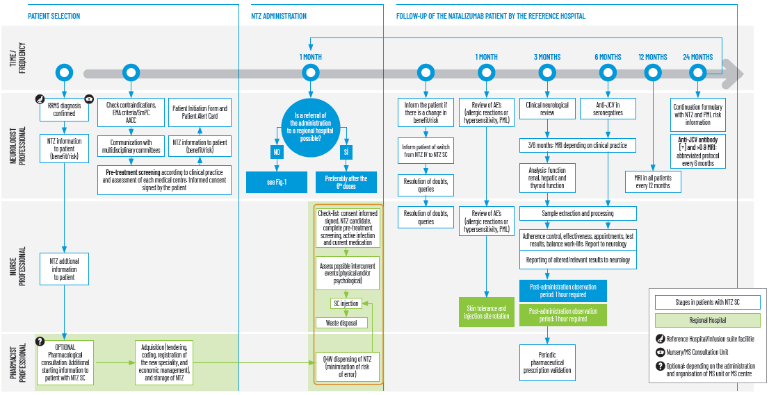
AACC: Autonomous Community, AE: Adverse events, EMA: European Medicines Agency, IV: Intravenous, JCV: John Cunningham virus, MRI: Magnetic resonance imaging, NTZ: Natalizumab, PML: Progressive multifocal leukoencephalopathy, Q4W: Every four weeks, RRMS: Relapsing-remitting multiple sclerosis, SC: Subcutaneous, SmPC: Summary of product characteristics.

