PharmacoEconomics Open
Cost-Effectiveness of Nivolumab Plus Ipilimumab for the First-Line Treatment of Intermediate/Poor-Risk Advanced and/or Metastatic Renal Cell Carcinoma in Switzerland
Esra Çakar · César Oniangue-ndza · Ralph P. Schneider · Sven L. Klijn · Ursula M. Vogl ·
Christian Rothermundt · Jessica R. May
Correspondence to: César Oniangue-ndza (Bristol Myers Squibb SA, Steinhausen, Switzerland), Hinterbergstrasse 16, 6330 Steinhausen Switzerland, tel. +41 41 767 73 54, e-mail: cesar.oniangue-ndza@bms.com
Funding: This study was funded by Bristol Myers Squibb.
Conflicts of interest: EÇ reports funding (institutional) from Bristol Myers Squibb (BMS) to write this manuscript. UMV reports honoraria (institutional) from Merck, BMS, Merck Sharp & Dohme (MSD), Pfizer, Janssen, Astellas, Roche, Bayer, Ipsen, and Sanofi, and (personal) from the Swiss Academy of Multidisciplinary Oncology (SAMO), Inselspital Bern, and Healthbook; payment for expert testimony (institutional) from Merck; travel support from Merck and Ipsen; and advisory board fees from Merck, BMS, MSD, Pfizer, Janssen, Astellas, Roche, Bayer, Ipsen, and Sanofi. CR reports consulting fees from Merck (Schweiz) AG (personal) and Pfizer, BMS, MSD Oncology, Bayer (Schweiz) AG, and Ipsen (institutional). SLK reports consulting fees (institutional) from Bayer, BMS, Kite, and Janssen. CO, RPS, and JRM are employed by and have stock ownership in BMS.

SUPPLEMENTARY MATERIALS

Sensitivity analyses
One-way sensitivity analysis (OWSA) results. The OWSA results show that the top three model drivers were the proportion of progressed patients that received a subsequent treatment after sunitinib (SUN), pazopanib (PAZ) or nivolumab (NIVO), respectively, and the mean progression-free survival (PFS) in second-line treatment (Fig. S1). Varying these parameters resulted in changes of ±14.1%, ±9.8% and ±6.7% in the incremental cost-utility ratio (ICUR), respectively, versus SUN, and changes of ±12.9%, ±8.6% and ±5.5% in the ICUR, respectively, versus PAZ.
Drug acquisition costs were assumed not to be subject to uncertainty and therefore were not included in the sensitivity analyses.

Fig. S1 One-way sensitivity analysis versus SUN and PAZ.
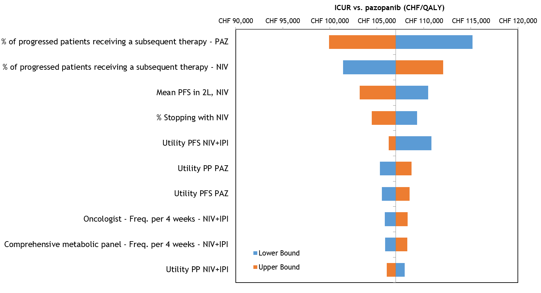
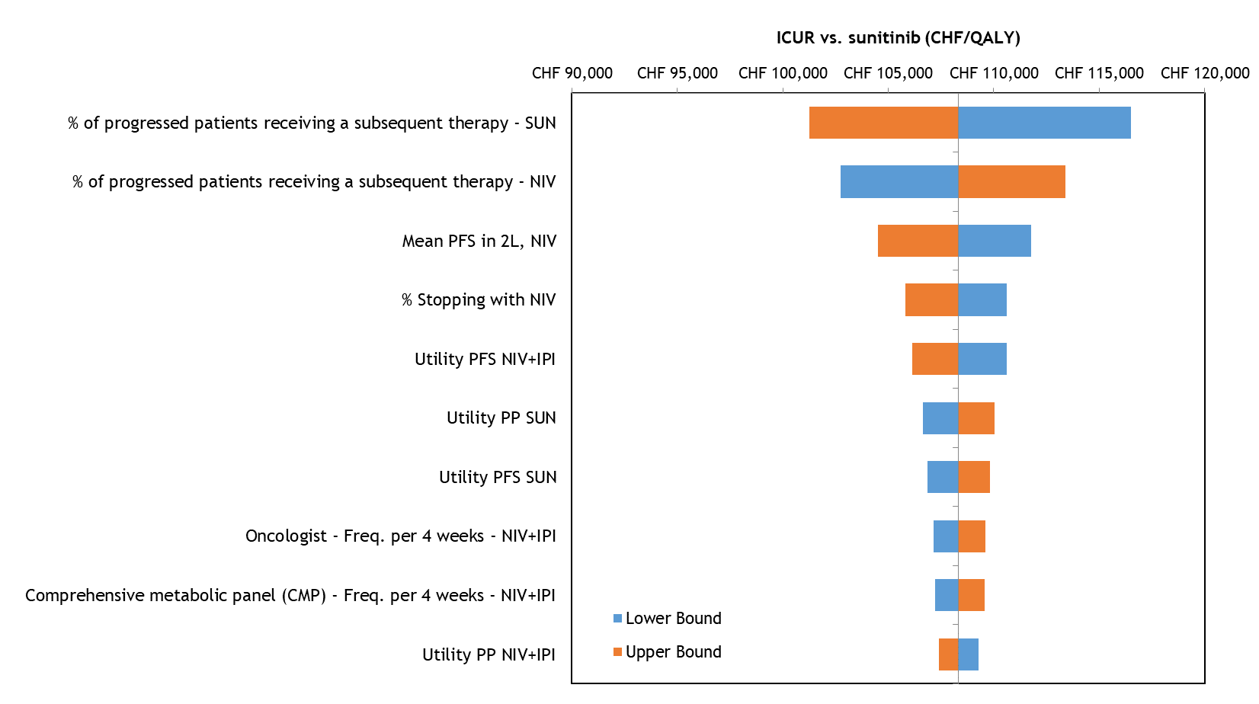
2L second line, CHF Swiss francs, NIVO nivolumab, NIVO+IPI nivolumab plus ipilimumab, PAZ pazopanib, PFS progression-free survival, PP post-progression, SUN sunitinib
Probabilistic analysis results. Of 1000 iterations, all demonstrated a QALY gain for NIVO+IPI at an increased cost relative to SUN or PAZ (Fig. S2). The deterministic ICUR varied from the probabilistic ICUR 0.61% and 0.60% versus SUN and PAZ, respectively indicating that the probabilistic model outcomes are robust.
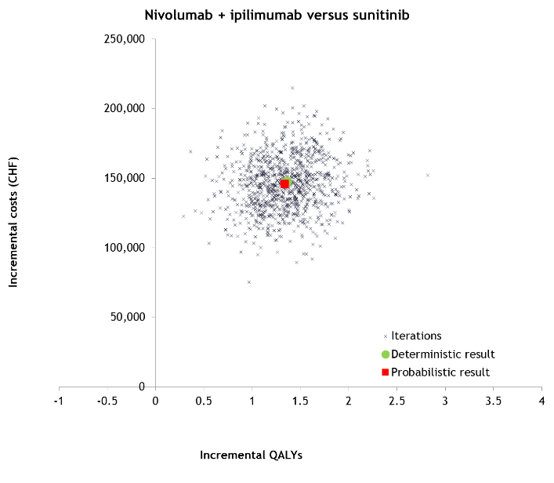
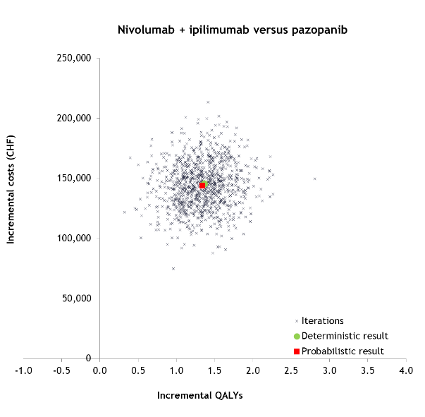
Fig. S2 Incremental cost-effectiveness plane of NIVO+IPI versus SUN and PAZ.

CHF Swiss francs, NIVO+IPI nivolumab plus ipilimumab, PAZ pazopanib, QALY quality-adjusted life-year, SUN sunitinib

Efficacy and survival
Progression-free survival. The proportional-hazards assumption between treatment arms was tested. The assumption of proportional-hazards effect between treatments was rejected with a P value inferior to 0.05 (P = 0.001). This result was also confirmed by visual assessment of the log-cumulative hazard plot (Fig. S3), which shows crossing of the trial arms, and the Schoenfeld residuals (Fig. S4), which shows a clear declining trend over time. As the proportional-hazards assumption was violated, separate independent parametric models were fitted to the two trial arms.
Fig. S3 PFS; log-cumulative hazard plot.
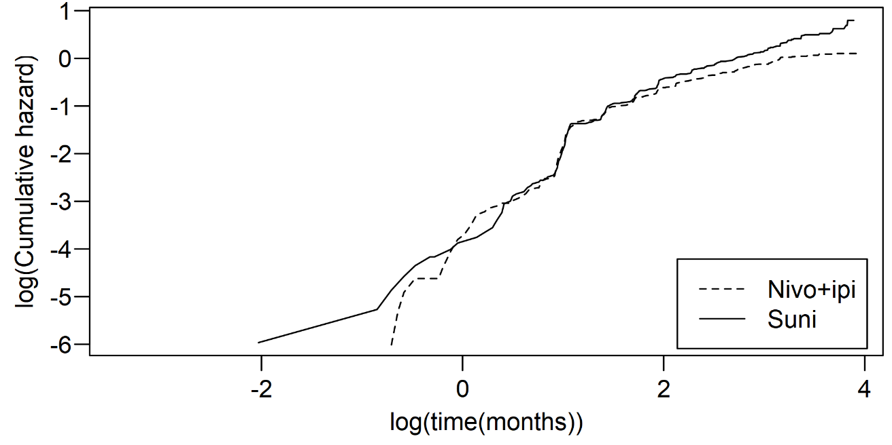
Fig. S4 PFS; Schoenfeld residuals.
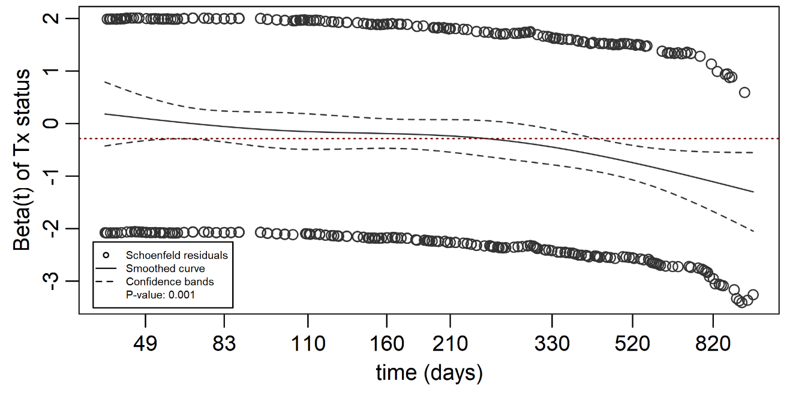

Table S1 shows the AIC and BIC values of the NIVO+IPI and SUN arms, as well as the parametrization for the selected distribution. Based on both criteria, the parametric spline models provide an improved fit over the traditional parametric distribution models. The odds spline one-knot is the best performing model, as it minimizes the AIC and BIC of both arms. Considering both AIC and BIC on both trial arms, the hazard spline one-knot seems to be the second-best fitting distribution, as it stays within 2 points deviation in terms of BIC for NIVO+IPI and in terms of AIC and BIC for sunitinib. The best non-spline option is the generalized gamma distribution, minimizing both AIC and BIC of NIVO+IPI for the conventional distributions.
Table S1 PFS; AIC and BIC values for nivolumab plus ipilimumab and sunitinib, and the parametrization for the best performing model.
Survival model | PFS NIVO+IPI |  | PFS SUN
Survival model | AIC | BIC | AIC | BIC
Exponential | 3696.4 | 3700.5 | 3596.4 | 3600.4
Weibull | 3657.5 | 3665.6 | 3597.2 | 3605.3
Gompertz | 3578.4 | 3586.5 | 3580.0 | 3588.1
Log-logistic | 3610.0 | 3618.1 | 3556.8 | 3564.9
Log-normal | 3593.1 | 3601.2 | 3549.1 | 3557.2
Gamma | 3672.5 | 3680.6 | 3598.4 | 3606.5
Generalized gamma | 3543.7 | 3555.8 | 3546.4 | 3558.6
Hazard spline one knot | 3533.7 | 3545.8 | 3538.3 | 3550.4
Hazard spline two knots | 3531.9 | 3548.1 | 3539.3 | 3555.5
Odds spline one knot | 3531.6 | 3543.8 | 3537.8 | 3549.9
Odds spline two knots | 3532.2 | 3548.4 | 3539.7 | 3555.8
Probit spline one knot | 3533.2 | 3545.3 | 3543.2 | 3555.4
Parameters best performing model | Input parameters NIVO+IPI |  | Input parameters SUN
Odds spline 1-knot | γ0: –12.44  γ1: 2.49  γ2: 0.14  Min: 2.71  Knot 1: 4.93  Max: 7.11 |  | γ0: –12.29  γ1: 2.54  γ2: 0.07  Min: 1.39  Knot 1: 5.11  Max: 7.25
AIC Akaike’s information criterion, BIC Bayesian information criterion, NIVO+IPI nivolumab plus ipilimumab, PFS progression-free survival, SUN sunitinib

Overall survival. The log-cumulative hazard plot is displayed in Figure S5. The log-cumulative hazard plot does not suggest proportional hazards due to the crossing of the NIVO+IPI and the SUN curves. However, the chi-square test could not be labelled as statistically significant (P = 0.672), which means that the proportional-hazard assumption cannot be rejected based on this test. In addition, the assumption of a constant HR does not appear violated by the Schoenfeld residuals, as no clear trend in time can be observed (Fig. S6). Based on these results, the proportional-hazard assumption was not rejected for OS and a single dependent model, including a treatment effect (HR), was fitted on both the NIVO+IPI and SUN arms.
Fig. S5 OS; Log-cumulative hazard plot.
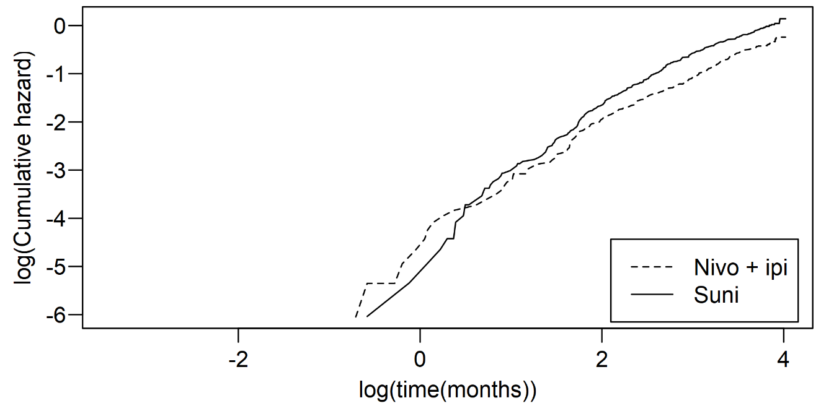
Fig. S6 OS; Schoenfeld residuals.
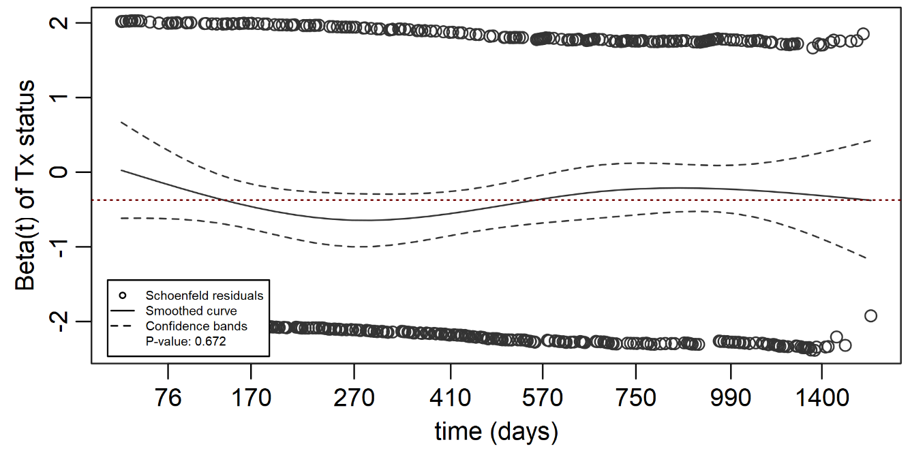
AIC and BIC were evaluated to statistically compare model fits, as presented in Table S2. Based on these criteria, the log-normal distribution provides the best statistical fit to the data as it minimizes BIC. Further, it deviates less than 2.0 points from the hazard spline one-knot in terms of AIC, providing substantial support that the curves perform equally well in terms of AIC. The log-normal distribution is followed by the hazard spline one-knot and the odds spline one-knot.

Table S2 OS; AIC and BIC values for nivolumab plus ipilimumab and sunitinib, and the parametrization for the best performing model.
Survival model
Survival model | AIC | BIC
Exponential | 7741.1 | 7750.6
Weibull | 7741.1 | 7755.4
Gompertz | 7727.1 | 7741.3
Log-logistic | 7718.5 | 7732.7
Log-normal | 7708.1 | 7722.3
Gamma | 7742.6 | 7756.8
Generalized gamma | 7709.7 | 7728.7
Hazard spline one knot | 7707.6 | 7726.5
Hazard spline two knots | 7709.1 | 7732.8
Odds spline one knot | 7707.7 | 7726.6
Odds spline two knots | 7709.1 | 7732.8
Probit spline one knot | 7709.0 | 7727.9
Parameters best performing model | Input parameters NIVO+IPI | Input parameters SUN
Dependent log-normal | Meanlog: 6.78  Sdlog: 1.49  tx: 0.42 | Meanlog: 6.78  Sdlog: 1.49  tx: 0.00
AIC Akaike’s information criterion, BIC Bayesian information criterion, NIVO+IPI nivolumab plus ipilimumab, OS overall survival, SUN sunitinib

Time to treatment discontinuation. The log-cumulative hazard plot is displayed in Figure S7. The log-cumulative hazard plot does not suggest proportional hazards due to the crossing of the NIVO+IPI and the SUN curves. However, the chi-square test could not be labelled as statistically significant (P = 0.672), which means that the proportional-hazard assumption cannot be rejected based on this test. In addition, the assumption of a constant HR does not appear violated by the Schoenfeld residuals, as no clear trend in time can be observed (Fig. S8). Based on these results, the proportional-hazard assumption was not rejected for OS and a single dependent model, including a treatment effect (HR), was fitted on both the NIVO+IPI and SUN arms.

Fig. S7 TTD; log-cumulative hazard plot.
Fig. S8 TTD; Schoenfeld residuals.
AIC and BIC were evaluated to statistically compare model fits, as presented in Table S3. The results show the best AIC and BIC values for the log-logistic model in the NIVO+IPI arm, followed by the odds spline one-knot. For SUN, the probit spline two-knots minimizes the AIC, while the log-logistic distribution minimizes BIC. Considering both trial arms, there is an overall preference for the log-logistic model over the spline models.
Table S3 TTD; AIC and BIC values for nivolumab plus ipilimumab, and the parametrization for the best-performing model.
Survival model | TTD NIVO+IPI |  | TTD SUN
Survival model | AIC | BIC | AIC | BIC
Exponential | 5386.8 | 5390.9 | 5581.2 | 5585.3
Weibull | 5295.4 | 5303.5 | 5566.9 | 5574.9
Gompertz | 5290.1 | 5298.2 | 5556.0 | 5564.1
Log-logistic | 5279.6 | 5287.7 | 5553.0 | 5561.1
Log-normal | 5290.5 | 5298.6 | 5576.4 | 5584.5
Gamma | 5310.7 | 5318.8 | 5573.6 | 5581.7
Generalized gamma | 5283.5 | 5295.6 | 5554.6 | 5566.7
Hazard spline one knot | 5282.6 | 5294.7 | 5551.5 | 5563.6
Hazard spline two knots | 5283.0 | 5299.2 | 5549.9 | 5566.1
Odds spline one knot | 5280.9 | 5293.0 | 5551.0 | 5563.2
Odds spline two knots | 5282.8 | 5299.0 | 5552.5 | 5568.7
Probit spline one knot | 5282.4 | 5294.6 | 5553.3 | 5565.4
Parameters best performing model | Input parameters NIVO+IPI |  | Input parameters SUN
Independent log-logistic | Shape: 0.99  Scale: 214.40 |  | Shape: 1.33  Scale: 185.35
AIC Akaike’s information criterion, BIC Bayesian information criterion, NIVO+IPI nivolumab plus ipilimumab, SUN sunitinib, TTD time to treatment discontinuation
Table S4 Distribution of subsequent treatment inputs (2L+, 2020) in the model by 1L treatment received
Subsequent systemic therapy received | Base case (based on CheckMate 214 data) |  | Scenario analysis (based on Swiss expert opinion)
Subsequent systemic therapy received | First-line therapy received
Subsequent systemic therapy received | 1L NIVO+IPI | 1L SUN or PAZ | 1L NIVO+IPI | 1L SUN or PAZ
Any type of subsequent treatment | 66% | 71% | 85% | 85%
2L+ NIVO monotherapy | 14% | 60% | 0% | 80%
2L+ SUN | 48% | 18% | 10% | 0%
2L+ PAZ | 38% | 11% | 0% | 0%
2L+ axitinib | 36% | 39% | 60% | 10%
2L+ cabozantinib | 29% | 23% | 30% | 10%
2L+ everolimus | 19% | 21% | 0% | 0%
2L+ sorafenib | 5% | 2% | 0% | 0%
Percentages do not add up to 100% as a patient can get more than one subsequent treatment.
1L first line, 2L+ second line and subsequent lines, NIVO nivolumab, NIVO+IPI nivolumab plus ipilimumab, PAZ pazopanib, SUN sunitinib

Resource use
Treatment acquisition, administration and monitoring. NIVO+IPI was administered intravenously at 3 mg/kg every 3 weeks, for four doses, in the induction phase, followed by NIVO monotherapy at 3 mg per kg every 2 weeks in the maintenance phase (maximum of four doses). Patients in the SUN arm received 50 mg orally once daily for 4 weeks of each 6-week cycle [1]. PAZ, which is also an oral multi-TKI inhibitor, was administered at the approved daily dose of 800 mg [2].

Table S5 Disease management resource use estimates
Unit | At treatment initiation |  | Progression-free state |  |  |  |  |  | Progressive disease state
Outpatient visits |  |  | NIVO+IPI |  | SUN |  | PAZ |  | Active treatment |  | BSC
 | % patient | Resource use | % patient | Resource use frequency per 4 weeks | % patient | Resource use frequency per 4 weeks | % patient | Resource use frequency per 4 weeks | % patient | Resource use frequency per 4 weeks | % patient | Resource use frequency per 4 weeks
General practitioner, visits per 4 weeks | 28% | 1 | 28% | 0.5 | 53% | 1 | 53% | 1 | 53% | 1.5 | 63% | 2
Oncologist,  visits per 4 weeks | 100% | 2.5 | 100% | 2 | 100% | 2 | 100% | 2 | 100% | 2 | 100% | 1
Kidney specialist,  visits per 4 weeks | 8% | 0.5 | 3% | 0.5 | 0 | NA | 0% | NA | 0% | NA | 0% | NA
Full blood test | 100% | 1.5 | 100% | 2 | 100% | 1.5 | 100% | 2 | 100% | 2 | 55% | 1
CMP | 100% | 1.5 | 100% | 2 | 100% | 1.5 | 100% | 2 | 100% | 2 | 50% | 0.5
LDH | 100% | 1.5 | 100% | 0.5 | 100% | 0.5 | 100% | 0.5 | 100% | 0.5 | 0% | NA
CT scan abdomen | 100% | 1 | 100% | 0.4 | 100% | 0.4 | 100% | 0.4 | 100% | 0.4 | 0% | NA
CT scan thorax | 100% | 1 | 100% | 0.4 | 100% | 0.4 | 100% | 0.4 | 100% | 0.4 | 0% | NA
BSC best supportive care, CMP comprehensive metabolic panel, CT computed tomography, LDH lactate dehydrogenase, NA not applicable, NIVO+IPI nivolumab plus ipilimumab, PAZ pazopanib, SUN sunitinib

Table S6 Scenario analyses results overview
Assumption |  | Base-case value | Scenario analysis value | ICUR vs SUN  (CHF/QALY) | Change from base case SUN (%) | ICUR vs PAZ  (CHF/QALY) | Change from base case PAZ (%)
Base case |  |  |  | 108,326 |  | 106,996
Dosing schedule |  | Weight-based dosing of 3 mg/kg during maintenance phase | 240 mg (Q2W) flat dosing of NIVO during maintenance phase | 126,127 | 16.4 | 124,797 | 16.6
Survival extrapolation | PFS | Independent odds spline one-knot | Independent generalized gamma | 110,325 | 1.8 | 109,160 | 2.0
Survival extrapolation | TTD | Independent log-logistic | Independent odds spline  one-knot | 105,782 | –2.3 | 104,554 | –2.3
Survival extrapolation | OS | Dependent log-normal | Dependent hazard spline  one-knot | 84,312 | –22.2 | 83,296 | –22.2
Survival extrapolation | OS | Dependent log-normal | Independent log-normal | 78,864 | –27.2 | 77,914 | –27.2
Utilities from CheckMate 214 |  | Using treatment-specific utilities in PF, non-treatment specific utilities in PD | Using treatment-specific utilities in both PF and PD | 102,595 | –5.3 | 101,336 | –5.3
 |  |  | Using non-treatment specific utilities in both PF (0.798) and PD (0.772) | 126,216 | 16.5 | 124,667 | 16.5
 |  | Using a French tariff | Using a German tariff (0.905 and 0.874 for NIVO+IPI and SUN respectively in PF, 0.875 for both arms in PD) | 105,408 | –2.7 | 104,114 | –2.7
Subsequent treatment |  | Treatment distribution informed by the CheckMate 214 RCT | Treatment distribution informed by Swiss clinical expert opinion (See Table S1) | 99,515 | –8.1 | 98,185 | –8.2
Maximum treatment duration |  | Patients on NIVO stop treatment within  3 months after a CR | Patients on NIV stop treatment within 24 months after a CR | 112,442 | 3.8 | 111,111 | 3.8
CR complete response, ICUR incremental cost-utility ratio, NIVO+IPI nivolumab plus ipilimumab, OS overall survival, PAZ pazopanib, PD progressed disease, PF progression-free, PFS progression-free survival, QALY quality-adjusted life-year, Q2W every 2 weeks, RCT randomized controlled trial, SUN sunitinib, TTD time to treatment discontinuation

References
1. Motzer RJ, Tannir NM, McDermott DF, et al. Nivolumab plus ipilimumab versus sunitinib in advanced renal-cell carcinoma. N Engl J Med. 2018;378(14):1277-90.
2. Sandmeier N, Rothschild SI, Rothermundt C, et al. Pattern of care study in metastatic renal-cell carcinoma in the preimmunotherapy era in Switzerland. Clin Genitourin Cancer. 2018;16(4):E711-8.

