Cost-Effectiveness of Recombinant Zoster Vaccine for the Prevention of Herpes Zoster in Hematopoietic Stem Cell Transplant Recipients and Other Immunocompromised Adults in the United States
Running heading: Cost-Effectiveness of RZV in US Immunocompromised Adults
Ahmed Salem (0000-0003-0704-8085)¹; Elizabeth M. La (0000-0001-5652-8961)²; Desmond Curran (0000-0002-7423-0111)¹; Brandon J. Patterson (0000-0002-5319-9493)^{2,6}; Justin Carrico (0000-0002-4659-9309)³; Stéphane Lorenc (0000-0001-5093-0247)¹; Katherine A. Hicks (0000-0002-1058-3401)³; Sara Poston (0000-0003-4735-057X)²; Christopher F. Carpenter (0000-0001-5708-5381)^{4,5}
¹GSK, Wavre, Belgium
²GSK, Philadelphia, PA, USA
³RTI Health Solutions, Research Triangle Park, NC, USA
⁴Beaumont Hospital, Royal Oak, MI, USA
⁵Oakland University William Beaumont School of Medicine, Rochester, MI, USA
⁶Current affiliation: Janssen Global Services, Raritan, NJ, USA

Correspondence to:
Ahmed Salem, MSc
GSK, Avenue Pascal 2-4-6, 1300 Wavre, Belgium
+32 487-307-864 | salem.x.ahmedehab@gsk.com
Financial support: Ahmed Salem is an employee of GSK and reports holding shares in the GSK group of companies.
Appendix
Table A1. Values and sources applied for demographic model inputs in base-case and sensitivity analyses
Table A2. Values and sources applied for epidemiological model inputs in base-case and sensitivity analyses
Table A3. Values and sources applied for vaccine-specific model inputs in base-case and sensitivity analyses
Table A4. Values and sources applied for individuals aged 18–49 years with healthy status
Table A5. Values and sources applied for cost inputs in base-case and sensitivity analyses
Table A6. Values and sources applied for utility inputs in base-case and sensitivity analyses
Table A7. Base-case and extreme values of key inputs observed in threshold analysis
Figure A1. Plain language summary of this cost-effectiveness study of recombinant zoster vaccine for use in
immunocompromised adults against herpes zoster in the United States
Figure A2. Incremental cost-effectiveness ratios for RZV versus no vaccine for US HSCT adults aged 35 years, when
values of key inputs are varied from –90% to +100% of base-case values
Figure A3. RZV efficacy over time in the ZONA IC Model for United States HSCT adults aged 35 years based on base-
case efficacy and waning data
Figure A4. RZV efficacy over time in the ZONA IC Model for United States adults with other immunocompromised
conditions
Figure A5. Association between herpes zoster incidence in placebo arm and initial RZV efficacy against herpes zoster
and postherpetic neuralgia, based on data from the ZOE-50 (Lal et al., 2015), ZOE-70 (Cunningham et al.,
2016), ZOE-HM (Dagnew et al., 2019), and ZOE-HSCT (Bastidas et al., 2019) clinical trials*
Figure A6. Association between herpes zoster incidence in placebo arm and waning of RZV efficacy against herpes
zoster and postherpetic neuralgia, based on data from the ZOE-50 (Lal et al., 2015), ZOE-70 (Cunningham et
al., 2016), and ZOE-HSCT (Bastidas et al., 2019) clinical trials*

Table A1. Values and sources applied for demographic model inputs in base-case and sensitivity analyses
Category/input | Base-case value | Range* |  | Base-case value source | Range source
Category/input | Base-case value | Lower bound | Upper bound | Base-case value source | Range source
Population starting age (years) | 35 | -- | -- | Assumed† | --
IC status duration (years) | 5 | 2 | 5 | Sahoo et al.^{23‡} | Assumed‡
Annual probability of all-cause mortality§ | 0.0994 | -- | -- | Arias and Xu⁴³; Bastidas et al.¹⁹; Noone et al.⁴¹|| | --
HSCT = hematopoietic stem cell transplant; HZ = herpes zoster; IC = immunocompromised; RZV = recombinant zoster vaccine.
Note: -- = not varied in sensitivity or scenario analyses.
* For the probabilistic sensitivity analysis, the gamma distribution has been assumed for varying the IC status duration. All other inputs presented in this table were not varied in the probabilistic sensitivity analysis or in the deterministic sensitivity analysis.
† The population was assumed to be 35 years of age at the start of the model time horizon to represent a younger HSCT population; 75% of the population in the phase 3 clinical trial were aged 50 years and older.¹⁹
‡ Sahoo et al.²³ reported estimated HZ incidence in the 5 years following HSCT. Therefore, we assumed that the relevant period of reduced immune function also was 5 years. We assumed a lower bound of 2 years, which was similar to the length of the follow-up period observed in Bastidas et al.¹⁹ and Winston et al.³⁵ clinical trials of HZ prevention in HSCT recipients. The IC status duration was not varied to an upper bound value, as 5 years was assumed to fully capture the duration of increased risk of HZ due to HSCT.
§ Applies to individuals with IC status only.
|| Noone et al.⁴¹ reported the 5-year survival probability of 0.507, 0.714, 0.866, and 0.274 for multiple myeloma, non-Hodgkin’s lymphoma, Hodgkin’s lymphoma, and acute myeloid leukemia, respectively. The annual probabilities of death then were derived from the 5-year survival probability to 0.127, 0.065, 0.028, and 0.228, respectively. A weighted annual probability of death then was calculated based on the percentage of patients in the RZV autologous HSCT trial with myeloma (53.1%), non-Hodgkin’s lymphoma (33.1%), Hodgkin’s lymphoma (8.90%), and acute myeloid leukemia (2.3%)¹⁹; as a simplifying assumption, these conditions were assumed to represent the total trial population, as only 2.6% of the trial population had other conditions. This value was applied until the population returned to healthy status.

Table A2. Values and sources applied for epidemiological model inputs in base-case and sensitivity analyses
Category/input | Base-case value | Range* |  | Base-case value source | Range source
Category/input | Base-case value | Lower bound | Upper bound | Base-case value source | Range source
Annual incidence of initial and recurrent HZ (per person-year)†,‡ | 0.06 | 0.04 | 0.08 | Sahoo et al.²³ | Chen et al.¹⁷  Sahoo et al.^{23§}
Percentage of initial and recurrent HZ cases with PHN† | 12.9% | 8.5% | 17.3% | Sahoo et al.^{23§} | Sahoo et al.^{23§}
Case fatality rates for HZ cases
Ages 18–49 years | 0.0000% | 0.0000% | 0.0013% | Assumption; Le and Rothberg^{37||} | Le and Rothberg^{37||}
Ages 50–54 years | 0.0013% | 0.0009% | 0.0017% | Assumption; Le and Rothberg^{37||} | Le and Rothberg^{37||}
Ages 55–59 years | 0.0013% | 0.0009% | 0.0017% | Assumption; Le and Rothberg^{37||} | Le and Rothberg^{37||}
Ages 60–64 years | 0.0022% | 0.0017% | 0.0027% | Assumption; Le and Rothberg^{37||} | Le and Rothberg^{37||}
Ages 64–69 years | 0.0022% | 0.0017% | 0.0027% | Assumption; Le and Rothberg^{37||} | Le and Rothberg^{37||}
Ages 70–74 years | 0.0062% | 0.0053% | 0.0070% | Assumption; Le and Rothberg^{37||} | Le and Rothberg^{37||}
Ages 75–79 years | 0.0062% | 0.0053% | 0.0070% | Assumption; Le and Rothberg^{37||} | Le and Rothberg^{37||}
Ages 80–84 years | 0.0240% | 0.0219% | 0.0260% | Assumption; Le and Rothberg^{37||} | Le and Rothberg^{37||}
Ages 85+ years | 0.0734% | 0.0688% | 0.0778% | Assumption; Le and Rothberg^{37||} | Le and Rothberg^{37||}
Percentage of HZ cases with HZ-related complications†,¶
Ocular | 3.6% | 1.1% | 6.0% | Sahoo et al.^{23¶} | Sahoo et al.^{23¶}
Neurological | 1.8% | 0.1% | 3.5% | Sahoo et al.^{23¶} | Sahoo et al.^{23¶}
Cutaneous | 5.8% | 2.7% | 8.8% | Sahoo et al.^{23¶} | Sahoo et al.^{23¶}
Other non-pain | 0.9% | 0.0% | 2.1% | Sahoo et al.^{23¶} | Sahoo et al.^{23¶}

HSCT = hematopoietic stem cell transplant; HZ = herpes zoster; IC = immunocompromised; PHN = postherpetic neuralgia.
* For the probabilistic sensitivity analysis, the beta distribution has been assumed for the purpose of sampling values for all inputs in this table. The standard errors applied in the beta distribution parameters are consistent with the reported uncertainty ranges representing 95% confidence intervals.
† This input applies to individuals with IC status only.
‡ Sahoo et al.²³ reported average annual incidence rate of HZ among autologous HSCT recipients over a period of 5 years after HSCT. Herpes zoster episodes were identified through follow-up surveys to providers and to patients after receiving an HSCT; patient demographics and clinical characteristics were identified through retrospective review of databases and available medical records. The observation period was 2002–2010, and median follow-up was 39.7 months. Incidence was highest in the second year following HSCT (130 per 1,000 person-years). For recurrent HZ, 16% of those patients with an incident HZ case had at least one recurrent case of HZ over the 5-year period. We have assumed that the rate of recurrent HZ was the same as the rate of initial HZ cases. Cumulative incidence curves over time were similar between initial HZ episodes and recurrent episodes. The study population included antiviral prophylactic use of varying durations. The study conducted by Sahoo and colleagues²³ was selected as the source for the base-case incidence of HZ because it was deemed that this population better reflects a real-world HSCT population than do recent clinical trials assessing HZ vaccines in HSCT populations^{19, 35} which excluded patients with an expected duration of antiviral prophylaxis of more than 6 months. Sahoo et al.²³ also was selected because the study had the longest follow-up (median of 39.7 months) among the studies considered ^{17, 19, 23, 35, 36} and provided a 5-year annual incidence estimate following HSCT. The lower bound was based on the incidence of HZ among bone marrow or stem cell transplant recipients aged 18 to 49 years from Chen et al.¹⁷, which presented a lower (and therefore more conservative) estimate of HZ incidence than the lower bound of the 95% confidence interval reported by Sahoo et al.²³ The upper bound was the upper bound of the 95% confidence interval presented in Sahoo et al.²³
§ This rate of PHN among incident and recurrent HZ cases was reported by Sahoo et al.²³ The rate of PHN among HZ cases was similar between incident and recurrent cases. For the uncertainty range, a 95% confidence was derived from Sahoo et al.²³, based on the number of events and the sample size.
|| We have assumed no HZ-related mortality for ages 18 to 49 years. Base-case values and uncertainty ranges around HZ-related death rates for ages 50 years and older were assumed to be the same as those for an immunocompetent population, which rates were taken from Le and Rothberg.³⁶ For ages 18 to 49 years, we assumed the base-case HZ-related death rate for ages 50 to 59 years for the upper bound value.
¶ This rate of non-PHN complications among all HZ cases in HSCT recipients was reported by Sahoo et al.²³ These values were used only for generation of health outcomes; no costs due to complications other than PHN were explicitly considered in order to avoid potential double-counting with costs related to HZ from Eriksson et al.²², which did not report costs specific to non-PHN complications. A 95% confidence interval was derived from Sahoo et al.²³, based on the number of events and the sample size.

Table A3. Values and sources applied for vaccine-specific model inputs in base-case and sensitivity analyses
Category/input | Base-case value | Range* |  | Base-case value source | Range source
Category/input | Base-case value | Lower bound | Upper bound | Base-case value source | Range source
Vaccine efficacy/coverage
Initial RZV efficacy against HZ
One dose | 58.0% | 46.4% | 69.6% | Assumed† | Assumed†
Two doses | 72.5% | 58.3% | 82.4% | GSK (2020)^{45‡} | GSK (2020)^{45‡}
Initial RZV efficacy against PHN
One dose | 75.9% | 60.7% | 91.0% | Assumed† | Assumed†
Two doses | 94.8% | 58.3% | 100.0% | Bastidas et al.¹⁹; GSK (2020)^{45§} | Bastidas et al.¹⁹; GSK (2020)^{45§}
Annual waning of RZV efficacy||
One dose | 18.2% | 9.1% | 27.3% | Assumed¶ | Assumed¶
Two doses | 9.1% | 4.6% | 18.2% | Bastidas et al.¹⁹; GSK (2020)⁴⁵** | Assumed**
Second-dose compliance for RZV | 100.0% | 76.0% | 100.0% | Assumed†† | Assumed††
Time (months) between the first and second doses of RZV | 2 | -- | -- | Assumed‡‡ | --
Adverse events
Incidence of AE per RZV dose
Local/general | 0.8450 | --§§ | --§§ | GSK (2020b)⁴⁶; GSK (2020c)^{47§§} | --§§
PCP | 0.0203 | --§§ | --§§ | GSK (2020b)⁴⁶; GSK (2020c)^{47§§} | --§§
ER | 0.0045 | --§§ | --§§ | GSK (2020b)⁴⁶; GSK (2020c)^{47§§} | --§§
Hospitalization | 0.0045 | --§§ | --§§ | GSK (2020b)⁴⁶; GSK (2020c)^{47§§} | --§§
AE = adverse event; CDC = Centers for Disease Control and Prevention; CMS = Centers for Medicare and Medicaid Services; ER = emergency room; HSCT = hematopoietic stem cell transplant; HZ = herpes zoster; IC = immunocompromised; PCP = primary care provider; PHN = postherpetic neuralgia; QALY = quality-adjusted life-year; RZV = recombinant zoster vaccine.
Note: -- = not varied in sensitivity or scenario analyses.
* For the probabilistic sensitivity analysis, the beta distribution has been assumed for all efficacy and waning-related inputs except for second-dose compliance, for which the uniform distribution was used. The standard errors applied in the beta distribution parameters are consistent with the reported uncertainty ranges representing 95% confidence intervals.
† We have assumed a 20% relative reduction from two-dose efficacy, due to a lack of data for one-dose RZV (i.e., high second-dose compliance) in the clinical trials. We have assumed a ±20% relative change from the base-case value for the uncertainty range.
‡ Year 1 efficacy for RZV versus placebo in prevention of first or only episode of HZ was taken from the ZOSTER-002 phase 3 clinical trial of RZV in HSCT patients, as reported by GSK (2020)⁴⁵. The 95% confidence interval from GSK (2020)⁴⁵ was used for the uncertainty range.
§ Overall efficacy against PHN over the trial follow-up period was calculated based on the PHN incidence rate ratio for the modified total vaccinated cohort (0.5 per 1,000 person-years) times the PHN incidence among the placebo cohort (4.9 per 1,000 person-years), as reported by GSK (2020)⁴⁵. The initial efficacy against PHN then was derived by adjusting the overall efficacy of RZV against PHN, based on the relationship between the initial efficacy against HZ and the overall efficacy against HZ over the trial follow-up period.¹⁹ Lower-bound initial efficacy was derived by adjusting the lower-bound overall efficacy against PHN, based on the relationship between the initial efficacy against HZ⁴⁵ and the overall efficacy against HZ over the trial follow-up period.¹⁹
|| This applies to individuals with IC status only.
¶ We have assumed a 100% relative increase from two-dose waning of efficacy, due to a lack of data for one-dose RZV (i.e., high second-dose compliance) in the clinical trials. Assumed ±50% relative change from the base-case value for the uncertainty range.
** Annual linear waning was estimated based on efficacy estimates in year 1 (72.5%) and years 2 and beyond (54.3%) from the ZOSTER-002 phase 3 clinical trial of RZV in HSCT patients, as reported in GSK (2020)⁴⁵. Median follow-up in the clinical trial was 21 months (1.75 years)¹⁹; assuming an exponential distribution for the length of follow-up, mean follow-up was estimated to be 2.5 years. It then was assumed that year 1 efficacy was measured at the midpoint of year 1 (0.5 years), and annual waning was calculated as (72.5% – 54.3%) ÷ (2.5 – 0.5) = 9.1%. We assumed –50% and +100% relative change from the base-case value for the uncertainty range.
†† We have assumed 100% coverage of the second dose, based on Prosser et al.³⁰ assumptions and high completion rates (> 80%) of four-dose HZ vaccine during Merck's V212 trial.³⁵ The lower bound of 76% second-dose compliance was assumed from the CDC presentation on CMS data for the second dose of RZV from Dooling et al.⁸ The upper bound was assumed to be the same as the base-case value (100%).
‡‡We have assumed a 2-month interval between the first and second dose of RZV. The interval between first and second dose of RZV in clinical trials for IC populations was 1 to 2 months.^{19, 20, 48}
§§ GSK (2020b)⁴⁵ reported rates of local/general AEs and GSK (2020c)⁴⁷ reported the rates of medically attended visit types by time period post-vaccination and by age group for the RZV total vaccinated cohort in the ZOSTER-002 phase 3 clinical trial of RZV in HSCT individuals. The individual AE incidence rates were not varied in sensitivity analysis. However, the weighted AE cost per dose and weighted AE QALY loss per dose, which were calculated from these values, were varied.

Table A4. Values and sources applied for individuals aged 18–49 years with healthy status
Category/input | Base-case value | Range* |  | Base-case value source | Range source
Category/input | Base-case value | Lower bound | Upper bound | Base-case value source | Range source
Annual incidence of initial herpes zoster (per person-year) | 0.00375 | 0.00300 | 0.00451 | Johnson et al.² | Lower bound: assumed; Upper bound: Tseng et al.⁴⁹*
Percentage of initial herpes zoster cases with postherpetic neuralgia | 6.20% | 4.96% | 7.44% | Yawn et al.^{3†} | Assumed‡
Annual probability of recurrent herpes zoster (per person-year) | 0.00375 | 0.00110 | 0.00451 | Johnson et al.^{2§} | Lower bound: Tseng et al.⁵⁰; Upper bound: assumed||
Percentage of recurrent herpes zoster cases with postherpetic neuralgia | 6.20% | 3.72% | 8.68% | Yawn et al.^{51¶} | Assumed**
Herpes zoster case fatality (percentage per herpes zoster case) | 0.0000% | 0.0000% | 0.0013% | Le and Rothberg³⁷ | Assumed††
Percentage of herpes zoster cases with ocular complications | 3.16% | 1.00% | 4.64% | Yawn et al.³ | Yawn et al.^{3‡‡}
Percentage of herpes zoster cases with neurological complications | 1.67% | 0.59% | 2.76% | Yawn et al.³ | Yawn et al.^{3§§}
Percentage of herpes zoster cases with cutaneous complications | 1.12% | 0.23% | 2.00% | Yawn et al.³ | Yawn et al.^{3§§}
Percentage of herpes zoster cases with other non-pain complications | 0.74% | 0.02% | 1.47% | Yawn et al.³ | Yawn et al.^{3||||}

* Assumed –20% of the base incidence estimates for the lower bound; this was used instead of the published CIs to represent greater uncertainty around HZ incidence. The upper bound estimates were taken from Tseng et al.⁴⁹, which reported incidence based on ICD-9-CM diagnoses of HZ for an unvaccinated and healthy population of Kaiser Permanente members from 2007 to 2009.
† For ages 18 to 49, we assumed the same rate of PHN as ages 50 to 59, as Yawn et al.³ observed rates of PHN (pain for 90 days or more) that were the same for both ages 22 to 49 and ages 50 to 59.
‡ Assumed a range of ±20% of the base-case values.
§ Yawn et al.⁵¹ found that rates of recurrent HZ were as common as initial HZ. Based on that source, we assumed that annual probability of recurrent HZ case (and subsequent probability of PHN) is the same as the annual probability of an initial HZ case, which was estimated from Johnson et al.²
|| For the lower bound, we used values from Tseng et al.⁵⁰; values were taken from the lower bound of the CIs reported for recurrent HZ incidence in an unvaccinated cohort (based on a matched cohort study in Kaiser Permanente Southern California). The upper bound estimates were assumed to be the same as those for incidence of initial HZ.
¶ Based on Yawn et al.⁵¹, which found that rates of recurrent HZ were as common as initial HZ, it was assumed that the probability of PHN during a recurrent HZ case was the same as the probability during an initial HZ case.
** Assumed a range two times the width of the range for the probability of PHN in an initial case of HZ.
†† For ages 18 to 49, assumed the base-case HZ-related death rate for ages 50 to 59 for the upper bound value (for ages 50 and older, published 95% CIs from Le and Rothberg³⁷ were used).
‡‡ Derived a 95% CI based on a standard error that was calculated from the published data in Yawn et al.³ All lower bounds were set to a maximum of 1% for an estimate that would disfavor RZV cost-effectiveness. Standard errors were adjusted to account for the adjusted lower bounds.
§§ Derived a 95% CI based on a standard error that was calculated from the published data in Yawn et al.³ All lower bounds were set to a minimum of the published lower bound or 1% for an estimate that would disfavor RZV cost-effectiveness. Standard errors were adjusted to account for the adjusted lower bounds.
|||| Derived a 95% CI based on a standard error that was calculated from the published data in Yawn et al.³

Table A5. Values and sources applied for cost inputs in base-case and sensitivity analyses
Category/input | Base-case value | Range* |  | Base-case value source | Range source
Category/input | Base-case value | Lower bound | Upper bound | Base-case value source | Range source
Direct medical costs
Costs per HZ case†
Without PHN | US$3,577.75 | US$2,163.22 | US$5,155.87 | Eriksson et al.^{22‡} | Eriksson et al.^{22‡}
With PHN | US$8,512.86 | US$3,891.28 | US$12,428.34 | Eriksson et al.²², Moore et al.⁵², Oxman et al.^{53§} | Eriksson et al.²², Lieu et al.^{54§}
Costs per HZ-related complication† | US$0.00 | US$0.00 | US$0.00 | Assumed|| | N/A||
Direct vaccination costs
RZV vaccine price per dose¶ | US$162.01 | US$162.01 | US$186.31 | Micromedex⁵⁵ | Assumed
Administration cost per dose** | US$27.73 | US$15.00 | US$50.00 | Tsai et al.⁵⁶ | Assumed
AE costs
Local/general | US$17.59 | --†† | --†† | Ortega-Sanchez^{57‡‡} | N/A††
PCP | US$402.20 | --†† | --†† | Agency for Healthcare Research and Quality^{58††} | N/A††
ER | US$926.91 | --†† | --†† | Agency for Healthcare Research and Quality^{58§§} | N/A††
Serious (hospitalization) | US$8,291.69 | --†† | --†† | Le and Rothberg³⁶, Healthcare Cost and Utilization Project^{59||||} | N/A¶¶
Weighted AE cost per dose | US$64.51 | US$32.25 | US$129.02 | Calculation*** | Calculation***
Indirect costs
Indirect costs per HZ case† | US$199.50 | US$69.27 | US$384.28 | Eriksson et al.^{22†††} | Eriksson et al.^{22†††}
Discount rate
Costs | 3.0% | 0.0% | 6.0% | Sanders et al.¹³ | Assumed
AE = adverse event; ER = emergency room; HSCT = hematopoietic stem cell transplant; HZ = herpes zoster; IC = immunocompromised; N/A = not applicable; PCP = primary care provider; PHN = postherpetic neuralgia; QALY = quality-adjusted life-year; RZV = recombinant zoster vaccine; US = United States; ZVL = zoster vaccine live.
Note: -- = not varied in sensitivity or scenario analyses.
* For the probabilistic sensitivity analysis, the gamma distribution has been assumed for all cost-related inputs. The standard errors applied in the gamma distribution parameters are consistent with the reported uncertainty ranges representing 95% confidence intervals.
† This applies to individuals with IC status only.
‡ Eriksson et al.²² reported direct cost of HZ cases without PHN among 134 HSCT patients (reported in 2017 US dollars). About 90% of the costs were due to inpatient care. Costs were inflated to 2019 US dollars using the United States Bureau of Labor Statistics¹⁵ Consumer Price Index for Medical Care. The uncertainty range was obtained from the 95% confidence intervals from Eriksson et al.²²
§ Eriksson et al.²² reported direct cost of HZ cases with PHN among 21 HSCT patients (reported in 2017 US dollars). About 90% of the costs were due to inpatient care. Eriksson et al.²² noted several limitations in their estimate of costs for HZ cases with PHN, including limited follow-up for measuring resource utilization (6 months), missing data on the length of hospitalizations, and censoring of some PHN patients. Therefore, an average monthly cost of PHN was derived by dividing the cost estimate from Eriksson et al.²² by the duration of PHN reported in the study (approximately 6 months). The average monthly cost then was multiplied by the duration of PHN in months. The mean length of PHN was taken from Moore et al.,⁵² citing Oxman et al.,⁵³ which reported a mean duration of PHN of 12.9 months for immunocompetent individuals aged 70 years and older; the use of these data implicitly assumed that the duration of PHN was similar between individuals with IC status and immunocompetent individuals aged 70 years and older. Costs were inflated to 2019 US dollars using the United States Bureau of Labor Statistics Consumer Price Index for Medical Care.¹⁵ The lower-bound estimate was based on the estimate of direct costs of HZ cases with PHN from Eriksson et al.²² The upper bound was calculated as the same monthly cost as that used to calculate the base-case value but applied over a longer estimated duration of PHN (18.8 months) from Lieu et al.⁵⁴
|| We have assumed no direct costs specific to non-PHN complications in order to avoid potential double-counting with costs related to HZ with and without PHN from Eriksson et al.,²² which did not report costs specific to non-PHN complications. US$0 was applied for the lower and upper bound for all analyses.
¶ The base-case and lower-bound values are set to the Red Book price per dose of Shingrix as of January 1, 2021.⁵⁵ A 15% price increase was assumed for the upper bound based on Tsai et al.⁵⁶, which found that reimbursements for purchase of ZVL in a commercially insured population were approximately 15% higher than the private sector price for the vaccine.
** The base-case administration cost per RZV dose was obtained from Tsai et al.,⁵⁶ which estimated mean private reimbursements for vaccine administration in the US in 2016, based on an analysis of the MarketScan Commercial Claims and Encounters Database. The cost was inflated to 2019 US dollars, using the United States Bureau of Labor Statistics Consumer Price Index for Medical Care.¹⁵ We assumed a lower-bound value of US$15 in the deterministic sensitivity analysis. An upper bound value of US$50 was assumed, as RZV administration costs may be significantly higher if the vaccine is administered in a specialty practice setting. We assumed no indirect costs related to patient time for vaccination because the vaccine was assumed to be administered during routine medical follow-up for a patient's underlying condition.
†† Not applicable. The individual costs of AEs were not varied in sensitivity analysis. The weighted AE cost per dose, which was calculated from these values, was varied instead.
‡‡ Ortega-Sanchez reported US$11 per local reaction per expert opinion.⁵⁷ This cost was assumed to represent the cost of an over-the-counter analgesic. We adjusted this cost estimate to US$15 to account for any required travel to acquire the analgesic and inflated it to 2019 US dollars using the United States Bureau of Labor Statistics¹⁵ Consumer Price Index for Medical Care.
§§ Medical Expenditure Panel Survey reported the mean expense per person with a hospital outpatient or office-based provider visit due to an allergic reaction (average between 2013–2014).⁵⁸ It was assumed that 4 hours of patient productivity are lost due to a PCP visit; these work loss hours were multiplied by hourly wage estimates for individuals aged 18 to 49 years from the United States Bureau of Labor Statistics⁶⁰ and were adjusted for employment percentage estimates for individuals aged 18 to 49 years by the United States Bureau of Labor Statistics.⁶¹ Costs were inflated to 2019 US dollars using the United States Bureau of Labor Statistics Consumer Price Index for Medical Care.¹⁵ The cost was assumed to be the same for patients with IC status and patients with healthy status. However, these values may be an overestimate for IC patients, since average employment for HSCT individuals is likely lower than for the immunocompetent population.^{62, 63}
|||| Le and Rothberg³⁷ reported the cost of serious reaction from an HZ vaccine (assumed to be the same as an allergic reaction requiring hospitalization) based on the 2012 Health Care Utilization Project. We have assumed that 40 hours (5 working days) of patient productivity are lost due to a hospitalization, per the Healthcare Cost and Healthcare Cost and Utilization Project⁵⁹ which reported an average length of stay of 4.6 days across all inpatient stays in 2014. These work loss hours were multiplied by hourly wage estimates for individuals aged 18 to 49 years from the United States Bureau of Labor Statistics⁶⁰ and were adjusted for employment percentage estimates for individuals aged 18 to 49 years by the United States Bureau of Labor Statistics.⁶¹ Costs were inflated to 2019 US dollars using the United States Bureau of Labor Statistics Consumer Price Index for Medical Care.¹⁵ The cost was assumed to be the same for patients with IC status and patients with healthy status. However, these values may be an overestimate for IC patients, since average employment for HSCT individuals is likely lower than for the immunocompetent population.^{62, 63}
¶¶ Medical Expenditure Panel Survey reported the mean expense per person with an ER visit due to an allergic reaction (average between 2013-2014).⁵⁸ We have assumed that 8 hours (1 working day) of patient productivity are lost due to an ER visit; these work loss hours were multiplied by hourly wage estimates for individuals aged 18 to 49 years from the United States Bureau of Labor Statistics⁶⁰ and were adjusted for employment percentage estimates for individuals aged 18 to 49 years by the United States Bureau of Labor Statistics.⁶¹ Costs were inflated to 2019 US dollars using the United States Bureau of Labor Statistics Consumer Price Index for Medical Care.¹⁵ The cost was assumed to be the same for patients with IC status and patients with healthy status. However, these values may be an overestimate for IC patients, since average employment for HSCT individuals is likely lower than for the immunocompetent population.^{62, 63}
*** This was calculated as a weighted average based on the incidence of each AE and the QALY loss per AE. Uncertainty ranges of –50% to +100% of base-case values were considered.
††† Eriksson et al.²² reported mean indirect costs by HZ without PHN and HZ with PHN for an HSCT population. A weighted average indirect cost among all HZ cases was calculated based on the rate of PHN among HZ cases in the associated clinical trial.³⁵ Costs were inflated to 2019 US dollars using the United States Bureau of Labor Statistics general Consumer Price Index.¹⁴ Weighted values for the lower and upper bound were calculated based on the 95% confidence intervals in Eriksson et al.²² for indirect costs for HZ without PHN and HZ with PHN cases, which were weighted based on the rate of PHN among HZ cases in the associated clinical trial.³⁵ Costs were inflated to 2019 US dollars using the United States Bureau of Labor Statistics general Consumer Price Index.¹⁴

Table A6. Values and sources applied for utility inputs in base-case and sensitivity analyses
Category/input | Base-case value | Range* |  | Base-case value source |  | Range source
Category/input | Base-case value | Lower bound | Upper bound |  |  | Range source
General
Baseline utility†
Ages 18–49 | 0.8523 | 0.6818 | 1.0000 | Curran et al.^{21‡} |  | Assumed‡
Ages 50+ | 0.8003 | 0.6402 | 0.9604 |  |  | Assumed‡
Discount rate
Life-years | 3.0% | 0.0% | 6.0% | Sanders et al.¹³ |  | Assumed
QALYs | 3.0% | 0.0% | 6.0% | Sanders et al.¹³ |  | Assumed
Disease
QALY loss per HZ case without PHN†
Unvaccinated | 0.0144 | 0.0106 | 0.0181 | Eriksson et al.^{22§} |  | Eriksson et al.^{22§}
Vaccinated | 0.0047 | 0.0034 | 0.0144 | Bastidas et al.¹⁹, Eriksson et al.²², Curran et al.²¹ |  | Curran et al.²¹, Eriksson et al.^{22||}
QALY loss per HZ case with PHN†
Unvaccinated | 0.1972 | 0.0901 | 0.2879 | Eriksson et al.²², Moore et al.⁵², Oxman et al.^{53¶} |  | Eriksson et al.²², Lieu et al.^{54¶}
Vaccinated | 0.1972 | 0.1578 | 0.1972 | Eriksson et al.²²** |  | Assumed**
Adverse events
QALY loss from AE
Local/general | 0.00010 | --‡‡ | --‡‡ | Le and Rothberg^{37††} |  | N/A‡‡
AE requiring PCP visit | 0.00010 | --‡‡ | --‡‡ |  |  | N/A‡‡
AE requiring ER visit | 0.00010 | --‡‡ | --‡‡ |  |  | N/A‡‡
AE requiring hospitalization | 0.00820 | --‡‡ | --‡‡ |  |  | N/A‡‡
Weighted QALY loss per RZV dose
Ages 18–49 | 0.000124 | 0.000062 | 0.000248 | Calculation§§ |  | Calculation§§
Ages 50+ | 0.000102 | 0.000051 | 0.000205
AE = adverse event; ER = emergency room; HSCT = hematopoietic stem cell transplant; HZ = herpes zoster; IC = immunocompromised; N/A = not applicable; PCP = primary care provider; PHN = postherpetic neuralgia; QALY = quality-adjusted life-year; RZV = recombinant zoster vaccine.
Note: -- = not varied in sensitivity or scenario analyses.
* The beta distribution has been assumed for all utility inputs included in the probabilistic sensitivity analysis. The standard errors applied in the beta distribution parameters are consistent with the reported uncertainty ranges representing 95% confidence intervals.
† Applies to individuals with IC status only.
‡ Curran et al.²¹ reported pre-HZ EQ-5D utilities for an HSCT population. We have assumed ±20% relative change from base-case values for sensitivity analysis bounds.
§ Eriksson et al.²² estimated mean utility loss for HZ cases among HSCT patients without PHN based on assumed maximum time to HZ relief of 45 days. Loss of QALY was calculated by applying that mean utility loss (0.117) over 45 days and dividing by number of days in year (365). Derived lower bounds and upper bounds for QALY losses and from the 95% confidence intervals for mean utility loss were reported in Eriksson et al.²² Utility losses were converted to QALY losses using the approach described for the base-case values.
|| The QALY loss per acute unvaccinated HZ case among HSCT individuals derived from Eriksson et al.²² was adjusted by the reduction in QALY loss for HZ cases in individuals vaccinated with RZV versus unvaccinated HZ cases observed in an HSCT population in Curran et al.²¹ and Bastidas et al.¹⁹. EQ-5D utility scores were reported pre-HZ and for HZ cases among RZV recipients and unvaccinated individuals from rash onset through 10 weeks after diagnosis. Average EQ-5D was calculated based on an average of the utility for the given week and the utility from the previous week (e.g., average EQ-5D for week 2 was calculated based on an average of the week 2 and week 1 utility values). Utility loss was calculated by comparing the average utility for the given week to the pre-HZ utility value. QALY losses were calculated for RZV (0.005) and placebo (0.0155), based on the utility losses estimated in each week. QALY losses were 68% lower for HZ cases among RZV recipients than for HZ cases in unvaccinated individuals. For the lower bound, we assumed that the 68% reduction in QALY loss from Curran et al.²¹ was applied to the lower-bound QALY loss derived from Eriksson et al.²². For the upper bound, it was assumed that the QALY loss for an acute vaccinated HZ case was the same as the QALY loss for an acute unvaccinated case as derived from Eriksson et al.²² (i.e., the vaccine was assumed to have no effect on QALY loss).
¶ Eriksson et al.²² estimated mean utility loss for HZ cases among HSCT patients with PHN, based on mean utility before PHN end date and mean utility after PHN end date. Loss of QALY was calculated by applying mean utility loss (0.186) over mean duration of PHN and dividing by the number of days in a year (365). The mean duration of PHN was from Moore et al.⁵², citing Oxman et al.⁵³, which reported a mean duration of PHN of 12.9 months for immunocompetent individuals aged 70 years and older. Lower and upper bounds were estimated using the same mean daily utility loss from Eriksson et al.²² used to estimate the base-case value but applied over shorter and longer durations of PHN: 5.9 months from Eriksson et al.²² and 18.8 months from Lieu et al.⁵⁴, respectively.
** We conservatively assumed that QALY loss for vaccinated cases that develop PHN is the same as QALY loss for unvaccinated cases that develop PHN. The uncertainty range specified was from a lower bound of –20% of base-case value to an upper bound equal to the same QALY loss as unvaccinated HZ case (the same as the base-case value).
†† Base-case values were obtained from Le and Rothberg³⁷; it is implicitly assumed that persons requiring a PCP or ER visit from AEs experienced the QALY loss related to a local/general reaction.
‡‡ Not applicable; the individual QALY losses per AE were not varied in sensitivity analysis. Instead, the weighted QALY loss per vaccine dose, which was calculated from these values, was varied.
§§ Calculated as a weighted average based on the incidence of each AE and the QALY loss per AE. Uncertainty ranges of –50% to +100% of base-case values were considered.

Table A7. Base-case and extreme values of key inputs observed in threshold analysis
Input | Base-case value | Minimum value considered in threshold analysis* | Maximum value considered in threshold analysis*
Annual incidence of initial and recurrent HZ (per 1,000 person-year) | 60 | 18 | 72
IC status duration (years) | 5 | 1 | 10
Initial RZV efficacy  (2 doses)
   | Value
  HZ | 72.5%
  PHN | 94.8%
   | Value
  HZ | 29.0%
  PHN | 37.9%
   | Value
  HZ | 87.0%
  PHN | 100.0%
Waning of RZV efficacy  (2 doses) | 9.1% | 5.5% | 18.2%
Second-dose compliance for RZV | 100.0% | 10.0% | 100.0%
Weighted AE cost per RZV dose | US$64.51 | US$32.25 | US$129.02
Direct medical costs per HZ case without PHN | US$3,577.75 | US$357.78 | US$4,293.30
Direct medical costs per HZ case with PHN | US$8,512.86 | US$851.29 | US$10,215.43
AE = adverse event; HZ = herpes zoster; IC = immunocompromised; ICER = incremental cost-effectiveness ratio; PHN = postherpetic neuralgia; QALY = quality-adjusted life-year; RZV = recombinant zoster vaccine.
* The ranges explored in this analysis are not necessarily the same ranges explored in sensitivity analyses that were reported in Table 1 through Table 6. Inputs were varied from –90% to +100% relative changes in the input’s base-case value(s) or until the resulting ICER crossed the minimum and maximum thresholds of –US$20,000 and US$160,000 per QALY, respectively.

Figure A1. Plain language summary of this cost-effectiveness study of recombinant zoster vaccine for use in immunocompromised adults against herpes zoster in the United States
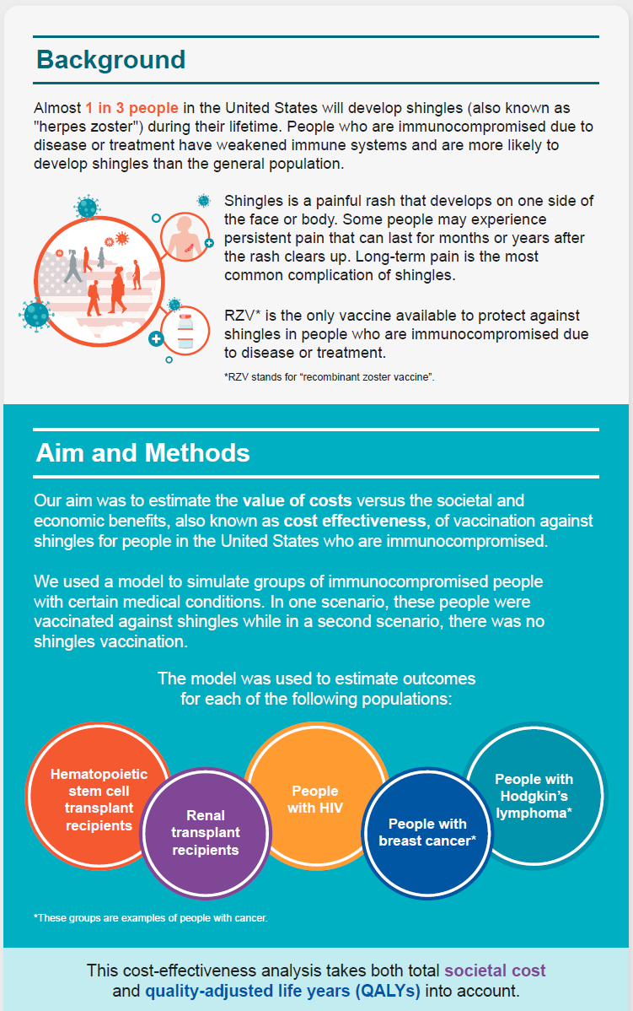
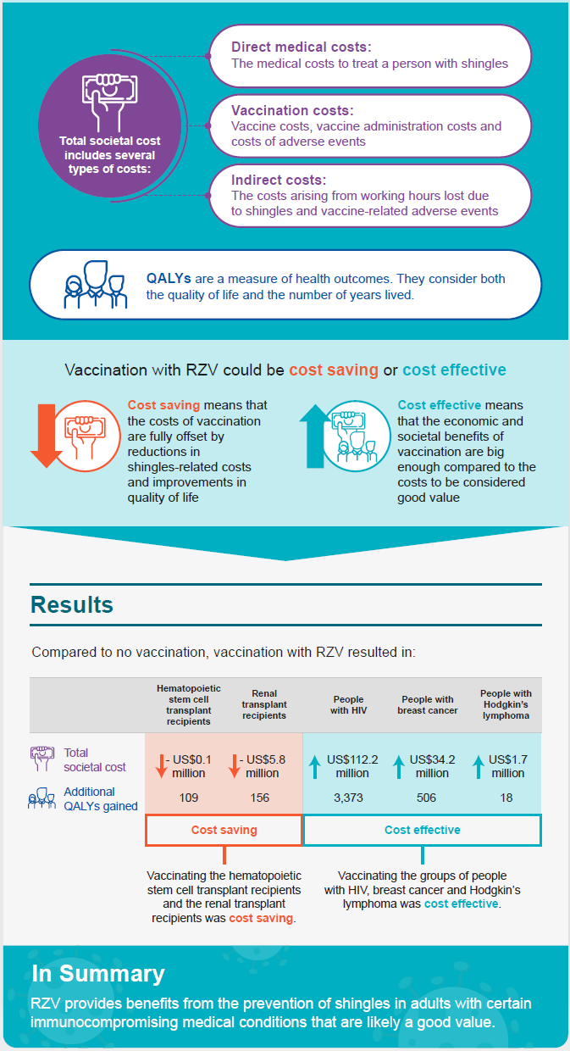
Figure A2. Incremental cost-effectiveness ratios for RZV versus no vaccine for US HSCT adults aged 35 years, when values of key inputs are varied from –90% to +100% of base-case values
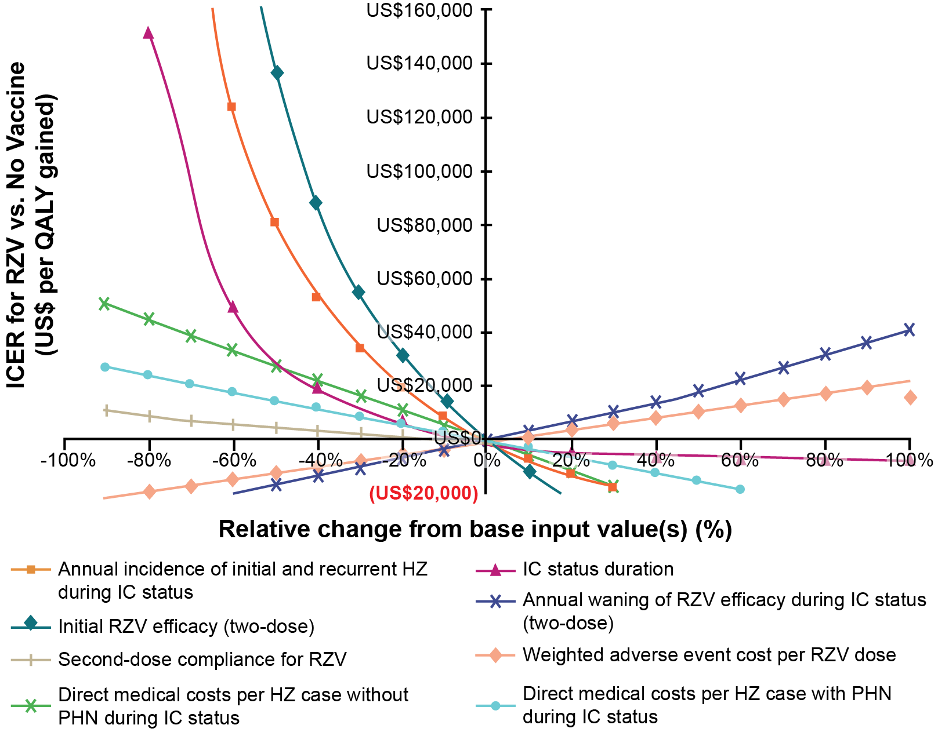

HSCT = hematopoietic stem cell transplant; HZ = herpes zoster; IC = immunocompromised; ICER = incremental cost-effectiveness ratio; PHN = postherpetic neuralgia; QALY = quality-adjusted life-year; RZV = recombinant zoster vaccine; US = United States.
Note: The base-case input values and input values at the minimum and maximum points considered in this figure are presented in Table A6.

Figure A3. RZV efficacy over time in the ZONA IC Model for United States HSCT adults aged 35 years based on base-case efficacy and waning data
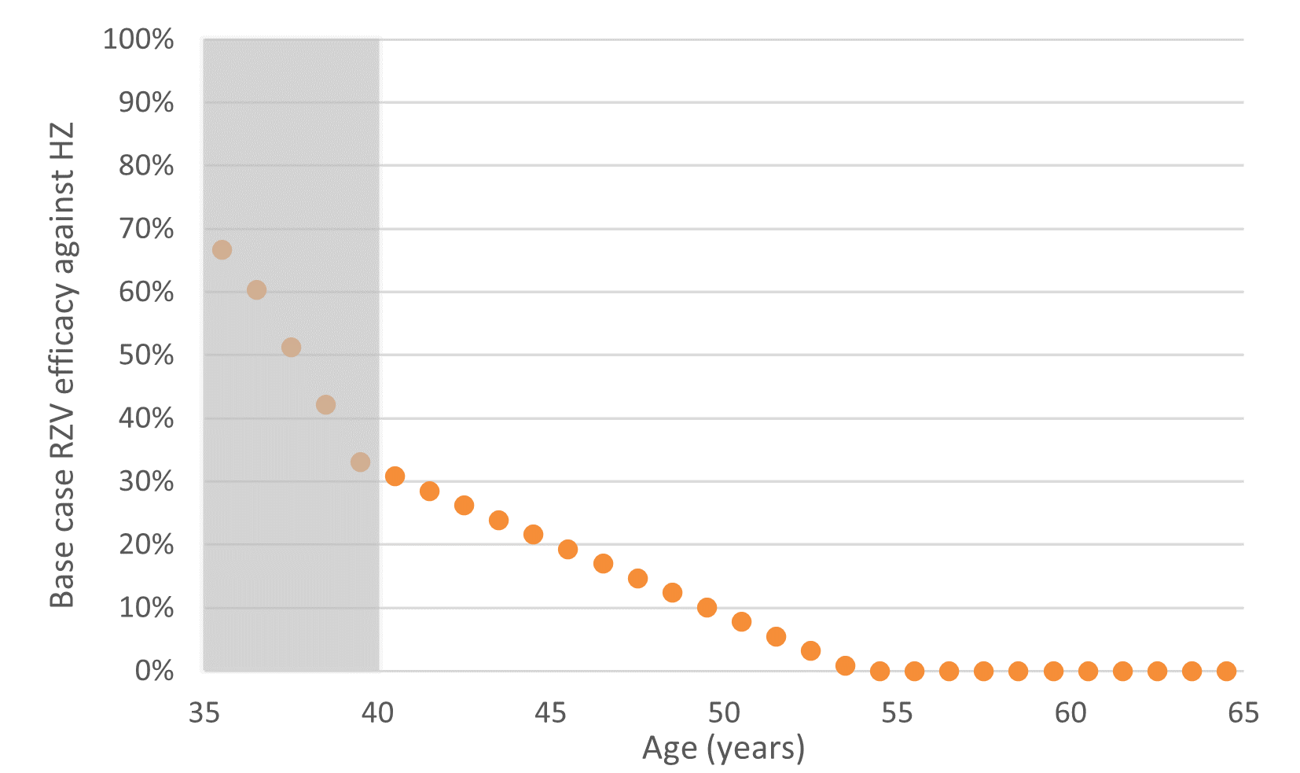
HSCT = hematopoietic stem cell transplant; HZ = herpes zoster; IC = immunocompromised; RZV = recombinant zoster vaccine; ZONA = Zoster Economic Analysis.

Note: The shaded region represents the IC status duration. The origin for the x-axis corresponds to the population starting age for the base-case analysis. The ZONA IC Model calculates efficacy at the midpoint of each year.
Figure A4. RZV efficacy over time in the ZONA IC Model for United States adults with other immunocompromised conditions
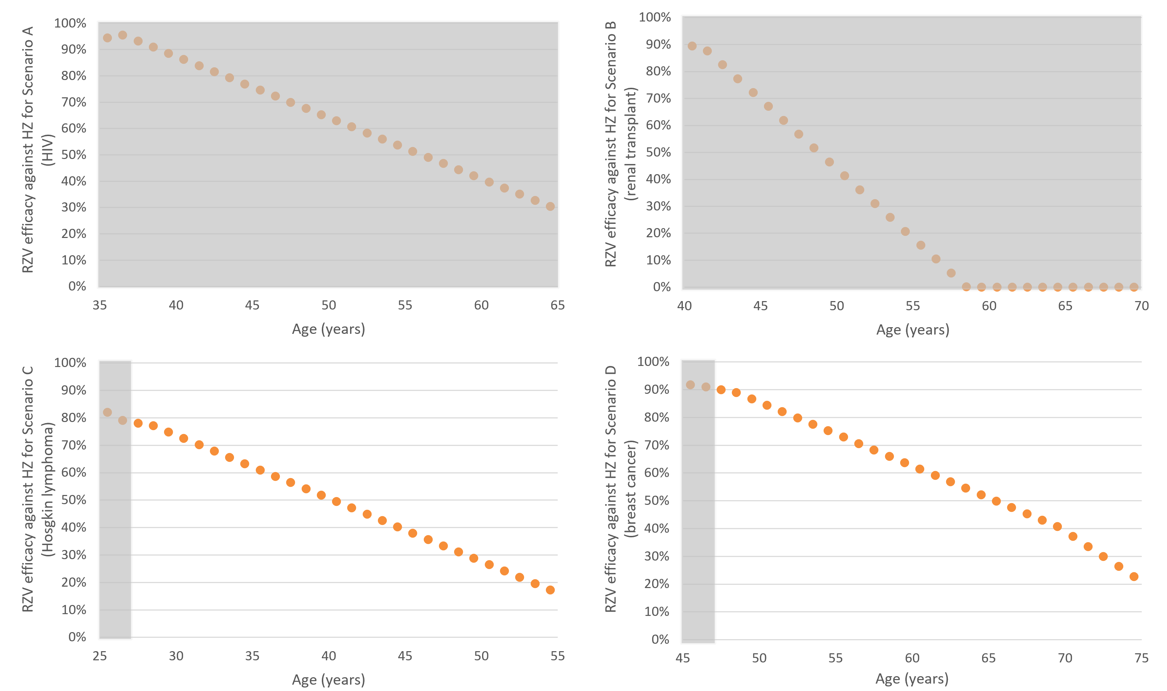
HIV = human immunodeficiency virus; HZ = herpes zoster; IC = immunocompromised; RZV = recombinant zoster vaccine; ZONA = Zoster Economic Analysis.
Note: The shaded region in each panel represents the IC status duration for the given scenario. The origin for the x-axis corresponds to the population starting age for the given scenario. The ZONA IC Model calculates efficacy at the midpoint of each year.

Figure A5. Association between herpes zoster incidence in placebo arm and initial RZV efficacy against herpes zoster and postherpetic neuralgia, based on data from the ZOE-50 (Lal et al., 2015),²⁵ ZOE-70 (Cunningham et al., 2016),²⁴ ZOE-HM (Dagnew et al., 2019),²⁰ and ZOE-HSCT (Bastidas et al., 2019)¹⁹ clinical trials*
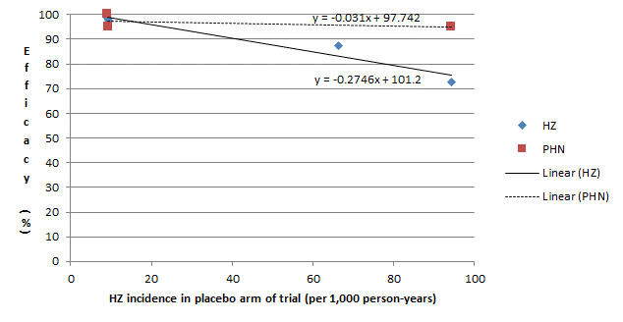
HM = hematological malignancy; HSCT = hematopoietic stem cell transplant; HZ = herpes zoster; PHN = postherpetic neuralgia; RZV = recombinant zoster vaccine.

* In the absence of vaccine efficacy data for the modeled IC populations other than HSCT recipients and Hodgkin’s lymphoma, assumptions around efficacy and waning were needed. Here, a regression approach was used to estimate efficacy, accounting for expected immune responses based on underlying risk of HZ. This regression equation was based on the association between placebo HZ incidence and initial RZV efficacy in immunocompetent and IC populations from RZV’s ZOE-50, ZOE-70, ZOSTER-002, and ZOSTER-039 clinical trials (Bastidas et al.¹⁹; Cunningham et al.²⁴; Dagnew et al.²⁰; Lal et al.²⁵).
Initial RZV efficacy values against HZ in the RZV trials included the following: ZOE-50: 98.4% at year 1 (vs. 97.2% over mean follow-up period of 3.2 years) (Lal et al.²⁵); ZOE-70: 97.6% at year 1 (vs. 89.8% over mean follow-up period of 3.7 years) (Cunningham et al.²⁴); ZOSTER-002: 72.5% at year 1 (vs. 68.2% over median follow-up period of 21 months) (GSK, 2020⁴⁶; Bastidas et al.¹⁹); and ZOSTER-039: 87.2% over median follow-up time of 11.1 months (Dagnew et al.²⁰).
The placebo HZ incidence values used to estimate efficacy from the regression equation for the IC conditions included the following: ZOE-50: 9.1 per 1,000 person-years (Lal et al.²⁵); ZOE-70: 9.3 per 1,000 person-years (Cunningham et al.²⁴); ZOSTER-002 (HSCT): 94.3 per 1,000 person-years (Bastidas et al.¹⁹); ZOSTER-039 (hematologic malignancy): 66.2 per 1,000 person-years (Dagnew et al.²⁰); HIV: 9.3 per 1,000 person-years (derived from Blank et al.³⁸); Renal transplant: 24.4 per 1,000 person-years (Pergam et al.⁴²); and Breast cancer: 17.1 per 1,000 person-years (derived from Habel et al.¹⁸).
Figure A6. Association between herpes zoster incidence in placebo arm and waning of RZV efficacy against herpes zoster and postherpetic neuralgia, based on data from the ZOE-50 (Lal et al., 2015),²⁵ ZOE-70 (Cunningham et al., 2016),²⁴ and ZOE-HSCT (Bastidas et al., 2019)¹⁹ clinical trials*
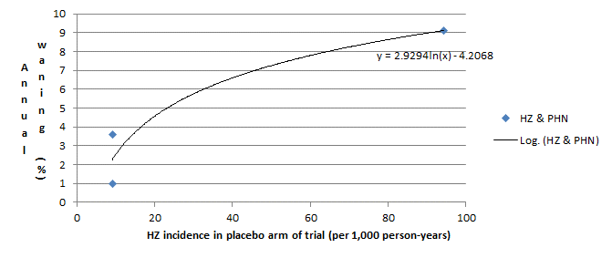
HM = hematological malignancy; HSCT = hematopoietic stem cell transplant; HZ = herpes zoster; PHN = postherpetic neuralgia; RZV = recombinant zoster vaccine.
*In the absence of vaccine efficacy data for the other modeled IC populations, assumptions around waning were needed. Here, a regression approach was used to estimate waning, accounting for expected immune responses based on underlying risk of HZ. Similar to the base-case analysis, the initial efficacy values begin waning immediately in each modeled population. This regression equation was based on the association between placebo HZ incidence and initial RZV efficacy in immunocompetent and IC populations from RZV’s ZOE-50, ZOE-70, ZOSTER-002, and ZOSTER-039 clinical trials (Bastidas et al.¹⁹; Cunningham et al.²⁴; Dagnew et al.²⁰; Lal et al.²⁵).
Renal transplant: The placebo HZ incidence for the renal transplant population used to estimate RZV efficacy against HZ was obtained from Pergam et al.⁴², which reported an annual incidence of HZ of 24.4 per 1,000 person-years among patients that received kidney transplants between 1995 and 2007. Therefore, waning of two-dose efficacy against HZ and PHN was estimated as (2.9294 × ln(24.4)) – 4.2068 = 5.15% based on the logarithmic regression equation above. For one-dose waning, a 100% relative increase from two-dose waning was assumed.
Hodgkin’s lymphoma: The placebo HZ incidence for the Hodgkin’s lymphoma population used to estimate RZV efficacy against HZ was derived from Habel et al.¹⁸, which reported the annual incidence rate of HZ among adults with hematologic malignancies from 2001 to 2006. Therefore, waning of two-dose efficacy against HZ and PHN was estimated as (2.9294 × ln(33.6)) – 4.2068 = 6.09% based on the logarithmic regression equation above. For one-dose waning, a 100% relative increase from two-dose waning was assumed.
Breast cancer: The placebo HZ incidence for the breast cancer population used to estimate RZV efficacy against HZ was derived from Habel et al.¹⁸, which reported the annual incidence rate of HZ among adults with solid tumors from 2001 to 2006. Therefore, waning of two-dose efficacy against HZ and PHN was estimated as (2.9294 × ln(33.6)) – 4.2068 = 4.11% based on the logarithmic regression equation above. For one-dose waning, a 100% relative increase from two-dose waning was assumed.

