Journal name: PharmacoEconomics - Open
Title: Understanding the natural history of chronic hepatitis D: Proposal of a model for cost-effectiveness studies
Authors:
Ankita Kaushik
Geoffrey Dusheiko
Chong Kim*^{,1}
Nathaniel J. Smith
Csilla Kinyik-Merena
Gian Luca Di Tanna
Robert J. Wong
*Corresponding author: chong.kim9@gilead.com
¹ Gilead Sciences, Inc., Foster City, CA, United States
Funding support: This study was supported by Gilead Sciences.
Conflicts of interest: Ankita Kaushik and Chong Kim are employees and stockholders of Gilead. Robert J. Wong has received consulting fees for Gilead Sciences and research grants (in kind) from Gilead Sciences. George Dusheiko has received consulting fees and speaker fees from Gilead Sciences, has participated on Data Safety Monitoring Board/Advisory Board for janssen, Glaxo Smith Kline, Arbutus, Aligos, Vir and has roles in the National Medical Research Council Singapore and the World Health Organisation Pediatric Working Group on Viral Hepatitis. A honorary fee has been paid from Gilead to The George Institute for methodological support provided by Gian Luca di Tanna. Nathaniel J. Smith and Csilla Kinyik-Merena have no financial disclosures.

Appendix S1. Executive summary of the Delphi panel methodology and proceedings
Background and Objective
An economic model has been developed that incorporates the natural history of chronic hepatitis delta virus (HDV) infection and the impact of treatment on disease progression. The modeled natural history includes progressive liver disease from HDV, leading to compensated cirrhosis, decompensated cirrhosis, and hepatocellular carcinoma. The rate of disease progression (i.e., transition to cirrhosis, decompensated cirrhosis, and hepatocellular carcinoma) is lower for patients who achieve a specific endpoint, a composite endpoint that consists of virologic (HDV RNA undetectable or ≥2-log decline) and biochemical (alanine aminotransferase, ALT, normalization) markers. This composite endpoint was used to measure the efficacy of HDV treatment, which is in line with guideline recommendations in Europe.
There is uncertainty in the difference in the disease progression rates between patients who have achieved the composite endpoint versus those who have not as there are no long-term data that follow patients based on their composite endpoint status. Without data linking the composite endpoint to the clinical events, assumptions are needed to inform the inputs of the economic model.
The objective of this Delphi panel was to systematically elicit expert clinical input on the assumptions and data used for the transitions in the economic model that may depend on achieving the composite outcome and to determine if consensus could be obtained.
Methods
To elicit input from clinical experts, a modified Delphi method was employed. The Delphi method is a systematic approach to gaining consensus from a group of experts on a particular topic or set of topics. The Delphi method is often preferred over a focus group because it seeks to minimize bias due to “groupthink”, a dominant participant, or varying levels of expertise within the focus group. The focus of this panel was to determine if consensus could be obtained on the clinical analogue that could be used to underpin the transitions in the economic model. Clinical experts met 1:1 with a facilitator and participated in a structured interview. They were given the same information and asked the same questions to ensure consistency. Prior to the first structured interview, each clinical expert was provided with background information on the composite endpoint and an overview of the economic model.
To facilitate the 1:1 conversations with clinical experts, a presentation was developed for the initial round of discussion. During the first part of the meetings, the information from the pre-read was reviewed with the clinical experts and each was given the opportunity to ask clarifying questions. Subsequently, the presentation included the Delphi-based questions focused on the potential clinical analogues that could be used to underpin the transitions in the economic model. Given the paucity of HDV-specific data, four approaches that have been previously suggested by experts in HDV to model the effects of achieving the composite endpoint were shared with the clinical experts:
- Based on the relationship to HDV RNA negativity: By achieving both a virologic (HDV RNA) and biochemical (ALT normalization) marker of disease control, though patients aren’t necessarily HDV RNA undetectable/negative, they would achieve a slowing of progression on par with achieving HDV RNA-.
- Based on hepatitis B virus (HBV) versus HDV progression differences: By achieving both a virologic (HDV RNA) and biochemical (ALT normalization) marker of disease control, patients would revert to rates of disease progression similar to those of HBV mono-infection.
- Inferred from ALT normalization impact in HBV: In the absence of reliable data from HDV, the impact of ALT normalization on disease progression could be inferred from a better-understood relationship of ALT normalization in HBV liver outcomes.
- Inferred from HBV DNA reduction impact in HBV: In the absence of reliable data from HDV, the impact of 2log HDV RNA reduction could be inferred based on the relationship of HBV DNA reduction and liver outcomes in HBV.
The clinical experts were then asked which approach they believed to be the most clinically reasonable to underpin the transitions in the model and to provide a rationale as to why they selected the approach (Figure A).
Figure A. HDV Delphi Panel Approaches and Question to Clinical Experts
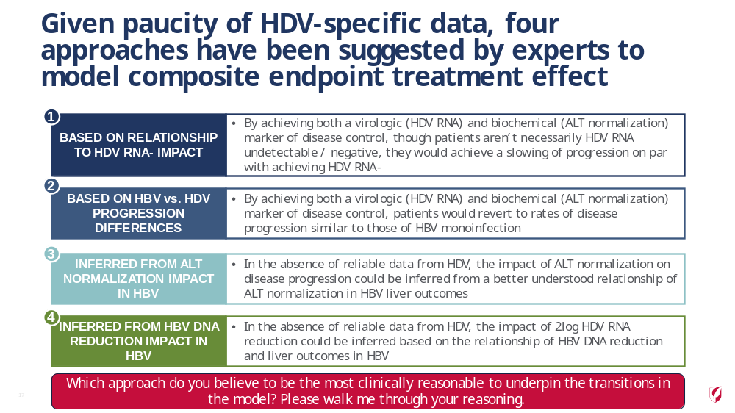

Twelve clinical experts from 6 countries (Germany, Italy, Spain, Turkey, UK, USA) agreed to participate in the modified Delphi panel. These experts are physicians who have treated HDV patients and are considered highly knowledgeable about HDV. One-on-one virtual meetings were scheduled with each clinical expert (via Zoom or WebEx) between May 28, 2011 – August 11, 2021. Meetings were recorded for note-taking purposes. The same facilitator-led each meeting. Clinical experts were given the same information and asked the same questions to ensure consistency. The clinical experts’ response and stated context and rationale were documented, and the recordings were revisited to capture additional details.
The design of the modified Delphi process included up to 3 rounds of questions to the experts. The consensus was reached when at least 75% of participants agree on a value or answer. If consensus was not obtained after the first round, the responses and context provided by the clinical experts were to be anonymized and shared with other participants in the subsequent round or used to ask a more refined question, with a narrower range of options for the answers. However, as consensus on the approach was attained after the first round and follow-up conversations, subsequent rounds were not pursued.

Results
Consensus on the approach was obtained with 10 of 12 (83%) of the clinical experts selecting HDV RNA undetectability as the clinical analogue after the first round of and follow-up discussions (Figure B). Given consensus was obtained, subsequent rounds were not pursued.
Figure B. Delphi panel results on the selected approach for a clinical analog

Abbreviations: ALT, alanine aminotransferase; HBV, hepatitis B virus; HDV, hepatitis delta virus.

The rationale for choosing the HDV RNA undetectability approach included the clinical rationale that achieving the composite endpoint would slow disease progression even among patients who did not achieve RNA undetectability and that these data exist for the HDV population (Table A). Two clinical experts selected an alternative approach: one selected HBV mono-infection and one selected ALT normalization.

Table A. Selected Delphi panel rationale for the selected approach
Approach | Select Rationale Provided by Clinical Experts
HDV RNA Undetectability | “Approach 1 is the most appealing as achieving both virologic HDV RNA and biochemical ALT normalization would achieve the slowing of disease progression even if they are RNA positive.”
HDV RNA Undetectability | “Best analogue of the 4 options because it is supported by the literature, although the key issue is that a 2log decline in HDV RNA does not yield the same outcomes as HDV RNA negative.”
HDV RNA Undetectability | “This approach is best because we have data on this endpoint.”
HBV Mono-infection | “If HDV RNA is cleared completely with ALT normalization, then HBV remains. But if HDV RNA is not cleared, progression will be faster than HBV.”
ALT Normalization | “This is the most compelling approach. Most of the patients [achieving the composite endpoint] will be more than 2log decline [in HDV RNA] with normal ALT. This is similar to other disease where you achieve ALT normalization.”
Abbreviations: ALT, alanine aminotransferase; HBV, hepatitis B virus; HDV, hepatitis delta virus.

S2 Appendix

Figure. Model structure overview for treatment responders and non-responders
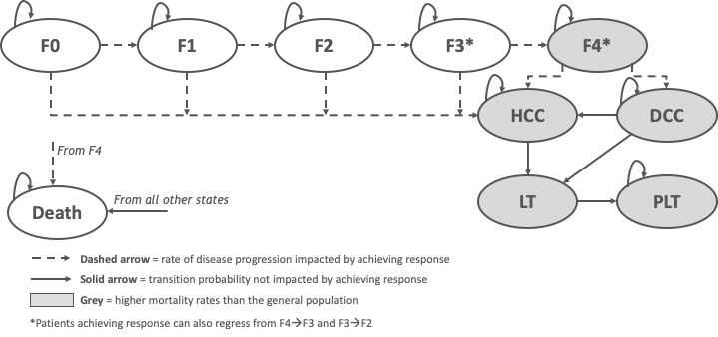
F0, fibrosis stage 0; F1, fibrosis stage 1; F2, fibrosis stage 2; F3, fibrosis stage 3; F4, fibrosis stage 4 or compensated cirrhosis; DCC, decompensated cirrhosis; HCC, hepatocellular carcinoma; LT, liver transplant; PLT, post-liver transplant

With consensus on the approach obtained, HDV RNA undetectability is the preferred clinical analog to underpin the transitions in the economic model. This approach assumes that if an HDV patient achieves the composite endpoint, their decreased rate of disease progression would be on par with the rate reduction of someone who achieves HDV RNA undetectability. To inform the specific values needed for the economic model, including the hazard ratios for progression to compensated cirrhosis, decompensated cirrhosis, hepatocellular carcinoma, and death, a systematic literature review may be undertaken to identify the relevant published literature.

Table S1. Alternate treatment response scenario analysis (per 10,000 patients)
 | Base case (75% responder rate) | 50% responder rate |  |  | 75% responder rate
 | Base case (75% responder rate) | Treatment-HBV |  | Treatment-ALT | Treatment-HBV |  | Treatment-ALT
CC
HDV treatment | 3,732 | 3,410 |  | 3,596 | 3,451 |  | 3,730
BSC | 3,327 | 3,326 |  | 3,327 | 3,326 |  | 3,327
Difference | -328 | -271 |  | -160 | -407 |  | -240
DCC
HDV treatment | 2,659 | 2,962 |  | 3,022 | 2,768 |  | 2,858
BSC | 3,346 | 3,347 |  | 3,347 | 3,347 |  | 3,347
Difference | -687 | -385 |  | -325 | -579 |  | -489
HCC
HDV treatment | 3,614 | 3,700 |  | 3,844 | 3,539 |  | 3,754
BSC | 4,020 | 4,020 |  | 4,021 | 4,020 |  | 4,021
Difference | -367 | -320 |  | -177 | -481 |  | -267
LT
HDV treatment | 233 | 254 |  | 261 | 238 |  | 248
BSC | 285 | 285 |  | 285 | 285 |  | 285
Difference | -52 | -31 |  | -24 | -47 |  | -37
Liver-related mortality
HDV treatment | 7,060 | 7,606 |  | 7,796 | 7,189 |  | 7,474
BSC | 8,435 | 8,435 |  | 8,437 | 8,435 |  | 8,437
Difference | -1,375 | -829 |  | -641 | -1,246 |  | -962
CC, compensated cirrhosis; DCC, decompensated cirrhosis; HCC, hepatocellular carcinoma; HDV, hepatitis D virus; LT, liver transplant.

Table S2. No regression scenario analyses (per 10,000 patients)
 | Base case  (75% responder rate) | 50% responder rate | 75% responder rate
CC
HDV treatment | 2,999 | 3,109 | 2,999
BSC | 3,327 | 3,327 | 3,327
Difference | -328 | -217 | -328
DCC
HDV treatment | 2,659 | 3,100 | 2,976
BSC | 3,346 | 3,347 | 3,347
Difference | -687 | -247 | -371
HCC
HDV treatment | 3,614 | 3,795 | 3,682
BSC | 4,020 | 4,021 | 4,021
Difference | -406 | -226 | -339
LT
HDV treatment | 233 | 264 | 254
BSC | 285 | 285 | 285
Difference | -52 | -21 | -31
Liver-related mortality
HDV treatment | 7,060 | 7,857 | 7,565
BSC | 8,435 | 8,437 | 8,437
Difference | -1,375 | -580 | -872
CC, compensated cirrhosis; DCC, decompensated cirrhosis; HCC, hepatocellular carcinoma; HDV, hepatitis D virus; LT, liver transplant.

