PharmacoEconomics
Rod S Taylor, Anthony Bentley, Kaylie Metcalfe, Melvin D Lobo, Ajay J Kirtane, Michel Azizi, Christopher Clark, Kieran Murphy, Jennifer H Boer, Marjolijn van Keep, An Thu Ta, Neil C Barman, Garrett Schwab, Ron Akehurst, Roland E Schmieder
Cost-effectiveness of Endovascular Ultrasound Renal Denervation in Patients with Resistant Hypertension
Address for correspondence: Prof Rod Taylor. MSc, PhD. Professor of Population Health Research. MRC/CSO Social and Public Health Sciences Unit & Robertson Centre for Biostatistics, Institute of Health and Well Being, University of Glasgow, 90 Byres Rd, Glasgow, G12 8TB, United Kingdom. Email: rod.taylor@glasgow.ac.uk
Source of funding: This work was supported by ReCor Medical.
Disclosure of Interest: RST has received personal consultancy fees from ReCor Medical; AB and KM are employees of Mtech Access, contractor for ReCoR Medical; MDL has received grant support from ReCor Medical and personal fees from ReCor Medical, Medtronic, CVRx, Ablative Solutions, Vascular Dynamics, ROX Medical and Tarilan Laser Technologies and grants from Medtronic; AJK reports Institutional funding to Columbia University and/or Cardiovascular Research Foundation from Medtronic, Boston Scientific, Abbott Vascular, Abiomed, CSI, Siemens, Philips, ReCor Medical, Neurotronic. In addition to research grants, institutional funding includes fees paid to Columbia University and/or Cardiovascular Research Foundation for consulting and/or speaking engagements in which AJK controlled the content. Personal: Consulting from IMDS; MA has received research grants from the French Ministry of Health, Quantum Genomics, and the European Horizon 2020 program; has received grant support and nonfinancial support from ReCor Medical and Idorsia; and has received personal fees from CVRx; CC has received personal fees from ReCor Medical and Bayer; KM is an employee of ReCor Medical; JHB, MvK, and ATT were previously employees of BresMed, a contractor for ReCor Medical; NCB is an employee of ReCor Medical; GS has received personal fees from ReCor Medical; RES received research grants to the institution from ReCor Medical, Medtronic Inc and Ablative Solutions, he received personal consultancy and speaker fees from ReCor Medical, Medtronic Inc and Ablative Solutions.

eAppendix 1. Baseline characteristics & Cost-effectiveness model inputs
Table 1: Baseline characteristics
Variable | Mean (SE or alpha, beta) | Distribution | Source
General
Age (years) | 52.60 (0.72) | Normal | RADIANCE-HTN TRIO(1)
Proportion female | 20% (26,104) | Beta | RADIANCE-HTN TRIO(1)
Baseline office SBP (mmHg) | 155.3 (1.46) | Normal | RADIANCE-HTN TRIO(1)
Weight (kg) | 99.9 (1.82) | Normal | RADIANCE-HTN TRIO(1)
Height (m) | 1.70 (0.01) | Normal | RADIANCE-HTN TRIO(1)
Body mass index (kg/m²) | 32.6 (0.49) | Normal | RADIANCE-HTN TRIO(1)
Medical
Current smoker (%) | 16% (84, 440) | Beta | Gladwell et al. Supplementary material(2)
Alcohol consumption (oz/week) | 8.00 (0.80) | Normal | Gladwell et al. Supplementary material(2)
Diabetes mellitus (%) | 26.2% (34, 96) | Beta | RADIANCE-HTN TRIO(1)
Women in menopause | 80% (19, 5) | Beta | Gladwell et al. Supplementary material(2)
Hypertensive medication (%) | 100% (0, 130) | Beta | RADIANCE-HTN TRIO(1)
Low-density lipoprotein cholesterol (mg/dl) | 104.9 (3.34) | Normal | RADIANCE-HTN TRIO(1)
High-density lipoprotein cholesterol (mg/dl) | 49.8 (1.36) | Normal | RADIANCE-HTN TRIO(1)
Triglycerides (mg/dl) | 165.1 (9.19) | Normal | RADIANCE-HTN TRIO(1)
Total cholesterol (mg/dl) | 188.0 (3.43) | Normal | RADIANCE-HTN TRIO(1)
Heart rate at rest (bpm) | 79.2 (1.08) | Normal | RADIANCE-HTN TRIO(1)
Fasting glucose (mg/dl) | 96 (9.56) | Normal | Khan et al, 2019(3)
QRS duration (msec) | 92 (9.19) | Normal | Khan et al, 2019(3)
Gamma-glutamyl transpeptidase, female | 16.00 (1.6) | Normal | Gladwell et al. Supplementary material(2)
Gamma-glutamyl transpeptidase, male | 31.00 (3.1) | Normal | Gladwell et al. Supplementary material(2)
Vital lung capacity, female | 3.60 (0.36) | Normal | Gladwell et al. Supplementary material(2)
Vital lung capacity, male | 4.60 (0.46) | Normal | Gladwell et al. Supplementary material(2)
Ethnicity
Females of African descent (%) | 26.9% (7, 19) | Beta | RADIANCE-HTN TRIO(1)
Males of African descent (%) | 19.2% (20, 84) | Beta | RADIANCE-HTN TRIO(1)
Disease prevalence rates
(Un)stable angina pectoris | 3.8% (5, 125) | Beta | RADIANCE-HTN TRIO(1)
Proportion of stable angina pectoris | 15% (85, 481) | Beta | Gladwell et al. Supplementary material(2)
Coronary heart disease | 2.3% (3, 127) | Beta | RADIANCE-HTN TRIO(1)
Cardiovascular disease | 19.2% (25, 105) | Beta | RADIANCE-HTN TRIO(1)
Cardiovascular disease + atrial fibrillation | 23.8% (31, 99) | Beta | RADIANCE-HTN TRIO(1)
Family history of myocardial infarction | 16.5% (83, 422) | Beta | Gladwell et al. Supplementary material(2)
Left ventricular hypertrophy | 20.8% (79, 301) | Beta | Gladwell et al. Supplementary material(2)
Atrial fibrillation | 2% (3, 127) | Beta | RADIANCE-HTN TRIO(1)
Cardiomegaly | 20.75% (79, 302) | Beta | Gladwell et al. Supplementary material(2)
Valve disease | 1.89% (98, 5092) | Beta | Gladwell et al. Supplementary material(2)
Key: bpm, beats per minute; CVD, cardiovascular disease; dl, decilitre; mmHg, millimetres of mercury; SBP, systolic blood pressure; SE, standard error.

Cardiovascular event risk inputs
Table 2: Cardiovascular event risks inputs (relative risks and hazard ratios)
Parameter | Implementation | Base case value per cycle (1 month) | Reference
Risk of developing AP/CHD | $$Risk of CHD=1-\exp\left(-\exp\left(\frac{\ln\left(t\right)-m}{s}\right)\right)$$  t = time in years  m = intercept + $\sum{β_{i}x_{i}}$  s = extreme scale value parameter | Varying from 0.042% in cycle 0 to 0.207% at age 66. | D’Agostino et al. (2000)(4) – Framingham Heart Study
  Variable (x) | β Men | β Women
  Intercept | 12.7868 | 20.9717
  Age | -0.0405 | -0.0621
  Postmenopausal status (yes/no) | – | -3.8522
  Age * menopause | – | 0.0726
  ln (total cholesterol/HDL cholesterol) | -0.9494 | -0.6256
  ln (SBP) | -1.0163 | -2.2449
  Interaction term for antihypertensive therapy and SBP# | -0.0161 | -0.098
  Diabetes mellitus (yes/no) | -0.4412 | -0.5243
  Smoker (yes/no) | -0.6042 | -0.3777
  ln (triglycerides) | – | -0.2688
  Alcohol use (ounces per week) | – | 0.0529
  Extreme value scale parameter (s) | 0.7764 | 0.7467
  Notes: # This is computed as coefficient * antihypertension medication use (yes/no) * ((200 – SBP) * (SBP – 110)/100). The coefficient should only be added when the SBP is between 110 and 200.
Risk of developing ESRD | We fitted a linear model through the Hsu et al. (2009) HRs, and used this model to calculate the risk of ESRD:  $$Risk of ESRD=0.195+(0.01525*SBP)$$  This HR was then applied to the baseline population risk of developing ESRD, based on ERA-EDTA (2020) data. | 0.00365% at baseline, where SBP was 155.3 mmHg. | ERA-EDTA (2020)(5) Hsu et al. (2009)(6)
  Blood pressure category | SBP (mmHg) | HRs (95% CI)
  Normal | < 120 | 1
  Prehypertension | 120–139 | 1.72 (1.32, 2.24)
  Stage 2 hypertension | 140–159 | 2.94 (2.21, 3.92)
  Stage 3 hypertension | > 160 | 2.33 (1.78, 3.05)
Risk of developing heart failure (base case) | $$Risk of HF=\frac{1}{1+e-x}$$  $$where x= intercept+ \sum{β_{1}}x_{1}$$ | Varying from 0.021% in cycle 0 to 0.087% at age 99.9. | Kannel et al. (1999)(7) – Framingham Heart Study
  Variable (x) | β  men | β  women
  Intercept | -7.3611 | -5.4997
  Age (years) | 0.0313 | 0.0216
  Left ventricular hypertrophy (yes/no) | 0.8428 | 1.0072
  Vital capacity (L) | -0.30 | -0.87
  Heart rate (10 bpm) | 0.0144 | 0.0092
  Systolic blood pressure (mmHg) | 0.0067 | 0.0032
  Coronary heart disease (yes/no) | 1.5333 | 1.5358
  Valve disease (yes/no) | 0.8868 | 1.2454
  Diabetes mellitus (yes/no) | 0.2383 | 1.4275
  Cardiomegaly (yes/no) | 0.7968 | 0.4792
  Valve disease * diabetes | – | -0.9293
Risk of developing heart failure (alternative) | $Risk of HF=1-{S_{0}}^{e^{\left(IndX-MeanCV\right)}}$. | Varying from 0.015% in cycle 0 to 0.036% at age 99.9. | Khan et al. (2019)(3)
  Variable | White male | White female | Black male | Black female
  ln age (years) | 41.9 | 20.55 | 2.88 | 51.75
  Ln age squared | -0.88 | N/A | N/A | N/A
  Ln treated SBP (mmHg) | 1.03 | 12.95 | 2.31 | 29.0
  Ln age x Ln treated SBP | N/A | -2.96 | N/A | -6.59
  Ln untreated SBP (mmHg) | 0.91 | 11.86 | 2.17 | 28.18
  Ln age x ln untreated SBP | N/A | -2.73 | N/A | -6.42
  Current smoker (1 = yes, 0 = no) | 0.74 | 11.02 | 1.66 | 0.76
  Ln age x current smoker | N/A | -2.50 | -0.25 | N/A
  ln treated glucose (mg/dL) | 0.90 | 1.04 | 0.64 | 0.97
  Ln untreated glucose (mg/dL) | 0.78 | 0.91 | 0.58 | 0.80
  Ln TC (mg/dL) | 0.49 | N/A | N/A | 0.32
  Ln HDL-C (mg/dL) | -0.44 | -0.07 | -0.81 | N/A
  Ln body mass index (kg/m²) | 37.2 | 1.33 | 1.16 | 21.24
  Ln age x ln body mass index | -8.83 | N/A | N/A | -5.0
  Ln QRS duration (msec) | 0.63 | 1.06 | 0.73 | 1.27
  Mean coefficient x value (MeanCV) | 171.5 | 99.73 | 28.73 | 233.9
  Baseline survival (S₀) | 0.98752 | 0.99348 | 0.98295 | 0.99260
Risk of developing heart failure when already diagnosed with AP/CHD | To model the increased risk of heart failure in patients with AP/CHD, we use a 1.35 HR by Badar et al. (2014). | 0.0079% | Badar et al. (2014)(8)
Risk of developing HF after an MI | To model the increased risk of developing HF after an MI, we apply an acute risk of 23.1%, based on findings from Velagaleti et al. (2008). | 23.1% | Velagaleti et al. (2008)(9)
Risk of developing MI | $$Risk of MI= \frac{1}{1+\exp\left(-y\right)}$$  $where$ $y= intercept+ \sum{β_{i} x_{i}}$ | Varying from 0.031% in cycle 0 to 1.303% at age 99.9. | Voss et al. (2002)(10) – PROCAM
  Variable (x) | β
  Intercept | -31.6879
  Age (Years) | 0.0979
  Triglycerides (mg/dl) | -0.226
  ln(triglycerides) (mg/dl) | 5.7525
  HDL cholesterol (mg/dl) | -0.4106
  LDL cholesterol (mg/dl) | 0.0151
  Systolic blood pressure (mmHg) | 0.0140
  Gamma glutamyl transferase (units/litre) | -0.0257
  Smoking (yes/no) | 0.7547
  Diabetes mellitus (yes/no) | 0.5827
  Family history of MI (yes/no) | 0.4154
  HDL cholesterol * ln (HDL cholesterol) (mg/dl) | 0.0899
  Triglycerides * HDL cholesterol (mg/dl) | -0.0004
  Triglycerides * gamma glutamyl transferase (mg/dl, units/litre) | 0.0001
Risk of developing an MI when already diagnosed with AP/CHD | An age-dependent RR of MI is applied for patients who have been diagnosed with AP/CHD | Varying from 0.019% in cycle 0 to 2.380% at age 99.9. | Hunink et al. (1997)(11)
  Age | RR
  15-43 | 0.261
  45-53 | 0.630
  55-63 | 1
  65-73 | 1.371
  75+ | 1.826
Risk of developing stroke | Probability of developing an initial stroke = 1 – (S(t))^{B}  $$B=e^{A}$$  A= L - M  $$L = \sum{β_{1}}x_{1}$$  M = 5.6770 for men, and M = 7.5766 for women  Underlying survivor function S(t): | Varying from 0.035% in cycle 0 to 0.169% at age 60. | Wolf et al. (1991)(12) & d'Agostino et al. (1994)(13)  – Framingham Heart Study
  Variable | β (SE) - Men | β (SE) - Women
  Age (Years) | 0.0488 (0.0103) | 0.0699 (0.0089)
  SBP (mmHg) | 0.0152 (0.0031) | 0.0161 (0.0024)
  NEWHRXSBP# | 0.00019 (0.00010) | 0.00026 (0.0007)
  Cardiovascular disease* | 0.5460 (0.0151) | 0.4404 (0.1462)
  Left ventricular hypertrophy (yes/no) | 0.7864 (0.2846) | 0.8055 (0.2429)
  Smoking (yes/no) | 0.5224 (0.1429) | 0.5419 (0.1453)
  Atrial fibrillation | 0.5998 (0.3011) | 1.1173 (0.2302)
  Diabetes mellitus (yes/no) | 0.3429 (0.1894) | 0.5604 (0.1706)
  Notes:
  * Cardiovascular disease = history of myocardial infarction, angina pectoris, coronary insufficiency, intermittent claudication, or congestive heart failure.
  # NEWHRXSBP* = Hypertension medication (yes/no)*(SBP-110)*(200-SBP) * 0 when SBP<110 or SBP>200.
  Year (t) | S(t) Men | S(t) Women
  1 | 0.9948 | 0.9977
  2 | 0.9889 | 0.9920
  3 | 0.9826 | 0.9864
  4 | 0.9740 | 0.9802
  5 | 0.9642 | 0.9741
  6 | 0.9551 | 0.9665
  7 | 0.9422 | 0.9584
  8 | 0.9270 | 0.9509
  9 | 0.9144 | 0.9448
  10 | 0.9044 | 0.9353
Risk of developing stroke when already diagnosed with AP/CHD | The risk of stroke in patients with AP/CHD is modelled with same risk equation as initial stroke in hypertension patients, but with the coefficient for cardiovascular disease applied. | Varying from 0.060% in cycle 0 to 0.282% at age 60. | Wolf et al. (1991)(12) & d'Agostino et al. (1994)(13)  – Framingham Heart Study
Risk of developing stroke when already diagnosed with ESRD | To calculate the risk of stroke in patients with ESRD, we apply an ethnicity- and gender-specific relative risk to the general stroke risk based on a publication by Seliger et al. (2003). | Varying from 0.223% in cycle 0 to 1.052% at age 60. | Seliger et al. (2003)(14):
Risk of recurrent stroke | Recurrent stroke is modelled using the Birmingham 2009 risk prediction model, known as CHA₂DS₂-VASc(15). Using the CHA2DS2-VASc score patients are divided into three risk categories: low risk, intermediate risk, and high risk. We fitted a model on the data presented by Ntaios et al. (2016), as they present the cumulative probability of stroke or TIA recurrence based on patients’ pre-stroke CHA₂DS₂-VASc scores. For this model, we have used the high-risk group, as all patients will fall into this category given they already have had a previous stroke and underlying resistant hypertension. | 0.679% in the first cycle after stroke, slowly decreasing over time. | Ntaios et al. (2016)(16) – Figure 4
Relative effect measures (base case) |  | N/A | Thomopoulos et al. (2014)(19)
  Outcome | RR per 10 mmHg reduction (95% CI) | RR for Paradise vs SoC
  Stroke | 0.63 (0.56, 0.71) | 0.675
  CHD | 0.78 (0.72, 0.85) | 0.810
  HF | 0.54 (0.45, 0.64) | 0.592
Relative effect measures (alternative 1) |  | N/A | Ettehad et al. (2016)(17)
  Outcome | RR per 10 mmHg reduction (95% CI) | RR for Paradise vs SoC
  Myocardial infarctions | 0.83 (0.78, 0.88) | 0.854
  Stroke | 0.73 (0.68, 0.77) | 0.765
  Heart failure | 0.72 (0.67, 0.78) | 0.756
  Renal failure | 0.95 (0.84, 1.07) | 0.957
Relative effect measures (alternative 2) |  | N/A | Rahimi et al. (2021)(18)
  Outcome | HR per 5 mmHg reduction (95% CI) | HR for Paradise vs SoC
  Major CVE with CVD baseline | 0.89 (0.86, 0.92) | 0.820
  Major CVE no CVD baseline | 0.91 (0.89, 0.94) | 0.852
Key: AP/CHD, angina pectoris / coronary heart disease; BMI, body mass index; bpm, beats per minute; CI, confidence interval; CHA₂DS₂-VASc, congestive heart failure, hypertension, age ≥ 75 years, diabetes mellitus, stroke or transient ischemic attack (TIA), vascular disease, age 65 to 74 years, sex category score: a validated tool to predict the risk of stroke and systemic emboli in patients with non-valvular atrial fibrillation; CHD, coronary heart disease; CI, confidence interval; CVD, cardiovascular disease; CVE, cardiovascular event; dl, decilitre; ESRD, end-stage renal disease; HDL, high-density lipoprotein; HDL-C, high-density lipoprotein cholesterol; HF, heart failure; HR, hazard ratio; L, litre; LDL, low-density lipoprotein; Ln, natural logarithm; mg, milligram; MI, myocardial infarction; N/A, not applicable; OR, odds ratio; RR, relative risk; S(t), survivor function without stroke; SBP, systolic blood pressure; SE, standard error; t, time.

Mortality inputs
Table 3: Mortality inputs for health states
Health State | Details | Age/SBP  Group | Value | References
HTN | General population mortality for the UK |  |  | ONS (2022)(20)
AP | Annual mortality rate  – male patients | 35–44 years | 0.46% | Weinstein et al. (1987)(21), appendix III.
AP | Annual mortality rate  – male patients | 45–54 years | 1.07% | Weinstein et al. (1987)(21), appendix III.
AP | Annual mortality rate  – male patients | 55–64 years | 1.84% | Weinstein et al. (1987)(21), appendix III.
AP | Annual mortality rate  – male patients | 65–74 years | 3.27% | Weinstein et al. (1987)(21), appendix III.
AP | Annual mortality rate  – male patients | ≥ 75 years | 10.59% | Weinstein et al. (1987)(21), appendix III.
AP | Annual mortality rate  – female patients | 35–44 years | 0.25% | Weinstein et al. (1987)(21), appendix III.
AP | Annual mortality rate  – female patients | 45–54 years | 0.62% | Weinstein et al. (1987)(21), appendix III.
AP | Annual mortality rate  – female patients | 55–64 years | 1.20% | Weinstein et al. (1987)(21), appendix III.
AP | Annual mortality rate  – female patients | 65–74 years | 2.51% | Weinstein et al. (1987)(21), appendix III.
AP | Annual mortality rate  – female patients | ≥ 75 years | 9.64% | Weinstein et al. (1987)(21), appendix III.
ESRD | 90-day mortality | 0-19 years | 0.8% | ERA-EDTA (Annual Report 2020)(5) – Table B.6.6 – Dialysis patients
ESRD | 90-day mortality | 20-44 years | 0.9%
ESRD | 90-day mortality | 45-64 years | 2.7%
ESRD | 90-day mortality | 65-74 years | 5.2%
ESRD | 90-day mortality | 75+ years | 9.1%
ESRD | 1-year mortality | 0-19 years | 1.9%
ESRD | 1-year mortality | 20-44 years | 3.3%
ESRD | 1-year mortality | 45-64 years | 9.2%
ESRD | 1-year mortality | 65-74 years | 15.9%
ESRD | 1-year mortality | 75+ years | 25.1%
ESRD | 2-year mortality | 0-19 years | 4.6%
ESRD | 2-year mortality | 20-44 years | 6.6%
ESRD | 2-year mortality | 45-64 years | 16.5%
ESRD | 2-year mortality | 65-74 years | 27.2%
ESRD | 2-year mortality | 75+ years | 41.0%
ESRD | 5-year mortality | 0-19 years | 11.8%
ESRD | 5-year mortality | 20-44 years | 19.7%
ESRD | 5-year mortality | 45-64 years | 40.2%
ESRD | 5-year mortality | 65-74 years | 57.7%
ESRD | 5-year mortality | 75+ years | 74.9%
MI | Acute risk | 35–44 years | 1.50% | Rogers et al. (2008)(22)  Flack et al. (1995)(23)  Barakat et al. (1999)(24)
MI | Acute risk | 45–54 years | 3.40%
MI | Acute risk | 55–64 years | 7.30%
MI | Acute risk | 65–74 years | 15.90%
MI | Acute risk | ≥ 75 years | 29.50%
MI | Long term risk – per cycle probability | < 120 mmHg | 0.168% | Flack et al. (1995)(23) mortality rates + odds ratio from Rogers et al. (2008)(22)  Long term probabilities converted to per year probabilities - using all data
MI | Long term risk – per cycle probability | 120–139 mmHg | 0.195%
MI | Long term risk – per cycle probability | 140–159 mmHg | 0.256%
MI | Long term risk – per cycle probability | ≥ 160 mmHg | 0.307%
MI | Long term risk – Hazard ratio to correct for age | < 60 years | 1 | Barakat et al. (1999)(24) – Table 3
MI | Long term risk – Hazard ratio to correct for age | 60–69 years | 1.28 | Barakat et al. (1999)(24) – Table 3
MI | Long term risk – Hazard ratio to correct for age | ≥ 70 years | 2.46 | Barakat et al. (1999)(24) – Table 3
Heart failure | 30-day mortality | Male patients | 6.00% | Roger et al. (2004)(25) – 5 year mortality extrapolated
Heart failure | 2–12-month mortality | Male patients | 21.00% | Roger et al. (2004)(25) – 5 year mortality extrapolated
Heart failure | Year 2+ mortality | Male patients | 50.00% | Roger et al. (2004)(25) – 5 year mortality extrapolated
Heart failure | 30-day mortality | Female patients | 4.00% | Roger et al. (2004)(25) – 5 year mortality extrapolated
Heart failure | 2–12-month mortality | Female patients | 17.00% | Roger et al. (2004)(25) – 5 year mortality extrapolated
Heart failure | Year 2+ mortality | Female patients | 46.00% | Roger et al. (2004)(25) – 5 year mortality extrapolated
Heart failure | Age-dependent HRs are applied to correct for age | < 50 | 1 | Pocock et al. (2006)(26)
Heart failure | Age-dependent HRs are applied to correct for age | 50-54 | 1.03 | Pocock et al. (2006)(26)
Heart failure | Age-dependent HRs are applied to correct for age | 55-59 | 1.02 | Pocock et al. (2006)(26)
Heart failure | Age-dependent HRs are applied to correct for age | 60-64 | 1.28 | Pocock et al. (2006)(26)
Heart failure | Age-dependent HRs are applied to correct for age | 65-69 | 1.72 | Pocock et al. (2006)(26)
Heart failure | Age-dependent HRs are applied to correct for age | 70-74 | 2.20 | Pocock et al. (2006)(26)
Heart failure | Age-dependent HRs are applied to correct for age | 75-79 | 2.86 | Pocock et al. (2006)(26)
Heart failure | Age-dependent HRs are applied to correct for age | 80+ | 3.68 | Pocock et al. (2006)(26)
Stroke | Acute risk – rate per month | 12.60% |  | Saposnik et al. (2008)(27)
Stroke | Long term risk – HR vs. background mortality | Modelled based on a curve from Ntaios et al. (2016) |  | Ntaios et al. (2016)(16) – Figure 5
Stroke | Acute risk – relative risk for patients post-MI | 2.27 |  | Witt et al. (2005)(28)
Stroke | Long term risk – relative risk for patients post-MI | 2.99 |  | Witt et al. (2005)(28)
Stroke | Long term risk – hazard ratio for patients post-HF | 2.189 |  | Haeusler et al. (2011)(29)
Stroke | Recurrent stroke | Modelled based on a curve from Ntaios et al. (2016) |  | Ntaios et al. (2016)(16) – Figure 5
Key: AP/CHD, angina pectoris / coronary heart disease; ESRD, end-stage renal disease; HTN, hypertension; MI, myocardial infarction;

Utility inputs

Health state utility values
Table 4: Utilities by health state
Health state | Utility ǂ | References – assessment method
Hypertension | 1.00 | NICE Guideline NG136 (2019)(30)  Ward et al. (2007)(31) – assumption based on hypertension being asymptomatic
CHD/AP# | 0.91 (unstable)  0.96 (stable) | Ward et al. (2007)(31)  Goodacre et al. (2004)(32) – EQ-5D questionnaire (UK)
ESRD | 0.92 | Gorodetskaya et al. (2005)(33) – time trade-off method (US)
MI – First 30 days | 0.90 | Ward et al. (2007)(31)  Goodacre et al. (2004)(32) – EQ-5D questionnaire (UK)
MI – Month 2–6 | 0.90 | Ward et al. (2007)(31)  Goodacre et al. (2004)(32) – EQ-5D questionnaire (UK)
MI – Month 7+ | 1.00 | Gladwell et al. (2014)(2)  Ameniya et al. (2009)(34) – assumed fully recovered
Heart failure | 0.88 | Comin-Colet et al. (2003)(35) – EQ-5D questionnaire (Swiss)
Stroke | 0.85 | Ward et al. (2007)(31)/ Tengs et al. (2003)(36) – meta-analysis of utilities values (different methods of elicitation) for stroke (international)
Subsequent stroke | 0.70–0.78 | Disutility dependent on time since stroke, applied to base stroke utility based on Luengo-Fernandez et al. (2013)(37) – EQ-5D questionnaire (UK)
Age-correction | Correction of utilities for age is performed based on Ara & Brazier (2010)(38)
Key: AP, angina pectoris; CHD, coronary heart disease; ESRD, end-stage renal disease; HF, heart failure; MI, myocardial infarction; NICE, National Institute for Health and Care Excellence.
# The proportion of stable and unstable AP has been set to 15%, based on Gladwell et al. (2014)(2)
ǂ Utility estimates are corrected back for age

Utility values for patients with ESRD
A memory for ESRD was added to the existing model structure developed by Geisler et al. (2012)(39). Three methods were explored to model utilities in the health states downstream:
- An additive method, using a constant absolute decrement
- A multiplicative method, using a constant relative decrement
- A minimal method, uses the lowest assigned health state utility
Following National Institute for Health and Care Excellence (NICE) recommendations, and in absence of a better way to model utilities when multiple morbidities are present, the multiplicative method is used in the base case model.

Table 5: Utilities by health state in patients with ESRD
Health state | Utility value when ESRD is present^{ǂ*}
Hypertension | ESRD utility = 0.92
CHD/AP# | 0.84
ESRD | 0.92
MI – First 30 days | 0.83
MI – Month 2–6 | 0.83
MI – Month 7+ | 0.92
Heart failure | 0.80
Stroke | 0.78
Subsequent stroke | 0.64-0.72
Key: AP, angina pectoris; CHD, coronary heart disease; ESRD, end-stage renal disease; HF, heart failure; MI, myocardial infarction.
# The proportion of stable and AP has been set to 15%, based on Gladwell et al. (2014)(2)
ǂ Using the multiplicative method; utility estimates are corrected back for age
*all based on EQ-5D (US)

Cost inputs

Health state costs
Table 6: Costs by health state
Event |  | Cost summary | Reference*
Hypertension | One-off procedure cost: this includes both the stent and the hospital costs | £6,500 | Data on file – ReCor Medical
Hypertension | Monthly maintenance costs | Medication costs:  - £33.01 (Paradise™)  - £33.74 (SoC)  Monitoring cost are based on an estimate of 2 GP visits per year:  - £7 per month for both arms | RADIANCE-HTN TRIO  eMIT 2023(40)  PSSRU 2023(41)
AP/CHD | Acute | £2,507.22 | Danese et al. (2016)(42), inflated using PSSRU 2022(41)
AP/CHD | Monthly maintenance costs | £191.98 | Danese et al. (2016)(42), inflated using PSSRU 2022(41)
ESRD | Acute | £1,749.28 | See 2.4.2
ESRD | Monthly maintenance costs | £1,656.72 | See 2.4.2
MI | Acute | £4,356.70 | Danese et al. (2016)(42), inflated using PSSRU 2022(41)
MI | Monthly maintenance costs | £70.82 | Danese et al. (2016)(42), inflated using PSSRU 2022(41)
HF | Acute | £2,292.70 | Danese et al. (2016)(42), inflated using PSSRU 2022(41)
HF | Monthly maintenance costs | £65.11 | Danese et al. (2016)(42), inflated using PSSRU 2022(41)
Stroke | Acute | £11,266.93 | Patel et al., 2020(43), inflated using PSSRU 2022(41)
Stroke | Monthly maintenance costs | £664.17 | Patel et al., 2020(43), inflated using PSSRU 2022(41)
Key: AP, angina pectoris; CHD, coronary heart disease; ESRD, end-stage renal disease; GP, general practitioner; HF, heart failure; MI, myocardial infarction.
* All costs are inflated to the year 2021/2022

ESRD costs details
Table 7: ESRD costs
Cost category | Total expenditure | Number of patients | Unit cost | Number per year | Extra in first year | Source
GP consultations |  |  | £42.00 | 2 | 2 | Unit cost: PSSRU 2022(41)  Number per year: Kerr 2012(44)
Consultation with practice nurse |  |  | £18.00 | 0.8 |  | Unit cost: PSSRU 2022(41)  Number per year: Kerr 2012(44)
ACR/PCR tests |  |  | £4.28 | 0.8 | 2 | Kerr 2012(44), inflated(41)
Vitamin D/EPO/ESAs/ phosphate binders | £32,850,816 | 1,962,990 | £16.74 | 1 |  | Number of patients with CKD: NHS. Quality and outcomes framework, 2021-22(45)  Total costs: Kerr 2012(44), inflated(41)
Outpatient consultations | £92,158,182 | 1,962,990 | £46.95 | 1 |  | Total expenditure: NHS ref costs 2021/22(46).  50% for CKD stage 3-5 from Kerr 2012(44)
Admitted patient care | £74,134,107 | 1,962,990 | £37.77 | 1 |  | NHS reference costs 2021/2022 total HRGs LA08G-P and LA05Z(46).
Transplants | £225,404,520 | 40,962 | £6,806.84 | 1 |  | Number of RRT patients in England in 2008: Kerr 2012(44)
Dialysis | £666,291,235 | 58,817 | £11,328.21 | 1 |  | Number of RRT patients in England: The Renal Association 2021(47)  NHS reference costs 2021/22(46). RENALCKD, all codes for 19 and over
NHS funded transport | £50,000,000 | 40,962 | £1,509.92 | 1 |  | Number of RRT patients in England in 2008: Kerr 2012(44)
Excess bed days |  | 1,810,000 | £278.32 | 0.11 |  | Kerr 2012(44), inflated(41)
MRSA infections |  | 1,962,990 | £11,523.74 | 0.00008 |  | Kerr 2012(44), inflated(41)
Total costs – first year | £19,973
Total costs – subs years | £19,881
Key: ACR, albumin creatinine ratio; PCR, protein creatinine ratio; EPO, erythropoietin; ESAs, erythropoiesis-stimulating agents; ESRD, end-stage renal disease; GP, general practitioner; MRSA, methicillin-resistant Staphylococcus aureus; NHS, National Health Service.

Drug acquisition costs
Table 8: Drug acquisition costs
Drug | Dose per tablet (mg) | Tablets per pack | Pack price (£) | cost per mg (£)
Amlodipine | 10.0 | 28 | 0.91 | 0.02
Losartan | 25.0 | 28 | 0.85 | 0.02
Bendroflumethiazide | 5.0 | 28 | 0.36 | 0.01
Spironolactone | 25.0 | 28 | 0.85 | 0.02
Bisoprolol | 10.0 | 28 | 0.30 | 0.01
Moxonidine | 0.3 | 28 | 4.33 | 0.15
Doxazosin | 4.0 | 28 | 0.39 | 0.03
Notes: It is assumed that patients can receive multiple drug treatments in parallel.
Source: Drugs and Pharmaceutical electronic market information tool(40)

Drug usage distributions – Paradise™ arm
Table 9: Drug usage distributions
Drug | Admin dose | Distribution  Paradise™ | Distribution  SoC
Amlodipine | 10.0 mg | 100% | 97%
Losartan | 50.0 mg | 97% | 97%
Bendroflumethiazide | 5.0 mg | 97% | 97%
Spironolactone | 25.0 mg | 3% | 11%
Bisoprolol | 10.0 mg | 8% | 8%
Moxonidine | 0.3 mg | 0% | 0%
Doxazosin | 4.0 mg | 0% | 2%
Source: RADIOSOUND-HTN TRIO(48) for distributions, NHS hypertension guidance(49) for averaged administration doses

Parameters included in sensitivity analyses
Table 10: Overview of parameter inclusion in sensitivity analyses
Parameter group | Included in OWSA | Included in PSA | Distribution
Baseline demographics | No | Yes | Please see Table 1
Blood pressure levels | No | Yes | Normal
Blood pressure reduction | Yes | Yes | Normal
Coefficients of risk equations | No | No | Normal
HRs and RRs of event risk | No | Yes | Gamma
Relative effect of interventions vs comparator | Yes | Yes | Normal
Baseline incidence of events | Yes | Yes | Normal
Mortality estimators | Yes | Yes | Mortality rates/probabilities: Beta  Survival curves: Normal
Utility values | Yes | Yes | Beta
Procedure costs | No | No | Normal*
Antihypertensive medication costs | Yes | Yes | Normal*
Dosing | No | No | Gamma
Market shares of antihypertensive medication | Yes | Yes | Beta
Cost and frequency of GP visits | Yes | Yes | Cost: Normal*  Frequency: Gamma
Health state costs | Included if the uncertainty distribution was available |  | Normal
Key: GP, general practitioner; HR, hazard ratio; OWSA, one-way sensitivity analysis; PSA, probabilistic sensitivity analysis; RR, relative risk
*: normal distribution/central central theorem as costs sourced from large sample sizes

eAppendix 2. Detailed results

2.1 Results of patient-level simulation

2.1.1 Comparison of patient characteristics of the simulated cohort with the TRIO cohort from the RADIANCE-HTN study

Table 11: Patient characteristics of the simulated cohort versus the TRIO cohort
Variables | Simulated  Mean (SD)  (n = 1,000) | TRIO cohort  Mean (SD)  N = 110
Baseline characteristics
Baseline age (years) | 52.7 (8.1) | 52.6 (8.2)
Weight (kg) | 100.4 (21.2) | 99.9 (20.7)
Height (m) | 1.70 (0.09) | 1.7 (0.1)
Body mass index (kg/m²) | 32.85 (5.6) | 32.6 (5.6)
Sex - Female | 21.1% | 20%
Proportion of male patients from African descent | 22.4% | 19.2%
Proportion of female patients of African descent | 32.8% | 26.9%
Clinical characteristics
Low-density lipoprotein (LDL) cholesterol (mg/dL) | 103.5 (39.6) | 104.9 (38.1)
High density lipoprotein (HDL) cholesterol (mg/dL) | 49.3 (16.3) | 49.8 (15.5)
Triglycerides (mg/dL) | 169.8 (97.5) | 165.1 (104.8)
Total cholesterol (TC) (mg/dL) | 186.3 (46.1) | 188.0 (39.1)
Heart rate at rest (office) | 79.2 (3.9) | 79.2 (12.3)
Comorbidities
Baseline diabetes mellitus (DM) | 26.7% | 26.2%
Baseline angina pectoris (AP) | 5.8% | 3.8%
Baseline coronary heart disease (CHD) | 3.2% | 2.3%
Baseline cardiovascular disease (CVD) | 19.2%% | 19.2%
Baseline cardiovascular disease + (CVD +) | 22.8% | 23.8%
Baseline atrial fibrillation (AF) | 2.4% | 2.3%
Systolic blood pressure
Baseline office systolic blood pressure (mmHg) | 155.0 (5.5) | 155.3 (16.7)
Key: AP, documented episode of angina; AF, atrial arrhythmia; CHD, ischemic heart disease;
CVD, history of cerebrovascular events, coronary artery bypass surgery, documented episode of angina, heart valve repair/replacement, heart failure, ischemic heart disease, peripheral vascular disease, myocardial infarction, surgical coronary procedure, or stent;
CVD + = History of cerebrovascular events, coronary artery bypass surgery, documented episode of angina, heart valve repair/replacement, heart failure, ischemic heart disease, peripheral vascular disease, myocardial infarction, surgical coronary procedure, stent, atrial arrhythmia, bradycardia, implantable cardiac defibrillator, cardiac arrest, atrial ablation, or ventricular arrhythmia.

2.1.2 Simulation results
Table 12: Simulation results
 | Simulation Mean  (1,000 patients) | Deterministic Mean
Incremental LYs | 0.734 | 0.770
Incremental QALYs | 0.604 | 0.629
Incremental costs | £3,678 | £3,523
ICER (£/LY) | £5,012 | £4,578
ICER (£/QALY) | £6,087 | £5,600
Key: £, British pound; ICER, incremental cost-effectiveness ratio; LY, life year; QALY, quality-adjusted life year.

2.2 Uncertainty analyses

2.2.1 Parameter uncertainty: Probabilistic sensitivity analysis
Table 3: Incremental results comparison between PSA and deterministic results
 | Mean of PSA  (1,000 iterations) | Deterministic Mean
Incremental QALYs | 0.635 | 0.629
Incremental costs | £3,578 | £3,523
ICER (£/QALY) | £5,632 | £5,600
Key: £, British pound; ICER, incremental cost-effectiveness ratio; LY, life year; PSA, Probabilistic sensitivity analysis; QALY, quality-adjusted life year.

Figure 1: Cost-effectiveness acceptability curve
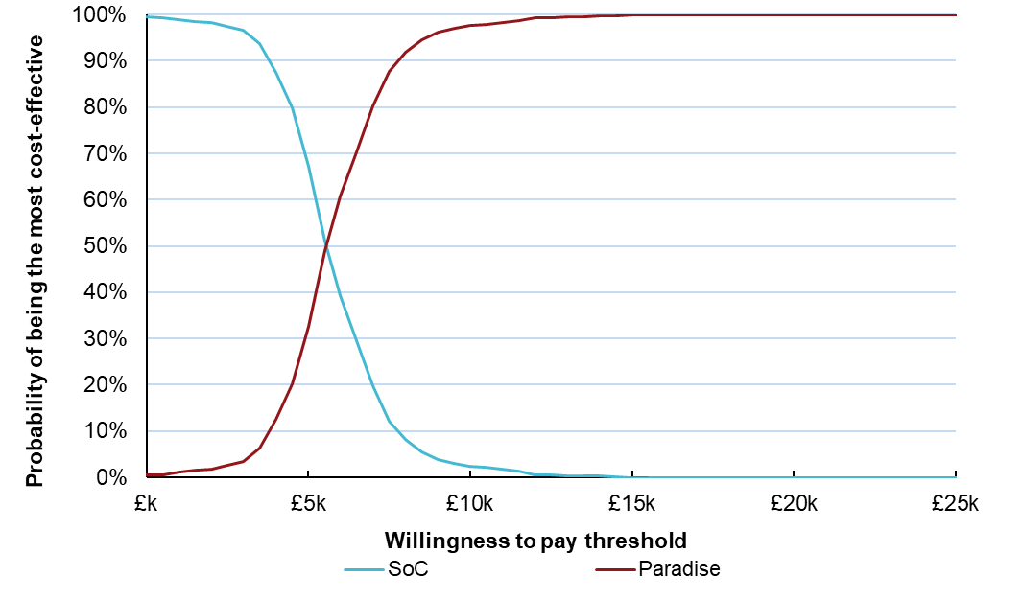
Key: SoC, standard of care.

Figure 2: PSA stability curves for incremental costs (left) and QALYs (right)
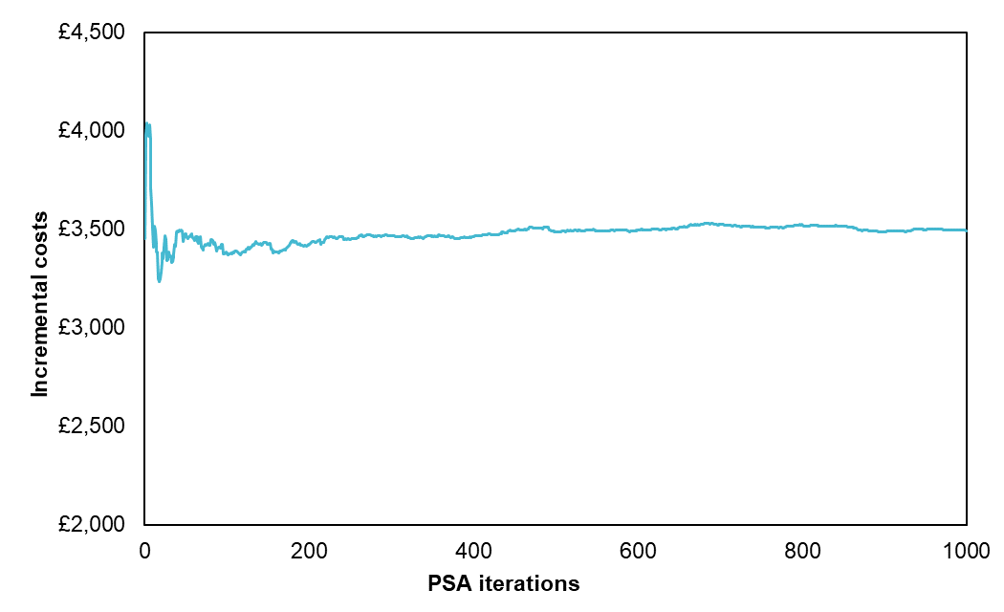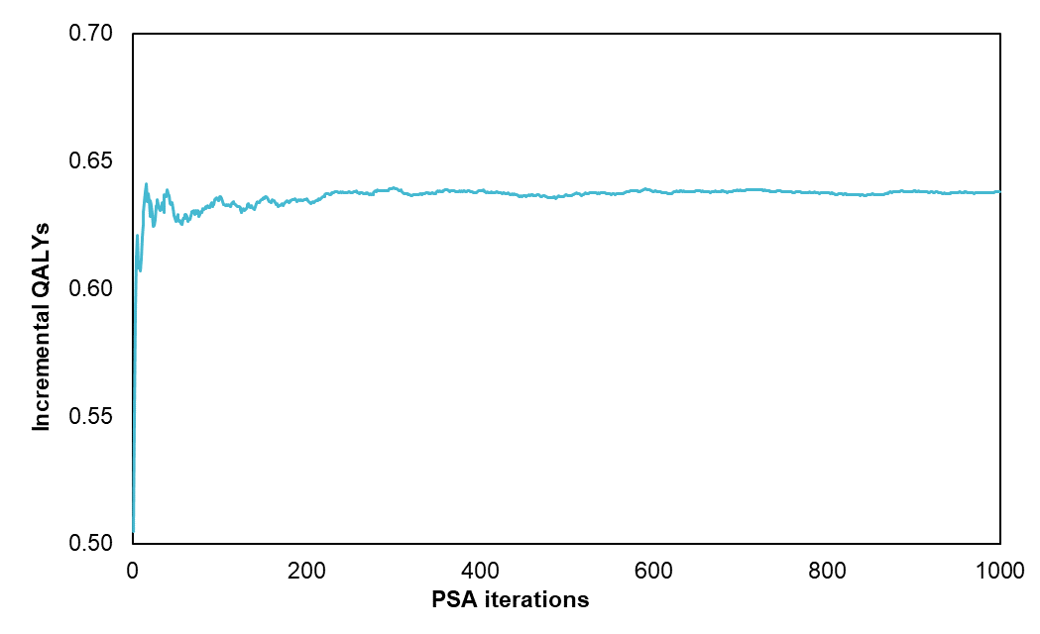
Key: PSA, probabilistic sensitivity analysis; QALY, quality-adjusted life year.

2.2.2 Robustness of model results: most influential parameters
Table 14: OWSA results: Top 10 most influential parameters
Rank | Factor | Parameter values |  |  | Difference in ICER  (compared to the base case)
Rank | Factor | LB | UB | Source | LB | UB | ∆
1 | RR of stroke per 10 mmHg SBP reduction | 0.68 | 0.77 | Thomopoulos et al. (2014) (19) | £3,511 | £8,321 | £4,810
2 | Stroke utility | 0.66 | 0.97 | Ward et al. (2007)(31)  Tengs et al. (2003)(36) | £5,139 | £5,932 | £793
3 | RR of MI per 10 mmHg SBP reduction | 0.78 | 0.88 | Thomopoulos et al. (2014) (19) | £5,437 | £5,782 | £345
4 | HF utility | 0.67 | 0.99 | Comin-Colet et al. (2003)(35) | £5,387 | £5,721 | £334
5 | Stroke mortality in the first month | 0.10 | 0.15 | Saposnik et al. (2008) | £5,466 | £5,738 | £272
6 | AP utility, initial, unstable | 0.83 | 0.97 | Sullivan et al. (2006)  Vella et al. (2003) | £5,716 | £5,525 | £191
7 | RR of HF per 10 mmHg SBP reduction | 0.67 | 0.78 | Thomopoulos et al. (2014) (19) | £5,502 | £5,691 | £189
8 | Paradise SBP reduction | 3.82 | 13.18 | RADIANCE-HTN TRIO (1) | £5,687 | £5,533 | £154
9 | HF mortality, RR by age category | 0.77 – 2.85 | 1.00 – 4.73 | Pocock et al. (2006)(26) | £5,523 | £5,644 | £121
10 | Age correction for post 30 day MI mortality | 0.87 – 1.74 | 1.88 – 3.48 | Barakat et al. (1999) | £5,551 | £5,665 | £115
Key: AP, documented episode of angina; CHD, ischemic heart disease; ESRD, end-stage renal disease; HF, heart failure; HR, hazard ratio; ICER, incremental cost-effectiveness ratio; OWSA, one-way sensitivity analysis; RR, relative risk; SBP, systolic blood pressure.

Appendix 3. Variance-covariance matrix of baseline patient characteristics
Table 15: Variance-covariance matrix of baseline patient characteristics
Key: AP, documented episode of angina; SBP, systolic blood pressure

eAppendix 4. Validation

4.1 Validation versus the Thomopoulos et al. (2014)(19) meta-analysis
Figure 3: Validation versus the Thomopoulos et al. (2014) meta-analysis
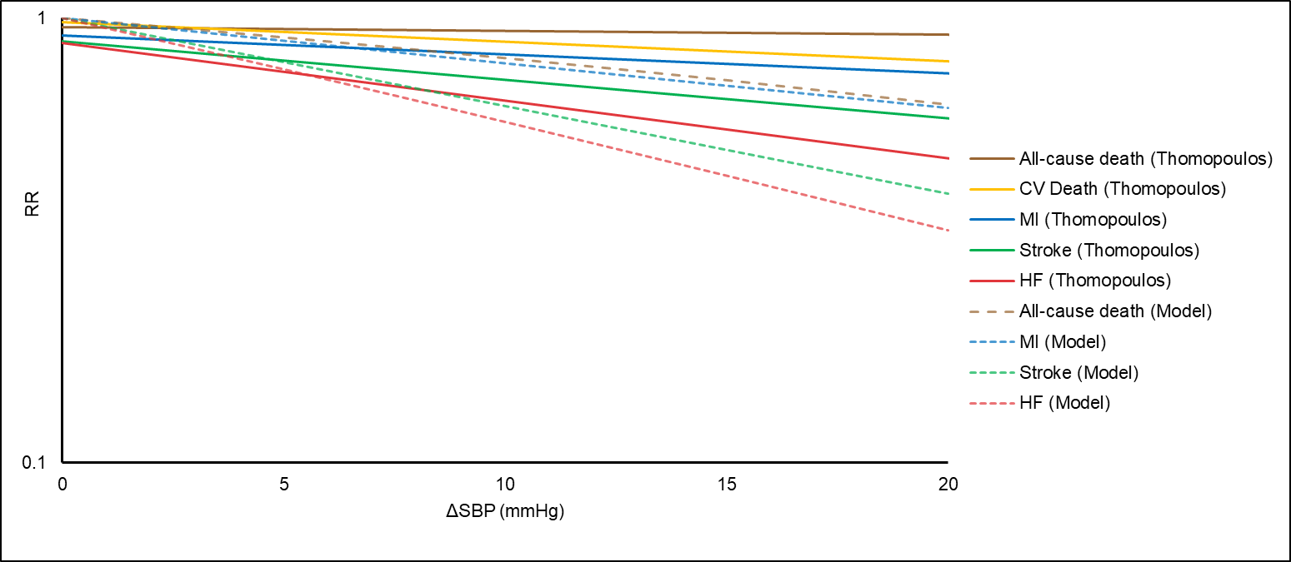
Key: CV, cardiovascular; HF, heart failure; MI, myocardial infarction; SBP, systolic blood pressure.

4.2 Validation versus the BPLTTC meta-analysis(50)
Figure 4: Validation versus the BPLTTC meta-analysis
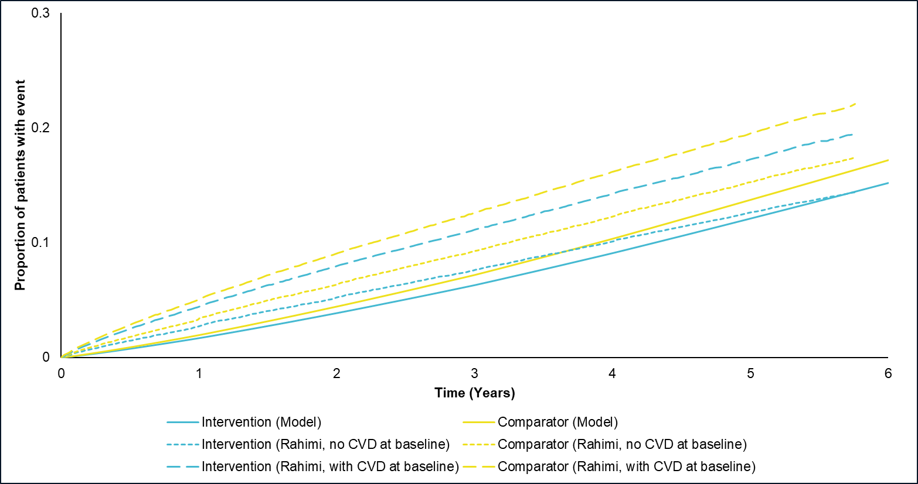
Key: BPLTTC, The Blood Pressure Lowering Treatment Trialists Collaboration; CVD, cardiovascular disease.

 | Reported (95% CI) |  | Modelled
 | With CVD | Without CVD | Modelled
HR per 5 mmHg | 0.89 (0.86, 0.92) | 0.91 (0.89, 0.94) | 0.88
Key: CI, confidence interval; CVD, cardiovascular disease; HR, hazard ratio.

4.3 Validation of model RRs versus two meta-analyses(17,19)
Table 16: Validation of model RRs versus Ettehad et al. (2016) and Thomopoulos et al. (2014) meta-analyses
Outcome | Ettehad et al RR (95% CI) | Thomopoulos et al RR (95% CI) | Model RR (assuming 10 mmHg effect)
Major cardiovascular events | 0.80 (0.77-0.83) | NR | 0.70
Coronary heart disease | 0.83 (0.78-0.88) | 0.78 (0.72-0.85) | 0.79
Stroke | 0.73 (0.68-0.77) | 0.63 (0.56-0.71) | 0.63
Heart Failure | 0.72 (0.67-0.78) | 0.54 (0.45-0.64) | 0.58
Renal failure | 0.95 (0.84-1.07) | NR | 0.95
Stroke + CHD | NR | 0.75 (0.71-0.79) | 0.69
Stroke + CHD + HF | NR | 0.74 (0.69-0.81) | 0.66
All-cause mortality | 0.87 (0.84-0.91) | 0.88 (0.82-0.93) | 0.82
Key: CI, confidence interval; NR, not reported; RR, relative risk.

4.4 Comparison to QRISK3 (Hippisley-Cox et al., 2017(51))
Table 17: Comparison to QRISK3 (Hippisley-Cox et al., 2017)
 | Example
Characteristics | 1 | 2 | 3 | 5 | 6
Female | 0 | 0 | 0 | 1 | 48
Age | 44 | 45 | 48 | 61 | 86.7
Weight | 78.6 | 64.7 | 85.8 | 97.4 | 200
Total cholesterol | 280 | 270 | 220 | 320 | 47.6
HDL cholesterol | 45.9 | 42.9 | 44.0 | 66.7 | 4.2
TC/HDL | 6.1 | 6.3 | 5 | 4.8 | 140
SBP | 130 | 115 | 124 | 155 | 0
African descent | 0 | 0 | 0 | 1 | 0
Smoking status | 1 | 0 | 1 | 0 | 0
Family history of coronary heart disease | 0 | 0 | 0 | 0 | 0
Type 1 Diabetes Mellitus | 0 | 0 | 0 | 0 | 0
Type 2 Diabetes Mellitus | 0 | 1 | 0 | 0 | 0
Total Diabetes Mellitus | 0 | 1 | 0 | 0 | 1
Treated hypertension | 0 | 0 | 0 | 0 | 0
Rheumatoid arthritis | 0 | 0 | 0 | 0 | 0
Atrial Fibrillation | 0 | 0 | 0 | 0 | 0
Chronic kidney disease | 0 | 0 | 0 | 0 | 1
Migraine | 1 | 0 | 1 | 0 | 0
Corticosteroid use | 0 | 0 | 1 | 0 | 0
Systemic lupus erythematosus | 0 | 0 | 0 | 0 | 0
Atypical antipsychotic use | 0 | 0 | 0 | 1 | 0
Severe mental illness | 0 | 0 | 0 | 1 | 0
Erectile dysfunction or treatment | 0 | 1 | 0 | NA | 0
Standard deviation of SBP | 6 | 40 | 3.1 | 33 | 9.2%
Model A 10 year predicted risk | 9.2% | 8.3% | 6% | 9.4% | 11%
Model B 10 year predicted risk | 11% | 9.9% | 11% | 13% | 9.5%
Model C 10 year predicted risk | 11% | 13% | 11% | 15% | 8%
Paradise model 10 year predicted risk | 10% | 7% | 11% | 16% | 8%
Key: HDL, high-density lipoprotein; SBP, systolic blood pressure; TC, total cholesterol.

eAppendix 5. References
1. Azizi M, Sanghvi K, Saxena M et al. Ultrasound renal denervation for hypertension resistant to a triple medication pill (RADIANCE-HTN TRIO): a randomised, multicentre, single-blind, sham-controlled trial. Lancet (London, England) 2021;https://doi.org/10.1016/S0140-6736(21)00788-1.
2. Gladwell D, Henry T, Cook M, Akehurst R. Cost effectiveness of renal denervation therapy for the treatment of resistant hypertension in the UK. Applied health economics and health policy 2014;12:611-22.
3. Khan SS, Ning H, Shah SJ et al. 10-Year Risk Equations for Incident Heart Failure in the General Population. Journal of the American College of Cardiology 2019;73:2388-2397.
4. D'Agostino RB, Russell MW, Huse DM et al. Primary and subsequent coronary risk appraisal: new results from the Framingham study. Am Heart J 2000;139:272-81.
5. ERA-EDTA Registry. Annual Report 2017. 2017. Available at: http://ERA-Registry-Annual-Report2020.pdf
6. Hsu CY, Iribarren C, McCulloch CE, Darbinian J, Go AS. Risk factors for end-stage renal disease: 25-year follow-up. Arch Intern Med 2009;169:342-50.
7. Kannel WB, D'Agostino RB, Silbershatz H, Belanger AJ, Wilson PW, Levy D. Profile for estimating risk of heart failure. Arch Intern Med 1999;159:1197-204.
8. Badar AA, Perez-Moreno AC, Jhund PS et al. Relationship between angina pectoris and outcomes in patients with heart failure and reduced ejection fraction: an analysis of the Controlled Rosuvastatin Multinational Trial in Heart Failure (CORONA). European heart journal 2014;35:3426-3433.
9. Velagaleti RS, Pencina MJ, Murabito JM et al. Long-term trends in the incidence of heart failure after myocardial infarction. Circulation 2008;118:2057-62.
10. Voss R, Cullen P, Schulte H, Assmann G. Prediction of risk of coronary events in middle-aged men in the Prospective Cardiovascular Münster Study (PROCAM) using neural networks. International journal of epidemiology 2002;31:1253-62; discussion 1262-64.
11. Hunink MG, Goldman L, Tosteson AN et al. The recent decline in mortality from coronary heart disease, 1980-1990: the effect of secular trends in risk factors and treatment. Jama 1997;277:535-542.
12. Wolf PA, D'Agostino RB, Belanger AJ, Kannel WB. Probability of stroke: a risk profile from the Framingham Study. Stroke 1991;22:312-8.
13. D'Agostino RB, Wolf PA, Belanger AJ, Kannel WB. Stroke risk profile: adjustment for antihypertensive medication. The Framingham Study. Stroke 1994;25:40-3.
14. Seliger SL, Gillen DL, Longstreth WT, Jr, Kestenbaum B, Stehman-Breen CO. Elevated risk of stroke among patients with end-stage renal disease. Kidney Int 2003;64:603-9.
15. Lip GY, Nieuwlaat R, Pisters R, Lane DA, Crijns HJ. Refining clinical risk stratification for predicting stroke and thromboembolism in atrial fibrillation using a novel risk factor-based approach: the euro heart survey on atrial fibrillation. Chest 2010;137:263-72.
16. Ntaios G, Vemmos K, Lip GY et al. Risk Stratification for Recurrence and Mortality in Embolic Stroke of Undetermined Source. Stroke 2016;47:2278-85.
17. Ettehad D, Emdin CA, Kiran A et al. Blood pressure lowering for prevention of cardiovascular disease and death: a systematic review and meta-analysis. The Lancet 2016;387:957-967.
18. Rahimi K, Bidel Z, Nazarzadeh M et al. Pharmacological blood pressure lowering for primary and secondary prevention of cardiovascular disease across different levels of blood pressure: an individual participant-level data meta-analysis. The Lancet 2021;397:1625-1636.
19. Thomopoulos C, Parati G, Zanchetti A. Effects of blood pressure lowering on outcome incidence in hypertension. 1. Overview, meta-analyses, and meta-regression analyses of randomized trials. J Hypertens 2014;32:2285-95.
20. Office for National Statistics. National life tables, UK: 2018–2020. Author London, England, 2021. Available at: https://www.ons.gov.uk/peoplepopulationandcommunity/birthsdeathsandmarriages/lifeexpectancies/datasets/nationallifetablesunitedkingdomreferencetables
21. Weinstein MC, Coxson PG, Williams LW, Pass TM, Stason WB, Goldman L. Forecasting coronary heart disease incidence, mortality, and cost: the Coronary Heart Disease Policy Model. American Journal of Public Health 1987;77:1417-1426.
22. Rogers WJ, Frederick PD, Stoehr E et al. Trends in presenting characteristics and hospital mortality among patients with ST elevation and non-ST elevation myocardial infarction in the National Registry of Myocardial Infarction from 1990 to 2006. Am Heart J 2008;156:1026-34.
23. Flack JM, Neaton J, Grimm R, Jr. et al. Blood pressure and mortality among men with prior myocardial infarction. Multiple Risk Factor Intervention Trial Research Group. Circulation 1995;92:2437-45.
24. Barakat K, Wilkinson P, Deaner A, Fluck D, Ranjadayalan K, Timmis A. How should age affect management of acute myocardial infarction? A prospective cohort study. Lancet (London, England) 1999;353:955-9.
25. Roger VL, Weston SA, Redfield MM et al. Trends in heart failure incidence and survival in a community-based population. Jama 2004;292:344-50.
26. Pocock SJ, Wang D, Pfeffer MA et al. Predictors of mortality and morbidity in patients with chronic heart failure. Eur Heart J 2006;27:65-75.
27. Saposnik G, Hill MD, O'Donnell M, Fang J, Hachinski V, Kapral MK. Variables associated with 7-day, 30-day, and 1-year fatality after ischemic stroke. Stroke 2008;39:2318-24.
28. Witt BJ, Brown RD, Jr., Jacobsen SJ, Weston SA, Yawn BP, Roger VL. A community-based study of stroke incidence after myocardial infarction. Annals of internal medicine 2005;143:785-92.
29. Haeusler KG, Laufs U, Endres M. Chronic heart failure and ischemic stroke. Stroke 2011;42:2977-82.
30. National Institute for Health Care and Excellence. Hypertension in adults: diagnosis and management [NG136]. 2019. Available at: https://www.nice.org.uk/guidance/ng136.
31. Ward S, Lloyd Jones M, Pandor A et al. A systematic review and economic evaluation of statins for the prevention of coronary events. Health technology assessment (Winchester, England) 2007;11:1-160, iii-iv.
32. Goodacre S, Nicholl J, Dixon S et al. Randomised controlled trial and economic evaluation of a chest pain observation unit compared with routine care. BMJ 2004;328:254.
33. Gorodetskaya I, Zenios S, Mcculloch CE et al. Health-related quality of life and estimates of utility in chronic kidney disease. Kidney international 2005;68:2801-2808.
34. Amemiya S TH. Computed Tomographic Coronary Angiography for Diagnosing Stable Coronary Artery Disease: A Cost-Utility and Cost-Effectiveness Analysis. Circ J 2009;73:9.
35. Comin-Colet J, Lainscak M, Dickstein K et al. The effect of intravenous ferric carboxymaltose on health-related quality of life in patients with chronic heart failure and iron deficiency: a subanalysis of the FAIR-HF study. European heart journal 2013;34:30-38.
36. Tengs TO, Lin TH. A meta-analysis of quality-of-life estimates for stroke. Pharmacoeconomics 2003;21:191-200.
37. Luengo-Fernandez R, Gray AM, Bull L et al. Quality of life after TIA and stroke: ten-year results of the Oxford Vascular Study. Neurology 2013;81:1588-1595.
38. Ara R, Brazier JE. Populating an economic model with health state utility values: moving toward better practice. Value in Health 2010;13:509-518.
39. Geisler BP, Egan BM, Cohen JT et al. Cost-effectiveness and clinical effectiveness of catheter-based renal denervation for resistant hypertension. Journal of the American College of Cardiology 2012;60:1271-7.
40. Department of Health and Social Care. Drugs and pharmaceutical electronic market information tool (eMIT). 2023 Available at: https://www.gov.uk/government/publications/drugs-and-pharmaceutical-electronic-market-information-emit
41. Curtis LH, Burns A. PSSRU Unit costs of health and social care 2020. 2020. Available at: https://kar.kent.ac.uk/100519/1/Unit%20Costs%20of%20health%20and%20Social%20Care%202022%20%28amended%2013%20July%202023%29.pdf
42. Danese MD GM, Kutikova L, Griffiths RI , Azough A, Khunti K, Seshasai SRK, Ray KK. Estimating the economic burden of cardiovascular events in patients receiving lipid-modifying therapy in the UK. BMJ Open 2016.
43. Patel A BV, Quayyum Z. Estimated societal costs of stroke in the UK based on discrete event simulation. Age and Ageing 2020;49:7.
44. Kerr M BB, Medcalf. Estimating the financial cost of chronic kidney disease to the NHS in England. Nephrol Dial Transplant 2012;27.
45. National Health Service (NHS). Quality and outcomes framework, 2020-2021 Available at: https://digital.nhs.uk/data-and-information/publications/statistical/quality-and-outcomes-framework-achievement-prevalence-and-exceptions-data/2021-22
46. National Health Service (NHS). National schedule of reference costs 2020. 2021. Available at: https://www.england.nhs.uk/costing-in-the-nhs/national-cost-collection/
47. The Renal Association. UK Renal Registry 22nd Annual report. 2018. Available at: https://renal.org/sites/renal.org/files/publication/file-attachments/22nd_UKRR_ANNUAL_REPORT_FULL.pdf.
48. Esler MD, Krum H, Sobotka PA, Schlaich MP, Schmieder RE, Böhm M. Renal sympathetic denervation in patients with treatment-resistant hypertension (The Symplicity HTN-2 Trial): a randomised controlled trial. Lancet (London, England) 2010;376:1903-9.
49. National Health Service (NHS). High blood pressure (hypertension). 2019. Available at: https://www.nhs.uk/conditions/high-blood-pressure-hypertension/.
50. Rahimi K. Pharmacological blood pressure-lowering for primary and secondary prevention of cardiovascular disease across different levels of blood pressure. ESC, 2020.
51. Hippisley-Cox J, Coupland C, Brindle P. Development and validation of QRISK3 risk prediction algorithms to estimate future risk of cardiovascular disease: prospective cohort study. BMJ 2017;357:j2099.

