Supplementary File
Cost-effectiveness of fruquintinib for refractory metastatic colorectal cancer in the United States
PharmacoEconomics - Open
Dong-Won Kang¹, Patricio B. Lynn¹, Li Wang², Shouhao Zhou^{2*}, Chan Shen^{1, 2*}
¹Department of Surgery, Penn State College of Medicine, Hershey, Pennsylvania, United States of America
²Department of Public Health Sciences, Penn State College of Medicine, Hershey, Pennsylvania, United States of America
*Authors contributed equally to this study.

Corresponding Author:
Chan Shen, PhD
The Pennsylvania State University
College of Medicine
Department of Surgery
500 University Drive, H151
Hershey, PA 17033-0850
Phone: 717-531-4494
Fax: 717-531-4464
Email: chanshen@psu.edu

Funding: The authors did not receive support from any organization for the submitted work.
Conflicts of Interest/Competing Interests: The authors have no competing interests to declare that are relevant to the content of this article.

Supplementary Table 1 The type and proportion of drugs used in subsequent treatment and the cost per model cycle
Drug | Proportion (%) |  | Drug cost per model cycle ($) | Total cost per model cycle ($)
Drug | Fruquintinib | Placebo | Drug cost per model cycle ($) | Fruquintinib | Placebo
Fluorouracil | 32.8 | 41.8 | 24.99 | 2,884.58 | 2,655.15
Capecitabine | 20.1 | 15.2 | 131.58 | 2,884.58 | 2,655.15
Folinic acid | 16.4 | 24.1 | 1.47 | 2,884.58 | 2,655.15
Calcium folinate | 9.0 | 11.4 | 241.40 | 2,884.58 | 2,655.15
Oxaliplatin | 26.1 | 31.6 | 158.66 | 2,884.58 | 2,655.15
Regorafenib | 25.4 | 22.8 | 6,877.92 | 2,884.58 | 2,655.15
Irinotecan | 23.1 | 20.3 | 64.46 | 2,884.58 | 2,655.15
Bevacizumab | 17.2 | 24.1 | 1,673.56 | 2,884.58 | 2,655.15
Cetuximab | 6.7 | 5.1 | 4,020.50 | 2,884.58 | 2,655.15
Panitumumab | 6.0 | 5.1 | 4,152.75 | 2,884.58 | 2,655.15
Trifluridine–Tipiracil; | 11.2 | 7.6 | 1,976.91 | 2,884.58 | 2,655.15

Supplementary Table 2 AIC and BIC for each distribution of progression-free survival and overall survival curves
Clinical outcomes  (Model) | Treatment | Distribution | AIC | BIC
Progression-free survival  (Dependent) | Fruquintinib, Placebo | Weibull | 2539.994 | 2553.608
Progression-free survival  (Dependent) | Fruquintinib, Placebo | Lognormal | 2437.867 | 2451.482
Progression-free survival  (Dependent) | Fruquintinib, Placebo | Log-logistic | 2442.299 | 2455.914
Progression-free survival  (Dependent) | Fruquintinib, Placebo | Exponential | 2730.078 | 2739.154
Progression-free survival  (Dependent) | Fruquintinib, Placebo | Generalized gamma | 2438.793 | 2456.946
Progression-free survival  (Dependent) | Fruquintinib, Placebo | Gompertz | 2682.770 | 2696.385
Overall survival  (Independent) | Fruquitinib | Weibull | 2046.077 | 2054.344
Overall survival  (Independent) | Fruquitinib | Lognormal | 2038.496 | 2046.763
Overall survival  (Independent) | Fruquitinib | Log-logistic | 2037.641 | 2045.908
Overall survival  (Independent) | Fruquitinib | Exponential | 2130.398 | 2134.532
Overall survival  (Independent) | Fruquitinib | Generalized gamma | 2036.623 | 2049.023
Overall survival  (Independent) | Fruquitinib | Gompertz | 2080.979 | 2089.246
Overall survival  (Independent) | Placebo | Weibull | 1032.376 | 1039.252
Overall survival  (Independent) | Placebo | Lognormal | 1012.532 | 1019.409
Overall survival  (Independent) | Placebo | Log-logistic | 1015.942 | 1022.818
Overall survival  (Independent) | Placebo | Exponential | 1038.727 | 1042.165
Overall survival  (Independent) | Placebo | Generalized gamma | 1014.151 | 1024.465
Overall survival  (Independent) | Placebo | Gompertz | 1040.307 | 1047.183
Abbreviations: AIC, Akaike Information Criterion; BIC, Bayes Information Criterion.

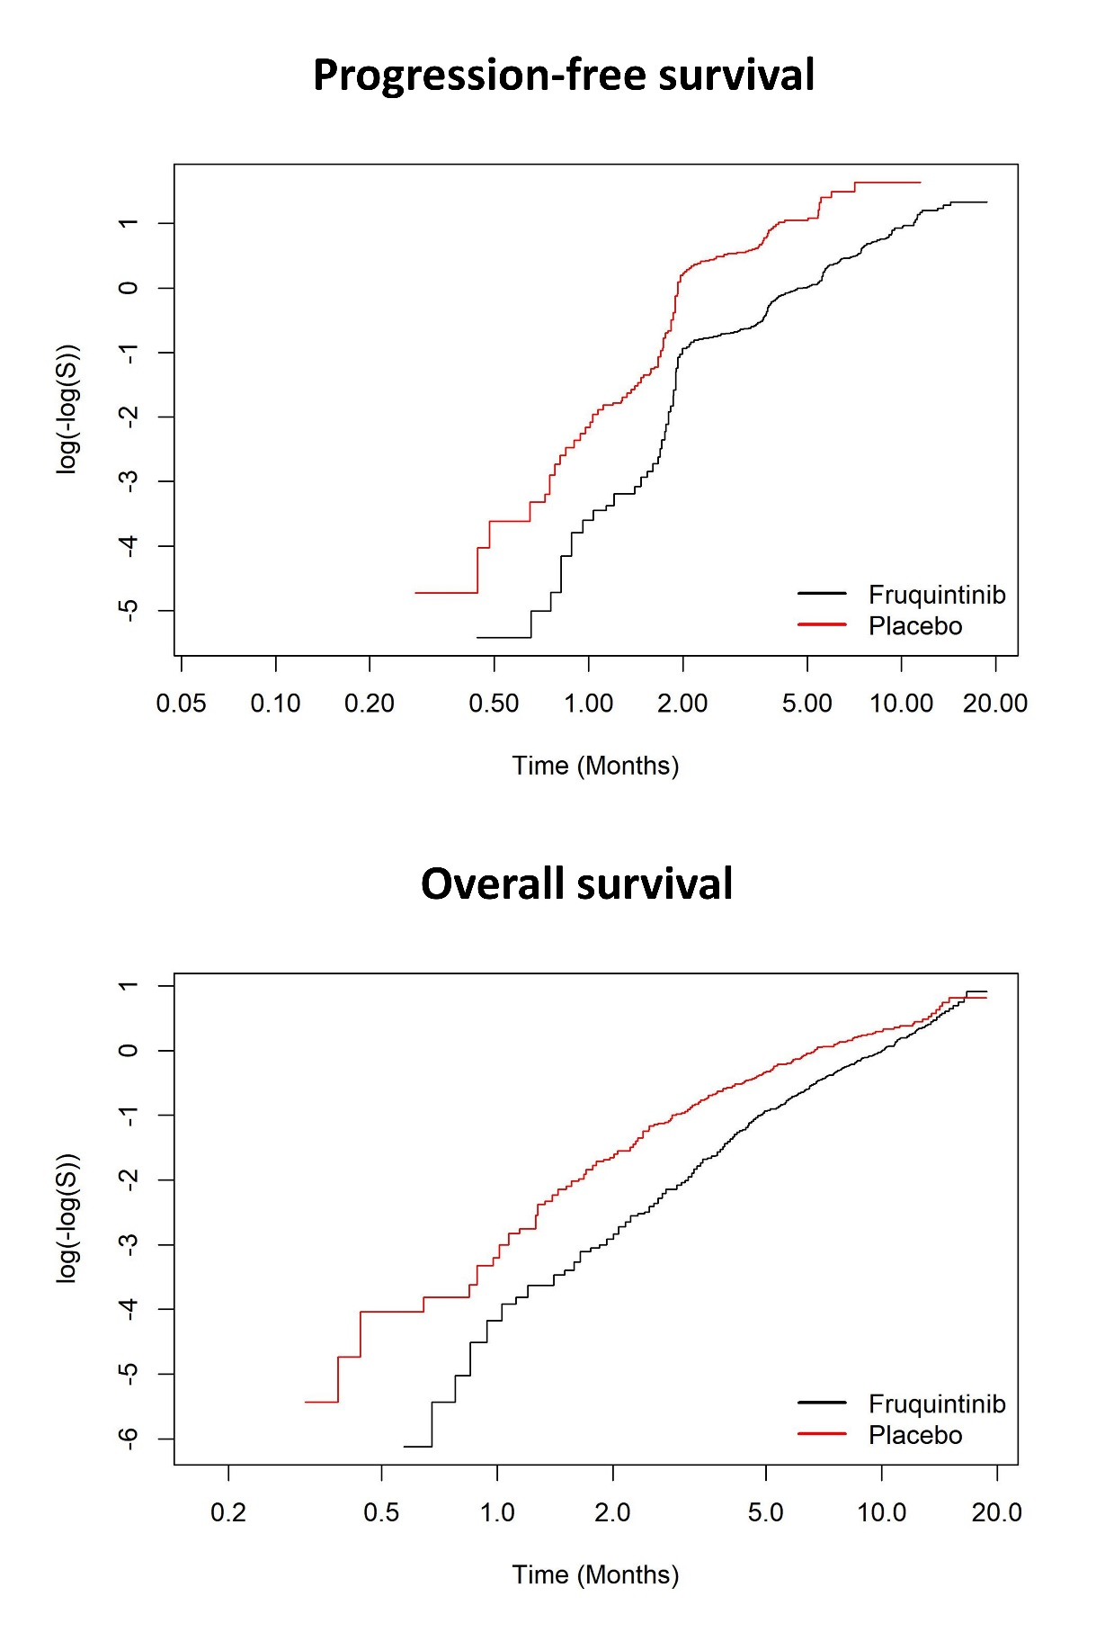
Supplementary Fig. 1 Log-cumulative hazard plots for progression-free survival and overall survival curves

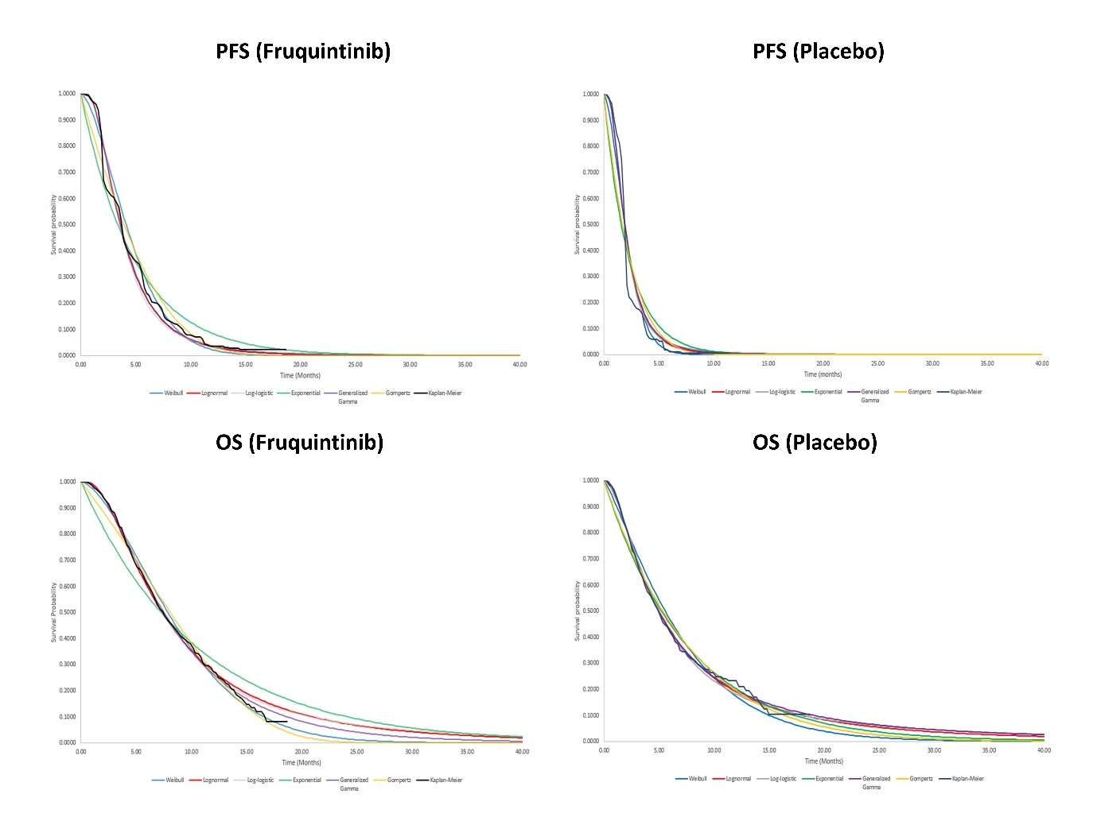
Supplementary Fig. 2 Visual plots of each distribution for progression-free survival and overall survival curves. Abbreviations: PFS=progression-free survival, OS=overall survival.

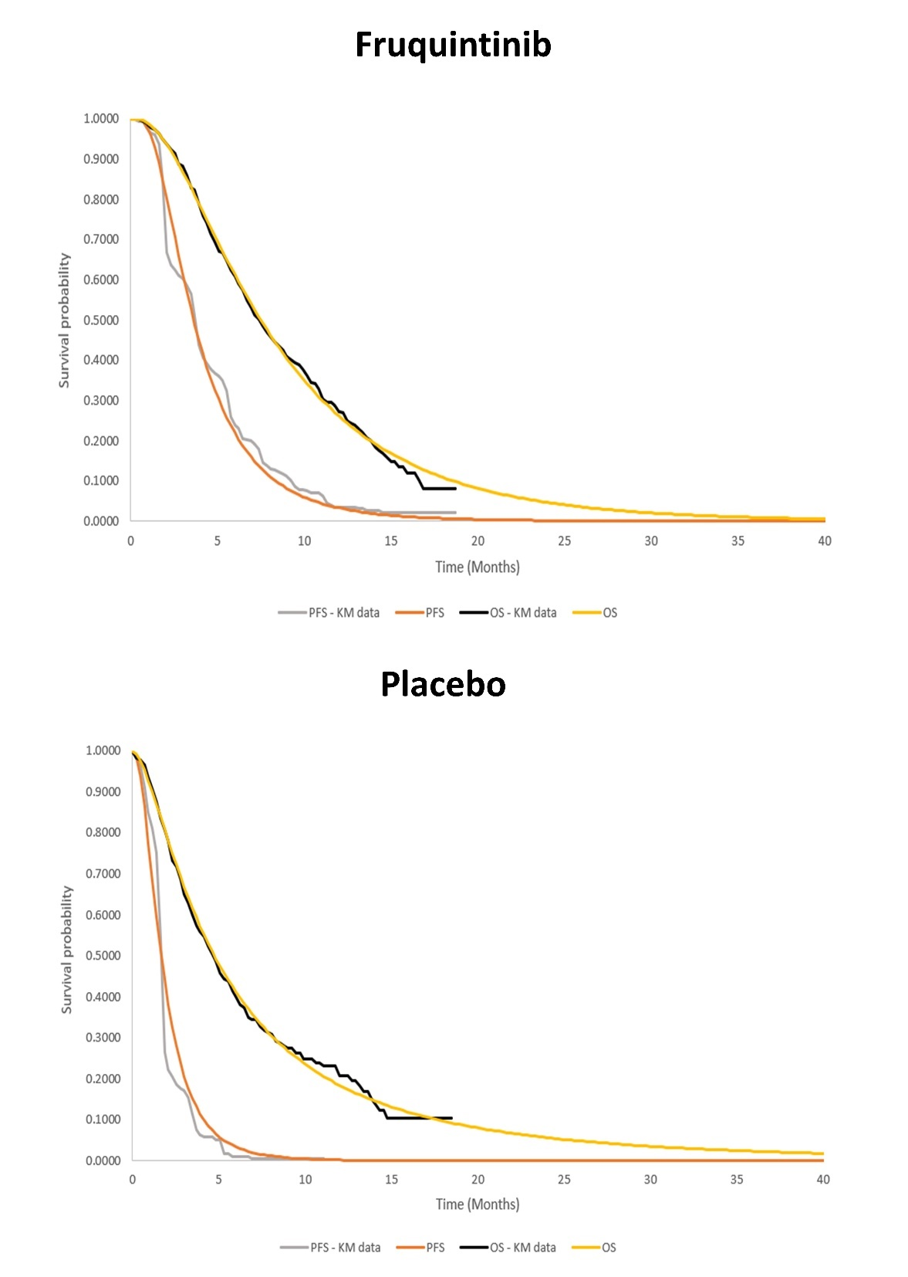
Supplementary Fig. 3 Visual plots of best-fitted distribution for progression-free survival and overall survival curves. Abbreviations: PFS=progression-free survival, KM=Kaplan-Meier, OS=overall survival.

