Supplementary Material
Article title: Cost-Effectiveness of Nivolumab Plus Ipilimumab versus Chemotherapy for Previously Untreated Metastatic NSCLC Using Mixture-cure Survival Analysis based on CheckMate 227 5-year Data
Journal name: PharmacoEconomics
Authors: Alison D Griffiths, MPH,¹ Robert O Young, MRes,¹ Yong Yuan, PhD,² Mohammad A. Chaudhary, PhD,² Adam Lee, MSc,³ Jason Gordon, PhD,¹ Philip McEwan, PhD¹
¹Health Economics and Outcomes Research Ltd, Cardiff, UK
²Bristol-Myers Squibb, Princeton, NJ, USA
³Bristol-Myers Squibb, Uxbridge, UK
Corresponding Author: Robert Young, MRes; Health Economics and Outcomes Research Ltd, Cardiff, UK; rob.young@heor.co.uk
Funding: This work was supported by Bristol Myers Squibb who supplied clinical trial input data and research funding for this study.
Conflicts of interest: YY, MAC, and AL are employees of Bristol-Myers Squibb. RY, AG, JG, and PM are employees of Health Economics and Outcomes Research Ltd. Health Economics and Outcomes Research Ltd. received fees from Bristol Myers Squibb in relation to this study.
Supplementary S1: Summary of core assumptions
Feature | Cost-effectiveness model summary
Model type | Discrete time four state Markov model with time-varying transition intensities
Health states | Progression-free (non-LTR), progression-free (LTR), progressed disease, death
Cycle length | 3 weeks
Time horizon | Lifetime (until 99.9% of patients have died on NIVO+IPI)
Perspective | US 3rd party payer perspective
Comparators | Nivolumab plus ipilimumab (NIVO +IPI) versus platinum-doublet chemotherapy (Chemo)
Population | Baseline age: 63.20; sex: 33.3% female - derived from CheckMate 227 Part 1 population
Resource use | Treatment costs (including administration and monitoring), health state specific disease management costs, treatment related adverse events, terminal care.
Discount rates | 3% costs and 3% effects consistent with ICER reference case
Abbreviations: Chemo, platinum-doublet chemotherapy; ICER, Institute for Clinical and Economic Review; IPI, ipilimumab; LTR, long-term responder; NIVO, nivolumab

Supplementary S2: Utility estimates from CM-227
 | Distribution for PSA | CheckMate 227²² |  |  | CheckMate 9LA²³ pooled mean utility*
 | Distribution for PSA | Pooled mean utility | Treatment-specific utility |  | CheckMate 9LA²³ pooled mean utility*
 | Distribution for PSA | Pooled mean utility | NIVO+IPI | Chemo | CheckMate 9LA²³ pooled mean utility*
Health state
Progression-free | Beta | 0.795 (0.005) | 0.793 (0.006) | 0.796 (0.007) | 0.797 (0.008)
Progressive disease | Beta | 0.746 (0.005) | 0.752 (0.007) | 0.739 (0.007) | 0.738 (0.010)
Long-term responsive | None | 0.815²⁶ | 0.815²⁶ | 0.815²⁶ | 0.815²⁶
Time-to-death**
0-4 weeks | Beta | 0.577 (0.005) | - | - | -
4-26 weeks | Beta | 0.715 (0.005) | - | - | -
26-52 weeks | Beta | 0.794 (0.005) | - | - | -
52 weeks+ | Beta | 0.838 (0.011) | - | - | -
End of life
0-4 weeks | Beta | 0.577 (0.011) | - | - | -
*Used in scenario analysis. **Mixed model (repeated measures per patient) regression on CheckMate 227. Time-to-death utilities adapted to 3-week cycle length. Source: Berling et al.²² Treatment ratio of health state utility values from CheckMate 227 used to scale CheckMate 9LA utilities to treatment specific values. Age adjustment performed per US population norms.²⁶ Pooled utilities used in base case. Bracketed values are standard error of mean used for PSA sampling
Abbreviations: Chemo, platinum-doublet chemotherapy; IPI, ipilimumab; NIVO, nivolumab; PSA, probabilistic sensitivity analysis

Supplementary S3: Drug acquisition costs
Drug components | Dose / unit | Total dose per administration | Vial/pack size | Cost per vial/pack ($)³² | Vial/pack units used per dose  (with wastage) | Cost per dose $
Nivolumab | 3 mg/kg | 210 mg | 240 mg | 6914.93 | 0 | 6270.89
Nivolumab |  |  | 100 mg | 2881.22 | 1 | 6270.89
Nivolumab |  |  | 40 mg | 1129.89 | 3 | 6270.89
Ipilimumab | 1 mg/kg | 70 mg | 200 mg | 31530.00 | 0 | 15765
Ipilimumab |  |  | 50 mg | 7882.50 | 2 | 15765
Cisplatin | 75 mg/m2 | 133 mg | 200 mg | 72.20 | 0 | 33.39
Cisplatin |  |  | 100 mg | 18.05 | 1 | 33.39
Cisplatin |  |  | 50 mg | 15.34 | 1 | 33.39
Pemetrexed | 500 mg/m2 | 890 mg | 500 mg | 3963.73 | 2 | 7927.46
Pemetrexed |  |  | 100 mg | 792.75 | 0 | 7927.46
Carboplatin | 685 mg | 685 mg | 600 mg | 44.00 | 1 | 61.59
Carboplatin |  |  | 450 mg | 33.00 | 0 | 61.59
Carboplatin |  |  | 150 mg | 17.59 | 1 | 61.59
Carboplatin |  |  | 50 mg | 6.92 | 0 | 61.59
Gemcitabine | 1250 mg/m2 | 2224 mg | 2000 mg | 44.50 | 1 | 62.62
Gemcitabine |  |  | 1000 mg | 22.00 | 0 | 62.62
Gemcitabine |  |  | 200 mg | 9.06 | 2 | 62.62
Source: Berling et al.22
Final costs used in model use a dose intensity modifier

Supplementary S4: First-line drug acquisition cost modifier (relative dose intensity)
Comparator | Drug component | Mean exposure* (PSA: normal distribution) | Mean expected* (PSA: normal distribution) | Relative dose intensity
Chemo | Gemcitabine | 6148.01 (181.97) | 7502.22 (185.31) | 81.9%
Chemo | Cisplatin | 244.67 (5.51) | 263.62 (6.24) | 92.8%
Chemo | Carboplatin | 17.13 (0.29) | 18.74 (0.32) | 91.4%
Chemo | Pemetrexed | 4408.97 (237.71) | 4837.34 (262.62) | 91.1%
NIVO+IPI | Nivolumab | 47.45 (2.00) | 51.25 (2.12) | 92.6%
NIVO+IPI | Ipilimumab | 5.47 (0.218) | 5.73 (0.229) | 95.5%
*mg/kg (nivolumab, ipilimumab); mg/m^2 (cisplatin, gemcitabine, pemetrexed); AUC (carboplatin). Values in brackets are standard error of mean, used for PSA. Expected exposure calculated according to difference between maximum and minimum exposure times per patient per treatment component, per trial reported RDI summary. Source: CheckMate 227 5 year DCO, BMS data on file.
Abbreviations: Chemo, platinum-doublet chemotherapy; IPI, ipilimumab; NIVO, nivolumab; PSA, probabilistic sensitivity analysis.

Supplementary S5: Drug administration costs
Description | Data source | Unit cost ($)
Chemo iv infusion 1 hr | 96413: Medicare physician fee schedule 2020³³ | 140.16
Chemo iv infusion additional hr | 96415: Medicare physician fee schedule 2020³³ | 29.76
Chemo iv infusion each additional sequence | 96417: Medicare physician fee schedule 2020³³ | 68.00
Source: Berling et al.²²
Abbreviations: Chemo, platinum-doublet chemotherapy

Supplementary S6: Drug monitoring costs
Description | Unit cost $ | NIVO+IPI per 4 weeks | Chemo per 4 weeks
Office visit | 98.97ª | 1.00^{b} | 1.00^{c}
Hepatic enzymes | 8.17^{d} | 1.00^{b} | 1.00^{c}
Renal function | 8.68^{d} | 1.00^{b} | 1.00^{c}
Thyroid test | 16.80^{d} | 1.00^{b} | 0.00
CBC | 7.77^{d} | 0.00 | 1.33^{c}
Comprehensive metabolic panel + ACTH | 49.18^{d} | 1.00^{b} | 0.00
Total per 3-week model cycle |  | 136.35 | 94.62
ªSource: 2022 Medicare physician fee schedule,³⁴ 99214 non-facility price.
^{b}Source: Product label.¹⁵
^{c}Source: Product labels.³⁵⁻³⁸
^{d}Source: 2022 Medicare clinical laboratory fee schedule, HCPCS codes 80053 (comprehensive metabolic panel), 80069 (renal function panel), 80076 (hepatic function panel), 84443 (assay thyroid hormone), 82024 (assay of adrenocorticotropic hormone), 82962 (glucose blood test), 85025 (complete blood cell count).³⁹
Source: Berling et al (2022)²²
Abbreviations. ACTH: adrenocorticotrophic hormone; CBC: complete blood count; Chemo: platinum-doublet chemotherapy; IPI: ipilimumab NIVO: nivolumab.

Supplementary S7: Costs of subsequent systemic therapy
First-line treatment | NIVO+IPI | Chemo
n/N (%) patients receiving any subsequent systemic therapy / ITTª | 235/583 (40.3%) | 321/583 (55.1%)
n/N (%) patients receiving any subsequent systemic therapy / patients progressedª | 235/351 (67.0%) | 321/364 (88.2%)
Subsequent therapyª
Pemetrexed | 56.17% | 9.66%
Nivolumab | 12.77% | 60.75%
Pembrolizumab | 3.83% | 13.71%
Atezolizumab | 4.68% | 4.36%
Carboplatin | 67.66% | 12.46%
Cisplatin | 28.51% | 4.67%
Docetaxel | 22.13% | 33.96%
Gemcitabine | 23.83% | 12.77%
Paclitaxel | 31.06% | 13.08%
Vinorelbine | 11.06% | 8.10%
Total cost per patient subsequent therapies ($) | 22093.29 | 35894.90
ªSource: CheckMate 227 5 year DCO, BMS data on file.
Patients modelled as progressing incur a weighted sum of mean second-line treatment costs, reduced to the fraction of patients receiving any subsequent systemic therapy. In the base case, this is per ITT; in a scenario analysis, costs are reduced to the fraction of progressors receiving subsequent systemic therapy.
Abbreviations. Chemo: platinum-doublet chemotherapy; DCO: data cut-off; IPI: ipilimumab NIVO: nivolumab.

Supplementary S8: Treatment-related adverse events
 | Rates |  | Disutility | Cost per episode ($)
 | NIVO+IPI | Chemo | Disutility | Cost per episode ($)
Anaemia | 1.39% | 11.58% | –0.125⁴⁰ | 8,425.02
Neutropenia | 0.00% | 14.57% | –0.350⁴¹ | 14,074.55
Neutrophil count decreased | 0.00% | 6.32% | –0.35* | 14,074.55*
Thrombocytopenia | 0.35% | 4.39% | –0.108⁴² | 10,881.04
Febrile neutropenia | 0.00% | 2.46% | –0.470⁴¹ | 14,074.55
*Disutility, cost assumed the same as neutropenia. Source: Berling et al.²²
Abbreviations: Chemo, platinum-doublet chemotherapy; IPI, ipilimumab; NIVO, nivolumab

Supplementary S9: Disease management costs: pre-progression-free
 | Freq. per 3 weeks (PSA: lognormal distribution) | Data source | Unit cost $
Office visit | 0.75ª (0.08) | 2020 Medicare Physician Fee Schedule; 99214 facility price (May 2020)³³ | 80.48
Radiotherapy | 0.23^{b} (0.02) | 2020 Medicare Physician Fee Schedule; 77373 (May 2020)³³ | 1230.66
CT scan | 0.23^{b} (0.02) | 2020 Medicare Physician Fee Schedule; 70450, 71250, 74150 Sum of the average across all 3 modifier types (facility price) (May 2020)³³ | 286.31
X-ray | 0.50^{b} (0.05) | 2020 Medicare Physician Fee Schedule; 71047 facility average across all modifiers (May 2020)³³ | 27.91
ªAssumption, TA374.⁴³
^{b}Assumption, NICE TA403.⁴⁴
Numbers in brackets are assumed standard error of mean for PSA
Abbreviations. CT, computed tomography; Freq., frequency; PSA, probabilistic sensitivity analysis
Source: Berling et al (2022)²²

Supplementary S10: Disease management costs: post-progression
 | Freq. per 3 weeks (PSA: lognormal distribution) | Data source | Unit cost $
Office visit | 1.33ª (0.13) | 2020 Medicare Physician Fee Schedule; 99214 facility price (May 2020)³³ | 80.48
Radiotherapy | 0.75^{b} (0.08) | 2020 Medicare Physician Fee Schedule; 77373 (May 2020)³³ | 1230.66
Blood transfusion | 0.35^{b} (0.03) | 2020 Medicare Physician Fee Schedule, HCPCS 36430 ($35.73 facility price)³³ and inflated US blood transfusion costs from Toner et al (2011) (May 2020) | 289.16
CT scan | 0.23^{b} (0.02) | 2020 Medicare Physician Fee Schedule; 70450, 71250, 74150 Sum of the average across all 3 modifier types (facility price) (May 2020)³³ | 286.31
X-ray | 0.35^{b} (0.03) | 2020 Medicare Physician Fee Schedule; 71047 facility average across all modifiers (May 2020)³³ | 27.91
Oxygen | 1.00^{b} (0.10) | April 2020 Medicare DMEPOS; EO424 (average across all states) (May 2020)³³ | 73.98
ªAssumption, TA374.⁴³
^{b}Assumption, NICE TA403.⁴⁴
Numbers in brackets are assumed standard error of mean for PSA
Abbreviations. CT, computed tomography; Freq., frequency; PSA, probabilistic sensitivity analysis
Source: Berling et al (2022)²²

Supplementary S11: Description of parameter sensitivity analyses
Scenario | Lower range | Upper range | Rationale
Discount rate: QALY | 0.0% | 6.0% | Berling et al²²
Discount rate: costs | 0.0% | 6.0% | Berling et al²²
Utility value: non-LTR | 0.785 | 0.805 | ±1.96 SE
Utility value: PD | 0.736 | 0.756 | ±1.96 SE
Utility value: LTR | 0.777 | 0.853 | 95% CI
Acquisition cost: NIVO | $5,017 | $7,525 | ±20%
Acquisition cost: IPI | $12,612 | $18,918 | ±20%
Acquisition cost: Chemo (/3 weeks) | $4,613 | $6,919 | ±20%
Acquisition cost: maintenance PEM (/3weeks) | $6,342 | $9,513 | ±20%
Disease management costs: non-LTR | $256 | $384 | ±20%
Disease management costs: PD | $768 | $1,152 | ±20%
TRAE costs | $948 | $1,422 | ±20%
Subsequent anti-cancer costs (Chemo: NIVO+IPI) | $28,712:$17,675 | $43,073:$26,512 | ±20%
EOL costs | $9,842 | $14,764 | ±20%
Abbreviations: Chemo, platinum-d-oublet chemotherapy; EOL, end of life; ICER, incremental cost-effectiveness ratio; IPI, ipilimumab; LTR, long-term responder; NIVO, nivolumab; PD, progressed disease; PEM, pemetrexed; QALY, quality-adjusted life year; TRAE, treatment-related adverse event

Supplementary S12: Goodness-of-fit statistics and estimated LTR fractions for mixture-cure models of OS based upon CheckMate 227
Distribution of uncured | Fully independent models |  |  |  | Scaled non-LTR |  |  |  | Shared non-LTR
Distribution of uncured |  |  | LTR fraction [%] |  |  |  | LTR fraction [%] |  |  |  | LTR fraction [%]
Distribution of uncured | AIC | BIC | NIVO+IPI | Chemo | AIC | BIC | NIVO+IPI | Chemo | AIC | BIC | NIVO+IPI | Chemo
Exponential | 8144.64 | 8162.11 | 21.6 | 10.2 | 8144.64 | 8164.88 | 21.6 | 10.2 | 8143.34 | 8158.52 | 22.1 | 9.9
Weibull | 8136.88 | 8163.09 | 21.2 | 11.7 | 8142.41 | 8167.71 | 22.5 | 11.0 | 8141.26 | 8161.50 | 22.9 | 10.7
Gamma | 8131.83 | 8158.04 | 21.6 | 11.6 | 8138.48 | 8163.78 | 22.6 | 11.0 | 8137.19 | 8157.44 | 23.0 | 10.7
Gompertz | 8144.14 | 8170.35 | 11.2 | 10.9 | 8145.90 | 8171.20 | 20.3 | 9.3 | 8144.44 | 8164.68 | 20.9 | 8.5
Log-logistic | 8112.10 | 8138.31 | 11.0 | 5.3 | 8120.82 | 8146.12 | 15.5 | 1.9 | 8118.86 | 8139.11 | 15.4 | 2.0
Lognormal | 8117.22 | 8143.43 | 8.2 | 5.1 | 8127.29 | 8152.59 | 14.9 | 0.1 | 8126.43 | 8146.67 | 14.6 | 1.9
Gen. Gamma | 8115.30 | 8150.25 | 13.00 | 9.3 | 8123.15 | 8153.52 | 19.6 | 6.7 | 8121.17 | 8146.48 | 19.5 | 6.9
Bold: minimum AIC/BIC; Italics: > 10 units from minimum AIC/BIC model
Abbreviations: AIC, Akaike information criterion; BIC, Bayesian information criterion; Chemo, platinum-doublet chemotherapy; Gen. Gamma, generalised gamma; IPI, ipilimumab; LTR, long-term response; NIVO, nivolumab

Supplementary S13: Hazard functions of models used in the base case
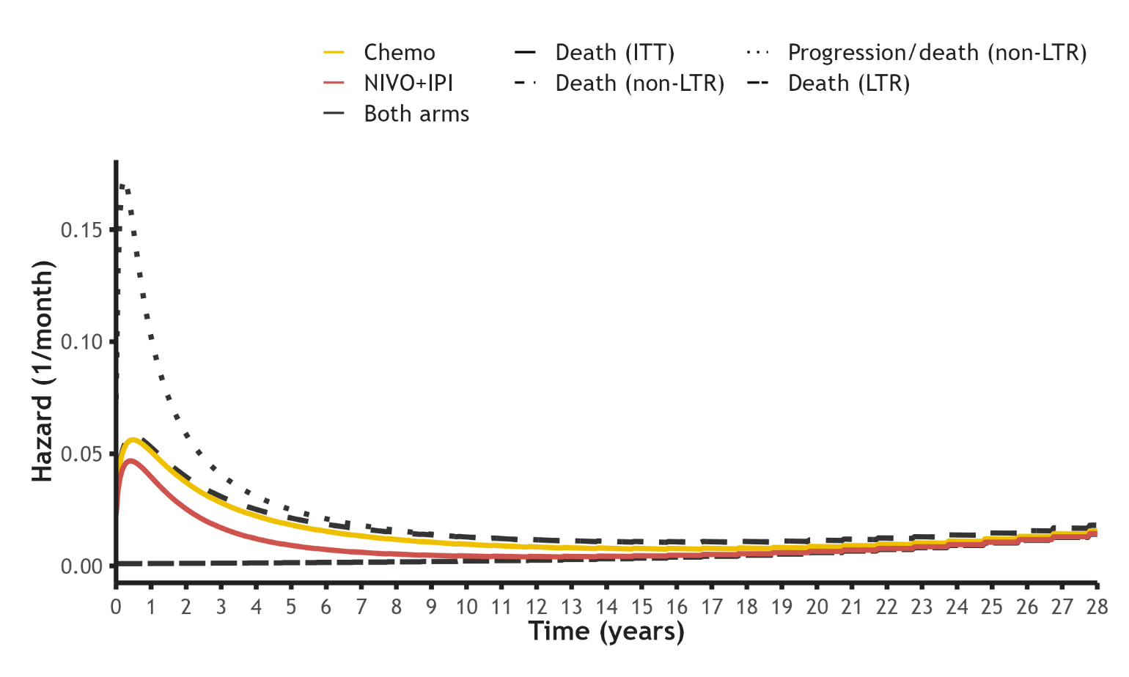
Abbreviations: Chemo, platinum-doublet chemotherapy; ITT, intention to treat; IPI, ipilimumab; LTR, long-term response; NIVO, nivolumab

Supplementary S14: Log-logistic mixture-cure OS model predictions and Kaplan-Meier estimators from CheckMate 227
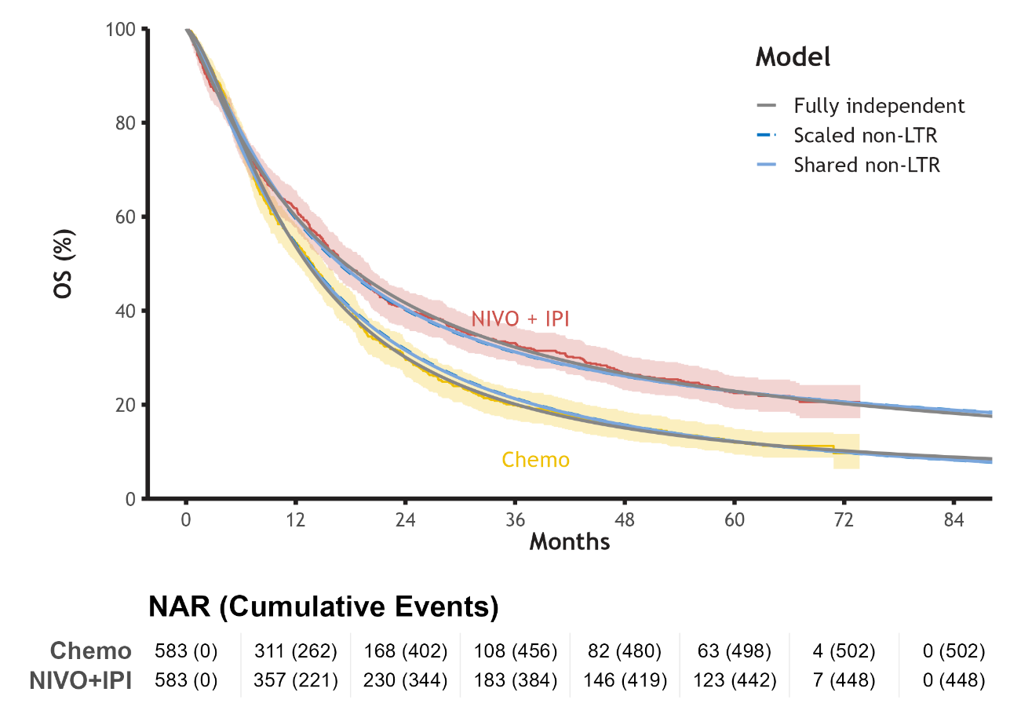
Fully independent models fit parameters of non-LTR distribution and proportion LTR independently per treatment arm. Scaled non-LTR model allows LTR fraction and the location parameter with accelerated failure time property of the non-LTR distribution to vary per arm. Shared non-LTR model imposes identical parameters on non-LTR distribution of both arms, but LTR fraction is free to vary. Shaded regions are 95% confidence intervals of Kaplan-Meier estimator of OS from 5 year DCO of CheckMate 227. Scaled non-LTR model obscured by shared non-LTR model. Model predictions for the CheckMate 227 part 1 population, using matched life tables to inform baseline hazard per the Ederer (I) method. Abbreviations: Chemo, platinum-doublet chemotherapy; IPI, ipilimumab; LTR, long-term response; NAR, number at risk; NIVO, nivolumab

Supplementary S15: Log-logistic models using PFS to estimate cure fraction
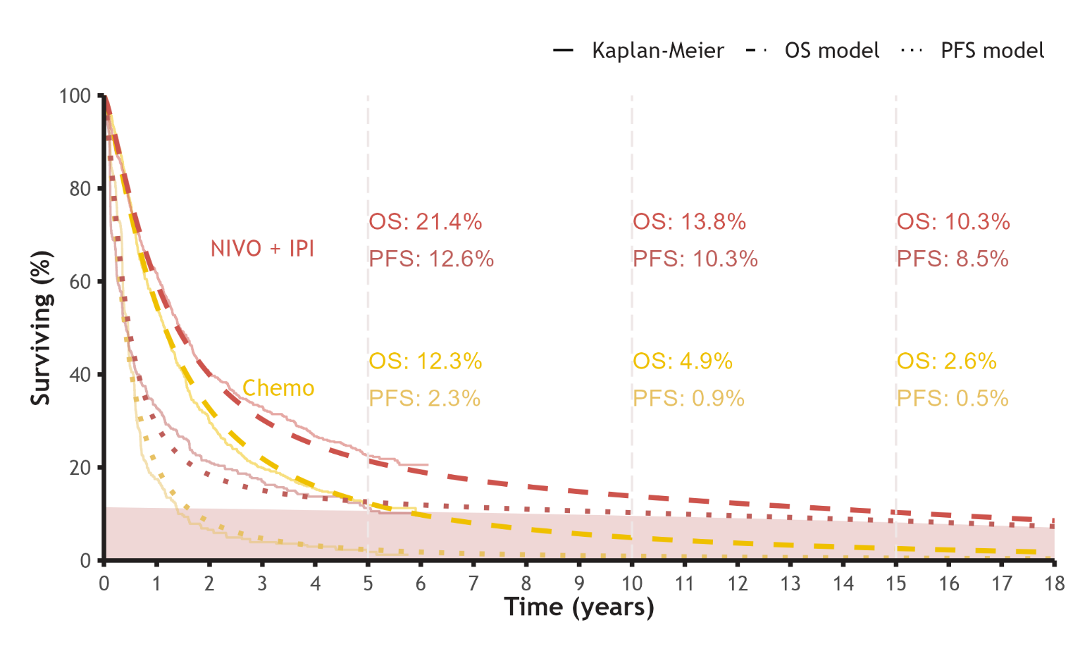

Abbreviations: Chemo, platinum-doublet chemotherapy; IPI, ipilimumab; NIVO, nivolumab; OS, overall survival; PFS, progression-free survival

Supplementary S12: Platinum-doublet chemotherapy treatment distribution
Chemotherapy | Percentage | Calculationª
Gemcitabine + cisplatin | 10.12 | 59/583
Gemcitabine + carboplatin | 18.01 | 105/583
Pemetrexed + cisplatin | 27.96 | 163/583
Pemetrexed + carboplatin | 43.91 | 256/583
an/N values represent the number of patients receiving each treatment combination divided by the total number of patients receiving Chemo in Part 1 of CheckMate 227. Treatments assumed to be: cisplatin, 75 mg/m2 Q3W; gemcitabine, 1,000 mg/m2 Q3W; pemetrexed, 500 mg/m2 Q3W; carboplatin, 563 mg Q3W; each up to 4 treatment cycles. Pemetrexed maintenance allowed as per CheckMate 227 trial design.
Source: BMS data on file.
Abbreviations: Chemo, platinum-doublet chemotherapy; Q3W, every 3 weeks

