PharmacoEconomics – Open
Assessing the Value for Money of Enzyme Replacement Therapy in Gaucher Disease Types 1 and 3b: Can Expanded Coverage Be Justified?
Waranya Rattanavipapong¹, Thunyarat Anothaisintawee², Wanrudee Isaranuwatchai^{1,3} Duangrurdee Wattanasirichaigoon⁴, Thipwimol Tim-Aroon⁴, Khunton Wichajarn⁵, Achara Sathienkijkanchai⁶, Pimlak Charoenkwan⁷, Kanya Suphapeetiporn⁸, Chanchai Traivaree⁹, Chulaluck Kuptanon¹⁰, and Yot Teerawattananon^{1,11}
¹Health Intervention and Technology Assessment Program, Ministry of Public Health, Nonthaburi, Thailand
²Department of Clinical Epidemiology and Biostatistics, Faculty of Medicine, Ramathibodi Hospital, Mahidol University, Bangkok, Thailand
³Institute or Health Policy, Management and Evaluation, University of Toronto, Toronto, Ontario, Canada
⁴Department of Pediatrics, Faculty of Medicine Ramathibodi Hospital, Mahidol University, Bangkok, Thailand
⁵Department of Pediatrics, Faculty of Medicine, Khon Kaen University, Khon Kaen, Thailand
⁶Department of Pediatrics, Faculty of Medicine, Siriraj Hospital, Mahidol University, Bangkok, Thailand
⁷Department of Pediatrics, Faculty of Medicine, Chiang Mai University, Chiang Mai, Thailand
⁸Department of Pediatrics, Faculty of Medicine, Chulalongkorn University, Bangkok, Thailand
⁹Department of Pediatrics, Phramongkutklao Hospital and Phramongkutklao College of Medicine, Bangkok, Thailand
¹⁰Department of Medical Services, Queen Sirikit National Institute of Child Health, Ministry of Public Health, Bangkok, Thailand
¹¹Saw Swee Hock School of Public Health, National University of Singapore, Singapore
Corresponding author
Waranya Rattanavipapong
Address: Health Intervention and Technology Assessment Program, 6th Floor, 6th Building, Department of Health, Ministry of Public Health, Tiwanon Rd., Muang, Nonthaburi 11000, Thailand
Email: waranya.r@hitap.net
ORCID iDs
Waranya Rattanavipapong https://orcid.org/0000-0001-8628-2149
Thunyarat Anothaisintawee http://orcid.org/0000-0003-1002-8536
Wanrudee Isaranuwatchai https://orcid.org/0000-0002-8368-6065
Duangrurdee Wattanasirichaigoon https://orcid.org/0000-0003-2329-2176
Thipwimol Tim-Aroon https://orcid.org/0000-0001-8044-7993
Khunton Wichajarn https://orcid.org/0000-0003-4324-7487
Achara Sathienkijkanchai https://orcid.org/0000-0001-8275-9616
Pimlak Charoenkwan https://orcid.org/0000-0002-9123-9177
Kanya Suphapeetiporn https://orcid.org/0000-0001-5679-7547
Chanchai Traivaree https://orcid.org/0000-0001-5635-1238-6065
Yot Teerawattananon https://orcid.org/0000-0003-2217-2930
Funding
This study was funded by the Food and Drug Administration, Ministry of Public Health, Thailand and Thailand Science Research and Innovation.
Conflicts of interest
The authors declare no conflicts of interest.

PharmacoEconomics – Open
Supplementary information
Table S1 Results from the Mann-Whitney U test comparing utility values derived from the value sets of seven Asian countries using the EQ-5D-Y-3L questionnaire.
 | China | Indonesia | Japan | Malaysia | Singapore | Taiwan | Vietnam
Symptomatic state (N=7) versus Symptom-free state (N=2) in patients with Gaucher disease type 1
Mean difference | -0.398 | -0.304 | -0.235 | -0.401 | -0.469 | -0.533 | -0.406
Pooled standard deviation | 0.379 | 0.351 | 0.231 | 0.409 | 0.455 | 0.519 | 0.386
Standardized mean differences | -1.051 | -0.865 | -1.019 | -0.981 | -1.030 | -1.028 | -1.053
p-value | 0.209 | 0.311 | 0.225 | 0.245 | 0.219 | 0.220 | 0.208
Symptomatic state (N=8) versus Improved state (N=4) in patients with Gaucher disease type 3b
Z statistic | -2.57 | -2.399 | -2.57 | -2.57 | -2.57 | -2.57 | -2.57
Mean difference | -0.357 | -0.254 | -0.219 | -0.348 | -0.411 | -0.459 | -0.373
Pooled standard deviation | 0.258 | 0.229 | 0.148 | 0.249 | 0.288 | 0.329 | 0.257
Standardized mean differences | -1.382 | -1.112 | -1.481 | -1.397 | -1.424 | -1.398 | -1.454
p-value | 0.015 | 0.065 | 0.007 | 0.013 | 0.011 | 0.013 | 0.009

Table S2 Markov Cohort Traces Under the ‘Current Policy' and ‘New Policy'
Gaucher disease type 1 - Current Policy
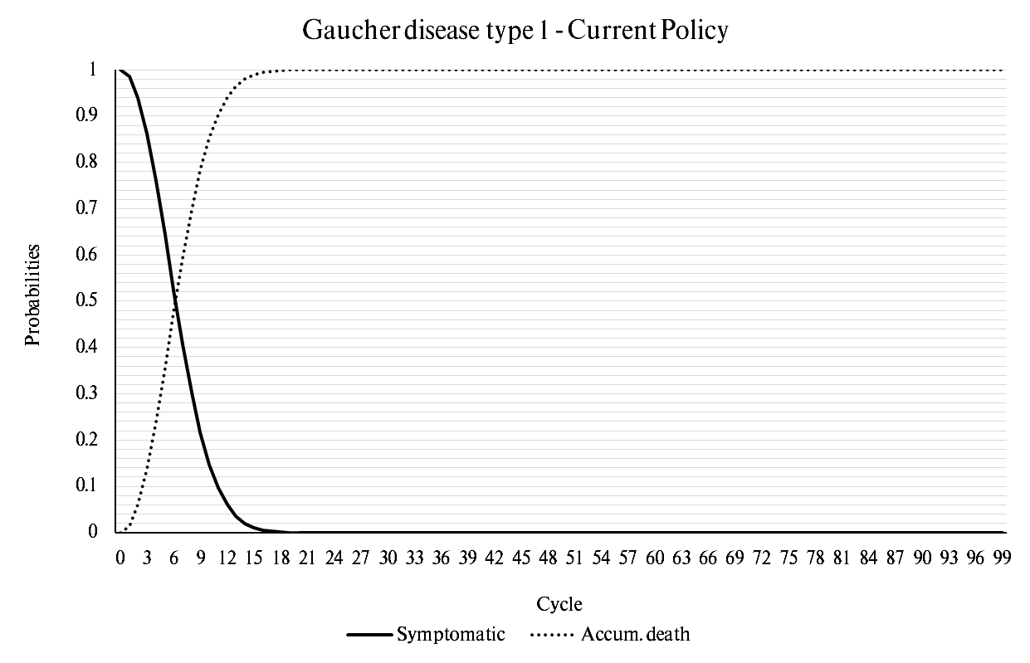
Gaucher disease type 1 - New Policy (Imiglucerase)
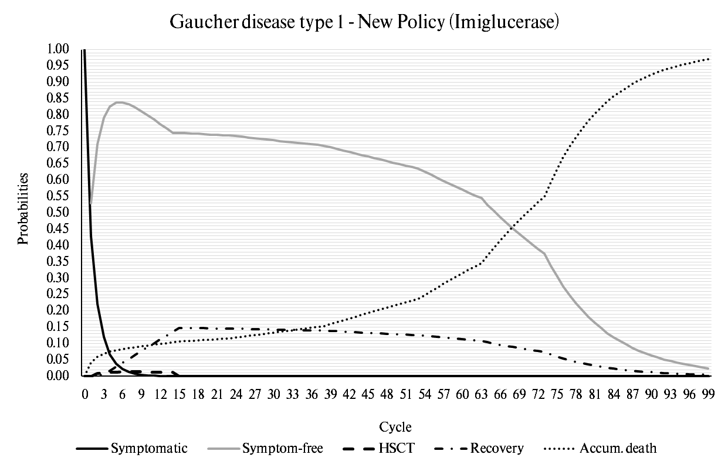
Gaucher disease type 1 - New Policy (Velaglucerase)

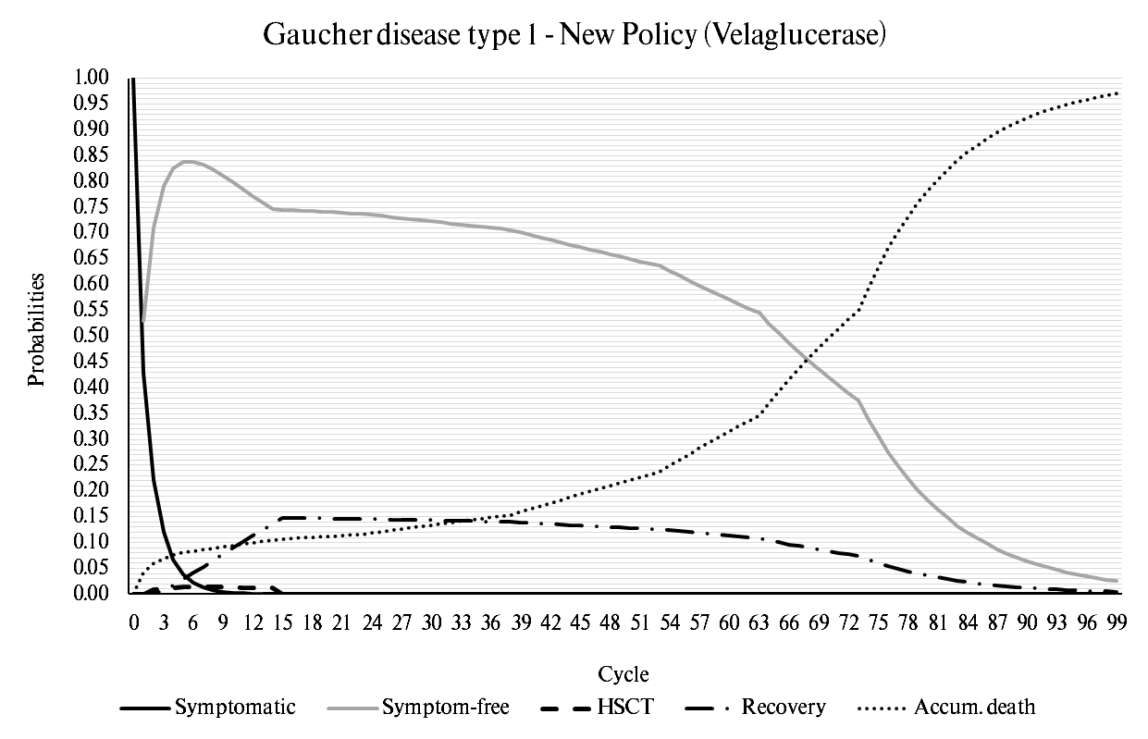
Gaucher disease type 3b - Current Policy
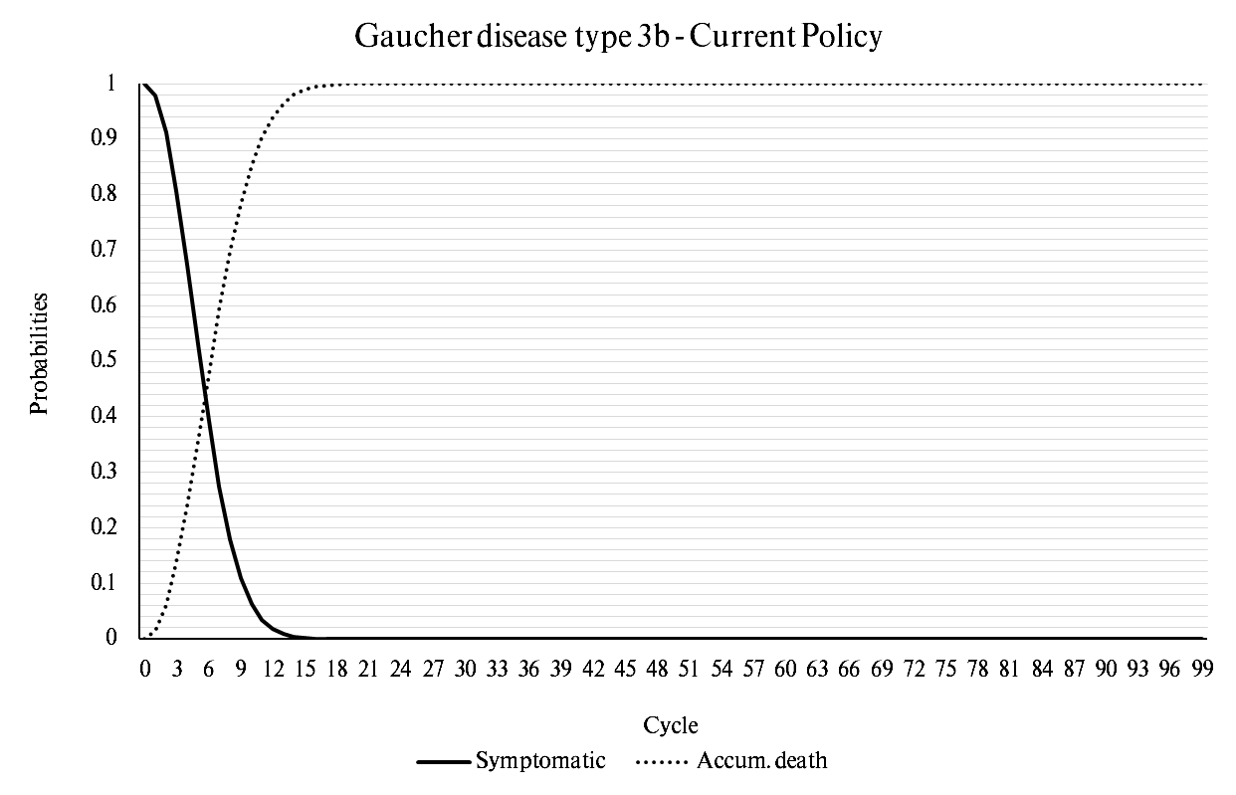

Gaucher disease type 3b - New Policy (Imiglucerase)

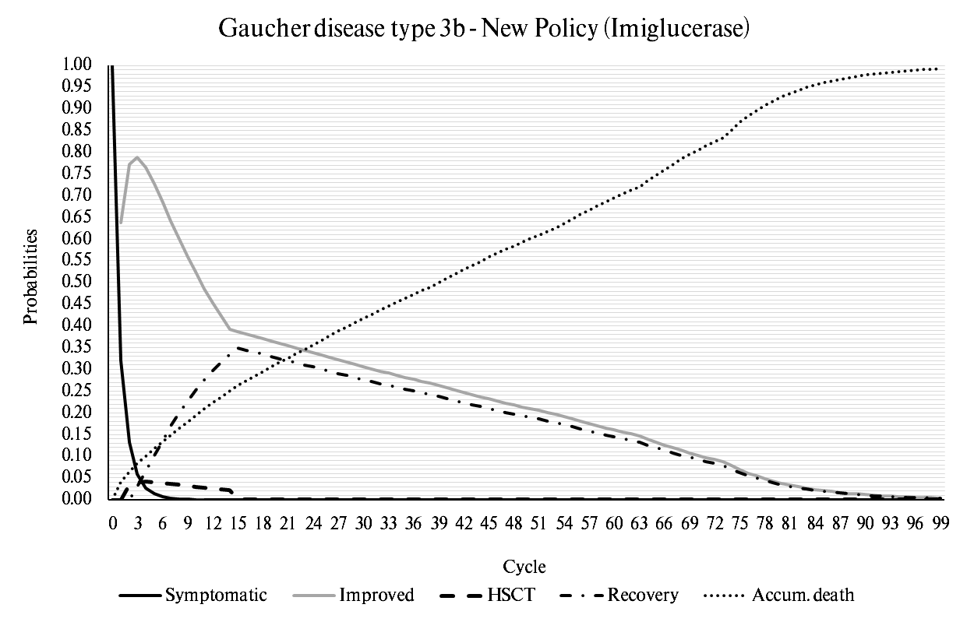
Gaucher disease type 3b - New Policy (Velaglucerase)
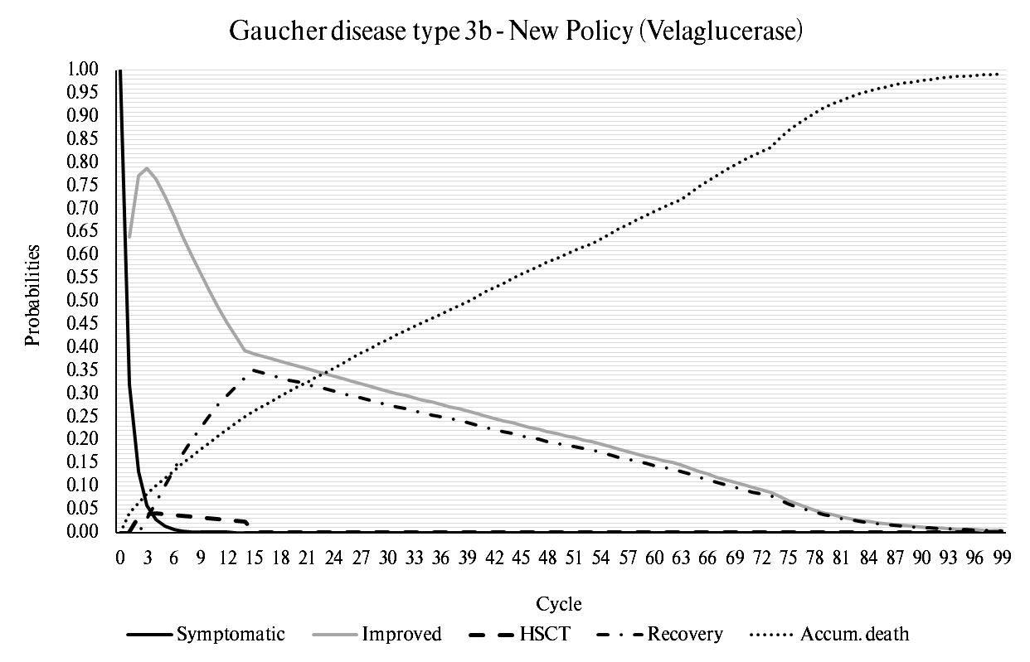

Patients with Gaucher disease Type 1, initially treated with enzyme replacement therapy, may later develop symptoms indicative of Gaucher disease Type 3b, leading to treatment discontinuation.

