Supplementary Appendix

Journal Name: PharmacoEconomics - Open
Title: Impact of Inhibitor Development on the Cost-Effectiveness of Prophylactic treatment with Recombinant Factor VIII in Previously Untreated Patients with Severe Hemophilia A
Authors: Li Yang¹, Jie Peng², Congling Gu³, Zhenguo Wang³, Genyong Zuo^{4*}
Affiliations:
1. Jinan Preschool Education College, Jinan, China
2. Xiangya Hospital Central South University, Changsha, China
3. Takeda (China) International Trade Co., Ltd., Beijing, China
4. Shandong University, Jinan, China
Correspondence Author:
Genyong Zuo
Shandong University, Jinan, China
Email: smartyong@sdu.edu.cn

This appendix has been provided by the authors to give readers additional information about their work.
Table of contents
Methods and Results of the Systematic Literature Review 3
1. Objective and Scope 3
2. Data Sources and Search Strategy 3
3. Inclusion and Exclusion Criteria 3
4. Data Extraction 4
5. Data Synthesis and Primary Parameters Estimation Methods 4
5.1 Approaches for Evidence Synthesis 5
5.2 Estimation of Primary Parameters 5
6. Tables and Figures 8
Figure S1. PRISMA 2020 flow diagram of the literature search and selection process [31] 8
Figure S2. Relationship between Annual Bleeding Rate (ABR) and Quality of Life Utility Values in Hemophilia A Patients: Based on a European Cohort Study 9
Table S1. Full Search Strategies and Results of the Systematic Literature Review 10
Table S2. Age-specific Baseline Intracranial Hemorrhage (ICH) Risks in the General Population from a Retrospective Cohort Study 16
Table S3. Hemophilia-Specific Mortality Risks for Patients Without Bleeding-Related Complications 17
Table S4. First-Year Mortality Rates for Three Bleeding-Related Complications and Long-Term Relative Mortality Risk for Intracranial Hemorrhage (ICH) 17
Table S5. Detailed Breakdown of Drug Acquisition Costs at Initial Age 18
Table S6. Other Direct Medical Costs 19
Table S7: Parameters and Distributions for Probabilistic Sensitivity Analysis (PSA) 19
Table S8. Scenario Analysis of Total Life Years, QALYs, and Direct Medical Costs for Prophylactic Treatment with rAHF-PFM and BAY 81-8973 at Different Time Horizons 21
Reference 22

Methods and Results of the Systematic Literature Review

1. Objective and Scope
This systematic literature review (SLR) was conducted to inform the key parameters of the economic model, including cohort baseline characteristics, clinical efficacy, disease progression, health-related quality of life (HRQoL), and cost inputs for previously untreated patients (PUPs) with severe hemophilia A receiving prophylactic treatment with recombinant factor VIII (rFVIII).

2. Data Sources and Search Strategy
A comprehensive literature search was conducted across seven major databases, including four English-language databases (MEDLINE, Embase, Web of Science, Cochrane Library) and three Chinese-language databases (CNKI, WANFANG, VIP).
- Search Timeframe:
  - Clinical efficacy of rFVIII: from January 1, 2000, to July 7, 2023.
  - Other model parameters: studies published within the last 10 years (2013-2023).
- Geographic limitations:
  - Cohort characteristics, treatment patterns, and direct medical costs: limited to China.
  - Disease progression: limited to East Asia.
  - Clinical efficacy and HRQoL: no regional restriction.
The full search strategies and results are presented in Supplementary Table S1. Due to space and language limitations, only the search strategies and results from three databases—MEDLINE, EMBASE, and Web of Science—are shown.

3. Inclusion and Exclusion Criteria
Inclusion Criteria:
- Original research articles.
- Target population: patients with hemophilia A.
- Use of rFVIII products approved in China (e.g., Advate, Kovaltry, etc.).
- Reported outcomes relevant to model parameters (e.g., inhibitor incidence, ABR, costs).
Exclusion Criteria:
- Non-original research (e.g., reviews).
- Non-observational designs (for cohort and cost parameters).
- Inappropriate population (e.g., patients with inhibitors in efficacy studies of prophylaxis).
- Inadequate reporting of relevant parameter data.
A total of 104 studies were included after performing systematic searches and screening across both English and Chinese databases. The literature search and screening process is illustrated in Supplementary Figure S1 using a PRISMA flow diagram.

4. Data Extraction
Data extraction forms were developed to align with model input requirements. The primary extracted outcomes included:
- Study characteristics: design, location, inclusion and exclusion criteria.
- Baseline characteristics: definition of study population, sample size, demographic information (age, sex distribution, weight), and disease information (severity of hemophilia).
- Treatment information: regimens, dosing, frequency, duration.
- Clinical efficacy outcomes of prophylactic therapy: inhibitor incidence rate, distribution of inhibitor titers, proportion of patients with bleeding, annual bleeding rate (ABR), and proportion of patients with different bleeding sites.
- Clinical efficacy outcomes of inhibitor treatment: inhibitor eradication success rate, proportion of patients with bleeding, and ABR.
- Quality of life: utility values based on ABR or complications.
- Costs: healthcare resource use and direct medical costs by treatment state.

5. Data Synthesis and Primary Parameters Estimation Methods
To ensure model transparency and evidence traceability, different methods were used to synthesize data depending on the number and quality of available studies:

5.1 Approaches for Evidence Synthesis
Three approaches were used to synthesize parameters derived from the literature, based on data availability and reporting consistency:
1. Meta-analysis (single-arm): Used when ≥2 studies reported the same parameter with statistical detail (e.g., mean and SD or event count and sample size). Random-effects models were used. Pooled estimates and 95% CIs were generated using R (v4.3.1).
2. Weighted average: Used when ≥2 studies reported means or proportions without dispersion measures. Formula used:
Weighted mean = ∑(sample size × reported value) / ∑(sample size).
3. Direct citation: Used when only one study provided a parameter. The reported value was adopted directly.

5.2 Estimation of Primary Parameters

5.2.1 Clinical efficacy

5.2.1.1 Inhibitor Incidence
This parameter determines the proportion of patients transitioning to an inhibitor-positive state at the end of the first model cycle. Based on single-arm meta-analyses of 2 studies for rAHF-PFM and 1 study for BAY 81-8973, the estimated inhibitor incidence was 30.3% (95% CI: 13.9%, 46.6%) and 54.8% (95% CI: 39.7%, 69.0%), respectively[1-3].

5.2.1.2 Distribution of Inhibitor Titers
Patients developing inhibitors are categorized into low- and high-titer groups based on thresholds: high-titer ≥5 BU/mL; low-titer >0.6 and <5 BU/mL. Based on weighted averages from 8 rAHF-PFM studies and 1 BAY 81-8973 study, the proportion of low- vs. high-titer was 44.7% vs. 55.3% for rAHF-PFM and 26.1% vs. 73.9% for BAY 81-8973[2,4-11].

5.2.1.3 Annualized Bleeding Risk
The proportion of patients experiencing ≥1 bleeding episode annually among all patients receiving treatment. This parameter is used to determine whether bleeding occurs in each simulation cycle during the prophylactic treatment period in the model cohort. Based on single-arm meta-analyses of 4 studies for rAHF-PFM and 6 studies for BAY 81-8973, the estimated annualized bleeding risk in severe PUPs receiving prophylactic treatment was 69.2% (95% CI: 59.4%, 79.0%) for rAHF-PFM and 73.0% (95% CI: 63.6%, 82.4%) for BAY 81-8973[2,12-19].

5.2.1.4 Annualized Bleeding Rate
Annual bleeding rate (ABR) refers to the average number of bleeding episodes per year among patients who experienced at least one bleed. If ABR among bleeders is directly reported in the literature, it is used as-is. If only total ABR and the annual bleeding risk are available, the ABR among bleeders is estimated by dividing the total ABR by the annual bleeding risk. This parameter is used in the model to estimate the number of bleeding events that occur in each simulation cycle among patients transitioning to the bleeding state. Based on single-arm meta-analyses of 3 clinical studies for rAHF-PFM and 5 for BAY 81-8973, the estimated ABR was 3.6 (95% CI: 2.4, 4.7) for rAHF-PFM and 5.3 (95% CI: 3.8, 6.8) for BAY 81-8973[2,11,17-21].

5.2.2 Annual Complication Risk
The model considers three major complications: hemophilic arthropathy, and severe bleeding of vital organs including intracranial hemorrhage (ICH) and gastrointestinal (GI) bleeding. An association between ABR and complication risk was established using the parameter "incremental complication risk per unit increase in ABR." Given that ICH is a cerebrovascular event also present in the general elderly population and increases with age, the ICH risk estimate was adjusted to account for baseline age-specific incidence[22].
The formulas used to calculate the annual risks of complications in the model are as follows:
- Hemophilic arthropathy or GI bleeding:Annual risk = (incremental risk per ABR) × (annualized bleeding rate)
- Intracranial hemorrhage:Annual risk = (incremental ICH risk per ABR) × (annualized bleeding rate) + (age-specific baseline ICH risk)
According to a prospective study[23], the incremental risks per unit increase in ABR were 0.046 for arthropathy, 0.001 for GI bleeding, and 0.003 for ICH. Age-specific baseline ICH risks in the general population were derived from a large retrospective cohort study (Supplementary Table S2)[24].

5.2.3 Hemophilia-related Mortality Risk
Mortality risks were estimated based on the presence and type of complications. For patients without bleeding-related complications, hemophilia-specific mortality risks were used as reported in the literature (Supplementary Table S3)[25]. For patients with bleeding-related complications, mortality risks were estimated separately for the first year after complication onset and subsequent years. Based on clinical experts feedback, hemophilic arthropathy and GI bleeding were not considered to cause long-term increases in mortality; thus, mortality beyond the first year was modeled using the baseline hemophilia mortality rate. First-year mortality rates for all three complications, and long-term relative mortality risk for ICH, are summarized in Supplementary Table S4[25-28].

5.2.4 Health Utility Values
Health utility values were estimated based on the model-defined health states, which included: free of bleeding episode, bleeding episode, bleeding-related complications (first year), and bleeding-related complications (subsequent year).
For patients with bleeding-related complications, a study in Chinese patients with hemophilia reported that the utility ratio relative to the general population was 0.898 (95% CI: 0.793, 1.000) for those without bleeding and 0.439 (95% CI: 0.407, 0.471) for those with complications[29]. The utility in the first year of complication was assigned as 0.439. Based on expert clinical interviews, hemophilic arthropathy and intracranial hemorrhage were considered to have long-term impacts on quality of life; thus, utilities in subsequent years remained at 0.439. For patients with GI bleeding, utility was assumed to return to the non-complication level after the first year.
For patients free of complications, quality of life was estimated according to the number of bleeding episodes. A European study reported a linear relationship between annual bleeding rate (ABR) and utility[30], where each additional bleed decreased the utility ratio by 0.061 (95% CI: 0.027, 0.096), and utility plateaued at 0.552 when ABR ≥5 (Supplementary Figure S2).
Accordingly, utility was calculated for patients without complications as follows:
• If ABR < 5: Utility = 0.898 - 0.061 × ABR
• If ABR ≥ 5: Utility = 0.552

6. Tables and Figures

Figure S1. PRISMA 2020 flow diagram of the literature search and selection process [31]
Figure S1A. Model Cohort Characteristics Parameters
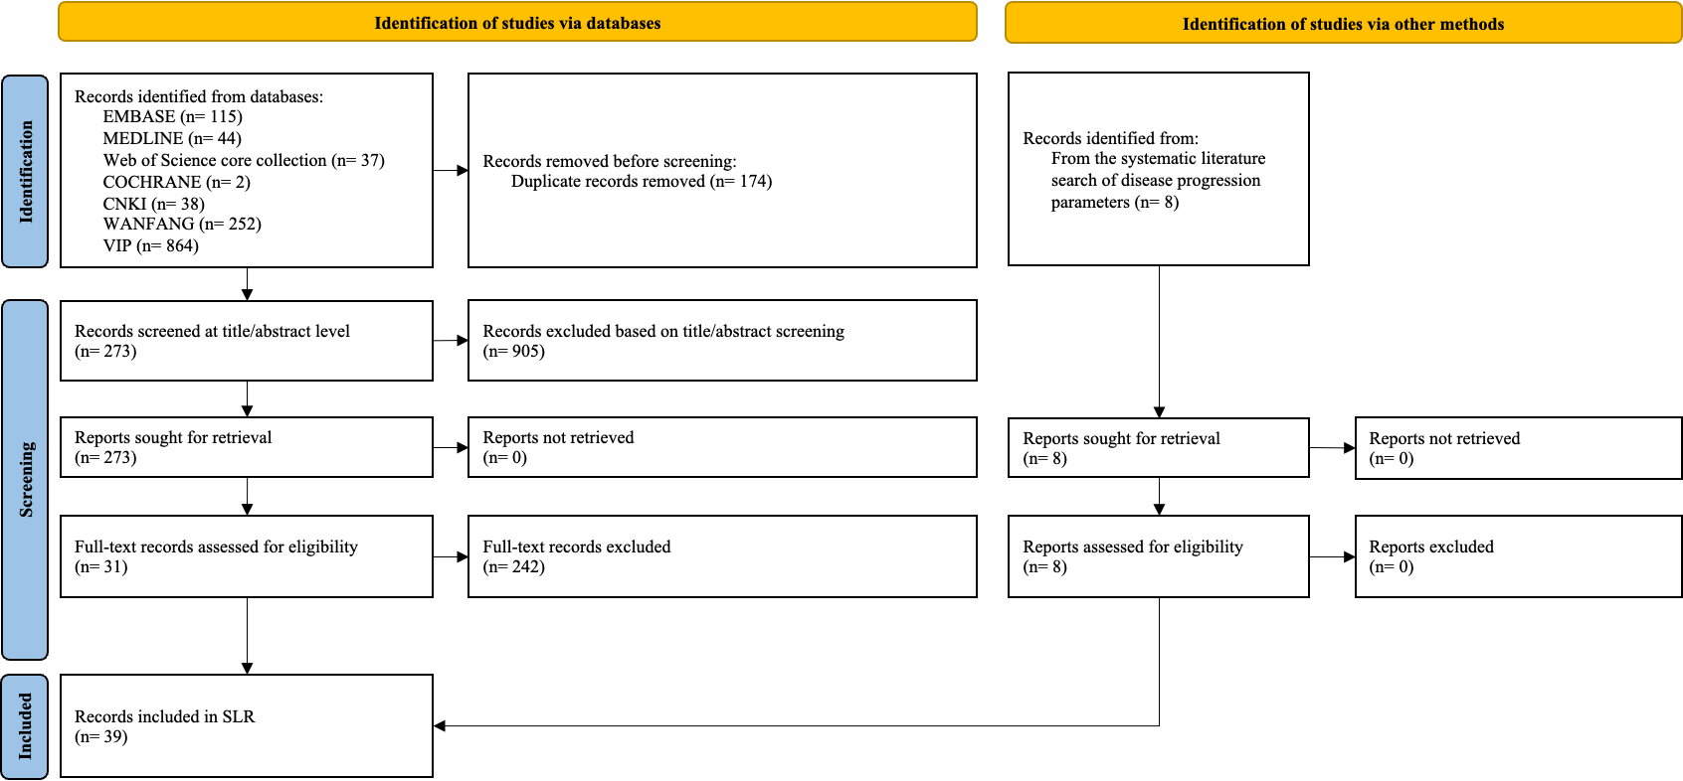
Figure S1B. Clinical Efficacy Parameters
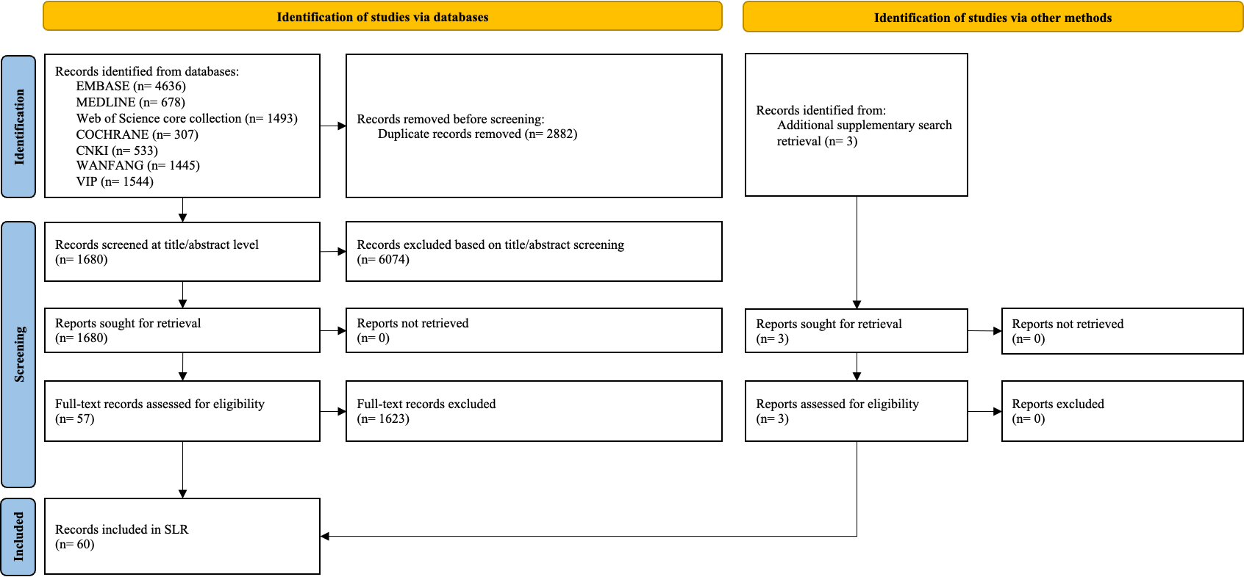

Figure S1C. Disease Progression Parameters
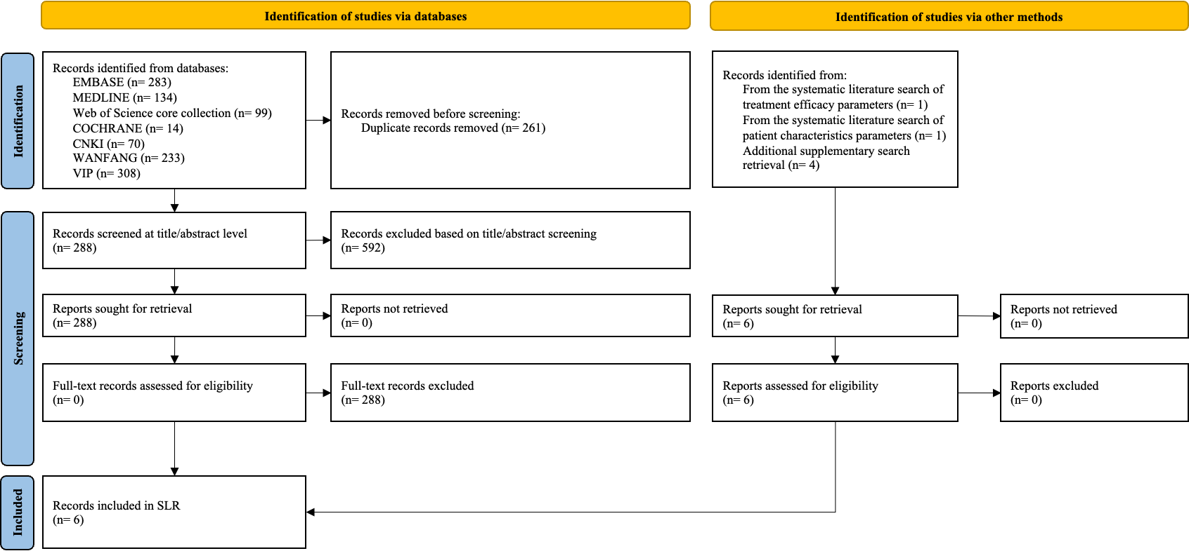
Figure S1D. Quality of life Parameters
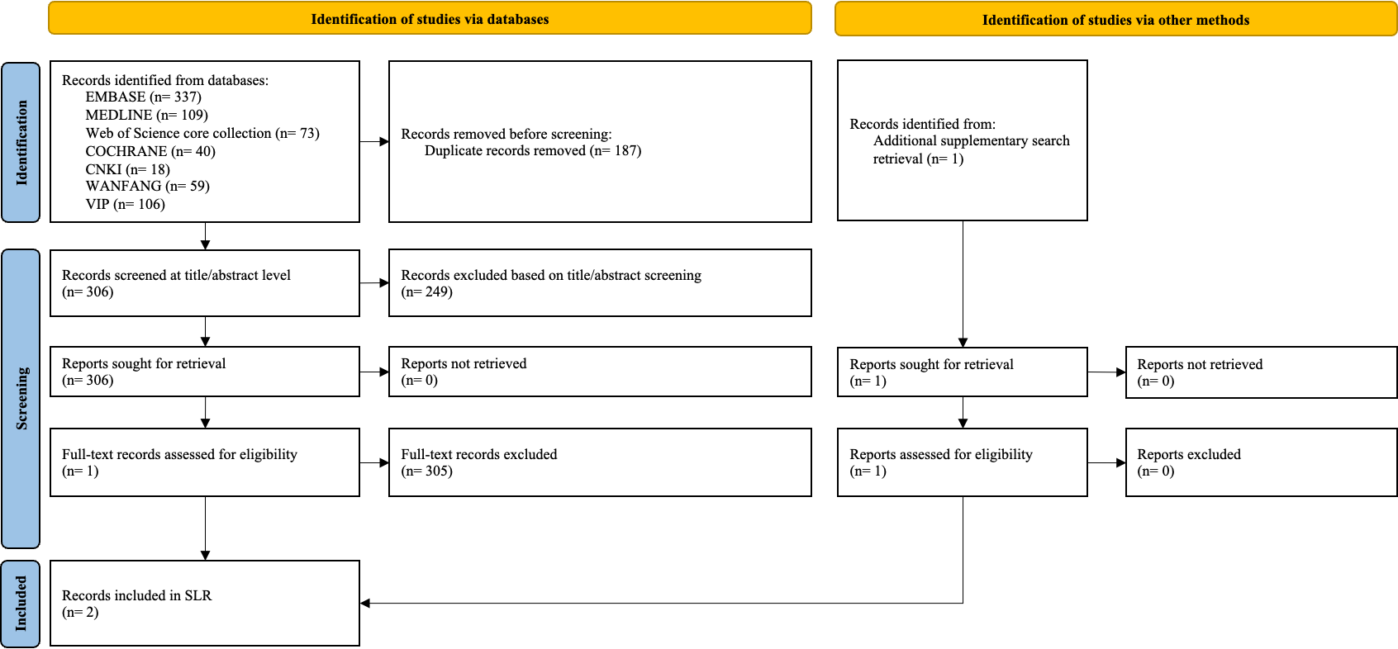
*SLR: systematic literature review

Figure S2. Relationship between Annual Bleeding Rate (ABR) and Quality of Life Utility Values in Hemophilia A Patients: Based on a European Cohort Study
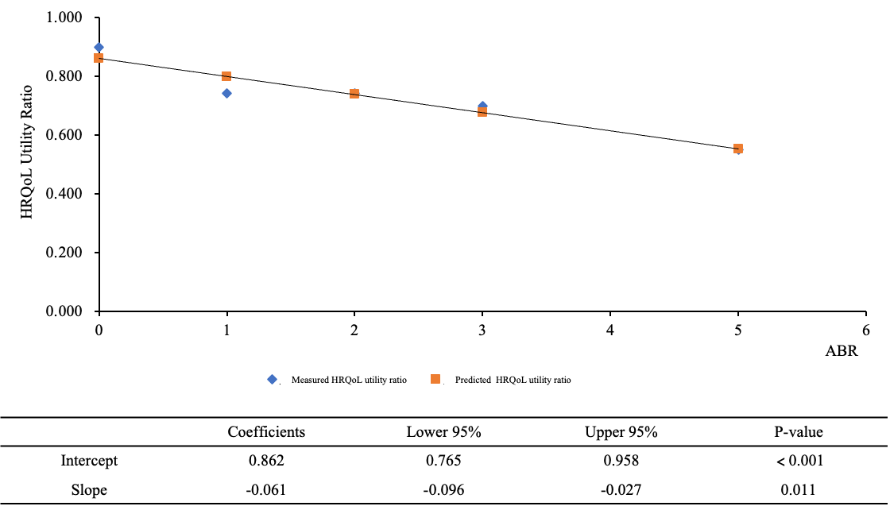
*HRQoL: health-related quality of life

Table S1. Full Search Strategies and Results of the Systematic Literature Review
Table S1A. Search Strategies and Results from EMBASE
# | Searches | Results
1 | 'Hemophilia A'/exp | 30,200
2 | 'Hemophilia A':ti,ab,kw | 13,654
3 | #1 or #2 | 30,200
4 | #3 AND [embase]/lim AND [english]/lim | 21,774
5 | #4 AND ([article]/lim OR [article in press]/lim OR [conference abstract]/lim OR [conference paper]/lim OR [data papers]/lim OR [short survey]/lim OR [preprint]/lim) | 18,030
6 | #5 and [2013-2023]/py | 11,456
7 | (prospective* or retrospective* or observation* or 'cross-section*' or 'cross section*' or 'real world' or 'real-world' or cohort* or survey* or questionnaire or registr*):ti,ab,kw | 6,714,878
8 | (China or Chinese):ti,ab,kw | 609,794
9 | #6 and #7 and #8 | 115
10 | (China or Chinese or Hong Kong or hongkong or Taiwan or Taiwanese or Japan or Japanese or Korea or Korean* or Singapore or Singaporean*):ti,ab,kw | 692,950
11 | #6 and #7 and #10 | 186
12 | #5 and [2000-2023]/py | 16,223
13 | ('trial*' or 'RCT' or 'random*' or 'phase'):ti,ab,kw | 4,234,004
14 | (prospective* or retrospective* or observation* or 'cross-section*' or 'cross section*' or 'real world' or 'real-world' or 'real life' or cohort* or registr*):ti,ab,kw | 5,758,641
15 | #13 or #14 | 8,946,671
16 | ((('Factor VIII' or 'Factor Ⅷ' or 'Factor 8' or 'AHF VIII' or 'AHF Ⅷ' or 'Factor eight' or FVIII or FⅧ) and Recombinant) or rFⅧ or rFVIII):ti,ab,kw | 6,782
17 | #6 and #15 and #16 | 1,908
18 | (inhibitor* or 'antibod*'):ti,ab,kw | 3,139,281
19 | ('immune tolerance induction' or 'ITI' or 'Factor VIII' or 'Factor Ⅷ' or 'Factor 8' or 'AHF VIII' or 'AHF Ⅷ' or 'Factor eight' or FVIII or FⅧ):ti,ab,kw | 39,811
20 | (aPCC or 'activated prothrombin complex concentrate' or 'prothrombin complex concentrate' or PCC or bypassing or rFⅦa or rFVIIa or 'recombinant activated factor VII' or emicizumab or hemlibra or ACE910):ti,ab,kw | 33,855
21 | #19 or #20 | 70,687
22 | #6 and #15 and #18 and #21 | 2,728
23 | ('hemophilic arthropath*' or 'joint* damage' or 'joint* bleeding' or disability or disable or 'Intracerebral hemorrhage' or 'Intracerebral bleeding' or 'intracranial bleeding' or 'intracranial hemorrhage' or 'ICH' or 'CNS bleeding' or 'central nervous system bleeding' or stroke or 'gastrointestinal bleeding' or 'gastrointestinal hemorrhage' or gastrorrhagia or 'urinary bleeding' or 'urinary hemorrhage' or 'renal bleeding' or 'renal hemorrhage' or 'bladder bleeding' or 'bladder hemorrhage' or 'urethral bleeding' or 'urethral hemorrhage' or Hematuria or depression or anxiety or complication*):ti,ab,kw | 3,216,648
24 | #6 and #10 and #23 | 97
25 | (VAS or 'visual analogue scale' or TTO or 'time trade-off' or SG or 'standard-gamble' or 'EQ5D*' or 'EQ-5D*' or 'EuroQoL-5D*' or 'EuroQol EQ-5D*' or 'European Quality of Life-5 Dimensions' or 'European Quality of Life 5 Dimensions' or 'SF-36' or SF36 or '36-Item Short Form Survey' or 'Short Form-36' or 'Short Form 36 Health Survey' or 'SF-12' or SF12 or '12-Item Short Form Survey' or 'Short Form-12' or 'WHO-BREF' or 'WHO-QoL-BREF' or 'WHOQOL-BREF' or 'World Health Organization Quality of Life Brief Form' or 'Haemo-QoL-A' or 'haemophilia-specific health related quality of life questionnaire for adults' or 'Haem-A-QoL' or 'Haemophilia Quality of Life Questionnaire for Adults' or PedsQL or 'pediatric quality of life inventory' or HJHS or 'hemophilia joint health score' or FISH or 'functional independence score in hemophilia' or HAL or 'hemophilia activities list' or 'pedHAL' or 'pediatric hemophilia activities list' or 'PROBE questionnaire' or CHO-KLAT or 'Kids Life Assessment Tool'):ti,ab,kw | 477,764
26 | #6 and #25 | 337
27 | ('cost effectiveness analysis' or 'cost benefit analysis' or 'program cost effectiveness' or 'cost utility analysis' or 'cost minimization analysis')/exp | 270,210
28 | ('cost effectiveness' or 'cost-effectiveness' or 'cost utility' or 'cost-utility' or 'cost-benefit' or 'cost benefit' or 'cost-minimization' or 'cost minimization' or 'budget impact' or 'budget-impact' or CEA or CUA or CBA or CMA or BIA or ICER or 'Incremental Cost Effectiveness Ratio*' or 'economic burden' or 'disease burden' or 'illness burden' or 'health technology assessment' or HTA or 'net-benefit' or 'net benefit'):ti,ab,kw | 275,964
29 | #27 or #28 | 439,907
30 | 'health care utilization'/exp | 93,870
31 | ('health resource utilization' or 'health care utilization' or HRU or hospitalization* or 'hospital admission*' or 'hospital stay length' or 'length of hospital stay' or 'length of hospital stay' or 'length of stay' or LOS or inpatient* or outpatient* or 'emergency room visit*'):ti,ab,kw | 1,076,760
32 | cost/exp | 406,455
33 | (cost* or expense* or expenditure* or payment* or insurance or reimbursement or claim*):ti,ab,kw | 1,452,774
34 | #30 or #31 or #32 or #33 | 2,560,843
35 | #29 or #34 | 2,735,538
36 | #6 and #8 and #35 | 49

Table S1B. Search Strategies and Results from MEDLINE
# | Searches | Results
1 | exp "Hemophilia A"/ | 22,805
2 | ("Hemophilia A").ti,ab,kw. | 6,060
3 | 1 or 2 | 24,295
4 | limit 3 to english language | 20,131
5 | limit 4 to yr="2013 -current" | 6,521
6 | limit 5 to (address or autobiography or bibliography or biography or case reports or comment or consensus development conference or consensus development conference, nih or dictionary or directory or duplicate publication or editorial or "expression of concern" or festschrift or government publication or guideline or interactive tutorial or interview or introductory journal article or lecture or legal case or legislation or letter or news or newspaper article or patient education handout or periodical index or personal narrative or portrait or practice guideline or published erratum or "research support, american recovery and reinvestment act" or research support, nih, extramural or research support, nih, intramural or research support, non us gov't or research support, us gov't, non phs or research support, us gov't, phs or retracted publication or "retraction of publication" or "review" or "scientific integrity review" or video-audio media or webcast) | 3,879
7 | 5 not 6 | 2,642
8 | (prospective$ or retrospective$ or observation$ or "cross-section$" or "cross section$" or "real world" or "real-world" or cohort$ or survey* or questionnaire or registr$).ti,ab,kw. | 4,677,834
9 | (China or Chinese).ti,ab,kw. | 547,086
10 | 7 and 8 and 9 | 44
11 | (China or Chinese or Hong Kong or hongkong or Taiwan or Taiwanese or Japan or Japanese or Korea or Korean$ or Singapore or Singaporean$).ti,ab,kw. | 956,046
12 | 7 and 8 and 11 | 92
13 | limit 4 to (address or autobiography or bibliography or biography or case reports or comment or consensus development conference or consensus development conference, nih or dictionary or directory or duplicate publication or editorial or "expression of concern" or festschrift or government publication or guideline or interactive tutorial or interview or introductory journal article or lecture or legal case or legislation or letter or news or newspaper article or patient education handout or periodical index or personal narrative or portrait or practice guideline or published erratum or "research support, american recovery and reinvestment act" or research support, nih, extramural or research support, nih, intramural or research support, non us gov't or research support, us gov't, non phs or research support, us gov't, phs or retracted publication or "retraction of publication" or "review" or "scientific integrity review" or video-audio media or webcast) | 11,712
14 | 4 not 13 | 7,698
15 | limit 14 to yr="2000 -current" | 3,981
16 | ("trial*" or "RCT" or "random*" or "phase").ti,ab,kw. | 2,590,272
17 | (prospective* or retrospective* or observation* or "cross-section*" or "cross section*" or "real world" or "real-world" or "real life" or cohort* or registr*).ti,ab,kw. | 3,304,947
18 | 16 or 17 | 5,302,752
19 | ((("Factor VIII" or "Factor 8" or "AHF VIII" or "Factor eight" or FVIII) and Recombinant) or rFVIII).ti,ab,kw. | 2,585
20 | 7 and 18 and 19 | 277
21 | (inhibitor* or antibod*).ti,ab,kw. | 2,349,773
22 | ("immune tolerance induction" or "ITI" or "Factor VIII" or "Factor 8" or "AHF VIII" or "Factor eight" or FVIII).ti,ab,kw. | 24,019
23 | (aPCC or "activated prothrombin complex concentrate" or "prothrombin complex concentrate" or PCC or bypassing or rFVIIa or "recombinant activated factor VII" or emicizumab or hemlibra or ACE910).ti,ab,kw. | 23,368
24 | 22 or 23 | 46,155
25 | 7 and 18 and 21 and 24 | 401
26 | ("hemophilic arthropath$" or "joint* damage" or "joint$ bleeding" or disability or disable or "Intracerebral hemorrhage" or "Intracerebral bleeding" or stroke or "intracranial bleeding" or "intracranial hemorrhage" or "ICH" or "CNS bleeding" or "central nervous system bleeding" or "gastrointestinal bleeding" or "gastrointestinal hemorrhage" or gastrorrhagia or "urinary bleeding" or "urinary hemorrhage" or "renal bleeding" or "renal hemorrhage" or "bladder bleeding" or "bladder hemorrhage" or "urethral bleeding" or "urethral hemorrhage" or Hematuria or depression or anxiety or complication$).ti,ab,kw. | 2,151,485
27 | 7 and 11 and 26 | 42
28 | (VAS or "visual analogue scale" or TTO or "time trade-off" or SG or "standard-gamble" or "EQ5D$" or "EQ-5D*" or "EuroQoL-5D$" or "EuroQol EQ-5D$" or "European Quality of Life-5 Dimensions" or "European Quality of Life 5 Dimensions" or "SF-36" or SF36 or "36-Item Short Form Survey" or "Short Form-36" or "Short Form 36 Health Survey" or "SF-12" or SF12 or "12-Item Short Form Survey" or "Short Form-12" or "WHO-BREF" or "WHO-QoL-BREF" or "WHOQOL-BREF" or "World Health Organization Quality of Life Brief Form" or "Haemo-QoL-A" or "haemophilia-specific health related quality of life questionnaire for adults" or "Haem-A-QoL" or "Haemophilia Quality of Life Questionnaire for Adults" or PedsQL or "pediatric quality of life inventory" or HJHS or "hemophilia joint health score" or FISH or "functional independence score in hemophilia" or HAL or "hemophilia activities list" or "pedHAL" or "pediatric hemophilia activities list" or "PROBE questionnaire" or CHO-KLAT or "Kids Life Assessment Tool").ti,ab,kw. | 341,167
29 | 7 and 28 | 109
30 | "cost effectiveness analysis"/ or "cost benefit analysis"/ or "program cost effectiveness"/ or "cost utility analysis"/ or "cost minimization analysis"/ | 142,045
31 | ("cost effectiveness" or "cost-effectiveness" or "cost utility" or "cost-utility" or "cost-benefit" or "cost benefit" or "cost-minimization" or "cost minimization" or "budget impact" or "budget-impact" or CEA or CUA or CBA or CMA or BIA or ICER or "Incremental Cost Effectiveness Ratio$" or "economic burden" or "disease burden" or "illness burden" or "health technology assessment" or HTA or "net-benefit" or "net benefit").ti,ab,kw. | 182,630
32 | 30 or 31 | 277,000
33 | health care utilization/ | 54,838
34 | ("health resource utilization" or "health care utilization" or HRU or hospitalization* or "hospital admission$" or "hospital stay length" or "length of hospital stay" or "length of hospital stay" or "length of stay" or LOS or inpatient$ or outpatient$ or "emergency room visit$").ti,ab,kw. | 649,044
35 | cost/ | 51,405
36 | (cost$ or expense$ or expenditure$ or payment$ or insurance or reimbursement or claim$).ti,ab,kw. | 1,066,961
37 | 33 or 34 or 35 or 36 | 1,675,167
38 | 32 or 37 | 1,771,472
39 | 7 and 9 and 38 | 16

Table S1C. Search Strategies and Results from Web of Science
# | Searches | Results
1 | TS=("Hemophilia A") | 8,242
2 | PY="2013-2023" | 24,576,268
3 | #1 and #2 | 4,813
4 | TS=(animal$ not human$) | 754,994
5 | TI="case report" | 168,699
6 | #4 or #5 | 922,724
7 | #3 not #6 | 4,632
8 | TS=(prospective* or retrospective* or observation* or "cross-section*" or "cross section*" or "real world" or "real-world" or cohort* or survey* or questionnaire or registr*) | 5,412,041
9 | TS=(China or Chinese) | 1,001,858
10 | #7 and #8 and #9 | 37
11 | TS=(China or Chinese or Hong Kong or hongkong or Taiwan or Taiwanese or Japan or Japanese or Korea or Korean* or Singapore or Singaporean*) | 1,659,800
12 | #7 and #8 and #11 | 67
13 | #1 not #6 | 8,182
14 | PY="2000-2023" | 39,758,804
15 | TS=("trial*" or "RCT" or "random*" or "phase") | 5,206,319
16 | TS=(prospective* or retrospective* or observation* or "cross-section*" or "cross section*" or "real world" or "real-world" or "real life" or cohort* or registr*) | 4,358,701
17 | #15 or #16 | 8,769,932
18 | TS=((("Factor VIII" or "Factor Ⅷ" or "Factor 8" or "AHF VIII" or "AHF Ⅷ" or "Factor eight" or FVIII or FⅧ) and Recombinant) or rFⅧ or rFVIII) | 4,191
19 | #7 and #17 and #18 | 878
20 | TS=(inhibitor* or antibod*) | 2,728,595
21 | TS=("immune tolerance induction" or "ITI" or "Factor VIII" or "Factor Ⅷ" or "Factor 8" or "AHF VIII" or "AHF Ⅷ" or "Factor eight" or FVIII or FⅧ) | 21,596
22 | TS=(aPCC or "activated prothrombin complex concentrate" or "prothrombin complex concentrate" or PCC or bypassing or rFⅦa or rFVIIa or "recombinant activated factor VII" or "recombinant activated factor 7" or emicizumab or hemlibra or ACE910) | 177,115
23 | #21 or #22 | 197,269
24 | #7 and #17 and #20 and #23 | 615
25 | TS=("hemophilic arthropath*" or "joint* damage" or "joint* bleeding" or disability or disable or "Intracerebral hemorrhage" or "Intracerebral bleeding" or stroke or "intracranial bleeding" or "intracranial hemorrhage" or "ICH" or "CNS bleeding" or "central nervous system bleeding" or "gastrointestinal bleeding" or "gastrointestinal hemorrhage" or gastrorrhagia or "urinary bleeding" or "urinary hemorrhage" or "renal bleeding" or "renal hemorrhage" or "bladder bleeding" or "bladder hemorrhage" or "urethral bleeding" or "urethral hemorrhage" or Hematuria or depression or anxiety or complication*) | 2,106,513
26 | #7 and #11 and #25 | 32
27 | TS=(VAS or "visual analogue scale" or TTO or "time trade-off" or SG or "standard-gamble" or "EQ5D*" or "EQ-5D*" or "EuroQoL-5D*" or "EuroQol EQ-5D*" or "European Quality of Life-5 Dimensions" or "European Quality of Life 5 Dimensions" or "SF-36" or SF36 or "36-Item Short Form Survey" or "Short Form-36" or "Short Form 36 Health Survey" or "SF-12" or SF12 or "12-Item Short Form Survey" or "Short Form-12" or "WHO-BREF" or "WHO-QoL-BREF" or "WHOQOL-BREF" or "World Health Organization Quality of Life Brief Form" or "Haemo-QoL-A" or "haemophilia-specific health related quality of life questionnaire for adults" or "Haem-A-QoL" or "Haemophilia Quality of Life Questionnaire for Adults" or PedsQL or "pediatric quality of life inventory" or HJHS or "hemophilia joint health score" or FISH or "functional independence score in hemophilia" or HAL or "hemophilia activities list" or "pedHAL" or "pediatric hemophilia activities list" or "PROBE questionnaire" or CHO-KLAT or "Kids Life Assessment Tool") | 556,840
28 | #7 and #25 | 73
29 | TS=("cost effectiveness" or "cost-effectiveness" or "cost utility" or "cost-utility" or "cost-benefit" or "cost benefit" or "cost-minimization" or "cost minimization" or "budget impact" or "budget-impact" or CEA or CUA or CBA or CMA or BIA or ICER or "Incremental Cost Effectiveness Ratio*" or "economic burden" or "disease burden" or "illness burden" or "health technology assessment" or HTA or "net-benefit" or "net benefit") | 220,649
30 | TS=("health resource utilization" or "health care utilization" or HRU or hospitalization* or "hospital admission*" or "hospital stay length" or "length of hospital stay" or "length of hospital stay" or "length of stay" or LOS or inpatient* or outpatient* or "emergency room visit*") | 540,051
31 | TS=(cost* or expense* or expenditure* or payment* or insurance or reimbursement or claim*) | 1,953,133
32 | #27 or #28 or #29 | 2,475,872
33 | #7 and #9 and #32 | 17

Table S2. Age-specific Baseline Intracranial Hemorrhage (ICH) Risks in the General Population from a Retrospective Cohort Study
Age group | Number of studies | Sample size | Baseline value | 95%CI
0~14 | 1 | 40442 | 0.000
15~24 | 1 | 33452 | 0.000
25~34 | 1 | 49460 | 0.000 | 0.000 | 0.000
35~44 | 1 | 65694 | 0.000 | 0.000 | 0.000
45~54 | 1 | 36088 | 0.001 | 0.000 | 0.001
55~64 | 1 | 24144 | 0.003 | 0.002 | 0.004
65~74 | 1 | 19622 | 0.009 | 0.007 | 0.010
75~ | 1 | 8470 | 0.017 | 0.014 | 0.020

Table S3. Hemophilia-Specific Mortality Risks for Patients Without Bleeding-Related Complications
Age group | Number of studies | Sample size | Baseline value | 95%CI
0~14 | 1 | 80000 | 1.351 | 1.000 | 2.070
15~24 | 1 | 34286 | 4.070 | 3.205 | 5.167
25~34 | 1 | 44000 | 1.664 | 1.303 | 2.125
35~44 | 1 | 27500 | 1.455 | 1.153 | 1.835
45~54 | 1 | 18537 | 1.660 | 1.372 | 2.008
55~64 | 1 | 10893 | 2.214 | 1.928 | 2.541
65~74 | 1 | 5449 | 2.576 | 2.304 | 2.879
75~ | 1 | 1813 | 2.470 | 2.217 | 2.747

Table S4. First-Year Mortality Rates for Three Bleeding-Related Complications and Long-Term Relative Mortality Risk for Intracranial Hemorrhage (ICH)
Parameter Name | Number of studies | Sample size | Baseline value | 95%CI
First-Year Mortality Rates for ICH | 1 | 125 | 34.8% | 27.0% | 43.5%
First-Year Mortality Rates for GI bleeding | 2 | - | 5.8% | 4.5% | 7.2%
First-Year Mortality Rates for hemophilic arthropathy
0~4 | 1 | 12667 | 0.0% | 0.0% | 0.1%
5~14 | 1 | 80000 | 0.0% | 0.0% | 0.0%
15~24 | 1 | 34286 | 0.2% | 0.2% | 0.2%
25~34 | 1 | 44000 | 0.1% | 0.1% | 0.2%
35~44 | 1 | 27500 | 0.3% | 0.2% | 0.3%
45~54 | 1 | 18537 | 0.6% | 0.5% | 0.7%
55~64 | 1 | 10893 | 1.8% | 1.6% | 2.1%
65~74 | 1 | 5449 | 5.4% | 4.8% | 6.0%
75~ | 1 | 1813 | 15.6% | 14.0% | 17.3%
Long-Term Relative Mortality Risk for Intracranial Hemorrhage (ICH)
0~4 | 1 | - | 32.174
5~14 | 1 | - | 30.411
15~24 | 1 | - | 26.005
25~34 | 1 | - | 21.600
35~44 | 1 | - | 17.194
45~54 | 1 | - | 12.788
55~64 | 1 | - | 8.382
65~74 | 1 | - | 3.976
75~ | 1 | - | 2.470
*GI: gastrointestinal; ICH: intracranial hemorrhage

Table S5. Detailed Breakdown of Drug Acquisition Costs at Initial Age
Treatment pattern | Medication | Annual dosage quantity | Drug unit price[32] | Annual drug acquisition costs
rAHF-PFM prophylaxis | rAHF-PFM 500IU | 167 | ¥1,170 | ¥310,296
rAHF-PFM prophylaxis | rAHF-PFM 250IU | 167 | ¥688 | ¥310,296
BAY 81-8973 prophylaxis | BAY 81-8973 500IU | 167 | ¥1,344 | ¥356,400
BAY 81-8973 prophylaxis | BAY 81-8973 250IU | 167 | ¥790 | ¥356,400
rAHF-PFM hemostasis | rAHF-PFM 1000IU | 25 | ¥1,989 | ¥66,855
rAHF-PFM hemostasis | rAHF-PFM 250IU | 25 | ¥688 | ¥66,855
BAY 81-8973 hemostasis | BAY 81-8973 1000IU | 37 | ¥2,284 | ¥114,512
BAY 81-8973 hemostasis | BAY 81-8973 250IU | 37 | ¥790 | ¥114,512
rAHF-PFM high-dose prophylaxis for LTI eradication treatment | rAHF-PFM 1000IU | 183 | ¥1,989 | ¥363,206
BAY 81-8973 high-dose prophylaxis for LTI eradication treatment | BAY 81-8973 1000IU | 183 | ¥2,284 | ¥417,170
ITI treatment with rAHF-PFM or pdFVIII for HTI eradication treatment | rAHF-PFM 1000IU | 183 | ¥1,989 | ¥452,932
 | rAHF-PFM 250IU | 183 | ¥688 | ¥452,932
ITI treatment with BAY 81-8973 or pdFVIII for HTI eradication treatment | BAY 81-8973 1000IU | 183 | ¥2,284 | ¥506,633
 | BAY 81-8973 250IU | 183 | ¥790 | ¥506,633
*LTI: low-titer inhibitors; HTI: high-titer inhibitors; pdFVIII: plasma-derived Factor VIII
1. Weight and Initial Age: The table shows the drug acquisition costs corresponding to the model cohort’s initial weight (27.3kg). It is important to note that in the model, drug costs will dynamically change as the simulation progresses, depending on factors such as patient weight, treatment regimens, and treatment duration.
2. Annual Dosage Quantity for Hemostasis: The Annual dosage quantity for hemostasis is calculated as the product of the average number of doses per bleeding episode (7 doses) and the ABR for the two drugs.
3. HTI Eradication Treatment: The costs for HTI eradication treatment are weighted. The table lists the drug acquisition costs for rAHF-PFM and BAY 81-8973 monotherapy. The calculation includes a weighted sum of the annual costs corresponding to three treatment regimens (FVIII, FVIII+Prednisone, FVIII+Rituximab) with weights of 32.0%, 42.0%, and 26.0%, respectively. Additionally, the FVIII cost is weighted based on rFVIII and pdFVIII, with weights of 21.3% and 78.8%, respectively.

Table S6. Other Direct Medical Costs
Cost Item | Baseline Value[32]
Average dosage cost per administration | ¥25
Inhibitor testing cost (First year) | ¥2,520
Inhibitor testing cost (Annual cost after the first year) | ¥720
Complication treatment costs (First year)
Intracranial hemorrhage | ¥166,667
Hemophilic arthropathy (Non-surgical treatment) | ¥17,000
Hemophilic arthropathy (Surgical treatment) | ¥168,333
Gastrointestinal bleeding | ¥29,667
Complication management costs (Annual cost after the first year)
Intracranial hemorrhage | ¥12,500
Hemophilic arthropathy | ¥10,513

Table S7: Parameters and Distributions for Probabilistic Sensitivity Analysis (PSA)
Parameter | Distribution | Parameter 1 (α) | Parameter 2 (β)
Mean age (years) | Gamma | 441.3 | 0.02
Age indication for joint surgery (years) | Gamma | 918.8 | 0.04
Proportion of patients with hemophilic arthropathy undergoing joint surgery | Beta | 54.46 | 90.77
Inhibitor incidence: rAHF-PFM | Beta | 8.88 | 20.47
Annualized bleeding proportion: rAHF-PFM | Beta | 58.4 | 26.01
Annualized bleeding rate: rAHF-PFM | Gamma | 38.93 | 0.09
Inhibitor incidence: BAY 81-8973 | Beta | 23.86 | 19.68
Annualized bleeding proportion: BAY 81-8973 | Beta | 62.08 | 22.95
Annualized bleeding rate: BAY 81-8973 | Gamma | 50.23 | 0.11
Success rate of inhibitor eradication
Low-titer inhibitors | Beta | 22.4 | 1.28
High-titer inhibitors | Beta | 100.99 | 27.58
Annualized bleeding proportion
During ITI for high-titer inhibitors | Beta | 25.98 | 10.51
Prophylaxis for low-titer inhibitors: rAHF-PFM | Beta | 58.4 | 26.01
Prophylaxis for low-titer inhibitors: BAY 81-8973 | Beta | 62.08 | 22.95
Post-ITI failure on emicizumab prophylaxis: Low-titer | Beta | 8.82 | 73.29
Post-ITI failure on emicizumab prophylaxis: High-titer | Beta | 93.12 | 105.45
Post-ITI failure on-demand therapy: Low-titer | Beta | -1 | 0
Post-ITI failure on-demand therapy: High-titer | Beta | -1 | 0
ABR
During ITI for high-titer inhibitors | Gamma | 20.48 | 0.23
Prophylaxis for low-titer inhibitors: rAHF-PFM | Gamma | 38.93 | 0.09
Prophylaxis for low-titer inhibitors: BAY 81-8973 | Gamma | 50.23 | 0.11
Age-specific Baseline ICH Risks in General Population
25-34 years | Beta | 1.75 | 86795.78
35-44 years | Beta | 10 | 65660.5
45-54 years | Beta | 25.98 | 36033.4
55-64 years | Beta | 73.76 | 23993.74
65-74 years | Beta | 165.57 | 19288.11
75+ years | Beta | 139.6 | 8187.17
Mortality risk ratio for hemophilia patients vs. general population
0-4 years | Beta | -9.96 | 2.59
5-14 years | Beta | -9.96 | 2.59
15-24 years | Beta | -207.06 | 156.18
25-34 years | Beta | -43.43 | 17.33
35-44 years | Beta | -33.22 | 10.38
45-54 years | Beta | -70.67 | 28.09
55-64 years | Beta | -246.1 | 134.94
65-74 years | Beta | -489.26 | 299.34
75+ years | Beta | -493.06 | 293.46
Mortality in the first year of a complication
ICH | Beta | 43.94 | 82.39
Hemophilic arthropathy: 0-4 years | Beta | 0.57 | 5321.72
Hemophilic arthropathy: 5-14 years | Beta | 19.88 | 75307.53
Hemophilic arthropathy: 15-24 years | Beta | 65.99 | 33580.81
Hemophilic arthropathy: 25-34 years | Beta | 62.82 | 43075.25
Hemophilic arthropathy: 35-44 years | Beta | 69.69 | 26945.59
Hemophilic arthropathy: 45-54 years | Beta | 103.97 | 18214.66
Hemophilic arthropathy: 55-64 years | Beta | 197.24 | 10631.34
Hemophilic arthropathy: 65-74 years | Beta | 292.11 | 5138.58
Hemophilic arthropathy: 75+ years | Beta | 281.59 | 1528
GI bleeding | Beta | 63.94 | 1046.66
Utility Ratios vs. General Population
Utility ratio for bleed-free/complication-free patients | Beta | 28.6 | 3.25
Disutility per unit increase in ABR | Beta | 11.33 | 173.03
Utility ratio for patients with/after complications | Beta | 398.03 | 509.11
*ABR: annual bleeding rate; GI: gastrointestinal; ICH: intracranial hemorrhage

Table S8. Scenario Analysis of Total Life Years, QALYs, and Direct Medical Costs for Prophylactic Treatment with rAHF-PFM and BAY 81-8973 at Different Time Horizons
Prophylactic Treatment Scenario | rAHF-PFM | BAY 81-8973 | Difference
5-Year Horizon
Total Life Years | 4.294 | 4.282 | 0.012
Total QALYs | 2.781 | 2.438 | 0.343
Total Direct Medical Costs (¥) | ¥2,090,388 | ¥2,865,165 | -¥774,778
ICER for rAHF-PFM vs. BAY 81-8973 | -¥2,260,240
10-Year Horizon
Total Life Years | 7.617 | 7.590 | 0.027
Total QALYs | 4.592 | 4.022 | 0.570
Total Direct Medical Costs (¥) | ¥4,408,167 | ¥6,086,963 | -¥1,678,796
ICER for rAHF-PFM vs. BAY 81-8973 | -¥2,946,492
20-Year Horizon
Total Life Years | 12.148 | 12.106 | 0.042
Total QALYs | 6.770 | 6.036 | 0.734
Total Direct Medical Costs (¥) | ¥7,751,537 | ¥10,700,217 | -¥2,948,681
ICER for rAHF-PFM vs. BAY 81-8973 | -¥4,017,636
*QALY: quality-adjusted life-year; ICER: incremental cost-effectiveness ratio

Reference
1. Jardim LL, Santana MP, Chaves DG, et al. Risk factors for antibody formation in children with hemophilia: methodological aspects and clinical characteristics of the HEMFIL cohort study. Blood Coagul Fibrinolysis. 2021;32(7):443-450. https://doi.org/10.1097/MBC.0000000000001057
2. Ljung R, Chan AKC, Glosli H, et al. BAY 81-8973 Efficacy and Safety in Previously Untreated and Minimally Treated Children with Severe Hemophilia A: The LEOPOLD Kids Trial. Thromb Haemost. 2023;123(1):27-39. https://doi.org/10.1055/s-0042-1757876
3. Auerswald G, Kurnik K, Aledort LM, et al. The EPIC study: a lesson to learn. Haemophilia. 2015;21(5):622-628. https://doi.org/10.1111/hae.12666
4. Peyvandi F, Cannavò A, Garagiola I, et al. Timing and severity of inhibitor development in recombinant versus plasma-derived factor VIII concentrates: a SIPPET analysis. J Thromb Haemost. 2018;16(1):39-43. https://doi.org/10.1111/jth.13888
5. Taki M, Hanabusa H, Fukutake K, et al. Real-life clinical experience of 117 previously untreated patients (PUPs) treated with antihemophilic factor (recombinant), plasma/albumin free method in a Japanese post-authorization safety study. Haemophilia. 2014;20:18. https://doi.org/10.1111/hae.12400
6. Calvez T, Chambost H, Claeyssens-Donadel S, et al. Recombinant factor VIII products and inhibitor development in previously untreated boys with severe hemophilia A. Blood. Nov 2014;124(23):3398-3408. https://doi.org/10.1182/blood-2014-07-586347
7. Auerswald G, Thompson AA, Recht M, et al. Experience of Advate rAHF-PFM in previously untreated patients and minimally treated patients with haemophilia A. Thromb Haemost. 2012;107(6):1072-1082. https://doi.org/10.1160/TH11-09-0642
8. Calvez T, Chambost H, d'Oiron R, et al. Analyses of the FranceCoag cohort support differences in immunogenicity among one plasma-derived and two recombinant factor VIII brands in boys with severe hemophilia A. Haematologica. 2018;103(1):179-189. https://doi.org/10.3324/haematol.2017.174706
9. Collins PW, Palmer BP, Chalmers EA, et al. Factor VIII brand and the incidence of factor VIII inhibitors in previously untreated UK children with severe hemophilia A, 2000-2011. Blood. Nov 2014;124(23):3389-3397. https://doi.org/10.1182/blood-2014-07-580498
10. Prezotti ANL, Cerqueira MH, Renni M, et al. Incidence of inhibitors in a previously untreated patients with severe hemophilia a cohort treated with a single third-generation recombinant factor VIII concentrate. Blood. 2018;132. https://doi.org/10.1182/blood-2018-99-119754
11. Jardim LL, Antônio Portugal Santana M, Gonçalves Chaves D, et al. Clinical characteristics and incidence of inhibitors in previously untreated children with haemophilia: An update of the hemfil cohort study. Res Pract Thromb Haemost. 2021;5(SUPPL 2). https://doi.org/10.1002/rth2.12589
12. Olivieri M, Simpson M, Yan S, et al. Analysis of pooled real-world data from Germany, Italy, and the United States of rVIII-SingleChain compared with standard- and long-acting FVIII products for prophylaxis of hemophilia A. Curr Med Res Opin. 2022;38(7):1133-1139. https://doi.org/10.1080/03007995.2022.2062180
13. Blanchette VS, Shapiro AD, Liesner RJ, et al. Plasma and albumin-free recombinant factor VIII: pharmacokinetics, efficacy and safety in previously treated pediatric patients. J Thromb Haemost. 2008;6(8):1319-1326. https://doi.org/10.1111/j.1538-7836.2008.03032.x
14. Valentino LA, Mamonov V, Hellmann A, et al. A randomized comparison of two prophylaxis regimens and a paired comparison of on-demand and prophylaxis treatments in hemophilia A management. J Thromb Haemost. 2012;10(3):359-367. https://doi.org/10.1111/j.1538-7836.2011.04611.x
15. Tsakiris DA, Oldenburg J, Klamroth R, et al. Effectiveness and Safety Outcomes in Patients with Hemophilia a Receiving Antihemophilic Factor (Recombinant) for at Least 5 Years in a Real-World Setting: 6-Year Interim Analysis of the Ahead International and German Studies. Blood. 2020;136:1. https://doi.org/10.1182/blood-2020-139873
16. Mahlangu JN, Kavakli K, Hvitfeldt Poulsen L, et al. Prophylactic efficacy of twice-weekly vs. 3-timesweekly bay 81-8973 in severe hemophilia A: Results of the Leopold I and II clinical trials. J Thromb Haemost. 2015;13:858. https://doi.org/10.1111/jth.12993
17. Kavakli K, Yang R, Rusen L, et al. Prophylaxis vs. on-demand treatment with BAY 81-8973, a full-length plasma protein-free recombinant factor VIII product: results from a randomized trial (LEOPOLD II). J Thromb Haemost. 2015;13(3):360-369. https://doi.org/10.1111/jth.12828
18. Saxena K, Lalezari S, Oldenburg J, et al. Efficacy and safety of BAY 81-8973, a full-length recombinant factor VIII: results from the LEOPOLD I trial. Haemophilia. 2016;22(5):706-712. https://doi.org/10.1111/hae.12952
19. Mahlangu J, Lopez Fernandez MF, Santagostino E, et al. BAY 81-8973 demonstrated efficacy, safety and joint status improvement in patients with severe haemophilia A in the LEOPOLD I extension for ≤2 years. Eur J Haematol. 2020;104(6):594-601. https://doi.org/10.1111/ejh.13402
20. Chowdary P, Fischer K, Collins PW, et al. Modeling to Predict Factor VIII Levels Associated with Zero Bleeds in Patients with Severe Hemophilia A Initiated on Tertiary Prophylaxis. Thromb Haemost. 2020;120(5):728-736. https://doi.org/10.1055/s-0040-1709519
21. Khair K, Mazzucconi MG, Parra R, et al. Pattern of bleeding in a large prospective cohort of haemophilia A patients: A three-year follow-up of the AHEAD (Advate in HaEmophilia A outcome Database) study. Haemophilia. 2018;24(1):85-96. https://doi.org/10.1111/hae.13361
22. National Center for Cardiovascular Diseases. China Cardiovascular Health and Disease Report 2020 (In Chinese). Science Press, 2021.
23. Musso R, Santagostino E, Faradji A, et al. Safety and efficacy of sucrose-formulated full-length recombinant factor VIII: experience in the standard clinical setting. Thromb Haemost. 2008;99(1):52-58. doi:10.1160/TH07-06-0409
24. Yang QD, Niu Q, Zhou YH, et al. Incidence of cerebral hemorrhage in the Changsha community. A prospective study from 1986 to 2000. Cerebrovasc Dis. 2004;17(4):303-313. doi:10.1159/000077341
25. Darby SC, Kan SW, Spooner RJ, et al. Mortality rates, life expectancy, and causes of death in people with hemophilia A or B in the United Kingdom who were not infected with HIV. Blood. 2007;110(3):815-825. doi:10.1182/blood-2006-10-050435
26. Zwagemaker AF, Gouw SC, Jansen JS, et al. Incidence and mortality rates of intracranial hemorrhage in hemophilia: a systematic review and meta-analysis. Blood. 2021;138(26):2853-2873. doi:10.1182/blood.2021011849
27. Chen Y, Wright N, Guo Y, et al. Mortality and recurrent vascular events after first incident stroke: a 9-year community-based study of 0·5 million Chinese adults. Lancet Glob Health. 2020;8(4):e580-e590. doi:10.1016/S2214-109X(20)30069-3
28. Dou X, Liu W, Poon MC, et al. Patients with haemophilia A with inhibitors in China: a national real-world analysis and follow-up. Br J Haematol. 2021;192(5):900-908. doi:10.1111/bjh.17322
29. Xu RH, Dong D, Luo N, et al. Evaluating the psychometric properties of the EQ-5D-5L and SF-6D among patients with haemophilia. Eur J Health Econ. 2021;22(4):547-557. doi:10.1007/s10198-021-01273-5
30. Young L, Chen Y, Alvir J, Burke T, Ferri Grazzi E, Winburn I. The impact of bleeding event frequency on health-related quality of life and work productivity outcomes in a European cohort of adults with haemophilia A: insights from the CHESS II study. Orphanet J Rare Dis. 2023;18(1):227. Published 2023 Aug 3. doi:10.1186/s13023-023-02690-w
31. Page MJ, McKenzie JE, Bossuyt PM, Boutron I, Hoffmann TC, Mulrow CD, et al. The PRISMA 2020 statement: an updated guideline for reporting systematic reviews. BMJ 2021;372:n71. doi: 10.1136/bmj.n71
32. Yaozhi Data. Yaozhi Database [Internet]. Chongqing (China): Yaozhi Data Technology Co., Ltd; 2024 [cited 2024 May]. Available from: https://db.yaozh.com/

Drug acquisition costs were sourced from the Yaozhi Database [32]. Annual dosage quantity were derived from a survey of five clinical experts in the field of hemophilia.
Drug acquisition costs were sourced from the Yaozhi Database [32]. Data on treatment pattern were derived from a survey of five clinical experts in the field of hemophilia.

