PharmacoEconomics – Open
Cost-effectiveness of RefluxStop versus Nissen Fundoplication and Proton Pump Inhibitors for Refractory Gastroesophageal Reflux Disease: A Spanish Healthcare Perspective

Sam Harper¹, Khanh Ha Bui², Stuart Mealing¹, Daniel Sanchez³, Pablo Priego Jiménez⁴, Carlos Moreno Sanz⁵

¹York Health Economics Consortium, York, United Kingdom
²Implantica AG, Zug, Switzerland
³Hospital Universitario Infanta Sofía, Madrid, Spain
⁴Hospital Universitario La Paz, Madrid, Spain
⁵Hospital General La Mancha Centro, Ciudad Real, Spain

Corresponding author
Khanh Ha Bui
Implantica AG, Zug, Switzerland
Email: khanhha.bui@implantica.com

Deterministic Sensitivity Analysis
Supplementary Figure 1. Tornado diagram for RefluxStop compared to Medical Management
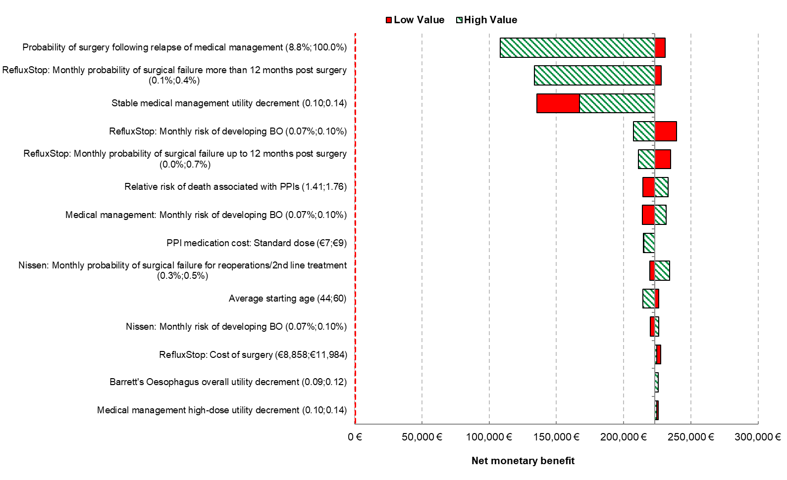

Supplementary Figure 2. Tornado diagram for RefluxStop compared to Nissen fundoplication
