Title: Cost-Utility Analysis of Faricimab Versus Aflibercept in Treating Neovascular Age-Related Macular Degeneration (nAMD) in the United States
PharmacoEconomics - Open
Authors and Affiliations
Ahmead Baljoon, M.Sc;¹ Vakaramoko Diaby, PhD;² Sandra Suther, Ph.D;¹ Matthew Dutton, Ph.D;¹Askal Ali, Ph.D;¹ Islam Eljilany, PhD^{3*}
¹Economic, Social and Administrative Pharmacy (ESAP) Department, College of Pharmacy and Pharmaceutical Sciences, Institute of Public Health, Florida A&M University, Tallahassee, FL 32307, USA
²Indepnedent researcher, Gainesville, FL 32606, United States
³Department of Cutaneous Oncology, H. Lee Moffitt Cancer Center and Research Institute, Tampa, FL 33612, United States

*Corresponding Author:
Islam Eljilany, PhD
Department of Cutaneous Oncology
H. Lee Moffitt Cancer Center and Research Institute,
10920 McKinley Dr., Tampa, FL 33612, United States
Email: islam.eljilany@hotmail.com
ORCID: 0000000163875419
Phone: +1 352-281-6765

Supplementary Methods
Cohort regrouping
On day one, 183 participants (13.75%) were able to read ≥74 letters, 765 participants (57.55%) read between 73 and 55 letters, and 381 participants (28.7%) read ≤54 letters. However, the current model defines five distinct VA health states: VA ≥84, 69–83, 54–68, 39–53, and VA ≤38. As a result, the original letter-based classifications must be regrouped to align with these predefined VA states. In this context, participants who could read ≥74 letters represent 13.75% (0.1375) of the total cohort, those reading between 73 and 55 letters account for 57.55% (0.5755), and those reading ≤54 letters constitute 28.7% (0.287). To map these groups to the model’s health states, the ≥74 letter group is distributed between the VA ≥84 and 69–83 categories, the 73–55 letter group is assigned to the 69–83 and 54–68 categories, and the ≤54 letter group is divided among the 54–68, 39–53, and ≤38 VA states.
Initial and incremental costs calculations
The initial cost for faricimab included four monthly injections as a loading dose, one initial office visit, three follow-up office visits, four OCTs, and one FA. For aflibercept, the initial cost included three monthly injections, one initial office visit, two follow-up office visits, three OCTs, and one FA, as shown in Equation 1.
Equation 1. Faricimab and Aflibercept initial cost equations.
Far initial cost = 4×(cAqFar+cIntra) + cIOV+3×cSOV+cFA+4×cOCT
Afl initial cost = 3×(cAqAfl+cIntra) + cIOV+2×cSOV+cFA+3×cOCT
Afl, aflibercept; cAqAfl, acquisition cost of aflibercept 2.0 mg per dose; cAqFar, acquisition cost of faricimab 6.0 mg per dose; cFA, cost of fluorescein angiography; cIntra, intravitreal injection cost for faricimab or aflibercept; cIOV, cost of initial office visit; cOCT, cost of optical coherence tomography; cSOV, cost of subsequent office visit; Far, faricimab.
Since the three-month cycle length was selected, only one dosing interval or group in the faricimab arm received Q12w as a maintenance dose besides Q8w and Q16w. Establishing the estimated number of faricimab maintenance dose injections administered per cycle is necessary.
We calculated the estimated number of faricimab and aflibercept maintenance injections per cycle manually as shown in Table 1 and Figures 2 and 3 below (Accessible in the online article).
The incremental cost for both treatment arms was calculated by first estimating the number of injections administered in each treatment cycle. This value was then multiplied by the total cost, which included the costs associated with the injections, OCT, and subsequent office visits, as shown in Equation 2.
Equation 2. Faricimab and Aflibercept incremental cost equations.
Far incremental cost = nInj_cycle_Far x cInj_Far (cAqFar + cIntra + cOCT + cSOV)
Afl incremental cost = nInj_cycle_Afl x cInj_Afl (cAqAfl + cIntra + cOCT + cSOV)

Afl, aflibercept; cAqAfl, acquisition cost of aflibercept 2.0 mg per dose; cAqFar, acquisition cost of faricimab 6.0 mg per dose; cInj_Afl, aflibercept combined costs; cInj_Far, faricimab combined costs; cIntra, intravitreal injection cost for faricimab or aflibercept; cOCT, cost of optical coherence tomography; cSOV, cost of subsequent office visit; Far, faricimab; nInj_cycle_Afl, number of aflibercept injections received per cycle (every 3 months); nInj_cycle_Far, number of faricimab injections received per cycle (every 3 months).

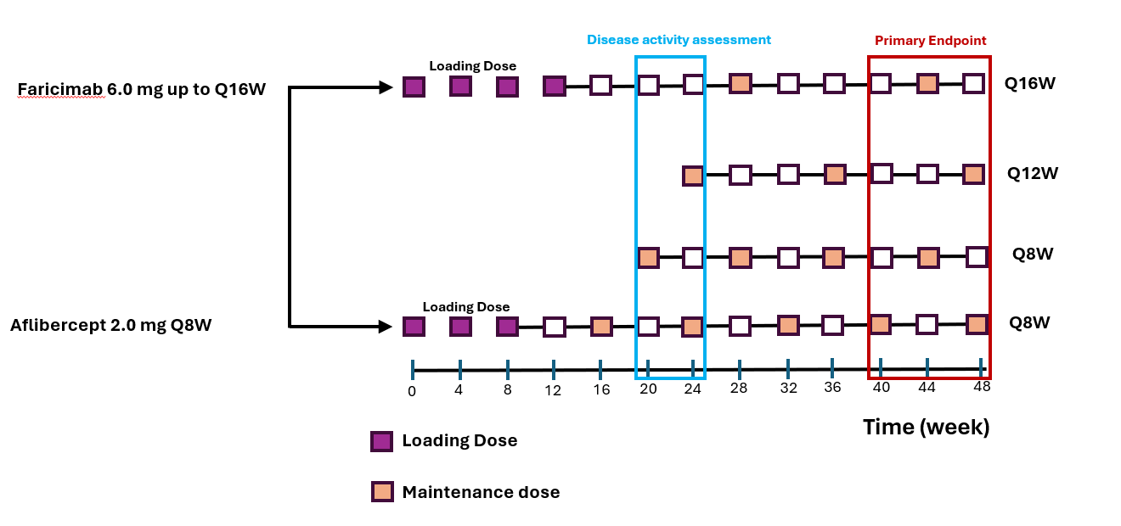
Figure 1. Faricimab and aflibercept regimen of week 40, 44, and 48 follow-ups.
mg, milligram; Q8W, every 8 weeks; Q12W, every 12 weeks; Q16W, every 16 weeks.

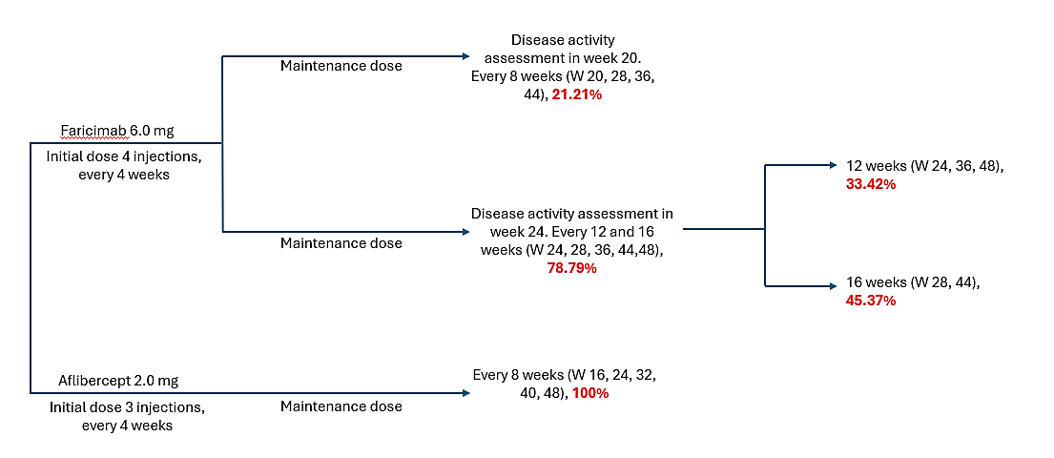

Figure 2. Faricimab and aflibercept percentage of week40, 44, and 48 follow-ups. W, week.

Table 1. Number of doses per cycle and dose interval
Markov Cycle | Aflibercept Q8W | Faricimab Q8W | Faricimab Q12W | Faricimab Q16W
0 | 3 | 4 | 4 | 4
1 | 2 | 2 | 1 | 1
2 | 1 | 1 | 1 | 0
3 | 2 | 2 | 1 | 1
4 | 2 | 2 | 1 | 1
5 | 1 | 1 | 1 | 1
6 | 2 | 2 | 1 | 1
7 | 1 | 1 | 1 | 0
8 | 2 | 2 | 2 | 1
9 | 2 | 2 | 1 | 1
10 | 1 | 1 | 1 | 1
11 | 2 | 2 | 1 | 1
12 | 2 | 2 | 1 | 1
13 | 1 | 1 | 1 | 0
14 | 2 | 2 | 1 | 1
15 | 1 | 1 | 1 | 1
16 | 2 | 2 | 1 | 1
17 | 2 | 2 | 1 | 1
18 | 1 | 1 | 1 | 0
19 | 2 | 2 | 1 | 1
Total | 34 | 35 | 24 | 19
Q8W, every 8 weeks; Q12W, every 12 weeks; Q16W, every 16 weeks.

Supplementary Table S1. Pooled estimate of participant characteristics in TENAYA and LUCERNE clinical trials.
Parameters | TENAYA trial [1] |  | LUCERNE trial [1] |  | Pooled TENAYA and LUCERNE
Parameters | Far 6.0 mg n=334 | Afl 2.0 mg n=337 | Far 6.0 mg n=331 | Afl 2.0 mg n=327 | Far 6.0 mg n=665 | Afl 2.0 mg n=664 | Far 6.0 mg & Afli 2.0 mg n=1,329
Age. mean (SD), in years | 75.9  (8.6) | 76.7  (8.8) | 74.8  (8.4) | 76.1  (8.6) | 75.35  (8.5) | 76.4  (8.63) | 75.9  (8.57)
Gender, n (%)
Female | 191  (57.2%) | 211  (62.6%) | 203  (61.3%) | 188  (57.7%) | 394  (59.2%) | 399  ( 60.1%) | 793  (59.65%)
Male | 143  (42.8%) | 126  (37.4%) | 128  (38.7%) | 139  (42.5%) | 271  (40.8%) | 165  (39.9%) | 436  (40.35%)
Ethnicity, n (%)
Hispanic or Latino | 26  (7.8%) | 26  (7.7%) | 35  (10.6%) | 46  (14.1%) | 61  (9.2%) | 72  (10.8%) | 133  (10%)
Not Hispanic or Latino | 303  (90.7%) | 308  (91.4%) | 287  (86.7%) | 274  (83.8%) | 590  (88.7%) | 582  (87.7%) | 1,172  (88.2%)
Unknown or No Reported | 5  (1.5%) | 3  (0.9%) | 9  (2.7%) | 7  (2.1%) | 14  (2.1%) | 10  (1.5%) | 24  (1.8%)
Race, n (%)
White | 303  (90.7%) | 302  (89.6%) | 278  (84.0%) | 270  (82.6%) | 581  (87.4%) | 572  (86.2%) | 1,153  (86.8%)
Asian | 26  (7.8%) | 28  (8.3%) | 38  (11.5%) | 34  (10.4%) | 64  (9.6%) | 62  (9.3%) | 126  (9.45%)
Black or African American | 0  (0.0%) | 3  (0.9%) | 2  (0.6%) | 5  (1.5%) | 2  (0.3%) | 8  (1.2%) | 10  (0.7%)
American Indian or Alaska Native | 1  (0.3%) | 2  (0.6%) | 1  (0.3%) | 0  (0.0%) | 2  (0.3%) | 2  (0.3%) | 4  (0.3%)
Multiple | 1  (0.3%) | 0  (0.0%) | 0  (0.0%) | 1  (0.3%) | 1  (0.1%) | 1  (0.1%) | 2  (0.1%)
Unknown | 3  (0.9%) | 2  (0.6%) | 12  (3.6%) | 17  (5.2%) | 15  (2.3%) | 19  (2.9%) | 34  (2.6%)
Region of Enrolment, n (%)
United States and Canada | 182  (54.5%) | 184  (54.6%) | 135  (40.8%) | 132  (40.4%) | 317  (47.7%) | 316  (47.6%) | 633  (47.65%)
Asia | 26  (7.8%) | 26  (7.7%) | 35  (10.6%) | 33  (10.1%) | 61  (9.1%) | 59  (8.9%) | 120  (9%)
Rest of the World | 126  (37.7%) | 127  (37.7%) | 161  (48.6%) | 162  (49.5%) | 287  (43.2%) | 289  (43.5%) | 576  (43.35%)
Abbreviations: Far, faricimab; Afl, aflibercept; SD, standard deviation; mg, milligram; n, patient numbers.

Supplementary Table S2. Pooled estimate of participants’ BCVA letter score categories in TENAYA and LUCERNE clinical trials.
BCVA letter score categories in the study eye, n (%) | TENAYA trail [1] |  | LUCERNE trail [1] |  | Pooled TENAYA and LUCERNE
 | Far 6.0 mg n=334 | Afli 2.0 mg n=337 | Far 6.0 mg n=331 | Afl 2.0 mg n=327 | Far 6.0 mg & Afli 2.0 mg n=1,329
≥74 Letters | 47 (14.1%) | 52 (15.4%) | 45 (13.6%) | 39 (11.9%) | 183 (13.75%)
73 to 55 Letters | 200 (59.9%) | 201 (59.6%) | 181 (54.7%) | 183 (56.0%) | 765 (57.55%)
≤54 Letters | 87 (26.0%) | 84 (24.9%) | 105 (31.7%) | 105 (32.1%) | 381 (28.7%)
Abbreviations: Afl, aflibercept; BCVA, best corrected visual acuity; Far, faricimab; mg, milligram; n, patient numbers.

Supplementary Table S3. CHEERS 2022 checklist
Topic | No. | Item | Location where item is reported
Title
Title | 1 | Identify the study as an economic evaluation and specify the interventions being compared. | 1
Abstract
Abstract | 2 | Provide a structured summary that highlights context, key methods, results, and alternative analyses. | 3-4
Introduction
Background and objectives | 3 | Give the context for the study, the study question, and its practical relevance for decision making in policy or practice. | 6-7
Methods
Health economic analysis plan | 4 | Indicate whether a health economic analysis plan was developed and where available. | 8
Study population | 5 | Describe characteristics of the study population (such as age range, demographics, socioeconomic, or clinical characteristics). | 9
Setting and location | 6 | Provide relevant contextual information that may influence findings. | 9
Comparators | 7 | Describe the interventions or strategies being compared and why chosen. | 9
Perspective | 8 | State the perspective(s) adopted by the study and why chosen. | 7, 8
Time horizon | 9 | State the time horizon for the study and why appropriate. | 8
Discount rate | 10 | Report the discount rate(s) and reason chosen. | 8
Selection of outcomes | 11 | Describe what outcomes were used as the measure(s) of benefit(s) and harm(s). | 10
Measurement of outcomes | 12 | Describe how outcomes used to capture benefit(s) and harm(s) were measured. | 10
Valuation of outcomes | 13 | Describe the population and methods used to measure and value outcomes. | 10
Measurement and valuation of resources and costs | 14 | Describe how costs were valued. | 12-14
Currency, price date, and conversion | 15 | Report the dates of the estimated resource quantities and unit costs, plus the currency and year of conversion. | 12-14
Rationale and description of model | 16 | If modelling is used, describe in detail and why used. Report if the model is publicly available and where it can be accessed. | 8-9
Analytics and assumptions | 17 | Describe any methods for analysing or statistically transforming data, any extrapolation methods, and approaches for validating any model used. | 16-18
Characterising heterogeneity | 18 | Describe any methods used for estimating how the results of the study vary for subgroups. | 16-18
Characterising distributional effects | 19 | Describe how impacts are distributed across different individuals or adjustments made to reflect priority populations. | 18
Characterising uncertainty | 20 | Describe methods to characterise any sources of uncertainty in the analysis. | 17-18
Approach to engagement with patients and others affected by the study | 21 | Describe any approaches to engage patients or service recipients, the general public, communities, or stakeholders (such as clinicians or payers) in the design of the study. | N/A
Results
Study parameters | 22 | Report all analytic inputs (such as values, ranges, references) including uncertainty or distributional assumptions. | 19
Summary of main results | 23 | Report the mean values for the main categories of costs and outcomes of interest and summarise them in the most appropriate overall measure. | 19-20
Effect of uncertainty | 24 | Describe how uncertainty about analytic judgments, inputs, or projections affect findings. Report the effect of choice of discount rate and time horizon, if applicable. | 24
Effect of engagement with patients and others affected by the study | 25 | Report on any difference patient/service recipient, general public, community, or stakeholder involvement made to the approach or findings of the study | NA
Discussion
Study findings, limitations, generalisability, and current knowledge | 26 | Report key findings, limitations, ethical or equity considerations not captured, and how these could affect patients, policy, or practice. | 25-30
Other relevant information
Source of funding | 27 | Describe how the study was funded and any role of the funder in the identification, design, conduct, and reporting of the analysis | 31
Conflicts of interest | 28 | Report authors conflicts of interest according to journal or International Committee of Medical Journal Editors requirements. | 31
From: Husereau D, Drummond M, Augustovski F, et al. Consolidated Health Economic Evaluation Reporting Standards 2022 (CHEERS 2022) Explanation and Elaboration: A Report of the ISPOR CHEERS II Good Practices Task Force. Value Health 2022;25. doi:10.1016/j.jval.2021.10.008

Supplementary Table S4. One-year efficacy endpoint parameters from the TENAYA and LUCERNE clinical trials.
Parameters, n (%) | TENAYA trial [1] |  | LUCERNE trail [1] |  | Pooled TENAYA and LUCERNE trials [1]
Parameters, n (%) | Far 6.0 mg n=334 | Afl 2.0 mg n=337 | Far 6.0 mg n=331 | Afl 2.0 mg n=327 | Far 6.0 mg n=665 | Afl 2.0 mg n=664
Numbers and % of participants gaining ≥15 letters from  the baseline BCVA in the study eye averaged over weeks 40,44 and 48. CI unit | 292 (20.0%)  (15.6% to 24.4%) | 300 (15.7%)  (11.9% to 19.6%) | 302  (20.2%)  (15.9% to 24.6%) | 291  (22.2%)  (17.7% to 26.8%) | 594  (20.1%)  (15.6 %to 24.6%) | 591  (18.9%)  (11.9% to 26.8%)
Numbers and % of participants avoided a loss of ≥15 letters, averaging over weeks 40,44 and 48. CI unit | 292  (95.4%)  (93.0% to 97.7%) | 300  (94.1%)  (91.5% to 96.7%) | 302  (95.8%)  (93.6% to 98.0%) | 291  (97.3%)  (95.5% to 99.1%) | 594  (95.6%)  (93.0% to 98.0%) | 591  (95.7%)  (91.5% to 99.1%)
Numbers and % of participants gaining ≥15 letters, with ≥84 letters in the study eye weeks 40,44 and 48. CI unit | 292  (24.3 %)  (19.5% to 29.1%) | 300  (21.3 %)  (16.8% to 25.7%) | 302  (24.5 %)  (19.8% to 29.2%) | 291  (26.2 %)  (21.2% to 31.1%) | 594  (24.6%)  (19.5% to 29.2%) | 591  (23.71%)  (16.8% to 31.1%)
Numbers and % of participants with ≥69 in the study eye averaged over weeks 40,44 and 48. CI unit | 292  (56.4 %)  (51.5% to 61.4%) | 300  (57.0 %)  (51.9% to 62.1%) | 302  (55.2 %)  (50.1% to 60.2%) | 291  (49.4 %)  (44.4% to 54.4%) | 594  (55.8%)  (51.5% to 60.2%) | 591  (53.3%)  (51.9% to 54.4%)
Endophthalmitis | 3  (0.9 %)  (0.7 to 1.1%) | 0  (0%) | 2  (0.6%)  (0.5% to 0.8%) | 4  (1.2%)  (0.9% to 1.5%) | 5  (0.8%)  (0.6% to 0.9%) | 4  (0.6%)  (0.5% to 0.8%)
Abbreviations: Afl, aflibercept; BCVA, best corrected visual acuity; CI = confidence interval; Far, faricimab; mg, milligram; n, patient numbers.

Supplementary Table S5. Scenario values for the three-month transition probabilities between visual acuity
Probabilities | Scenario 1  TENAYA trial [1] |  | Scenario 2  LUCERNE trail [1] |  | Scenario 3  Equal values
Probabilities | Far 6.0 mg n=334 | Afl 2.0 mg n=337 | Far 6.0 mg n=331 | Afl 2.0 mg n=327 | Far 6.0 mg / Afl 2.0 mg
Prob of VA ≤ 38 to 39-53 | 0.0166 | 0.018181 | 0.0207 | 0.0194 | 0.0338
Prob of VA 39-53 to ≤ 38 | 0.0184 | 0.0185 | 0.0184 | 0.0185 | 0.0185
Prob of VA 54-68 to 39-53 | 0.0117 | 0.0154 | 0.0105 | 0.0068 | 0.023
Prob of VA 39-53 to 54-68 | 0.0166 | 0.0181 | 0.0207 | 0.0194 | 0.0338
Prob of VA 54-68 to 69-83 | 0.0497 | 0.0507 | 0.0482 | 0.0443 | 0.0481
Prob of VA 69-83 to 54-68 | 0.0117 | 0.0154 | 0.0105 | 0.0068 | 0.023
Prob of VA 69-83 to VA ≥84 | 0.0170 | 0.0135 | 0.0174 | 0.0191 | 0.0171
Prob of VA ≥84 to VA ≥ 69-83 | 0.0117 | 0.0154 | 0.0105 | 0.0068 | 0.023
The Prob of Endophthalmitis for one year | 0.009 | 0.000 | 0.006 | 0.012 | 0.007
Abbreviations: Afl, aflibercept; Far, faricimab; mg, milligram; n, patient numbers.

Supplementary Table S6. All model inputs for probabilistic sensitivity analysis..
Input | Base-case value | Ranges used for DSA  (range of variation was set as ±25%) |  | Distribution used for PSA | Reference
 |  | Lower bond | High bond
General Inputs
Discount rate (outcomes and costs) | 3.0% | 3.75% | 2.25% | Beta | Assumption
Population Inputs
Transition probability
Transition probability of Faricimab from (VA > or = 84 state) to (69 to 83 state) | 0.0112 | 0.0084 | .0140 | Beta | Pooled estimate of Lucerne & Tenaya clinical trials
Transition probability of Faricimab from (VA ≥ 84 states) to (VA ≥ 84 states) | 0.9798 | 0.7137 | 1.189 | Beta | Pooled estimate of Lucerne & Tenaya clinical trials
Transition probability of Faricimab from (69 to 83 states) to (VA ≥ 84 states) | 0.0173 | 0.0130 | 0.0216 | Beta | Pooled estimate of Lucerne & Tenaya clinical trials
Transition probability of Faricimab from (69 to 83 state) to (54 to 68 state) | 0.0112 | 0.0084 | 0.0140 | Beta | Pooled estimate of Lucerne & Tenaya clinical trials
Transition probability of Faricimab from (69 to 83 state) to (69 to 83 state) | 0.9616 | 0.7007 | 1.168 | Beta | Pooled estimate of Lucerne & Tenaya clinical trials
Transition probability of Faricimab from (54 to 68 state) to (69 to 83 state) | 0.0497 | 0.0373 | 0.0621 | Beta | Pooled estimate of Lucerne & Tenaya clinical trials
Transition probability of Faricimab from (54 to 68 state) to (39 to 53 state) | 0.0112 | 0.0084 | 0.0140 | Beta | Pooled estimate of Lucerne & Tenaya clinical trials
Transition probability of Faricimab from (54 to 68 state) to (54 to 68 state) | 0.9292 | 0.6764 | 1.128 | Beta | Pooled estimate of Lucerne & Tenaya clinical trials
Transition probability of Faricimab from (39 to 53 state) to (54 to 68 state) | 0.0546 | 0.0410 | 0.0686 | Beta | Pooled estimate of Lucerne & Tenaya clinical trials
Transition probability of Faricimab from (39 to 53 state) to (VA ≤ 38 state) | 0.0184 | 0.0138 | 0.0230 | Beta | Pooled estimate of Lucerne & Tenaya clinical trials
Transition probability of Faricimab from (39 to 53 state) to (39 to 53 state) | 0.9171 | 0.6673 | 1.112 | Beta | Pooled estimate of Lucerne & Tenaya clinical trials
Transition probability of Faricimab from (VA ≤ 38 state) to (39 to 53 state) | 0.0546 | 0.0410 | 0.0683 | Beta | Pooled estimate of Lucerne & Tenaya clinical trials
Transition probability of Faricimab from (VA ≤ 38 state) to (VA ≤ 38 state) | 0.9355 | 0.6811 | 1.135 | Beta | Pooled estimate of Lucerne & Tenaya clinical trials
Transition probability of Aflibercept from (VA ≥ 84 state) to (69 to 83 state) | 0.0347 | 0.0260 | 0.0434 | Beta | Pooled estimate of Lucerne & Tenaya clinical trials
Transition probability of Aflibercept from (VA ≥ 84 states) to (VA ≥ 84 states) | 0.9554 | .6932 | 1.155 | Beta | Pooled estimate of Lucerne & Tenaya clinical trials
Transition probability of Aflibercept from (69 to 83 states) to (VA ≥ 84 states) | 0.0168 | 0.0126 | 0.0210 | Beta | Pooled estimate of Lucerne & Tenaya clinical trials
Transition probability of Aflibercept from (69 to 83 state) to (54 to 68 state) | 0.0347 | 0.0260 | 0.0434 | Beta | Pooled estimate of Lucerne & Tenaya clinical trials
Transition probability of Aflibercept from (69 to 83 state) to (69 to 83 state) | 0.9386 | 0.6806 | 1.134 | Beta | Pooled estimate of Lucerne & Tenaya clinical trials
Transition probability of Aflibercept from (54 to 68 state) to (69 to 83 state) | 0.0465 | 0.0349 | 0.0581 | Beta | Pooled estimate of Lucerne & Tenaya clinical trials
Transition probability of Aflibercept from (54 to 68 state) to (39 to 53 state) | 0.0347 | 0.0260 | 0.0434 | Beta | Pooled estimate of Lucerne & Tenaya clinical trials
Transition probability of Aflibercept from (54 to 68 state) to (54 to 68 state) | 0.9089 | 0.6583 | 1.097 | Beta | Pooled estimate of Lucerne & Tenaya clinical trials
Transition probability of Aflibercept from (39 to 53 states) to (54 to 68 states) | 0.0130 | 0.0098 | 0.0163 | Beta | Pooled estimate of Lucerne & Tenaya clinical trials
Transition probability of Aflibercept from (39 to 53 state) to (VA ≤ 38 state) | 0.0185 | 0.0139 | 0.0231 | Beta | Pooled estimate of Lucerne & Tenaya clinical trials
Transition probability of Aflibercept from (39 to 53 state) to (39 to 53 state) | 0.9586 | 0.6956 | 1.159 | Beta | Pooled estimate of Lucerne & Tenaya clinical trials
Transition probability of Aflibercept from (VA ≤ 38 state) to (39 to 53 state) | 0.0130 | 0.0098 | 0.0163 | Beta | Pooled estimate of Lucerne & Tenaya clinical trials
Transition probability of Aflibercept from (VA ≤ 38 state) to (VA ≤ 38 state) | 0.9771 | 0.7094 | 1.182 | Beta | Pooled estimate of Lucerne & Tenaya clinical trials
Transition probability of Faricimab & Aflibercept from any state to death. | 0.0099 | 0.0074 | 0.01234 | Beta | Calculation
Transition probability of endophthalmitis with Faricimab | 0.0075 | 0.0056 | 0.0094 | Beta | Pooled estimate of Lucerne & Tenaya clinical trials
Transition probability of endophthalmitis with Aflibercept | 0.006 | 0.0045 | 0.0075 | Beta | Pooled estimate of Lucerne & Tenaya clinical trials
Utility
VA ≥ 84 | .95 | 0.7125 | 1.187 | Beta | Brown et al. 2003
69 to 83 | .86 | 0.6450 | 1.075 | Beta | Brown et al. 2003
54 to 68 | .75 | 0.5625 | 0.9375 | Beta | Brown et al. 2003
39 to53 | .67 | 0.5025 | 0.8375 | Beta | Brown et al. 2003
VA ≤ 38 | .54 | 0.4050 | 0.6750 | Beta | Brown et al. 2003
Costs
Treatments cost
Faricimab 6.0 mg cost per dose | $2,089.44 | $1,594.85 | $2,658.08 | Gamma | Medicare reimbursement J3590
Aflibercept 2.0 mg cost per dose | $1,670.798 | $1,261.82 | $2,103.05 | Gamma | Medicare reimbursement J0178
Administration Costs
Cost of intravitreal injection | $125.28 | $93.96 | $156.6 | Gamma | CMS Physician Fee CPT 67028
Cost of an initial office visit | $226.53 | $169.90 | $283.16 | Gamma | CMS Physician Fee CPT 99204
Cost of subsequent office visit (comprehensive eye examination) | $157.64 | $118.23 | $197.05 | Gamma | CMS Physician Fee CPT 92014
Monitoring/Disease State Costs
OCT | $54.17 | $40.63 | $67.71 | Gamma | CMS Physician Fee CPT 92134
FA | $114.37 | $85.78 | $142.96 | Gamma | CMS Physician Fee CPT 92235
Adverse event cost
Cost of the management of endophthalmitis | $3,958.12 | $2,968.59 | $4,947.65 | Gamma | Schmie et al. 2016
Abbreviations: AMD, age-related macular degeneration; FA, fluorescein Angiography; OCT, optical Coherence Tomography; PSA, probabilistic sensitivity analysis; VA, visual Acuity.

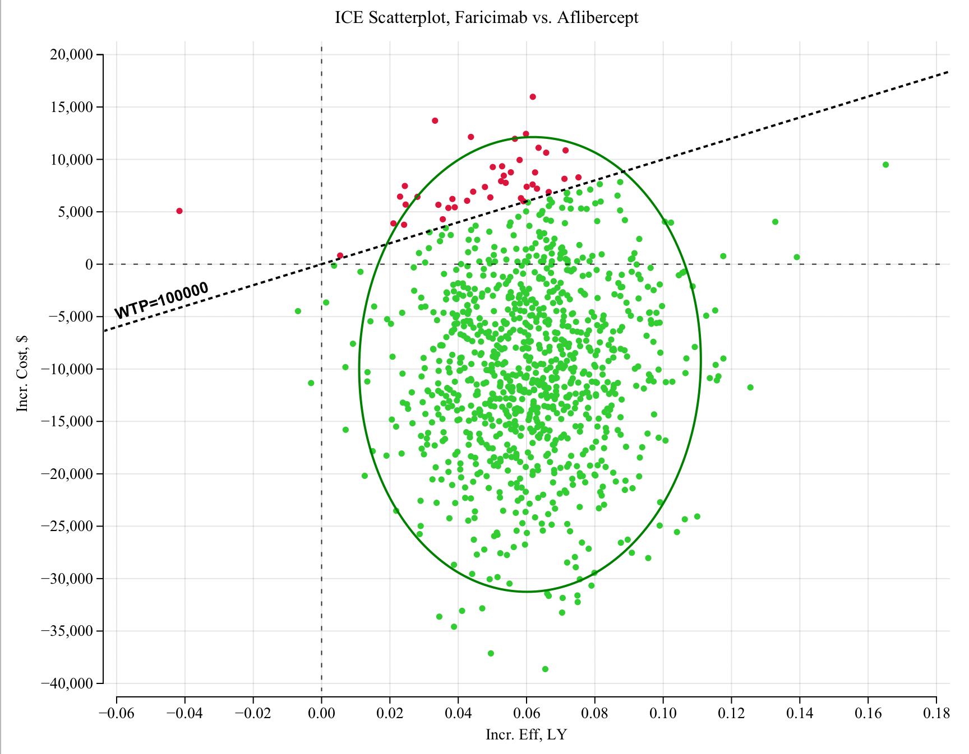
Supplementary Figure S3. Incremental cost-effectiveness scatterplot faricimab vs aflibercept. The distribution of incremental cost versus incremental effectiveness for numerous simulated scenarios. Each point represents a simulation outcome, with green points indicating scenarios where faricimab is more cost-effective and red points indicating scenarios where aflibercept is more cost-effective. The majority of points fall in the green region, suggesting that Faricimab is more cost-effective in most simulations. The dashed line represents the WTP threshold of $100,000 per unit of effectiveness, and the points under it indicate that Faricimab is less costly and more effective. Abbreviations: ICE, incremental cost-effectiveness WTP, willingness-to-pay.

References
1. Heier JS, Khanani AM, Ruiz CQ, Basu K, Ferrone PJ, Brittain C, Figueroa MS, Lin H, Holz FG, Patel V. Efficacy, durability, and safety of intravitreal faricimab up to every 16 weeks for neovascular age-related macular degeneration (TENAYA and LUCERNE): two randomised, double-masked, phase 3, non-inferiority trials. The Lancet. 2022;399(10326):729-40.

