Supplementary Document to:
Integrating Structured Expert Elicitation with External Evidence to Inform Earlier Reimbursement Decisions: A Norwegian Case Study of Selpercatinib for Non-Small Cell Lung Cancer

Authors: Yancy S. Wu¹, Emily A. Burger^{1,2}, Magnus Bangum³, Fredrik Holmboe³, Francisco Oteiza⁴, Christoffer Bugge⁴, Erik Magnus Sæther⁴, Eline Aas^{1,5}

Affiliations:
¹Department of Health Management and Health Economics, University of Oslo, Norway;
²Center for Health Decision Science, Harvard T.H. Chan School of Public Health, Boston, MA, USA;
³AbbVie, Oslo, Norway;
⁴Oslo Economics, Oslo, Norway;
⁵Division for Health Services, Norwegian Institute of Public Health, Oslo, Norway

Table of Contents
Absolute shortfall and cost-effectiveness thresholds 3
Structured expert elicitation (SEE) reporting 4
Supplementary Figures and Tables 8
Figure S1. Three-state Markov model 8
Figure S2. Structured expert elicitation process 9
Figure S3. Progression-free survival extrapolation and hazard assessment for selpercatinib based on LIBRETTO-001 10
Figure S4. Overall survival extrapolation and hazard assessment for selpercatinib based on LIBRETTO-001 11
Figure S5. Progression-free survival extrapolation and hazard assessment for SoC based on KEYNOTE-189 12
Figure S6. Overall survival extrapolation and hazard assessment for SoC based on KEYNOTE-189 13
Figure S7. Progression-free survival extrapolation and hazard assessment for SoC based on US RWE 14
Figure S8. Overall survival extrapolation and hazard assessment for SoC based on US RWE 15
Figure S9. Progression-free survival extrapolation and hazard assessment for selpercatinib based on LIBRETTO-431 16
Figure S10. Overall survival extrapolation and hazard assessment for selpercatinib based on LIBRETTO-431 17
Figure S11. Progression-free survival extrapolation and hazard assessment for SoC based on LIBRETTO-431 18
Figure S12. Overall survival extrapolation and hazard assessment for SoC based on LIBRETTO-431 19
Figure S13. Overall survival extrapolation and hazard assessment for SoC based on KEYNOTE five-year outcome 20
Table S1. Absolute shortfall across standard-of-care (SoC) evidence sources 21
Table S2. Demographic and disease characteristics of the patients across published clinical evidence 22
Table S3. Akaike and Bayesian information criteria (AIC/BIC) for candidate parametric models used in survival extrapolation 23
Table S4. Summary of survival extrapolation and hazard plausibility assessment for progression-free and overall survival 26
Table S5. Comparison of SEE procedures used in this study with established elicitation frameworks 27
Table S6. SEE Extrapolation 29
Table S7. Adverse events included in this study, according to LIBRETTO-431 trial data 35
Table S8. Disaggregated mean discounted cost components across pre- and post-submission analyses 36
Table S9. Undiscounted life-years (LY) and quality-adjusted life years (QALY) from the probabilistic analysis 38
Table S10. Probabilistic mean (95% credible interval) cost-effectiveness results from time-horizon scenario analyses 40
Table S11. Probabilistic mean (95% credible interval) cost-effectiveness results from parametric survival distribution scenario analyses 43

Absolute shortfall and cost-effectiveness thresholds
We calculated absolute shortfall values and corresponding severity-specific cost-effectiveness thresholds separately for each SoC source and for averages of different combinations of SoC sources (Table S1).
In accordance with Norwegian guidelines [1], absolute shortfall (Equation 1) was used to quantify the disease severity, and was defined as the difference between the expected remaining QALYs in the general population and the undiscounted QALYs accrued by patients receiving SoC.
Equation 1. $Absolute Shortfall=E\left[Undiscounted QALYs \left(general population\right)\right]-E[Undiscounted QALYs (SoC)]$
The median age of the patient population in this study was 72 years [2]. Based on data from Norwegian Medical Product Agency [3], the expected remaining QALYs for a 72-year-old in the general population is 11.68. Undiscounted QALYs for patients receiving SoC ranged from 1.06 to 1.66 across multiple evidence sources (Table S1). Accordingly, absolute shortfall values ranged from 10.02 to 10.62 QALYs across individual SoC sources and averages of different combinations of SoC evidence.
According to Norwegian documents on severity of illness and priority setting [4], an absolute shortfall between 8.0 and 11.9 QALYs corresponds to a severity-specific cost-effectiveness threshold of 495,000 NOK per QALY (~ 46,015 USD per QALY). Across all SoC sources, the resulting severity-adjusted thresholds were the same.
Notably, Norwegian guidelines recommend using the mean age of the target population when calculating absolute shortfall [1]. However, for this specific RET fusion–positive NSCLC population in Norway, only the median age was available. Given that RET fusion–positive patients tend to be younger than the overall NSCLC population, the mean age is likely lower than the observed median. Consequently, our use of a median age of 72 years likely resulted in a conservative cost-effectiveness threshold, as a lower mean age would imply higher remaining general-population QALYs and, therefore, a larger absolute shortfall and a higher cost-effectiveness threshold.

Structured expert elicitation (SEE) reporting

Recruitment and Selection of Experts
Clinical experts were identified through a structured process. The Norwegian Medical Products Agency provided a list of clinicians with relevant expertise, which was used as a starting point to identify suitable candidates. From this pool, three clinical oncologists were invited to participate based on their experience in treating patients with non–small cell lung cancer (NSCLC) within the Norwegian healthcare system. Experts were intentionally selected from Norway, given the HTA decision context, to ensure that elicited judgments reflected Norwegian clinical practice, treatment pathways, and patient management.
All invited experts were actively practicing clinicians with direct experience in managing advanced NSCLC. None of the participating experts were employees of the manufacturer of selpercatinib, and no financial incentives were provided for participation. Experts were asked to declare any potential conflicts of interest prior to the elicitation, and none were identified with conflicts of interest.

Evidence Dossier Preparation
Prior to the elicitation, an evidence dossier was prepared to ensure that all experts had access to the same relevant clinical information. The dossier summarizes the available clinical evidence for RET fusion–positive NSCLC, including results from the phase I/II LIBRETTO-001 trial. In addition, the dossier includes summary of trial design, patient characteristics, and reported survival outcomes, a description of the elicitation task, educational material describing probabilistic judgments, and an explanation of the chips-and-bins (i.e., fixed interval) elicitation method.
The dossier was shared with experts in advance of the interviews, allowing time for review and reflection. The elicitation took place before the publication of phase III results, enabling later validation of SEE outputs against subsequently observed trial evidence.
Elicitation Team and Facilitation
The elicitation was conducted by two facilitators. One facilitator, who had expertise in health economics, economic modelling, and survival analysis, led the interview and posed the elicitation questions. The second facilitator was responsible for documenting responses, managing the elicitation software, and providing technical support.
The facilitators did not provide clinical opinions and did not influence the experts’ judgments beyond clarifying the task and ensuring consistency in interpretation.
Elicitation of Survival Estimates
We conducted the elicitation using the evidence dossier with the experts. Experts provided individual estimates for PFS and OS at 12, 24, and 60 months for standard-of-care regimens (platinum-based chemotherapy with or without pembrolizumab), as well as for selpercatinib in both treatment-naïve and previously treated RET fusion–positive NSCLC populations. Uncertainty around each estimate was elicited using the Roulette method.
Elicitations were conducted individually, without interaction between experts, using a fixed interval method (FIM), specifically the chips-and-bins approach (Figure S2). Experts expressed their uncertainty over survival probabilities by distributing probability mass across predefined intervals. The facilitators placed the chips on behalf of experts based on the experts’ verbal instructions.
Experts were explicitly informed that the elicited quantities represented survival probabilities and were bounded between 0 and 1. They were not required to specify parametric survival models or functional forms.
Feedback and Revision
During each elicitation, real-time feedback was provided by visually displaying the chips-and-bins distributions. Experts were given the opportunity to revise their judgments after reviewing the implied distributions. This iterative feedback process helped identify misunderstandings and allowed experts to correct or refine their responses.

Fitting Probability Distributions
We quantified expert judgements at the individual level prior to aggregation by fitting beta distributions to the elicited probabilities for each time point. Individual elicited distributions were fitted using the MATCH Uncertainty Elicitation Tool. The beta distribution was chosen due to its flexibility. Alternative distributions (e.g., Normal, Student-t, Scaled Beta, Log-Normal, or Gamma) were not explored in this analysis.

Aggregation of Expert Judgments
Individual expert distributions were aggregated using mathematical aggregation provided in the “expertsurv” R package [5] using linear pooling with equal weights (Figure S2), consistent with Medical Research Council (MRC) frameworks for expert elicitation [6]. A consensus meeting (i.e., (behavioral aggregation) was initially planned. However, due to scheduling constraints and time availability, this step was not conducted. As a result, experts did not directly discuss or revise their judgments collectively.
Overall, our elicitation process was designed to ensure transparency, reproducibility, and alignment with established good practices. We developed a SEE checklist (Table S5), mapping the elicitation procedures used in this study against key recommendations from established SEE frameworks, including the SHELF [7], Modified Delphi [8], Cooke’s Method [9], IDEA [10], MRC [6], and STEER frameworks [11].

Structured expert elicitation (SEE) Extrapolation
We extrapolated long-term PFS and OS curves, based on pooled distributions, using parametric survival modeling provided by the “expertsurv” R package [5] (Table S6).
In our analysis, Elicited estimates were utilized in two ways as “pre-submission phase” SoC evidence:
1) as the sole source of information
2) combined with other external published clinical evidence (i.e., the KEYNOTE-189 phase III trial or US RWE study), in which the external published clinical evidence was used as prior information.
When SEE was combined with external published clinical evidence, the external evidence was incorporated as prior information within a Bayesian survival modelling framework. Specifically, parametric survival models for PFS and OS were first fitted using data from the external evidence sources (the KEYNOTE-189 or US RWE study). The resulting parametric survival distributions were then treated as Bayesian priors. Expert-elicited survival judgments, quantified as probability distributions at predefined time points, were subsequently incorporated through Bayesian updating using the expertsurv framework. This process produced posterior survival distributions that formally integrate trial or RWE data with expert judgment.

Supplementary Figures and Tables

Figure S1. Three-state Markov model

Progression-free
(PF)

Death
(D)

Progressive disease
(PD)

Figure S2. Structured expert elicitation process

Individual Elicitation | Aggregation | Extrapolation

Figure S3. Progression-free survival extrapolation and hazard assessment for selpercatinib based on LIBRETTO-001
Figure S3a Kaplan–Meier with fitted parametric curves | Figure S3b Observed and predicted hazard functions
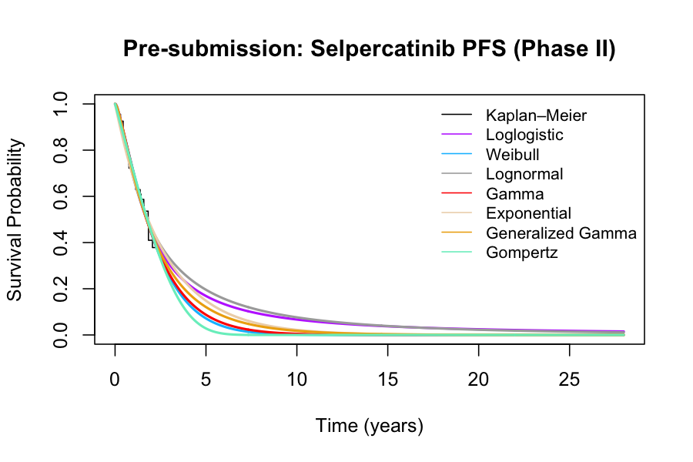 | 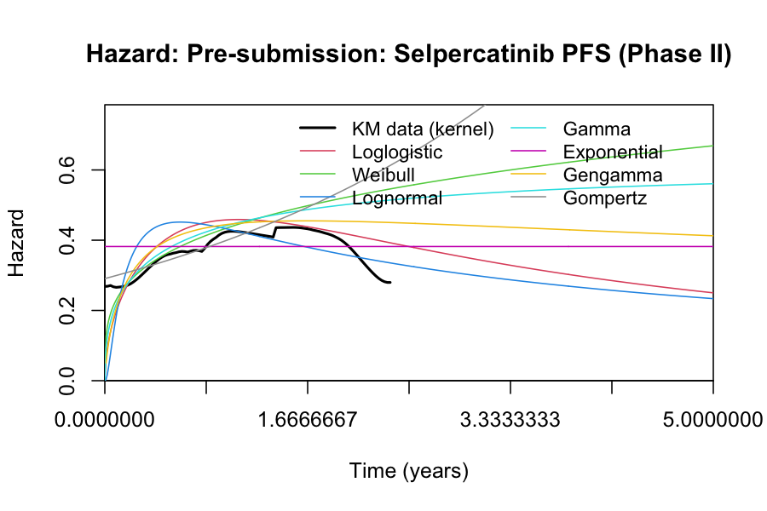

Figure S4. Overall survival extrapolation and hazard assessment for selpercatinib based on LIBRETTO-001
Figure S4a Kaplan–Meier with fitted parametric curves | Figure S4b Observed and predicted hazard functions
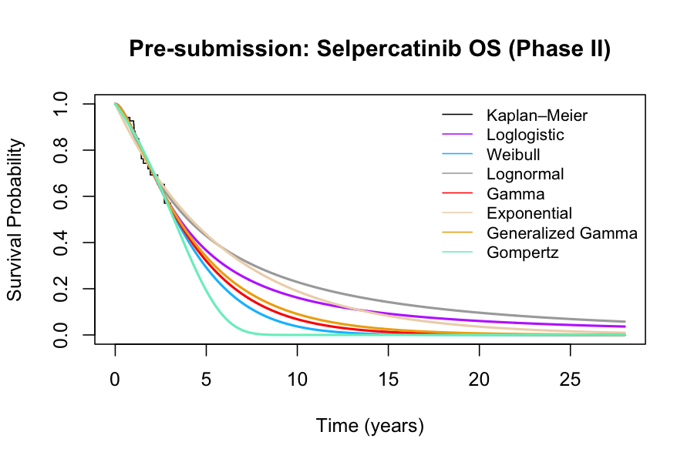 | 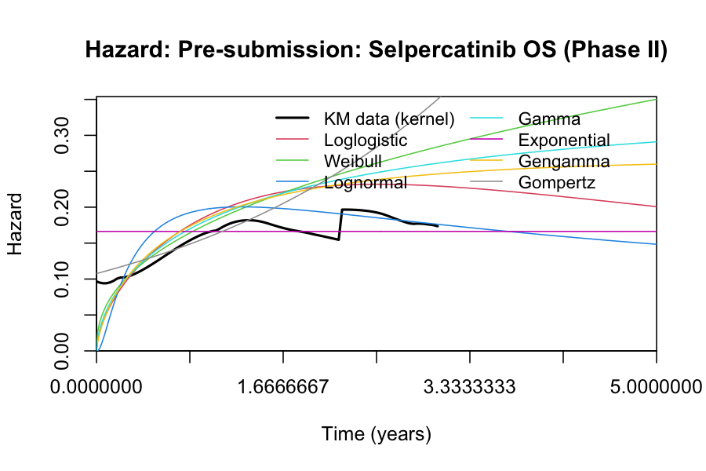

Figure S5. Progression-free survival extrapolation and hazard assessment for SoC based on KEYNOTE-189
Figure S5a Kaplan–Meier with fitted parametric curves | Figure S5b Observed and predicted hazard functions
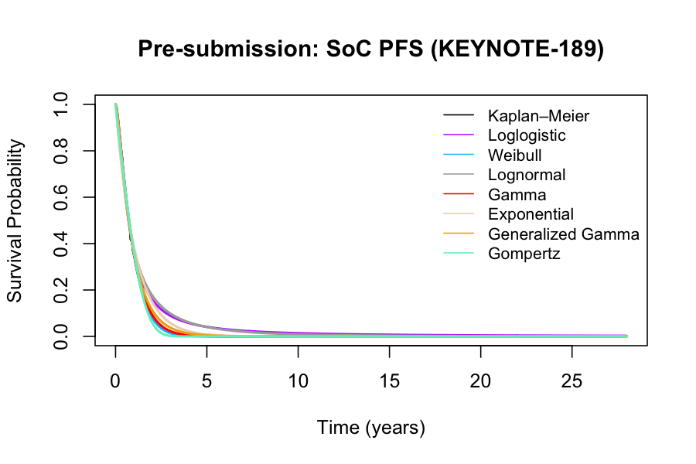 | 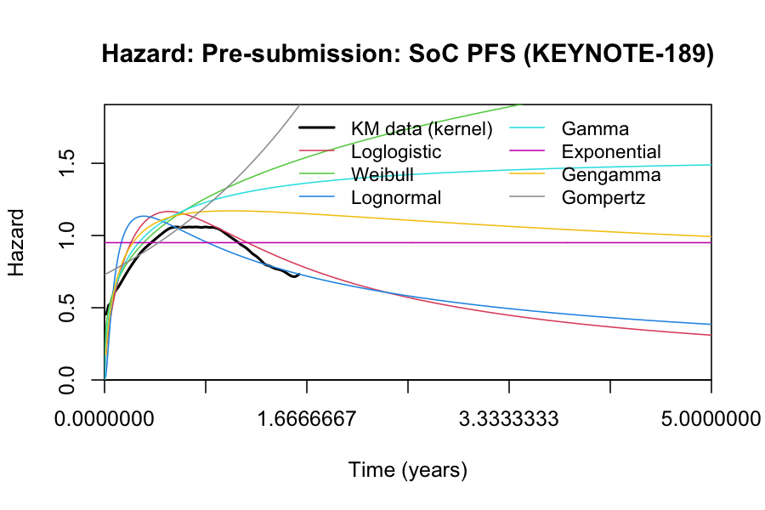

Figure S6. Overall survival extrapolation and hazard assessment for SoC based on KEYNOTE-189
Figure S6a Kaplan–Meier with fitted parametric curves | Figure S6b Observed and predicted hazard functions
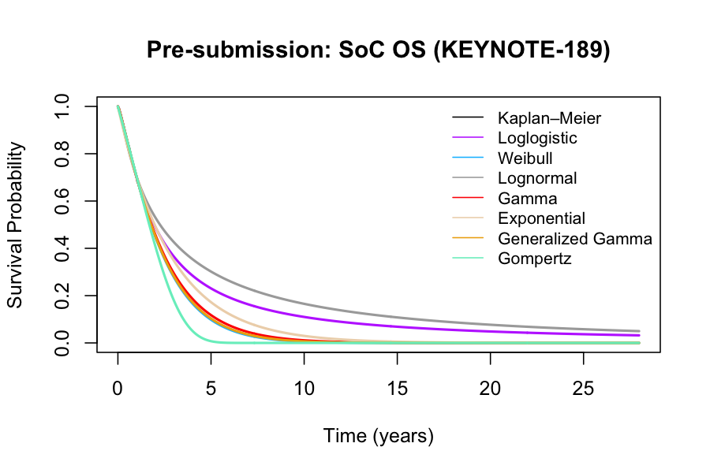 | 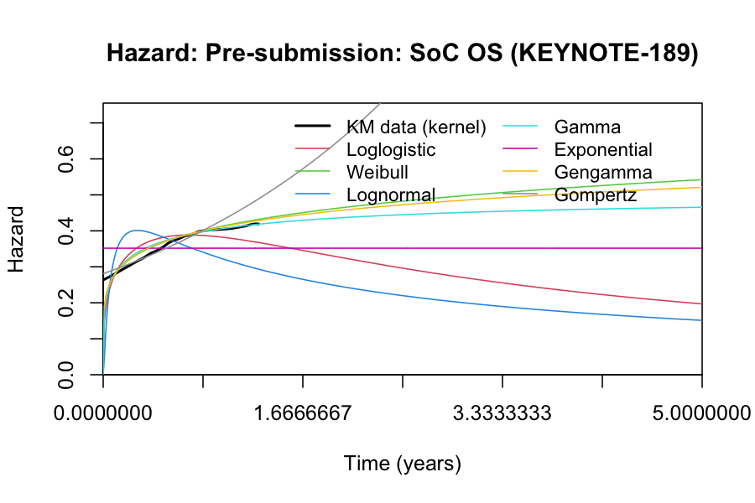

Figure S7. Progression-free survival extrapolation and hazard assessment for SoC based on US RWE
Figure S7a Kaplan–Meier with fitted parametric curves | Figure S7b Observed and predicted hazard functions
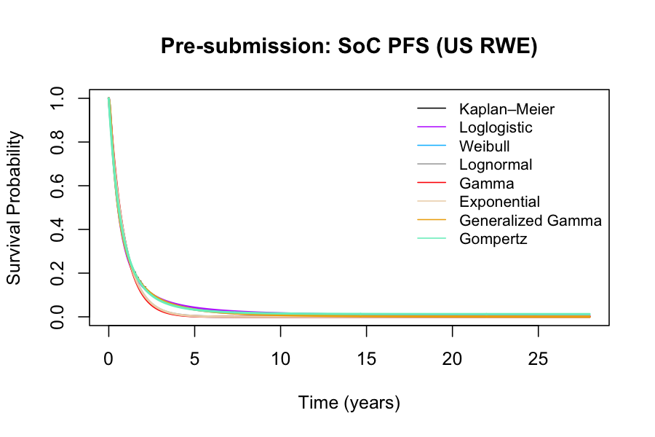 | 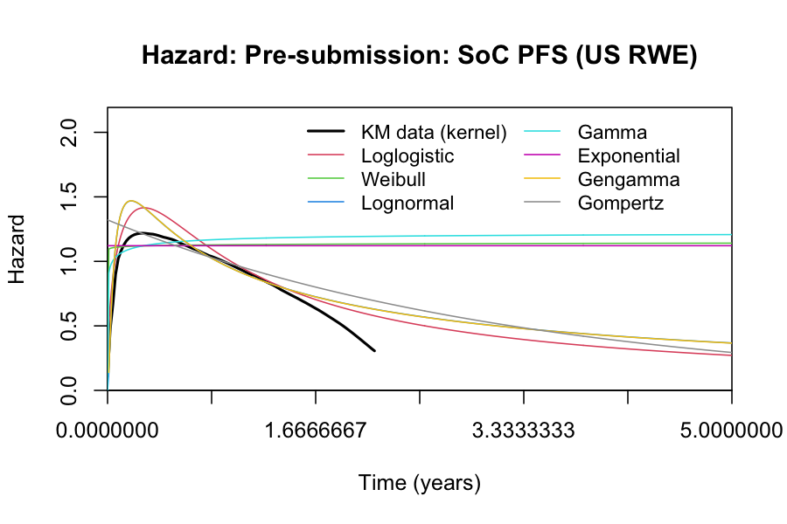

Figure S8. Overall survival extrapolation and hazard assessment for SoC based on US RWE
Figure S8a Kaplan–Meier with fitted parametric curves | Figure S8b Observed and predicted hazard functions
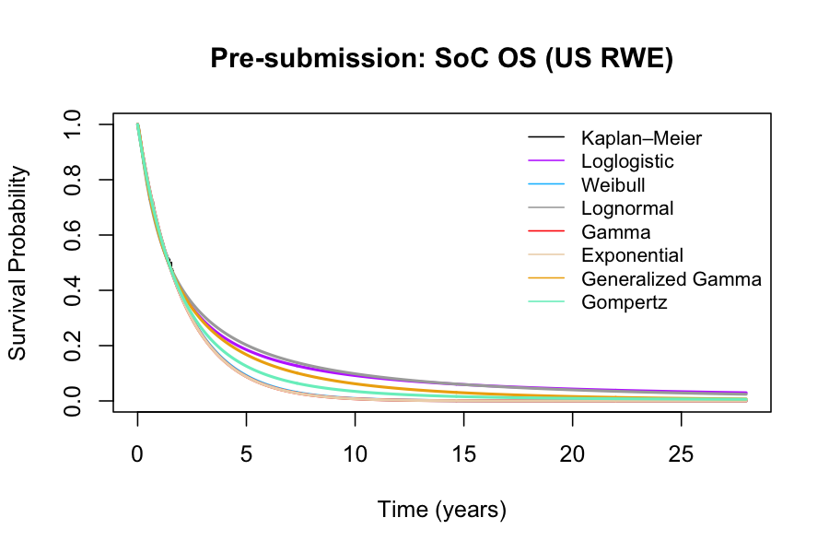 | 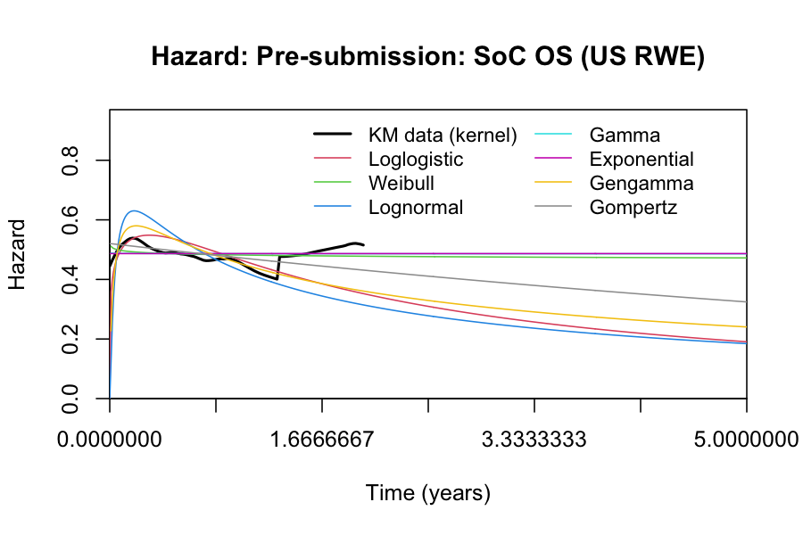

Figure S9. Progression-free survival extrapolation and hazard assessment for selpercatinib based on LIBRETTO-431
Figure S9a Kaplan–Meier with fitted parametric curves | Figure S9b Observed and predicted hazard functions
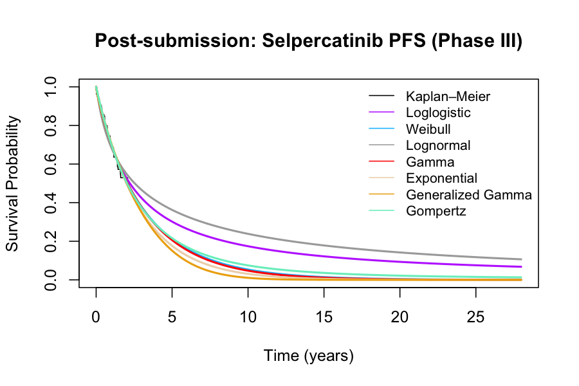 | 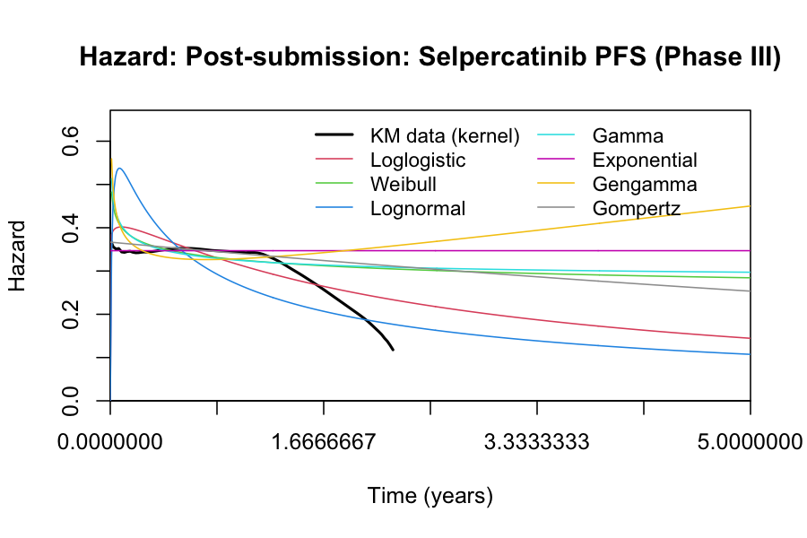

Figure S10. Overall survival extrapolation and hazard assessment for selpercatinib based on LIBRETTO-431
Figure S10a Kaplan–Meier with fitted parametric curves | Figure S10b Observed and predicted hazard functions
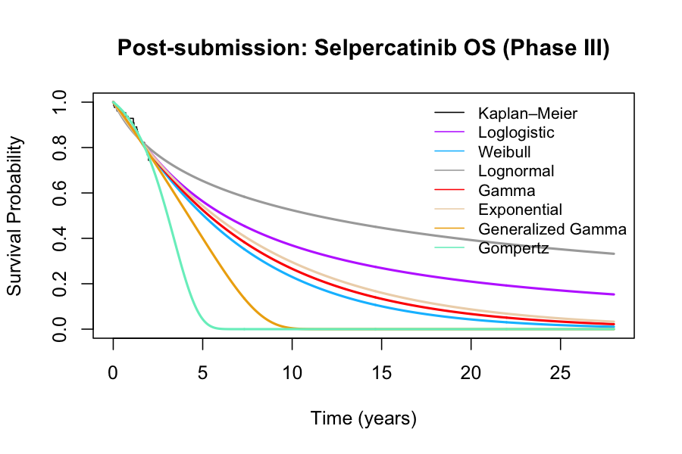 | 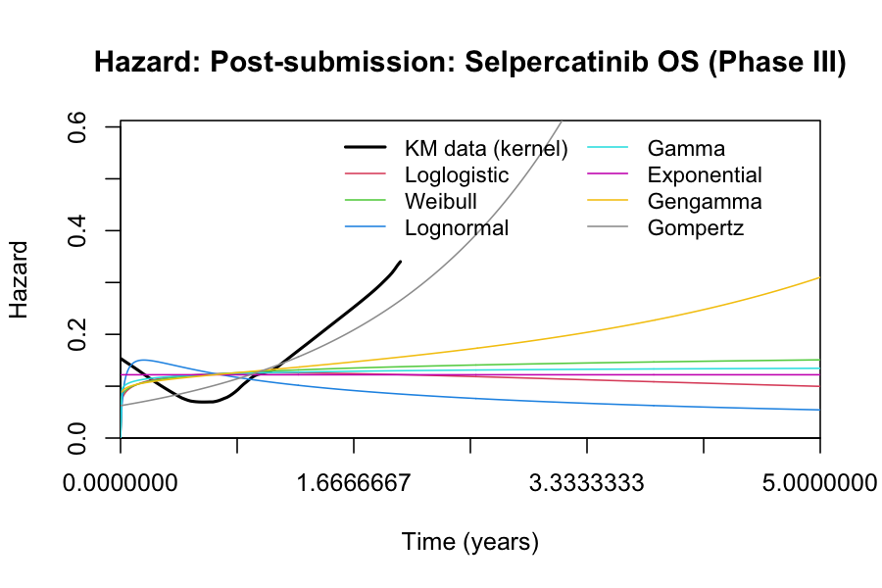

Figure S11. Progression-free survival extrapolation and hazard assessment for SoC based on LIBRETTO-431
Figure S11a Kaplan–Meier with fitted parametric curves | Figure S11b Observed and predicted hazard functions
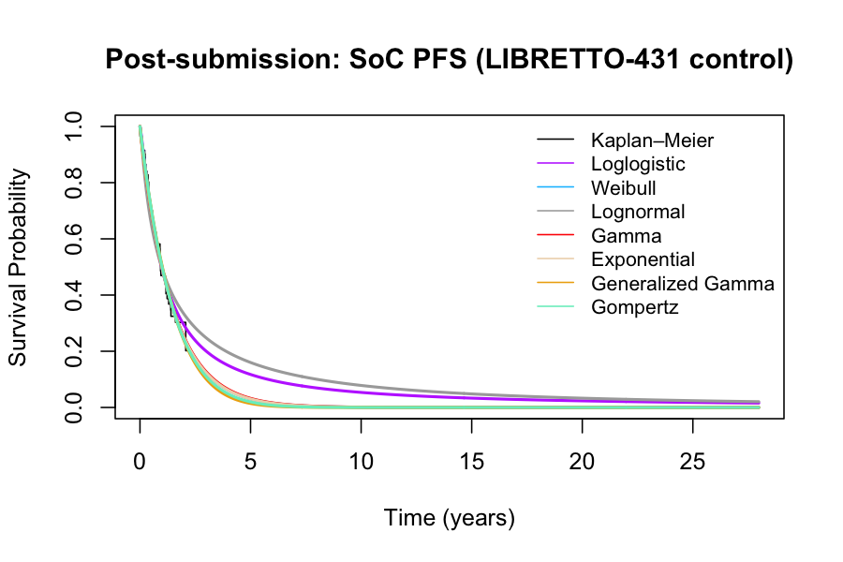 | 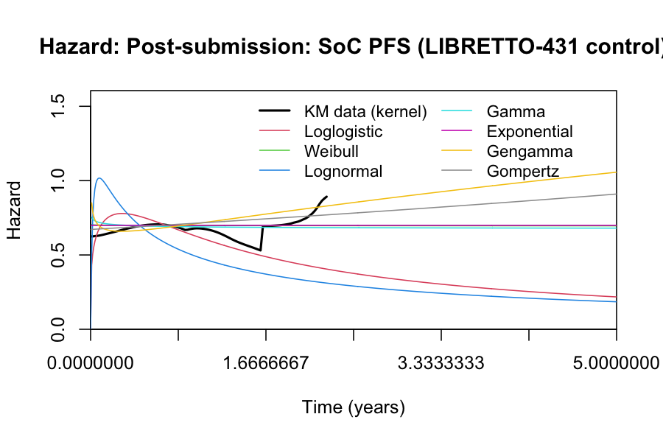

Figure S12. Overall survival extrapolation and hazard assessment for SoC based on LIBRETTO-431
Figure S12a Kaplan–Meier with fitted parametric curves | Figure S12b Observed and predicted hazard functions
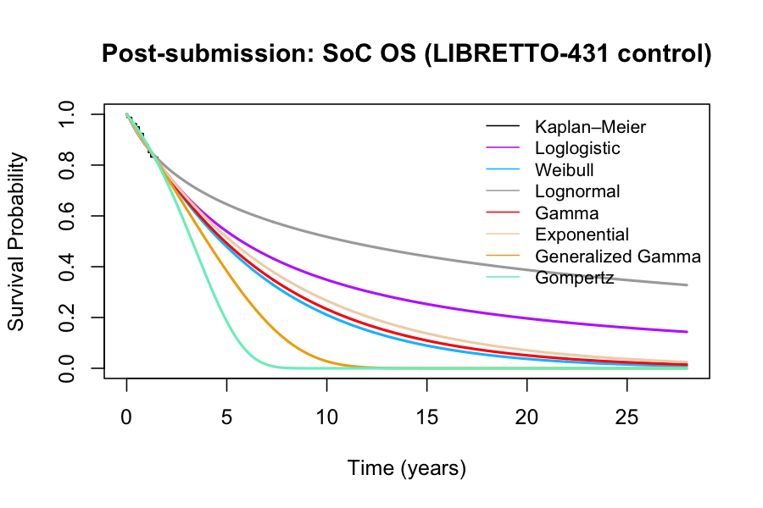 | 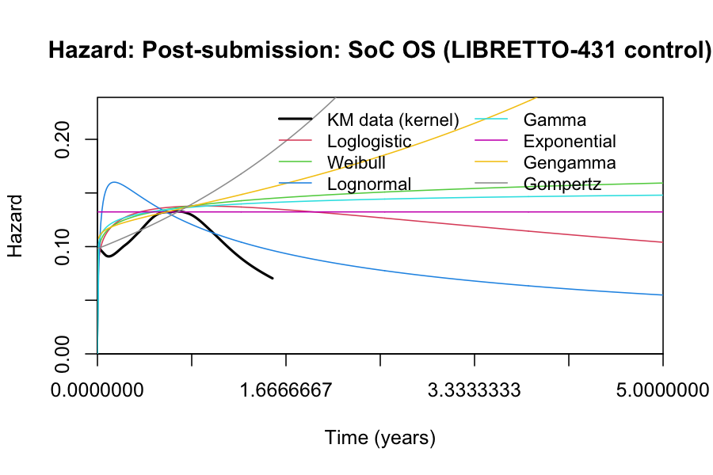

Figure S13. Overall survival extrapolation and hazard assessment for SoC based on KEYNOTE five-year outcome
Figure S13a Kaplan–Meier with fitted parametric curves | Figure S13b Observed and predicted hazard functions
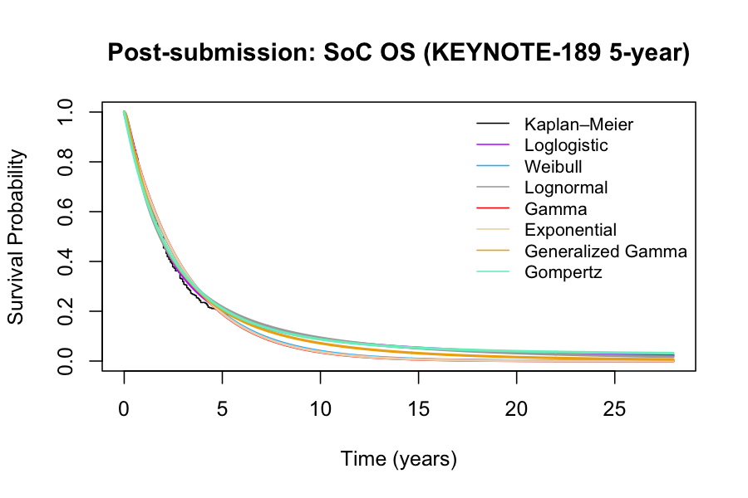 | 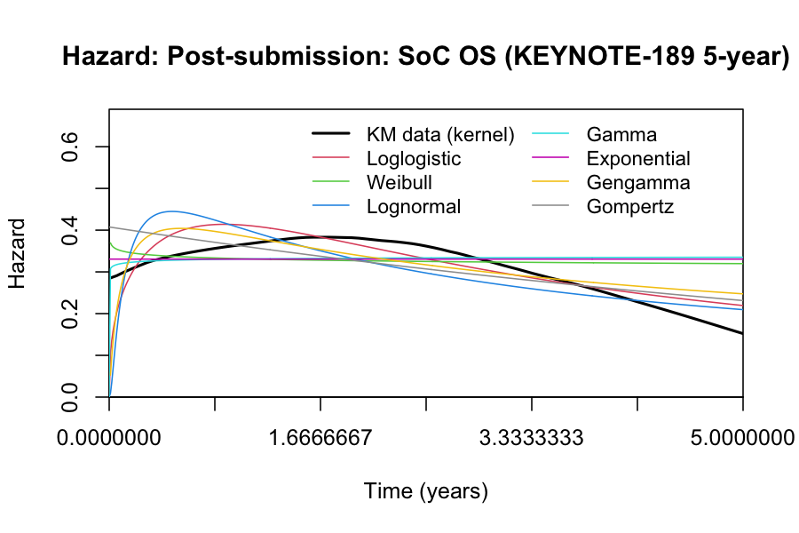

Table S1. Absolute shortfall across standard-of-care (SoC) evidence sources
SoC evidence source | Undiscounted QALYs^{d} | Absolute shortfall
KEYNOTE-189 | 1.16 | 10.52
US RWE | 1.05 | 10.62
SEE | 1.66 | 10.02
SEE + KEYNOTE-189 | 1.26 | 10.42
SEE + US RWE | 1.40 | 10.28
KEYNOTE 5-year Outcome | 1.32 | 10.36
Average (non-SEE SoC evidence)ª | 1.18 | 10.50
Average (SEE-informed SoC evidence)^{b} | 1.43 | 10.25
Average (all SoC evidence)^{c} | 1.31 | 10.37

Abbreviations: SEE, structured expert elicitation; RWE, real-world evidence; QALY, quality-adjusted life year.
ª Average of KEYNOTE-189, U.S. RWE, and KEYNOTE-189 five-year follow-up.
^{b} Average of SEE alone, SEE + KEYNOTE-189, and SEE + US RWE.
^{c} Average across all SoC evidence sources listed above.
^{d} Rounded to closest two decimals.

Table S2. Demographic and disease characteristics of the patients across published clinical evidence
Treatment | 1st line SoC |  |  | 1st line Selpercatinib
Trial | KEYNOTE-189  (N = 410) | US RWE  (N = 283) | LIBRETTO-431  (N = 83) | LIBRETTO-001  (N = 39) | LIBRETTO-431  (N = 129)
Characteristics
Age, median (range) - years | 65 (34-84) | 66 (33-84) | 62 (31-83) | 61 (21-86) | 60 (31-84)
Sex, male – no. (%) | 254 (62.0) | 168 (59.4) | 35 (42.2) | 17 (43.6) | 64 (49.6)
ECOG performance-status score – no. (%)
0 | 186 (45.4) | 134 (47.3) | 27 (32.5) | 18 (46.1) | 45 (34.9)
1 | 221 (53.9) | 149 (52.7) | 52 (62.7) | 21 (53.8) | 81 (62.8)
2 | 1 (0.2) | 0 (0.0) | 4 (4.8) | 0 (0.0) | 3 (2.3)
Smoking status
Current or former | 362 (88.3) | 260 (91.9) | 24 (28.9) | 10 (25.6) | 44 (34.1)
Never | 48 (11.7) | 23 (8.1) | 59 (71.1) | 29 (74.4) | 85 (65.9)
Brain metastases – no. (%) | 73 (17.8) | 34 (12.0) | 18 (21.7) | 7 (17.9) | 25 (19.4)
PD-L1 expression level – no. (%)
< 1% | 127 (31.0) | 79 (27.9) | 8 (9.6) | NA | 8 (6.2)
≥ 1% | 260 (63.4) | 156 (55.1) | 31 (37.3) | NA | 47 (36.4)
1% - 49% | 128 (31.2) | 77 (27.2) | 17 (20.5) | NA | 25 (19.4)
≥ 50% | 132 (32.2) | 79 (27.9) | 14 (16.9) | NA | 22 (17.5)
Unknown | 23 (5.6) | 48 (17.0) | 32 (38.6) | NA | 43 (33.3)
Abbreviations: ECOG, Eastern Cooperative Oncology Group; NA, not available; PD-L1, programmed death ligand 1; RWE, real-world evidence; SoC, standard of care.
Note: Patient characteristics for KEYNOTE-189 and the KEYNOTE-189 five-year outcome are identical because the latter reports longer follow-up from the same trial population.

Table S3. Akaike and Bayesian information criteria (AIC/BIC) for candidate parametric models used in survival extrapolation
Analysis and evidence source | Distribution | AIC | BIC
Pre-submission selpercatinib PFS | Loglogistic | 127.209 | 131.677
Pre-submission selpercatinib PFS | Weibull | 127.402 | 131.87
Pre-submission selpercatinib PFS | Lognormal | 127.872 | 132.34
Pre-submission selpercatinib PFS | Gamma | 127.225 | 131.693
Pre-submission selpercatinib PFS | Exponential | 127.58 | 129.814
Pre-submission selpercatinib PFS | Gen gamma | 129.091 | 135.793
Pre-submission selpercatinib PFS | Gompertz | 128.422 | 132.89
Pre-submission selpercatinib OS | Loglogistic | 112.878 | 117.346
Pre-submission selpercatinib OS | Weibull | 113.089 | 117.558
Pre-submission selpercatinib OS | Lognormal | 113.573 | 118.041
Pre-submission selpercatinib OS | Gamma | 112.997 | 117.465
Pre-submission selpercatinib OS | Exponential | 113.768 | 116.002
Pre-submission selpercatinib OS | Gen gamma | 114.981 | 121.683
Pre-submission selpercatinib OS | Gompertz | 114.158 | 118.626
Pre-submission SoC PFS (KEYNOTE-189) | Loglogistic | 490.745 | 498.777
Pre-submission SoC PFS (KEYNOTE-189) | Weibull | 492.98 | 501.012
Pre-submission SoC PFS (KEYNOTE-189) | Lognormal | 498.751 | 506.784
Pre-submission SoC PFS (KEYNOTE-189) | Gamma | 491.148 | 499.18
Pre-submission SoC PFS (KEYNOTE-189) | Exponential | 510.564 | 514.58
Pre-submission SoC PFS (KEYNOTE-189) | Gen gamma | 492.327 | 504.376
Pre-submission SoC PFS (KEYNOTE-189) | Gompertz | 503.577 | 511.609
Pre-submission SoC OS (KEYNOTE-189) | Loglogistic | 512.444 | 520.476
Pre-submission SoC OS (KEYNOTE-189) | Weibull | 511.907 | 519.939
Pre-submission SoC OS (KEYNOTE-189) | Lognormal | 516.507 | 524.539
Pre-submission SoC OS (KEYNOTE-189) | Gamma | 511.918 | 519.95
Pre-submission SoC OS (KEYNOTE-189) | Exponential | 513.211 | 517.227
Pre-submission SoC OS (KEYNOTE-189) | Gen gamma | 513.905 | 525.954
Pre-submission SoC OS (KEYNOTE-189) | Gompertz | 512.663 | 520.696
Pre-submission SoC PFS (KEYNOTE-189) | Loglogistic | 490.745 | 498.777
Pre-submission SoC PFS (KEYNOTE-189) | Weibull | 492.98 | 501.012
Pre-submission SoC PFS (KEYNOTE-189) | Lognormal | 498.751 | 506.784
Pre-submission SoC PFS (KEYNOTE-189) | Gamma | 491.148 | 499.18
Pre-submission SoC PFS (KEYNOTE-189) | Exponential | 510.564 | 514.58
Pre-submission SoC PFS (KEYNOTE-189) | Gen gamma | 492.327 | 504.376
Pre-submission SoC PFS (KEYNOTE-189) | Gompertz | 503.577 | 511.609
Pre-submission SoC OS (US RWE) | Loglogistic | 495.204 | 502.488
Pre-submission SoC OS (US RWE) | Weibull | 495.904 | 503.187
Pre-submission SoC OS (US RWE) | Lognormal | 493.928 | 501.212
Pre-submission SoC OS (US RWE) | Gamma | 495.934 | 503.218
Pre-submission SoC OS (US RWE) | Exponential | 493.934 | 497.576
Pre-submission SoC OS (US RWE) | Gen gamma | 495.143 | 506.068
Pre-submission SoC OS (US RWE) | Gompertz | 495.606 | 502.89
Post-submission selpercatinib PFS | Loglogistic | 214.812 | 220.531
Post-submission selpercatinib PFS | Weibull | 213.462 | 219.182
Post-submission selpercatinib PFS | Lognormal | 219.877 | 225.596
Post-submission selpercatinib PFS | Gamma | 213.333 | 219.053
Post-submission selpercatinib PFS | Exponential | 211.971 | 214.831
Post-submission selpercatinib PFS | Gen gamma | 215.033 | 223.613
Post-submission selpercatinib PFS | Gompertz | 213.893 | 219.612
Post-submission selpercatinib OS | Loglogistic | 147.512 | 153.232
Post-submission selpercatinib OS | Weibull | 146.517 | 152.237
Post-submission selpercatinib OS | Lognormal | 151.653 | 157.373
Post-submission selpercatinib OS | Gamma | 146.659 | 152.378
Post-submission selpercatinib OS | Exponential | 144.745 | 147.605
Post-submission selpercatinib OS | Gen gamma | 147.535 | 156.115
Post-submission selpercatinib OS | Gompertz | 143.25 | 148.969
Post-submission SoC PFS (LIBRETTO-431) | Loglogistic | 145.322 | 150.16
Post-submission SoC PFS (LIBRETTO-431) | Weibull | 142.522 | 147.36
Post-submission SoC PFS (LIBRETTO-431) | Lognormal | 154.696 | 159.534
Post-submission SoC PFS (LIBRETTO-431) | Gamma | 142.5 | 147.337
Post-submission SoC PFS (LIBRETTO-431) | Exponential | 140.522 | 142.941
Post-submission SoC PFS (LIBRETTO-431) | Gen gamma | 144.094 | 151.35
Post-submission SoC PFS (LIBRETTO-431) | Gompertz | 142.473 | 147.311
Post-submission SoC OS (LIBRETTO-431) | Loglogistic | 82.684 | 87.522
Post-submission SoC OS (LIBRETTO-431) | Weibull | 82.498 | 87.336
Post-submission SoC OS (LIBRETTO-431) | Lognormal | 84.769 | 89.607
Post-submission SoC OS (LIBRETTO-431) | Gamma | 82.529 | 87.367
Post-submission SoC OS (LIBRETTO-431) | Exponential | 80.582 | 83.001
Post-submission SoC OS (LIBRETTO-431) | Gen gamma | 84.342 | 91.599
Post-submission SoC OS (LIBRETTO-431) | Gompertz | 82.147 | 86.984
Post-submission SoC OS (KEYNOTE-189 5-year) | Loglogistic | 1321.94 | 1329.97
Post-submission SoC OS (KEYNOTE-189 5-year) | Weibull | 1343.67 | 1351.7
Post-submission SoC OS (KEYNOTE-189 5-year) | Lognormal | 1331.73 | 1339.77
Post-submission SoC OS (KEYNOTE-189 5-year) | Gamma | 1343.87 | 1351.9
Post-submission SoC OS (KEYNOTE-189 5-year) | Exponential | 1341.93 | 1345.95
Post-submission SoC OS (KEYNOTE-189 5-year) | Gen gamma | 1329.45 | 1341.5
Post-submission SoC OS (KEYNOTE-189 5-year) | Gompertz | 1334.38 | 1342.41

Abbreviations: AIC, Akaike information criterion; BIC, Bayesian information criterion; OS, overall survival; PFS, progression-free survival; RWE, real-world evidence; SoC, standard of care.

Table S4. Summary of survival extrapolation and hazard plausibility assessment for progression-free and overall survival
End point | Evidence source | Extrapolation assessment | Hazard rate assessment | Selected distribution
“Pre-submission” selpercatinib PFS | LIBRETTO-001 trial | Figure S3a | Figure S3b | Gamma
“Pre-submission” selpercatinib OS | LIBRETTO-001 trial | Figure S4a | Figure S4b | Gompertz
“Pre-submission” SoC PFS in analysis 4 | KEYNOTE-189 trial | Figure S5a | Figure S5b | Log-logistic
“Pre-submission” SoC OS in analysis 4 | KEYNOTE-189 trial | Figure S6a | Figure S6b | Weibull
“Pre-submission” SoC PFS in analysis 5 | US RWE study | Figure S7a | Figure S7b | Log-logistic
“Pre-submission” SoC OS in analysis 5 | US RWE study | Figure S8a | Figure S8b | Exponential
“Post-submission” selpercatinib PFS | LIBRETTO-431 trial | Figure S9a | Figure S9b | Gamma
“Post-submission” selpercatinib OS | LIBRETTO-431 trial | Figure S10a | Figure S10b | Gompertz
“Post-submission” SoC PFS | LIBRETTO-431 trial | Figure S11a | Figure S11b | Gamma
“Post-submission” SoC OS in analysis 6 | LIBRETTO-431 trial | Figure S12a | Figure S12b | Gompertz
“Post-submission” SoC OS in analysis 7 | KEYNOTE-189 five-year outcome | Figure S13a | Figure S13b | Log-logistic

Abbreviations: OS, overall survival; PFS, progression-free survival; SoC, standard of care.

Table S5. Comparison of SEE procedures used in this study with established elicitation frameworks
Features | SEE procedures in our analysis | SHELF | Modified Delphi | Cooke | IDEA | MRC | STEER
Encoding | FIM | FIM & VIM | No guidance | VIM | No guidance | FIM (preferred) | FIM (preferred)
Level of elicitation | Individual | Group preceded by individual | Multiple rounds of individual | Individual | Two rounds of individual | Individual (preferred) | Group-based elicitation with individual judgments
Aggregation Approach | Mathematical | Consensus | Iterative consensus | Mathematical | Mathematical | Mathematical | Mathematical or consensus
Interaction between experts | No interaction | Yes, facilitated | No interaction | No interaction | Optional | No interaction | Optional
Mode of administration | Digital/ Remote | Face to face (preferred) | Remote | Face to face (preferred) | Both possible | Face to face (preferred) | Both possible
Feedback to experts | Yes, visual feedback during individual interview | Group discussion | Summaries of previous rounds | Yes | Feedback between rounds | Yes | Yes
Rationales | Not formally captured | Captured and discussed | Captured and reported | Captured and reported | Captured and discussed | Captured and reported | Captured and reported
Distribution fitting | MATCH uncertainty elicitation tool | Embedded in SHELF software | No guidance | No guidance | No guidance | No guidance | Recommends fitting distributions to individual judgments prior to aggregation
Validation | Not explicit | Not explicit | Not explicit | Seed questions used for weighting | Past assessments may inform screening | Emphasizes internal and external review | Emphasizes internal and external review
Managing biases | Pre-read dossier evidence and materials; framing using bounds | Bounds-first questioning | Bounds-first questioning | Bounds-first questioning and performance weighting | Bounds-first questioning | Bounds-first questioning | Pre-read dossier evidence and materials; training and Bounds-first questioning

Abbreviations: SEE, structured expert elicitation; FIM, fixed-interval method; VIM, variable-interval method; SHELF, Sheffield Elicitation Framework; IDEA, Investigate–Discuss–Estimate–Aggregate framework; MRC, UK Medical Research Council guidance on expert elicitation; MATCH, Multidisciplinary Assessment of Technology for Healthcare; STEER, Structured Expert Elicitation Resources.

Table S6. SEE Extrapolation
Modeling fitting curves | Extrapolation results
“Pre-submission” SoC OS using SEE only | 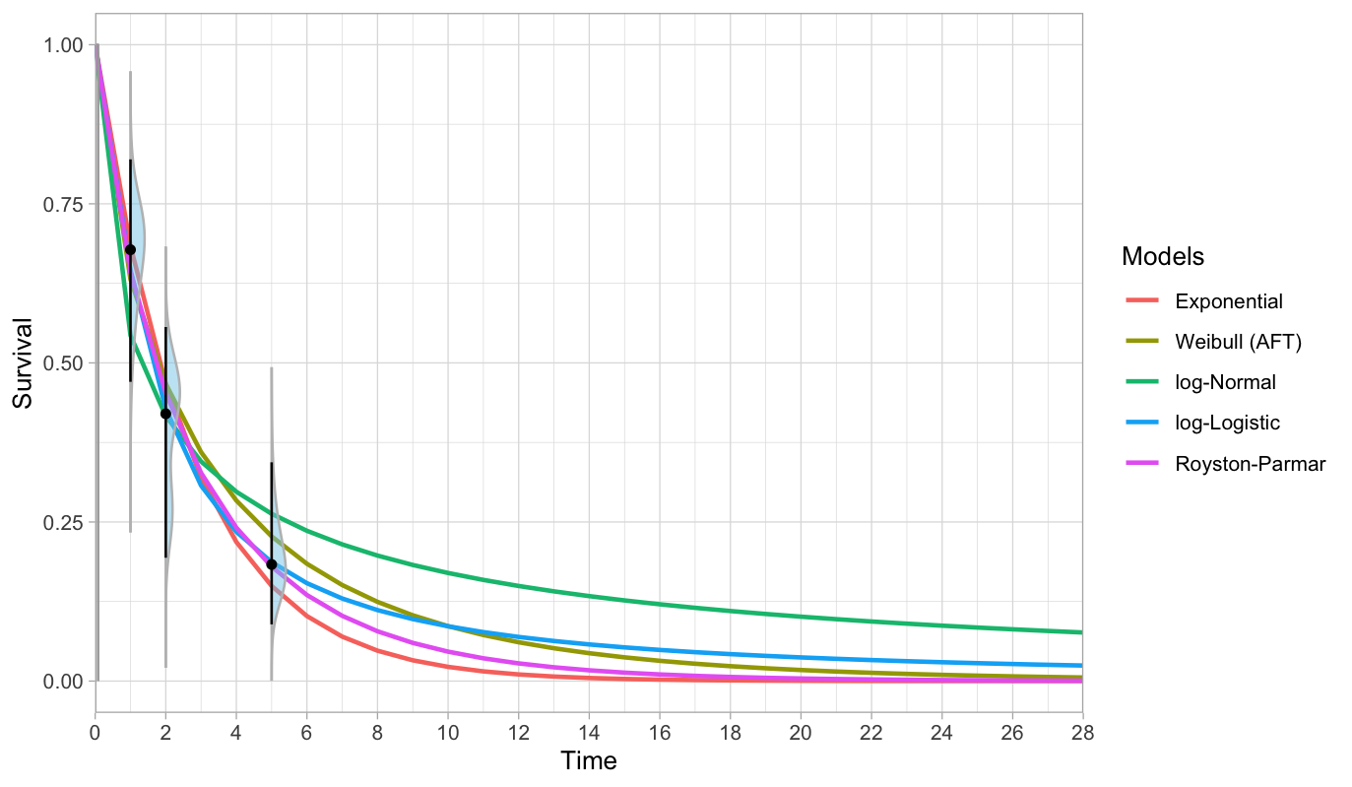
“Pre-submission” SoC OS using SEE and KEYNOTE-189 trial data (as a prior) | 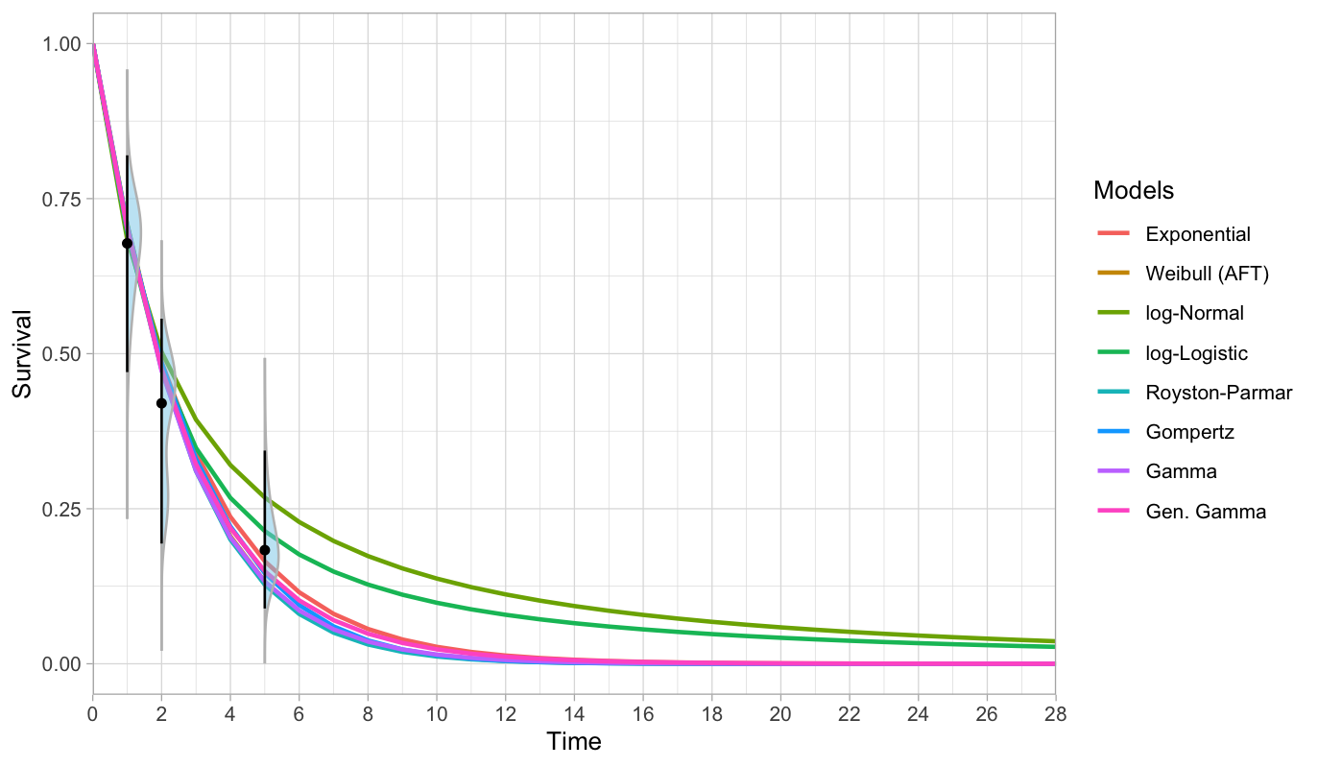
“Pre-submission” SoC OS using SEE and US RWE study data (as a prior) | 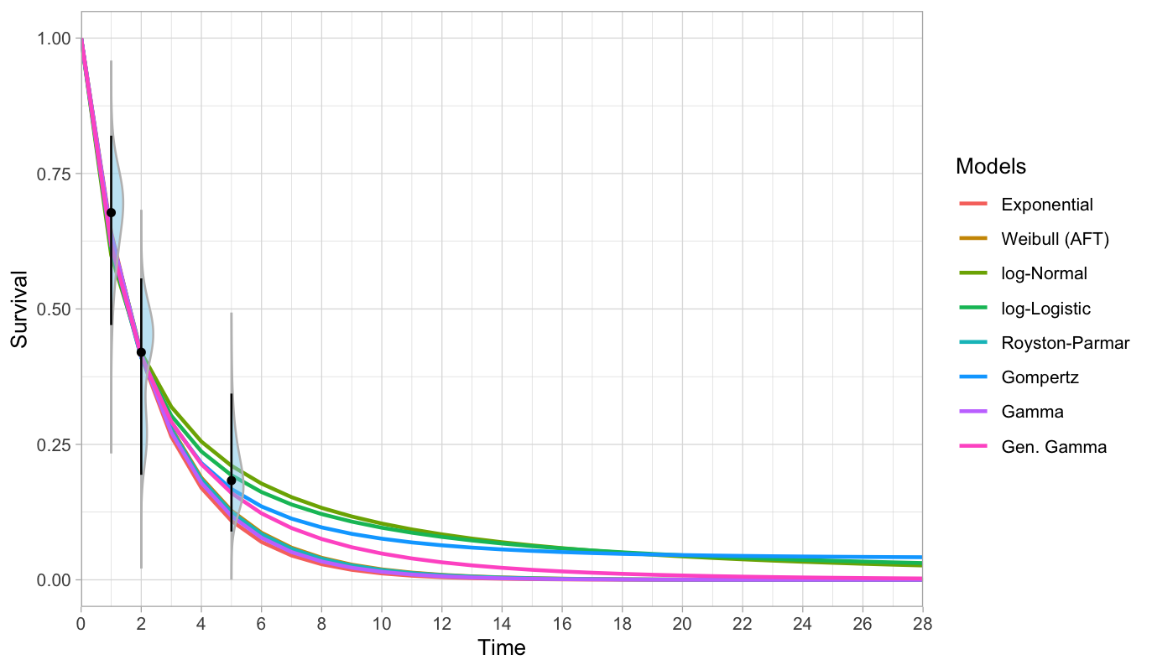
“Pre-submission” SoC PFS using SEE only | 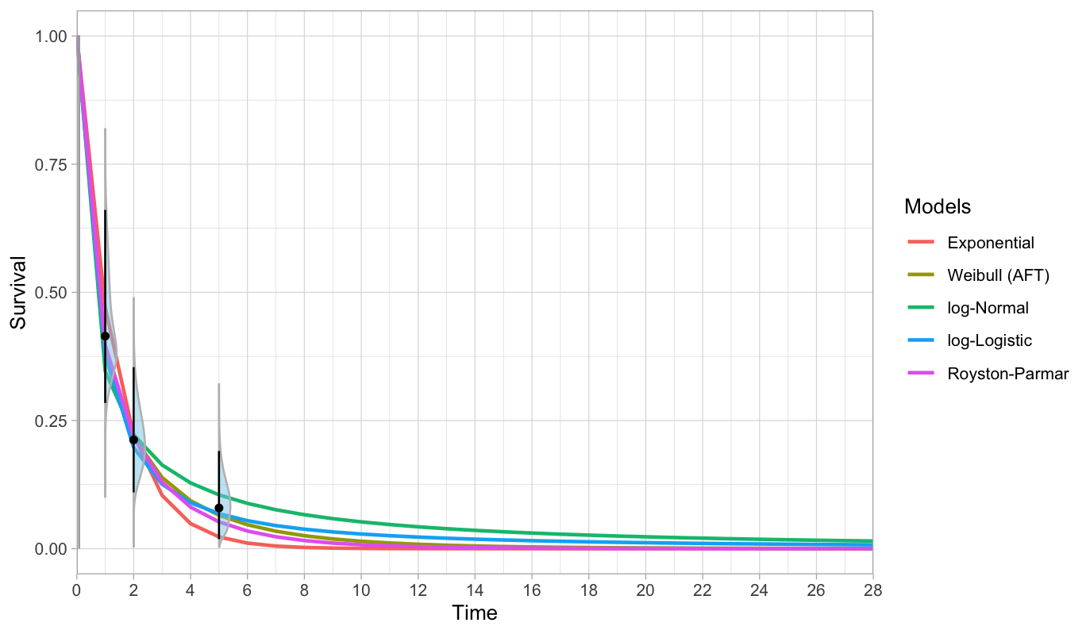
“Pre-submission” SoC PFS using SEE and KEYNOTE-189 trial data (as a prior) | 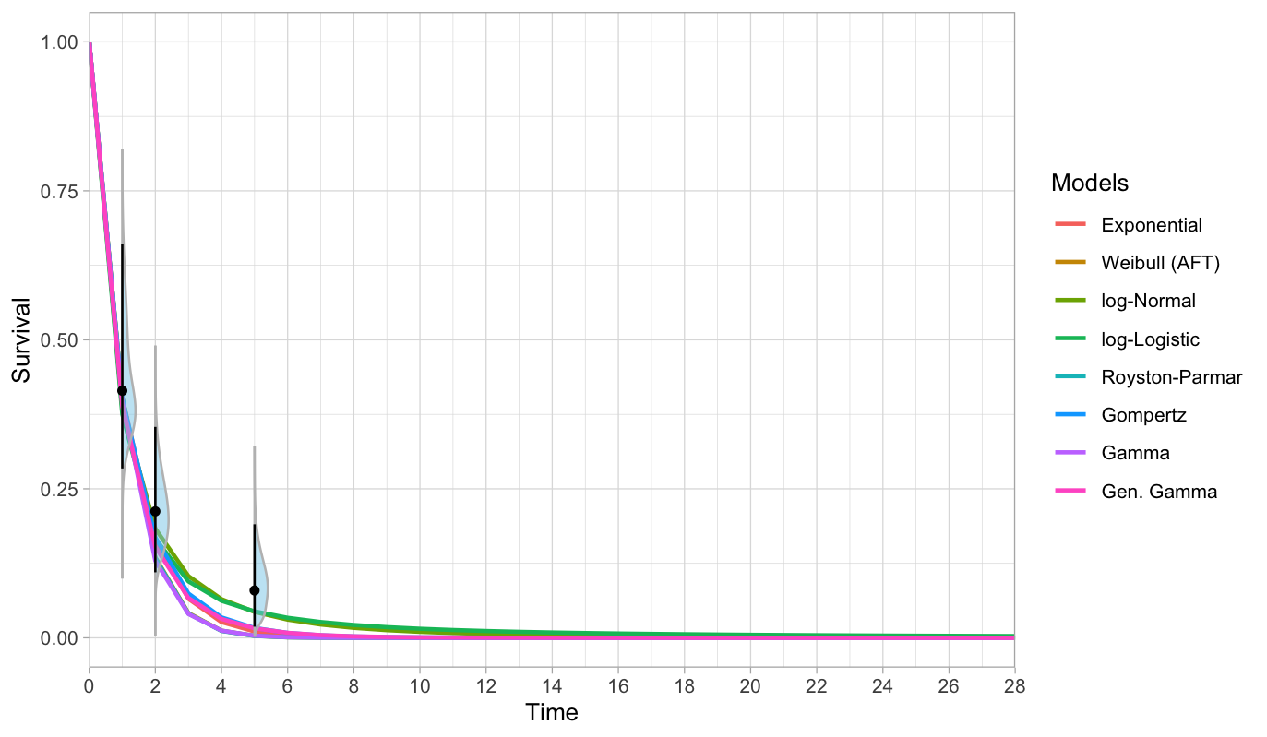
“Pre-submission” SoC PFS using SEE and US RWE study data (as a prior) | 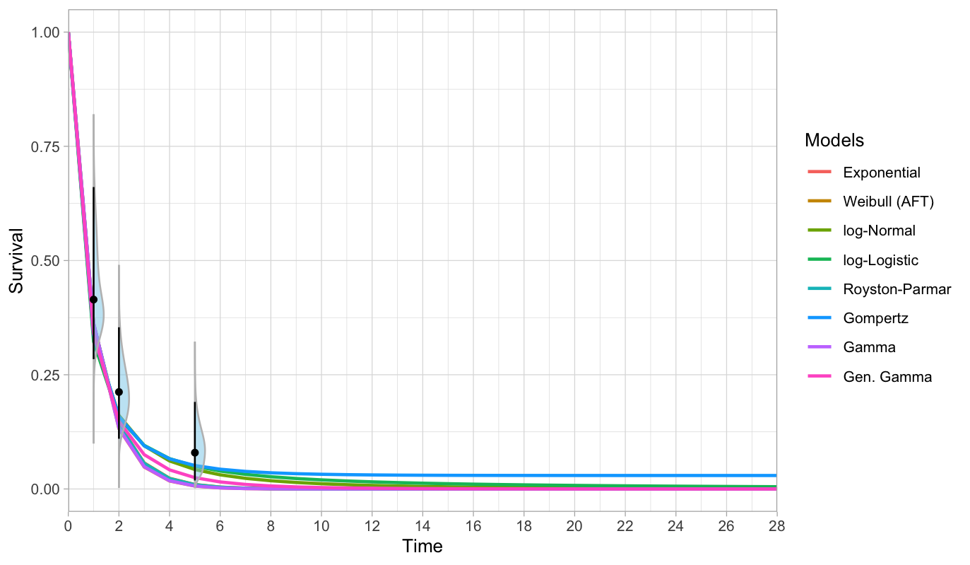

Table S7. Adverse events included in this study, according to LIBRETTO-431 trial data
Event | Mean length of hospitalization stay (days) [12] | Selpercatinib | SoC
AST increase | 7.7 | 13% | 1%
ALT increase | 7.7 | 22% | 3%
Hypertension | 4.2 | 20% | 3%
Fatigue | 3.1 | 3% | 5%
Thrombocytopenia | 5.3 | 3% | 7%
Leukopenia | 6.8 | 1% | 7%
Neutropenia | 6.8 | 2% | 28%
QT prolongation on ECG | 4.2 | 9% | 0%
Anemia | 3.7 | 1% | 10%

Abbreviations: ALT, alanine aminotransferase; AST, aspartate aminotransferase; ECG, electrocardiogram; QT, QT interval; SoC, standard of care.

Table S8. Disaggregated mean discounted cost components across pre- and post-submission analyses
Analysis | Arm | Source of evidence | First-line treatment | Second-line treatment | Best supportive care | Patient follow-up | Adverse event management | End-of-life
Pre-submission | Selpercatinib | LIBRETTO-001 | 18,219 (35.04%) | 2,416 (4.65%) | 4,561 (8.77%) | 646 (1.24%) | 13,124 (25.24%) | 13,029 (25.06%)
Pre-submission | SoC | SEE | 6,990 (19.32%) | 86 (0.22%) | 5,887 (15.40%) | 852 (2.23%) | 11,074 (28.97%) | 13,332 (34.88%)
Pre-submission | SoC | SEE + KEYNOTE-189 | 7,636 (19.91%) | 59 (0.16%) | 5,210 (13.59%) | 745 (1.94%) | 11,074 (28.88%) | 13,724 (36.85%)
Pre-submission | SoC | SEE + US RWE | 6,838 (18.36%) | 70 (0.19%) | 4,845 (13.01%) | 692 (1.86%) | 11,074 (29.73%) | 13,724 (36.85%)
Pre-submission | SoC | KEYNOTE-189 | 7,478 (20.26%) | 54 (0.15%) | 3,783 (10.25%) | 641 (1.74%) | 11,074 (30.00%) | 13,884 (37.61%)
Pre-submission | SoC | US RWE | 6,497 (18.34%) | 73 (0.21%) | 3,180 (8.98%) | 573 (1.62%) | 11,074 (31.26%) | 14,032 (39.61%)
Post-submission | Selpercatinib | LIBRETTO-431 | 24,176 (43.13%) | 2,843 (5.07%) | 2,027 (3.62%) | 562 (1.00%) | 13,124 (23.42%) | 13,315 (23.76%)
Post-submission | SoC | LIBRETTO-431 | 10,539 (21.74%) | 75 (0.15%) | 13,868 (28.61%) | 1,248 (2.57%) | 11,074 (22.85%) | 11,664 (24.06%)
Post-submission | SoC | LIBRETTO-431 + KEYNOTE 5-Year Outcomes | 8,756 (21.39%) | 54 (0.13%) | 6,958 (17.00%) | 896 (2.19%) | 11,074 (27.06%) | 13,188 (32.22%)

Abbreviations: SEE, structured expert elicitation; SoC, standard of care; RWE, real-world evidence.
Note: Values are mean discounted costs in 2024 US$, with percentage contribution to total mean discounted costs shown in parentheses. Costs were rounded to the nearest integer and percentages to two decimal places. Patient follow-up includes costs of outpatient visits and CT scans.

Table S9. Undiscounted life-years (LY) and quality-adjusted life years (QALY) from the probabilistic analysis
Phases | Strategies | Sources of evidence | Undiscounted  total QALYs | Undiscounted  total LYs
Pre-submission | SoC
Pre-submission | 1) | KEYNOTE-189 | 1.16  (0.92 - 1.43) | 2.47  (2.02 – 3.04)
Pre-submission | 2) | US RWE | 1.05  (0.82 – 1.32) | 2.26  (1.90 – 2.69)
Pre-submission | 3) | SEE | 1.66  (1.10 – 2.58) | 3.80  (2.42 – 8.38)
Pre-submission | 4) | SEE + KEYNOTE-189 | 1.26  (1.02 - 1.53) | 2.88  (2.55 – 3.27)
Pre-submission | 5) | SEE + US RWE | 1.40  (1.10 – 1.74) | 3.80  (3.06 – 4.62)
Pre-submission | Selpercatinib | LIBRETTO-001 | 2.85  (1.57 – 6.55) | 4.73  (2.67 – 12.23)
Post-submission | SoC
Post-submission | 6) | LIBRETTO-431 | 1.89  (0.95 – 4.86) | 6.52  (2.09 – 21.52)
Post-submission | 7) | LIBRETTO-431 +  KEYNOTE 5-Year Outcome | 1.32  (0.99 – 1.70) | 3.09  (2.74 – 3.46)
Post-submission | Selpercatinib | LIBRETTO-431 | 3.06  (1.65 – 7.74) | 4.53  (2.61 – 11.77)
Abbreviations: LY, life-year; QALY, quality-adjusted life-year; RWE, real-world evidence; SEE, structured expert elicitation; SoC, standard of care.

Table S10. Probabilistic mean (95% credible interval) cost-effectiveness results from time-horizon scenario analyses
Panel A. 5-year time horizon
Phases | Strategies | Sources of evidence | Discounted total costs ($) | Discounted total QALYs | Discounted total LYs | ICER ($/QALY) | ICER ($/LY)
Pre-submission | SoC | 1) SEE | 33,283 (28,810–38,429) | 0.95 (0.71–1.22) | 2.05 (1.59–2.42) | 15,690 | 15,607
 |  | 2) SEE + KEYNOTE-189 | 35,063 (30,717–39,877) | 0.96 (0.79–1.12) | 2.18 (1.97–2.39) | 13,679 | 15,875
 |  | 3) SEE + US RWE | 34,065 (29,916–38,729) | 0.84 (0.69–1.00) | 1.97 (1.77–2.16) | 13,057 | 13,310
 |  | 4) KEYNOTE-189 | 35,367 (31,189–40,116) | 0.90 (0.74–1.06) | 2.03 (1.73–2.31) | 12,416 | 12,724
 |  | 5) US RWE | 34,145 (30,132–38,680) | 0.77 (0.62–0.92) | 1.79 (1.58–2.01) | 12,020 | 11,097
 | Selpercatinib | LIBRETTO-001 | 46,290 (38,643–54,962) | 1.78 (1.42–2.14) | 2.89 (2.39–3.42) | / | /
Post-submission | SoC | 6) LIBRETTO-431 | 38,266 (32,008–44,370) | 1.20 (0.88–1.56) | 2.89 (1.96–3.83) | 13,816 | 227,521
 |  | 7) LIBRETTO-431 + KEYNOTE 5-Year Outcome | 35,164 (30,708–40,146) | 1.09 (0.83–1.36) | 2.23 (2.07–2.38) | 15,568 | 19,500
 | Selpercatinib | LIBRETTO-431 | 49,121 (40,716–58,633) | 1.98 (1.63–2.33) | 2.94 (2.54–3.52) | / | /

Panel B. 10-year time horizon
Phases | Strategies | Sources of evidence | Discounted total costs (US$) | Discounted total QALYs | Discounted total LYs | ICER (US$/QALY) | ICER (US$/LY)
Pre-submission | SoC | 1) SEE | 36,276 (31,160–42,088) | 1.15 (0.82–1.58) | 2.57 (1.93–3.41) | 18,253 | 19,697
 |  | 2) SEE + KEYNOTE-189 | 37,653 (33,072–42,859) | 1.07 (0.87–1.29) | 2.51 (2.11–2.97) | 15,023 | 16,416
 |  | 3) SEE + US RWE | 36,446 (32,059–41,356) | 0.95 (0.77–1.15) | 2.30 (1.96–2.66) | 14,507 | 14,160
 |  | 4) KEYNOTE-189 | 36,808 (32,387–41,908) | 0.99 (0.80–1.18) | 2.19 (1.82–2.63) | 14,606 | 12,465
 |  | 5) US RWE | 35,329 (31,192–39,977) | 0.86 (0.69–1.04) | 1.94 (1.69–2.22) | 14,235 | 11,237
 | Selpercatinib | LIBRETTO-001 | 50,680 (42,503–60,788) | 1.93 (1.47–2.48) | 3.30 (2.47–4.98) | / | /
Post-submission | SoC | 6) LIBRETTO-431 | 42,912 (35,694–53,291) | 1.35 (0.90–2.08) | 3.65 (2.00–6.67) | 11,545 | -60,244
 |  | 7) LIBRETTO-431 + KEYNOTE 5-Year Outcome | 38,544 (33,721–43,948) | 1.20 (0.91–1.53) | 2.73 (2.49–2.98) | 13,808 | 22,049
 | Selpercatinib | LIBRETTO-431 | 54,476 (44,648–66,635) | 2.35 (1.78–2.98) | 3.46 (2.76–4.98) | / | /

Abbreviations: ICER, incremental cost-effectiveness ratio; LY, life-year; QALY, quality-adjusted life-year; RWE, real-world evidence; SEE, structured expert elicitation; SoC, standard of care.
Note: Values are probabilistic means with 95% credible intervals from 10,000 simulations. We calculated ICERs relative to selpercatinib within the corresponding phase and evidence scenario. Costs were converted from NOK to US$ using 1 US$ = 10.7574 NOK. Costs and ICERs were rounded to the nearest integer; QALYs and LYs were rounded to two decimal places.

Table S11. Probabilistic mean (95% credible interval) cost-effectiveness results from parametric survival distribution scenario analyses
Scenario analysis | Parametric distribution | Discounted total costs (US$) | Discounted total QALYs | Discounted total LYs | ICER (US$/QALY) | ICER (US$/LY)
Pre-submission SEE-only SoC OS | Weibull (base case) | 38,220 (31,947–47,728) | 1.29 (0.85–2.84) | 2.99 (2.03–5.08) | 19,819 | 25,146
 | Exponential (scenario) | 36,554 (31,771–42,189) | 1.21 (0.82–2.00) | 2.55 (2.02–3.30) | 20,084 | 15,573
Post-submission LIBRETTO-431 SoC OS | Gompertz (base case) | 48,467 (35,718–82,526) | 1.56 (0.90–3.28) | 4.86 (2.00–13.25) | 8,257 | -6,385
 | Weibull (scenario) | 50,859 (37,750–68,531) | 1.64 (1.00–2.52) | 5.37 (2.19–9.06) | 6,226 | -3,051

Abbreviations: ICER, incremental cost-effectiveness ratio; LY, life-year; OS, overall survival; QALY, quality-adjusted life-year; SEE, structured expert elicitation; SoC, standard of care.
Note: Values are probabilistic means with 95% credible intervals from 10,000 simulations. We calculated ICERs relative to selpercatinib in the corresponding base-case analysis. Costs and ICERs were rounded to the nearest integer; QALYs and LYs were rounded to two decimal places.

Reference

[1] Norwegian Institute of Public Health. Guidelines for the submission of documentation for single technology assessment (STA) of pharmaceuticals 2018.
[2] Nye Metoder. Method Notice: ID2020_076 (ID2022_118) Selperkatinib (Retsevmo) as Monotherapy for Treating Adults with Advanced RET-Fusion-Positive Non-Small Cell Lung Cancer (NSCLC) Who Have Not Previously Been Treated with a RET Inhibitor – New Price 2022.
[3] Norwegian Medical Products Agency. Severity calculation and age adjustment n.d.
[4] Norwegian Directorate of Health. Regelverk for innsatsstyrt finansiering 2024 (ISF-regelverket) 2023.
[5] Cooney P, White A. Direct Incorporation of Expert Opinion into Parametric Survival Models to Inform Survival Extrapolation. Med Decis Making 2023;43:325–36. https://doi.org/10.1177/0272989X221150212.
[6] Bojke L, Soares M, Claxton K, Colson A, Fox A, Jackson C, et al. Developing a reference protocol for structured expert elicitation in health-care decision-making: a mixed-methods study. Health Technol Assess 2021;25:1–124. https://doi.org/10.3310/hta25370.
[7] Oakley J. SHELF: Tools to Support the Sheffield Elicitation Framework 2015:1.12.0. https://doi.org/10.32614/CRAN.package.SHELF.
[8] Rowe G, Wright G, Bolger F. Delphi: A reevaluation of research and theory. Technol Forecast Soc Change 1991;39:235–51. https://doi.org/10.1016/0040-1625(91)90039-I.
[9] Cooke RM. Experts In Uncertainty: Opinion and Subjective Probability in Science. Oxford University PressNew York, NY; 1991. https://doi.org/10.1093/oso/9780195064650.001.0001.
[10] Hemming V, Burgman MA, Hanea AM, McBride MF, Wintle BC. A practical guide to structured expert elicitation using the IDEA protocol. Methods Ecol Evol 2018;9:169–80. https://doi.org/10.1111/2041-210X.12857.
[11] Jankovic D, Horscroft J, Lee D, Bojke L, Soares M. STEER: Open Access Resources for Conducting Structured Expert Elicitation for Health Care Decision Making. Med Decis Making 2025;45:627–39. https://doi.org/10.1177/0272989X251343013.
[12] Bilir SP, Ma Q, Zhao Z, Wehler E, Munakata J, Barber B. Economic Burden of Toxicities Associated with Treating Metastatic Melanoma in the United States. Am Health Drug Benefits 2016;9:203–13.

