Estimating the long-term clinical and economic impact of universal varicella vaccination in Portugal using a dynamic transmission model
Short running title: Estimating the impact of varicella vaccination in Portugal
Colleen Burgess (0000-0003-0393-0767),¹ Stephanie A. Kujawski (0000-0001-7915-8553)¹, Miguel Amorim (0009-0008-0400-8305),² and John C. Lang (0000-0002-1770-2995)^{3,*}
¹Merck & Co., Inc., Rahway, NJ, USA
²MSD (Portugal) Lda., Paço de Arcos, Portugal
³Merck Canada Inc., Kirkland, QC, Canada
Corresponding author:
John C. Lang
Merck Canada Inc.
16750 Trans-Canada Hwy,
Kirkland, QC, Canada
Email: john.lang@merck.com
Phone: 431-279-3780
Words of text: 2,769

Abstract
Background: Varicella vaccination is not currently included in Portugal’s childhood national immunization program. We modeled the clinical and economic impact of a 2-dose universal varicella vaccination (UVV) program in Portugal.
Methods: A dynamic transmission model was adapted to Portugal to assess the impact of UVV over a 50-year time horizon. Two 2-dose UVV strategies (first dose at 12 months, second dose at 5 years) were compared to no vaccination. Clinical outcomes included varicella and herpes zoster incidence rates, cases, deaths, quality-adjusted life years (QALYs) lost, and varicella-related health care resource use. Costs were assessed from the payer perspective (direct costs of treatment) and societal perspective (direct costs plus indirect costs of lost workdays).
Results: Both UVV strategies reduced total varicella cases by 79.4–85.3%, outpatient visits by 78.9–84.8%, and varicella hospitalizations by 69.3–71.3% compared to no varicella vaccination. Herpes zoster cases were reduced by 2.4–2.9%. These strategies resulted in the gain of 5,977–6,094 QALYs and cost savings of €12.0M–15.9M from the payer perspective and €84.2M–93.9M from the societal perspective.
Conclusions: A 2-dose UVV program is estimated to substantially reduce the burden of varicella disease in Portugal and to be cost-saving from both the payer and societal perspectives.
Keywords: Varicella, herpes zoster, universal varicella vaccination, cost-effectiveness modeling, Portugal

Key points for decision makers
- Compared to no varicella vaccination, UVV strategies reduced varicella cases by up to 85.3% and varicella-related hospitalizations by up to 71%.
- UVV strategies were estimated to save up to €15.9M from the payer perspective and €93.9 million from the societal perspective over 50 years, with averted varicella treatment costs more than offsetting the cost of the vaccination program.
- Implementing a 2-dose UVV program in Portugal is projected to reduce disease burden and lead to cost savings.

1.0 Introduction
Varicella (chickenpox) is a highly infectious viral disease whose symptoms include generalized rash, fever, headache, and fatigue [1]. Most cases are mild and self-limiting, but a small percentage progress to dermatological, neurologic, and respiratory complications and occasionally death [1]. Although varicella is primarily a childhood disease, morbidity and mortality rates are higher among adults and infants than among children, and are also increased in pregnant, immunocompromised, and immunosuppressed individuals [1]. Following the resolution of acute varicella illness, the varicella zoster virus establishes a latent infection within the trigeminal and dorsal root ganglia; subsequent reactivation of the virus results in herpes zoster (shingles), a painful rash with the potential to cause serious complications such as chronic neuralgia or death [2].
Both varicella and herpes zoster are associated with significant morbidity, health care costs, and societal costs in Portugal and elsewhere [3-7]. In Portugal, the estimated varicella incidence is 12,693 per 100,000 in children <5 years of age and 5,788 per 100,000 in children 5–9 years of age [8]. The direct costs of varicella hospitalization among children and adolescents between 2000 and 2015 were estimated to be €444,420 per year [4], while a 2021 study estimated the total annual treatment and productivity loss costs of varicella in Portugal to be €6.7M (€2.7M in direct costs and €4.0M in indirect costs) [9]. There are no published estimates of the cost of herpes zoster in Portugal, but the annual direct costs of hospitalization for herpes zoster in neighbouring Spain were recently estimated to be >€35M [10].
Safe and effective varicella vaccines are available, both as monovalent vaccines and as quadrivalent vaccines against measles, mumps, rubella, and varicella (MMRV), and are effective means of decreasing varicella incidence, morbidity, mortality, health care resource use, and costs in countries that have implemented universal varicella vaccination (UVV) [11, 12]. Despite these benefits, however, Portugal is one of several European countries that has not yet incorporated UVV into their national immunization program (NIP) [13]. This is due in part to concerns that UVV could result in an increased incidence of herpes zoster via exogenous boosting. Exogenous boosting hypothesizes that when an adult who was previously infected with varicella is exposed again to the virus, this external exposure strengthens the body’s immune memory against VZV without causing illness, and prevents reactivation of the latent virus as herpes zoster [14-16]. The extension of this is that a reduction in circulating varicella could prevent this repeated external exposure, indirectly resulting in an increase in the incidence of herpes zoster. However, a 2020 UK study reported that the exogenous boosting effect is not as strong or as persistent as previously thought: the chance of developing herpes zoster was estimated to decrease by 33% for 2 years after varicella exposure and by 27% for 10–20 years after exposure [17], whereas some earlier modeling studies had assumed complete protection for up to 20 years [14]. In line with the UK study’s findings, recent real-world data demonstrate that the incidence of herpes zoster has not increased after the implementation of UVV programs [12, 16, 18, 19].
With this in mind, the objective of the current study was to model the clinical and economic impacts of UVV in Portugal over a 50-year time horizon, including effects on both varicella and herpes zoster outcomes.

2.0 Methods

2.1 Model structure, input data, and parameters
The dynamic transmission model used in the current study is described in detail elsewhere [20]. Briefly, a commonly used Maternal–Susceptible–Exposed–Infected–Recovered–Vaccinated model structure was comprehensively updated with the most recent data on duration of infection, health utilities, case fatality rates, exogenous boosting, vaccine performance, and other parameters (Online Resource Tables 1-7) [20]. The model assumed an exogenous boosting proportion of 33.45% and a boosting duration of 81.3 years [17, 20]. The model was further adapted for the current study by incorporating input data and parameters specific to Portugal, or, when such data were not available, the closest available proxy countries or regions (parameters and data sources provided in the Online Resource Tables 1–5, 7). Demographic parameters were populated from Portuguese population data [21]. The model was calibrated against Portugal-specific varicella seroprevalence data and herpes zoster incidence data from Spain (Online Resource Tables 2-3) [22, 23]. Since this was a modeling study using de-identified data as model inputs, no ethical approval or informed consent was required.

2.2 Vaccination strategies
Two UVV strategies were modeled and compared to no varicella vaccination. Both strategies comprised a first dose at 1 year of age with a monovalent varicella vaccine and a second dose at 5 years of age with a quadrivalent MMRV vaccine (due to overlap with the measles, mumps, and rubella (MMR) vaccine schedule in year 5). Vaccination coverage rates (VCRs) were based on the 2023 Portuguese VCRs for the MMR vaccine and were set to 98% for the first dose and 95% for the second [24]. Strategy 1 used vaccines manufactured by Merck Sharp & Dohme, LLC (Rahway, NJ, USA; UVV–MSD): varicella virus vaccine live (Varivax®; V-MSD) for the first dose and MMRV vaccine live (ProQuad®; MMRV–MSD) for the second. Strategy 2 used vaccines manufactured by GlaxoSmithKline (Wavre, Belgium; UVV–GSK): varicella virus vaccine live (Varilrix®; V-GSK) for the first dose and MMRV vaccine live (Priorix-Tetra®; MMRV–GSK) for the second. Both strategies also included a year-long catch-up vaccination program for children 2–5 years of age at the time of UVV initiation, using a single dose of the respective monovalent varicella vaccine at a VCR of 90%. Varicella vaccine characteristics, including vaccine failure and take rates, along with duration of protection against varicella and waning of herpes zoster immunity following vaccination, were parameterized based on long-term clinical trial data on breakthrough varicella infections, i.e., varicella infections occurring in previously-vaccinated individuals [25].

2.3 Costs and health utilities
Since UVV is not yet available in Portugal, vaccine prices are not publicly known. Thus, the input vaccination cost parameters assumed price parity between the following pairs of vaccines: V-MSD and V-GSK; MMRV–MSD and MMRV–GSK; and the MMR vaccines (M-M-R®II; MMR–MSD and Priorix®; MMR–GSK), whose costs were used to calculate the incremental cost of the varicella component of the MMRV vaccines (Online Resource Table 4).
The model used Portugal-specific data for health-utility values for healthy individuals (Online Resource Table 5), including the common assumption that individuals <18 years of age experience full health (i.e., have a health utility value of 1). Health-utility values associated with disease states were obtained from health utilities index questionnaires and pain inventory questionnaires to estimate per-episode quality-adjusted life years (QALYs) lost due to varicella and herpes zoster [26-28]. Direct health care costs associated with the treatment of varicella were also drawn from Portugal-specific data sources (Online Resource Table 7); in contrast, health care resource use data for varicella, and all health care use and cost data for herpes zoster, were drawn from Spanish sources (Online Resource Table 7). Workdays lost to illness were modeled using Portuguese data for varicella cases among caregivers of individuals <18 years of age; due to lack of local data, French data was used for varicella among individuals ≥18 years of age, and US data for herpes zoster (Online Resource Table 7). Productivity loss was calculated by multiplying workdays lost by the Portuguese mean daily wage for 2021 [29]. We assumed that there was no productivity loss among individuals ≥65 years of age. All cost data were inflated to 2023 Euros, and an annual discount rate of 4% was applied to costs and QALYs, per official Portuguese economic evaluation guidelines [30].

2.4 Model calibration
Model calibration was necessary for two categories of parameters: age-specific relative risks of varicella infection and herpes zoster reactivation rate parameters. The relative risks of varicella infection were identified using pre-UVV age-stratified VZV seroprevalence data from Portugal [22] (Online Resource Table 2). Since Portuguese data were unavailable, the herpes zoster reactivation rate parameters were identified using pre-UVV HZ incidence data from Spain [23] (Online Resource Table 3). The calibration was performed in two steps. First, a point estimate for calibrated model parameters was estimated via maximum likelihood estimation. Second, using the point estimate to inform an initial search region, the distributions of the calibrated model parameters were estimated by re-calibrating the model using a history matching procedure and then applying a posterior sampling procedure [31, 32]. All model calculations were performed in Mathematica 13.4; maximum likelihood estimation was performed with the Nelder-Mead algorithm as implemented by the NMinimize routine.

2.5 Model outcomes
All outcomes were modeled over a 50-year time horizon (2023–2072). Clinical outcomes included the incidence, number of cases and deaths, and QALYs lost for both varicella and herpes zoster, as well as varicella-related outpatient visits and hospitalizations. Varicella cases were separated into natural and breakthrough infections, and herpes zoster cases were separated into wild-type cases (i.e., resulting from prior natural varicella infection) and vaccine-type cases caused by reactivation of live varicella vaccine virus, i.e., cases of herpes zoster occurring in individuals previously vaccinated against varicella.
The economic outcomes of the model were costs from the payer perspective (direct costs of vaccination and of varicella- and herpes zoster-associated treatment) and the societal perspective (costs from the payer perspective plus costs of workdays lost to illness). As there is no official cost-effectiveness threshold for Portugal, we considered a vaccination strategy to be cost-effective if the incremental cost per incremental QALY gained compared to no varicella vaccination was below the 2023 per-capita GDP of Portugal (€25,225) [33].

2.6 Sensitivity analyses
The impact of input parameters on QALY and cost outcomes was assessed in deterministic and probabilistic sensitivity analyses. In the deterministic and probabilistic sensitivity analyses, the following probability distributions were assigned. Calibrated parameter distributions were determined empirically through the calibration procedure. Vaccine parameters distributions were estimated from clinical trial data [25]. To simplify the sensitivity analysis, costs and QALY parameters were aggregated into seven categories: vaccination costs, direct treatment costs, indirect treatment costs, natural varicella QALYs, breakthrough varicella QALYs, herpes zoster (without PHN) QALYs, and herpes zoster (with PHN) QALYs. Cost scaling factors were assumed to be lognormally distributed with mean 1 and standard deviation 20%. QALY scaling factors were assumed to be proportional to a Beta distributed random variable with standard deviation of 5%. For parameters whose variance could not be informed by published literature, the standard deviation was assumed to be at the upper end of a plausible range. Additional details are available in the Sensitivity Analysis section of the Online Resource (see also Online Resource Table 8). Lower and upper bounds for the deterministic sensitivity analysis corresponded to the 95% intervals for parameter distributions. The probabilistic sensitivity analysis modeled 1,000 randomly drawn parameter sets.

3.0 Results

3.1 Clinical outcomes: varicella
In the calibration analysis, the model’s varicella seroprevalence and herpes zoster incidence estimates for different age groups reproduced the respective published real-world pre-UVV clinical outcomes data (Online Resource Tables 2-3, Online Resource Figure 1) [22, 23]. In the absence of UVV, the overall annual incidence of varicella in Portugal was 860.0 per 100,000 population.
Both UVV strategies substantially decreased the incidence of varicella over 50 years, to 63.3 per 100,000 under Strategy 1 and 111.2 per 100,000 under Strategy 2 (Figure 1). The decline in varicella incidence among young children was immediate, steep, and sustained for both strategies: by year 10, Strategy 1 had reduced the incidence of varicella by 89.9% among children 0–4 years of age and by 97.2% among those 5–9 years of age, and Strategy 2 by 81.8% and 95.3%, respectively.
Fig 1 Incidence of A) varicella and B) herpes zoster over 50 years
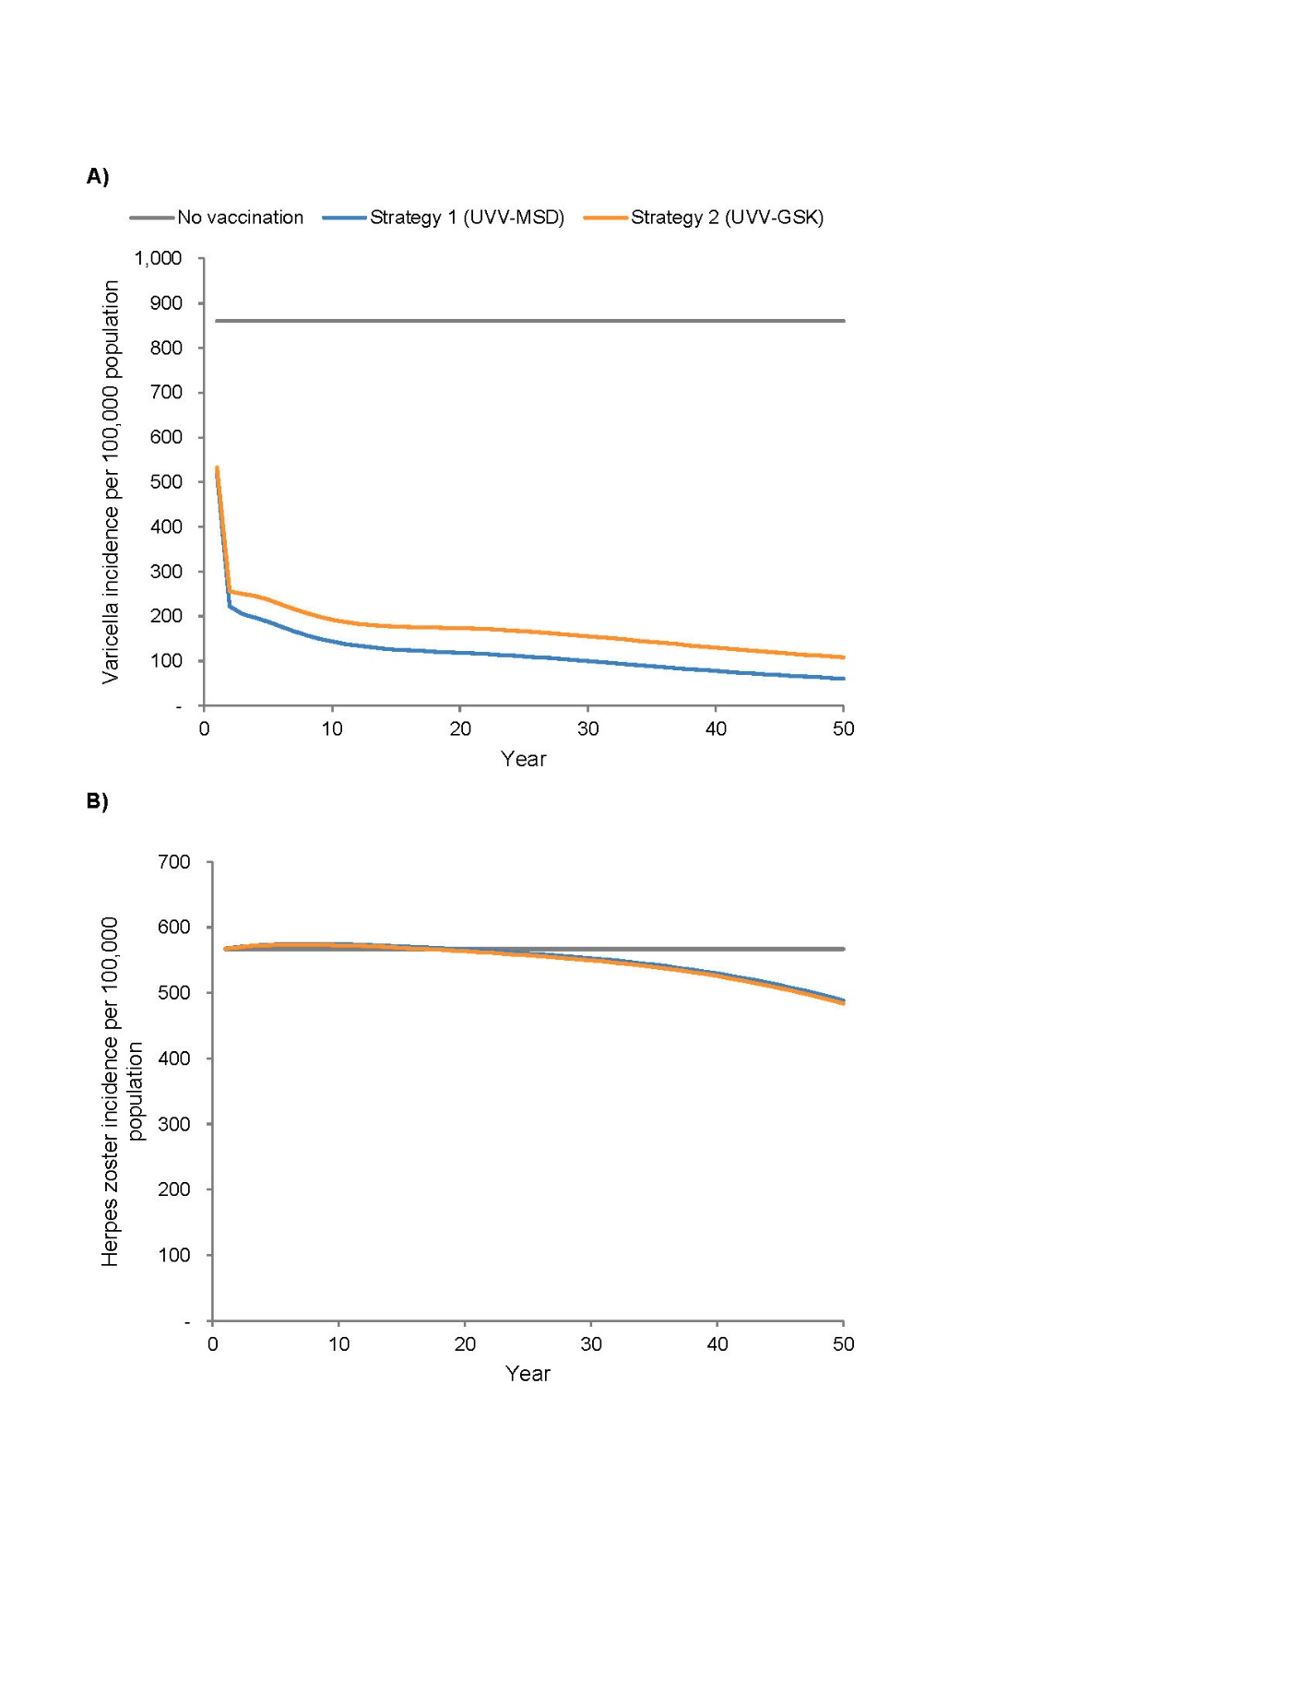
Both UVV strategies also decreased the total cumulative number of varicella cases over the time horizon in all age groups compared to no varicella vaccination (85.3% decrease under Strategy 1 and 79.4% decrease under Strategy 2; Table 1, Online Resource Figure 2). Most (88.3%) of the overall difference between strategies was due to the >3-fold greater number of breakthrough varicella infections that were predicted to occur under Strategy 2 compared with Strategy 1 (Strategy 2, 281,959 cases; Strategy 1, 192,382 cases). Compared to no varicella vaccination, both UVV strategies also decreased the total number of varicella-related outpatient visits (84.8% decrease under Strategy 1; 78.9% decrease under Strategy 2), hospitalizations (Strategy 1, 71.3%; Strategy 2, 69.3%), and deaths (Strategy 1, 33.8%; Strategy 2, 32.3%) compared to no varicella vaccination (Online Resource Figure 2).

3.2 Clinical outcomes: herpes zoster
In the absence of UVV, the overall annual incidence of herpes zoster was 566.9 per 100,000 population; this incidence temporarily rose under both UVV strategies but then decreased to below baseline by 2040–2042, to a final incidence of 488.3 per 100,000 (13.9% decrease) under Strategy 1 and 483.9 per 100,000 (14.6% decrease) under Strategy 2 by the end of the time horizon (Figure 1). Both UVV strategies also resulted in a slight decrease in the overall cumulative number of herpes zoster cases compared to no varicella vaccination (Strategy 1, 2.4% decrease; Strategy 2, 2.9%; Table 1). Implementing UVV increased the number of herpes zoster-associated deaths by about 3% (Strategy 1, 3.4%; Strategy 2, 3.2%), or by approximately 1 death every 2 years during the 50-year time horizon (no varicella vaccination, 809 deaths; Strategy 1, 836 deaths; Strategy 2, 835 deaths).

3.3 Economic outcomes
Both UVV strategies were cost-saving compared to no varicella vaccination, from the payer and the societal perspectives (Table 2). Strategy 1 resulted in 6,094 QALYs gained – 6,190 QALYs gained due to varicella and 96 QALYs lost due to HZ – and €15.9 million in cost savings from the payer perspective, resulting from nearly €149.7 million in cost savings for varicella treatment, offsetting an additional €10.4 million in HZ treatment costs and €123.4 million for vaccination (Table 3, Table 4). Strategy 1 also resulted in €93.9 million in cost savings from the societal perspective. Strategy 2 resulted in 5,977 QALYs saved – 6,025 QALYs averted due to varicella and 48 QALYs lost due to HZ – and €12.0 million in cost savings from the payer perspective, resulting from €142.1 million in cost savings for varicella treatment, offsetting €9.8 million in additional HZ treatment costs and €120.2 million in vaccination costs (Table 3, Table 4). Strategy 2 resulted in €84.2 million in cost savings from the societal perspective.

3.4 Sensitivity analyses
In a deterministic sensitivity analysis, the herpes zoster-related health utility had the greatest impact on QALY outcomes, followed by the natural varicella utility and the vaccine failure rate (Online Resource Figure 3). In addition, the breakthrough varicella health utility impacted QALY outcomes for Strategy 2. For both UVV strategies, the total cost outcomes were most sensitive to direct treatment costs, followed by the cost of vaccination and the vaccine failure rate; in the analysis from the societal perspective, indirect treatment costs also influenced total costs.
Probabilistic sensitivity analyses demonstrated that model outcomes were robust to simultaneous variation in multiple parameters (Figure 2). For Strategy 1, 67% of the 1,000 iterations were cost-saving from the payer perspective, compared to 64% for Strategy 2; all iterations of both strategies were cost-effective versus no vaccination at a threshold of €25,225/QALY. From the societal perspective, 99% of iterations for both strategies were cost-saving and all iterations were cost-effective. In 83% of realizations, Strategy 1 resulted in more QALYs saved than Strategy 2, compared with no vaccination; in 64% (95%) of realizations, Strategy 1 resulted in greater cost savings than Strategy 2 from the payer (societal) perspective, compared with no vaccination.
Fig 2 Probabilistic sensitivity analysis from the payer (top panels) and societal (bottom panels) perspectives
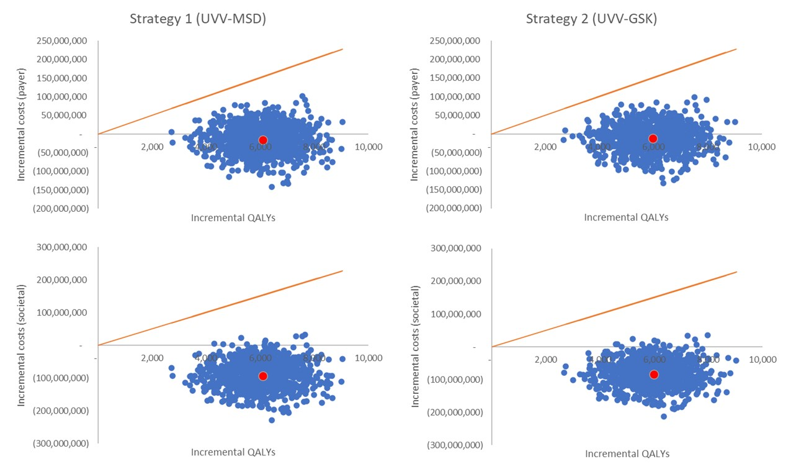
QALY, quality-adjusted life years. All cost data are presented in 2023 Euros. The orange line indicates the willingness-to-pay threshold of €25,225 per QALY gained; the red dot indicates the base-case incremental cost per incremental QALY gained, estimated by the model; and each blue dot indicates a parameter set iteration. Quality-adjusted life years and costs were estimated over 50 years under 2 universal varicella vaccination strategies, compared to no varicella vaccination. The costs for the analysis from the payer perspective included the costs of vaccination and of varicella- and herpes zoster-associated health care use; the analysis from the societal perspective also considered the costs of patient and caregiver workdays lost to varicella and herpes zoster infection.

4.0 Discussion
In this study, we adapted a dynamic transmission model to estimate the clinical and economic impact of UVV in Portugal. Both UVV strategies were predicted to decrease the incidence and clinical burden of varicella and herpes zoster in Portugal by the end of the 50-year time horizon. There was a small, temporary increase in the overall annual incidence of herpes zoster under both UVV strategies, but the incidence subsequently decreased to pre-UVV levels by years 17–19 and then continued to fall during the remainder of the 50-year time horizon. The strategies were cost-saving from both the payer and the societal perspectives, but Strategy 1 (UVV–MSD) was predicted to result in more QALYs saved and greater cost savings than Strategy 2 (UVV–GSK). The model was robust to variations in input parameters.
The model’s prediction that UVV would decrease the clinical burden of varicella and herpes zoster in Portugal is consistent with many modeling and real-world studies from other high-income countries [11, 12, 20, 34-40]. Strategy 1 resulted in greater decreases in varicella incidence, cases, hospitalizations, and deaths than Strategy 2, largely due to the greater number of breakthrough varicella infections predicted for Strategy 2. This difference between strategies reflects the higher first dose permanent protection (‘take’) conferred by the MSD vaccines compared to the respective GSK vaccines; this model input parameter was based on long-term follow-up data from large randomized clinical trials, and the current findings are consistent with previous real-world and modeling studies [6, 11, 20, 25, 34, 35].
Our model incorporated the most recent estimates available for the extent and duration of exogenous boosting [17, 20]. As a result of the partial protection conferred by exogenous boosting from circulating varicella zoster virus, we predicted a small, temporary increase in the incidence of herpes zoster under both UVV strategies. This finding was consistent with other modeling studies; as in other modeling and real-world studies, UVV led to a decrease in the incidence of herpes zoster over the longer term [11, 12, 16, 18-20, 40-42]. The lower first dose vaccine ‘take’ and increased number of cases of varicella predicted for Strategy 2 resulted in slightly greater decreases in the incidence and number of cases of herpes zoster under this strategy, compared to Strategy 1, as a result of exogenous boosting. The predicted temporary increase in herpes zoster incidence following the introduction of UVV could potentially be mitigated via universal or targeted adult herpes zoster vaccination, which is not currently included in Portugal’s NIP [13].
Our model estimated that UVV strategies would be cost-saving in Portugal, from both the payer and the societal perspectives. Our finding that greater cost savings were predicted for Strategy 1 (UVV–MSD) than for Strategy 2 (UVV–GSK) mirrors the conclusions of previous comparative modeling studies conducted for Denmark and Italy [20, 35].
While a number of modeling studies from other countries have found that UVV is cost-effective from the payer perspective [20, 34, 36, 37, 40, 41, 43], fewer studies found that UVV is cost-saving from the payer perspective, although not all studies included herpes zoster outcomes [35, 43]. The cost-saving nature of UVV in Portugal reflects the country’s relatively high direct costs of health care (particularly outpatient care) compared to the cost of vaccination, and the country’s aging population (Portugal has one of the oldest populations in Europe, with individuals ≥65 years of age comprising ~25% of the national population) [20, 21, 39, 44].
A major strength of the current analysis is that our model incorporated the most recent real-world data available on important population-independent model input parameters such as exogenous boosting and long-term vaccine performance [20]. Further, we used Portugal-specific input data for population-dependent parameters where possible; however, data were not available for all model parameters, and the use of proxy data from other countries may have affected the model’s relevance to Portugal. The model also assumed a static population and did not account for changes in the population age distribution over time. Given Portugal’s aging population [44], this assumption (as well as our assumption of no productivity losses for individuals ≥65 years of age) may have resulted in an underestimation of the herpes zoster-associated direct and indirect costs saved over the 50-year time horizon. In addition, our model employed the assumption of a health utility value of 1 for healthy children <18 years of age. While this is a common approach in cost-effectiveness modeling, as healthy utility values are generally not available for this population, the assumption may nevertheless impact the cost-effectiveness implications of UVV within the paediatric population. Finally, standard errors were not available for all model parameters used in the DSA and PSA; for these parameters, standard error was assumed to be a percentage of the mean at the upper end of a plausible range.

5.0 Conclusions
In conclusion, UVV was predicted to be a cost-saving intervention in Portugal that would substantially decrease the clinical and economic burden of varicella and herpes zoster over a 50-year time horizon. Policymakers in Portugal should consider implementing UVV program as a strategy to reduce varicella burden of disease.

Declarations

Funding
This work was supported by Merck Sharp & Dohme LLC, a subsidiary of Merck & Co., Inc., Rahway, NJ, USA.

Conflicts of Interest
JCL is an employee of Merck Canada Inc., a subsidiary of Merck & Co., Inc., Rahway, NJ, USA. CB is a contractor with Merck Sharp & Dohme LLC, a subsidiary of Merck & Co., Inc., Rahway, NJ, USA and was compensated for her work. MA is an employee of MSD (Portugal) Lda., a subsidiary of Merck & Co., Inc., Rahway, NJ, USA. SAK is an employee of Merck Sharp & Dohme LLC, a subsidiary of Merck & Co., Inc., Rahway, NJ, USA. JCL, MA, and SAK may hold stock and/or stock options in Merck & Co., Inc., Rahway, NJ, USA.

Availability of Data and materials
The data underlying this article are available in the article and in its online resources.

Ethics Approval: N/A.

Consent to Participate: N/A.

Consent to Publish: N/A.

Author Contributions
Conceptualization: Stephanie A. Kujawski, Miguel Amorim, and John C. Lang
Methodology: Colleen Burgess, Stephanie A. Kujawski, and John C. Lang
Data Curation/Software/Formal Analysis/Visualization: Colleen Burgess and John C. Lang
Validation: Colleen Burgess, Stephanie A. Kujawski, Miguel Amorim, and John C. Lang
Investigation: Colleen Burgess, Stephanie A. Kujawski, and John C. Lang
Writing - Original Draft: Colleen Burgess and Stephanie A. Kujawski
Writing - Review & Editing: Colleen Burgess, Stephanie A. Kujawski, Miguel Amorim, and John C. Lang

Code Availability
The Mathematica model is not publicly shared. Additional details necessary to reproduce the analyses are available from the corresponding author upon reasonable request.

Acknowledgements
The authors thank Cath Ennis, PhD, in collaboration with ScribCo for medical writing assistance.

References
- 1. European Centre for Disease Prevention and Control. Varicella (chickenpox). Available at: https://www.ecdc.europa.eu/en/varicella-chickenpox. Accessed August 2.
- 2. US Centers for Disease Control and Prevention. About shingles (herpes zoster). Available at: https://www.cdc.gov/shingles/about/index.html. Accessed August 2.
- 3. Bricout H, Haugh M, Olatunde O, Prieto RG. Herpes zoster-associated mortality in Europe: a systematic review. BMC Public Health 2015; 15: 466.
- 4. Fontoura-Matias J, Moreira RS, Reis-Melo A, Freitas A, Azevedo I. Varicella Admissions in Children and Adolescents in Portugal: 2000-2015. Hosp Pediatr 2021; 11(8): 856-64.
- 5. Mesquita M, Froes F. Hospital admissions for herpes zoster in Portugal between 2000 and 2010. Acta Med Port 2013; 26(5): 531-6.
- 6. Pawaskar M, Siddiqui MK, Takyar J, Sharma A, Fergie J. Relative efficacy of varicella vaccines: network meta-analysis of randomized controlled trials. Curr Med Res Opin 2022; 38(10): 1772-82.
- 7. Rodrigues F, Marlow R, Gouveia C, et al. Prospective study of loss of health-related quality adjusted life years in children and their families due to uncomplicated and hospitalised varicella. Vaccine 2023; 41(6): 1182-9.
- 8. Riera-Montes M, Bollaerts K, Heininger U, et al. Estimation of the burden of varicella in Europe before the introduction of universal childhood immunization. BMC Infect Dis 2017; 17(1): 353.
- 9. Pawaskar M, Meroc E, Samant S, et al. Economic burden of varicella in Europe in the absence of universal varicella vaccination. BMC Public Health 2021; 21(1): 2312.
- 10. Corcuera-Munguia M, Gil-Prieto R, Garcia-Carretero R, Gil-de-Miguel A. Hospitalization Burden Related to Herpes Zoster Infection in Spain (2016-2019). Infect Dis Ther 2023; 12(1): 143-56.
- 11. Marin M, Marti M, Kambhampati A, Jeram SM, Seward JF. Global Varicella Vaccine Effectiveness: A Meta-analysis. Pediatrics 2016; 137(3): e20153741.
- 12. Varela FH, Pinto LA, Scotta MC. Global impact of varicella vaccination programs. Hum Vaccin Immunother 2019; 15(3): 645-57.
- 13. European Centre for Disease Prevention and Control. Vaccine Scheduler. Available at: https://vaccine-schedule.ecdc.europa.eu/. Accessed April 4.
- 14. Brisson M, Gay NJ, Edmunds WJ, Andrews NJ. Exposure to varicella boosts immunity to herpes-zoster: implications for mass vaccination against chickenpox. Vaccine 2002; 20(19-20): 2500-7.
- 15. Hope-Simpson RE. The Nature of Herpes Zoster: A Long-Term Study and a New Hypothesis. Proc R Soc Med 1965; 58(1): 9-20.
- 16. Wutzler P, Bonanni P, Burgess M, Gershon A, Safadi MA, Casabona G. Varicella vaccination - the global experience. Expert Rev Vaccines 2017; 16(8): 833-43.
- 17. Forbes H, Douglas I, Finn A, et al. Risk of herpes zoster after exposure to varicella to explore the exogenous boosting hypothesis: self controlled case series study using UK electronic healthcare data. BMJ 2020; 368: l6987.
- 18. Harpaz R. Do varicella vaccination programs change the epidemiology of herpes zoster? A comprehensive review, with focus on the United States. Expert Rev Vaccines 2019; 18(8): 793-811.
- 19. Leung J, Dooling K, Marin M, Anderson TC, Harpaz R. The Impact of Universal Varicella Vaccination on Herpes Zoster Incidence in the United States: Comparison of Birth Cohorts Preceding and Following Varicella Vaccination Program Launch. J Infect Dis 2022; 226(Suppl 4): S470-S7.
- 20. Burgess C, Samant S, leFevre T, Schade Larsen C, Pawaskar M. Universal varicella vaccination in Denmark: Modeling public health impact, age-shift, and cost-effectiveness. PLOS Glob Public Health 2023; 3(4): e0001743.
- 21. Instituto Nacional de Estatística. Estatísticas Demográficas - 2021. Available at: https://www.ine.pt/xportal/xmain?xpid=INE&xpgid=ine_publicacoes&PUBLICACOESpub_boui=13932532&PUBLICACOESmodo=2. Accessed July 26.
- 22. Freitas MG, Paixão MT. Avaliação do Programa Nacional de Vacinação: 2º Inquérito Serológico Nacional Portugal Continental 2001-2002. Available at: https://www.dgs.pt/upload/membro.id/ficheiros/i009552.pdf. Accessed June 27.
- 23. Morant-Talamante N, Diez-Domingo J, Martinez-Ubeda S, Puig-Barbera J, Aleman-Sanchez S, Perez-Breva L. Herpes zoster surveillance using electronic databases in the Valencian Community (Spain). BMC Infect Dis 2013; 13: 463.
- 24. Direção-Geral da Saúde. Relatório Síntese Anual da Vacinação. Available at: https://www.dgs.pt/paginas-de-sistema/saude-de-a-a-z/programa-nacional-de-vacinacao/relatorios-e-publicacoes.aspx. Accessed February 6.
- 25. Pillsbury M, Carias C, Samant S, Greenberg D, Pawaskar M. Comparison of performance of varicella vaccines via infectious disease modeling. Vaccine 2022; 40(29): 3954-62.
- 26. Brisson M, Edmunds W. Varicella vaccination in England and Wales: cost-utility analysis. Archives of disease in childhood 2003; 88(10): 862-9.
- 27. Pellissier JM, Brisson M, Levin MJ. Evaluation of the cost-effectiveness in the United States of a vaccine to prevent herpes zoster and postherpetic neuralgia in older adults. Vaccine 2007; 25(49): 8326-37.
- 28. Oster G, Harding G, Dukes E, Edelsberg J, Cleary PD. Pain, medication use, and health-related quality of life in older persons with postherpetic neuralgia: results from a population-based survey. J Pain 2005; 6(6): 356-63.
- 29. Instituto Nacional de Estatística. Labour market. Available at: https://www.ine.pt/xportal/xmain?xpgid=ine_tema&xpid=INE&tema_cod=1114.
- 30. Perelman J, Soares M, Mateus C, et al. Methodological Guidelines for Economic Evaluation Studies: INFARMED - National Authority of Medicines and Health Products, I.P., Lisbon, 2019.
- 31. Andrianakis I, Vernon IR, McCreesh N, et al. Bayesian history matching of complex infectious disease models using emulation: a tutorial and a case study on HIV in Uganda. PLoS computational biology 2015; 11(1): e1003968.
- 32. Cody P, Tobe K, Abe M, Elbasha EH. Public health impact and cost effectiveness of routine and catch-up vaccination of girls and women with a nine-valent HPV vaccine in Japan: a model-based study. BMC Infectious Diseases 2021; 21(1): 11.
- 33. The World Bank. Portugal. Available at: https://data.worldbank.org/country/portugal. Accessed April 16.
- 34. Akpo EIH, Cristeau O, Hunjan M, Casabona G. Epidemiological Impact and Cost-Effectiveness of Varicella Vaccination Strategies in the United Kingdom. Clin Infect Dis 2021; 73(11): e3617-e26.
- 35. Azzari C, Baldo V, Giuffrida S, et al. The Cost-Effectiveness of Universal Varicella Vaccination in Italy: A Model-Based Assessment of Vaccination Strategies. Clinicoecon Outcomes Res 2020; 12: 273-83.
- 36. Heininger U, Pillsbury M, Samant S, et al. Health Impact and Cost-effectiveness Assessment for the Introduction of Universal Varicella Vaccination in Switzerland. Pediatr Infect Dis J 2021; 40(6): e217-e21.
- 37. Lenne X, Diez Domingo J, Gil A, Ridao M, Lluch JA, Dervaux B. Economic evaluation of varicella vaccination in Spain: results from a dynamic model. Vaccine 2006; 24(47-48): 6980-9.
- 38. Marin M, Lopez AS, Melgar M, Dooling K, Curns AT, Leung J. Decline in Severe Varicella Disease During the United States Varicella Vaccination Program: Hospitalizations and Deaths, 1990-2019. J Infect Dis 2022; 226(Suppl 4): S407-S15.
- 39. Pawaskar M, Burgess C, Pillsbury M, Wisloff T, Flem E. Clinical and economic impact of universal varicella vaccination in Norway: A modeling study. PLoS One 2021; 16(7): e0254080.
- 40. Sharomi O, Xausa I, Nachbar R, et al. Modeling the Impact of Exogenous Boosting and Universal Varicella Vaccination on the Clinical and Economic Burden of Varicella and Herpes Zoster in a Dynamic Population for England and Wales. Vaccines (Basel) 2022; 10(9).
- 41. Damm O, Ultsch B, Horn J, Mikolajczyk RT, Greiner W, Wichmann O. Systematic review of models assessing the economic value of routine varicella and herpes zoster vaccination in high-income countries. BMC Public Health 2015; 15: 533.
- 42. Wolfson LJ, Daniels VJ, Pillsbury M, et al. Cost-effectiveness analysis of universal varicella vaccination in Turkey using a dynamic transmission model. PLoS One 2019; 14(8): e0220921.
- 43. Anderson R, Kim S, Roberts N, Petrou S. Systematic review of economic evaluations of varicella vaccination programmes. PLoS One 2023; 18(3): e0282327.
- 44. Eurostat. Population structure indicators at national level. Available at: https://ec.europa.eu/eurostat/databrowser/view/DEMO_PJANIND__custom_6853095/default/table?lang=en. Accessed August 7.

Tables

Table 1. Varicella and herpes zoster clinical outcomes over 50 years
Outcome | No vaccination | Strategy 1 (UVV–MSD) |  | Strategy 2 (UVV–GSK)
Outcome | No vaccination | Number | % change ª | Number | % change ª
Varicella
Total varicella cases | 3,644,520 | 537,455 | −85.3 | 752,261 | −79.4
Age group (years)
0–4 | 1,975,784 | 207,100 | −89.5 | 353,242 | −82.1
5–9 | 969,954 | 45,902 | −95.3 | 64,060 | −93.4
10–14 | 334,960 | 55,327 | −83.5 | 72,387 | −78.4
15–44 | 253,507 | 143,050 | −43.6 | 172,149 | −32.1
45–64 | 72,921 | 58,867 | −19.3 | 62,423 | −14.4
≥65 | 37,394 | 27,208 | −27.2 | 28,001 | −25.1
Infection type
Natural | 3,644,520 | 445,073 | −87.8 | 470,303 | −87.1
Breakthrough | NA | 92,382 | NA | 281,959 | NA
Treatment type
Outpatient | 3,309,289 | 503,865 | −84.8 | 699,734 | −78.9
Hospitalization | 17,877 | 5,129 | −71.3 | 5,497 | −69.3
Total varicella deaths | 367 | 243 | −33.8 | 248 | −32.4
Herpes zoster
Total herpes zoster cases | 2,402,501 | 2,344,166 | −2.4 | 2,332,740 | −2.9
Infection type
Wild-type | 2,402,501 | 2,268,315 | −5.6 | 2,270,170 | −5.5
Vaccine-type | NA | 75,851 | NA | 62,570 | NA
Total herpes zoster deaths | 809 | 836 | +3.4 | 835 | +3.2
NA, not applicable.
ª Compared to no varicella vaccination.

Table 2. Cost-effectiveness outcomes for universal varicella vaccination over 50 years from the payer and societal perspectives
Vaccination strategy | Total QALYs lost | Incremental QALYs gained ª | Payer perspective |  | Societal perspective
Vaccination strategy | Total QALYs lost | Incremental QALYs gained ª | Total costs (€) | Incremental costs (€) ª | Total costs (€) | Incremental costs (€) ª
No vaccination | 28,275 | NA | 547,974,216 | NA | 698,411,744 | NA
Strategy 1 (UVV–MSD) | 22,181 | 6,094 | 532,107,927 | −15,866,289 | 604,483,209 | −93,928,535
Strategy 2 (UVV–GSK) | 22,298 | 5,977 | 535,971,426 | −12,002,789 | 614,203,858 | −84,207,886
NA, not applicable; QALY, quality-adjusted life year. All cost data are presented in 2023 Euros.
The costs for the analysis from the payer perspective included the costs of vaccination and of varicella- and herpes zoster-associated health care use; the analysis from the societal perspective also considered the costs of workdays lost to varicella and herpes zoster infection.
ª Compared to no varicella vaccination.

Table 3. Treatment and vaccination costs for universal varicella vaccination over 50 years from the payer perspective
Vaccination Strategy | VZV treatment |  | HZ treatment |  | VZV vaccination
Vaccination Strategy | Total treatment cost (€) | Incremental treatment cost (€) ª | Total treatment cost (€) | Incremental treatment cost (€) ª | Total vaccination cost (€) | Incremental vaccination cost (€) ª
No vaccination | 191,688,950 | N/A | 356,285,265 | N/A | - | N/A
Strategy 1 (UVV–MSD) | 42,031,057 | -149,657,893 | 366,643,350 | 10,358,085 | 123,433,516 | 123,433,516
Strategy 2 (UVV–GSK) | 49,581,532 | -142,107,418 | 366,136,103 | 9,850,838 | 120,253,794 | 120,253,794
NA, not applicable; HZ, herpes zoster. All cost data are presented in 2023 Euros.
ª Compared to no varicella vaccination.

Table 4. QALY loss for universal varicella vaccination over 50 years
Vaccination Strategy | Total VZV QALYs lost | Incremental VZV QALYs gained ª | Total HZ QALYs lost | Incremental HZ QALYs gained ª
No vaccination | 10,587 | N/A | 17,688 | N/A
Strategy 1 (UVV–MSD) | 4,396 | 6,190 | 17,784 | -96
Strategy 2 (UVV–GSK) | 4,561 | 6,025 | 17,737 | -48
NA, not applicable; QALY, quality-adjusted life year; HZ, herpes zoster.
ª Compared to no varicella vaccination.

