(Supplementary data)
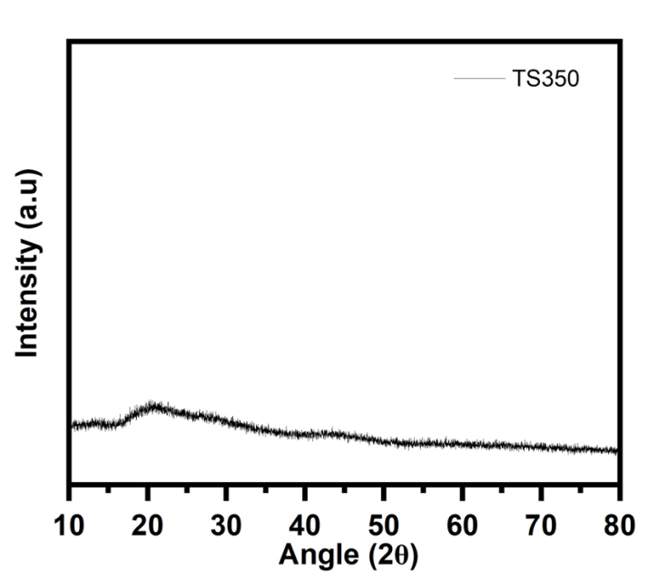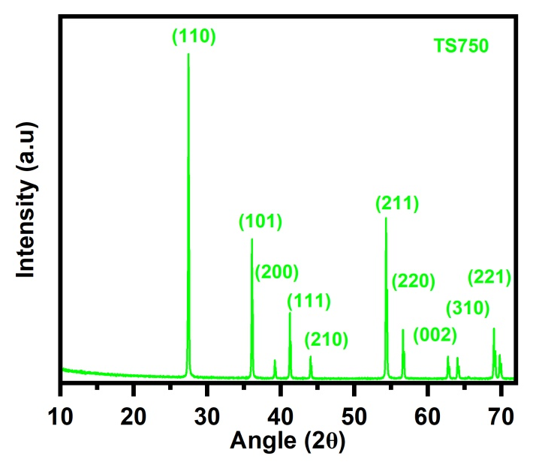
(b)
(a)
Fig 1S: PXRD spectra of (a) TS350 (b) TS750
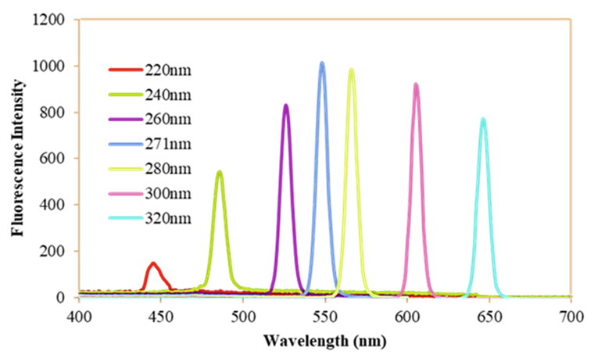
Fig. 2S: Fluorescence intensity of TS550 NP’s at different excitation wavelengths

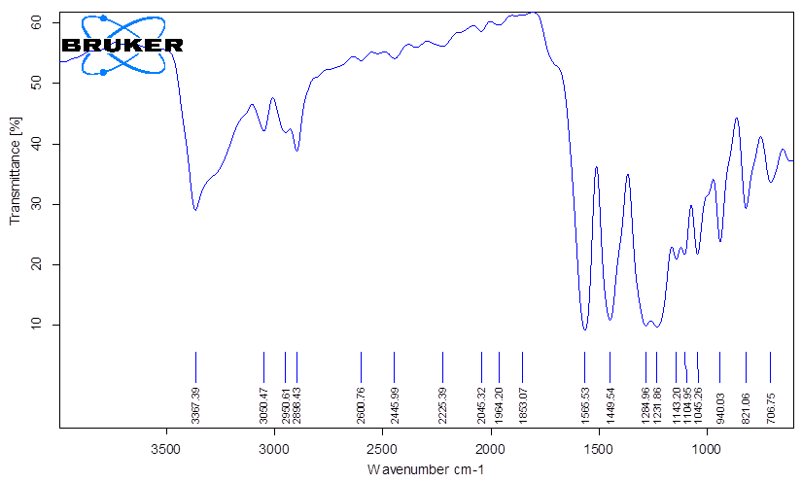
Figure 3S: FT-IR spectra of Imidacloprid
Table 1S: Structures of different pesticides selected in present work.
Sr. No. | Name of Pesticide | Structure of Pesticide
1 | Imidacloprid  (neonicotinoid)
2 | Thiamethoxam  (neonicotinoid)
3 | Quinalphos  (organothiophosphate)
4 | Triazophos  (organothiophosphate)
5 | Dichlorvos  (organophosphate)
6 | Cypermethrin  (pyrethroid)
7 | Chlorantaranilipore (ryanoid)
8 | Lambda cyhalothrin  (pyrethroid)
9 | Cartap hydrochloride  (carbamate)

Table 2S: Physico-chemical properties of soil selected
Soil |  | Bathinda
Texture |  | Loamy Sand
pH |  | 8.3
Electrical conductivity (mmho/cm) |  | 0.59
Organic Matter (%) |  | 0.285
Mineral content | Potassium (ppm) | 180
Mineral content | Zinc (ppm) | 1.992
Mineral content | Manganese (ppm) | 11.11
Mineral content | Iron (ppm) | 7.9
Mineral content | Copper (ppm) | 1.196
Table 3S: Parameters obtained from XRD spectra of NP’s
Nanoparticle | Crystallite size (nm) | Lattice strain | d-spacing  (Å)
TS550 | 14nm | 11.28 × 10⁻³ | 3.5053
TS750 | 121.68 nm | 1.2 × 10⁻³ | 3.24625
TS550 on interaction with IMP | 13.76nm | 11.47 × 10⁻³ | 3.5080

