Supplementary

Supplementary Table S1. List of plastic categories collected in the Bay of Biscay (Atlantic Ocean) and the Adriatic Sea (Mediterranean Sea) and used in the present study. For each plastic category, the polymer composition is reported. PE: polyethylene; PP: polypropylene; PET: polyethylene terephthalate; PVC: polyvinyl chloride; PS: polystyrene.
 | Geographic Area | Plastic category | Polymer composition
Mediterranean Sea | Adriatic Sea | Hard Plastic containers (HP) | 73% PP, 13% PE, 6% PET, 6% PS, 2% PVC
Mediterranean Sea | Ligurian Sea | Plastic bottles | 100% PET
Atlantic Ocean | Biscay Bay | Hard Plastic containers (HP) | 83.5% PE, 16.5% PP

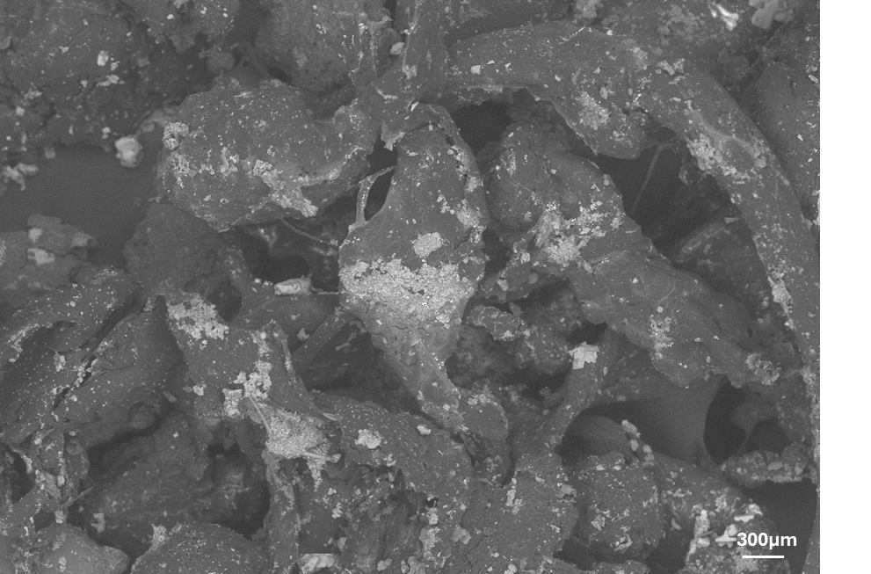

Figure S1 Image of fouled MPs acquired through SEM analysis with a 180x magnification, showing biofilm coverage.
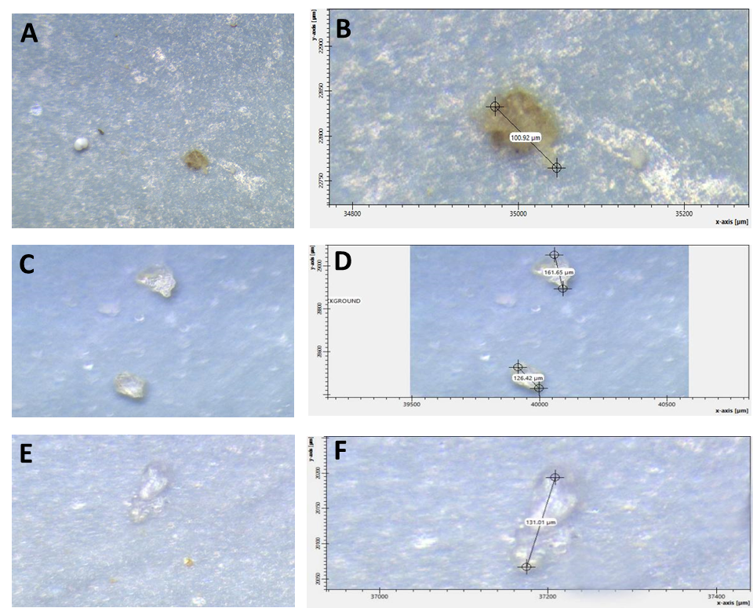

Figure S2 Images acquired through FT-IR Microscope, showing examples and size of micronized PP (A, B), PET (C, D) and PE (E, F) particles ingested by ephyrae jellyfish after 24h exposure.

