Diversity and Sources of Airborne Eukaryotic Communities (AEC) in the Global Dust Belt over the Red Sea
- Nojood A. Aalismail ^{1*}, Rubén Díaz-Rúa ¹, Nathan Geraldi¹, Michael Cusack¹, and Carlos M. Duarte¹

¹Red Sea Research Centre and Computational Bioscience Research Center, King Abdullah University of Science and Technology, Thuwal, Saudi Arabia
* Correspondence:
Nojood A. Aalismail
Nojood.aalismail@kaust.edu.sa
- Keywords: Atmosphere, Eukaryotes, Dust, Red Sea, Global Dust Belt.

Table S1. Sample metadata. Sample collection data and the backward air masses trajectories at the sampling dates with the total suspended particles (TSP) concentrations of each sample.

Sample | Location | Date | Season | Trajectory | Latitude | Longitude | TSP conc. (µg m^{–1})
KAUST-00 | onshore | 9/13/15 | Fall2015 | NW | 22.41 | 39.15 | NA
KAUST-01 | onshore | 9/14/15 | Fall2015 | NE | 22.41 | 39.15 | 247
KAUST-02 | onshore | 9/15/15 | Fall2015 | NW | 22.41 | 39.15 | 333
KAUST-03 | onshore | 9/16/15 | Fall2015 | NW | 22.41 | 39.15 | 207
KAUST-04 | onshore | 9/17/15 | Fall2015 | NW | 22.41 | 39.15 | 159
KAUST-05 | onshore | 9/19/15 | Fall2015 | NW | 22.41 | 39.15 | 86
KAUST-06 | onshore | 10/9/15 | Fall2015 | NW | 22.41 | 39.15 | 163
KAUST-07 | onshore | 10/18/15 | Fall2015 | NW | 22.41 | 39.15 | 108
KAUST-08 | onshore | 10/25/15 | Fall2015 | S | 22.41 | 39.15 | 156
KAUST-09 | onshore | 11/2/15 | Fall2015 | NW | 22.41 | 39.15 | 99
KAUST-010 | onshore | 11/10/15 | Fall2015 | NW | 22.41 | 39.15 | 85
KAUST-011 | onshore | 11/22/15 | Fall2015 | W | 22.41 | 39.15 | 86
KAUST-012 | onshore | 11/30/15 | Fall2015 | NW | 22.41 | 39.15 | 90
KAUST-013 | onshore | 12/9/15 | Winter2015 | NW | 22.41 | 39.15 | 156
KAUST-014 | onshore | 12/17/15 | Winter2015 | NW | 22.41 | 39.15 | 75
KAUST-015 | onshore | 12/24/15 | Winter2015 | NW | 22.41 | 39.15 | 51
KAUST-016 | onshore | 12/31/15 | Winter2015 | NW | 22.41 | 39.15 | 77
KAUST-017 | onshore | 1/10/16 | Winter2015 | NW | 22.41 | 39.15 | 103
KAUST-018 | onshore | 1/17/16 | Winter2015 | NE | 22.41 | 39.15 | 205
KAUST-019 | onshore | 1/25/16 | Winter2015 | NW | 22.41 | 39.15 | 104
KAUST-020 | onshore | 1/28/16 | Winter2015 | NW | 22.41 | 39.15 | 37
KAUST-021 | onshore | 2/4/16 | Winter2015 | NW | 22.41 | 39.15 | 51
KAUST-022 | onshore | 2/7/16 | Winter2015 | S | 22.41 | 39.15 | 444
KAUST-023 | onshore | 2/14/16 | Winter2015 | NW | 22.41 | 39.15 | 88
KAUST-024 | onshore | 3/2/16 | Spring2016 | W | 22.41 | 39.15 | 151
KAUST-025 | onshore | 3/8/16 | Spring2016 | NW | 22.41 | 39.15 | 96
KAUST-026 | onshore | 3/14/16 | Spring2016 | N | 22.41 | 39.15 | 79
KAUST-027 | onshore | 3/24/16 | Spring2016 | NW | 22.41 | 39.15 | 112
KAUST-028 | onshore | 4/1/16 | Spring2016 | NW | 22.41 | 39.15 | 84
KAUST-029 | onshore | 4/5/16 | Spring2016 | N | 22.41 | 39.15 | 11
KAUST-030 | onshore | 4/17/16 | Spring2016 | NW | 22.41 | 39.15 | 72
KAUST-031 | onshore | 4/23/16 | Spring2016 | S | 22.41 | 39.15 | 262
KAUST-032 | onshore | 5/1/16 | Summer2016 | SW | 22.41 | 39.15 | 148
KAUST-034 | onshore | 5/4/16 | Summer2016 | SW | 22.41 | 39.15 | NA
KAUST-035 | onshore | 5/5/16 | Summer2016 | NW | 22.41 | 39.15 | 132
KAUST-036 | onshore | 5/6/16 | Summer2016 | S | 22.41 | 39.15 | 83
KAUST-037 | onshore | 5/11/16 | Summer2016 | NW | 22.41 | 39.15 | 99
KAUST-038 | onshore | 5/13/16 | Summer2016 | NW | 22.41 | 39.15 | 135
KAUST-039 | onshore | 5/19/16 | Summer2016 | NW | 22.41 | 39.15 | 136
KAUST-040 | onshore | 5/21/16 | Summer2016 | NW | 22.41 | 39.15 | 104
KAUST-041 | onshore | 5/23/16 | Summer2016 | NW | 22.41 | 39.15 | 89
KAUST-042 | onshore | 6/3/16 | Summer2016 | NW | 22.41 | 39.15 | 83
KAUST-043 | onshore | 6/5/16 | Summer2016 | NE | 22.41 | 39.15 | 147
KAUST-044 | onshore | 6/7/16 | Summer2016 | NE | 22.41 | 39.15 | 111
KAUST-045 | onshore | 6/12/16 | Summer2016 | NW | 22.41 | 39.15 | 89
KAUST-046 | onshore | 6/14/16 | Summer2016 | NW | 22.41 | 39.15 | 180
KAUST-047 | onshore | 6/16/16 | Summer2016 | NW | 22.41 | 39.15 | 221
KAUST-048 | onshore | 6/21/16 | Summer2016 | NW | 22.41 | 39.15 | 189
KAUST-049 | onshore | 6/23/16 | Summer2016 | NW | 22.41 | 39.15 | 110
KAUST-050 | onshore | 6/25/16 | Summer2016 | NW | 22.41 | 39.15 | 122
KAUST-051 | onshore | 7/1/16 | Summer2016 | NW | 22.41 | 39.15 | 74
KAUST-052 | onshore | 7/3/16 | Summer2016 | NW | 22.41 | 39.15 | 67
KAUST-053 | onshore | 7/5/16 | Summer2016 | NW | 22.41 | 39.15 | 70
KAUST-054 | onshore | 7/2/16 | Summer2016 | NW | 22.41 | 39.15 | 80
KAUST-055 | onshore | 7/4/16 | Summer2016 | NW | 22.41 | 39.15 | 72
KAUST-056 | onshore | 7/6/16 | Summer2016 | NW | 22.41 | 39.15 | 81
KAUST-057 | onshore | 7/8/16 | Summer2016 | NW | 22.41 | 39.15 | 76
KAUST-058 | onshore | 7/10/16 | Summer2016 | NW | 22.41 | 39.15 | 87
KAUST-059 | onshore | 7/12/16 | Summer2016 | NW | 22.41 | 39.15 | 74
KAUST-060 | onshore | 7/26/16 | Summer2016 | W | 22.41 | 39.15 | 646
KAUST-061 | onshore | 7/28/16 | Summer2016 | NW | 22.41 | 39.15 | 336
KAUST-062 | onshore | 7/30/16 | Summer2016 | W | 22.41 | 39.15 | 297
KAUST-063 | onshore | 8/1/16 | Summer2016 | NW | 22.41 | 39.15 | 265
KAUST-064 | onshore | 8/18/16 | Summer2016 | W | 22.41 | 39.15 | 98
KAUST-065 | onshore | 8/21/16 | Summer2016 | NW | 22.41 | 39.15 | 119
KAUST-066 | onshore | 8/27/16 | Summer2016 | NW | 22.41 | 39.15 | 64
KAUST-067 | onshore | 8/30/16 | Summer2016 | W | 22.41 | 39.15 | 124
KAUST-068 | onshore | 9/2/16 | Fall2016 | NW | 22.41 | 39.15 | 111
KAUST-069 | onshore | 9/4/16 | Fall2016 | NW | 22.41 | 39.15 | 262
KAUST-070 | onshore | 9/6/16 | Fall2016 | N | 22.41 | 39.15 | 70
KAUST-071 | onshore | 9/8/16 | Fall2016 | NW | 22.41 | 39.15 | 73
KAUST-072 | onshore | 9/10/16 | Fall2016 | NW | 22.41 | 39.15 | 94
KAUST-073 | onshore | 9/12/16 | Fall2016 | N | 22.41 | 39.15 | 90
KAUST-074 | onshore | 9/14/16 | Fall2016 | W | 22.41 | 39.15 | 98
KAUST-075 | onshore | 9/16/16 | Fall2016 | E | 22.41 | 39.15 | 114
KAUST-076 | onshore | 9/18/16 | Fall2016 | NW | 22.41 | 39.15 | 86
KAUST-077 | onshore | 9/20/16 | Fall2016 | NW | 22.41 | 39.15 | 74
KAUST-078 | onshore | 9/22/16 | Fall2016 | NW | 22.41 | 39.15 | 129
KAUST-079 | onshore | 9/24/16 | Fall2016 | NW | 22.41 | 39.15 | 105
KAUST-080 | onshore | 9/26/16 | Fall2016 | NW | 22.41 | 39.15 | 138
KAUST-081 | onshore | 9/28/16 | Fall2016 | N | 22.41 | 39.15 | 81
KAUST-082 | onshore | 10/5/16 | Fall2016 | NW | 22.41 | 39.15 | 98
KAUST-083 | onshore | 10/7/16 | Fall2016 | NW | 22.41 | 39.15 | 79
KAUST-084 | onshore | 10/9/16 | Fall2016 | NW | 22.41 | 39.15 | 92
KAUST-085 | onshore | 10/13/16 | Fall2016 | N | 22.41 | 39.15 | 119
KAUST-086 | onshore | 10/15/16 | Fall2016 | NW | 22.41 | 39.15 | 148
KAUST-087 | onshore | 10/17/16 | Fall2016 | W | 22.41 | 39.15 | 100
KAUST-088 | onshore | 10/22/16 | Fall2016 | NW | 22.41 | 39.15 | 88
KAUST-089 | onshore | 10/26/16 | Fall2016 | S | 22.41 | 39.15 | 80
KAUST-090 | onshore | 10/30/16 | Fall2016 | NW | 22.41 | 39.15 | 115
KAUST-091 | onshore | 11/11/16 | Fall2016 | SE | 22.41 | 39.15 | 5
Thuwal-01 | offshore | 2/22/16 | Winter2015 | NE | 25.28 | 36.8 | 57
Thuwal-02 | offshore | 2/27/16 | Winter2015 | NW | 25.27 | 36.9 | 63
Thuwal-03 | offshore | 3/8/16 | Spring2016 | NW | 22.41 | 39.15 | 7
Thuwal-04 | offshore | 3/25/16 | Spring2016 | E | 22.41 | 39.15 | 36
Thuwal-05 | offshore | 3/29/16 | Spring2016 | NW | 27.4 | 34.87 | 84
Thuwal-06 | offshore | 3/31/16 | Spring2016 | NW | 27.07 | 35.07 | 73
Thuwal-09 | offshore | 5/5/16 | Spring2016 | NW | 22.41 | 39.15 | 112
Thuwal-010 | offshore | 5/6/16 | Spring2016 | SW | 22.41 | 39.15 | 71
Thuwal-011 | offshore | 5/11/16 | Spring2016 | NW | 22.41 | 39.15 | 124
Thuwal-012 | offshore | 5/13/16 | Spring2016 | W | 22.41 | 39.15 | 97
Thuwal-013 | offshore | 6/3/16 | Summer2016 | NW | 22.41 | 39.15 | 33
Thuwal-014 | offshore | 6/5/16 | Summer2016 | NE | 22.41 | 39.15 | 96
Thuwal-015 | offshore | 6/7/16 | Summer2016 | NE | 22.41 | 39.15 | 57
Thuwal-016 | offshore | 7/21/16 | Summer2016 | NW | 27.04 | 35.5 | 63
Thuwal-017 | offshore | 7/24/16 | Summer2016 | NW | 27.04 | 35.5 | 53
Thuwal-018 | offshore | 7/24/16 | Summer2016 | NW | 27.85 | 35.32 | 90
Thuwal-019 | offshore | 8/28/16 | Summer2016 | NW | 27.85 | 35.32 | 6
Thuwal-020 | offshore | 9/6/16 | Fall2016 | NW | 22.41 | 39.15 | 214
Thuwal-021 | offshore | 9/7/16 | Fall2016 | NW | 22.41 | 39.15 | 97
Thuwal-022 | offshore | 9/21/16 | Fall2016 | NW | 22.41 | 39.15 | 212
Thuwal-023 | offshore | 9/22/16 | Fall2016 | NW | 19.62 | 39.68 | 192
Thuwal-024 | offshore | 9/23/16 | Fall2016 | NW | 17.54 | 41.44 | 109
Thuwal-025 | offshore | 9/24/16 | Fall2016 | NW | 17.66 | 41.09 | 180
Thuwal-026 | offshore | 9/25/16 | Fall2016 | NW | 17.65 | 41.43 | 163
Thuwal-027 | offshore | 9/26/16 | Fall2016 | NW | 18.6 | 40.28 | 147
Thuwal-028 | offshore | 9/27/16 | Fall2016 | NW | 18.6 | 40.28 | 113
Thuwal-029 | offshore | 9/28/16 | Fall2016 | NW | 20.71 | 39.15 | NA
Thuwal-030 | offshore | 10/3/16 | Fall2016 | NW | 22.41 | 39.15 | NA
Thuwal-031 | offshore | 10/4/16 | Fall2016 | W | 22.41 | 39.15 | 52
Thuwal-032 | offshore | 10/5/16 | Fall2016 | NN | 26.27 | 35.98 | 36
Thuwal-033 | offshore | 10/6/16 | Fall2016 | NW | 26.27 | 35.98 | 42
Thuwal-034 | offshore | 10/7/16 | Fall2016 | N | 26.27 | 35.98 | 43
Thuwal-035 | offshore | 10/8/16 | Fall2016 | NW | 24.93 | 36.8 | 66
Thuwal-036 | offshore | 10/9/16 | Fall2016 | NE | 24.93 | 36.8 | NA
Thuwal-037 | offshore | 10/10/16 | Fall2016 | NW | 22.41 | 39.15 | 82
Thuwal-038 | offshore | 11/5/16 | Fall2016 | NW | 22.41 | 39.15 | 33
Thuwal-039 | offshore | 11/6/16 | Fall2016 | NE | 26.07 | 35.77 | 77
Thuwal-040 | offshore | 11/8/16 | Fall2016 | E | 26.07 | 35.77 | 79
SW-016 | water | 6/20/16 | Summer2016 | TS | 22.31 | 39 | NA
TS-017 | water | 7/11/16 | Summer2016 | TS | 22.31 | 39 | NA
TS-018 | water | 7/26/16 | Summer2016 | TS | 22.31 | 39 | NA
TS-019 | water | 8/8/16 | Summer2016 | TS | 22.31 | 39 | NA
TS-020 | water | 8/22/16 | Summer2016 | TS | 22.31 | 39 | NA
TS-021 | water | 9/4/16 | Fall2016 | TS | 22.31 | 39 | NA
TS-022 | water | 9/27/16 | Fall2016 | TS | 22.31 | 39 | NA
TS-023 | water | 10/17/16 | Fall2016 | TS | 22.31 | 39 | NA
TS-024 | water | 10/31/16 | Fall2016 | TS | 22.31 | 39 | NA
TS-025 | water | 11/14/16 | Fall2016 | TS | 22.31 | 39 | NA

Table S2. Estimation of alpha diversity index and richness (number of SVs) of eukaryotic communities.

Sample type | Observed | Chao1 | se.chao1 | ACE | se.ACE | Shannon | Simpson | InvSimpson | Fisher
Onshore air | 14156 | 31533.2 | 847.194 | 26391.6 | 89.5045 | 6.0832 | 0.97827 | 46.0111 | 1759.58
Offshore air | 5518 | 7793.08 | 169.776 | 7501.15 | 44.8068 | 5.06311 | 0.96239 | 26.5875 | 679.261
Surface water | 2447 | 2692.79 | 49.0168 | 2544.74 | 23.028 | 5.44775 | 0.98268 | 57.7454 | 325.164
Winter | 8117 | 15169.7 | 408.614 | 13454.7 | 63.4107 | 6.3135 | 0.98842 | 86.3233 | 1261.7
Spring | 5772 | 9683.5 | 261.38 | 8894.89 | 50.9197 | 5.47614 | 0.98341 | 60.2625 | 815.7
Summer | 8019 | 11297.5 | 224.938 | 10248 | 50.2209 | 5.68675 | 0.95777 | 23.6805 | 1010.02
Fall | 6003 | 9650.38 | 271.924 | 8375.31 | 46.7492 | 5.49007 | 0.97798 | 45.4117 | 697.863
N | 959 | 1596.03 | 99.1045 | 1531.04 | 21.7261 | 4.15806 | 0.97008 | 33.4188 | 117.096
NE | 3704 | 6098.07 | 202.381 | 5838.83 | 42.0524 | 4.97308 | 0.95147 | 20.6071 | 535.064
E | 1653 | 2915.48 | 144.35 | 2787.05 | 30.5 | 3.84989 | 0.90905 | 10.9948 | 251.189
SE | 143 | 143 | 0 | 143 | 5.09078 | 2.64152 | 0.73443 | 3.76546 | 17.5655
S | 1957 | 2830.28 | 97.3183 | 2846.3 | 29.0903 | 4.80246 | 0.97097 | 34.4417 | 280.336
SW | 1922 | 2992.44 | 106.073 | 3317 | 34.7429 | 4.43682 | 0.949 | 19.609 | 300.176
W | 2695 | 5920.45 | 318.62 | 5078.43 | 40.5858 | 5.01624 | 0.97603 | 41.722 | 363.492
NW | 13323 | 25763.3 | 611.037 | 22200.2 | 79.9909 | 5.90562 | 0.97369 | 38.014 | 1641.93

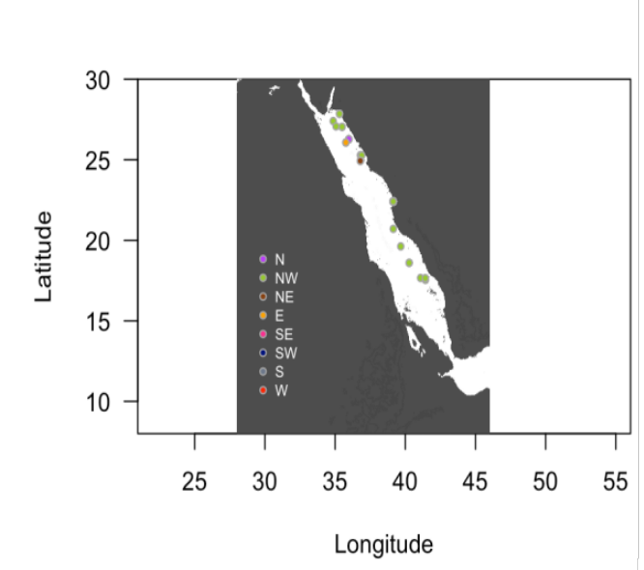
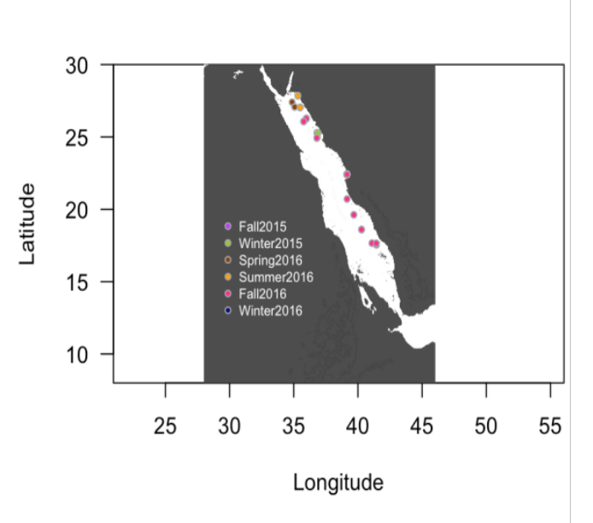
A
B

Figure S1. Map of sampling locations over the Red Sea. Colorful circles show (A) the sampling season and (B) the backward air mass trajectories at certain location.

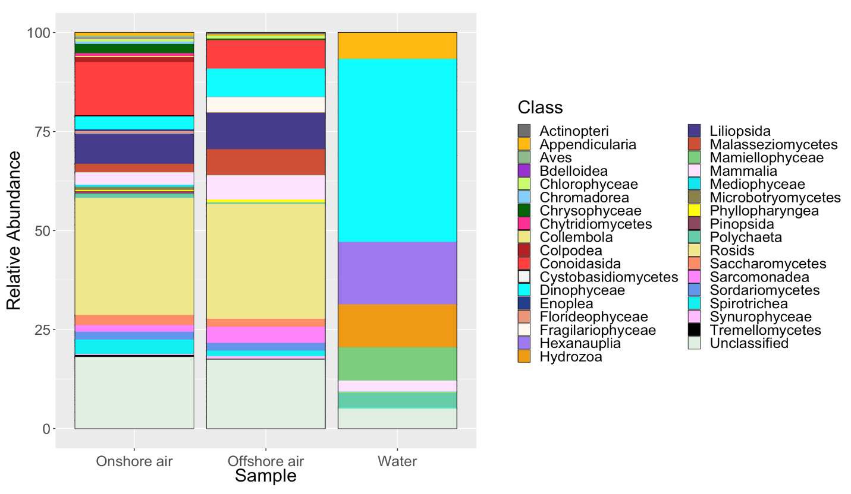
A

B

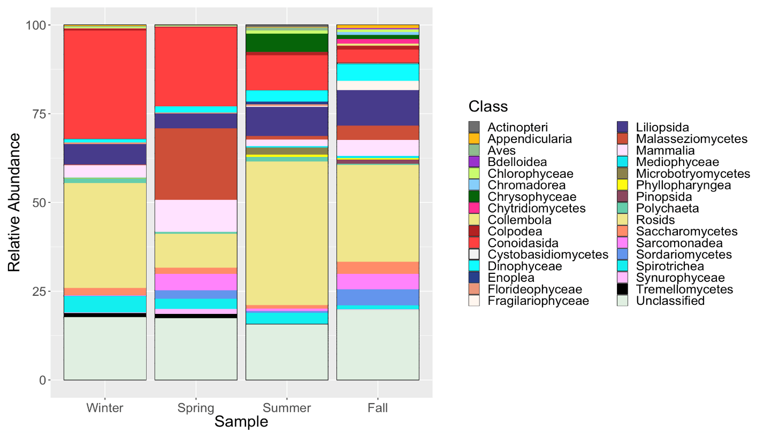

C
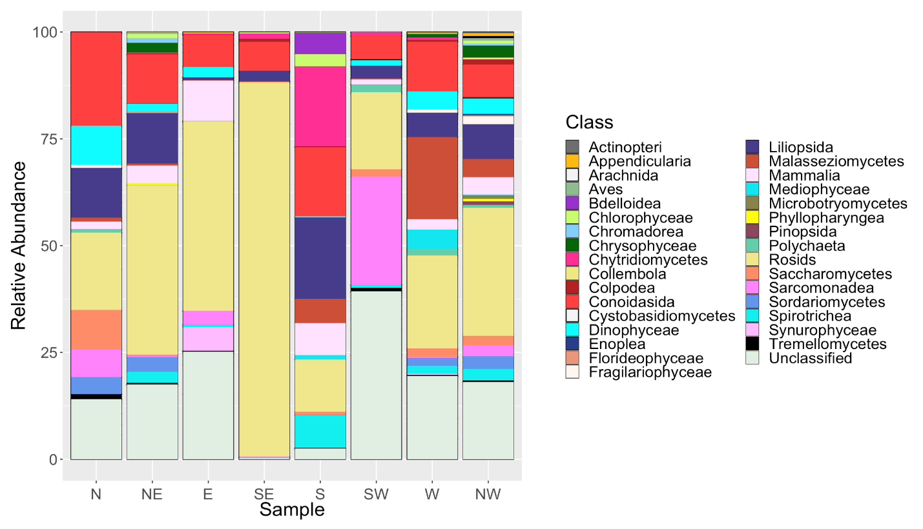

Figure S2. Taxonomic composition of eukaryotic reads at the class level. A) onshore air samples, offshore air samples, and surface water samples. B) sampling seasons. C) backward air mass trajectories.

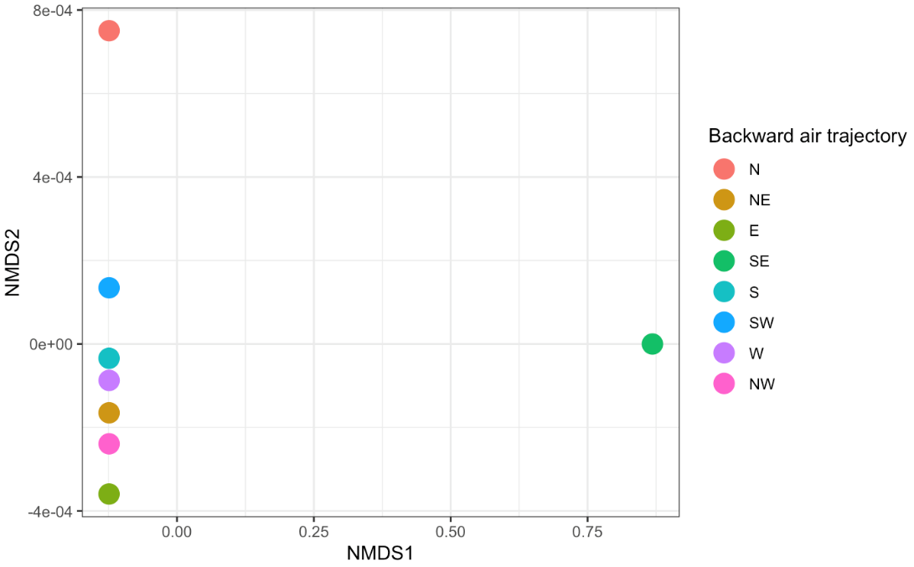
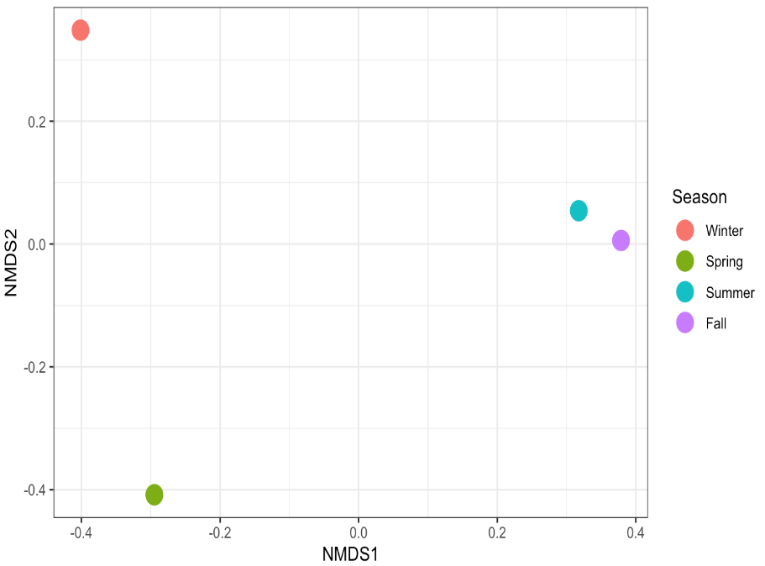
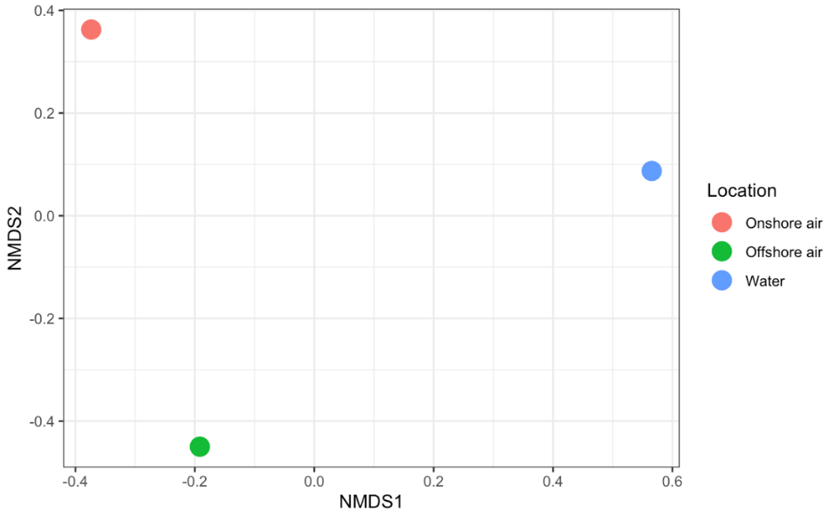
A
B
C
Figure S3. NMDS on Bray–Curtis distance and a multivariate t-distribution of eukaryotes for A) air and water composition, B) Seasons, and C) backward air trajectories. Different colors represent different sampling locations, seasons, and backward air trajectories. The distance between points represents the level of difference.

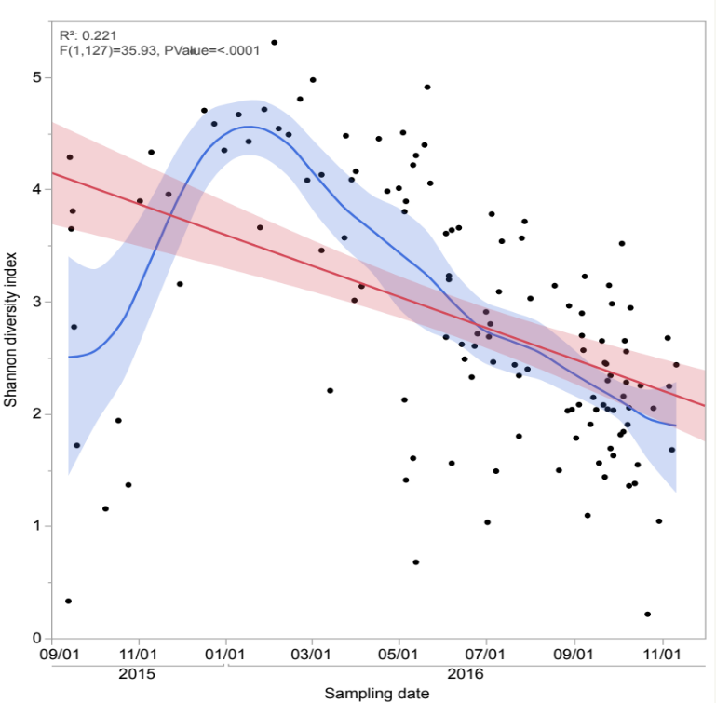

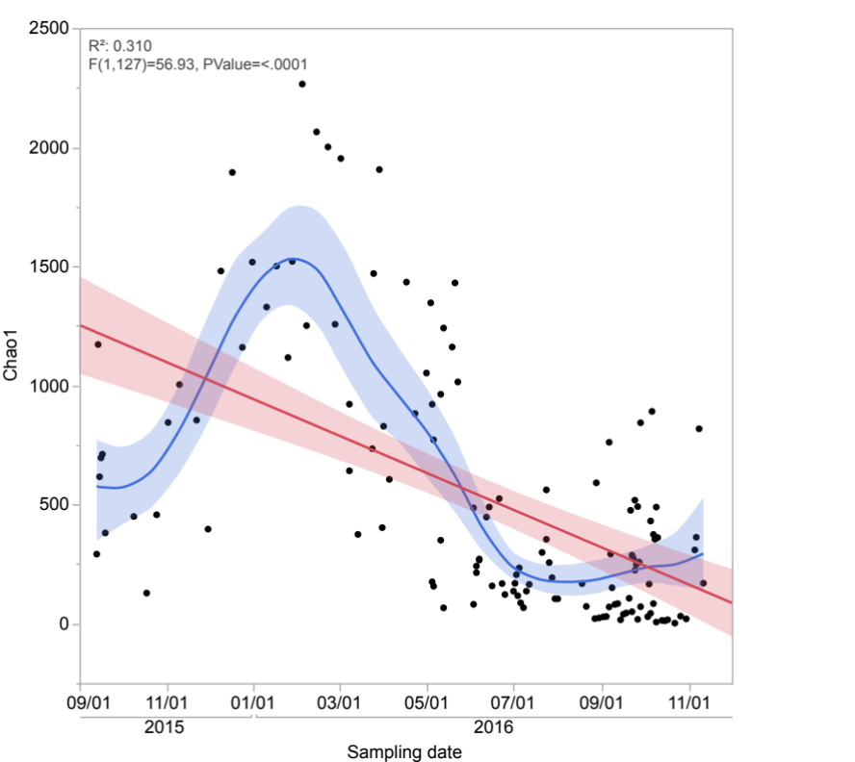

Figure S4. Time series of alpha diversity measures Chao1 and Shannon in the central Red Sea air sampling. Each data point represents an individual sample. The blue line represents the regression line and the blue band around it represents the confidence for the regression line.

