Determining robust optimal pumping solutions in a heterogeneous coastal aquifer using a robust decision-making approach and bargaining theory to resolve multiple sources of uncertainty
Ali Ranjbar
Ph. D. Student, School of Civil Engineering, University of Queensland, St Lucia, Qld, 4072, Australia
Email: a.ranjbarzeinalygharamaleki@uq.net.au
Claudia Cherubini
Department of Mathematics, Informatics and Geociences, University of Trieste, via Weiss 2, 34100 Trieste, Italy
Email: claudia.cherubini@units.it
Tom Baldock
School of Civil Engineering, University of Queensland, St Lucia, Qld, 4072, Australia
Email: t.baldock@uq.edu.au

Appendix A. Supplementary data
The inputs of the SMM algorithm are the time-variant pumping rate ($Qp$), groundwater head ($Hr$), in the observation wells adjacent to the Salt Lake recharge rate ($RT$ and initial $\overline{SWI}$ length at the beginning of each stress period and output are the net $\overline{SWI}$ length and $Hr$ at the end of the stress period.
To increase SMM model efficiency by using a dimensionless form of input parameters, pumping rates were sampled in an allowed range [0, 6450 $m^{3}/day$], and divided to $6450$
$m^{3}/day$. Regarding the large number of inputs (extraction rate), the domain is divided into 5 clusters, and a single SMM model is assigned to each cluster.
The criteria for assigning wells to each cluster are based on the sensitivity analysis presented in Fig. S1a. The distance of the well screen from the Salt Lake boundary and the well pumping rate are demonstrated with vertical and horizontal error bars in Fig. S1a, respectively. As shown, $SWI$ is affected by a high pumping rate from wells located in the middle of the region, whereas wells located near the lake boundary have a low pumping rate.
Thus, the main SMM is assigned to the input parameters of 5 (cluster)×4 (season)+ 5 ($RT$) + 4 ($Hr$) making the total number of inputs and outputs equal to 1728 (25 (years)×69 (wells)+3 (recharge and initial condition)) and 2 outputs, respectively.

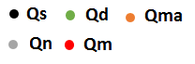
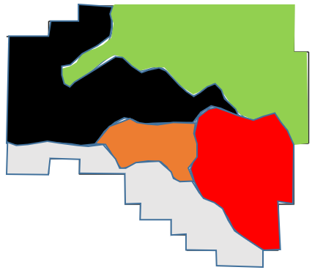
b)

Fig. S1. The sensitivity of each well on SWI rate and clustering zone for the surrogate model) vertical and horizontal error bars indicate the distance of the wells screen from Salt Lake boundary and the wells pumping rate, respectively, b) Domain geometry and different agricultural zone based. $Q_{s}$, $Q_{d}$, $Q_{ma}$, $Q_{n}$, $Q_{m}$ are the representative of pumping wells in the different agricultural zone including Serajeh, Dolatabad, Malekan, Noran, and Mohamadabad, respectively.

Approximately 1600 samples of pumping rate and TDS concentration were generated by the OLHSM and then used for training 6 MDT models. The lower and upper bounds of the 8 input samples in the SMM model, corresponding to $Q_{1}$, $Q_{2}$, $Q_{3}$, $Q_{4}$, $Q_{5}$ , $\overline{SWI}$, $Hr$ , and $RT$ are between (1900, 68500 $m^{3} /d$), (550, 22000 $m^{3} /d$), (300, 7600 $m^{3} /d$), (460, 16100 $m^{3} /d$), (850, 33110 $m^{3} /d$), (688, 806 $m$), (105, 608$m$), and ($0.000011, 0.0000125 m/day$), respectively. Fig. S2 shows time-variant groundwater head and TDS concentration along the sampling point (Fig. S2f) for 200 databases over a 2472-day stress period.
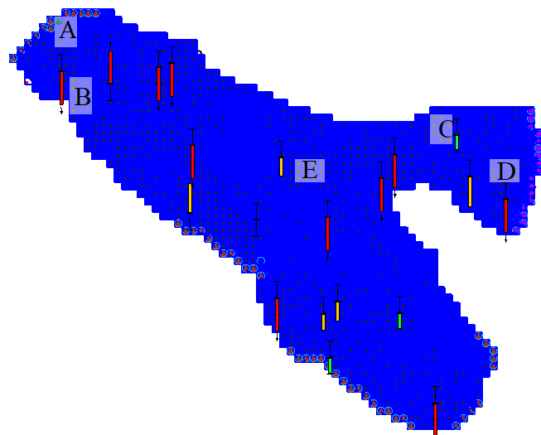
f

Fig. S2. Time series of TDS concentration over 5 databases (Each database includes 50 samples).

Fig. S2d shows the cells exposed to saltwater intrusion; thus, the TDS concentration increases with time whereas, the other sampling points are far from the salinity sources and the TDS concentration is reduced. Therefore, 155 sampling points are located around point D where the TDS concentration is higher than $8200 mg/lit.$ Based on the dashed line demonstrated in Fig. S2a..e, after a range of times, the TDS concentration can be fitted using nonlinear regression models. In other words, the TDS concentration simulated by SEAWAT is more likely to follow a regression relationship rather than sinusoidal behavior. As a result, the interval regression generated by the MDT was in good agreement with the simulated dataset. To eliminate the effect of the dimensions of the input parameters, the natural logarithm of the extraction rate and original recharge rates were used for training the SMM model. Compared to the original input parameters, the non-dimensional parameters led to a 15 % improvement in the prediction efficiency.
The best topology of a pruned tree after optimizing the nodes and leaves provides 22 regression models (see Fig. s3) which is summarized as follows:

If 4631 <$\overline{SWI}$<5697and Q₄<4725, Then $RR 1$
$RR 4 :\frac{\left(\overline{SWI}\right)}{76540}= e^{-0.073 ln\left(Q_{5}\right)-0.019\ln{(Q_{3}})+ 0.071 ln⁡(Q_{1})-0.108 ln⁡(Q_{4})-0.006 (RT)⁡-0.39 (Hr)} (1)$
If <$\overline{SWI}$<5697<4631 and $Q_{4}$>4725, Then $RR 2$
$$RR 4: \frac{\left(\overline{SWI}\right)}{632.8}= e^{-0.088 ln\left(Q_{5}\right)-0.089\ln{(Q_{2}})+0.128\ln{(Q_{3 }})+ 0.012 ln⁡(Q_{1})-0.003 ln⁡(Q_{ 4})-0.006 (RT)⁡-0.134 (Hr)} (2)$$
If 4631 <$\overline{SWI}$<5262 and $Hr$ <746, Then $RR 3$
$$RR 3\frac{\left(\overline{SWI}\right)}{384.4}= e^{-0.250 ln\left(Q_{5}\right)+0.247\ln{(Q_{3}})- 0.011 ln⁡(Q_{s})-0.003 ln⁡(Q_{ 4})-0.0002 (RT)⁡-0.133 (Hr)} (3)$$
If 4631 <$\overline{SWI}$<5262 and $Hr$>746, Then $RR 4$
$$RR 4: \frac{\left(\overline{SWI}\right)}{384.4}= e^{-0.220 ln\left(Q_{ 5}\right)+0.247\ln{(Q_{3}})- 0.009 ln⁡(Q_{1})-0.003 ln⁡(Q_{ 4})-0.0162 (RT)⁡-0.103 (Hr)} (3)$$
………………………………….
………………………………….
$$RR 22: \frac{\left(\overline{SWI}\right)}{67.8}= e^{+0.401 ln\left(Q_{5}\right)-0.255\ln{(Q_{3}})- 0.018 ln⁡(Q_{1})-0.007 ln⁡(Q_{4})-0.001 (RT)⁡-0.133 (Hr) } (4)$$
SWI
LM 9
LM 10
LM 19
LM 21
LM 20
LM 18
LM 17
LM 16
LM 15
LM 12
LM 11
LM 14
LM 13
LM 8
LM 7
LM 6
LM 5
LM 4
LM 3
LM 2
LM 1
SWI

SWI

Q₁
SWI

SWI

$$Hr$$
$$Hr$$
Q₂
Q₂
$$Hr$$
Q₅
Q₂
Q₁
Q₄
Q₂
SWI
RT
Q₄
Q₅
<5697
>5697
>4631
<4631
>47255
<4725
>5262
<5262
>14875
<746
>746
>20825
<20825
<33250
>33250
<26931
>6931
<8906
>8906
<.0001
>.0001
<56050
>56050
<8625
>8625
<20825
>20825
<5625
>5625
<772
>772
<8500
>8500
<88247
>8247
>13475
<13475
Fig. S3. The structure of SMM algorithm.
The generated regression relation (RR) indicates the local sensitivity of the input parameter to SWI. RR1 shows that if $Q_{4}<4710 m^{3}/day$ and $\overline{SWI}$ < 4622 $m$ $\overline{SWI}$ is the most affected by $Q_{4}$ and $Hr$. The negative coefficient of $Hr$ for all relationships, proves the inverse relationship between SWI and groundwater head near the Salt Lake boundary. Additionally, $\overline{SWI}$ is influenced by pumping from $Q_{4}$ and $Q_{5}$which are located adjacent to the lake boundary. However, in comparison to $Q_{4}$a large number of wells is located in $Q_{5}$ zone and hence $Q_{4}$ coefficient is smaller than $Q_{5}.$Fig. s3 implies that, $Hr$ is most effective parameters controlling $\overline{SWI}$, and thus, for the upper limit of $Hr$, the impact of $Q_{1}$, $Q_{2}$…$Q_{5}$ rates on $\overline{SWI}$ length is negligible. Among the extraction rates from the 5 zones, $Q_{1}$ and $Q_{5}$ have minimum and maximum effects on $\overline{SWI}$ length, respectively.
Fig. S4 illustrates the trend of the 2 salinity indexes (TDS and Cl) at the beginning of the 6-years operation period. As shown, there is good agreement between Cl and TDS levels at 18 observation points (Fig. 5c) hence, TDS concentration is considered as the salinity indicator in this study.
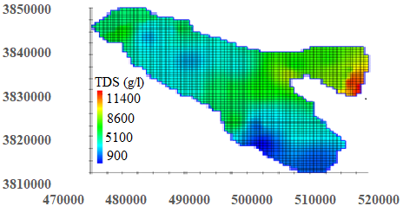 | 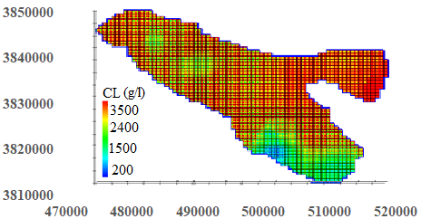
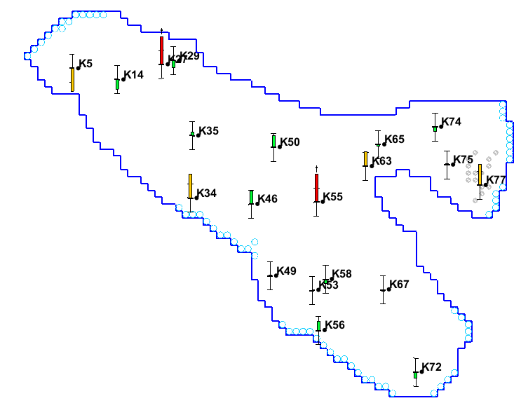

Fig. S4. b) The salinity distribution considering to indexes such as a) TDS, b) Cl throughout the study area. c) The location of the observation points and their distribution d) The scatter plot of the observed TDS versus Cl level.

The observed salinity data (TDS concentration) are recorded in a monthly time step for one year before the operation horizon (6 years). These salinity data in 3 observation wells near Salt Lake (k74, k75, k77) are used to calibrate the SEAWAT model parameters. The graph of the simulated TDS by SEAWAT m and MDT model versus the observed values at the Observation well k77 is illustrated in Fig. S5. As seen, the RMSE value of the predicted TDS (250 $mg/l$) by SEAWAT and MDT for validation step is less than 2 % of the maximum TDS values (12500 $mg/l$), and thus the MDT results are in good agreement with the observed values.
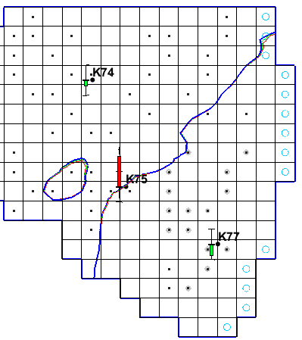

Fig. S5. The predicted TDS concentration by SEAWAT and MDT models versus observed values in Observation well k75.

