Unraveling Crop Nitrogen-Water Dynamics with Hyperspectral-Thermal Sensing in Northern Central Valley, California
Shahryar Fazli^{1,2,3}, Surendra Maharjan^{1,2,3}, Wenzhao Li^{2,3}, Joshua B. Fisher^{,3}, Rejoice Thomas^{2,3}, Fernando Romero Galvan⁴, Gabriela Shirkey^{3,5}, Hesham El-Askary^{2,3,6}

¹Computational and Data Sciences Graduate Program, Schmid College of Science and Technology, Chapman University, Orange, CA 92866, USA
²Earth Systems Science and Data Solutions Lab, Chapman University, Orange, CA 92866, USA
³Schmid College of Science and Technology, Chapman University, Orange, CA 92866, USA
⁴Cornell AgriTech, Cornell University, Geneva, NY 14853, USA
⁵Grand Challenge Initiative, Chapman University, Orange, CA 92866, USA
⁶Department of Environmental Sciences, Faculty of Science, Alexandria University, Moharem Bek, Alexandria 21522, Egypt

Supplementary Figures:
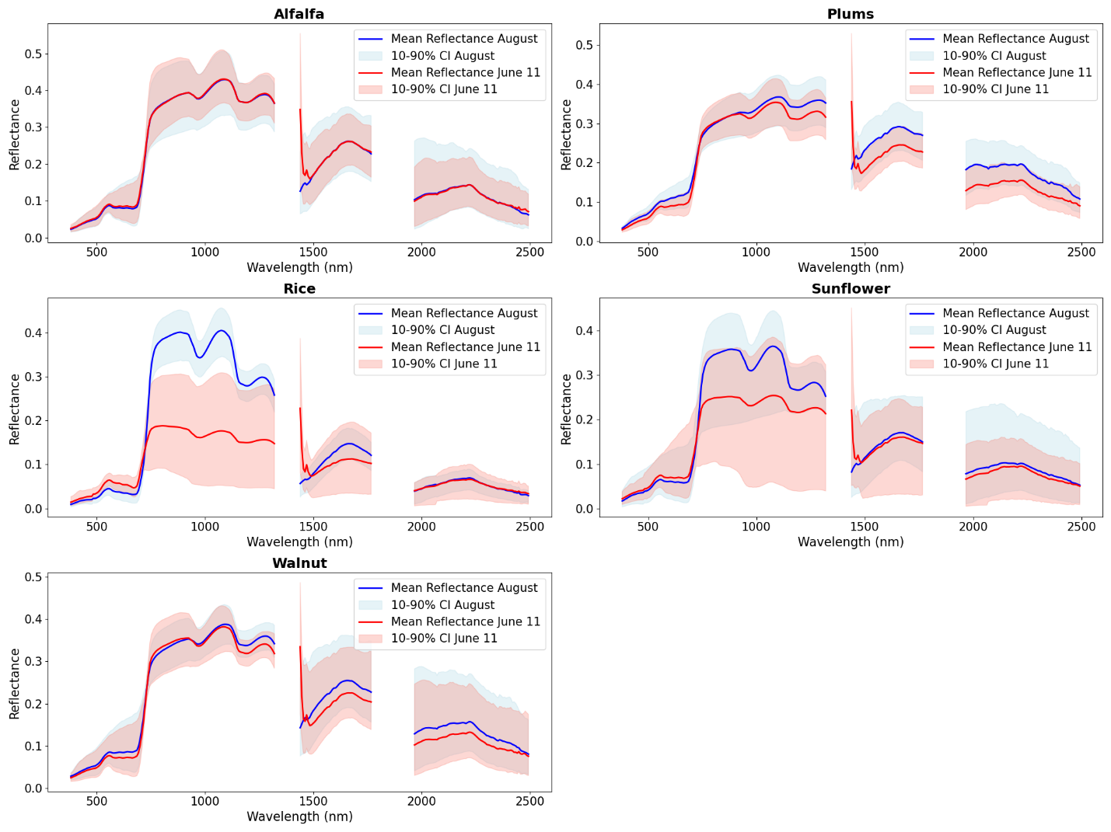
Figure.S1 Spectral reflectance characteristics of different crops with confidence intervals for June and August 2023. Mean spectral reflectance curves are shown for Alfalfa, Plums, Rice, Sunflower, and Walnut across the wavelength range from 400 to 2500 nm. The blue lines represent mean reflectance for August 3rd, while the red lines represent mean reflectance for June 11th. Shaded areas indicate 10-90% confidence intervals for each month. The spectral reflectance patterns illustrate the seasonal differences in crop physiology and the influence of growth stages, with notable variations in reflectance values particularly in the visible and near-infrared regions

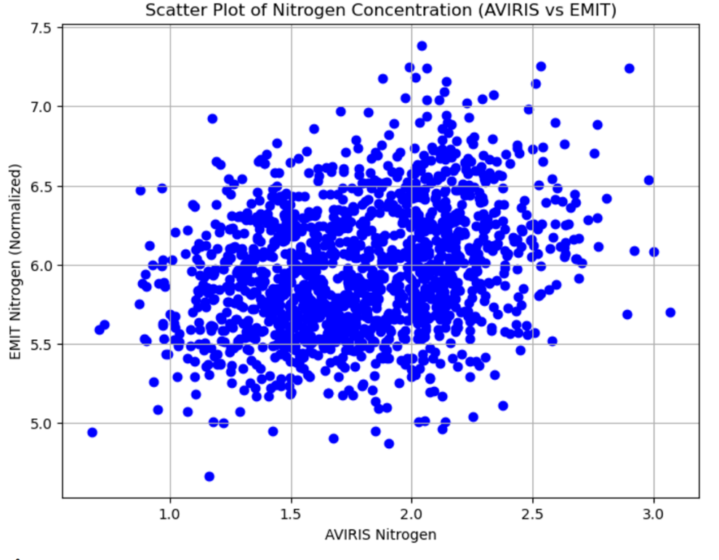
Correlation Coefficient (R):0.2931
Bias: -4.1775
MSE: 17.6837
Figure.S2 Scatter plot showing the correlation between nitrogen concentrations derived from EMIT and AVIRIS data during the SHIFT campaign in Santa Barbara

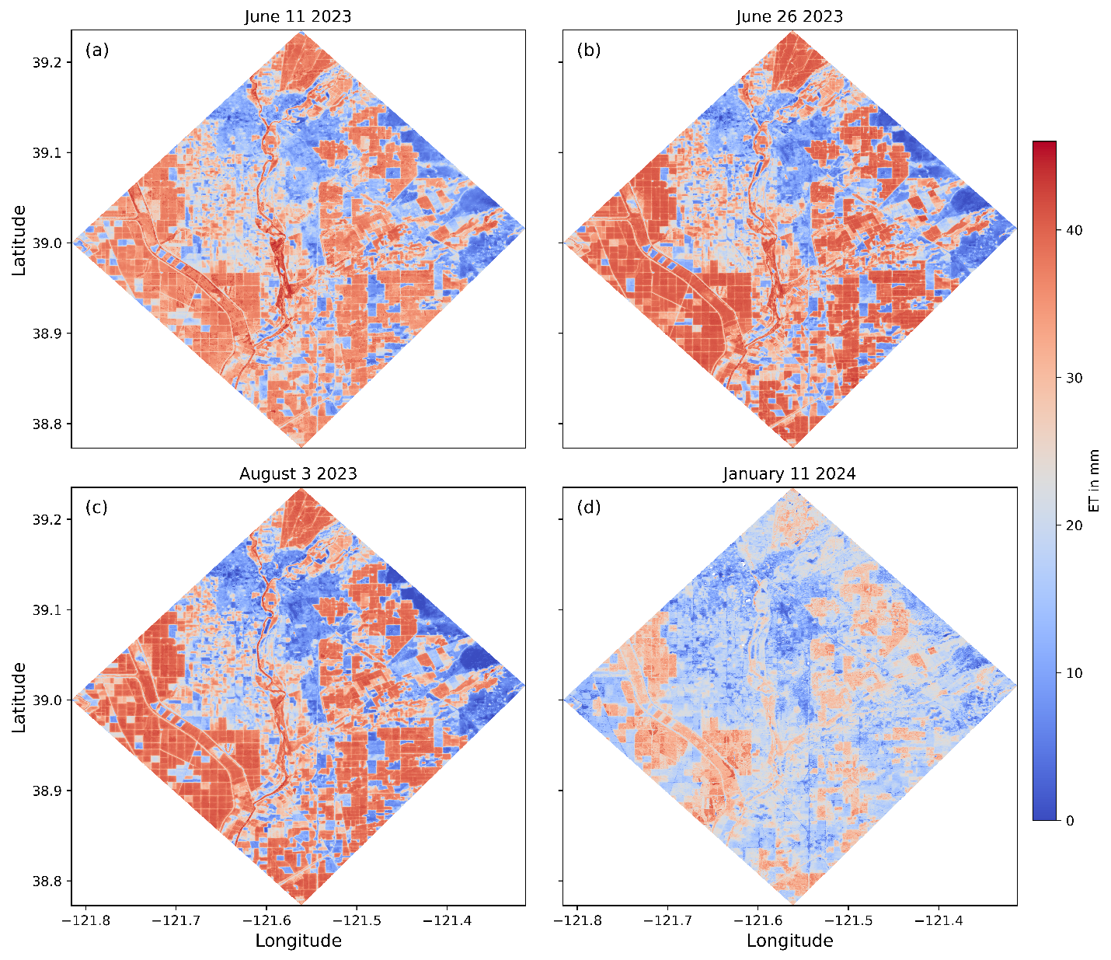
Figure.S3 Spatial distribution of evapotranspiration (ET) mm over the study region on four dates: June 11th, June 26th, August 3rd, 2023, and January 11th, 2024. The color scale represents the ET values, with red indicating higher ET and blue indicating lower ET. These maps highlight the spatial variability in water use across the region, showing significant differences between the growing season (June and August) and the dormant season (January). The changes in ET patterns over time reflect the seasonal dynamics of crop water use and environmental conditions

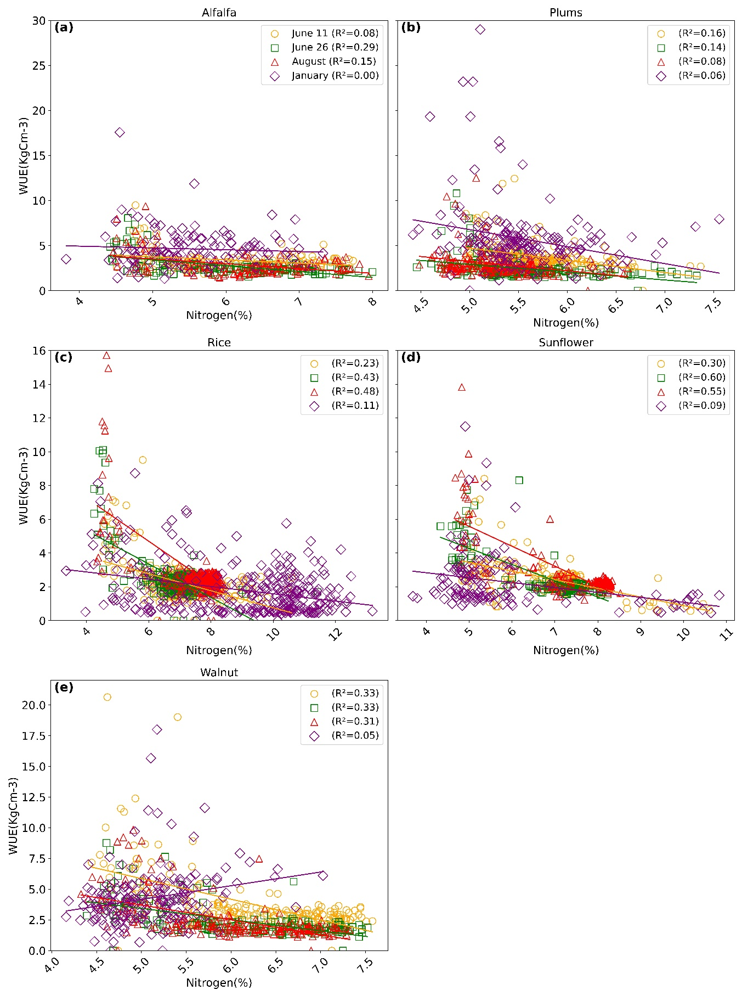
Figure.S4 Crop-based scatter plots between nitrogen content and crop Water Use Efficiency (WUE) over the study region on four dates. The scatter plots show the relationship between nitrogen content (%) and crop WUE (kg/Cm^-3) for Alfalfa (a), Plums (b), Rice (c), Sunflower (d), and Walnut (e) on June 11th, June 26th, August 3rd, 2023, and January 11th, 2024. The lines of best fit and corresponding R-squared values indicate the strength of the correlation between nitrogen content and WUE for each crop. The results show varying degrees of correlation across different crops and dates, with generally weaker correlations in January. These plots highlight the complexity of the relationship between nitrogen content and WUE, influenced by seasonal changes and crop-specific characteristics

