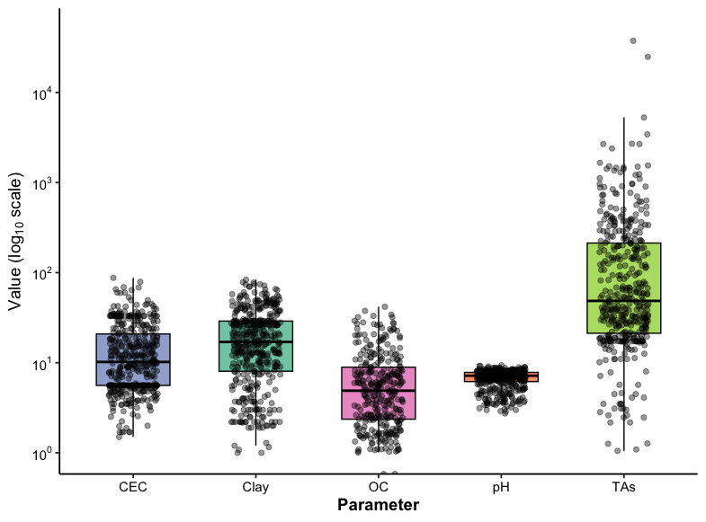
Figure S1. Distribution of key soil physicochemical parameters across the study dataset, presented on a logarithmic scale.
Boxplots depict the variability in cation exchange capacity (CEC), clay content, organic carbon (OC), pH, and total arsenic concentration (TAs) across all samples. Individual points represent raw observations, while box boundaries indicate the interquartile range (IQR), the central line denotes the median, and whiskers extend to 1.5×IQR. The y-axis is presented on a log₁₀ scale to accommodate the wide dynamic range of parameter values, particularly for TAs. Among the variables, TAs exhibited the greatest variability, spanning over four orders of magnitude, whereas soil pH values were narrowly distributed. This visualization highlights the heterogeneity of soil properties, which may influence arsenic mobility and model performance.

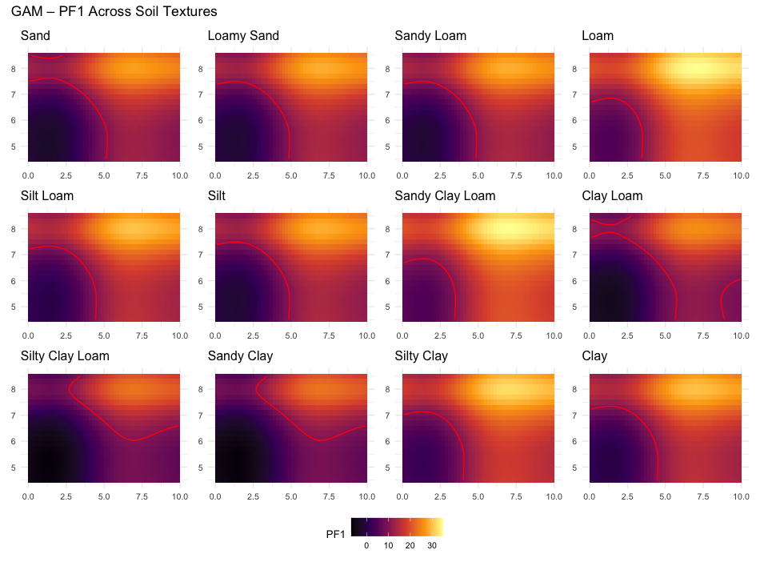
Figure S2. Simulated response surfaces showing predicted arsenic mobility (PF1, %) as a function of organic carbon (OC, %, y-axis) and pH (x-axis) for 12 USDA soil textural classes using the Generalized Additive Model (GAM).
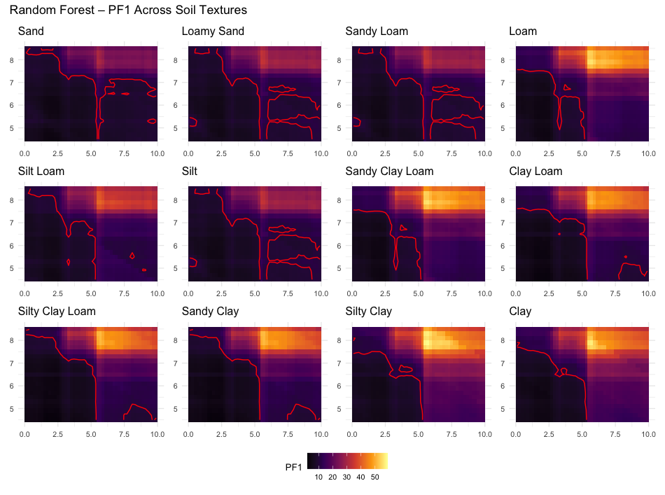
Figure S3. Simulated response surfaces showing predicted arsenic mobility (PF1, %) as a function of organic carbon (OC, %, y-axis) and pH (x-axis) for 12 USDA soil textural classes using the Random Forest (RF) model.

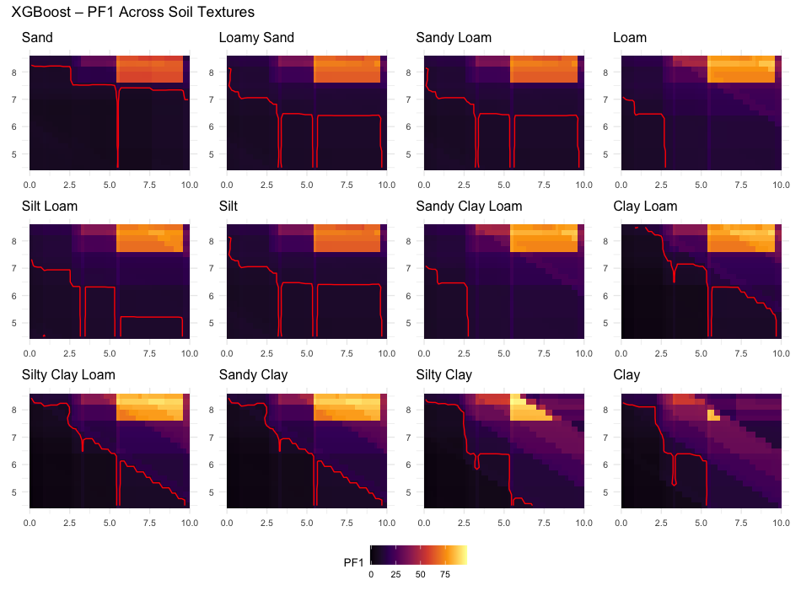
Figure S4. Simulated response surfaces showing predicted arsenic mobility (PF1, %) as a function of organic carbon (OC, %, y-axis) and pH (x-axis) for 12 USDA soil textural classes using the Extreme Gradient Boosting (XGBoost) model.

