Supplementary Materials accompanying article titled:
Enhancing Flood Forecasting with Machine Learning Informed by Integrated ParFlow-CLM Hydrological Modeling
Earth Systems and Environment
Samira Sadat Soltani *,^{a,b}, Zohreh Mohammadi, Ardalan Izadi, Stefan Kollet
ª Institute of Bio- and Geosciences (IBG-3, Agrosphere), Forschungszentrum Jülich GmbH, 52425 Jülich, Germany
^{b} Centre for High-Performance Scientiﬁc Computing in Terrestrial Systems, Geoverbund ABC/J, Jülich, Germany (email: s.soltani@fz-juelich.de)
List of Figures/Tables:
SM. Figure 1. Slope distribution across the case study including Ahr, Kyll and Prum basins.
SM. Figure 2. Length of stream orders (1–3) and their spatial distribution in the Ahr, Kyll, and Prüm basins.
SM. Figure 3. Topologic width function across the case study including Prum, Ahr, and Kyll basins.

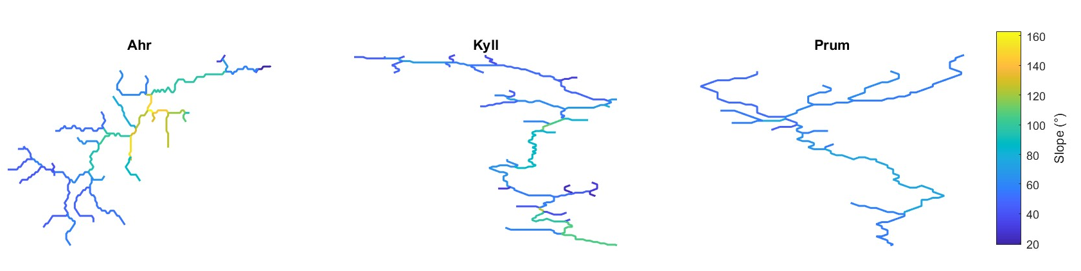
SM. Figure 1. Slope distribution across the case study including Ahr, Kyll and Prum basins.

SM. Figure 2. Length of stream orders (1–3) and their spatial distribution in the Ahr, Kyll, and Prüm basins.
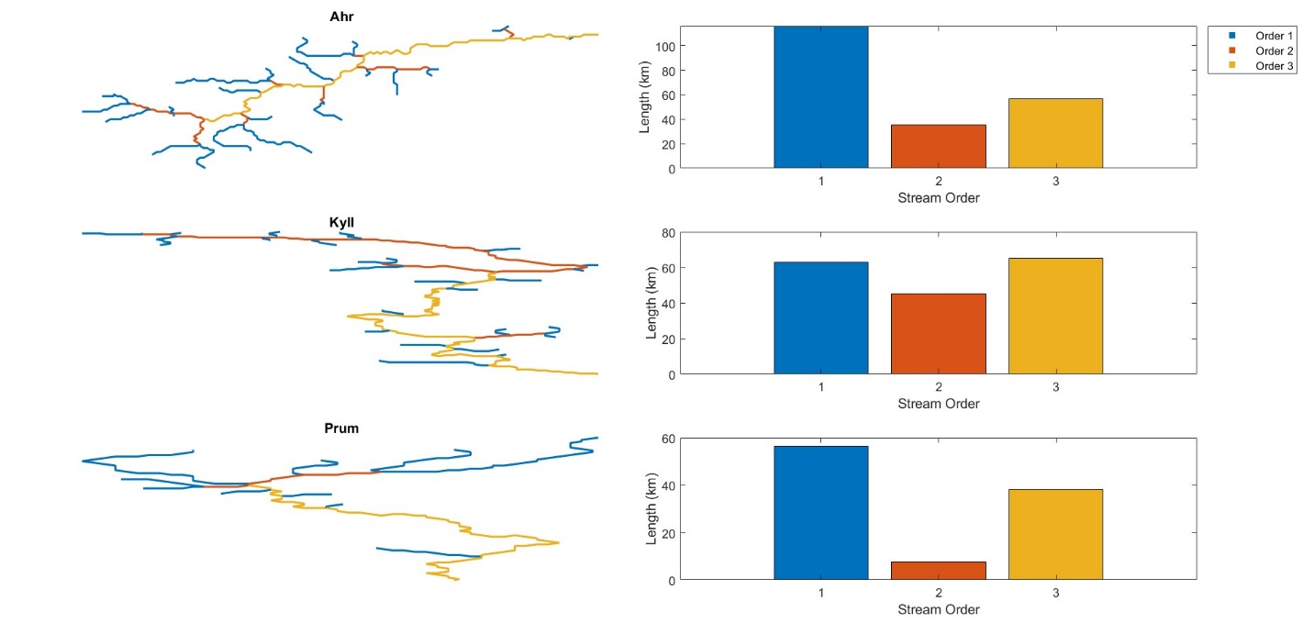
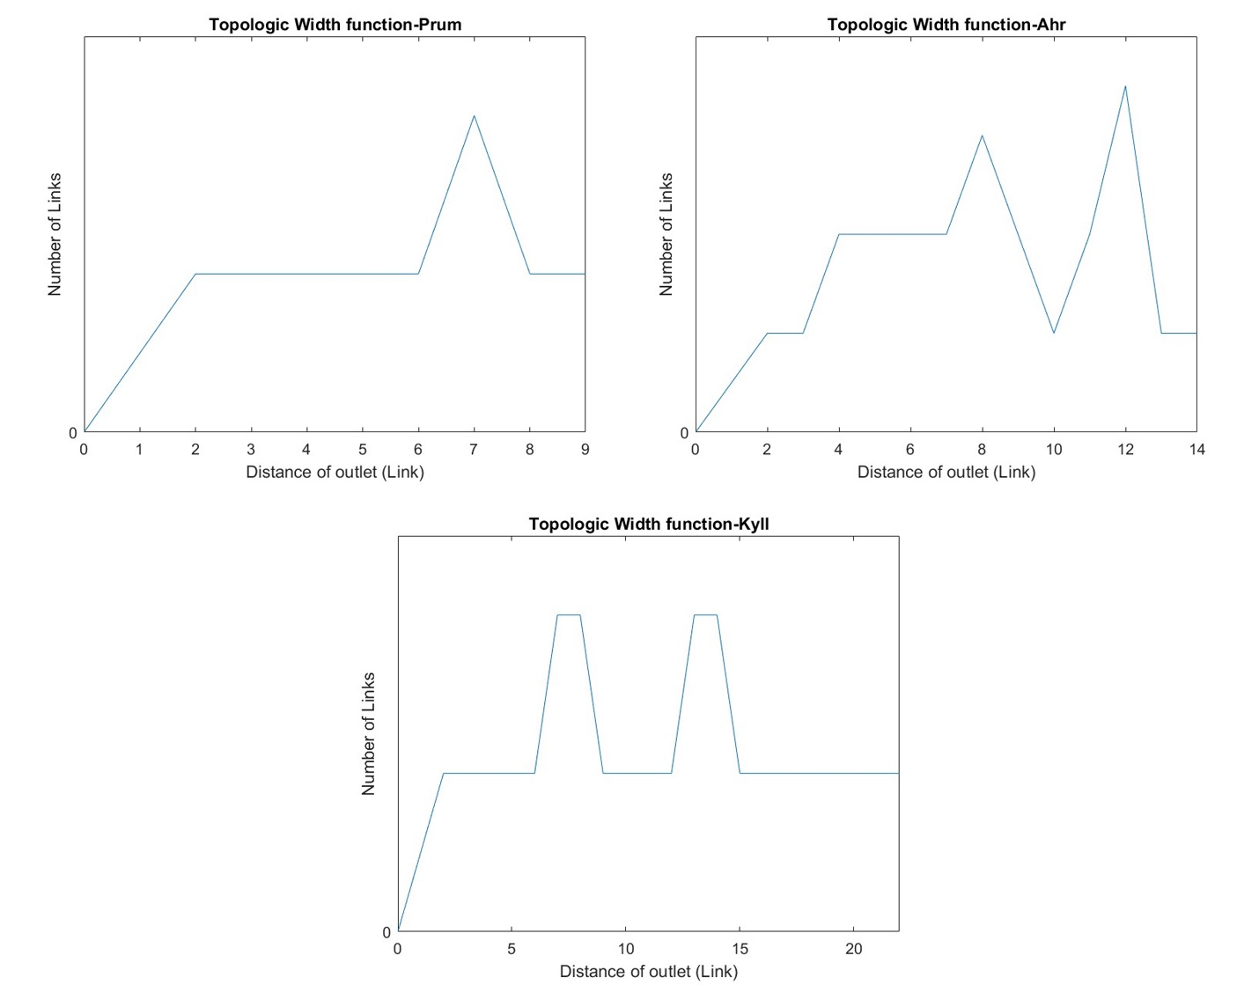
SM. Figure 3. Topologic width function across the case study including Prum, Ahr, and Kyll basins.

