Supplementary Material
This document serves as a supplement to the article “Climate-driven modeling of the initial development of Brazilian forest species under current and future climates” authored by M. Ferreira, F. Martins, C. Dias, F. Fagundes, R. Xavier, M. Faria, A.F. Ferreira and H. Costa.

Table S1 Species-specific initial developmental thermal thresholds
Forest species | Tb (ºC) | Topt (ºC) | TB (ºC)
B. forficata | 10.6 | 21.5 | 43.9
C. speciosa | 12.0 | 21.0 | 42.8
H. chrysotrichus | 11.4 | 23.3 | 41.9
H. impetiginosus | 12.6 | 21.1 | 42.6
T. roseoalba | 12.2 | 21.2 | 43.4
These thresholds were previously estimated by Ferreira (2025). Tb = base, Topt = optimum, and TB = maximum temperatures.

Table S2 List of NEX-GDDP-CMIP6 models used in the simulations and projections of the initial development of the five forest species studied and their respective development centers.
General Circulation Models (GCMs) | Developer Center
ACCESS-CM2 | Commonwealth Scientific and Industrial Organisation and Australian Research Council Centre of Excellence for Climate System Science (CSIRO-ARCCSS) - Australia
ACCESS-ESM1-5 | Commonwealth Scientific and Industrial Organisation (CSIRO). Austrália
CanESM5 | Canadian Centre for Climate Modelling and Analysis, Environment and Climate Change Canada (CCCma) - Canada
CMCC-ESM2 | Fondazione Centro Euro-Mediterraneo sui Cambiamenti Climatici (CMCC) - Italy
EC-Earth3 | EC-Earth consortium - Europe
EC-Earth3-Veg-LR | EC-Earth consortium - Europe
GFDL-ESM4 | National Oceanic and Atmospheric Administration, Geophysical Fluid Dynamics Laboratory (NOAA-GFDL) - Princeton, EUA
INM-CM4-8 | Institute for Numerical Mathematics, Russian Academy of Science - Russia
INM-CM5-0 | Institute for Numerical Mathematics, Russian Academy of Science - Russia
IPSL-CM6A-LR | Institut Pierre Simon Laplace (IPSL) - France.
MIROC6 | Japan Agency of Marine-Earth Science Technology, Atmosphere and Ocean Reserarch Institute, and RIKEN Center for Computacional Science - Japan
MPI-ESM1-2-HR | Max Planck Institute for Meteorology (MPI-M) - Germany
MPI-ESM1-2-LR | Max Planck Institute for Meteorology (MPI-M) - Germany
MRI-ESM2-0 | Meteorological Research Institute - Japan
NorESM2-LM | NorESM Climate Modeling Consortium - Norway
NorESM2-MM | NorESM Climate Modeling Consortium - Norway
Adapted from Dias et al. (2024)

Table S3 Bias values for mean air temperature (Tmean; ºC) simulated by 16 General Circulation Models from NEX-GDDP-CMIP6 and observed data provided by Xavier et al. (2016)
General Circulation Models (GCMs) | Maximum monthly | Minimum monthly s | Seasonal |  |  |  | Mean annual
General Circulation Models (GCMs) | Maximum monthly | Minimum monthly s | DJF | MAM | JJA | SON | Mean annual
ACCESS-CM2 | +1.72 | -0.76 | -0.58 | +0.53 | +0.89 | -0.28 | +0.14
ACCESS-ESM1-5 | +1.41 | -0.70 | -0.53 | +0.49 | +0.79 | -0.23 | +0.13
CanESM5 | +1.61 | -0.61 | -0.46 | +0.56 | +0.81 | -0.09 | +0.21
CMCC-ESM2 | +1.40 | -0.79 | -0.68 | +0.50 | +0.44 | -0.24 | +0.00
EC-Earth3 | +1.46 | -0.70 | -0.53 | +0.63 | +0.77 | -0.07 | +0.20
EC-Earth3-Veg-LR | +1.40 | -0.61 | -0.44 | +0.56 | +0.88 | -0.13 | +0.22
GFDL-ESM4 | +1.84 | -0.72 | -0.56 | +0.76 | +0.66 | -0.09 | +0.19
INM-CM4-8 | +1.52 | -0.75 | -0.51 | +0.66 | +0.45 | -0.35 | +0.06
INM-CM5-0 | +1.43 | -0.85 | -0.63 | +0.39 | +0.47 | -0.48 | -0.06
IPSL-CM6A-LR | +1.23 | -0.80 | -0.55 | +0.45 | +0.45 | -0.18 | +0.04
MIROC6 | +1.18 | -0.80 | -0.70 | +0.33 | +0.36 | -0.51 | -0.13
MPI-ESM1-2-HR | +1.24 | -0.73 | -0.53 | +0.41 | +0.63 | -0.35 | +0.04
MPI-ESM1-2-LR | +1.44 | -0.76 | -0.54 | +0.49 | +0.49 | -0.11 | +0.08
MRI-ESM2-0 | +1.51 | -0.77 | -0.64 | +0.42 | +0.60 | -0.33 | +0.01
NorESM2-LM | +1.09 | -0.76 | -0.66 | +0.27 | +0.53 | -0.34 | -0.05
NorESM2-MM | +1.51 | -0.79 | -0.62 | +0.45 | +0.34 | -0.33 | -0.04
ensemble | +1.43 | -0.74 | -0.57 | +0.49 | +0.60 | -0.26 | +0.07
DJF corresponds to December, January, and February; MAM to March, April, and May; JJA to June, July, and August; and SON to September, October, and November.

Table S4 F-test values obtained from ANOVA for the studied forest species.
Calculated F-test
Forest species | Sowing dates | Period | Shared Socioeconomic Pathway (SSP)
B. forficata | 2145.35 | 239.81 | 17.40
C. speciosa | 3257.67 | 397.83 | 130.86
H. chrysotrichus | 1859.51 | 97.23 | 55.47
H. impetiginosus | 1855.91 | 139.65 | 5.25
T. roseoalba | 2078.62 | 172.36 | 8.47
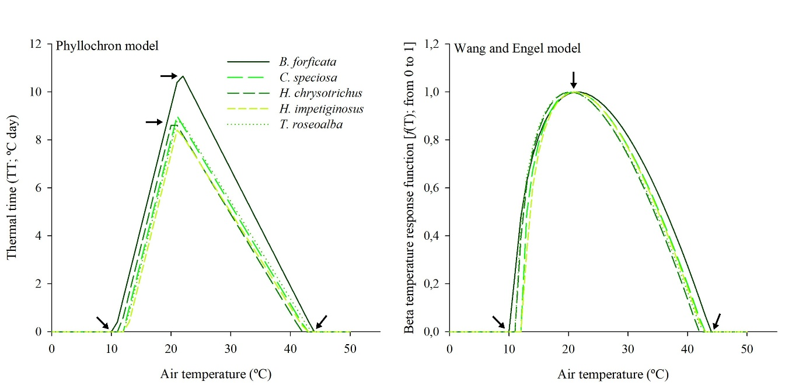
Fig. S1 Air temperature response functions used in the phyllochron model, given by thermal time, and in the Wang and Engel model, given by the beta function, to estimate the accumulated leaf number on the main stem. The arrows represent the thermal thresholds for the initial development of each forest species.

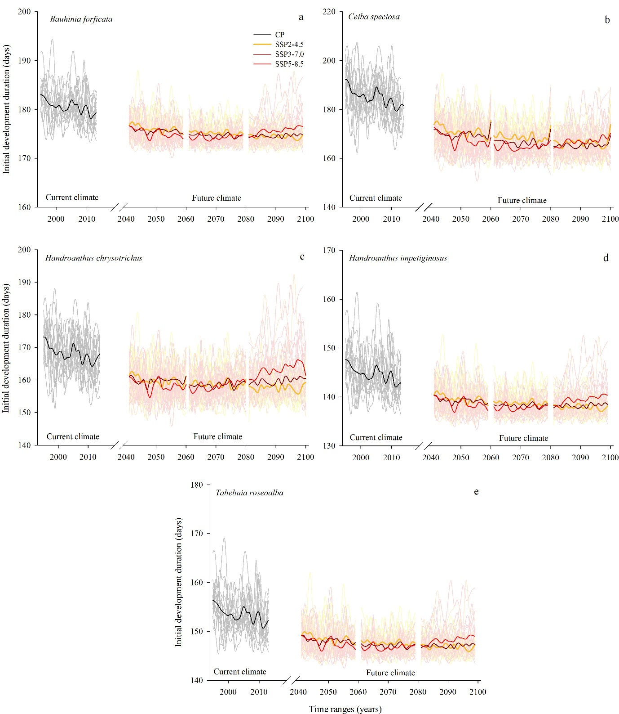
Fig. S2 Temporal variation of the initial development duration (IDD, in days) simulated for the current climate (CC = 1995-2014) and projected for the future climate (NF = 2041-2060, IF = 2061-2080 and FF = 2081-2100) under three socioeconomic scenarios (SSP2-4.5, SSP3-7.0 and SSP5-8.5) by 16 climate models from NEX-GDDP-CMIP6 for Bauhinia forficata (panel a), Ceiba speciosa (panel b), Handroathus chrysotrichus (panel c), Handroathus impetiginosus (panel d) and Tabebuia roseoalba (panel e). The lighter gray, yellow, orange, and red lines represent the IDD for each climate model, and the bold black, orange, brown, and red lines represent the IDD mean from the climate models.

