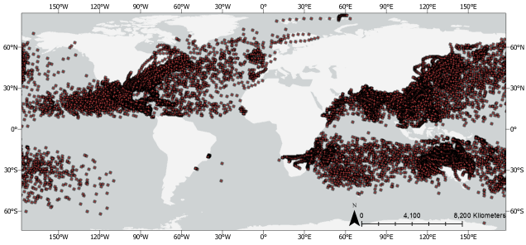
Supplementary Figure 1: Locations of all TC landfalls between 1950-2024.
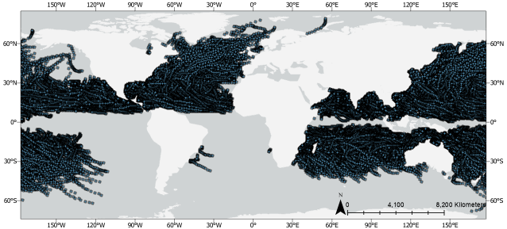
Supplementary Figure 2: Locations of all TC no landfalls between 1950-2024.

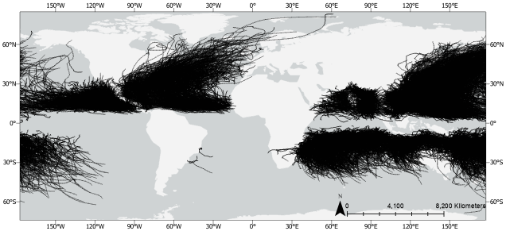
Supplementary Figure 3: Track locations of all TCs between 1950-2024.

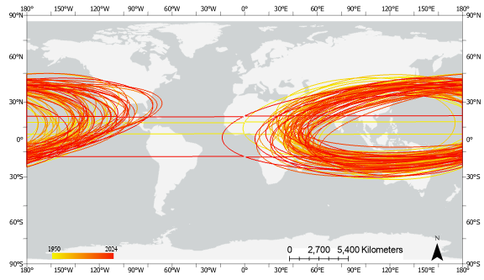(a)
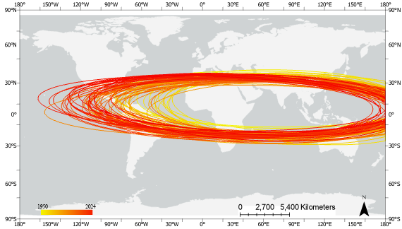
(b)
Supplementary Figure 4: (a) Annual Standard Deviational Ellipses for TC Landfall; (b) Annual Standard Deviational Ellipses for TC No-Landfall

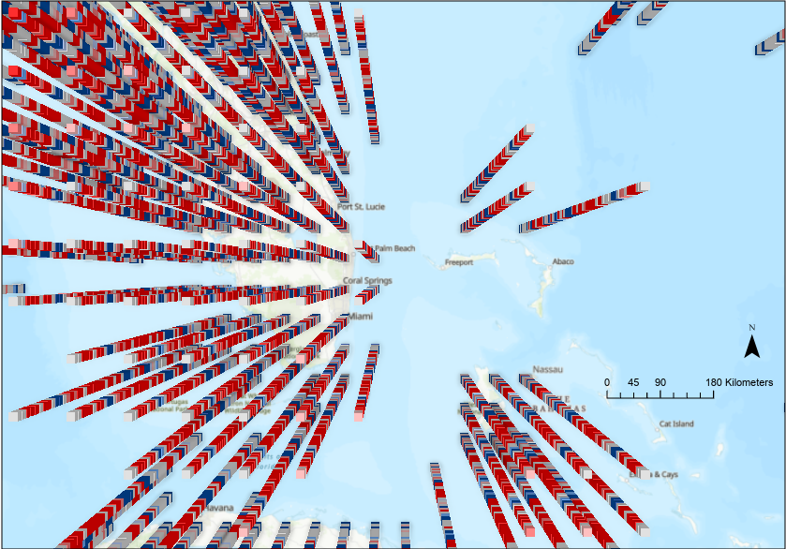
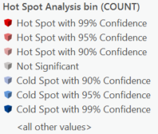
(a) Florida Peninsula
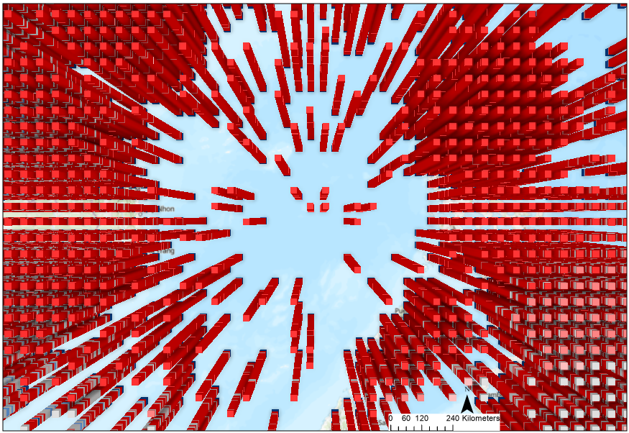
(b) East Pacific Ocean Basin
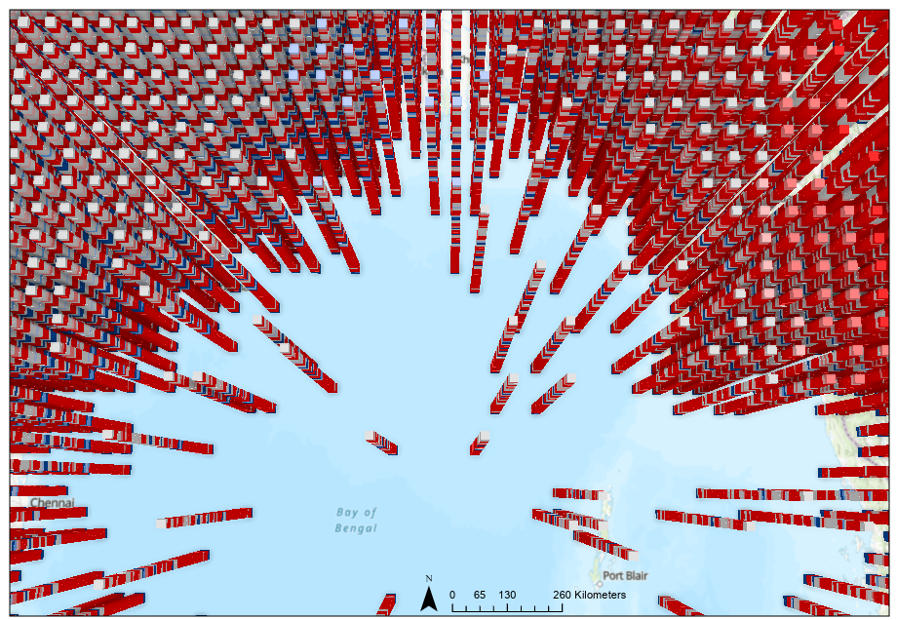
(c) North Indian Ocean Basin
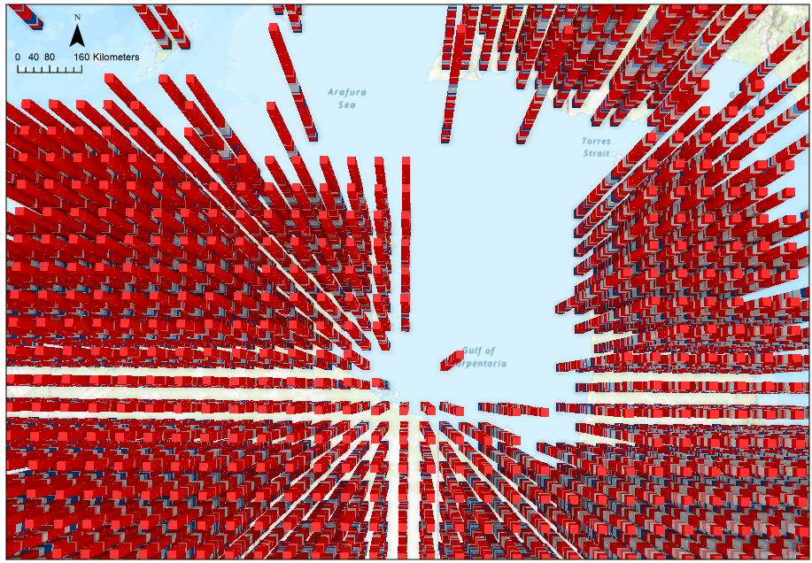
(d) South Indian Ocean Basin
Supplementary Figure 5: Visualization of Space Time Cube NetCDF files for TC landfalls (a) Florida Peninsula; (b) East Pacific Basin; (c) North Indian Ocean Basin; (d) South Indian Ocean Basin.

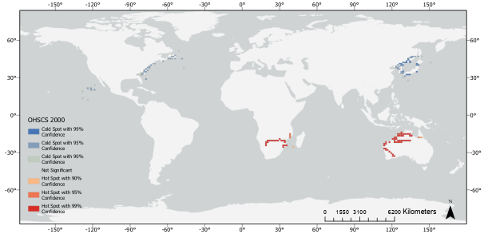
Supplementary Figure 6: Sample result of OHSA for TC landfall in 2000.

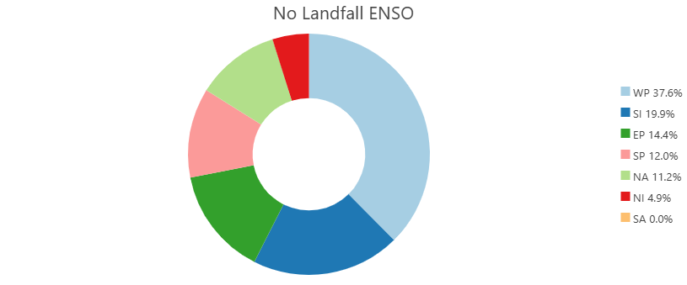
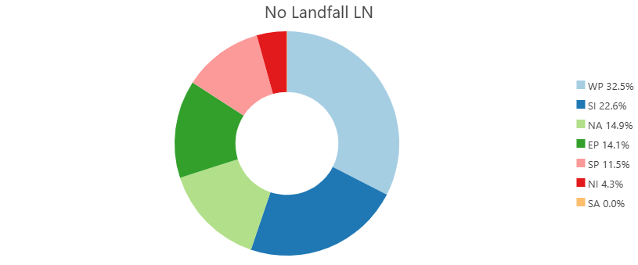
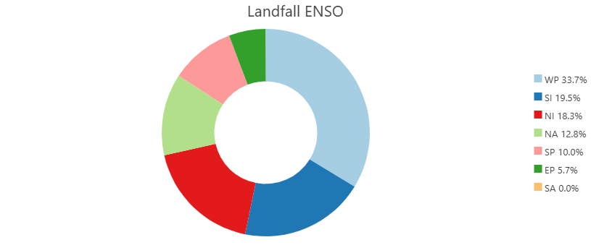
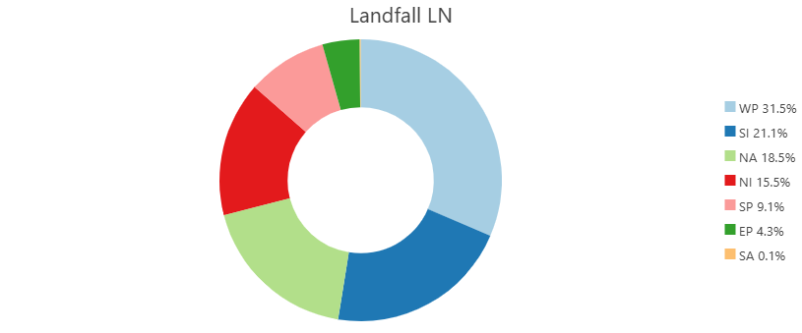
Supplementary Figure 7: Basin level proportions of TC landfall and no landfall for different phases of ENSO.

Processing scripts used in the study
Create Space Time Cube By Aggregating Points
=====================
Tool Path

Input Features Landfall50_24_P
Output Space Time Cube C:\Users\ssr\Box\Hurricanes\2025\Landfall.nc
Time Field DateEHSA
Template Cube
Time Step Interval 1 Years
Time Step Alignment END_TIME
Reference Time
Distance Interval 50 Kilometers
Summary Fields
Aggregation Shape Type FISHNET_GRID
Defined Polygon Locations
Location ID
=====================
Messages

Start Time: Wednesday, May 14, 2025 3:13:00 AM
WARNING 000642: Problems reading 38 of 55559 total records.
WARNING 000848: Features with bad records (only includes first 30): OBJECTID = 1250, 14464, 14467, 14837, 14993, 16525, 16558, 17326, 17753, 19172, 20767, 21536, 22668, 23206, 23277, 23314, 23748, 23791, 25019, 25218, 25341, 25656, 26877, 26910, 26932, 27509, 28429, 28948, 29081, 29190.
WARNING 110050: 5513 input features were considered significant temporal outliers, which can result in a large number of empty bins and memory overflow.
WARNING 110051: Features considered temporal outliers (only includes first 30): OBJECTID = 50046, 50047, 50048, 50049, 50050, 50051, 50052, 50053, 50054, 50055, 50056, 50057, 50058, 50059, 50060, 50061, 50062, 50063, 50064, 50065, 50066, 50067, 50068, 50069, 50070, 50071, 50072, 50073, 50074, 50075.
json:
{"element": "content", "data": "The space time cube has aggregated 55521 points into 454734 fishnet grid locations over 76 time step intervals. Each location is a 50 kilometers by 50 kilometers square. The entire space time cube spans an area 40100 kilometers west to east and 28350 kilometers north to south. Each of the time step intervals is 1 year in duration so the entire time period covered by the space time cube is 76 years. Of the 454734 total locations, 17248 (3.79%) contain at least one point for at least one time step interval. These 17248 locations comprise 1310848 space time bins of which 45136 (3.44%) have point counts greater than zero. There is not a statistically significant increase or decrease in point counts over time."}
json:
[{"element": "table", "data": [[{"data": "Input feature time extent", "prop": {"rowspan": 2}}, "1949-12-11 00:00:00"], [{"data": "to 2024-12-26 00:00:00", "prop": {"text-align": "right"}}], ["", ""], ["Number of time steps", "76"], ["Time step interval", "1 year"], ["Time step alignment", "End"], ["", ""], ["First time step temporal bias", "95.89%"], [{"data": "First time step interval", "prop": {"rowspan": 4}}, "after"], [{"data": "1948-12-26 00:00:00", "prop": {"text-align": "right"}}], [{"data": "to on or before", "prop": {"text-align": "right"}}], [{"data": "1949-12-26 00:00:00", "prop": {"text-align": "right"}}], ["", ""], ["Last time step temporal bias", "0.00%"], [{"data": "Last time step interval", "prop": {"rowspan": 4}}, "after"], [{"data": "2023-12-26 00:00:00", "prop": {"text-align": "right"}}], [{"data": "to on or before", "prop": {"text-align": "right"}}], [{"data": "2024-12-26 00:00:00", "prop": {"text-align": "right"}}], ["", ""], ["Coordinate System", "WGS 1984 World Mercator"], ["Cube extent across space", "(coordinates in meters)"], ["Min X", "-20050000.0000"], ["Min Y", "-10563983.2695"], ["Max X", "20050000.0000"], ["Max Y", "17786016.7305"], ["Rows", "567"], ["Columns", "802"], ["Total bins", "34559784"]], "elementProps": {"striped": "true", "noHeader": true, "title": "Space Time Cube Characteristics", "0": {"align": "left", "pad": "0px", "wrap": true}, "1": {"align": "right", "pad": "0px", "wrap": true}}}]
json:
[{"element": "table", "data": [[{"data": "Total number of locations", "prop": {"font-weight": "bold"}}, " 454734"], [{"data": "Locations with at least one point", "prop": {"font-weight": "bold"}}, " 17248"], [{"data": "- associated bins", "prop": {"font-weight": "bold"}}, "1310848"], [{"data": "- % non-zero (sparseness)", "prop": {"font-weight": "bold"}}, " 3.44"]], "elementProps": {"striped": "true", "title": "COUNT", "0": {"align": "left", "pad": "0px", "wrap": true}, "1": {"align": "right", "pad": "0px", "wrap": true}, "2": {"align": "left", "pad": "0px", "wrap": true}, "3": {"align": "right", "pad": "0px", "wrap": true}}}]
json:
[{"element": "table", "data": [["Trend direction", "Not Significant"], ["Trend statistic", "-1.5518"], ["Trend p-value", "0.1207"]], "elementProps": {"striped": "true", "noHeader": true, "title": "Overall Data Trend - COUNT", "0": {"align": "left", "pad": "0px", "wrap": true}, "1": {"align": "right", "pad": "0px", "wrap": true}}}]
Succeeded at Wednesday, May 14, 2025 3:13:13 AM (Elapsed Time: 12.89 seconds)
=========================================================================
Optimized Hot Spot Analysis
=====================
Tool Path

Input Features ENSO_RawData\Landfall50_24LN
Output Features C:\Users\ssr\Box\Hurricanes\2025\Hurricanes2025.gdb\Landfall50_24LN_OHSCS
Analysis Field
Incident Data Aggregation Method SNAP_NEARBY_INCIDENTS_TO_CREATE_WEIGHTED_POINTS
Bounding Polygons Defining Where Incidents Are Possible
Polygons For Aggregating Incidents Into Counts
Density Surface
Cell Size
Distance Band
=====================
Messages

Start Time: Wednesday, July 16, 2025 10:47:18 AM
WARNING 000642: Problems reading 14 of 24535 total records.
WARNING 000848: Features with bad records (only includes first 30): OBJECTID = 4784, 4817, 5585, 6012, 8020, 8789, 9426, 9459, 9481, 10058, 10978, 11624, 11711, 15635.
json:
{"element": "h5", "data": "Initial Data Assessment"}
Making sure there are enough incidents for analysis....
json:
{"element": "unorderedlist", "data": ["There are 24521 valid input features."]}
Looking for locational outliers....
json:
{"element": "unorderedlist", "data": ["There were 312 outlier locations; these will not be used to compute the snap distance."]}
json:
{"element": "h5", "data": "Incident Aggregation"}
Snapping nearby incidents together to create weighted points....
- For Snap nearby incidents to create weighted points, a snap distance is computed and used to aggregate nearby incident points. Each aggregated point is given a count reflecting the number of incidents that were snapped together. The aggregated points are then analyzed with the incident counts serving as the analysis field. The Snap nearby incidents to create weighted points option is an appropriate aggregation strategy when you have many coincident, or nearly coincident, points and want to maintain aspects of the spatial pattern of the original point data.

json:
{"element": "unorderedlist", "data": ["Aggregating features less than 16282.3977 meters from each other."]}
Evaluating incident counts and the number of weighted point features....
json:
{"element": "unorderedlist", "data": ["The aggregation process resulted in 8303 weighted points."]}
json:
[{"element": "table", "data": [["Min", "1.0000"], ["Max", "35.0000"], ["Mean", "2.9533"], ["Std. Dev.", "3.2998"]], "elementProps": {"striped": "true", "className": "small", "noHeader": true, "title": "Incident Count Properties:", "0": {"align": "left", "pad": "0px", "wrap": true}, "1": {"align": "right", "pad": "0px", "wrap": true}}}]
json:
{"element": "h5", "data": "Scale of Analysis"}
Looking for an optimal scale of analysis by assessing the intensity of clustering at increasing distances....
json:
{"element": "unorderedlist", "data": ["No optimal distance was found using this method."]}
Determining an optimal distance using the spatial distribution of features....
json:
{"element": "unorderedlist", "data": ["The optimal fixed distance band is based on the average distance to 30 nearest neighbors: 464222.0000 meters"]}
json:
{"element": "h5", "data": "Hot Spot Analysis"}
Finding statistically significant clusters of high and low ICOUNT values....
json:
{"element": "unorderedlist", "data": ["There are 5145 output features statistically significant based on an FDR correction for multiple testing and spatial dependence."]}
json:
{"element": "unorderedlist", "data": ["8.7% of features had less than 8 neighbors based on the distance band of 464222.0000 meters"]}
json:
{"element": "h5", "data": "Output"}
Creating output feature class: C:\Users\ssr\Box\Hurricanes\2025\Hurricanes2025.gdb\Landfall50_24LN_OHSCS
json:
{"element": "orderedlist", "data": ["Red output features represent hot spots where high ICOUNT values cluster.", "Blue output features represent cold spots where low ICOUNT values cluster."]}

Succeeded at Wednesday, July 16, 2025 10:53:38 AM (Elapsed Time: 6 minutes 19 seconds)
\documentclass[12pt]{article}

\usepackage{amsmath}
\usepackage{amssymb}
\usepackage{geometry}
\geometry{margin=1in}

\title{Getis-Ord Local Statistic}
\author{}
\date{}

\begin{document}

\maketitle

The Getis--Ord local statistic is given as:

\begin{equation}
G_i^{*} =
\frac{
\displaystyle \sum_{j=1}^{n} w_{i,j} x_j
- \overline{X} \displaystyle \sum_{j=1}^{n} w_{i,j}
}{
S \sqrt{
\frac{
n \displaystyle \sum_{j=1}^{n} w_{i,j}^{2}
- \left( \displaystyle \sum_{j=1}^{n} w_{i,j} \right)^{2}
}{n - 1}
}
}
\label{eq:gi}
\end{equation}

where \( x_j \) is the attribute value for feature \( j \), \( w_{i,j} \) is the spatial weight between feature \( i \) and \( j \), and \( n \) is the total number of features. The mean and standard deviation are defined as:

\begin{equation}
\overline{X} =
\frac{
\displaystyle \sum_{j=1}^{n} x_j
}{n}
\label{eq:mean}
\end{equation}

\begin{equation}
S =
\sqrt{
\frac{
\displaystyle \sum_{j=1}^{n} x_j^{2}
}{n}
- (\overline{X})^{2}
}
\label{eq:sd}
\end{equation}

The statistic \( G_i^{*} \) is a z-score, so no further calculations are required.

\end{document}

