Table S1. Köppen-Geiger Climate Classification System (KGCS) for arid (B), temperate (C) and polar (E) types.
Class/Climate | Type | Subtype
Arid (B)  $$MAP<10P_{th}$$ | Desert (Bw)  $$MAP<5P_{th}$$ | Hot (h)  $$MAT>18$$
Arid (B)  $$MAP<10P_{th}$$ | Steppe (Bh)  $$MAP>5P_{th}$$ | Cold (k)  $$MAT<18$$
Temperate (C)  $$T_{hot}>10 \&$$  $$0< T_{cold}<18$$ | Dry summer (Cs)  $$P_{sdry}<40 \& P_{sdry}<3P_{wwet}$$ | Hot summer (a)  $$T_{hot}>22$$
Temperate (C)  $$T_{hot}>10 \&$$  $$0< T_{cold}<18$$ | Dry winter (Cw)  $$P_{wdry}<10P_{swet}$$ | Warm summer (b)  $$T_{m10}≥4$$
Temperate (C)  $$T_{hot}>10 \&$$  $$0< T_{cold}<18$$ | Without dry season (Cf)  $$Not Cs or Cw$$ | Cold summer (c)  $$4> T_{m10}>0$$
Polar (E)  $$T_{hot}<10$$ | Tundra (Et)  $$T_{hot}>0$$  Frost (Ef)  $$T_{hot}≤0$$
Abbreviations: MAT: mean annual temperature (ºC); T_{cold}: temperature of the coldest month (ºC); T_{hot}: temperature of the warmest month (ºC); T_{m10}: number of months with mean temperature >10ºC; MAP: mean annual precipitation (mm); P_{th}: 2∙MAT if >70% of precipitation falls in winter, 2∙MAT+28 if >70% of precipitation fall in summer, 2∙MAT+14 otherwise; P_{swet}: precipitation of the summer wettest month; P_{wwet}: precipitation of the winter wettest month; P_{sdry}: precipitation of the summer dryest month; P_{wdry}: precipitation of the winter dryest month.

Table S2. Worldwide Bioclimatic Classification System (WBCS) for Mediterranean and Temperate bioclimates. Compensation requirements for Temperate macrobioclimate can be checked in Table A3.
Macrobioclimate | Bioclimate
Mediterranean (M.)  If ((23º to 52º N-S),  ${Ios}_{2}<2.0$))  If ((23º to 36º N-S),  ${Ios}_{2}<2.0$ &  ($T<25.0$ & $m<10.0$)  or  ($T<25.0$ & $It(c)<580$) or  ($m<10.0$ & $It(c)<580$)) | M. desertic oceanic (medo)  $Ic ≤21.0 \& 0.2<Io<1$.0
M. desertic continental (medc)
$Ic ≥21.0 \& 0.2<Io<1$.0
M. xeric oceanic (mexo)
$Ic ≤21.0 \& 1.0<Io<2$.0
M. xeric continental (mexc)
$$Ic ≥21.0 \& 1.0<Io<2.0$$
M. pluviseasonal oceanic (mepo)
$$Ic ≤21.0 \& Io>2.0$$
M. pluviseasonal continental (mepc)
$$Ic ≥21.0 \& Io>2.0$$
Temperate (T.)  If ((23º to 66º N- 54º S),  ${Ios}_{2}>2.0$)  If ((23º to 36º N-S),  ${Ios}_{2}>2.0$ &  $T<21.0$ &  $M<18.0$ &  $It(c)<470$) | T. hyperoceanic (teho)  $$Ic ≤11.0 \& Io>3.6$$
T. oceanic (teoc)
$$11.0<Ic<21.0 \& Io>3.6$$
T. continental (teco)
$$Ic ≥21.0 \& Io>3.6$$
T. xeric (texe)
$$Ic ≥4.0 \& Io≤3.6$$
Abbreviations: T: mean annual temperature; m: mean minimum temperature of the coldest month; M: mean maximum temperature of the coldest month; It(c): (compensated) thermicity index (10(T+M+m)); Ic: index of continentality (difference between mean annual maximum temperature and mean annual minimum temperature); Io: annual ombrothermic index (ratio between the sum of monthly temperatures exceeding 0ºC and the precipitation of those months); Ios₂: ombrothermic index of the two summer warmest months.

Table S3. Bioclimatic variants used in the comparative analysis between the Köppen-Geiger Climate Classification System (KGCS) and the Worldwide Bioclimatic Classification System (WBCS). More information can be found in Rivas-Martinez et al. (2011)
Bioclimatic variant | Conditions
Steppic  (stpc) | (Ic > 17.0) and (Ps > Pw) and (0.2 < Io < 6.0) and (Ps_{i}: P < 3T)
Submediterranean  (sbm) | (Not steppic) and  (Temperate macrobioclimate) and (Ps_{i}: P < 2.8T)  or  (Mediterranean macrobioclimate) and (  ((Io > 12) and (Ios₂ >1.9) and (Ios₃ > 2.0) and (Ios₄ > 2.0)) or  ((11 < Io < 10) and (Ios₂ >1.8) and (Ios₃ > 1.9) and (Ios₄ > 2.0)) or  ((10 < Io < 9) and (Ios₂ >1.8) and (Ios₃ > 1.9) and (Ios₄ > 2.0))  ((9 < Io < 8 and (Ios₂ >1.7) and (Ios₃ > 1.9) and (Ios₄ > 2.0)) or  ((8 < Io < 7 and (Ios₂ >1.5) and (Ios₃ > 1.8) and (Ios₄ > 2.0)) or  ((7 < Io < 6 and (Ios₂ >1.4) and (Ios₃ > 1.8) and (Ios₄ > 2.0)) or  ((6 < Io < 4.8 and (Ios₂ >1.3) and (Ios₃ > 1.8) and (Ios₄ > 2.0)) or  ((4.8 < Io < 3.6 and (Ios₂ >1.2) and (Ios₃ > 1.7) and (Ios₄ > 2.0)) or  ((3.6 < Io < 2.8 and (Ios₂ >1.1) and (Ios₃ > 1.7) and (Ios₄ > 2.0)) or  ((2.8 < Io < 2 and (Ios₂ >0.9) and (Ios₃ > 1.7) and (Ios₄ > 2.0))  )
Abbreviations. Ic: continentelity index. Ps: summer precipitation. Pw: winter precipitation. Io: annual ombrothermic index. Ps_{i}: precipitation of one of the summer months (whichever). P: total precipitation. T: mean temperature. Ios₂: ombrothermic index of the two warmest summer months. Ios₃: ombrothermic index of the summer quarter. Ios₄: ombrothermic index of the summer quarter and the preceding month.

Table S4. Modelling center and native resolution of the 25 CMIP6 Global Circulation Models (GCMs) considered in this study. More information can be found in https://esgf-node.llnl.gov/projects/cmip6/.
GCM name | Modelling center | Native resolution (X, Y)
ACCESS-CM2 | Commonwealth Scientific & Industrial Research Organization (Australia) | 1.875º x 1.250º
ACCESS-ESM1-5 |  | 1.875º x 1.250º
CanESM5 | Canadian Centre for Climate Modelling and Analysis (Canada) | 2.813º x 2.789º
CanESM5-CanOE | Canadian Centre for Climate Modelling and Analysis (Canada) | 2.813º x 2.789º
BCC-CSM2-MR | Beijing Climate Center (China) | 1.125º x 1.121º
CAS-ESM2-0 | Institute of Atmospheric Physics Chinese Academy of Sciences (China) | 1.406º x 1.417º
FGOALS-f3-L |  | 1.250º x 1.000
FIO-ESM2-0 | The First Institution of Oceanography (China) | 1.250º x 0.942º
CNRM-CM6-1 | Centre National de Recherches Météorologiques (France) | 1.406º x 1.400º
CNRM-ESM2-1 | Centre National de Recherches Météorologiques (France) | 1.406º x 1.400º
IPSL-CM6A-LR | Institut Pierre-Simon Laplace / Centre National de Recherche Scientifique (France) | 2.500º x 1.268ºº
MPI-ESM1-2-LR | Max-Planck-Institut fuer Meteorologie, Deutsches Klimarechenzentrum (Germany) | 1.875º x 1.865º
MPI-ESM1-2-HR |  | 0.938º x 0.935º
CMCC-ESM2 | Centro Euro-Mediterraneo sui Cambiamenti Climatici (Italy) | 1.250º x 0.942
MIROC6 | National Institute for Environmental Studies, Japan Agency for Marine-Earth Science and Technology (Japan) | 1.406º x 1.400º
MIROC-ES2L |  | 2.813º x 2.789º
MRI-ESM2-0 | Meteorological Research Institute (Japan) | 1.125º x 1.121º
INM-CM5-0 | Russian Academy of Sciences, Institute of Numerical Mathematics (Russia) | 2.000º x 1.500º
KACE-1-0-G | National Institute of Meteorological Sciences-Korea Met. Administration (South Korea) | 1.875º x 1.250º
HadGEM-GC31-LL | Met Office Hadley Centre (United Kingdom) | 1.875º x 1.250º
UKES-M1-1-LL | Met Office Hadley Centre (United Kingdom) | 1.875º x 1.250º
GFDL-ESM4 | Geophysical Fluid Dynamics Laboratory/NOAA (United States of America) | 1.250º x 1.000 º
GISS-E2-1-G | NASA Goddard Institute for Space Studies (United States of America) | 2.500º x 2.000º
GISS-E2-2-G |  | 2.500º x 2.000º
MCM-UA-1-0 | University of Arizona - Department of Geosciences (United States of America) | 3.750º x 2.235º

Table S5. Empirical Bayesian Kriging setting.
Parameter | Value
Output cell size | 0.1
Data transformation type | None
Semivariogram model type | Power
Maximum number of points in each local model | 100
Local model area overlap factor | 1
Number of simulated semivariograms | 100
Search neighborhood | Standar Circular
Max neighbors | 10
Min neighbors | 3
Radius | GCM resolution

Table S6. Performance metrics for each General Circulation Model (GCM) in the simulation of KGCS subtypes. χ²: Pearson's chi-squared; HSS: Heidke's Skill Score; PSS: Peirce's Skill Score; GS: Gerrity's Score. Comprehensive rating index (CRI) value is also displayed. The rank for each metric is shown between brackets. The top 5 models for each metric are highlighted in bold.
GCM | χ² | HSS | PSS | GS | CRI
ACCESS-ESM1-5 | 60106.77 (6) | 0.47 (5) | 0.46 (5) | 0.44 (8) | 0.76 (5)
ACCESS-CM2 | 45829.82 (16) | 0.31 (14) | 0.32 (14) | 0.34 (19) | 0.37 (16)
BCC-CSM2-MR | 55991.07 (9) | 0.40 (8) | 0.41 (8) | 0.41 (14) | 0.61 (9)
CanESM5 | 47258.57 (15) | 0.27 (18) | 0.29 (18) | 0.38 (17) | 0.32 (18)
CanESM5-CanOE | 38799.15 (21) | 0.12 (24) | 0.12 (24) | 0.25 (22) | 0.09 (23)
CAS-ESM2-0 | 51981.67 (11) | 0.30 (17) | 0.31 (16) | 0.43 (12) | 0.44 (13)
CMCC-ESM2 | 56796.47 (8) | 0.42 (7) | 0.42 (7) | 0.43 (9) | 0.69 (6)
CNRM-CM6 | 43573.07 (18) | 0.33 (12) | 0.34 (10) | 0.48 (5) | 0.55 (11)
CNRM-ESM2-1 | 40859.28 (20) | 0.31 (15) | 0.32 (15) | 0.45 (7) | 0.43 (14)
FGOALS-F3-L | 49439.57 (13) | 0.16 (21) | 0.17 (21) | 0.20 (24) | 0.21 (21)
FIO-ESM2 | 53495.32 (10) | 0.34 (9) | 0.36 (9) | 0.48 (6) | 0.66 (8)
GFDL-ESM4 | 96005.17 (1) | 0.55 (1) | 0.54 (2) | 0.56 (1) | 0.95 (1)
GISS-E2-1-G | 71154.45 (4) | 0.48 (3) | 0.48 (4) | 0.51 (2) | 0.87 (3)
GISS-E2-2-G | 43521.07 (19) | 0.22 (20) | 0.21 (20) | 0.43 (10) | 0.31 (19)
HadGEM-GC31-LL | 58346.64 (7) | 0.45 (6) | 0.46 (6) | 0.42 (13) | 0.68 (7)
INM-CM5-0 | 36875.24 (23) | 0.15 (22) | 0.16 (22) | 0.25 (21) | 0.12 (22)
IPSL-CM6A | 74191.92 (3) | 0.48 (4) | 0.48 (3) | 0.48 (4) | 0.86 (4)
KACE-1-0-G | 29802.95 (24) | 0.13 (23) | 0.13 (23) | 0.14 (25) | 0.05 (24)
MCM-UA-1-0 | 29131.41 (25) | 0.11 (25) | 0.11 (25) | 0.22 (23) | 0.02 (25)
MIROC6 | 49545.39 (12) | 0.33 (12) | 0.34 (12) | 0.40 (15) | 0.50 (12)
MIROC-ES2L | 45148.83 (17) | 0.25 (19) | 0.26 (19) | 0.43 (11) | 0.34 (17)
MPI-ESM1-2-HR | 62175.59 (5) | 0.34 (11) | 0.34 (11) | 0.40 (16) | 0.58 (10)
MPI-ESM1-2-LR | 38414.98 (22) | 0.30 (17) | 0.31 (17) | 0.33 (20) | 0.25 (20)
MRI-ESM2-0 | 84021.69 (2) | 0.55 (1) | 0.55 (1) | 0.49 (3) | 0.92 (2)
UKES-M1-1-LL | 49279.99 (14) | 0.32 (13) | 0.33 (13) | 0.35 (18) | 0.42 (15)

Table S7. Performance metrics for each General Circulation Model (GCM) in the simulation of WBCS bioclimates. χ²: Pearson's chi-squared; HSS: Heidke's Skill Score; PSS: Peirce's Skill Score; GS: Gerrity's Score. Comprehensive rating index (CRI) value is also displayed. The rank for each metric is shown between brackets. The top 5 models for each metric are highlighted in bold.
GCM | χ² | HSS | PSS | GS | CRI
ACCESS-ESM1-5 | 82217.10 (3) | 0.61 (1) | 0.61 (1) | 0.56 (2) | 0.93 (1)
ACCESS-CM2 | 57803.58 (19) | 0.52 (5) | 0.53 (5) | 0.51 (8) | 0.63 (8)
BCC-CSM2-MR | 83762.62 (2) | 0.57 (3) | 0.57 (3) | 0.55 (3) | 0.89 (3)
CanESM5 | 71713.07 (9) | 0.46 (14) | 0.46 (14) | 0.42 (18) | 0.45 (14)
CanESM5-CanOE | 56468.17 (20) | 0.26 (22) | 0.27 (21) | 0.31 (21) | 0.16 (21)
CAS-ESM2-0 | 61852.23 (15) | 0.47 (11) | 0.48 (9) | 0.45 (14) | 0.51 (12)
CMCC-ESM2 | 59024.39 (18) | 0.48 (9) | 0.47 (12) | 0.41 (19) | 0.42 (15)
CNRM-CM6 | 71541.25 (10) | 0.46 (13) | 0.47 (13) | 0.55 (4) | 0.60 (9)
CNRM-ESM2-1 | 65328.34 (12) | 0.40 (17) | 0.40 (19) | 0.52 (7) | 0.45 (13)
FGOALS-F3-L | 62200.40 (13) | 0.34 (20) | 0.34 (20) | 0.28 (23) | 0.24 (20)
FIO-ESM2 | 67576.54 (11) | 0.47 (12) | 0.48 (11) | 0.47 (12) | 0.54 (10)
GFDL-ESM4 | 90442.36 (1) | 0.55 (4) | 0.53 (4) | 0.51 (9) | 0.82 (4)
GISS-E2-1-G | 61833.09 (16) | 0.43 (16) | 0.42 (17) | 0.50 (10) | 0.41 (16)
GISS-E2-2-G | 43627.17 (22) | 0.27 (21) | 0.26 (22) | 0.40 (20) | 0.15 (22)
HadGEM-GC31-LL | 81078.97 (5) | 0.59 (2) | 0.59 (2) | 0.60 (1) | 0.90 (2)
INM-CM5-0 | 38366.12 (23) | 0.23 (23) | 0.24 (23) | 0.29 (22) | 0.09 (23)
IPSL-CM6A | 60409.33 (17) | 0.48 (10) | 0.48 (10) | 0.49 (11) | 0.52 (11)
KACE-1-0-G | 35252.02 (24) | 0.20 (24) | 0.20 (24) | 0.23 (24) | 0.04 (24)
MCM-UA-1-0 | 28439.17 (25) | 0.12 (25) | 0.14 (25) | 0.21 (25) | 0.00 (25)
MIROC6 | 75834.27 (7) | 0.50 (8) | 0.50 (7) | 0.53 (5) | 0.73 (6)
MIROC-ES2L | 73151.16 (8) | 0.39 (19) | 0.42 (16) | 0.42 (17) | 0.40 (18)
MPI-ESM1-2-HR | 82106.91 (4) | 0.51 (7) | 0.52 (6) | 0.46 (13) | 0.70 (7)
MPI-ESM1-2-LR | 61864.02 (14) | 0.45 (15) | 0.46 (15) | 0.44 (15) | 0.41 (17)
MRI-ESM2-0 | 80796.78 (6) | 0.51 (6) | 0.49 (18) | 0.52 (6) | 0.74 (5)
UKES-M1-1-LL | 51937.50 (21) | 0.40 (18) | 0.41 (8) | 0.43 (16) | 0.27 (19)

Table S8. Relative importance assigned by the Random Forest Multi-model ensemble in predicting Köppen-Geiger climate classification system (KGCS) climatic types and Worldwide Bioclimatic Classification System (WBCS) bioclimates for each of the General Circulation Models Evaluated. MDA: Mean Decrease Accuracy; GII: Gini impurity index.
 | KGCS |  | WBCS
 | MDA | GII | MDA | GII
ACCESS-CM2 | 0.09 | 1969.07 | 0.10 | 2343.91
ACCESS-ESM1-5 | 0.10 | 1604.85 | 0.05 | 1051.63
BCC-CSM2-MR | 0.07 | 1267.88 | 0.07 | 1480.88
CanESM5 | 0.05 | 737.42 | 0.05 | 958.99
CanESM5-CanOE | 0.03 | 485.89 | 0.02 | 536.19
CAS-ESM2-0 | 0.04 | 568.96 | 0.05 | 842.64
CMCC-ESM2 | 0.06 | 789.60 | 0.06 | 1392.57
CNRM-CM6 | 0.06 | 1258.57 | 0.04 | 775.53
CNRM-ESM2-1 | 0.04 | 692.42 | 0.03 | 358.59
FGOALS-F3-L | 0.06 | 798.24 | 0.04 | 994.64
FIO-ESM2 | 0.07 | 1424.88 | 0.05 | 720.36
GFDL-ESM4 | 0.23 | 3693.94 | 0.06 | 1154.40
GISS-E2-1-G | 0.11 | 1517.49 | 0.05 | 1085.28
GISS-E2-2-G | 0.04 | 582.67 | 0.02 | 326.86
HadGEM-GC31-LL | 0.07 | 1178.67 | 0.10 | 2207.97
INM-CM5-0 | 0.03 | 444.68 | 0.02 | 272.90
IPSL-CM6A | 0.10 | 1410.59 | 0.05 | 610.30
KACE-1-0-G | 0.02 | 307.29 | 0.01 | 122.44
MCM-UA-1-0 | 0.05 | 648.78 | 0.02 | 197.79
MIROC6 | 0.08 | 1152.81 | 0.13 | 2297.01
MIROC-ES2L | 0.04 | 599.71 | 0.05 | 962.31
MPI-ESM1-2-HR | 0.05 | 898.59 | 0.07 | 1306.33
MPI-ESM1-2-LR | 0.05 | 663.43 | 0.03 | 514.79
MRI-ESM2-0 | 0.15 | 2953.53 | 0.06 | 1063.32
UKES-M1-1-LL | 0.04 | 687.37 | 0.03 | 471.77

Table S9. Köppen-Geiger climate classification system (KGCS) climatic types change velocity (100 km²·año⁻¹) across three emission scenarios (SSP1-RCP2.6, SSP2-RCP4.5, SSP5-RCP8.5) between the reference temporal period (PR.; 1981-2010) and the short-term (SH.; 2026-2050), medium-term (ME.; 2051-2075), and long-term (LO.; 2076-2100) futures. NA indicates that the climatic type is not present. KGCS abbreviations can be found in Table S1.
 | SSP1-RCP2.6 |  |  | SSP2-RCP4.5 |  |  | SSP5-RCP8.5
 | SH. | ME. | LO. | SH. | ME. | LO. | SH. | ME. | LO.
Bwh | 113.3 | 75.1 | -41.4 | 128.5 | 57.6 | 78.4 | 148.0 | 150.0 | 119.2
Bwk | -177.3 | 15.1 | -27.8 | -169.2 | -4.4 | 6.7 | -178.4 | 33.4 | 29.4
Csa | 434.5 | -37.2 | 54 | 448.6 | 43.7 | -2.4 | 462.8 | 49.8 | 63.8
Csb | 254.5 | -33.8 | 13.6 | 236.6 | -85.8 | -74.8 | 216.7 | -25.6 | -146.5
Csc | -0.1 | -0.1 | NA | -0.2 | NA | NA | -0.1 | -0.1 | NA
Cfa | -90.8 | -9.2 | 1.4 | -99.6 | 8.5 | 12.8 | -96.5 | 37.7 | -8.6
Cfb | -510.9 | -9.8 | -0.8 | -523.4 | -15.8 | -14.9 | -531.4 | -50.4 | -53.6
Cfc | -17.9 | -2.1 | 2.8 | -18.0 | -3.8 | -4.6 | -15.7 | -14.8 | -3.8
Cwa | NA | 1.6 | -1.6 | 2.1 | 0.0 | -1.2 | NA | NA | NA
Et | -5.4 | NA | NA | -5.4 | NA | NA | -5.4 | NA | NA

Table S10. Worldwide Bioclimatic Classification System (WBCS) bioclimates change velocity (100 km²·año⁻¹) across three emission scenarios (SSP1-RCP2.6, SSP2-RCP4.5, SSP5-RCP8.5) between the reference temporal period (PR.; 1981-2010) and the short-term (SH.; 2026-2050), medium-term (ME.; 2051-2075), and long-term (LO.; 2076-2100) futures. NA indicates that the bioclimate is not present. WBCS abbreviations can be found in Table S2.
 | SSP1-RCP2.6 |  |  | SSP2-RCP4.5 |  |  | SSP5-RCP8.5
 | SH. | ME. | LO. | SH. | ME. | LO. | SH. | ME. | LO.
medo | 7.0 | 16.6 | -4.6 | 7.3 | 11.4 | 15.4 | 8.8 | 30.5 | 32.5
medc | 1.4 | 0.9 | 0.4 | 3.0 | 0.5 | 2.0 | 3.0 | 3.4 | 11.4
mexo | 74.0 | 29.4 | -30.1 | 76.0 | 15.8 | 50.8 | 79.4 | 76.2 | -9.7
mexc | 9.4 | 24.2 | -12.6 | 15.4 | 30.8 | 14.7 | 37.6 | 55.5 | 96.8
mepo | 224.7 | -54.1 | 20.9 | 234.9 | -52.1 | -99.0 | 192.2 | -145.5 | -162.8
mepc | 229.8 | 1.4 | 14.9 | 242.7 | 5.5 | 49.5 | 263.1 | 34.4 | 87.0
teho | -41.4 | -0.3 | NA | -41.6 | NA | NA | -41.6 | NA | NA
teoc | -414.5 | -14.0 | -8.7 | -419.8 | -33.5 | -24.4 | -454.9 | -47.2 | -25.6
teco | -70.9 | -4.0 | 21.2 | -97.2 | 20.8 | -9.1 | -66.6 | -9.0 | -29.1
texe | -19.6 | NA | -1.4 | -20.6 | 0.7 | 0.1 | -21.0 | 1.7 | -0.4

Table S11. Residuals of the chi squared test for the contingency table between Köppen-Geiger climate classification system (KGCS) climatic types and Worldwide Bioclimatic Classification System (WBCS) bioclimates nuanced by the bioclimatic variants (sbm: submediterranean; stpc: steppic). KGCS climatic types and WBCS bioclimates abbreviations can be found in Tables S1 and S2, respectively.
 | Bwh | Bwk | Cfa | Cfb | Cfc | Csa | Csb | Et
Medo | 28.01 | -0.76 | -0.69 | -1.78 | -0.33 | -0.95 | -0.68 | -0.14
Mepc | -3.53 | 12.67 | -8.02 | -38.65 | -8.07 | 20.53 | 36.96 | -3.45
Mepc_stpc | -0.76 | 2.16 | 17.02 | -5.32 | -1.74 | -5.05 | -3.34 | -0.75
Mepo | -4.75 | 25.57 | -14.54 | -49.04 | -10.86 | 52.00 | 8.62 | -4.64
Mepo_stpc | -0.71 | 10.11 | 2.39 | -1.78 | -1.63 | -4.72 | -3.41 | -0.70
Mexc | 21.26 | 24.89 | -4.46 | -11.44 | -2.10 | -2.81 | -4.13 | -0.90
Mexo | 37.50 | 32.22 | -5.54 | -14.21 | -2.61 | -6.39 | -5.45 | -1.11
Mexo_stpc | -0.10 | 3.70 | -0.49 | -1.26 | -0.23 | -0.67 | -0.48 | -0.10
Teco | -2.08 | -11.14 | -8.49 | 25.73 | 11.28 | -13.80 | -9.96 | 4.27
Teco_sbm | -0.85 | -4.56 | 4.87 | 3.86 | 0.18 | -4.99 | 0.35 | -0.83
Teco_stpc | -2.67 | -14.28 | 50.55 | 2.07 | -5.92 | -17.69 | -12.38 | -2.61
Teho | -0.34 | -1.79 | -1.63 | 5.27 | -0.77 | -2.22 | -1.60 | -0.33
Teho_sbm | -0.60 | -3.20 | -2.91 | 4.36 | -1.37 | -3.97 | 5.37 | -0.59
Teoc | -4.11 | -21.99 | -17.55 | 49.17 | 27.19 | -27.23 | -19.66 | 12.24
Teoc_sbm | -3.37 | -18.03 | -8.02 | 35.61 | -7.71 | -17.65 | -2.20 | -3.30
Teoc_stpc | -0.92 | -4.92 | 13.27 | 3.40 | -2.10 | -6.09 | -4.40 | -0.90
Texe_stpc | -0.96 | -5.13 | 34.78 | -9.53 | -2.19 | -6.35 | -4.59 | -0.94

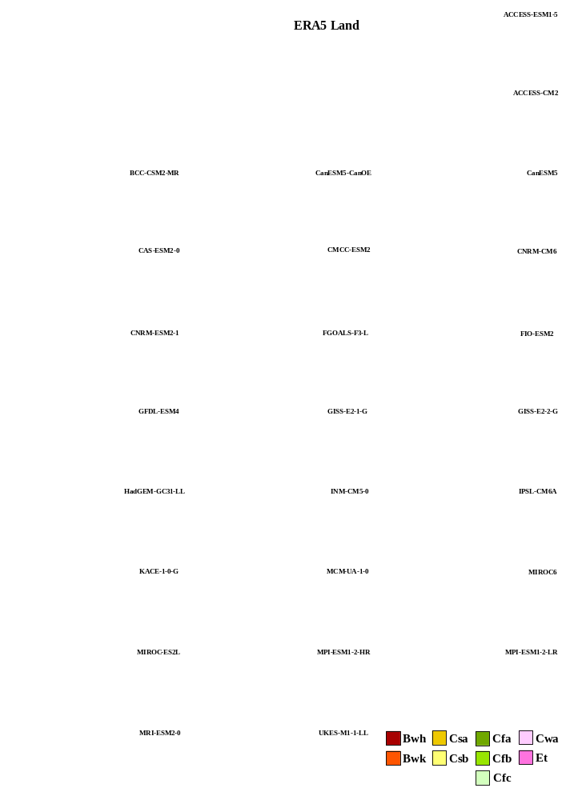
Figure S1. Climatic diagnosis according to the Köppen-Geiger Climate Classification System (KGCS) for the 25 assessed CMIP6 GCMs. ERA5 Land diagnosis is also shown. KGCS climatic types abbreviations can be found in Table S1.

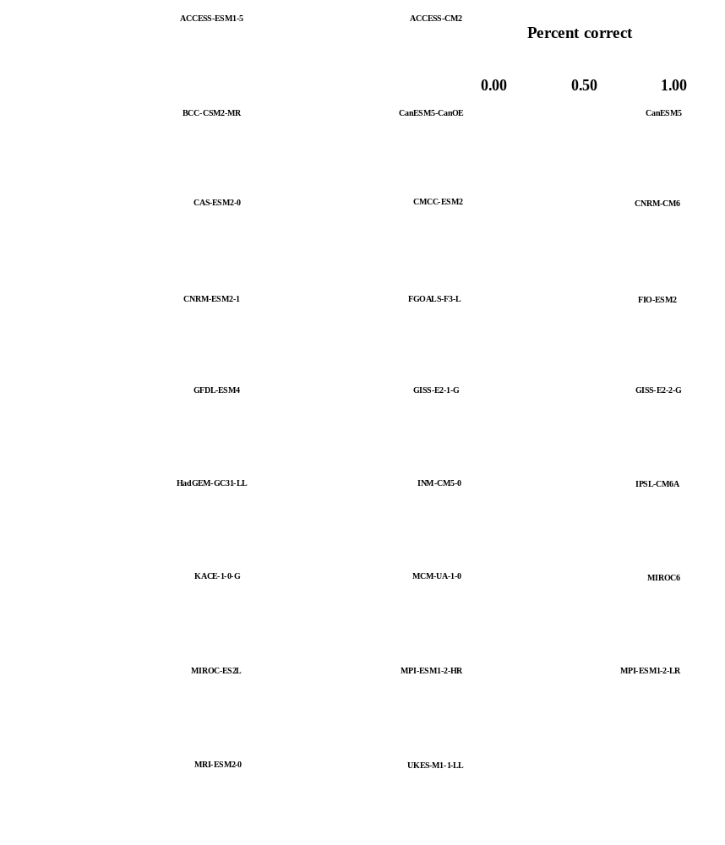
Figure S2. Percent correct -from 0, no hits, to 1, complete agreement- in the assignment of the Köppen-Geiger climatic types identified by ERA5 Land.

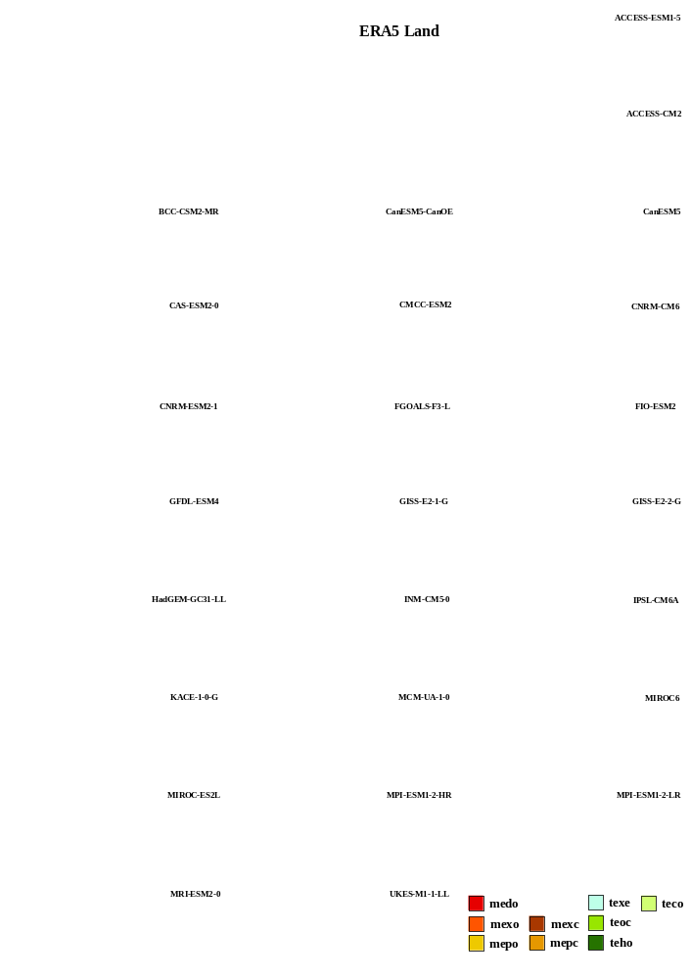
Figure S3. Climatic diagnosis according to the Worldwide Bioclimatic Classification System (WBCS) for the 25 assessed CMIP6 GCMs. ERA5 Land diagnosis is also shown. WBCS bioclimates abbreviations can be found in Table S2.

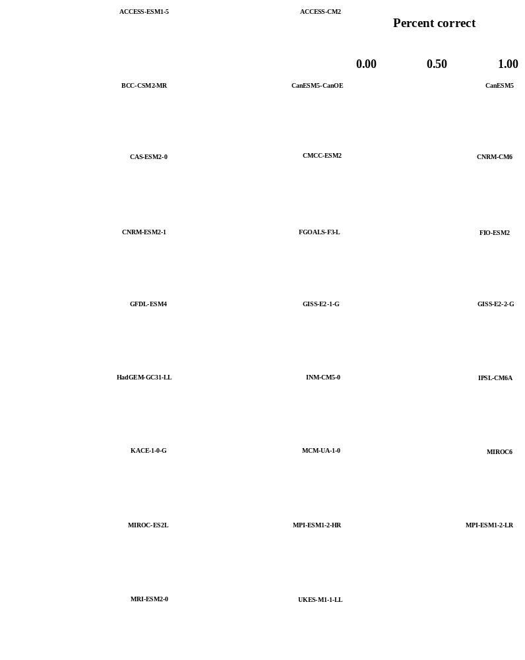
Figure S4. Percent correct -from 0, no hits, to 1, complete agreement- in the assignment of the Rivas-Martinez bioclimates identified by ERA5 Land.

Figure S5. The 25 runs of the Random Forest (RF) Multi-model Ensemble conducted for the Köppen-Geiger climate classification system (KGCS). KGCS climatic types abbreviations can be found in Table S1.
Figure S6. The 25 runs of the Random Forest (RF) Multi-model Ensemble conducted for the Worldwide Bioclimatic Classification System (WBCS). WBCS bioclimates abbreviations can be found in Table S2.

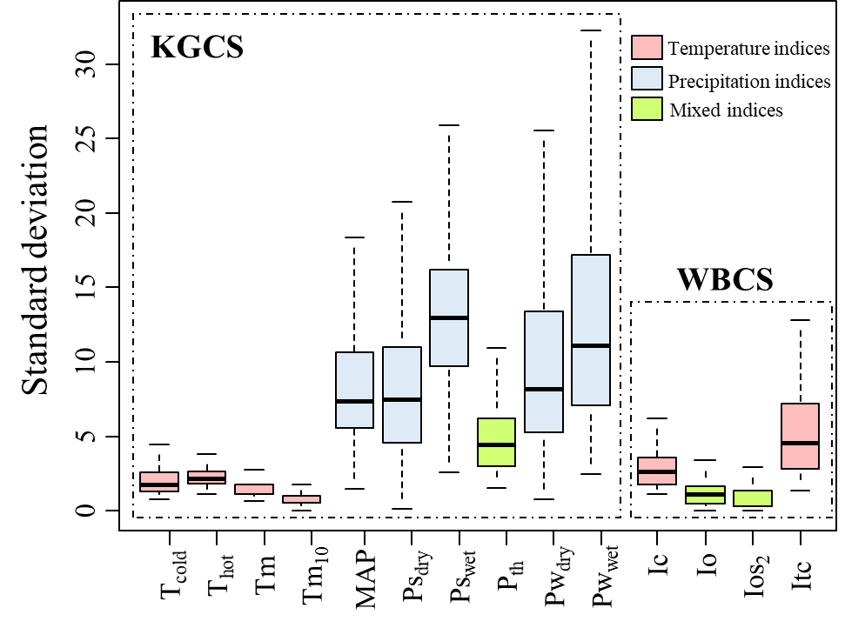
Figure S7. Standard deviation between the 25 implemented GCMs for the bioclimatic parameters and indices from Köppen–Geiger Classification System (KGCS) and Worldwide Bioclimatic Classification System (WBCS).

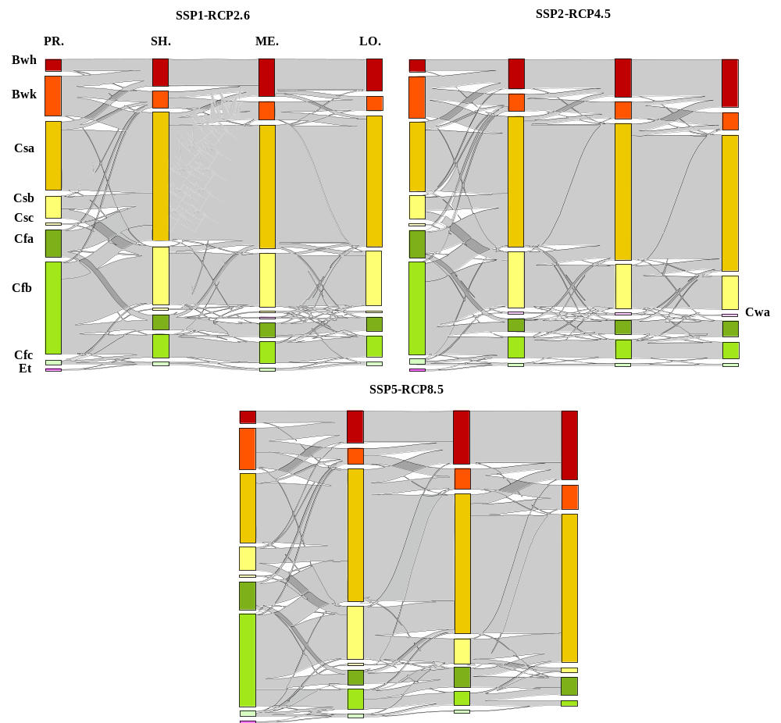
Figure S8. Transition of KGCS climatic subtypes across three emission scenarios (SSP1-RCP2.6, SSP2-RCP4.5, SSP5-RCP8.5) between the reference temporal period (PR.) and the short-term (SH.), medium-term (ME.), and long-term (LO.) futures. KGCS climatic types abbreviations can be found in Table S1.

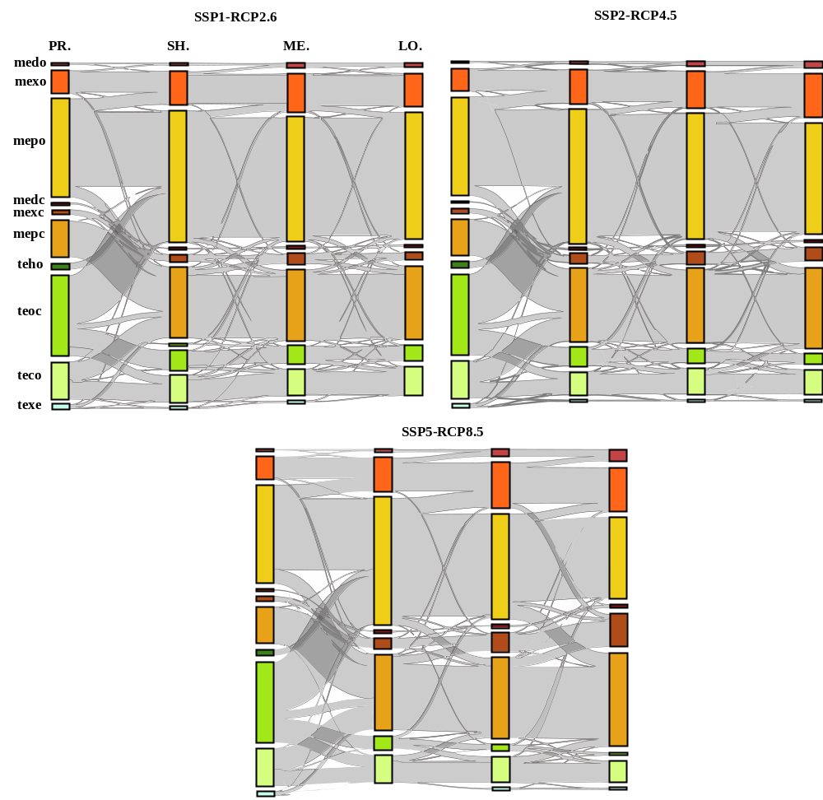
Figure S9. Transition of WBCS climatic subtypes across three emission scenarios (SSP1-RCP2.6, SSP2-RCP4.5, SSP5-RCP8.5) between the reference temporal period (PR.) and the short-term (SH.), medium-term (ME.), and long-term (LO.) futures. WBCS bioclimates abbreviations can be found in Table S2.

Figure S10. Confidence intervals (inter-model agreement) from Exceptionally unlikely to Virtually certain (Mastandrea et al. 2010) for bioclimatic shifts in Köppen-Geiger climate types in the short (2026-2050), medium (2051-2075) and long (2076-2100) term under different emission scenarios (SSP1-RCP2.6, SSP2-RCP4.5, SSP5-RCP8.5).
Figure S11. Confidence intervals (inter-model agreement) from Exceptionally unlikely to Virtually certain (Mastandrea et al. 2010) for bioclimatic shifts in Rivas-Martínez bioclimates in the short (2026-2050), medium (2051-2075) and long (2076-2100) term under different emission scenarios (SSP1-RCP2.6, SSP2-RCP4.5, SSP5-RCP8.5).

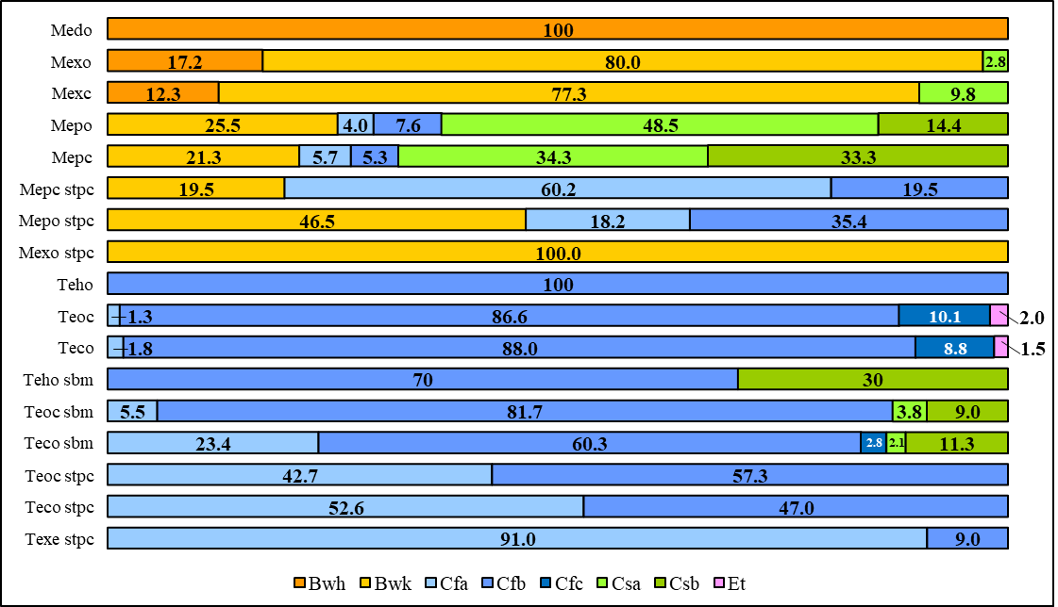
Figure S12. Percentual relationship between Köppen-Geiger climate classification system (KGCS) climatic types and Worldwide Bioclimatic Classification System (WBCS) bioclimates nuanced by the bioclimatic variants (sbm: submediterranean; stpc: steppic). KGCS climatic types and WBCS bioclimates abbreviations can be found in Tables S1 and S2, respectively.

