Graphic Abstract
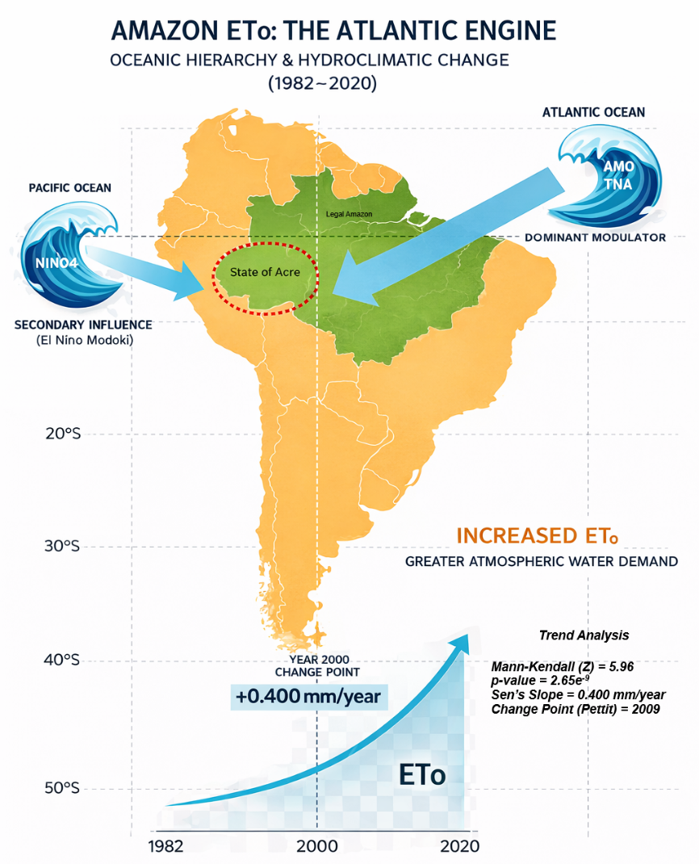
Descriptions of the Graphic Abstract: Reference evapotranspiration (ET₀) in southwestern Legal Amazon (Acre, Brazil) exhibits a significant long-term intensification from 1982 to 2020, marked by a positive trend of +0.400 mm year⁻¹ and a regime shift around 2000. Using an integrated framework of trend analysis, lagged correlations, composites, seasonal assessment, and wavelet coherence, this study reveals a clear hierarchy of oceanic controls on atmospheric water demand. Tropical Atlantic variability, particularly the Atlantic Multidecadal Oscillation (AMO) and the Tropical North Atlantic (TNA), emerges as the dominant and persistent driver of ET₀ variability, with strengthened coupling after the late 1990s. In contrast, Pacific influences associated with ENSO are secondary and episodic, characterized by delayed responses and a stronger sensitivity to central Pacific warming (NINO4; El Niño Modoki). The results highlight the leading role of Atlantic warming in modulating hydroclimatic demand over southwestern Amazonia.

