Supplementary Materials for
Unveiling changes in the seasonality of extreme precipitation shows an anticipation of short-duration extremes
Authors: Dario Treppiedi^{1*}, Gabriele Villarini^{2,3}, Calogero Mattina^{1,4}, Antonio Francipane¹, Leonardo Valerio Noto¹

1 Dipartimento di Ingegneria, Università degli Studi di Palermo, Palermo, Italy
2 Civil and Environmental Engineering, Princeton University, Princeton, NJ, United States of America
3 High Meadows Environmental Institute, Princeton University, Princeton, NJ, United States of America
4 Istituto Universitario di Studi Superiori di Pavia - IUSS Pavia, Pavia, Italy

Corresponding Author: dario.treppiedi@unipa.it
Corresponding Author Phone Number: +39 3282710434

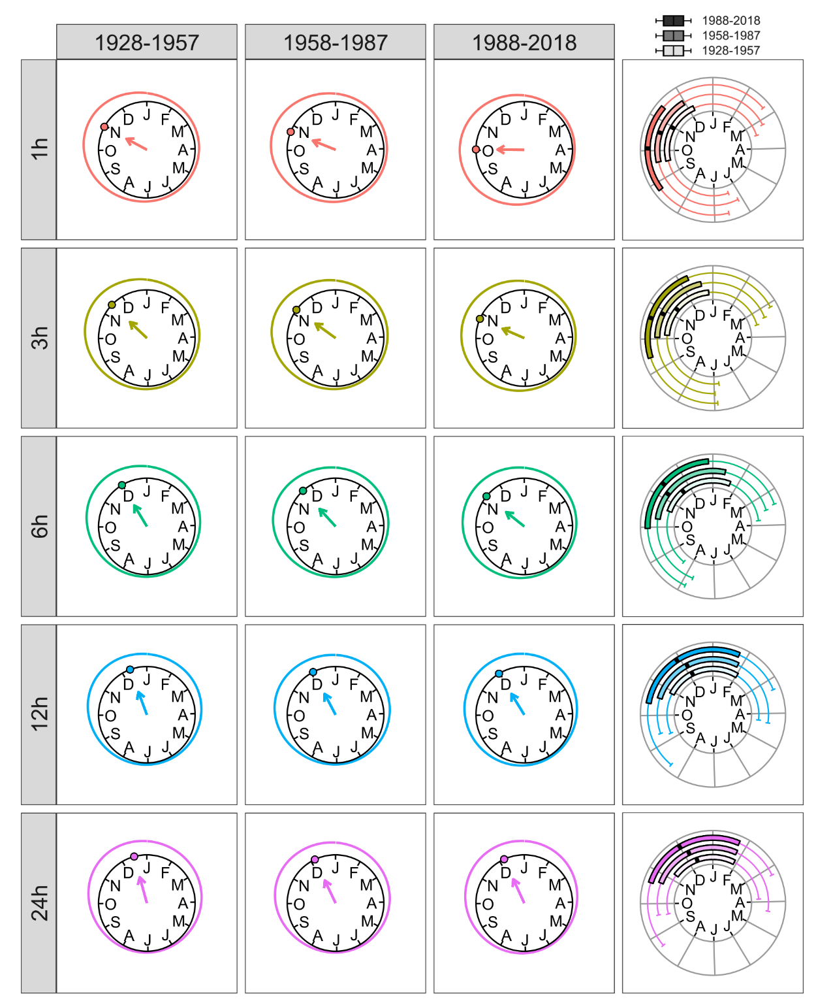
Figure S.1 – Empirical circular kernel densities for the annual maximum precipitation in the periods 1928-1957, 1958-1987, 1988-2018 (column 1 to 3, respectively) for different canonical durations (rows) from the “Long-Term” sample. The direction of the arrow (as well as the point on the unit circle) represents the sample mean direction (${\overline{θ}}_{i}$), while the sample mean resultant length is represented by its length. The fourth column shows the circular boxplots for the three 30-year periods for each duration. The interquartile range is defined as the empirical circular 25% and 75% quantiles, while the whiskers represent the empirical circular quantiles of 5% and 95%. The black bold segment within each box represents the circular median.
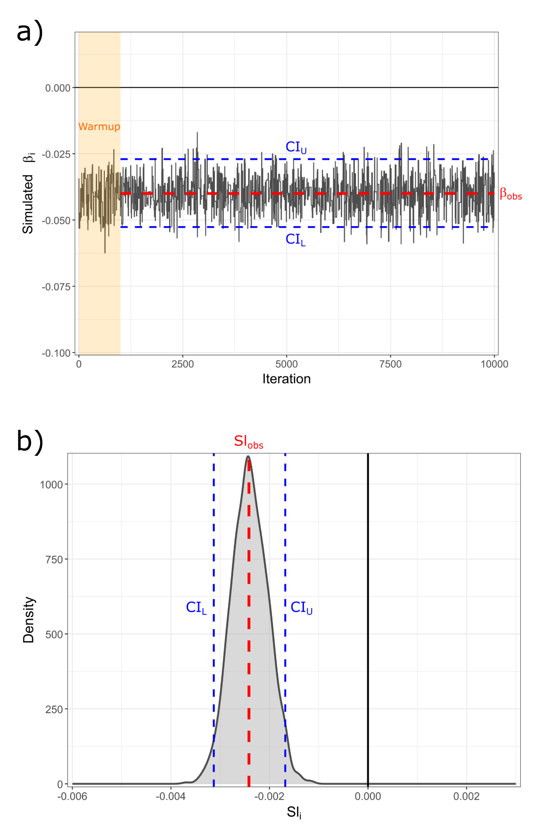

Figure S.2 – Example of the MCMC trace plot for the simulated values of $β_{i}$​ (a) and of the bootstrap distribution of the CTSS slopes ${sl}_{i}$​ (b). For panel a, the red dashed line represents the observed value $β_{obs}$ while the blue dashed lines represent the 95% credible interval (CI) obtained from 10,000 posterior simulations. The orange shaded area indicates the first 1,000 warm-up iterations. For panel b, the red dashed line marks the observed slope $sl_{\text{obs}}$, while the blue dashed lines indicate the 95% confidence interval obtained from 1,000 bootstrap resamples.

Table S.1 – Significance of $β_{i}$ and ${sl}_{i}$ for the B-GLM (a) and CTSS (b) methods at different durations and considering the “Regional” sample. The first column reports the observed value of $β_{i}$ (i.e., $β_{obs}$) and ${sl}_{i}$ (i.e., ${sl}_{obs}$), while the second and third indicate the upper and lower credible intervals (a) and confidence intervals (b). For the B-GLM the 95% credible intervals are derived from 10,000 simulations with a burn-in of 1,000. For the CTSS the 95% confidence intervals are obtained via a non-parametric bootstrap approach with 1,000 resamples. It is worth noting that for the B-GLM, the $β_{i}$ do not directly correspond to the slope (see eq. 3 in the main manuscript), while for CTSS the ${sl}_{i}$ values represent the angular change (in radians) per year.

a) | B-GLM
 | $$β_{obs}$$ | $$CI_{U}$$ | $$CI_{L}$$
1h | -0.040 | -0.027 | -0.052
3h | -0.039 | -0.025 | -0.053
6h | -0.030 | -0.015 | -0.044
12h | -0.028 | -0.014 | -0.043
24h | -0.019 | -0.004 | -0.033

b) | CTSS
 | $${Sl}_{obs}$$ | $$CI_{U}$$ | $$CI_{L}$$
1h | -0.0024 | -0.0017 | -0.0031
3h | -0.0020 | -0.0013 | -0.0027
6h | -0.0014 | -0.0006 | -0.0022
12h | -0.0013 | -0.0004 | -0.0021
24h | -0.0007 | 0 | -0.0015

Table S.2 – Same as Table S.1 but for the “Long-Term” sample.

a) | B-GLM
 | $$β_{obs}$$ | $$CI_{U}$$ | $$CI_{L}$$
1h | -0.094 | -0.051 | -0.137
3h | -0.081 | -0.037 | -0.125
6h | -0.072 | -0.029 | -0.120
12h | -0.039 | 0.006 | -0.082
24h | -0.032 | 0.007 | -0.071

b) | CTSS
 | $${Sl}_{obs}$$ | $$CI_{U}$$ | $$CI_{L}$$
1h | -0.0049 | -0.0027 | -0.0071
3h | -0.0041 | -0.0016 | -0.0065
6h | -0.0037 | -0.0014 | -0.0061
12h | -0.0023 | 0 | -0.0048
24h | -0.0022 | 0 | -0.0045

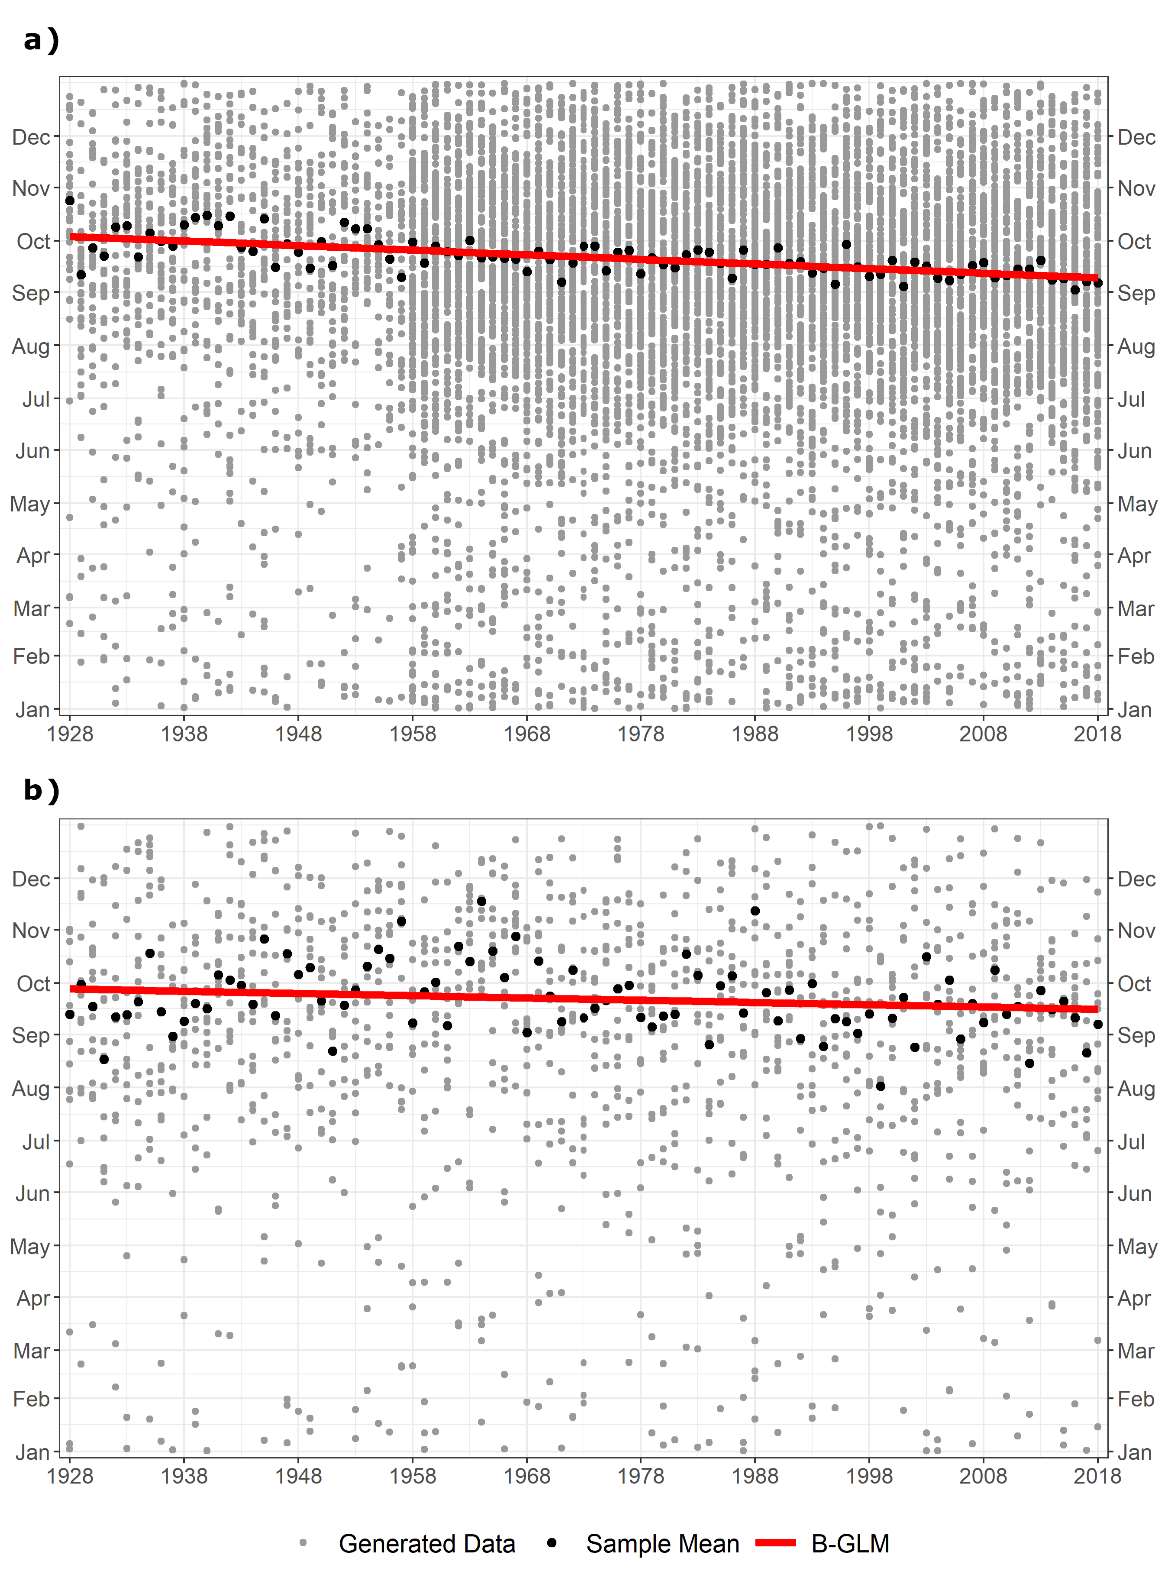

Figure S.3 – Example of synthetic samples generated to assess the ability of the B-GLM and CTSS methods. In panel a), the sample is randomly generated from a von Mises-Fisher (vMF) distribution with $μ_{0}$=3/2∙π and κ=1.3 (i.e., comparable with the characteristics of the 1-h observed data for the “Regional” sample), with ~40 values per year for the first 30 years and ~140 for the remaining 61 years. In panel b), the sample is randomly generated from a vMF distribution with $μ_{0}$=3/2∙π and κ=1.15 (i.e., comparable with the characteristics of the 1-h observed data for the “Long-Term” sample), with ~15 values per year for the whole period. In both cases, a temporal shift of $Δ_{day,tot}=-20 days$ in the vMF mean direction parameter ($μ_{0}$) was imposed over a 91-year period, such that the expected value evolves as $μ_{t}=μ_{0}+Δ_{day,tot}/91$.

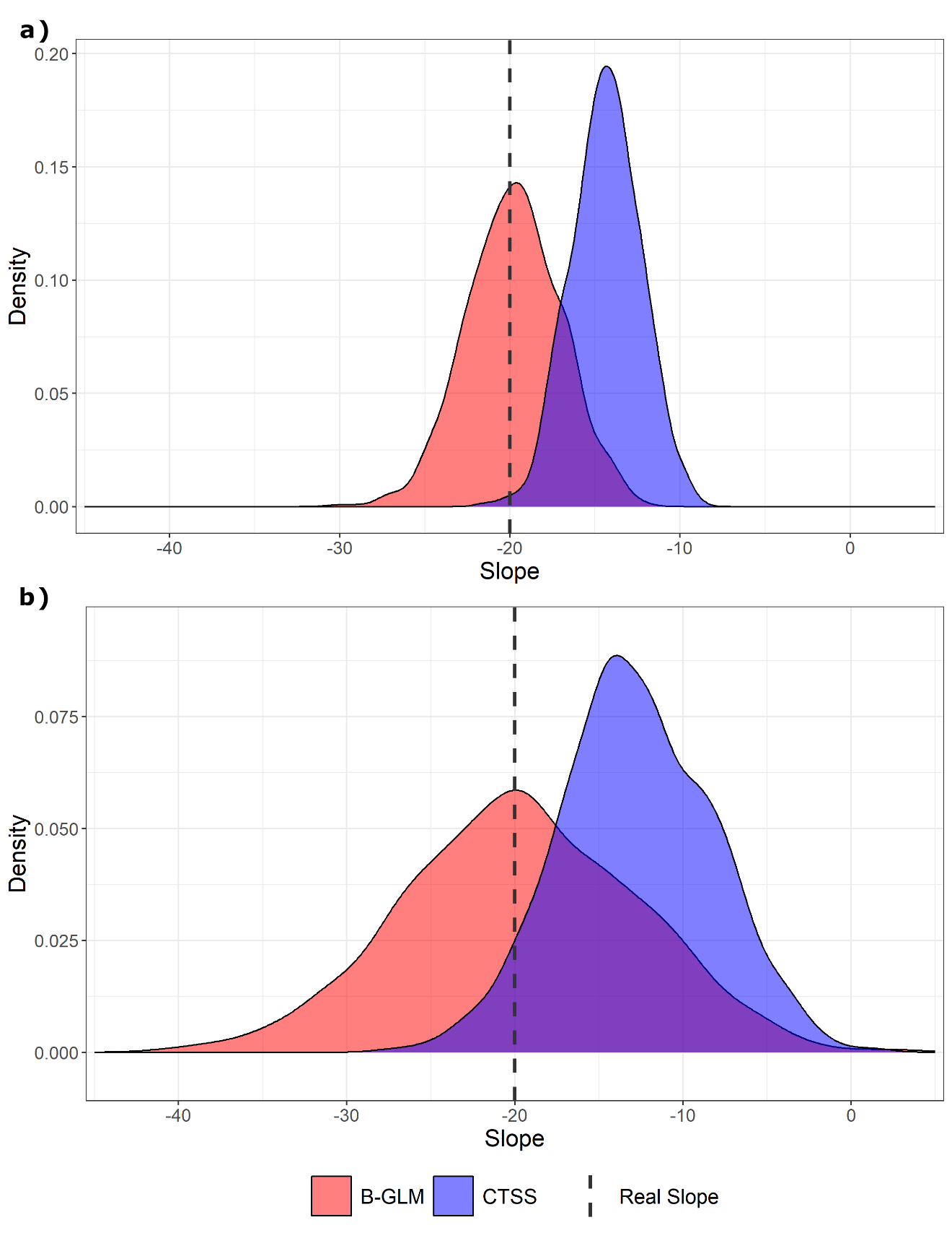

Figure S.4 – Densities of the estimated trends for the B-GLM (red) and the CTSS (blue) methods, obtained from 1,000 synthetic samples randomly generated for the two experiments shown in Figure S.3. The black dashed line indicates the true imposed slope ($Δ_{day,tot}=-20 days$).

Table S.3 – Same as Table S.1 but for the “At-Site” sample, hence considering the clusters obtained through the circular Ward-like hierarchical clustering.

a) | B-GLM
 | $$β_{obs}$$ | $$CI_{U}$$ | $$CI_{L}$$
 | CLUSTER 1
1h | -0.010 | 0.009 | -0.030
3h | -0.015 | 0.010 | -0.040
6h | -0.035 | -0.005 | -0.064
12h | -0.030 | -0.002 | -0.057
24h | -0.045 | -0.017 | -0.075
 | CLUSTER 2
1h | -0.054 | -0.020 | -0.088
3h | -0.045 | -0.006 | -0.097
6h | -0.031 | -0.0001 | -0.063
12h | -0.040 | -0.012 | -0.070
24h | -0.009 | 0.010 | -0.029
 | CLUSTER 3
1h | -0.037 | -0.004 | -0.072
3h | -0.027 | 0.006 | -0.060
6h | -0.021 | 0.008 | -0.054
12h | -0.022 | 0.014 | -0.059
24h
 | CLUSTER 4
1h | -0.052 | -0.011 | -0.096
3h | -0.033 | -0.002 | -0.068
6h
12h
24h

b) | CTSS
 | $${Sl}_{obs}$$ | $$CI_{U}$$ | $$CI_{L}$$
 | CLUSTER 1
1h | -0.0008 | 0.0003 | -0.0020
3h | -0.0009 | 0.0003 | -0.0024
6h | -0.0021 | -0.0004 | -0.0035
12h | -0.0017 | 0 | -0.0031
24h | -0.0026 | -0.0010 | -0.0040
 | CLUSTER 2
1h | -0.0034 | -0.0015 | -0.0053
3h | -0.0024 | 0 | -0.0049
6h | -0.0012 | 0.0006 | -0.0031
12h | -0.0019 | 0 | -0.0035
24h | 0 | 0.0013 | -0.0014
 | CLUSTER 3
1h | -0.0021 | 0 | -0.0041
3h | -0.0012 | 0.0004 | -0.0032
6h | -0.0012 | 0.0003 | -0.0029
12h | -0.0014 | 0.0009 | -0.0034
24h
 | CLUSTER 4
1h | -0.0030 | -0.0002 | -0.0055
3h | -0.0017 | 0 | -0.0040
6h
12h
24h

