SUPPLEMENTARY MATERIAL

Using multi-decadal satellite records to identify environmental drivers of fire severity across vegetation types

Dario Rodriguez-Cubillo^{1,2}, Gregory J. Jordan^{1,3}, Grant J. Williamson^{1,4}
¹ School of Natural Sciences, University of Tasmania, Private Bag 55, Hobart, Tasmania, 7001, Australia
² Corresponding author: dario.rodriguez@utas.edu.au (ORCID: 0000-0002-2684-8750)
³ ORCID: 0000-0002-6033-2766
⁴ ORCID: 0000-0002-3469-7550

Index of supplementary (“S”) tables and figures
Table S1 Fires used in the analyses of fire severity page 2
Table S2 Predictor variables not used in the Random Forests analyses page 7
Table S3 Mean of number of records across all datasets by non-aggregated vegetation, land tenure and fire type page 8
Table S4 Pearson’s correlation coefficients for all pairs of the 35 quantitative predictors page 9
Table S5 Cramér’s V coefficients for all pairs of the seven categorical predictors page 11
Table S6 Prediction accuracy of Random Forests models by measure of variable importance and aggregated vegetation page 12
Figure S1 Average precipitation (mm) for Tasmania for 1981–2010 page 13
Figure S2 Number of fires by number of months elapsed between fire ignition and post-fire image dates. page 14
Figure S3 Normal distribution of residuals of Random Forests models containing the four most important predictors page 15
Figure S4 Boxplots of sampled variable values by aggregated vegetation, across the 100 datasets, for the variables of the global GAMM page 16
Figure S5 Hexagonal heatmaps of sampled ΔNBRs by aggregated vegetation, across the 100 datasets, for the quantitative predictors of the global GAMM page 17
Figure S6 Partial dependence plots by aggregated vegetation for the three topographic predictors of the global GAMM page 19
References page 20
Table S1. Wildfires and prescribed burns used for the analyses of fire severity. Fire name is the name of the fire recorded in the fire history dataset (DPIPWE, 2017). Ignition date is the date when the fire was first recorded. Area is the area of the fire boundary calculated from the fire history dataset, while new area is the area of the redigitised fire boundary. Pre-image and post-image dates are the month and year of the Landsat images used to compute the pre-NBR and post-NBR, respectively. Note that multiple images (captured on different days) may be associated with a date.

Fire name | Ignition date | Fire type | Area (ha) | New area (ha) | Pre-image date | Post-image date
Tarkine
Mt Zeehan | 29/10/1992 | Wildfire | 1,812 | 1,479 | Mar 1992 | Jan 1993
Queenstown Aerodrome | 12/12/1994 | Wildfire | 1,152 | 1,089 | Jan 1993 | Dec 1995
South Farrell Rivulet | 01/01/1995 | Prescribed burn | 1,005 | 732 | Dec 1994 | Dec 1995
Pieman River | 23/01/1995 | Wildfire | 10,791 | 9,884 | Dec 1994 | Dec 1995
Temma Road | 24/02/1995 | Wildfire | 5,268 | 2,285 | Jan 1995 | Mar 1995
Ocean Beach | 20/01/1997 | Wildfire | 1,410 | 1,142 | Sep 1996 | Sep 1997
Strahan Mill Bay | 23/09/1997 | Prescribed burn | 206 | 125 | Sep 1996 | Sep 1997
Conical Rocks | 24/01/1998 | Wildfire | 3,442 | 2,854 | Sep 1997 | Nov 1998
Rocky Cape/Sisters Beach | 17/03/1998 | Wildfire | 2,047 | 1,920 | Nov 1997 | Sep 1998
FRBU Dempster Plains West | 06/10/2000 | Prescribed burn | 2,030 | 1,348 | Nov 1999 | Nov 2000
Whaleback Ridge | 01/01/2001 | Prescribed burn | 1,869 | 1,633 | Dec 2000 | Feb 2001
Pieman River | 14/01/2001 | Wildfire | 1,661 | 1,683 | Feb 2000 | Mar 2001
FRBU Dempster Plains South | 27/09/2001 | Prescribed burn | 2,217 | 1,880 | Feb 2000 | Feb 2002
Whyte River | 15/02/2002 | Wildfire | 2,613 | 2,574 | Mar 2001 | Mar 2002
Nelson Alert | 24/12/2002 | Wildfire | 1,539 | 1,300 | Mar 2001 | Jan 2003
Whaleback Ridge zone B | 07/05/2003 | Prescribed burn | 1,620 | 1,028 | Jan 2003 | Jan 2004
Mt Frankland Donaldson | 15/11/2003 | Wildfire | 78,169 | 77,524 | Jan 2003 | Jan 2004
Holder 11 (FT) | 17/11/2003 | Wildfire | 8,939 | 7,847 | Feb 2003 | Feb 2004
Montumana | 20/03/2004 | Wildfire | 1,466 | 1,515 | Jan 2003 | Jan 2005
FRBU Heemskirk | 29/10/2004 | Prescribed burn | 3,489 | 2,237 | Jan 2004 | Feb 2005
Quinn Creek | 26/01/2005 | Wildfire | 1,111 | 957 | Jan 2004 | Jan 2006
South Farrell Rivulet | 22/04/2005 | Prescribed burn | 1,005 | 150 | Jan 2004 | Jan 2006
Piney Creek South | 18/05/2005 | Prescribed burn | 1,277 | 481 | Jan 2004 | Jan 2006
F28 Wuthering Heights Rd West | 26/09/2005 | Prescribed burn | 1,369 | 405 | Feb 2005 | Mar 2006
Trial Harbour Rd | 20/01/2006 | Wildfire | 3,210 | 3,010 | Nov 2005 | Oct 2006
FRBU Dempster Plains North | 01/09/2007 | Prescribed burn | 1,457 | 1,424 | Mar 2007 | Feb 2008
Heemskirk Rd | 15/03/2008 | Wildfire | 13,719 | 13,227 | Mar 2007 | Feb 2009
Professor-Badger Combo | 17/04/2008 | Prescribed burn | 3,285 | 2,495 | Mar 2007 | Feb 2009
FRBU Salmon River Plain | 30/10/2009 | Prescribed burn | 1,345 | 1,099 | Feb 2009 | Mar 2010
Lake Macintosh | 25/01/2010 | Wildfire | 3,395 | 3,821 | Nov 2009 | Nov 2010
Harcus River Road | 29/01/2010 | Wildfire | 2,576 | 1,706 | Feb 2009 | Mar 2010
Trial Creek Track East | 19/04/2010 | Prescribed burn | 2,169 | 1,531 | Jan 2010 | Feb 2011
Top Farm Track Granville | 14/03/2011 | Wildfire | 1,549 | 1,122 | Oct 2010 | Oct 2011
Wild Wave/Nth Pedder APCAECO44 | 07/04/2011 | Prescribed burn | 2,152 | 1,438 | Oct 2010 | Oct 2011
Chimney Creek Interview River APCAECO53 | 08/04/2011 | Prescribed burn | 4,068 | 2,611 | Oct 2010 | Oct 2011
Whaleback Ridge MRRRSFR01 | 08/04/2011 | Prescribed burn | 2,685 | 1,994 | Oct 2010 | Oct 2011
Zeehan Hwy | 11/11/2012 | Wildfire | 1,314 | 1,037 | Jan 2011 | Feb 2013
Granville Harbour Rd | 29/11/2012 | Wildfire | 1,639 | 1,269 | Jan 2011 | Feb 2013
Speedwell Road | 05/01/2013 | Wildfire | 3,360 | 2,977 | July 2012 | Jul 2013
Mt Heemskirk MTHRRECO47 | 06/04/2013 | Prescribed burn | 1,307 | 970 | Feb 2013 | Jan 2014
Surprise Creek | 17/01/2014 | Wildfire | 2,426 | 1,646 | Jan 2014 | Feb 2015
Lake Burbury | 27/01/2014 | Wildfire | 2,114 | 2,055 | Sep 2013 | Oct 2014
McLeod River APCAECO43 | 14/04/2014 | Prescribed burn | 2,246 | 1,377 | Jan 2014 | Feb 2015
Italian River APCAECO50 | 17/04/2014 | Prescribed burn | 1,936 | 908 | Jan 2014 | Feb 2015
Mt Heemskirk MTHRREC047 | 17/04/2014 | Prescribed burn | 2,394 | 1,306 | Jan 2014 | Feb 2015
FRBU Salmon River Plain | 08/05/2014 | Prescribed burn | 1,161 | 983 | Jan 2014 | Feb 2015
Rebecca Sf Boundary | 01/09/2014 | Prescribed burn | 1,135 | 1,144 | Jan 2014 | Feb 2015
Rebecca ARPCA039AP | 14/10/2014 | Wildfire | 4,646 | 4,910 | Jan 2014 | Feb 2015
Pipeline Rd & Rulla Rd | 14/01/2016 | Wildfire | 61,819 | 58,985 | Jan 2014 | Jan 2017
Wuthering Heights | 21/01/2016 | Wildfire | 21,306 | 18,588 | Jan 2014 | Jan 2017

Fire name | Ignition date | Fire type | Area (ha) | New area (ha) | Pre-image date | Post-image date
Tasmanian Wilderness World Heritage Area
Birch Inlet | 26/04/2000 | Prescribed burn | 154 | 170 | Nov 1999 | Nov 2000
Ummarrah Creek | 26/04/2000 | Wildfire | 4,992 | 4,867 | Nov 1999 | Nov 2000
Davey Head | 30/08/2000 | Prescribed burn | 1,050 | 1,054 | May 1998 | Jun 2001
Olga-Wanderer Rivers #2 | 25/09/2000 | Prescribed burn | 3,698 | 1,114 | Sep 1999 | Nov 2000
Melaleuca | 26/09/2000 | Wildfire | 4,735 | 4,590 | Nov 1999 | Nov 2000
Maxwell River | 14/01/2001 | Wildfire | 1,479 | 1,509 | Sep 1999 | Aug 2002
Mt Braddon | 14/01/2001 | Wildfire | 253 | 227 | Sep 1999 | Aug 2002
King William Plains | 04/05/2001 | Prescribed burn | 183 | 98 | Jan 2000 | Dec 2002
Wedge Inlet | 11/10/2001 | Wildfire | 667 | 572 | Jan 2000 | Dec 2001
BS122H Bark Heap (FT) | 10/12/2002 | Wildfire | 153 | 183 | Jan 1999 | Feb 2003
Melaleuca | 01/01/2003 | Wildfire | 121 | 119 | Jan 2000 | Feb 2003
Twelvetrees Range | 14/01/2003 | Wildfire | 2,791 | 2,309 | Jan 2000 | Feb 2003
Picton 72A (FT) | 29/01/2003 | Wildfire | 112 | 93 | Jan 2003 | Mar 2003
Cardigan Flats North | 13/10/2003 | Prescribed burn | 104 | 88 | Nov 2000 | Nov 2003
Cardigan Flats South | 13/10/2003 | Prescribed burn | 185 | 141 | Nov 2000 | Nov 2003
Harbacks Road | 14/10/2003 | Prescribed burn | 115 | 114 | Mar 2003 | Feb 2004
Little Lake | 27/11/2003 | Wildfire | 1,192 | 1,102 | Mar 2003 | Mar 2004
Blowhole Valley | 09/09/2004 | Prescribed burn | 101 | 118 | Jan 2003 | Dec 2004
Huon Gorge | 26/01/2005 | Wildfire | 366 | 335 | Feb 2003 | Nov 2005
New River Lagoon | 26/01/2005 | Wildfire | 271 | 491 | Feb 2003 | Nov 2005
Little Navarre River | 22/04/2005 | Prescribed burn | 387 | 335 | Dec 2002 | Jan 2006
King William Plains | 21/09/2005 | Prescribed burn | 744 | 468 | Dec 2002 | Jan 2006
Little Navarre River | 22/09/2005 | Prescribed burn | 422 | 357 | Dec 2002 | Jan 2006
Mount Castor | 20/01/2006 | Wildfire | 2,699 | 2,768 | Feb 2003 | Feb 2007
King William Saddle | 27/04/2006 | Prescribed burn | 105 | 93 | Feb 2004 | Mar 2007
Sandfly Creek | 13/09/2006 | Prescribed burn | 162 | 174 | Feb 2003 | Jan 2008
Cracroft River | 17/02/2007 | Wildfire | 13,085 | 13,179 | Feb 2003 | Jan 2008
Reynolds Creek | 17/02/2007 | Wildfire | 25,273 | 25,067 | Feb 2003 | Apr 2007
Terminal Peak | 17/02/2007 | Wildfire | 909 | 873 | Mar 2005 | Jan 2008
Coates Creek | 25/04/2007 | Prescribed burn | 175 | 187 | Mar 2007 | Jan 2008
Navarre River | 25/04/2007 | Prescribed burn | 317 | 233 | Mar 2007 | Jan 2008
Edgar Dam | 23/08/2007 | Prescribed burn | 613 | 624 | Mar 2005 | Jan 2008
Burns Dam | 27/08/2007 | Prescribed burn | 101 | 64 | Mar 2007 | Jan 2008
Coates Creek | 27/08/2007 | Prescribed burn | 260 | 248 | Mar 2007 | Jan 2008
Navarre River | 27/08/2007 | Prescribed burn | 436 | 304 | Mar 2007 | Jan 2008
Gordon Plains (Clear Hill) | 06/09/2007 | Prescribed burn | 2,348 | 2,258 | Feb 2003 | Jan 2008
Packers Spur | 17/11/2007 | Wildfire | 3,967 | 3,422 | Feb 2003 | Jan 2008
Fincham | 29/01/2009 | Wildfire | 193 | 225 | Mar 2007 | Feb 2009
McPartlan Pass | 29/10/2009 | Prescribed burn | 168 | 30 | Oct 2008 | Oct 2010
Sentinel Range | 29/10/2009 | Wildfire | 430 | 257 | Oct 2008 | Oct 2010
Mt Alma | 01/01/2010 | Wildfire | 182 | 206 | Mar 2007 | Mar 2011
Wayatinah | 31/01/2010 | Wildfire | 2,586 | 3,930 | Jan 2010 | Dec 2010
Dublin Road (FT) | 02/02/2010 | Wildfire | 163 | 135 | Mar 2007 | Mar 2011
Clarence FRB | 19/04/2010 | Prescribed burn | 302 | 230 | Jan 2010 | Dec 2010
Olga-Wanderer Rivers | 19/04/2010 | Prescribed burn | 629 | 643 | Feb 2009 | Mar 2011
D'entrecasteaux Plains | 27/05/2010 | Prescribed burn | 178 | 265 | Feb 2008 | Jan 2011
Majors Lookout | 28/10/2010 | Prescribed burn | 214 | 301 | Mar 2007 | Mar 2011
Elliot Hill SNP15SFR | 06/04/2011 | Prescribed burn | 3,194 | 3,218 | Feb 2009 | Dec 2012
Towterer Creek SNP12SFR | 06/04/2011 | Prescribed burn | 540 | 537 | Feb 2007 | Dec 2012
Melaleuca Lagoon SCA1ECO | 07/04/2011 | Prescribed burn | 464 | 388 | Feb 2007 | Dec 2012
Wedge FRB | 16/04/2011 | Prescribed burn | 535 | 253 | Jan 2008 | Dec 2012
Birchs River FWRNPECO106 | 17/04/2011 | Prescribed burn | 5,271 | 4,622 | Feb 2009 | Dec 2012
Gunfight Creek South SNP1SFR | 17/04/2011 | Prescribed burn | 2,438 | 2,103 | Feb 2009 | Dec 2012
McPartlan Pass SNP7SFR | 17/04/2011 | Prescribed burn | 558 | 429 | Apr 2007 | Dec 2012
Red Tape Creek SNP3AP | 17/04/2011 | Prescribed burn | 156 | 148 | Jan 2008 | Dec 2012
Rowitta Plains SNP1ECO | 17/04/2011 | Prescribed burn | 2,839 | 2,332 | Feb 2007 | Dec 2012
Navarre FRB | 04/10/2011 | Prescribed burn | 196 | 120 | Dec 2010 | Dec 2012
Poatina | 29/11/2012 | Wildfire | 8,512 | 7,599 | Jan 2011 | Jan 2014
Giblin River | 03/01/2013 | Wildfire | 40,467 | 40,803 | Feb 2009 | Feb 2014
Moonlight Flats, Southwest | 07/02/2014 | Wildfire | 361 | 372 | Jan 2014 | Jan 2015
Mid Birchs Inlet FWRNPSFR102 | 28/04/2014 | Prescribed burn | 328 | 241 | Jan 2014 | Feb 2015
Navarre River FWRNPSFR15 | 28/08/2014 | Prescribed burn | 157 | 88 | Sep 2013 | Oct 2014
Giblin River SNP14SFR | 22/03/2015 | Prescribed burn | 1,719 | 1,487 | Feb 2014 | Mar 2016
Lower Hutt Plains SNP13SFR | 22/03/2015 | Prescribed burn | 947 | 1,203 | Feb 2014 | Mar 2016
Cataract Tier FWRNOSFR172 | 05/04/2015 | Prescribed burn | 153 | 165 | Feb 2015 | Mar 2016
Denison Gap FWRNP1SFR | 30/04/2015 | Prescribed burn | 1,407 | 455 | Mar 2015 | Mar 2016
Lake King William FWRNP192APZ | 11/09/2015 | Prescribed burn | 1,073 | 628 | Mar 2015 | Mar 2016
Collingwood Plains | 26/09/2015 | Prescribed burn | 175 | 89 | Mar 2015 | Mar 2016
Butlers Gorge Road - Butlers Gorge | 09/11/2015 | Wildfire | 217 | 152 | Mar 2015 | Mar 2016
Lake Bill | 15/01/2016 | Wildfire | 1,398 | 968 | Mar 2015 | Mar 2017
Gordon River Road | 17/01/2016 | Wildfire | 4,211 | 3,299 | Feb 2015 | Mar 2016
Maxwell River South | 18/01/2016 | Wildfire | 1,376 | 1,348 | Mar 2015 | Mar 2017
Lake Mackenzie Road | 19/01/2016 | Wildfire | 24,231 | 15,762 | Mar 2015 | Mar 2017
Mount Mary - FWRNP181SFR | 18/04/2016 | Prescribed burn | 687 | 222 | Mar 2015 | Mar 2017
North Birches - FWRNP101SFR | 18/04/2016 | Prescribed burn | 1,218 | 1,154 | Mar 2015 | Mar 2017
Cataract Tier - FWRNPSFR172 | 20/04/2016 | Prescribed burn | 614 | 762 | Mar 2015 | Mar 2017
Philips Lead - FWRNP162SFR | 20/04/2016 | Prescribed burn | 476 | 298 | Mar 2015 | Mar 2017

Table S2. Predictor variables not used in the Random Forests analyses. The “categories or range” column includes the categories of the categorical predictors or the ranges of the quantitative, continuous predictors. F is forested and T is treeless. Acronyms and abbreviations: BARRA is the Bureau of Meteorology Atmospheric high-resolution Regional Reanalysis for Australia (Su et al. 2019); DEM is the 25-m Digital Elevation Model of Tasmania (The LIST 2010); MRT is Mineral Resources Tasmania (1964); WorldClim 2 is WorldClim Global Climate Data version 2 (Fick and Hijmans 2017).

Predictor variable | Categories or range
Bioclimatic variables (WorldClim 2; pixel resolution: 695 m by 925 m)
Annual mean temperature (°C) | 4.5–12.8 (F&T)
Annual temperature range (°C) | 12.7–20.3 (F&T)
Isothermality (%) | 4.5–5.2 (F&T)
Mean temperature of coldest quarter (°C) | 0.6–9.6 (F&T)
Mean temperature of driest quarter (°C) | 8.6–16.4 (F&T)
Mean temperature of wettest quarter (°C) | 0.4–9.8 (F&T)
Minimum temperature of coldest month (°C) | −2.6–6.4 (F); −2.5–6.5 (T)
Precipitation of coldest quarter (mm) | 226.2–908.4 (F); 236.7–908.4 (T)
Precipitation of driest month (mm) | 38.2–138.5 (F); 39.5–138.5 (T)
Precipitation of warmest quarter (mm) | 137.5–508.4 (F); 144.0–508.4 (T)
Precipitation of wettest month (mm) | 83.8–320.6 (F); 87.7–320.6 (T)
Precipitation of wettest quarter (mm) | 247.4–944.2 (F); 258.8–944.2 (T)
Precipitation seasonality (coefficient of variation; %) | 17–36 (F&T)
Fire-weather variables (calculated from BARRA; pixel resolution: 1.1 km by 1.5 km)
Mean maximum monthly soil moisture (%) | 14.3–44.3 (F); 15.5–43.7 (T)
Mean minimum monthly Forest Fire Danger Index | 0.0–1.7 (F&T)
Environmental and topographic variables
Elevation (m) (DEM) | 1.0–1,355.0 (F); −4.0–1,315.0 (T)
Geological era (MRT) | Cenozoic, Mesozoic, Palaeozoic and Proterozoic
Geological period (MRT) | Cambrian, Ordovician, Silurian, Devonian, Carboniferous and Permian
Roughness (m) (DEM) | 0.0–155.2 (F); 0.0–166.1 (T)
Terrain ruggedness index (m) (DEM) | 0.0–58.9 (F); 0.0–59.5 (T)

Table S3. Mean of number of records (± standard deviation), across the 100 datasets, according to non-aggregated vegetation, land tenure and fire type.

Non-aggregated vegetation | Land tenure | Fire type |  | Total
Non-aggregated vegetation | Land tenure | Wildfire | Prescribed burn | Total
Forested vegetation
Dry eucalypt forest | Forestry | 1,294 ± 31 | 38 ± 6 | 1,332
 | Non-protected | 47 ± 8 | 4 ± 2 | 51
 | Protected | 1,743 ± 33 | 292 ± 16 | 2,035
 | Total | 3,084 | 334 | 3,418
Rainforest | Forestry | 614 ± 21 | 2 ± 1 | 616
 | Non-protected | 40 ± 6 | 4 ± 2 | 44
 | Protected | 1,152 ± 28 | 58 ± 8 | 1,210
 | Total | 1,806 | 64 | 1,870
Wet eucalypt forest | Forestry | 2,042 ± 39 | 59 ± 7 | 2,101
 | Non-protected | 118 ± 11 | 4 ± 2 | 122
 | Protected | 2,523 ± 48 | 272 ± 15 | 2,795
 | Total | 4,683 | 335 | 5,018
Total forested |  | 9,573 | 733 | 10,306
Treeless vegetation
Buttongrass, wetland and peatland | Forestry | 2,041 ± 36 | 1,982 ± 15 | 4,023
 | Non-protected | 595 ± 18 | 277 ± 8 | 872
 | Protected | 11,492 ± 58 | 7,412 ± 32 | 18,904
 | Total | 14,128 | 9,671 | 23,799
Scrub, heathland and coastal | Forestry | 1,364 ± 35 | 203 ± 13 | 1,567
 | Non-protected | 163 ± 13 | 13 ± 3 | 176
 | Protected | 4,079 ± 58 | 674 ± 21 | 4,753
 | Total | 5,606 | 890 | 6,496
Total treeless |  | 19,734 | 10,561 | 30,295
Grand total |  | 29,307 | 11,294 | 40,601

Table S4. Pearson’s correlation coefficients between all pairs of the 35 quantitative, continuous predictor variables. We selected four datasets out of the 100, produced four correlation matrices with Pearson’s correlation coefficients, and inspected them visually. The Pearson’s correlation coefficient is dimensionless and ranges from −1 (perfect negative linear association) to 1 (perfect positive linear association) (Sedgwick 2012). The coefficients were calculated with the rcorr function from the Hmisc R package (version 4.4.1; Harrell and Dupont 2006). As the coefficients between the same pairs of predictors across the four datasets were similar, we have averaged them in the correlation matrix shown on the next page. The predictors selected for the first round of Random Forests are shown in bold. Cells are coloured according to the groups that the predictors were classified into: green for fire-related attributes; blue for fire-weather predictors; yellow for environmental and topographic predictors; and grey for bioclimatic predictors. Acronyms and abbreviations: CV is Coefficient of Variation; FFDI is Forest Fire Danger Index; SM is soil moisture; TPI is Topographic Position Index; TRI is Terrain Ruggedness Index; Q is Quarter; prec. is precipitation; s.d. is standard deviation; and temp. is temperature.

 | Distance to closest road (m) | Time since previous fire (years) | Mean max monthly FFDI | Mean max monthly SM (%) | Mean monthly FFDI | Mean monthly SM (%) | Mean min monthly FFDI | Mean min monthly SM (%) | Distance to closest river/lake (m) | Elevation (m) | Eastness | Northness | Roughness (m) | Slope (°) | TPI (m) | TRI (m) | Annual mean temp. (°C) | Annual mean diurnal range (°C) | Isothermality (%) | Temp. seasonality (s.d.; °C) | Max temp. of warmest month (°C) | Min temp. of coldest month (°C) | Annual temp. range (°C) | Mean temp. of wettest Q (°C) | Mean temp. of driest Q (°C) | Mean temp. of warmest Q (°C) | Mean temp. of coldest Q (°C) | Mean annual prec. (mm) | Prec. of wettest month (mm) | Prec. of driest month (mm) | Prec. seasonality (CV; %) | Prec. of wettest Q (mm) | Prec. of driest Q (mm) | Prec. of warmest Q (mm) | Prec. of coldest Q (mm)
Distance to closest road (m) | 1.00
Time since previous fire (years) | 0.06 | 1.00
Mean max monthly FFDI | -0.25 | 0.25 | 1.00
Mean max monthly SM (%) | -0.01 | -0.07 | -0.49 | 1.00
Mean monthly FFDI | -0.31 | 0.13 | 0.56 | -0.54 | 1.00
Mean monthly SM (%) | 0.04 | -0.14 | -0.53 | 0.80 | -0.76 | 1.00
Mean min monthly FFDI | 0.03 | 0.11 | 0.21 | -0.48 | 0.45 | -0.38 | 1.00
Mean min monthly SM (%) | 0.05 | -0.20 | -0.61 | 0.74 | -0.70 | 0.96 | -0.33 | 1.00
Distance to closest river/lake (m) | -0.26 | -0.10 | 0.24 | -0.08 | -0.01 | -0.08 | -0.12 | -0.17 | 1.00
Elevation (m) | -0.34 | 0.13 | -0.17 | 0.38 | -0.19 | 0.26 | -0.21 | 0.23 | -0.12 | 1.00
Eastness | -0.06 | 0.02 | -0.02 | 0.04 | 0.03 | -0.01 | 0.02 | -0.01 | -0.01 | 0.08 | 1.00
Northness | -0.02 | 0.03 | -0.05 | 0.02 | 0.02 | 0.00 | 0.03 | 0.00 | -0.01 | 0.03 | 0.01 | 1.00
Roughness (m) | 0.06 | 0.19 | 0.01 | 0.03 | 0.07 | -0.06 | 0.07 | -0.08 | -0.09 | 0.20 | 0.03 | 0.15 | 1.00
Slope (°) | 0.06 | 0.20 | 0.02 | 0.03 | 0.08 | -0.06 | 0.07 | -0.08 | -0.09 | 0.20 | 0.02 | 0.15 | 0.97 | 1.00
TPI (m) | 0.01 | 0.03 | 0.01 | -0.01 | 0.02 | -0.02 | 0.02 | -0.02 | 0.00 | 0.04 | 0.01 | 0.00 | 0.07 | 0.07 | 1.00
TRI (m) | 0.06 | 0.19 | 0.01 | 0.03 | 0.07 | -0.06 | 0.07 | -0.08 | -0.09 | 0.20 | 0.03 | 0.14 | 0.99 | 0.97 | 0.07 | 1.00
Annual mean temp. (°C) | 0.21 | -0.13 | 0.25 | -0.44 | 0.28 | -0.32 | 0.22 | -0.30 | 0.17 | -0.97 | -0.07 | -0.04 | -0.21 | -0.21 | -0.01 | -0.21 | 1.00
Annual mean diurnal range (°C) | -0.51 | 0.04 | -0.10 | 0.33 | 0.05 | 0.31 | 0.02 | 0.33 | -0.15 | 0.63 | 0.09 | 0.04 | 0.07 | 0.07 | -0.01 | 0.07 | -0.63 | 1.00
Isothermality (%) | -0.02 | -0.26 | 0.18 | -0.14 | 0.10 | 0.00 | 0.08 | 0.01 | 0.20 | -0.74 | -0.06 | -0.06 | -0.27 | -0.27 | -0.02 | -0.26 | 0.75 | -0.20 | 1.00
Temp. seasonality (s.d.; °C) | -0.37 | 0.15 | -0.18 | 0.33 | -0.01 | 0.25 | -0.01 | 0.27 | -0.24 | 0.84 | 0.09 | 0.05 | 0.17 | 0.17 | 0.00 | 0.17 | -0.85 | 0.89 | -0.60 | 1.00
Max temp. of warmest month (°C) | -0.10 | -0.13 | 0.28 | -0.38 | 0.42 | -0.26 | 0.30 | -0.21 | 0.14 | -0.82 | -0.03 | -0.03 | -0.23 | -0.23 | -0.02 | -0.23 | 0.87 | -0.17 | 0.78 | -0.51 | 1.00
Min temp. of coldest month (°C) | 0.29 | -0.13 | 0.24 | -0.43 | 0.19 | -0.33 | 0.15 | -0.32 | 0.20 | -0.95 | -0.08 | -0.05 | -0.20 | -0.20 | -0.01 | -0.20 | 0.97 | -0.79 | 0.68 | -0.95 | 0.74 | 1.00
Annual temp. range (°C) | -0.47 | 0.10 | -0.14 | 0.33 | 0.03 | 0.28 | 0.00 | 0.30 | -0.19 | 0.76 | 0.09 | 0.05 | 0.12 | 0.12 | 0.00 | 0.12 | -0.76 | 0.97 | -0.41 | 0.96 | -0.34 | -0.89 | 1.00
Mean temp. of wettest Q (°C) | 0.28 | -0.13 | 0.22 | -0.42 | 0.23 | -0.30 | 0.20 | -0.28 | 0.16 | -0.98 | -0.07 | -0.04 | -0.20 | -0.20 | -0.01 | -0.20 | 1.00 | -0.67 | 0.74 | -0.88 | 0.83 | 0.98 | -0.80 | 1.00
Mean temp. of driest Q (°C) | 0.15 | -0.12 | 0.27 | -0.45 | 0.33 | -0.34 | 0.25 | -0.30 | 0.16 | -0.96 | -0.06 | -0.04 | -0.21 | -0.21 | -0.01 | -0.21 | 0.99 | -0.55 | 0.75 | -0.79 | 0.91 | 0.94 | -0.69 | 0.98 | 1.00
Mean temp. of warmest Q (°C) | 0.14 | -0.12 | 0.27 | -0.45 | 0.34 | -0.34 | 0.26 | -0.30 | 0.16 | -0.96 | -0.06 | -0.04 | -0.21 | -0.21 | -0.01 | -0.21 | 0.99 | -0.55 | 0.75 | -0.79 | 0.91 | 0.94 | -0.68 | 0.98 | 1.00 | 1.00
Mean temp. of coldest Q (°C) | 0.19 | -0.11 | 0.25 | -0.43 | 0.25 | -0.33 | 0.19 | -0.32 | 0.21 | -0.91 | -0.05 | -0.01 | -0.14 | -0.14 | 0.00 | -0.14 | 0.95 | -0.70 | 0.68 | -0.88 | 0.76 | 0.95 | -0.81 | 0.95 | 0.93 | 0.93 | 1.00
Mean annual prec. (mm) | 0.22 | 0.01 | -0.25 | 0.38 | -0.38 | 0.28 | -0.23 | 0.22 | 0.09 | 0.08 | 0.02 | 0.04 | 0.25 | 0.26 | 0.03 | 0.25 | -0.19 | 0.05 | 0.03 | -0.01 | -0.26 | -0.15 | 0.03 | -0.15 | -0.24 | -0.24 | -0.13 | 1.00
Prec. of wettest month (mm) | 0.08 | 0.01 | -0.08 | 0.28 | -0.23 | 0.14 | -0.24 | 0.07 | 0.21 | 0.01 | 0.01 | 0.03 | 0.23 | 0.23 | 0.03 | 0.22 | -0.07 | -0.03 | 0.11 | -0.13 | -0.14 | -0.02 | -0.07 | -0.04 | -0.11 | -0.12 | 0.00 | 0.94 | 1.00
Prec. of driest month (mm) | 0.38 | 0.01 | -0.30 | 0.36 | -0.49 | 0.32 | -0.20 | 0.26 | 0.01 | 0.06 | 0.00 | 0.03 | 0.25 | 0.25 | 0.02 | 0.24 | -0.20 | -0.01 | 0.00 | -0.03 | -0.32 | -0.14 | -0.02 | -0.14 | -0.26 | -0.26 | -0.14 | 0.96 | 0.83 | 1.00
Prec. seasonality (CV; %) | -0.57 | -0.03 | 0.45 | -0.36 | 0.57 | -0.41 | 0.08 | -0.38 | 0.26 | -0.18 | -0.01 | -0.01 | -0.16 | -0.16 | 0.00 | -0.16 | 0.36 | -0.09 | 0.22 | -0.20 | 0.47 | 0.32 | -0.13 | 0.29 | 0.41 | 0.41 | 0.36 | -0.52 | -0.22 | -0.71 | 1.00
Prec. of wettest Q (mm) | 0.12 | 0.01 | -0.14 | 0.31 | -0.30 | 0.20 | -0.24 | 0.13 | 0.17 | 0.03 | 0.01 | 0.04 | 0.23 | 0.24 | 0.03 | 0.23 | -0.11 | 0.01 | 0.09 | -0.09 | -0.18 | -0.07 | -0.03 | -0.08 | -0.16 | -0.16 | -0.04 | 0.98 | 0.99 | 0.89 | -0.34 | 1.00
Prec. of driest Q (mm) | 0.35 | 0.02 | -0.30 | 0.37 | -0.47 | 0.32 | -0.21 | 0.25 | 0.03 | 0.08 | 0.01 | 0.03 | 0.25 | 0.26 | 0.02 | 0.25 | -0.21 | 0.02 | -0.01 | -0.01 | -0.32 | -0.16 | 0.01 | -0.16 | -0.27 | -0.27 | -0.16 | 0.97 | 0.85 | 1.00 | -0.69 | 0.91 | 1.00
Prec. of warmest Q (mm) | 0.34 | 0.02 | -0.31 | 0.38 | -0.48 | 0.32 | -0.21 | 0.26 | 0.02 | 0.09 | 0.01 | 0.03 | 0.25 | 0.26 | 0.02 | 0.25 | -0.23 | 0.04 | -0.02 | 0.01 | -0.33 | -0.18 | 0.03 | -0.17 | -0.28 | -0.29 | -0.17 | 0.97 | 0.84 | 0.99 | -0.70 | 0.90 | 1.00 | 1.00
Prec. of coldest Q (mm) | 0.06 | -0.01 | -0.07 | 0.28 | -0.25 | 0.16 | -0.25 | 0.08 | 0.23 | 0.00 | 0.00 | 0.03 | 0.21 | 0.22 | 0.03 | 0.21 | -0.06 | -0.03 | 0.14 | -0.15 | -0.13 | -0.01 | -0.08 | -0.03 | -0.10 | -0.11 | 0.02 | 0.94 | 1.00 | 0.83 | -0.22 | 0.99 | 0.85 | 0.84 | 1.00

Table S5. Cramér’s V coefficients between all pairs of the seven categorical predictor variables. We selected four datasets out of the 100 and calculated the Cramér’s V coefficients in each dataset. The Cramér’s V coefficient is a dimensionless measure of association between two categorical predictors, and ranges from 0 (no association between the predictors) to 1 (complete association) (Acock and Stavig 1979). The coefficients were calculated with the cramersV function from the lsr R package (version 0.5; Navarro 2015). Note the similar values between the same pairs of predictors across the four datasets. Except for the geological era and geological period, all predictors were used in the first round of Random Forests.

Pair of predictors |  | Dataset |  |  |  | Mean
Predictor 1 | Predictor 2 | 1 | 2 | 3 | 4 | Mean
Geological era | Fire type | 0.40 | 0.40 | 0.40 | 0.39 | 0.40
Geological era | Fire type of previous fire | 0.17 | 0.17 | 0.17 | 0.17 | 0.17
Geological era | Geological period | 1.00 | 1.00 | 1.00 | 1.00 | 1.00
Geological era | Soil type | 0.34 | 0.34 | 0.34 | 0.34 | 0.34
Geological era | Land tenure | 0.44 | 0.44 | 0.45 | 0.45 | 0.45
Geological era | Non-aggregated vegetation | 0.32 | 0.33 | 0.32 | 0.32 | 0.32
Fire type | Fire type of previous fire | 0.29 | 0.29 | 0.28 | 0.29 | 0.29
Fire type | Geological period | 0.42 | 0.41 | 0.42 | 0.41 | 0.42
Fire type | Soil type | 0.25 | 0.25 | 0.26 | 0.25 | 0.25
Fire type | Land tenure | 0.39 | 0.39 | 0.39 | 0.39 | 0.39
Fire type | Non-aggregated vegetation | 0.35 | 0.36 | 0.35 | 0.35 | 0.35
Fire type of previous fire | Geological period | 0.26 | 0.26 | 0.25 | 0.26 | 0.26
Fire type of previous fire | Soil type | 0.13 | 0.13 | 0.13 | 0.13 | 0.13
Fire type of previous fire | Land tenure | 0.22 | 0.22 | 0.22 | 0.23 | 0.22
Fire type of previous fire | Non-aggregated vegetation | 0.19 | 0.18 | 0.18 | 0.18 | 0.18
Geological period | Soil type | 0.28 | 0.27 | 0.28 | 0.30 | 0.28
Geological period | Land tenure | 0.30 | 0.29 | 0.30 | 0.30 | 0.30
Geological period | Non-aggregated vegetation | 0.22 | 0.22 | 0.21 | 0.21 | 0.22
Soil type | Land tenure | 0.29 | 0.29 | 0.29 | 0.29 | 0.29
Soil type | Non-aggregated vegetation | 0.21 | 0.21 | 0.21 | 0.21 | 0.21
Land tenure | Non-aggregated vegetation | 0.22 | 0.22 | 0.23 | 0.23 | 0.23

Table S6. Prediction accuracy, calculated from training and testing the Random Forests models, according to the number of predictor variables, measure of variable importance and aggregated vegetation. The two measures of variable importance (MVI) were impurity corrected (IC) and permutation (P). The 100 datasets were split into 50 random pairs of training and testing datasets. Random Forests models (with 22, 11, six, four and three predictors) were fitted using the training dataset in each pair, and then tested using the testing dataset. The root mean square error (RMSE) and mean absolute error (MAE) were computed for each pair (Willmott and Matsuura 2005; Chai and Draxler 2014) and averaged across the 50 pairs.

Number of predictors | MVI | Forested |  |  | Treeless
Number of predictors |  |  | RMSE | MAE |  | RMSE | MAE
22 | IC |  | 0.152 | 0.115 |  | 0.124 | 0.091
 | P |  | 0.141 | 0.104 |  | 0.110 | 0.078
 | Mean |  | 0.147 | 0.110 |  | 0.117 | 0.085
11 | IC |  | 0.152 | 0.112 |  | 0.117 | 0.084
 | P |  | 0.150 | 0.108 |  | 0.116 | 0.082
 | Mean |  | 0.151 | 0.110 |  | 0.117 | 0.083
6 | IC |  | 0.157 | 0.117 |  | 0.121 | 0.087
 | P |  | 0.150 | 0.108 |  | 0.115 | 0.081
 | Mean |  | 0.154 | 0.113 |  | 0.118 | 0.084
4 | IC |  | 0.157 | 0.117 |  | 0.121 | 0.087
 | P |  | 0.152 | 0.109 |  | 0.116 | 0.082
 | Mean |  | 0.155 | 0.113 |  | 0.119 | 0.085
3 | IC |  | 0.172 | 0.129 |  | 0.137 | 0.101
 | P |  | 0.155 | 0.115 |  | 0.119 | 0.083
 | Mean |  | 0.164 | 0.122 |  | 0.128 | 0.092

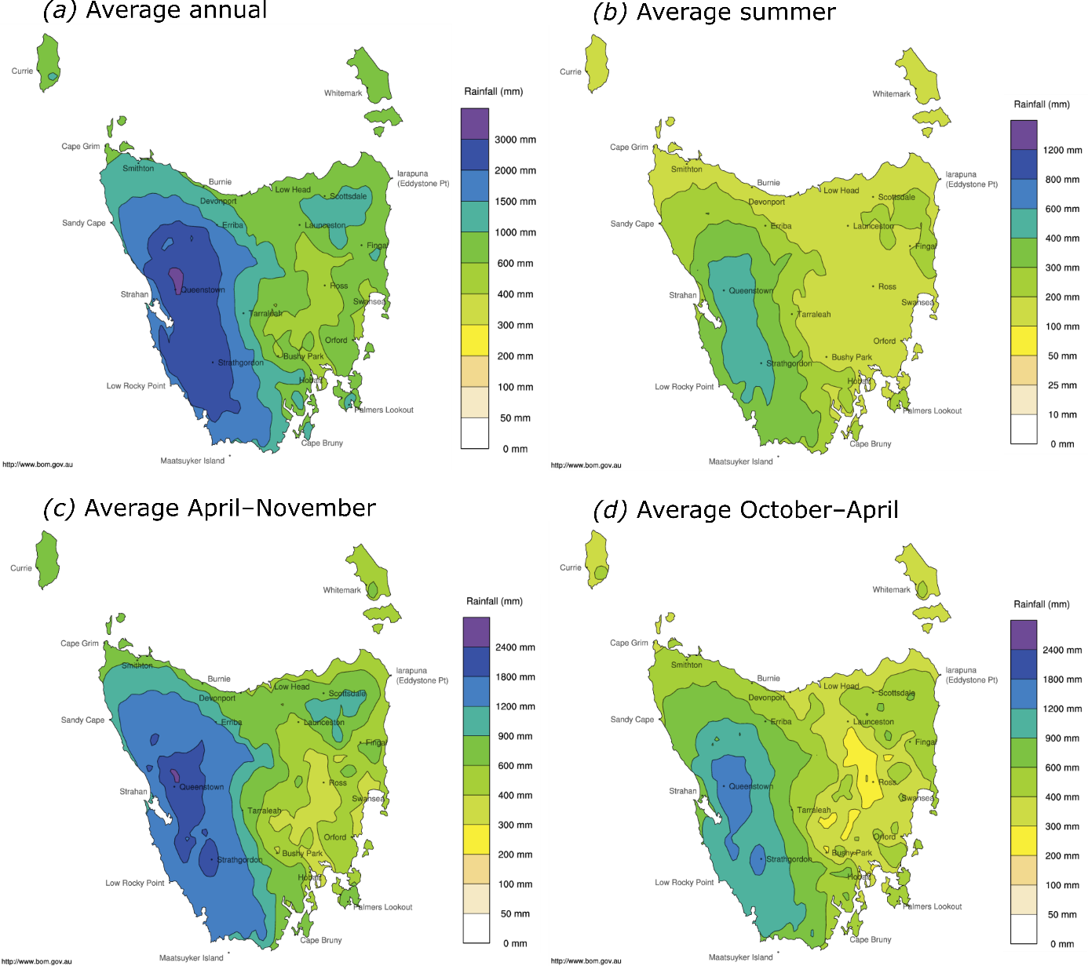

Figure S1. Average precipitation (mm) for Tasmania for 1981–2010: (a) annual; (b) summer (December–February); (c) April–November (approximately the cool season); and (d) October–April (approximately the dry season). The maps were produced by the Australian Bureau of Meteorology (BoM 2020).

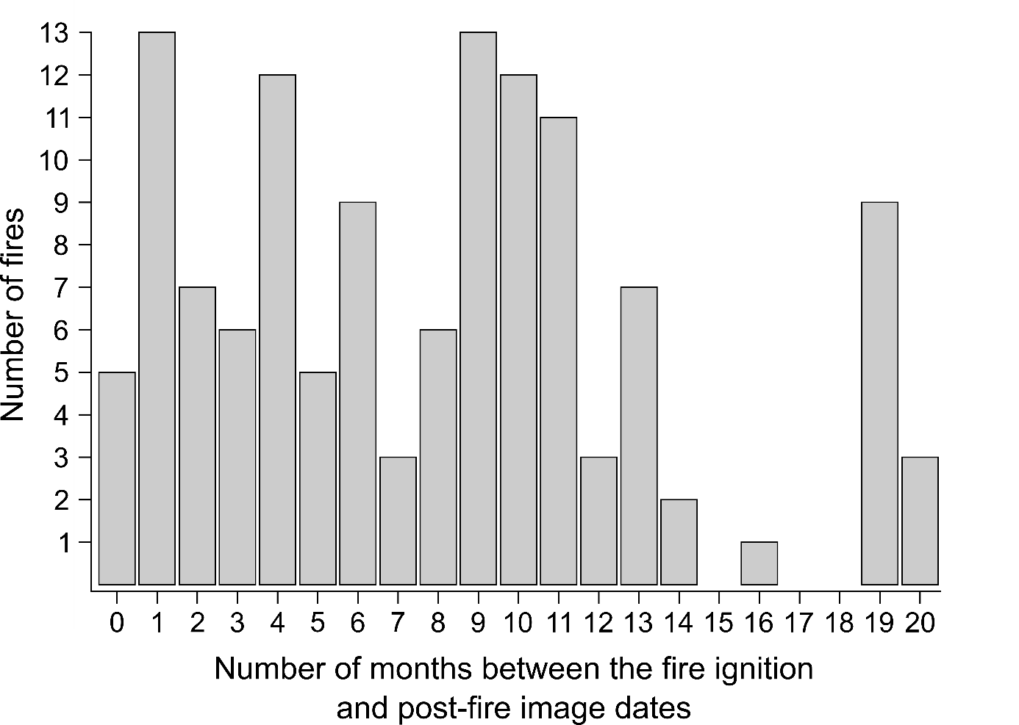
Figure S2. Number of fires in the study area by number of months elapsed between the fire ignition date and the post-fire image date.

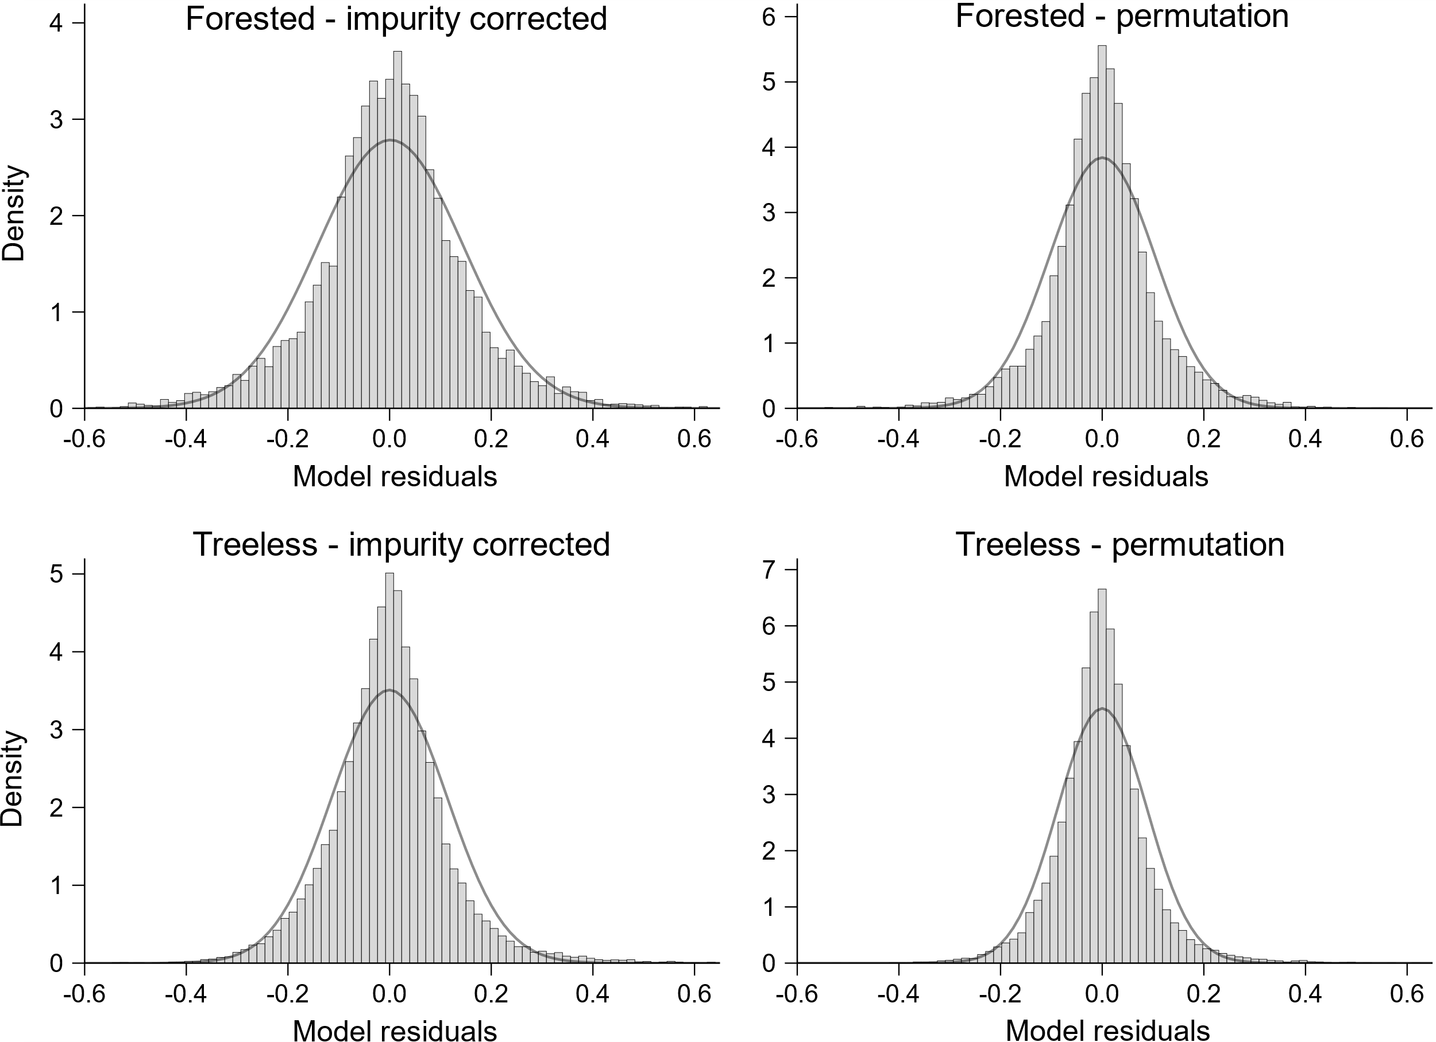
Figure S3. Normal distribution of residuals of the Random Forests models containing the four most important predictor variables from the third round of Random Forests, according to the measure of variable importance (impurity corrected and permutation) and aggregated vegetation (forested and treeless). We selected four datasets out of the 100, fitted the Random Forests models and computed the model residuals.

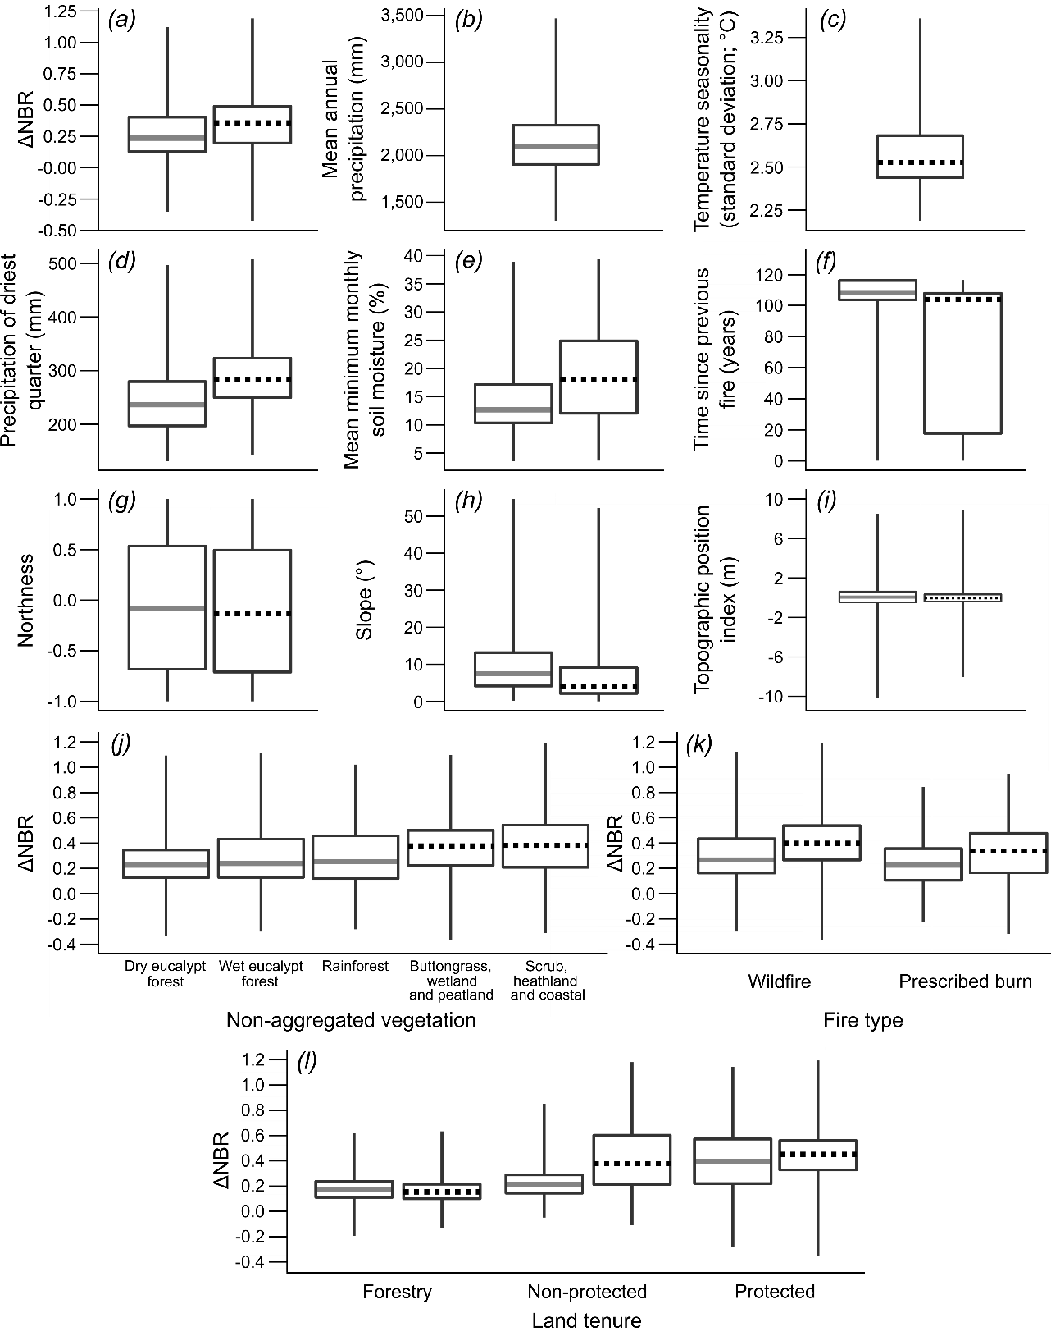
Figure S4. Boxplots of sampled variable values, across the 100 datasets, according to forested (solid grey line) and treeless (dashed black line) vegetation, for the response variable (ΔNBR) and predictor variables of the global GAMM (excluding eastings and northings). Plots (a) and (d–l) contain both forested and treeless vegetation, while plot (b) refers to forests and plot (c) to treeless vegetation. The boxes show the interquartile range, the inside line is the median, the lower whisker extends to the lowest value of the first quantile, and the upper whisker extends to the highest value of the fourth quartile. The boxplots were produced by calculating the four quartiles for each variable in each dataset, and averaging the quartiles across the 100 datasets.
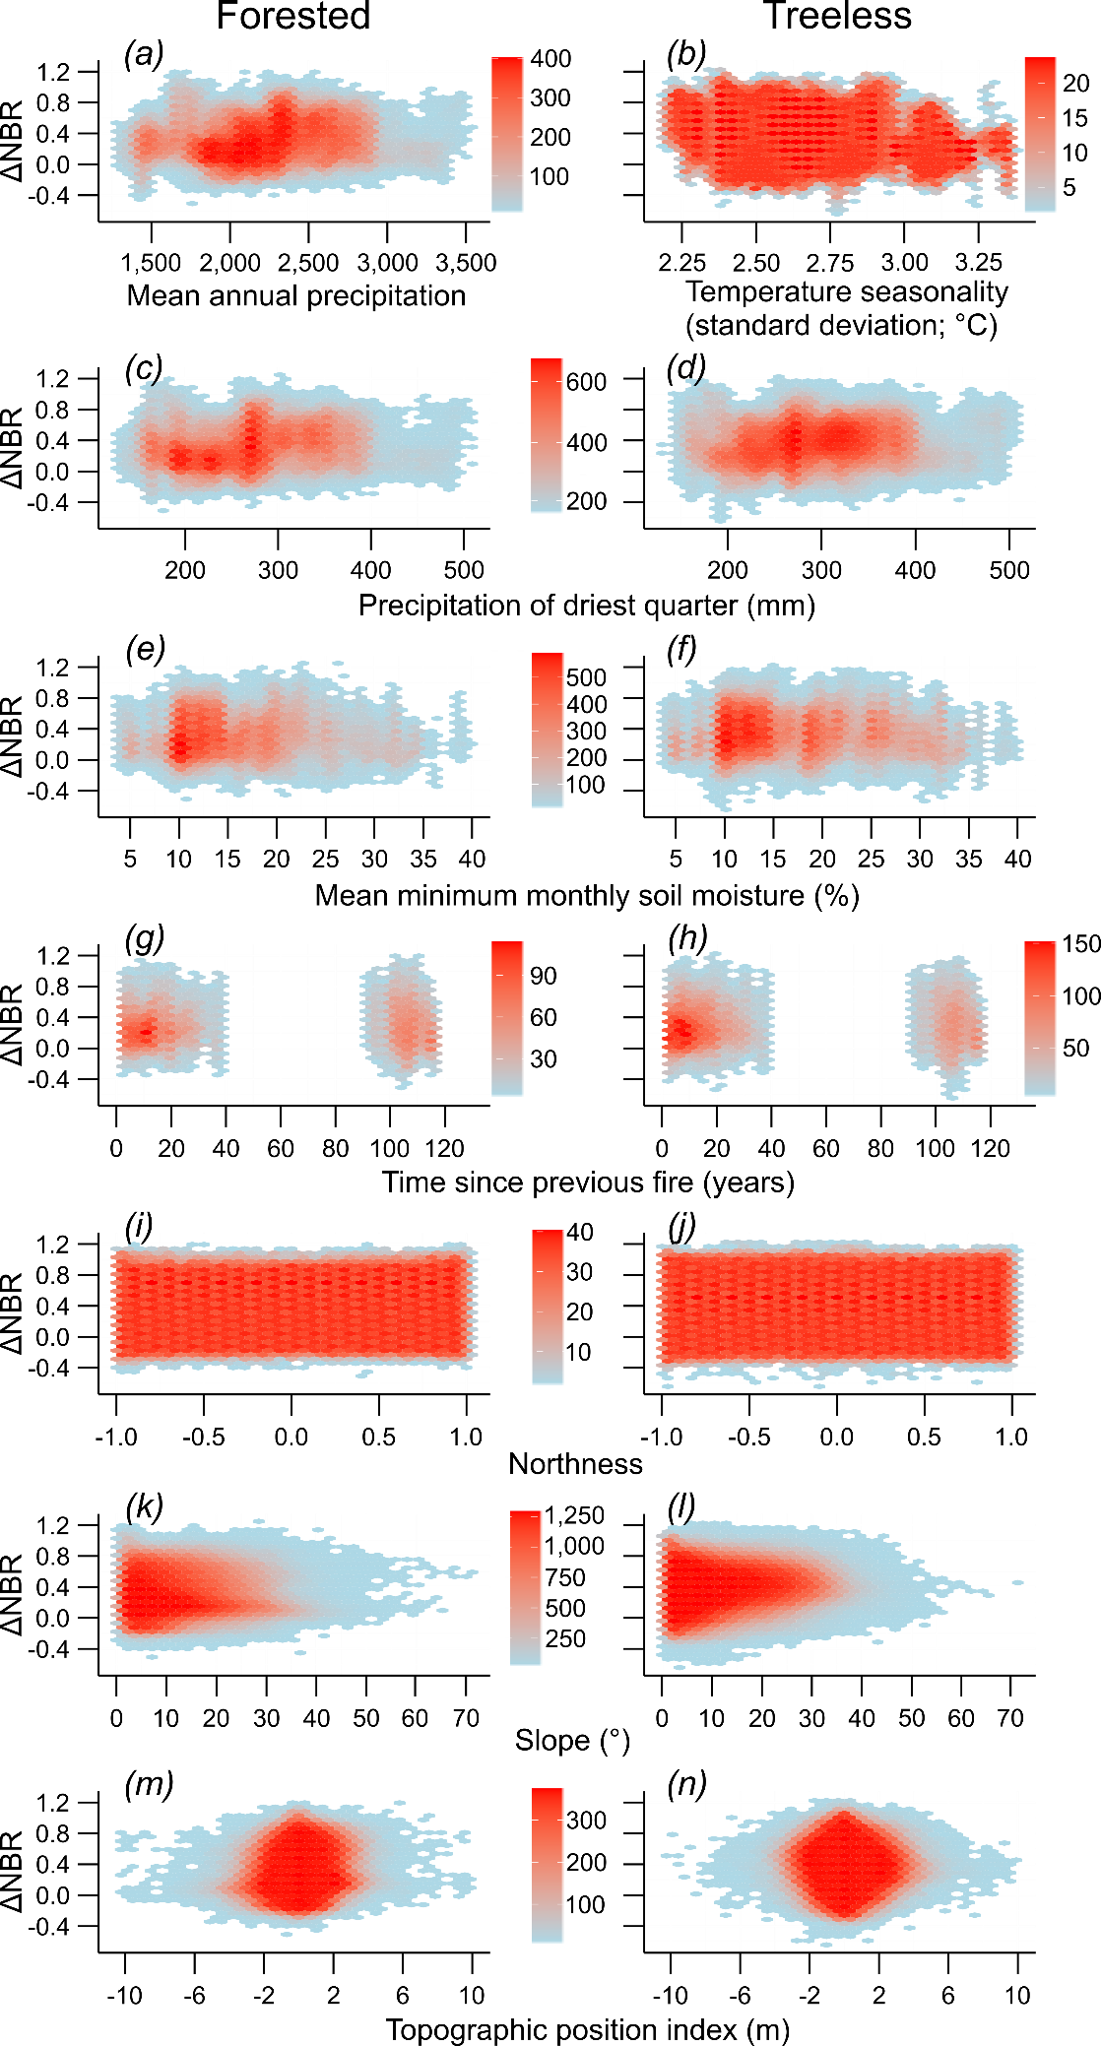
Figure S5. Hexagonal heatmaps of sampled ΔNBR values, across the 100 datasets, according to forested (left panels) and treeless (right panels) vegetation, for the quantitative predictor variables of the global GAMM (excluding eastings and northings). The divisions of the y-axes on the right panels are the same as the left panels. Heatmaps in panels (a, b, g, h) have their own legend, but the other pairs (c–d, e–f, i–j, k–l, m–n) share the legend. The heatmaps were produced by merging the 100 datasets, partitioned by aggregated vegetation, rounding the predictor values to two decimal places (to reduce computational time in creating the graphs), and generating hexagonal heatmaps of bin counts of sampled ΔNBRs per predictor. The heatmaps were created using the ggplot and stat_binhex functions from the ggplot2 R package (version 3.3.2; Wickham 2011).

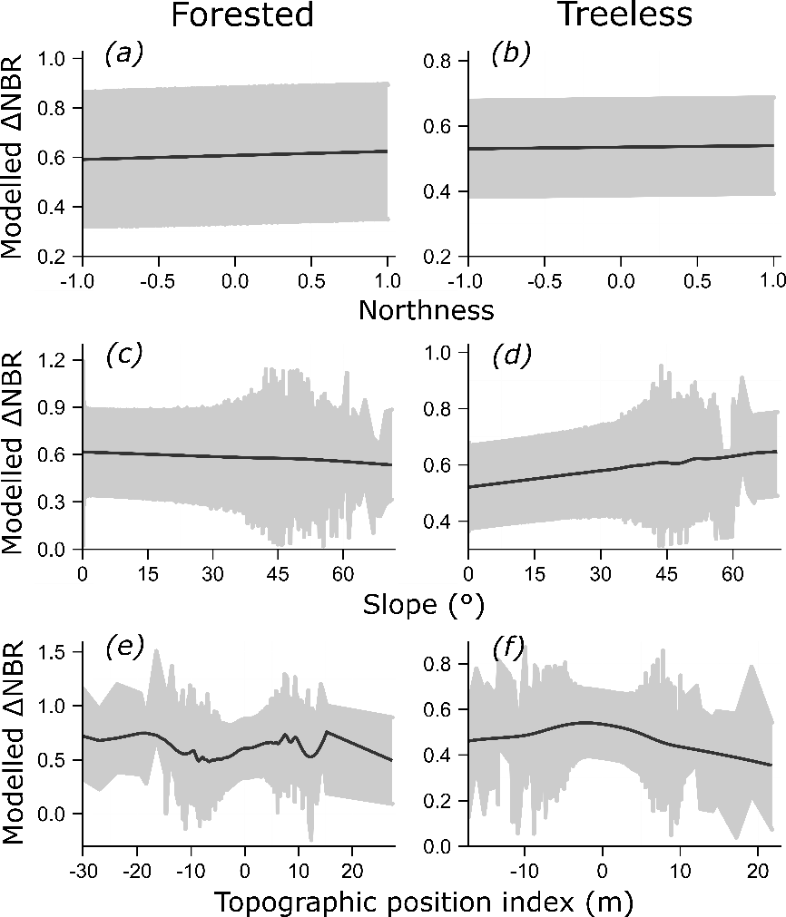

Figure S6. Partial dependence plots for the three topographic predictor variables of the global GAMM in forested and treeless vegetation. The plots were constructed by predicting ΔNBR values for each model in each dataset using the ggpredict function from the ggeffects R package (version 0.15.1; Lüdecke 2018). The grey shaded area shows the mean 95% confidence interval, while the solid black line represents a cubic smoothing spline on the mean of the ΔNBR predictions, obtained via the smooth.spline function from the stats R package (version 4.0.2; R Core Team 2020). Plots on the left (a, c, e) correspond to forests, while plots on the right (b, d, f) are for treeless vegetation.

References

Acock AC, Stavig GR (1979) A measure of association for nonparametric statistics. Soc Forces 57:1381–1386. https://doi.org/10.2307/2577276
BoM (Bureau of Meteorology) (2020) Averaged maps of annual, seasonal and monthly rainfall for Tasmania for 1981–2010. Australian Government. Accessed 31 March 2022: http://www.bom.gov.au/jsp/ncc/climate_averages/rainfall/index.jsp?period=an&area=ta#maps
Chai T, Draxler RR (2014) Root Mean Square Error (RMSE) or Mean Absolute Error (MAE)? - Arguments against avoiding RMSE in the literature. Geosci Model Dev 7:1247–1250. https://doi.org/10.5194/gmd-7-1247-2014
DPIPWE (Department of Primary Industries, Water and Environment) (2017) Tasmania fire history (1967–2016). Tasmanian Government. Available upon request: geodata.clientservices@dpipwe.tas.gov.au
Fick SE, Hijmans RJ (2017) WorldClim version 2: new 1-km spatial resolution climate surfaces for global land areas. Int J Climatol 37:4302–4315. https://doi.org/10.1002/joc.5086
Harrell FE, Dupont C (2006) Package Hmisc. R package. Accessed 31 March 2022: https://CRAN.R-project.org/package=Hmisc
Lüdecke D (2018) ggeffects: tidy data frames of marginal effects from regression models. J Open Source Softw 3:1–5. https://doi.org/10.21105/joss.00772
MRT (Mineral Resources Tasmania) (1964). 1:500,000 digital geology of Tasmania. Tasmanian Government. Accessed 31 March 2022: http://www.mrt.tas.gov.au/products/‌digital_data/accordion/1500,000_scale_digital_geology_of_tasmania
Navarro D (2015) Package lsr: companion to “Learning Statistics with R”. R package. Accessed 31 March 2022: https://CRAN.R-project.org/package=lsr
R Core Team (2020) The R Project for Statistical Computing. Accessed 31 March 2022: https://www.r-project.org
Sedgwick P (2012) Pearson’s correlation coefficient. BMJ 345:e4483. https://doi.org/10.1136/‌bmj.e4483
Su CH, Eizenberg N, Steinle P, Jakob D, Fox-Hughes P, White CJ, Rennie S, Franklin C, Dharssi I, Zhu HY (2019) BARRA v1.0: the Bureau of Meteorology Atmospheric high-resolution Regional Reanalysis for Australia. Geosci Model Dev 12:2049–2068. https://doi.org/10.5194/gmd-12-2049-2019
The LIST (Land Information System Tasmania) (2010) Tasmania 25-m Digital Elevation Model. Tasmanian Government. Accessed 31 March 2022: https://data.thelist.tas.gov.au/‌datagn/srv/eng/main.home?uuid=47b71113-a99d-4a9c-82c0-ba92c8313e79
Wickham H (2011) ggplot2. Wiley Interdiscip Rev Comput Stat 3:180–185. https://doi.org/‌10.1002/wics.147.
Willmott CJ, Matsuura K (2005) Advantages of the Mean Absolute Error (MAE) over the Root Mean Square Error (RMSE) in assessing average model performance. Clim Res 30:79–82. https://doi.org/10.3354/cr030079

