Supporting Information

SI-Table Contents
SI-1. Overall image of the continuous flow-type microwave reactor
SI-2. Heating of CPME by the continuous flow-type microwave reactor
SI-2-1. Heating of CPME by the ISO method
SI-2-2. Heating of CPME by the E-GRA method
SI-2-3. Heating of CPME by the Fl-GRA method
SI-3. Temperature distribution of the flow channel
SI-4. Dielectric properties of Duran pipe
SI-5. Reaction of Compound 1 in CPME in the continuous flow-type microwave reactor
SI-5-1. Reaction of Compound 1 in CPME solution using the E-GRA method
SI-5-2. Reaction of Compound 1 in CPME solution by Fl-GRA method
SI-5-3. Reactions of different CPME concentrations of Compound 1 using the ISO method
SI-6. ¹H and ¹³C NMR spectra of compounds 2 and 3
SI-6-1. ¹H NMR and ¹³C NMR spectra of compound 2
SI-6-2. ¹H NMR and ¹³C NMR spectra of compound 3

SI-1. Overall image of the continuous flow-type microwave reactor
The continuous flow-type microwave reactor is composed of a microwave generator unit, a microwave irradiation unit (TM₁₁₀ type rectangular resonant cavity), a flow unit and a personal computer (PC) controlling the device. The overall image of this device is shown in Figure SI-1.

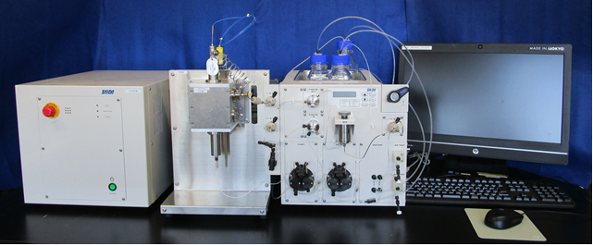
Figure SI-1. Overall image of continuous flow-type microwave reactor

SI-2. Heating of CPME by the continuous flow-type microwave reactor
SI-2-1. Heating of CPME by the E-GRA method
The applied powers, reflected powers, reflectances, temperatures, and resonance frequencies at each applied power are shown in Table SI-1 for flow microwave irradiation of CPME using the E-GRA method. The MW power is the detected input power of the MW cavity and is not the power consumption.

Table SI-1. Reflected powers, reflectances, temperatures and resonance frequencies of CPME at each applied power using the E-GRA method ª
Step | Applied  Power (W) | Reflected  Power (W) | Reflectance  (%) | Temperature  (℃) | Resonance Frequency (GHz)
1 | 20 | 4.1 | 20.5 | 129.5 | 2.46
2 | 25 | 4.8 | 19.2 | 143.8 | 2.46
3 | 30 | 5.2 | 17.3 | 159.8 | 2.46
4 | 35 | 5.5 | 15.7 | 179.8 | 2.46
5 | 40 | 5.5 | 13.8 | 199.2 | 2.46
6 | 45 | 5.4 | 12.0 | 215.2 | 2.46
7 | 50 | 5.1 | 10.2 | 231.2 | 2.45
8 | 55 | 4.8 | 8.7 | 254.5 | 2.45
9 | 60 | 4.5 | 7.5 | 268.7 | 2.45
10 | 65 | 4.1 | 6.3 | 272.9 | 2.45
11 | 70 | 3.4 | 4.9 | 273.7 | 2.45
12 | 75 | 2.6 | 3.5 | 274.6 | 2.45
13 | 80 | 2.1 | 2.6 | 275.8 | 2.45
ªApplied microwave power was increased stepwise by 5 W every 15 min from 20-80 W at a flow rate of 1.0 mL/min under a back pressure of 2.5 MPa

SI-2-2. Heating of CPME by the Fl-GRA method
The applied powers, reflected power, reflectances, temperatures, and resonance frequencies at each flow rate are shown in Table SI-2 for flow microwave irradiation of CPME using the Fl-GRA method.

Table SI-2. Reflected powers, reflectances, temperatures and resonance frequencies of CPME at each flow rate using the Fl-GRA methodª
Step | Flow Rate (ml/min) | Residence Time (sec) | Reflected Power (W) | Reflectance (%) | Temperature (℃) | Resonance Frequency (GHz)
1 | 2.4 | 26.3 | 6.7 | 13.4 | 186 | 2.45
2 | 2.2 | 28.6 | 6.5 | 13.0 | 195 | 2.45
3 | 2 | 31.5 | 6.3 | 12.6 | 204 | 2.45
4 | 1.8 | 35.0 | 6.0 | 12.0 | 210 | 2.45
5 | 1.6 | 39.4 | 5.8 | 11.6 | 218 | 2.45
6 | 1.4 | 45.0 | 5.6 | 11.2 | 222 | 2.45
7 | 1.2 | 52.5 | 5.3 | 10.6 | 233 | 2.45
8 | 1 | 63.0 | 4.9 | 9.8 | 240 | 2.45
9 | 0.8 | 78.8 | 4.6 | 9.2 | 246 | 2.45
10 | 0.6 | 105.0 | 4.3 | 8.6 | 255 | 2.45
ªThe flow rate was decreased from 2.4 mL/min to 0.6 mL/min stepwise by 0.2 mL/min every 10 min using an applied power of 50 W and under a back pressure of 2.5 MPa.
SI-3. Temperature distribution of the flow channel
It was necessary to measure the temperature distribution across the reactor tube, to confirm if an even distribution of temperature occurred or whether certain points were superheated. The temperature distribution of the reactor tube during MW irradiation of CPME was first measured under the following conditions: 1.0 mL / min flow rate, 2.5 MPa back pressure, 50 W MW power. After the temperature became constant, the temperature of the CPME at the cavity inlet (T_{in}) and outlet (T_{out}) was measured with a thermocouple. Inlet and outlet (liquid) temperatures were 26 ° C and 198 ° C, respectively. Next, the temperature of the reaction tube in the cavity was measured at seven points starting from near the entrance to near of the exit of the cavity, using a thermographic camera (TVS-500EX, Nippon Avionics Co., Ltd.) from a slit in the side plate of the cavity (this measures the surface of the reaction tube). The reactor tube has 8 coils in total. A frequency control tube (o.d. 20 mm, i.d. 17.6 mm) having a longitudinal slit of 5 mm width was installed around this reaction tube. Across the seven monitored points observed with the thermographic camera, the temperature rose towards the exit of the cavity. Because the CPME always flows into the reaction tube at room temperature, the temperature is low at the lower part inside the cavity and was sufficiently warmed at the upper part. At the same time, the temperature of the throughput CPME was measured with a thermocouple installed in the flow path of the inlet and the outlet of the reaction tube.
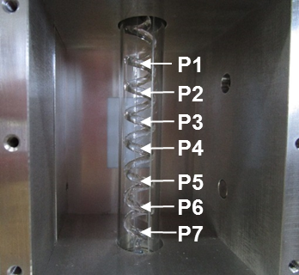
Figure SI-2. Image of flow channel with frequency tunable tube having slit (width 5 mm) in cavity under MW irradiation
The temperature distribution (P1 - P7) observed by the thermo camera during MW heating is that of the reaction tube surface. In order to confirm if this temperature distribution was representative of the internal liquid temperature distribution across the tube, calibration was necessary. In order to calibrate the thermographic data, CPME was passed through a furnace pre-heater before entering the cavity at high flow rate (2 x 7.5 mL/min) and the temperature of the reaction tube was measured at three points (PC1-PC3) starting from near the entrance to near of the exit of the cavity, using a thermographic camera (Figure SI-3). At the same time, the liquid temperature of the throughput CPME was measured with a thermocouple installed in the flow path of the inlet and the outlet of the reaction tube (T_{in} and T_{out}). Despite the high flow rate employed, the temperature differential of the flow path between the inlet and outlet of the reaction tube did increase slightly (when Tin = 48 ºC, Tout = 48 ºC but when Tin = 160 ºC, Tout = 151 ºC) as the inlet temperature was increased (Figure SI-4, top left). Although the position of PC1 is slightly below T_{out} and the position of PC3 is slightly above T_{in} (so that those variables could not be accurately calibrated), we reasonably assumed that the average internal liquid temperature across the tube (T_{AVG} = (T_{in} + T_{out})/2) should correspond to the internal liquid temperature at the center, which is the same position where the surface temperature is measured by thermography (PC2). Hence, T_{AVG} - PC2 vs. PC2 was plotted (Figure SI-4, top right). This graph shows the difference between the surface temperature and internal liquid temperature. At low reactor tube surface temperatures (PC2 = ~40 ºC) the internal liquid temperature is only ~5 ºC hotter than the internal temperature. At high temperatures (PC2 = ~120 ºC), the surface temperature is ~30 ºC hotter than the internal temperature. The calibration was performed at the same flow rate, from 48 °C to 151 °C and the resulting linear relationship between actual temperature and thermographic temperature was extrapolated (Figure SI-4, bottom). The calibration graph was then used to predict the actual temperature of the seven monitored points during the aforementioned MW heating experiment (according to y = mx + c x = (y/m) + (c/m) ). The predicted liquid temperature (ºC) rose linearly with distance (mm) across the measured points of the reactor tube, as did the temperature measured by thermography across points P7-P1.
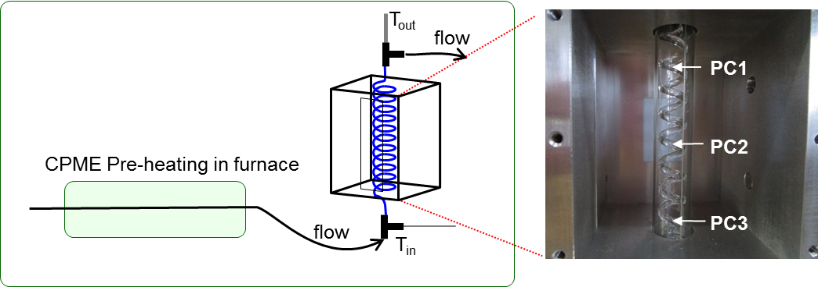
Figure SI-3. Image of flow channel with frequency tunable tube having slit (width 5 mm) in cavity under CPME pre-heating by furnace.
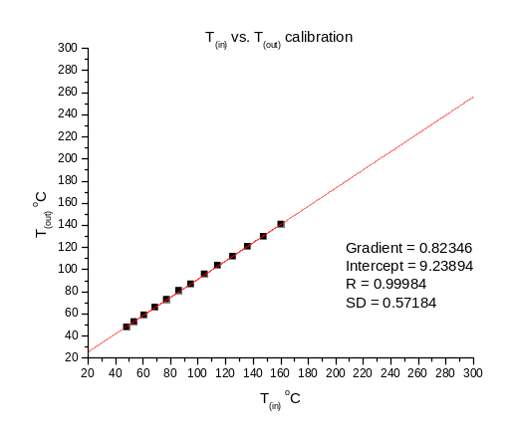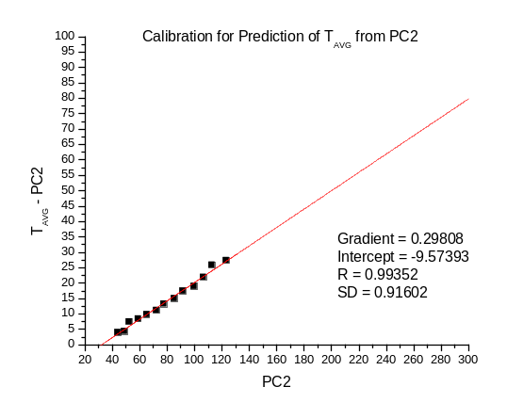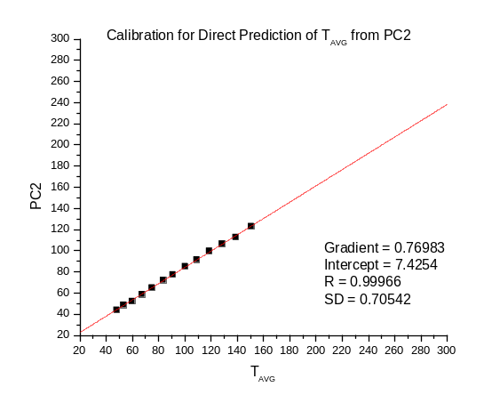
Figure SI-4. Top left: T_{in} vs. T_{out} calibration for actual liquid temperature. Top right: Calibration graph for the prediction of liquid temperature T_{AVG} at point PC2 measured by thermography. Bottom: PC2 vs. T_{AVG} calibration.
Table SI-3. Predicted internal liquid temperature by extrapolation
 | Observed surface temp PC2 (℃) | Calibrated internal liquid temp (℃)ª
T_{out} | 198 | -
P1 | 231 | 290
P2 | 216 | 271
P3 | 196 | 245
P4 | 167 | 207
P5 | 140 | 172
P6 | 103 | 124
P7 | 73 | 85
T_{in} | 26 | -
ªTemperature was calibrated by T_{AVG} =1.29899*PC2-9.64551
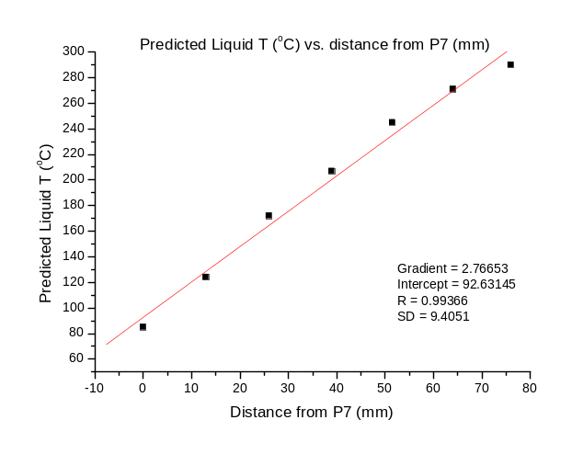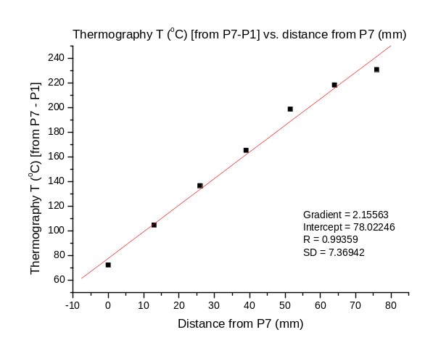
Figure SI-5. Left: Predicted liquid temperature distribution across the reactor tube as a function of distance from P7. Right: Thermography temperature distribution [from P7-P1] across the reactor tube as a function of distance from P7.
The temperature of P1 was considerably higher (92 °C) than T_{out}. The thermocouple at T_{out} directly measures the CPME in the flow path, whereas the thermo camera measures the surface of the reaction tube. The distance between T_{out} and corrected P1 is only 30 mm. This result informs either a) that rapid cooling occurs between P₁ and T_{out} (unlikely given the small distance) or b) that CPME has a microwave absorption rate lower than that of a reaction tube and the reaction tube is preferentially heated. Since the increase in temperature across the reaction tube was approximately linear, it was assumed that the increase in temperature of flowing CPME within the tube was also linear between the in-line thermocouples at the cavity entrance and exit. In either case, it was confirmed that the liquid inside the reaction tube can be sufficiently warmed by using the flow system using microwaves even if a low polarity solvent is used.
SI-4. Dielectric properties of Duran pipe
The dielectric constant of the Duran pipe is εr = 4.6 (1 MHz, 25 °C) and CPME is εr = 4.38 at 2.45 GHz, 25 °C (see manuscript Table 1). CPME has a relatively low dielectric constant and a value close to Duran. Therefore, given these data and the observation in SI-3, it seems that the reaction vessel and the frequency tunable tube both warm by absorbing MW irradiation and are transferring heat to the internal solvent/solution by conductive heating. However, the reaction mixture should be preferentially heated when high concentration reaction mixtures are employed (see manuscript Table 2 and discussion thereof).
SI-5. Reaction of 1 in CPME in the continuous flow-type microwave reactor
SI-5-1. Reaction of compound 1 in CPME solution using the E-GRA method
The applied powers, reflected powers, reflectances, temperatures, resonance frequencies and yields of compounds 1, 2 and 3 at each applied power are shown in Table SI-3 for the flow microwave reaction of a CPME solution of 1 using the E-GRA Method.
Table SI-4. Reflected powers, reflectances, temperatures and resonance frequencies of a CPME solution of 1 and the yields of 1 - 3 at each applied powerª
Step | Applied  Power (W) | Reflected Power (W) | Reflectance (%) | Temperature  (℃) | Resonance Frequency (GHz) | Yield (%)ª
 |  |  |  |  |  | 1 | 2 | 3
1 | 34 | 4.9 | 14.4 | 163.5 | 2.45 | 92.9 | 3.8 | 0
2 | 36 | 5.0 | 13.9 | 163.5 | 2.45 | 92.1 | 7.9 | 0
3 | 38 | 5.0 | 13.2 | 166.3 | 2.45 | 85.1 | 12.6 | 0
4 | 40 | 4.9 | 12.3 | 177.4 | 2.45 | 72.6 | 21.2 | 1.3
5 | 42 | 4.9 | 11.7 | 185.9 | 2.45 | 61.8 | 30.1 | 2.8
6 | 44 | 4.9 | 11.1 | 193.3 | 2.45 | 48.7 | 39.7 | 4.6
7 | 46 | 4.8 | 10.4 | 201.3 | 2.45 | 36.3 | 52.1 | 7.6
8 | 48 | 4.7 | 9.8 | 210.7 | 2.45 | 23.7 | 64.0 | 6.2
9 | 50 | 4.7 | 9.4 | 218.8 | 2.45 | 13.7 | 68.1 | 10.9
10 | 52 | 4.5 | 8.7 | 227.4 | 2.45 | 7.8 | 76.0 | 11.4
11 | 54 | 4.4 | 8.1 | 236.3 | 2.45 | 3.4 | 78.1 | 10.6
12 | 56 | 4.3 | 7.7 | 243.6 | 2.45 | 2.6 | 84.3 | 8.8
13 | 58 | 4.1 | 7.1 | 254.3 | 2.45 | 1.9 | 85.9 | 6.2
14 | 60 | 4.0 | 6.7 | 263.5 | 2.45 | 1.3 | 86.3 | 3.3
ªApplied microwave power was increased stepwise by 5 W every 15 min between 34-60 W using a flow rate of 1.0 mL/min under a back pressure of 2.5 MPa.
SI-5-2. Reaction of compound 1 in CPME solution using the Fl-GRA method
The flow rates, residence times, reflected powers, reflectances, temperatures, resonance frequencies and yields of compounds 1, 2 and 3 at each applied power are shown in Table SI-4 for the flow microwave reaction of a CPME solution of 1 using the Fl-GRA method.
Table SI-5. Reflected powers, reflectances, temperatures and resonance frequencies of a CPME solution of 1 and the yields of 1 - 3 at each flow rate.
Step | Flow Rate (mL/min) | Residence time (sec) | Reflected Power (W) | Reflectance (%) | Temperature  (℃) | Resonance Frequency (GHz) | Yield (%)ª
 |  |  |  |  |  |  | 1 | 2 | 3
1 | 2.2 | 28.9 | 5.6 | 11.2 | 180.1 | 2.45 | 97.2 | 1.8 | 0
2 | 2.0 | 31.8 | 5.4 | 10.8 | 185.8 | 2.45 | 92.4 | 4.1 | 0
3 | 1.8 | 35.3 | 5.3 | 10.6 | 189.8 | 2.45 | 84.9 | 8.6 | 0
4 | 1.6 | 39.8 | 5.1 | 10.2 | 199.4 | 2.45 | 77.9 | 18.7 | 0
5 | 1.4 | 45.4 | 4.9 | 9.8 | 212.5 | 2.45 | 53.4 | 35.9 | 4.0
6 | 1.2 | 53.0 | 4.6 | 9.2 | 218.7 | 2.45 | 27.3 | 57.1 | 9.3
7 | 1.0 | 63.6 | 4.3 | 8.6 | 225.3 | 2.45 | 8.1 | 75.0 | 10.1
8 | 0.8 | 79.5 | 4.0 | 8.0 | 230.5 | 2.45 | 1.0 | 93.7 | 4.2
9 | 0.6 | 106.0 | 3.7 | 7.4 | 232.3 | 2.45 | 0 | 89.7 | 2.4
ªThe flow rate was decreased from 2.2 mL/min to 0.6 mL/min stepwise by 0.2 mL/min every 26 min using an applied power of 50 W and under back pressure of 2.5 MPa
SI-5-3. Reactions of different CPME concentrations of Compound 1 using the ISO method
The flow rates, residence times, reflected powers, reflectances, temperatures, resonance frequencies and yields of compounds 1, 2 and 3 at each applied power are shown in Table SI-5 for flow microwave reaction of CPME solution of 1 using the ISO Method.
Table SI-6. Reflected powers, reflectances, temperatures and resonance frequencies of 1 of a CPME solution of 1 and the yields of 1 - 3 at each concentration
Concentration (M) | Reflected Power (W) | Reflectance (%) | Temperature  (℃) | Resonance Frequency (GHz) | Yield (%)ª
 |  |  |  |  | 1 | 2 | 3
0.05 | 4.94 | 9.9 | 215.5 | 2.45 | 20.8 | 67.5 | 11.6
0.1 | 4.77 | 9.5 | 221.1 | 2.45 | 12.4 | 75.1 | 12.0
0.2 | 4.84 | 9.7 | 220.4 | 2.45 | 12.6 | 76.8 | 10.1
0.5 | 4.73 | 9.5 | 223.0 | 2.45 | 9.4 | 83.0 | 7.1
1.0 | 4.73 | 9.5 | 225.5 | 2.45 | 4.2 | 91.1 | 4.5
2.0 | 4.55 | 9.1 | 232.8 | 2.45 | 0.7 | 96.2 | 2.7
ªFlow rate 1.0 mL/min, concentration of 1 0.05-2.0 M in CPME under the condition of applied power of 50 W and under back pressure of 2.5 MPa
SI-6. ¹H and ¹³C NMR spectra of compounds 2 and 3
SI-6-1. ¹H and ¹³C NMR spectra of compound 2
¹H NMR (400 MHz, CDCl₃) δ 8.18-8.15 (m, 1 H), 7.79-7.76 (m, 1 H), 7.48-7.42 (m, 2 H), 7.40 (d, J = 8.36 Hz, 1 H), 7.21 (d, J = 8.32 Hz, 1 H), 6.12-6.03 (m, 1 H) , 5.54 (s, 1 H), 5.26 (d, J = 10.32 Hz), 5.22 (m, 1 H), 3.57 (dt, J₁ = 6.24 Hz, J₂ = 1.60 Hz, 2 H) ppm. ¹³C NMR (400 MHz, CDCl₃) δ 149.55, 136.10, 133.73, 128.40, 127.50, 125.74, 125.27, 124.81, 121.29120.35, 177.77, 116.94, 35.71 ppm.
SI-6-2. ¹H and ¹³C NMR spectra of compound 3
¹H NMR (400 MHz, CDCl₃) δ 8.23-8.21 (m, 1 H), 7.97-7.95 (m, 1 H), 7.53-7.48 (m, 2 H), 7.14 (d, J = 7.64 Hz, 1 H), 6.77 (d, J = 7.56 Hz, 1 H), 6.13-6.03 (m, 1 H), 5.63 (brs, 1 H), 5.10-5.08 (m, 1 H), 5.05 (d, J = 10.54 Hz), 3.75 (d, J =6.20 Hz, 2 H) ppm. ¹³C NMR (400 MHz, CDCl3) δ150.72, 137.82, 133.41, 129.02, 126.77, 126.51, 125.36, 125.19, 124.56, 122.62, 116.29, 108.66, 37.28 ppm.

