Supporting Information
Continuous-Flow Synthesis and Application of Polymer-Supported BODIPY Photosensitisers for the Generation of Singlet Oxygen; Process Optimised by In-Line NMR Spectroscopy
Christopher G. Thomson¹, Callum M. S. Jones², Georgina Rosair¹, David Ellis¹, Jose Marques-Hueso², Ai-Lan Lee¹ and Filipe Vilela*¹
¹Institute of Chemical Sciences, School of Engineering and Physical Sciences, Heriot-Watt University, Edinburgh, EH14 4AS Scotland, United Kingdom
²Institute of Sensors, Signals and Systems, School of Engineering & Physical Sciences, Heriot-Watt University, Edinburgh, EH14 4AS, United Kingdom
*email: f.vilela@hw.ac.uk

Contents
Contents 1
1. General experimental 2
2. LED Module 2
3. Material Synthesis and Photochemical reactions set-up & apparatus 3
3.1. Batch photochemical reactions apparatus 3
3.2. Flow reactor photochemical reactions 3
3.3. Heterogeneous synthesis on polymer beads setup: Batch vs. Flow 5
4. Experimental section 7
4.1. Synthesis of 1,3,5,7-Tetramethyl-8-(4-[hydroxy]phenyl)-4,4-difluoroboradiazaindacene (BDP-PhOH, 1) 7
4.2. Synthesis of 1,3,5,7-Tetramethyl-2-chloro-8-[4-(benzoyloxy)phenyl]-4,4-difluoroboradiazaindacene (Ph-Est-BDP-Cl, 7) and 1,3,5,7-Tetramethyl-2,6-dichloro-8-[4-(benzoyloxy)phenyl]-4,4-difluoroboradiazaindacene (Ph-Est-BDP-Cl, 8) 7
4.3. Synthesis of 1,3,5,7-Tetramethyl-8-[4-(benzoyloxy)phenyl]-4,4-difluoroboradiazaindacene (Ph-Est-BDP, 6) 8
4.4. Flow Synthesis of Polystyrene-Supported 1,3,5,7-Tetramethyl-8-[4-(benzoyloxy)phenyl]-4,4-difluoroboradiazaindacene (PS-Est-BDP, 4) 9
4.5. Batch Synthesis of Polystyrene-Supported 1,3,5,7-Tetramethyl-8-[4-(benzoyloxy)phenyl]-4,4-difluoroboradiazaindacene (PS-Est-BDP, 5) 10
4.6. Flow Synthesis of Polystyrene-Supported 2,6-dichloro1,3,5,7-tetramethyl-8-[4-(benzoyloxy)phenyl]-4,4-difluoroboradiazaindacene (PS-Est-BDP-Cl₂, 9) 11
5. Singlet Oxygen (¹O₂) photosensitisation reactions for the conversion of α-terpinene to ascaridole 12
4.7. Batch Reactions 12
4.8. Flow Reactions Homogeneous 12
4.9. Flow Reactions Heterogeneous 13
4.10. Recycling experiments 13
6. Characterisation 14
6.1. ¹H-NMR & ¹³C-NMR spectra 14
6.1.1. BDP-PhOH (1) 14
6.1.2. Ph-Est-BDP-Cl₂ (8) 15
6.1.3. Ph-Est-BDP-Cl (7) 16
6.1.4. Ph-Est-BDP (6) 17
6.2. Solid-State Cross-Polarisation Magic Angle Spinning ¹³C-NMR spectra 18
6.2.1. PS-COH – Formyl polystyrene resins starting material (2) 18
6.2.2. PS-Est-BDP(Flow) (4) 18
6.2.3. PS-Est-BDP(Batch) (5) 19
6.2.4. PS-Est-BDP(Flow) (4) after 96 hours irradiation 19
6.3. Solution-State UV/Vis Spectra 20
6.4. Solution-State Emission Spectra 22
6.5. Photoluminesence Quantum Yield (PLQY) 25
6.6. Solid-State UV/Vis Absorption Spectra 27
6.7. FT-IR Spectra 30
6.8. Single Crystal X-Ray Diffraction 34
6.11.1. Ph-Est-BDP-Cl (7) 34
6.11.2. Ph-Est-BDP-Cl₂ (8) 35
7. In-line Benchtop NMR Spectrometer 36
8. References 39

General experimental
Instrumentation and Measurements. Solution-phase ¹H-NMR spectra were recorded on a Bruker AVIII300 spectrometer at 300.1 MHz at 25⁰C in CDCl₃. Solution-phase ¹³C-NMR measurements were recorded on a Bruker AVIII400 spectrometer at 100.6 MHz at 25⁰C in CDCl₃. Solid-state ¹³C-NMR measurements were carried out using a Bruker AVIII400 spectrometer operating at 100.6 MHz for ¹³C at 25⁰C, using a Bruker 4 mm CP-MAS probe, MAS = 10 kHz. Solution-state UV-Vis spectra were recorded on a Shimadzu UV-2550 system with 10 mm quartz cuvettes. Solid-state UV-Vis spectra were recorded on a PerkinElmer Lambda 25 system using a Labsphere RSA-PE-20 reflectance spectroscopy integration sphere. FT-IR spectra were recorded on a PerkinElmer Spectrum 100 FT-IR Spectrometer. X-ray crystallography was performed on a Bruker D8 Advanced instrument. A suitable crystal was selected and held in place on the instrument using a cryo-loop and frozen perfluoropolyether. The crystal was crash-cooled to 100K and data collected at this temperature. Photocatalysis reactions were carried out by using an LED module emitting at 500-510 nm with 7.44 W light output (EPILED, Future Eden Ltd.) at a distance of 7 cm. Photocatalysis reactions under flow conditions were carried out using commercial flow reactor (easy-Photochem, Vapourtec Ltd.) to pump reaction mixture through a 10 mL coil of transparent PTFE tubing (ID: 1 mm), or a transparent borosilicate glass column fixed-bed reactor (6.6 mm ID, 150 mm length). PLQY were measured using a calibrated spectrofluorometer (Edinburgh Instruments, FLS920) equipped with an integrating sphere (Jobin-Yvon) The FLS920 extended red sensitive detector (PMT; 200-1010nm) was used to measure sample emission and the excitation (Grating 750) and a Xenon lamp was used for the excitation.
Materials. All reagents and starting materials employed in this work were commercially available and used without further purification unless stated otherwise.

LED Module
All photosensitisation reactions were performed using an LED module built in our lab. The module comprises 4x 3W EPILED LED arrays with maximum emission at 500-510 nm, purchased from Future Eden Ltd. The forward voltage of each array is 3.4-4.0 V, with an average luminous flux of 70 lm. The LEDs were fixed to an aluminium heat sink with thermal glue and wired in series with AWG 20 0.5 mm² single core cable using solder. The array was wired to a DC constant-current LED driver with 12-24 V capacity at 600 mA current, purchased from eBay. The total average power rating of the device was 7.44 W. The driver power input was fitted with a standard UK plug before being PAT tested for safety. The heatsink maintained the device at <30 ºC for 24 hours of continuous operation in a ventilated fume cupboard. The total cost of the build, excluding tools, was 15 GBP. The spectral output of the individual LEDs is displayed below, along with an image of the finished module before PAT testing (Figure S1) an enclosure was added later to contain the contain the exposed mains wires.
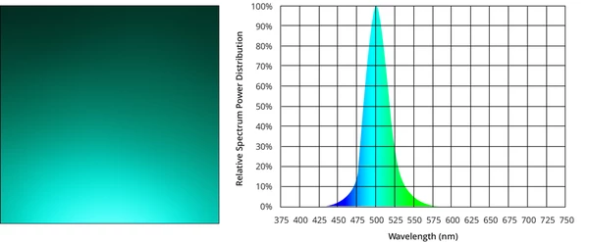
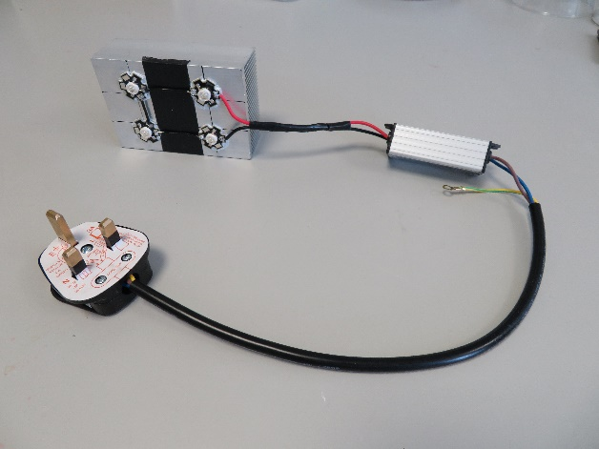
Figure S1. Spectral emission of Future Eden Ltd. 3W EPILED turquoise LEDs (left) and Image of finished LED module built in house (right).

Material Synthesis and Photochemical reactions set-up & apparatus

Batch photochemical reactions apparatus
Batch photochemical reactions were performed in 20 mL sample vials, placed 7 cm from the 500-510 nm LED module. Reactions were covered with a box lined with kitchen aluminium foil to irradiate the sample vials more evenly and reduce exposure of the high intensity light into the lab. The surface of the hotplate stirrer was also covered in aluminium foil (Figure S2).

Flow reactor photochemical reactions

Homogeneous
Homogenous flow reactions were carried out with a commercial E-series Photochem reactor by Vapourtec Ltd. with three V-3 peristaltic pumps and using an LED module emitting at 500-510 nm with 7.44 W light output (EPILED, Future Eden Ltd.) that evenly irradiate a coil of 1 mm ID PTFE tubing with 10 mL of total volume (Figure S3). Reaction vessels were stirred via a magnetic hotplate stirrer, set up adjacent to the flow machine. Vessels were covered with aluminium foil to minimise ambient light exposure, and ideally the room lighting was turned off whenever possible during reactions.

Heterogeneous
Heterogeneous photochemical flow reactions utilised the fixed bed column reactor. Catalyst was loaded to the reactor and a fine layer of sand was placed below and above the catalyst so that no beads were covered by the lips of the input and output adapters. The free volume of the column was minimised after swelling the polymer resins to their maximum volume. The column was suspended by a clamp and then irradiated using an LED module emitting at 500-510 nm with 7.44 W light output (EPILED, Future Eden Ltd.) (Figure S4).
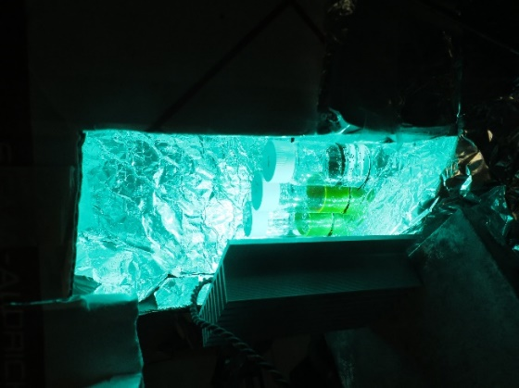
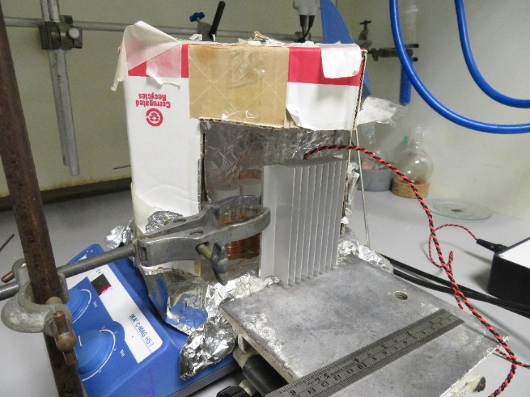

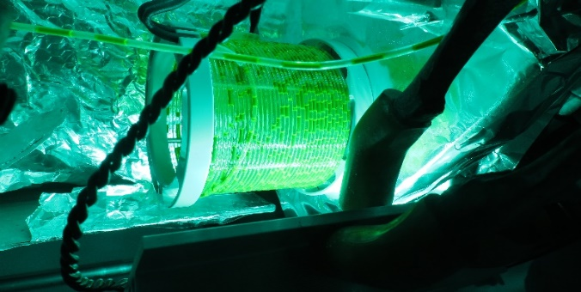
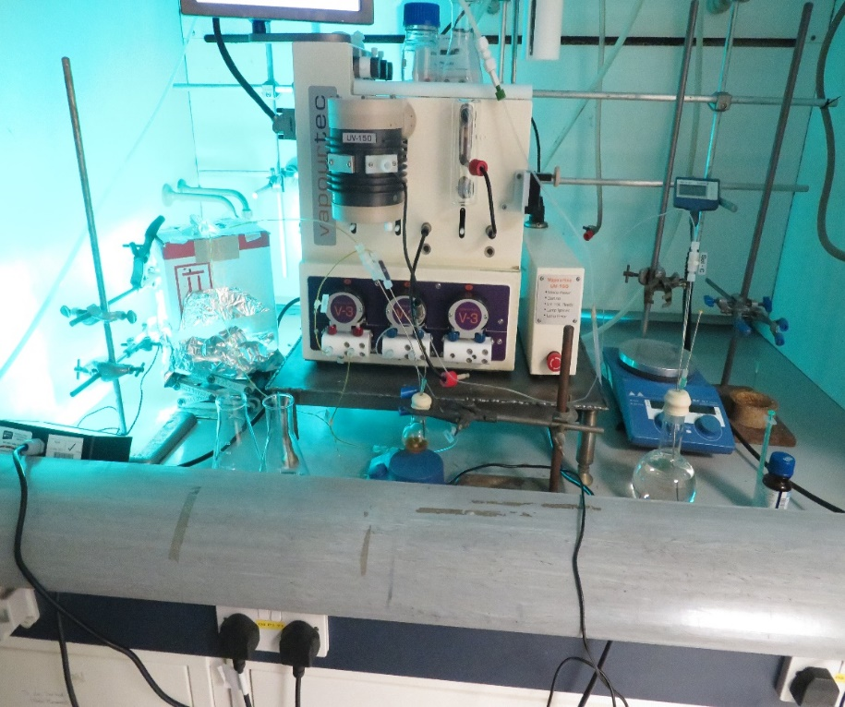
Figure S2. Batch photochemical reaction setup

Figure S3. Homogeneous flow photochemical reaction setup
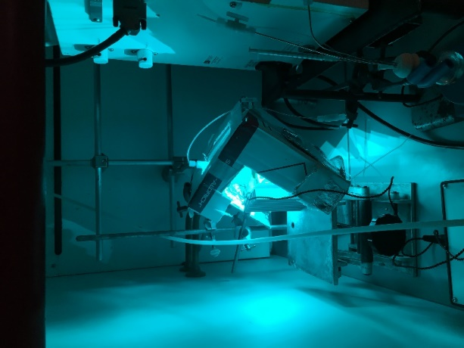
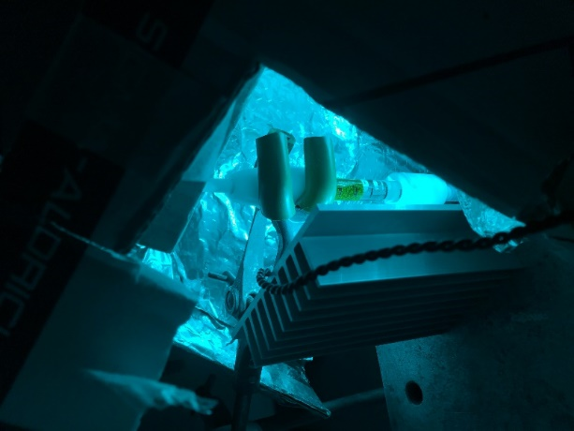
Figure S4. Polymer-supported photochemical reaction in flow with column reactor

Heterogeneous synthesis on polymer beads setup: Batch vs. Flow
During batch synthesis of the polymer supported catalysts, as a significant number of beads were present, and it was feared attrition or mechanical grinding by a magnetic stirrer bar may damage their structure. To avoid this, an overhead stirrer (Heidolph RZR 2102 control) was used and stirring rate was kept minimal (100-175 RPM). This proved to be a cumbersome set-up, (Figure S6A). Purification of product was carried out by Soxhlets extraction over a minimum of three days with various solvents. Comparatively, heterogeneous synthesis in flow utilising the fixed bed column reactor were significantly simplified, as the reaction solution was stirred externally, and the temperature and pressure control of the flow machine removed the need for a condenser (Figure S5 and S6B). The procedure in flow was further simplified as the purification of the product could be performed directly by exchanging the reaction solution with fresh solvent and flowing it through the system at elevated temperature – essentially an accelerated pseudo Soxhlets extraction.
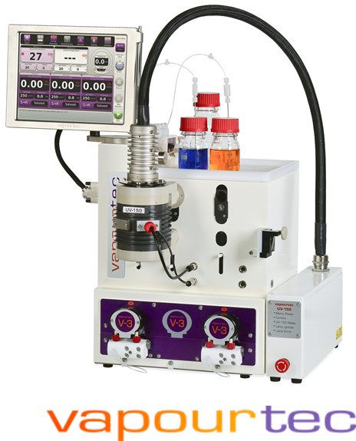
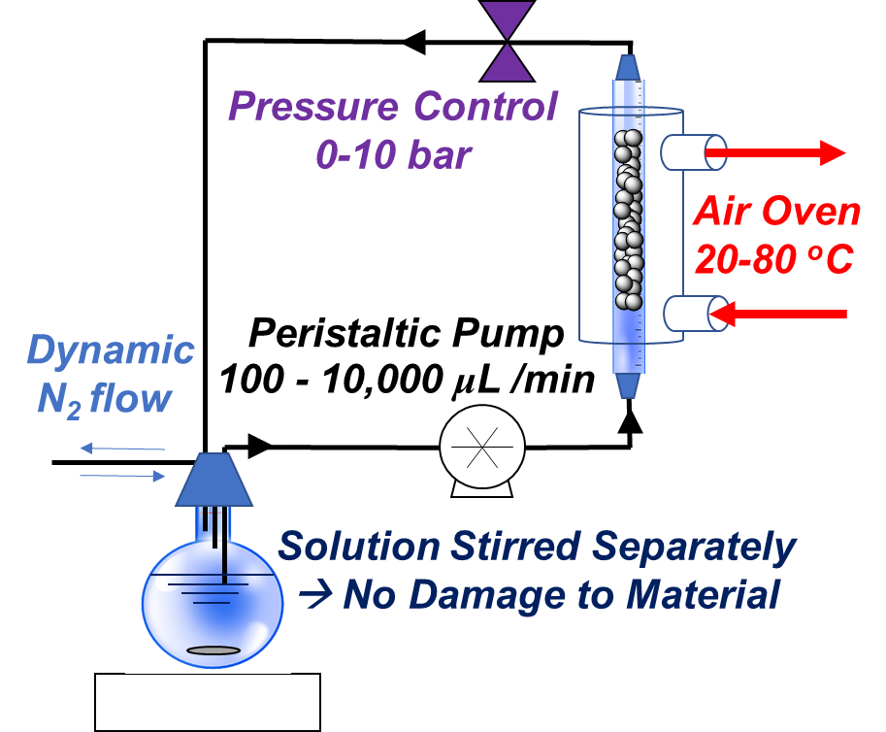
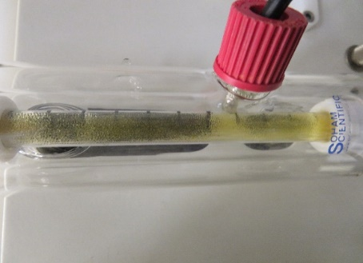

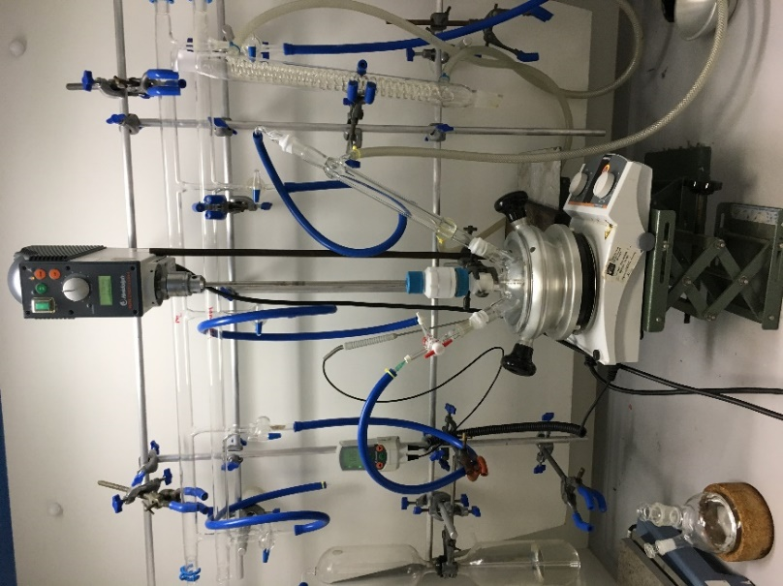
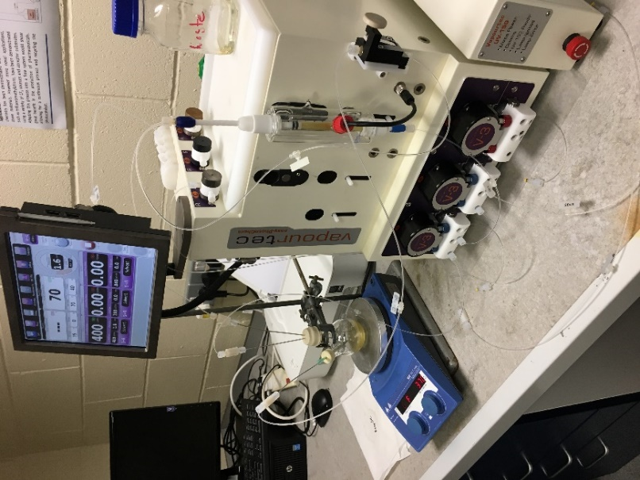
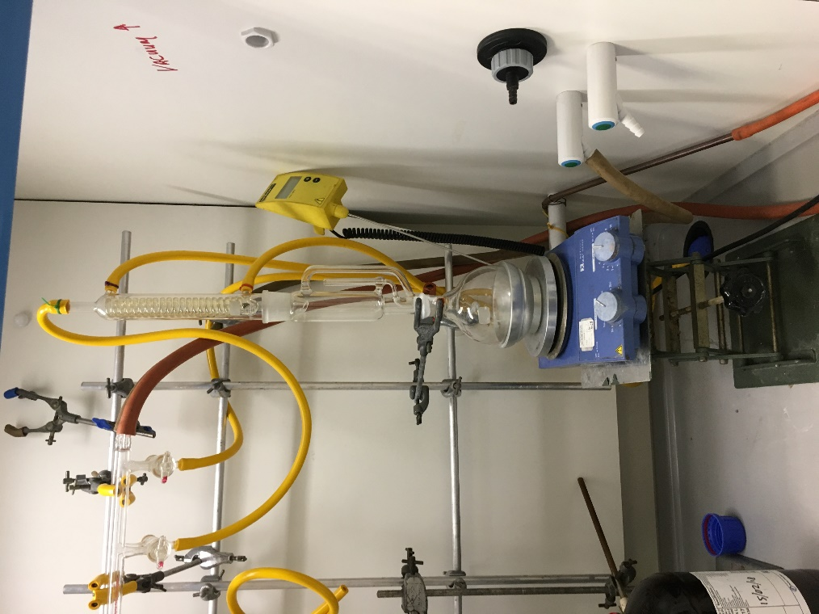
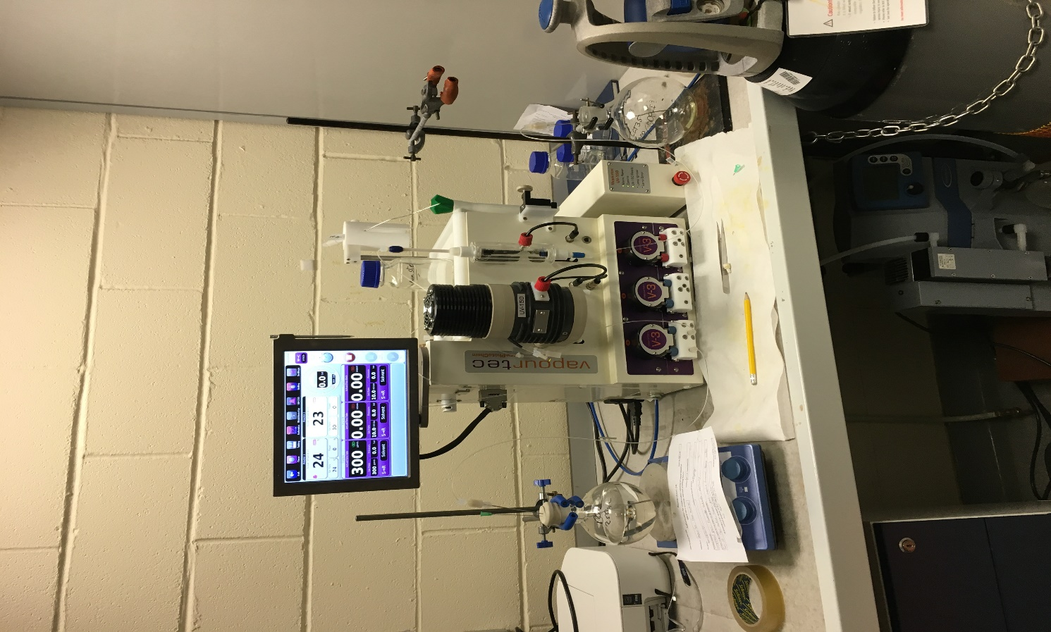
A
B
C
D
Figure S5. Comparison of experimental setups for an identical procedure in batch versus flow. A (left) showing the batch apparatus and B (right) showing the flow machine equivalent setup. C shows a typical Soxhlets extractor set up next to D which shows the comparative set up for purification.

Experimental section

Synthesis of 1,3,5,7-Tetramethyl-8-(4-[hydroxy]phenyl)-4,4-difluoroboradiazaindacene (BDP-PhOH, 1)
To a dry 500 mL two-neck round bottom flask loaded with a magnetic stirrer bar, fitted with an air condenser and sealed by a septum, 4-hydroxybenzaldehyde (0.67 g, 5.5 mmol) was added and dissolved in dry dichloromethane (DCM) (300 mL) under a nitrogen atmosphere. 2,4-Dimethylpyrrole (1.15 mL, 11 mmol) was injected through the side arm under nitrogen. Three drops of trifluoroacetic acid (TFA) was added to the solution and the reaction mixture was stirred at room temperature overnight. After this time, 2,3-dichloro-5,6-dicyano-1,4-benzoquinone (DDQ) (1.25 g, 5.5 mmol) was dissolved in dry DCM (100 mL) under nitrogen in a separate flask and injected slowly by syringe to the reaction mixture over 15 minutes. This mixture was then left to stir at room temperature under a nitrogen atmosphere for 15 minutes. Triethylamine (10 mL, excess) and boron trifluoride diethyl etherate (BF_{3.}OEt₂) (10 mL, excess) were then added to the reaction and left to stir at room temperature under a nitrogen atmosphere for 3 hours. The solution was then diluted in 100 mL of dichloromethane and washed with deionised water three times. The organic phase was dried over Na₂SO₄ and filtered. The crude product was purified through silica gel column chromatography with a EtOAc:hexane (1:1 v/v) eluent to yield a red-orange solid (636 mg, 34% yield). ¹H-NMR was used to compare the product with literature and deemed to be pure.[1]
¹H-NMR (300.1 MHz, CDCl₃); δ 7.06 (d, J= 8.6 Hz, 2H), 6.88 (d, J= 8.6 Hz, 2H), 5.91 (s, 2H), 2.48 (s, 6H), 1.37 (s, 6H). ¹³C-NMR (100 MHz, CDCl₃); δ 156.2, 155.4, 143.1, 141.7, 141.7, 131.9, 129.5, 121.1, 116.1, 29.7, 14.5.

Synthesis of 1,3,5,7-Tetramethyl-2-chloro-8-[4-(benzoyloxy)phenyl]-4,4-difluoroboradiazaindacene (Ph-Est-BDP-Cl, 7) and 1,3,5,7-Tetramethyl-2,6-dichloro-8-[4-(benzoyloxy)phenyl]-4,4-difluoroboradiazaindacene (Ph-Est-BDP-Cl, 8)
To a dry 50 mL two-neck round bottom flask loaded with a magnetic stirrer bar, fitted with an air condenser and sealed by a septum, trichloroisocyanuric acid (TCCA) (83 mg, 0.35 mmol) was added and dissolved in 5 mL dry degassed DCM. Benzaldehyde (0.3 mL, 0.32 mmol) was injected to the flask through the side arm septum and the mixture was left to stir under nitrogen for 5 days. After this time, a solution of BDP-PhOH (75 mg, 0.22 mmol) in dry DCM (10 mL) was injected into the reaction vessel, followed by NEt₃ (0.13 mL, 0.93 mmol) and finally DMAP (1 mg, 0.008 mmol (27 mol%)) dissolved in DCM (5 mL). The solution was stirred for a further 2 hours. After this time, the reaction diluted in DCM (50 mL) and washed with dionised water (50 mL x3) and brined (50 mL) before drying over Na₂SO₄. The crude mixture was concentrated in vacuo and purified by silica gel column chromatography with a EtOAc:hexane (1:2) eluent to yield Ph-Est-BDP-Cl₂ as dark red-pink solid (19.5 mg, 18% yield), and Ph-Est-BDP-Cl as an red solid (51.3 mg, 50%).
Ph-Est-BDP-Cl₂ (8)
R_{f} = 0.23 (EtOAc:Hexane 1:9); ¹H-NMR (400.1 MHz, CDCl₃); δ 8.27 (d, J= 7.61 Hz, 2H), 7.72 (t, J= 7.32 Hz, 1H), 7.59 (t, J= 7.70 Hz, 2H), 7.46 (d, J= 8.66 Hz, 2H), 7.37 (d, J= 8.40 Hz, 2H), 2.63 (s, 6H), 1.50 (s, 6H); ¹³C-NMR (100 MHz, CDCl₃); δ 12.1, 12.4, 29.7, 122.8, 123.0, 128.7, 129.2, 129.8, 130.2, 131.7, 133.9, 138.0, 141.4, 152.02, 152.9, 164.8; HRMS (ESI+): calculated for C₂₆H₂₂BCl₂F₂N₂O₂ (M+H) 513.1077, found 513.1114 (-3.70 ppm).
Ph-Est-BDP-Cl (7)
R_{f} = 0.21 (EtOAc:Hexane 1:9); ¹H-NMR (400.1 MHz, CDCl₃); δ 8.26 (d, J= 7.81 Hz, 2H), 7.72 (m, J= 4.67 Hz, 1H), 7.58 (m, J= 4.87 Hz, 2H), 7.44 (d, J= 8.46 Hz, 2H), 7.38 (d, J= 8.56 Hz, 2H), 6.09 (s, 1H), 2.62 (s, 6H), 1.52 (s, 3H), 1.49 (s, 3H); ¹³C-NMR (100 MHz, CDCl₃); δ 11.9, 12.2, 14.7, 29.7, 122.2, 122.8, 123.0, 128.7, 129.2, 130.2, 132.1, 132.1, 133.9, 136.4, 151.8, 164.8 HRMS (ESI+): calculated for C₂₆H₂₃BClF₂N₂O₂ (M+H) 479.1508, found 479.1504 (+0.43 ppm).

Synthesis of 1,3,5,7-Tetramethyl-8-[4-(benzoyloxy)phenyl]-4,4-difluoroboradiazaindacene (Ph-Est-BDP, 6)
To a dry 2-neck RBF loaded with a stirrer bar, was added BDP-PhOH (400 mg, 1.16 mmol) and DMAP (6 mg, 0.1 mmol) before sealing the side arm with a septum and attaching to an air condenser. The flask was flushed with nitrogen before injecting 30 mL of dry degassed DCM and triethylamine (0.1 mL, 0.7 mmol). The solution was stirred in an ice bath before slowly injecting benzoyl chloride (0.2 mL, 1.4 mmol) over 5 minutes. After this time the ice bath was removed, and the solution was left to stir for 5 hours. After total consumption of the starting material was confirmed by TLC, the mixture was washed with water and extracted with dichloromethane (2x 25 mL). The combined organic fractions were dried over Na₂SO₄, filtered and then concentrated in vacuo. The solid residue was recrystalised from MeOH and filtered to yield an orange crystalline solid (474 mg, 1.08 mmol, 92%). Spectroscopic analysis was compared with literature values and deemed to be pure.[2]
R_{f} = 0.19 (EtOAc:Hexane 1:9); ¹H-NMR (400.1 MHz, CDCl₃); δ 8.16 (d, 2H, J = 7.7 Hz), 7.60 (t, 1H, J = 7.7 Hz), 7.47 (t, 2H, J = 7.7 Hz), 7.30 (m, 4H), 5.93 (s, 2H), 2.49 (s, 6H), 1.41 (s, 6H); ¹³C-NMR (100 MHz, CDCl₃); δ 14.6 (2), 121.4 (2), 122.7, 128.7, 129.3, 130.2, 131.5, 132.6, 133.8, 140.7, 143.1, 151.6, 155.8, 164.9; HRMS (ESI+): calculated for C₂₆H₂₄BF₂N₂O₂ (M+H) 445.1889, found 445.1893 (-0.44 ppm).

Flow Synthesis of Polystyrene-Supported 1,3,5,7-Tetramethyl-8-[4-(benzoyloxy)phenyl]-4,4-difluoroboradiazaindacene (PS-Est-BDP, 4)
Polystyrene resins functionalised with benzaldehyde (750 mg, 0.465 mmol) were added to a dried fixed bed reactor for the Vapourtec flow machine and swollen in dry DCM by flowing solvent through the reactor at 1 mL/min for two hours. TCCA (139.4 mg, 0.6 mmol) was added to a dry 50 mL round bottom flask loaded with a stirrer bar. The flask was sealed with a septum and flushed with N₂ gas for 10 minutes via needles through a septum. Dry, degassed dichloromethane (15 mL) was introduced via injection through the septum. The resulting suspension was gently stirred at room temperature for 10 minutes and then incorporated to the flow system. The solution was flown through the fixed bed reactor at 1 mL/min for 5 days under a nitrogen atmosphere. After this time, a solution of BDP-PhOH (174 mg, 0.512 mmol) in dry DCM (10 mL) was injected into the reaction vessel, followed by NEt₃ (0.13 mL, 0.93 mmol) and finally DMAP (5 mg, 0.04 mmol (10 mol%)) in DCM (5 mL). The solution was circulated overnight at 1 mL/min. After this time, the reaction vessel was replaced with a beaker of DCM (100 mL) to wash the material. This was repeated with DI water (100 mL) and MeOH (100 mL), DCM/MeOH (1:1 v/v, 100 mL) and CHCl₃ (100 mL) at elevated temperature (40-80 ºC) and pressure (1-5 bar) until the resulting solution was clear and non-fluorescent under UV. The beads were collected by filtration and placed in a dry round bottom flask before being dried under vacuum overnight. The dried PS-Est-BDP were analysed by solid-state CP-MAS-¹³C-NMR spectroscopy, FT-IR and solid-state UV-Vis. Dry material recovery: 789 mg. Coupling efficiency calculated as 53% (0.33 mmol/g) by CHN and UV/Vis analysis.

Batch Synthesis of Polystyrene-Supported 1,3,5,7-Tetramethyl-8-[4-(benzoyloxy)phenyl]-4,4-difluoroboradiazaindacene (PS-Est-BDP, 5)
Polystyrene resins functionalised with benzaldehyde (250 mg, 0.155 mmol) and trichloroisocyanuric acid (53 mg, 0.229 mmol) were added to a dried 2-neck round bottom flask. The flask was connected to an overhead stirrer and the side arm was sealed by a septum. The flask was flushed with N₂ gas for 30 minutes via needles through a septum. Dry, degassed dichloromethane (15 mL) was injected through the septum. The resulting suspension was gently stirred at room temperature for 5 days under N₂. The reaction volume was closely monitored for evaporation and kept at 15 mL by injecting more DCM when necessary. After this time, a solution of BDP-PhOH (58 mg, 0.171 mmol) in dry DCM (10 mL) was injected into the reaction vessel, followed by NEt₃ (0.043 mL, 0.31 mmol) and finally DMAP (2 mg, 0.02 mmol (10 mol%)). The suspension was left stirring for a further 19 hours. After this time, the suspension was filtered to collect the resin materials and washed with DCM, MeOH and deionised water. The material was then placed in a Soxhlet’s extractor and purified for 5 days with DCM (3 days), ethyl acetate (1 day) and MeOH (1 day). The material was collected and dried under vacuum for 24 hours before analysis. Dry material recovery: 238 mg. Coupling efficiency calculated as 28% (0.17 mmol/g) by CHN and UV/Vis analysis.

Flow Synthesis of Polystyrene-Supported 2,6-dichloro1,3,5,7-tetramethyl-8-[4-(benzoyloxy)phenyl]-4,4-difluoroboradiazaindacene (PS-Est-BDP-Cl₂, 9)
PS-Est-BDP (Flow) (4) (250 mg, ~0.08 mmol w.r.t BDP) was loaded into a fixed bed reactor (PL: 5 cm, ID: 6.6) and attached to the Vapourtec flow machine. The beads were primed by flowing a 1:1 mixture of dichloromethane and hexafluoroisopropanol (HFIP) (5 mL) at 1 mL/min using the flow machines V3 peristaltic pump. N-chlorosuccinimide (70 mg, 0.5 mmol) was added to a 50 mL round bottom flask charged with a stirrer bar and dissolved in 1:1 dichloromethane:HFIP (20 mL total). The flask was sealed with a septum and connected to the flow machine to form a closed, continuous-flow system. Reagents were flown at 1 mL/min for 16 hours through the fixed bed reactor containing the PS-Est-BDP resins. After this time, the resins were washed with fresh DCM, methanol and acetone (100 mL, 1mL/min) to remove impurities. This washing process was continued until the outflow was clear and non-fluorescent. The modified resins were dried under high vacuum for 24 hours and analysed by solid-state UV/Vis, fluorescence and FTIR spectroscopies. Dry material recovery: 258 mg.

Singlet Oxygen (¹O₂) photosensitisation reactions for the conversion of α-terpinene to ascaridole

Batch Reactions
To a dry 20 mL sample vial loaded with a magnetic stirrer bar, was added 10 mol% of photosensitiser material/molecule and dissolved in chloroform (7.5 mL) and placed on a hot-plate stirrer covered in aluminium foil and covered by a reflective housing. An LED array (500-510 nm, 7.44 W) was placed at 7 cm from the sample vials. α-terpinene (0.08 mL, 0.5 mmol) was then added to the solution via syringe and sealed with a cap. The LED module was activated, and the stirring solution was irradiated for up to 24 hours. Samples were periodically taken, concentrated in vacuo and analysed by ¹H-NMR to monitor conversion via shifts in the alkene proton signals.

Flow Reactions Homogeneous
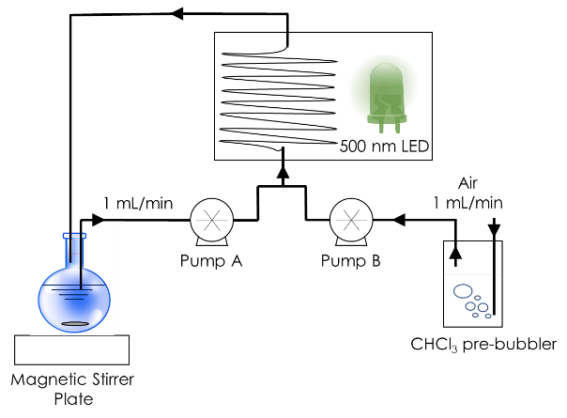
To a dry 20 mL round bottom flask loaded with a magnetic stirrer bar, was added 10 mol% of molecular photosensitiser and dissolved in chloroform (15 mL) before sealing with a septum. The flask was connected to the Vapourtec flow machine before injecting α-terpinene (0.16 mL, 1 mmol) and then covered to prevent photosensitisation events from ambient light. As described by the flow scheme above, the reaction solution was pumped at 1 mL/min using peristaltic pumps (Vapourtec V-3) to a T-junction where it was mixed with CHCl₃ saturated air from a CHCl₃ pre bubbler being pumped concurrently at 1 mL/min by a second peristaltic pump. The heterogeneous liquid-gas mixture formed a slug flow at the T-junction and was pumped through a 10 mL coil of transparent PTFE tubing (ID: 1 mm) placed in a reflective housing, irradiated by an LED array (500-510 nm, 7.44 W) at a net flow rate of 2 mL/min and then returning to the initial reaction flask to be continuously cycled for up to 8 hours. Samples were periodically taken, concentrated in vacuo and analysed by ¹H-NMR to monitor conversion via shifts in the alkene proton signals.

Flow Reactions Heterogeneous
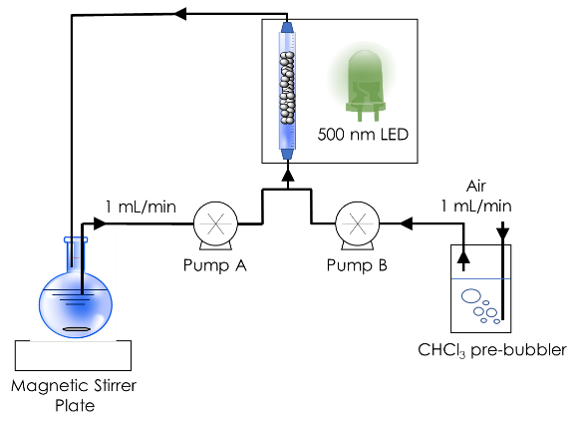
To a transparent borosilicate glass column fixed bed reactor (6.6 mm ID, 150 mm length) was added PS-Est-BDP (200 mg, 10 mol%) and swollen in CHCl₃ (15 mL) for 1 hour by flowing solvent through the column at 1 mL/min. To a dry 20 mL round bottom flask loaded with a magnetic stirrer bar, was added α-terpinene (0.16 mL, 1 mmol) and chloroform (15 mL) before sealing with a septum. The flask was connected to the Vapourtec flow machine and then covered to prevent photosensitisation events from ambient light. The CHCl₃ used to swell the beads was pumped to waste until the system was dry but the resins still swollen in CHCl₃. As described by the flow scheme above, the reaction solution was pumped at 1 mL/min using peristaltic pumps (Vapourtec V-3) to a T-junction where it was mixed with CHCl₃ saturated air from a CHCl₃ pre bubbler being pumped concurrently at 1 mL/min by a second peristaltic pump. The heterogeneous liquid-gas mixture formed a slug flow at the T-junction and was pumped through the fixed bed column reactor placed in a reflective housing, irradiated by an LED array (500-510 nm, 7.44 W) at a net flow rate of 2 mL/min and then returning to the initial reaction flask to be continuously cycled for 24 hours. The catalyst bed was permitted to form a ‘mixed bed’ regime (hybrid between a packed bed and fluidised bed) to prevent pressure build up under the triphasic system. Samples were periodically taken, concentrated in vacuo and analysed by ¹H-NMR to monitor conversion via shifts in the alkene proton signals.

Recycling experiments
To test the photostability of the materials, the same PS-Est-BDP material was cycled multiple times with a purification step between each cycle. For batch reactions, the material was collected by vacuum filtration and washed with fresh CHCl₃, DCM and MeOH (50 mL each) before drying in vacuo and then repeating the procedure outlined above. For flow reactions, the material was kept in the column reactor and flushed with fresh solvent CHCl₃, DCM and MeOH (50 mL each) at elevated temperature and pressure before drying the material by flowing air at 5 mL/min at elevated temperature using the Vapourtec flow machine before repeating the procedure outlined above. After 4 cycles (96 hours of irradiation) the materials were analysed by FT-IR, solid-state CP-MAS-¹³C-NMR and solid-state UV/Vis spectroscopies to assess photobleaching of the material.

Characterisation

¹H-NMR & ¹³C-NMR spectra

BDP-PhOH (1)
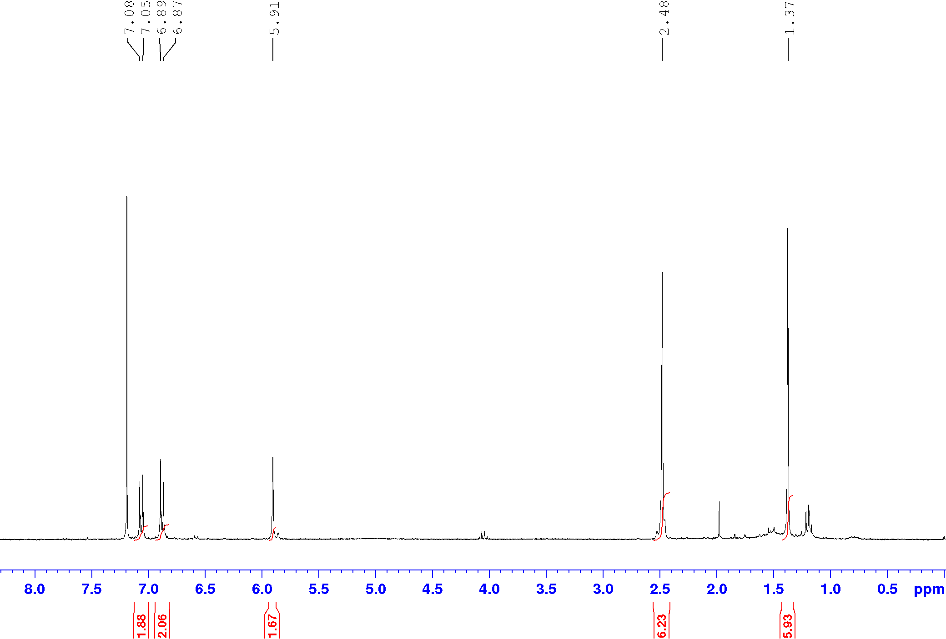
Figure S6. ¹H-NMR (CDCl₃, 400 MHz) spectra of BDP-PhOH (1)

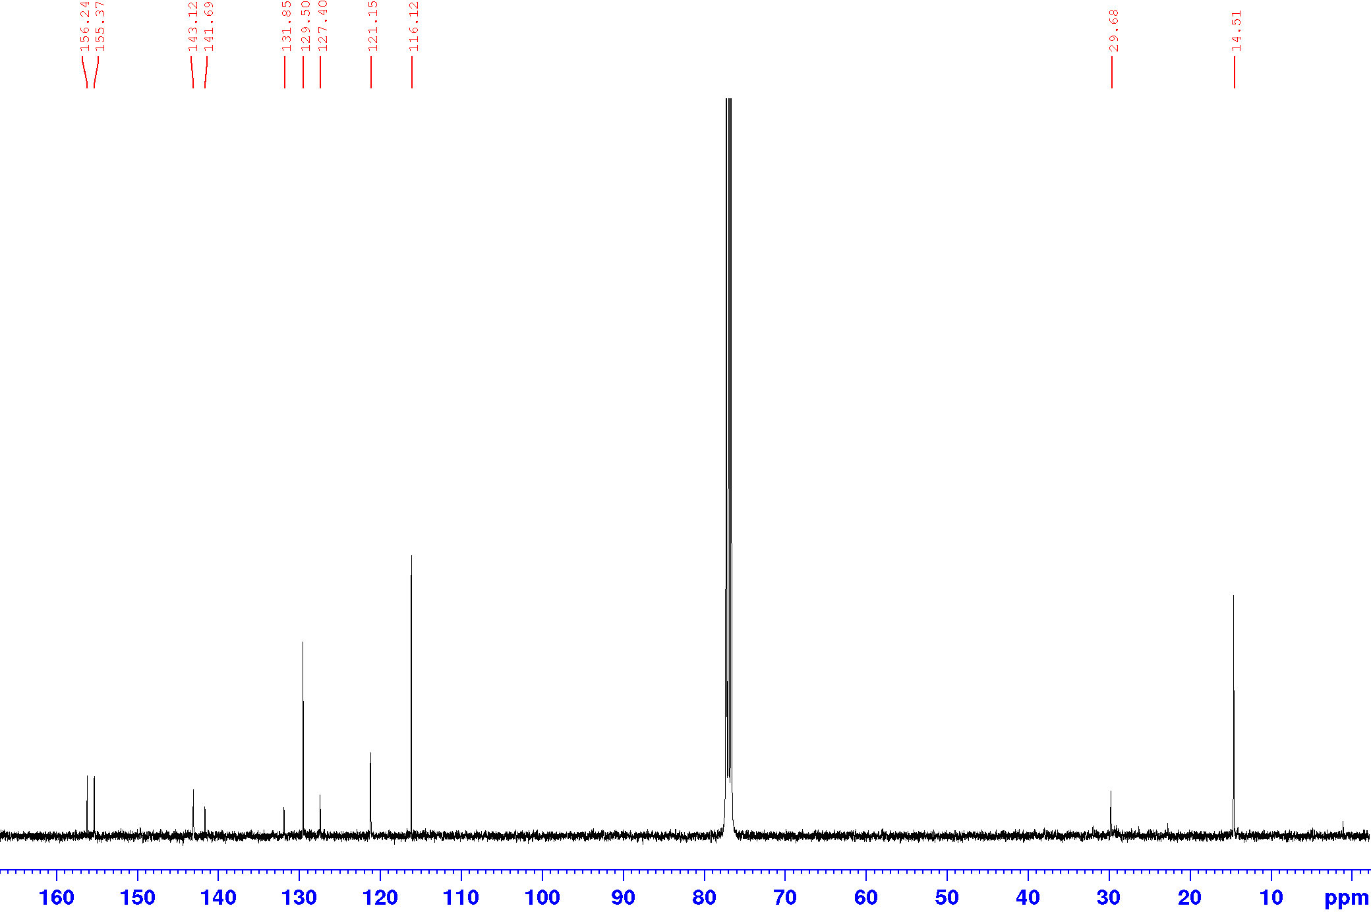
Figure S7. ¹³C-NMR (CDCl₃, 100 MHz) spectra of BDP-PhOH (1)

Ph-Est-BDP-Cl₂ (8)
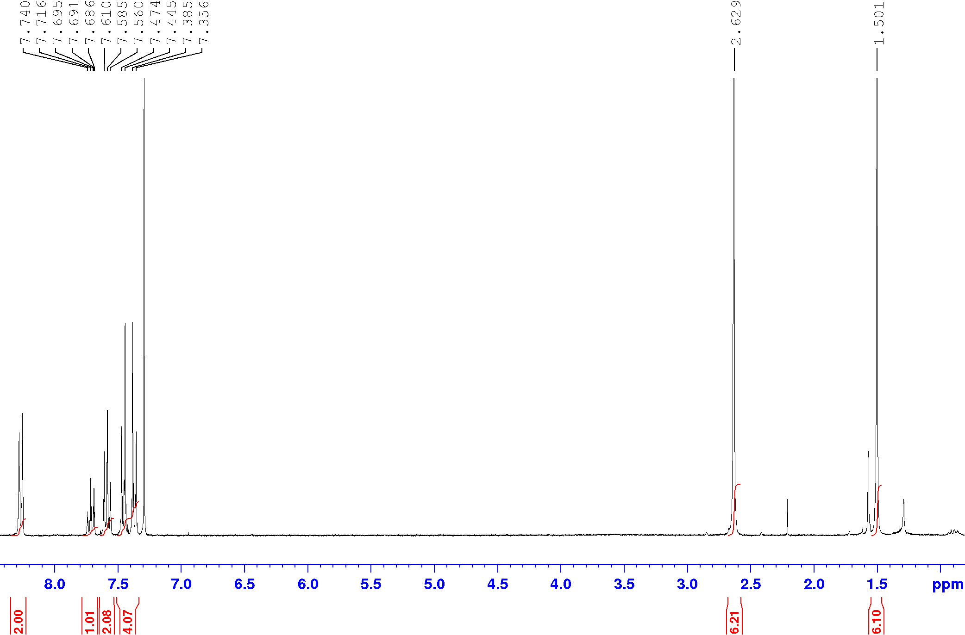
Figure S8. ¹H-NMR (CDCl₃, 400 MHz) spectra of Ph-Est-BDP-Cl₂ (8)

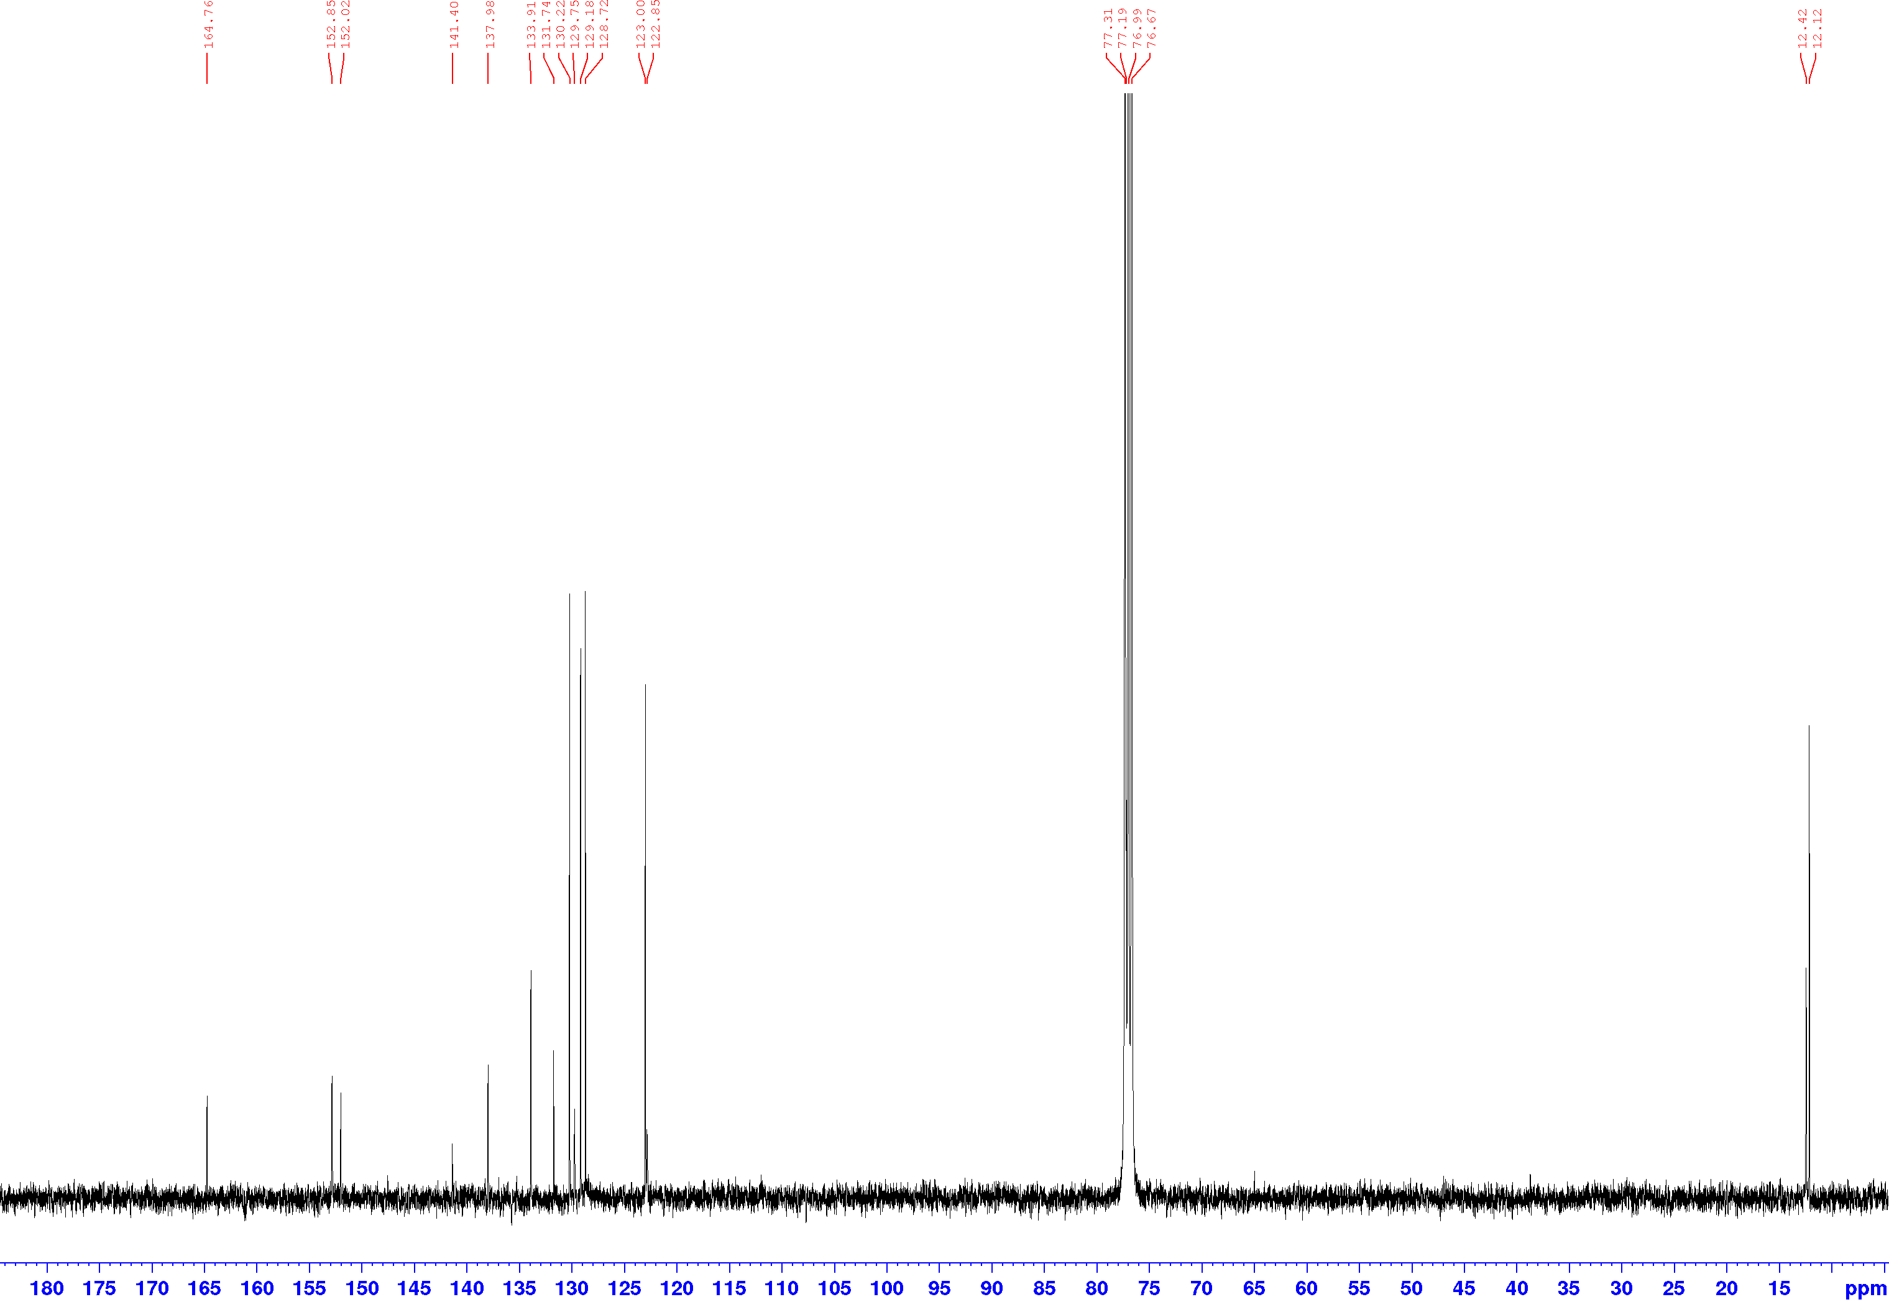
Figure S9. ¹³C-NMR (CDCl₃, 100 MHz) spectra of Ph-Est-BDP-Cl₂ (8)

Ph-Est-BDP-Cl (7)
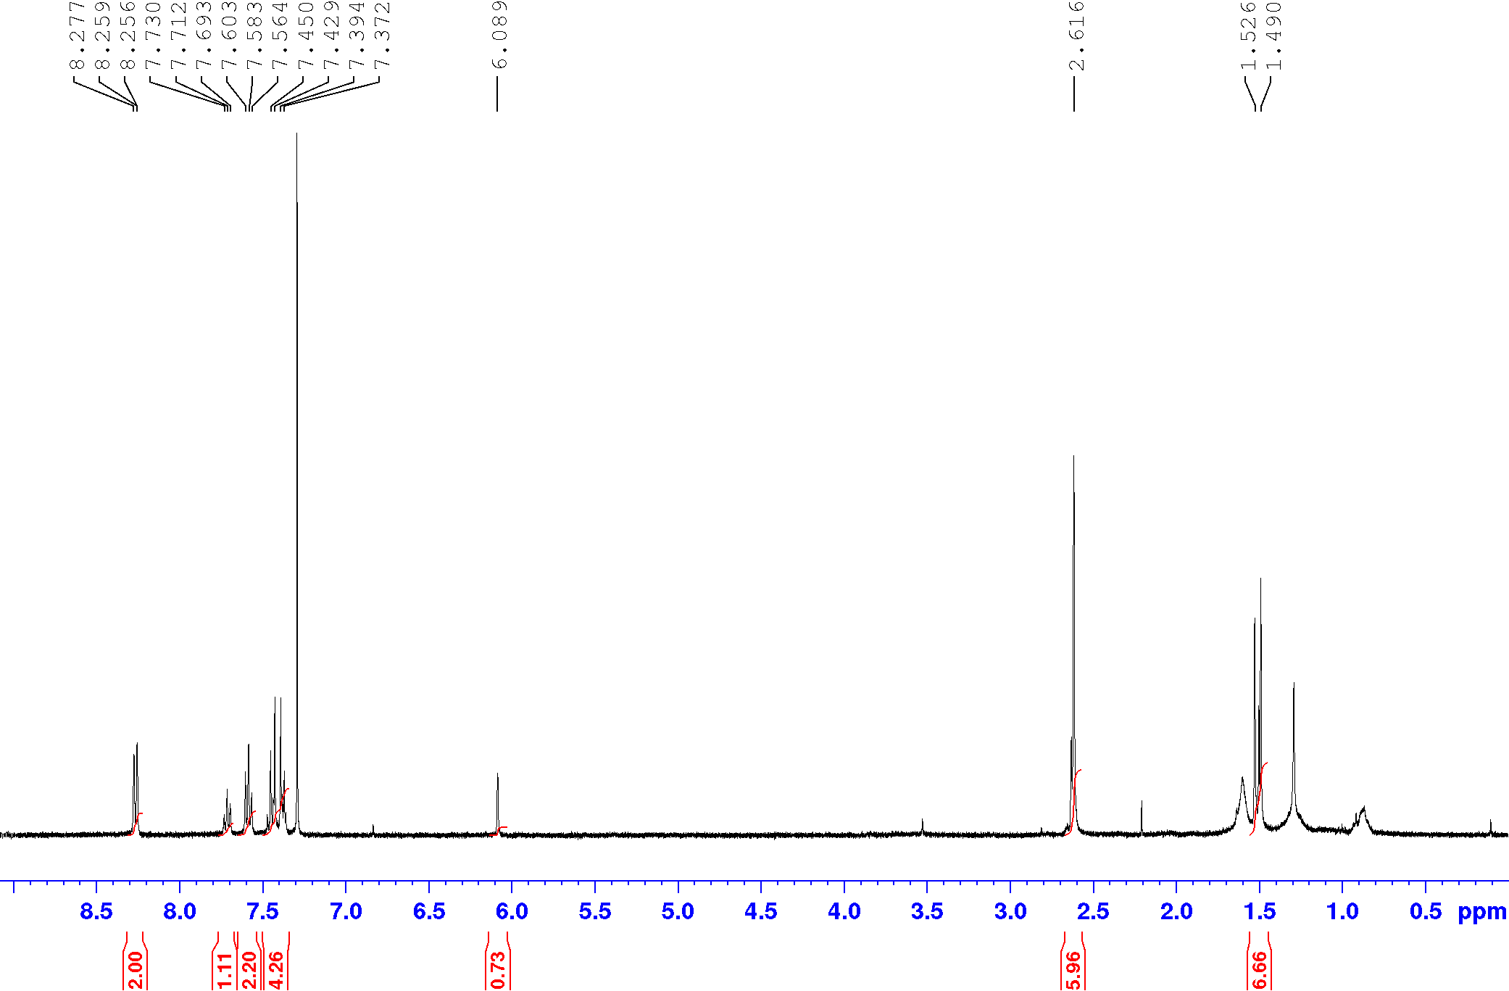
Figure S10. ¹H-NMR (CDCl₃, 400 MHz) spectra of Ph-Est-BDP-Cl (7)

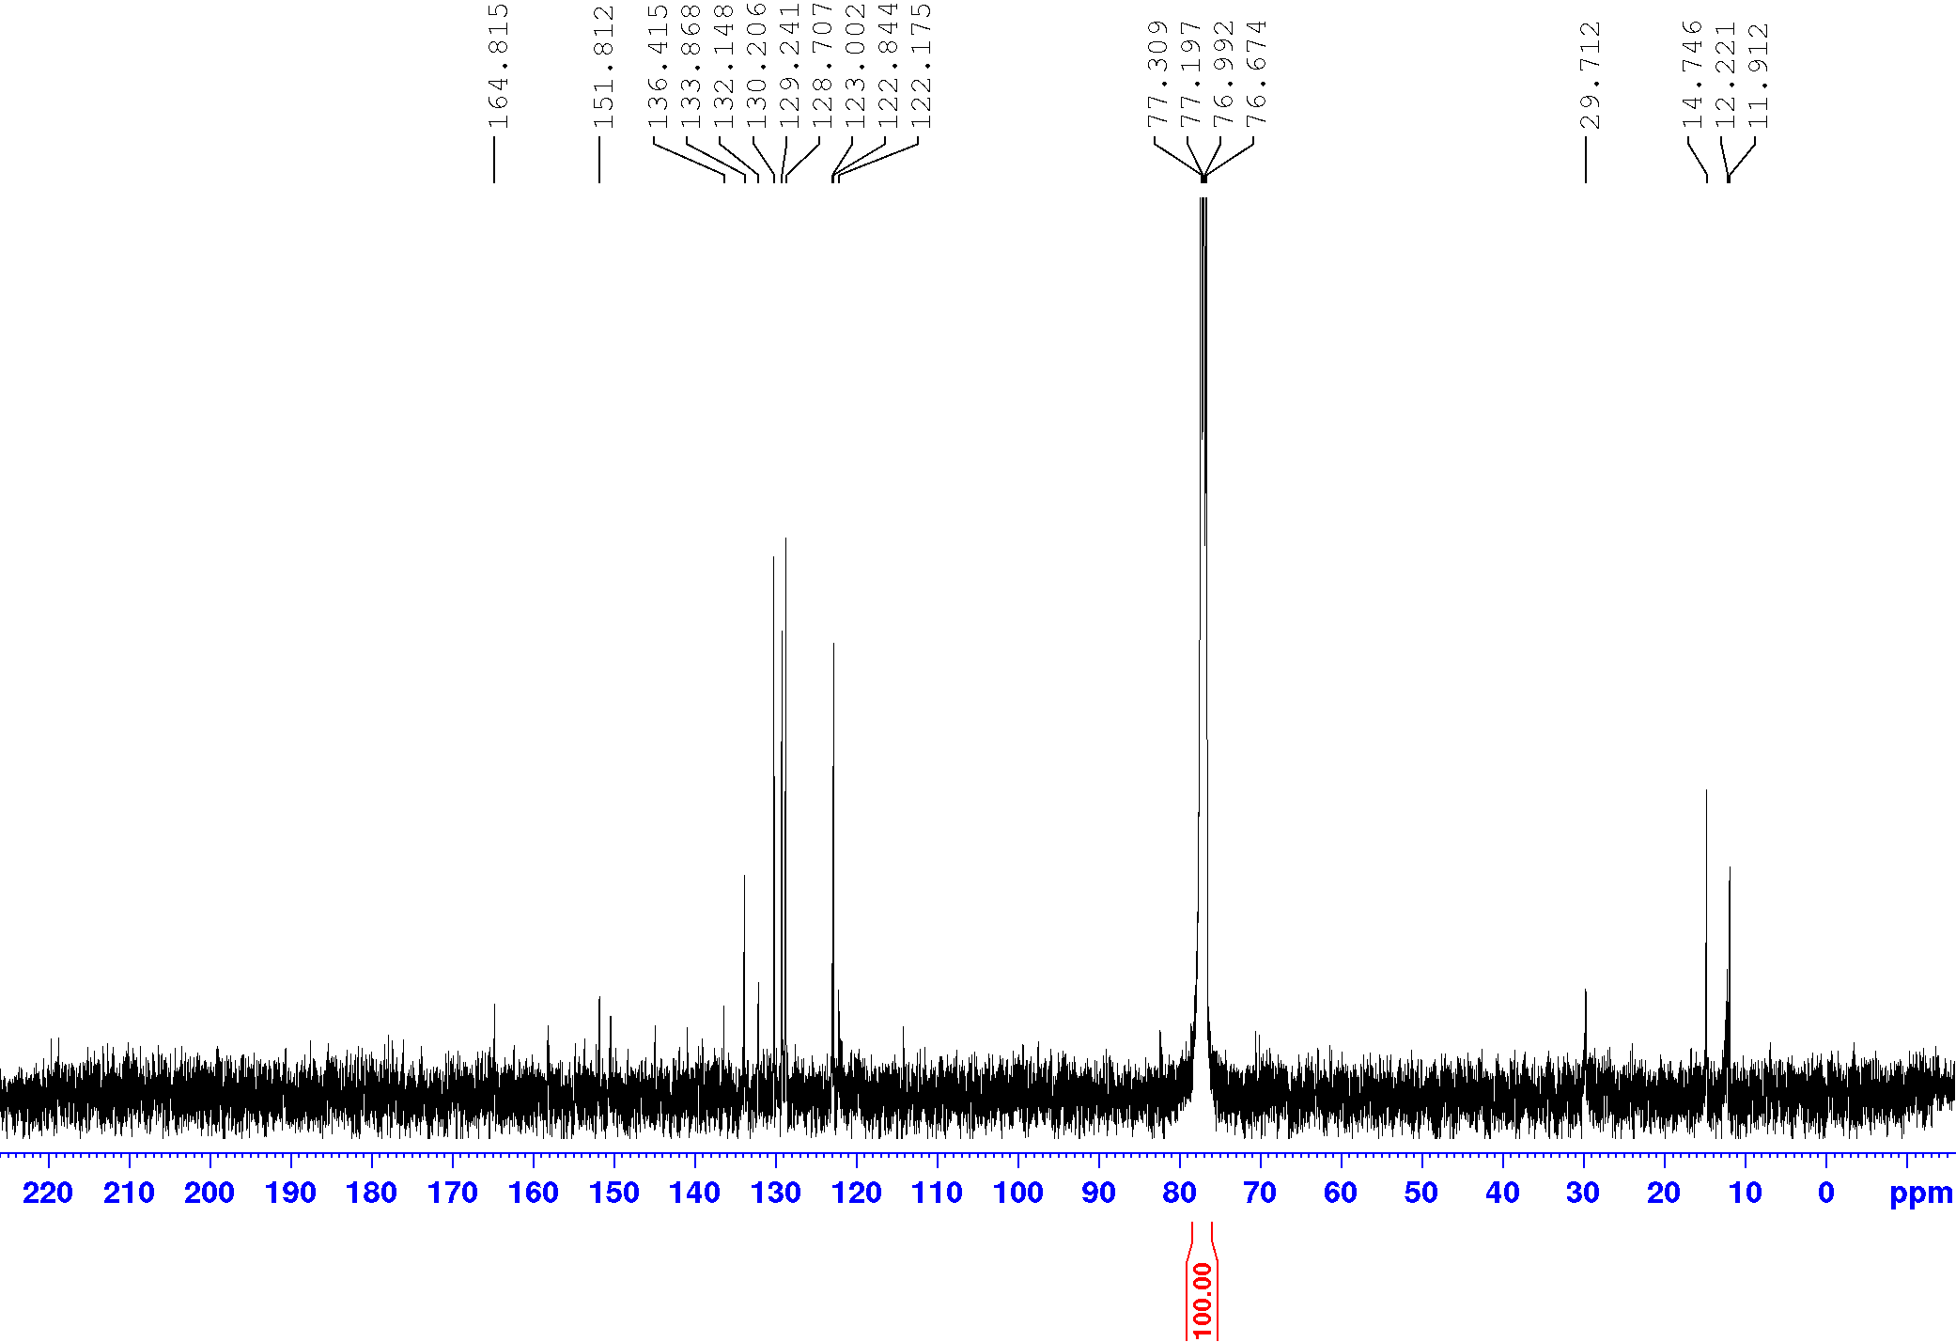
Figure S11. ¹³C-NMR (CDCl₃, 100 MHz) spectra of Ph-Est-BDP-Cl (7)

Ph-Est-BDP (6)
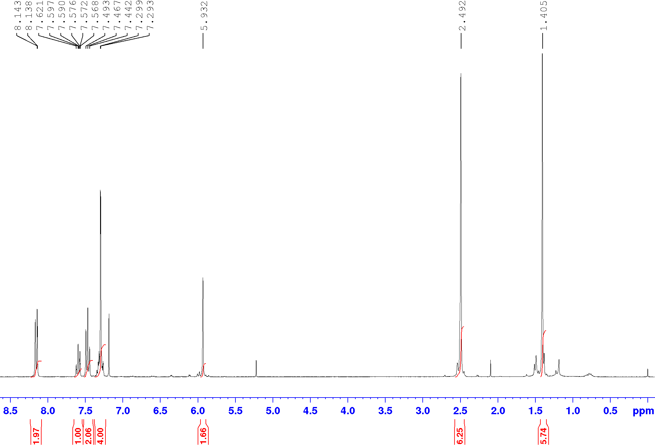
Figure S12. ¹H-NMR (CDCl₃, 400 MHz) spectra of Ph-Est-BDP (6)

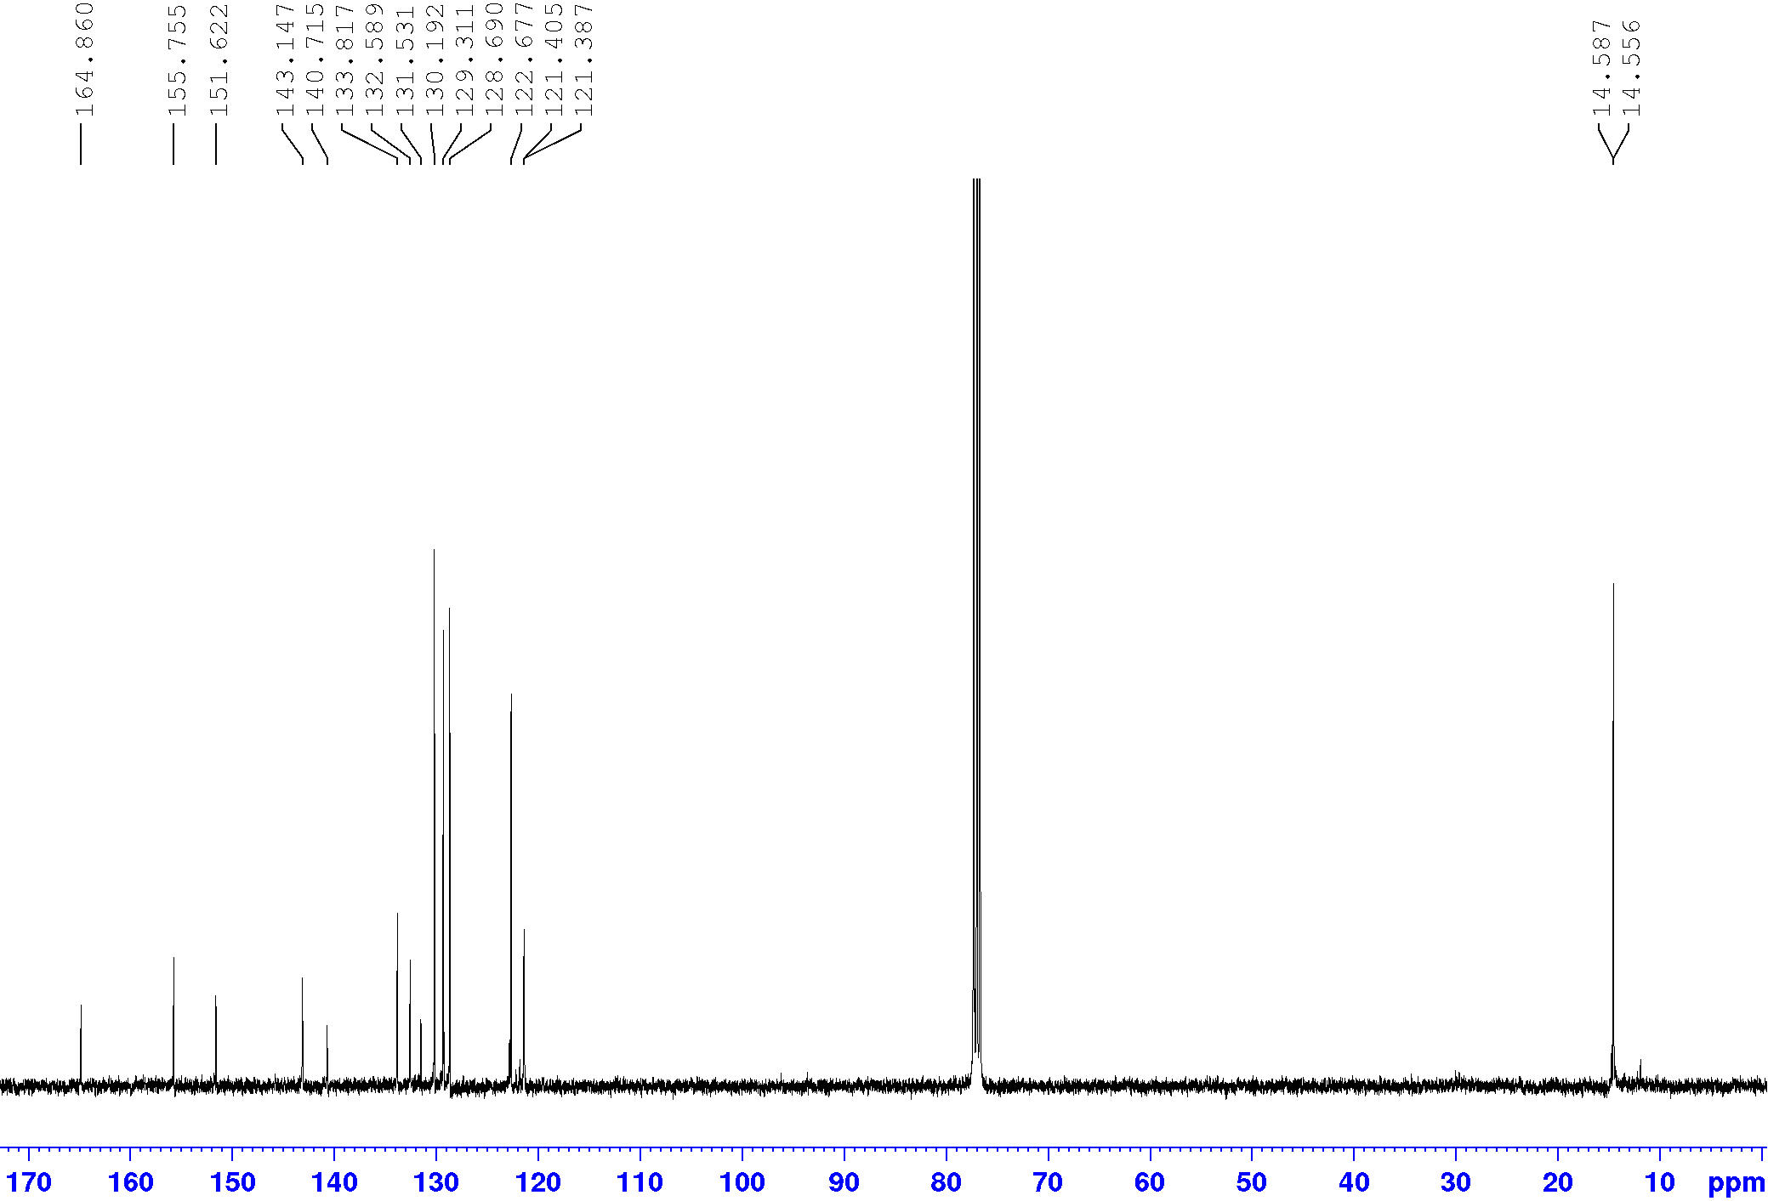
Figure S13. ¹³C-NMR (CDCl₃, 100 MHz) spectra of Ph-Est-BDP (6)

Solid-State Cross-Polarisation Magic Angle Spinning ¹³C-NMR spectra

PS-COH – Formyl polystyrene resins starting material (2)

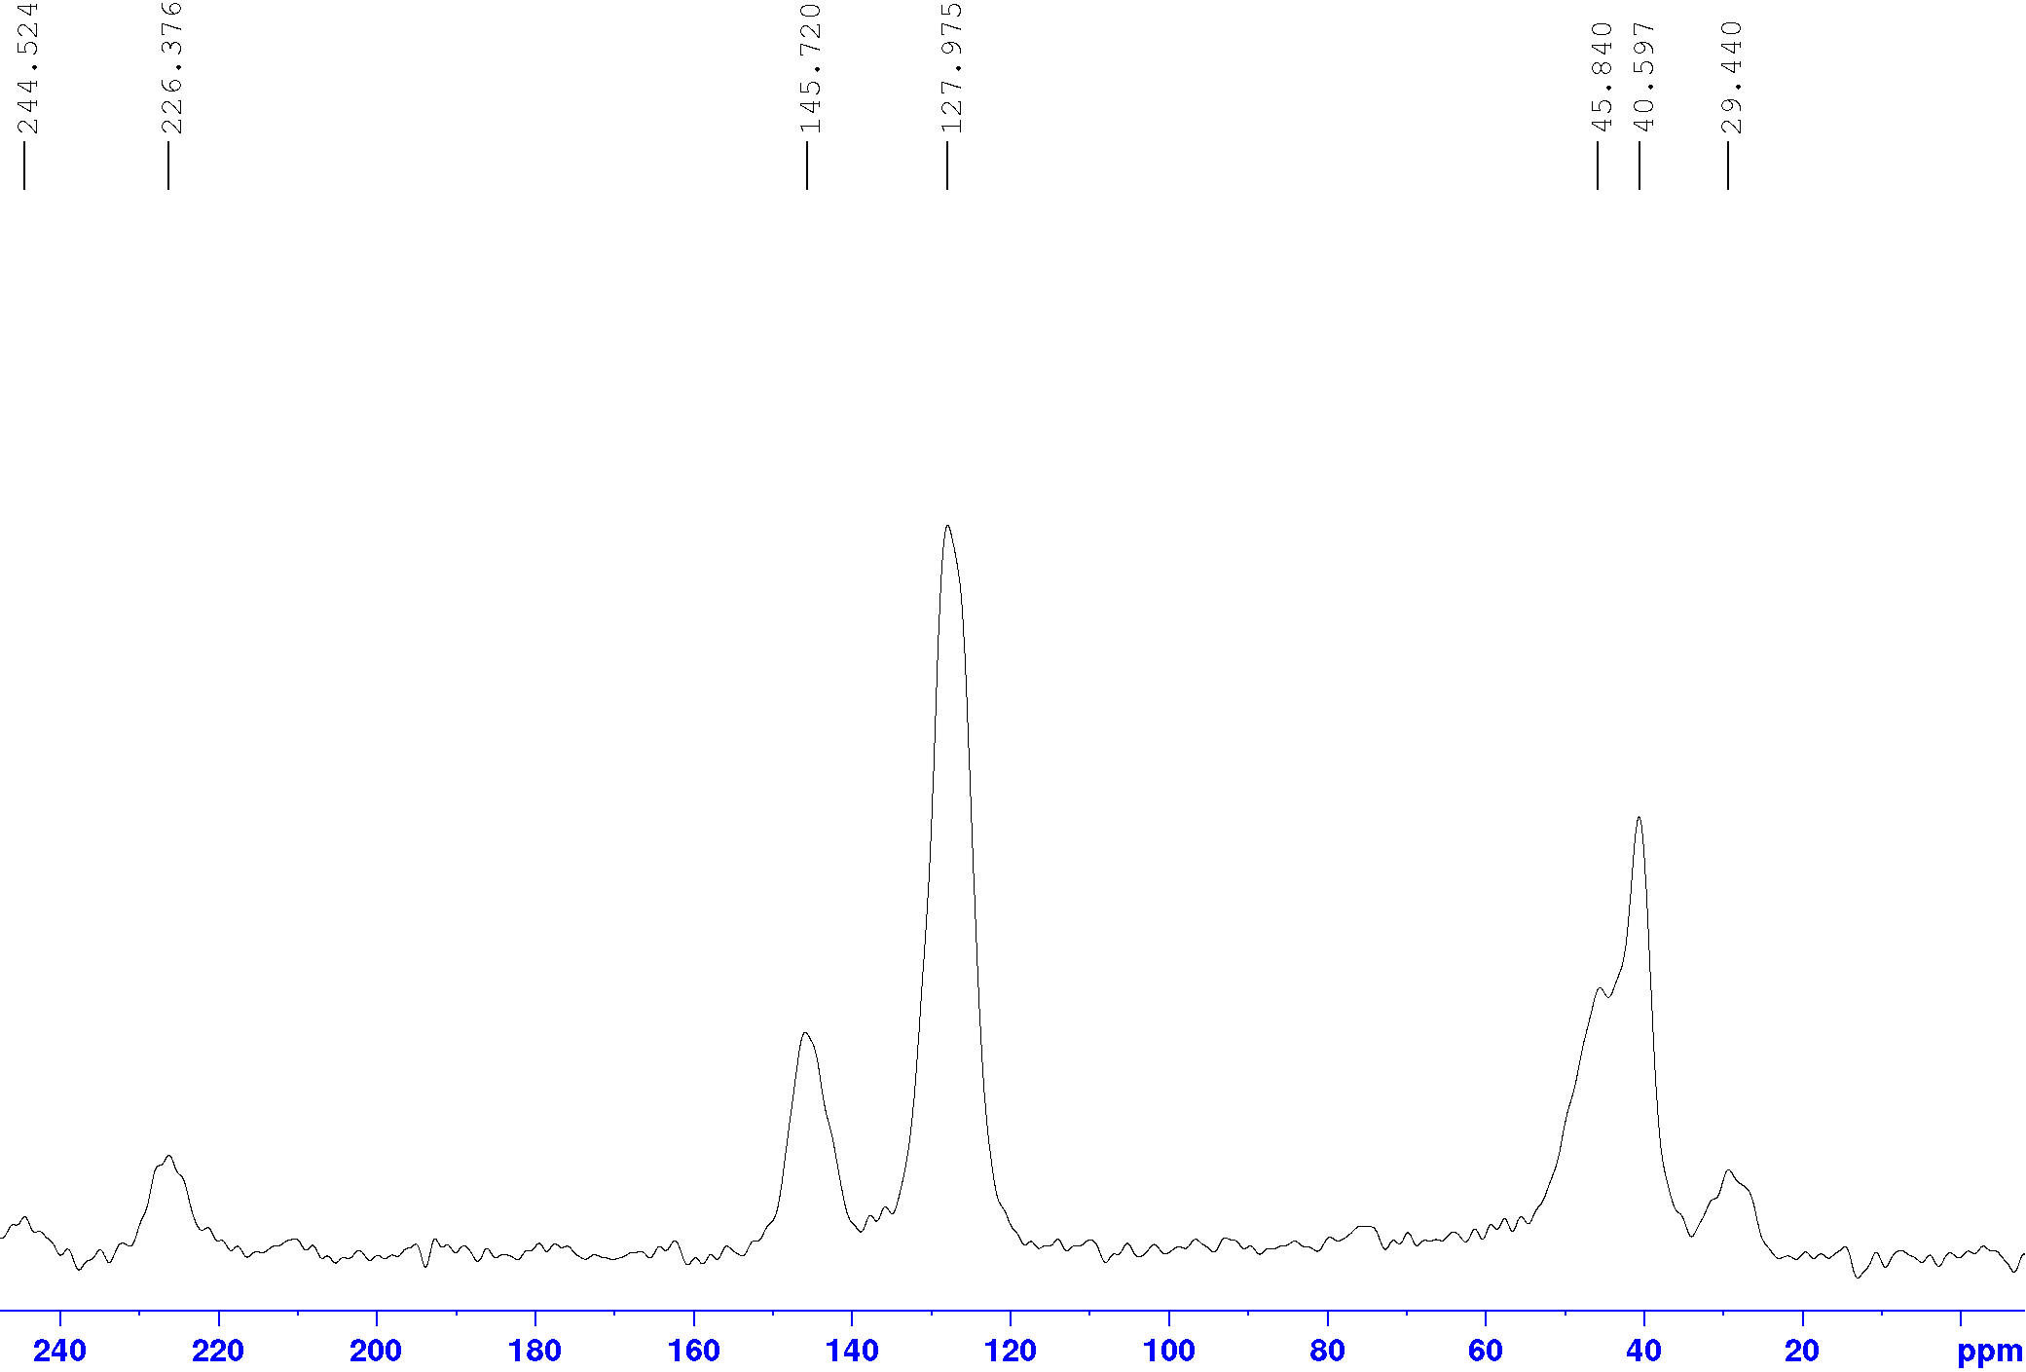
Figure S14. SS-CP-MAS-¹³C-NMR (100 MHz) spectra of Formyl (0.62 mmol/g) polystyrene resins starting material (PS-COH, 2).

PS-Est-BDP(Flow) (4)
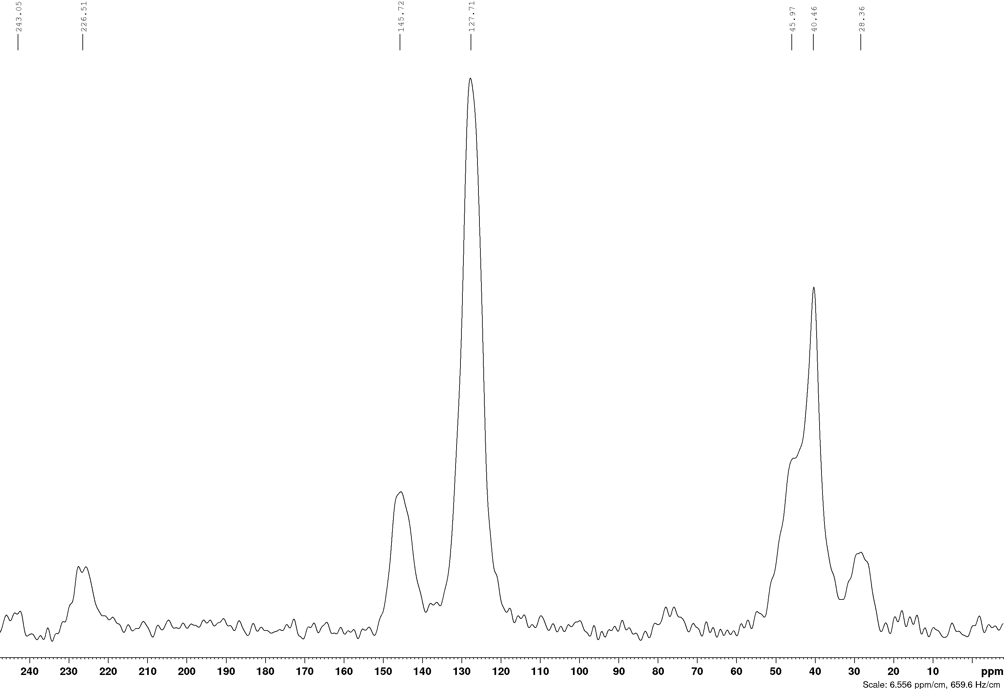
Figure S15. SS-CP-MAS-¹³C-NMR (100 MHz) spectra of PS-Est-BDP(Flow) (4).

PS-Est-BDP(Batch) (5)
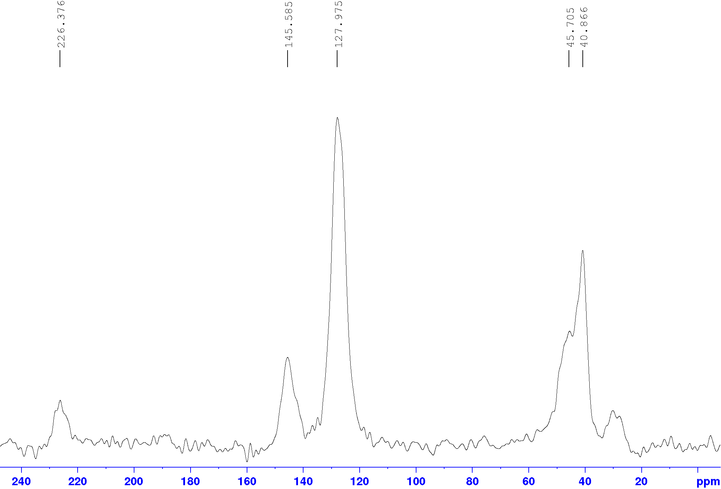
Figure S16. SS-CP-MAS-¹³C-NMR (100 MHz) spectra of PS-Est-BDP(Batch) (5).

PS-Est-BDP(Flow) (4) after 96 hours irradiation
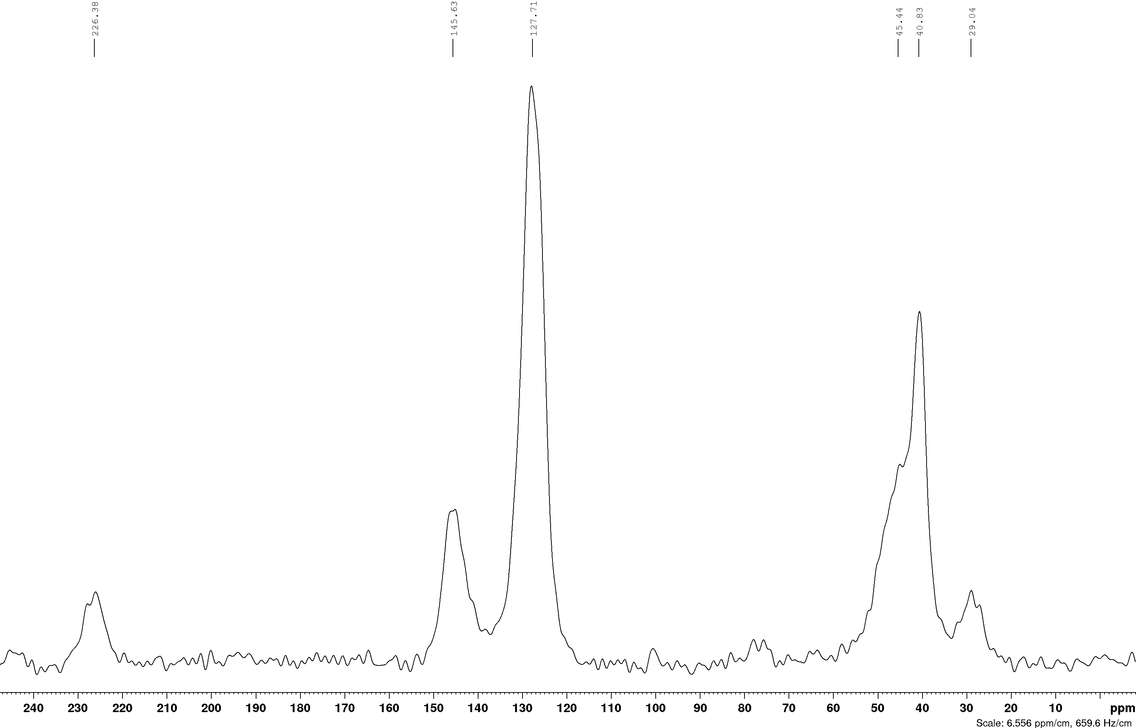
Figure S17. SS-CP-MAS-¹³C-NMR (100 MHz) spectra of PS-Est-BDP(Flow) (4) after 96 hours of singlet oxygen (heterogeneous, flow) reaction condition and irradiation.

Solution-State UV/Vis Spectra
Solution-state UV/Vis spectra were recorded at a fixed concentration of 1x10⁻⁵ M in CH₃CN solvent, with 10 mm quartz cuvettes between 350 and 800 nm wavelengths.
Figure S18. Solution-state UV/Vis absorption spectrum of BDP-PhOH (1) in CH₃CN (1x10⁻⁵ M).

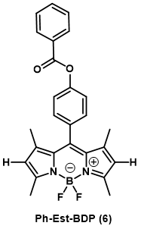
Figure S19. Solution-state UV/Vis absorption spectrum of Ph-Est-BDP (6) in CH₃CN (1x10⁻⁵ M).

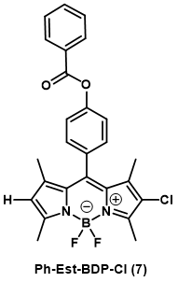
Figure S20. Solution-state UV/Vis absorption spectrum of Ph-Est-BDP-Cl (7) in CH₃CN (1x10⁻⁵ M).
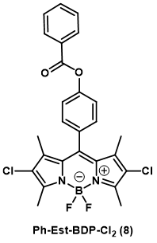
Figure S21. Solution-state UV/Vis absorption spectrum of Ph-Est-BDP-Cl₂ (8) in CH₃CN (1x10⁻⁵ M).

Figure S22. 2D-overlayed Solution-state UV/Vis absorption spectrum of homogeneous photosensitisers in CH₃CN (1x10⁻⁵ M).

Solution-State Emission Spectra
Solution-state UV/Vis spectra were recorded with 1 mL of 1x10⁻⁷ M CH₃CN solutions in sample vials between 490 and 800 nm wavelengths. The excitation wavelength was 475 nm.
Figure S22. Normalised solution-state emission spectrum of BDP-PhOH (1) in CH₃CN (1x10⁻⁷ M).

Figure S23. Normalised solution-state emission spectrum of Ph-Est-BDP (6) in CH₃CN (1x10⁻⁷ M).

Figure S24. Normalised solution-state emission spectrum of Ph-Est-BDP-Cl (7) in CH₃CN (1x10⁻⁷ M).

Figure S25. Normalised solution-state emission spectrum of Ph-Est-BDP-Cl₂ (8) in CH₃CN (1x10⁻⁷ M).

Figure S26. 2D-overlayed normalised Solution-state emission spectra of homogeneous photosensitisers in CH₃CN (1x10⁻⁷ M).

Photoluminesence Quantum Yield (PLQY)
The PLQY of the photosensitisers were measured using a calibrated spectrofluorometer (Edinburgh Instruments, FLS920) equipped with an integrating sphere (Jobin-Yvon). The FLS920 extended red sensitive detector (PMT; 200-1010nm) was used to measure sample emission and the excitation (Grating 750). A Xenon lamp was used for the excitation.The method and definition of PLQY used is:[3]

$$PLQY= \frac{\# photons emitted}{\# photons absorbed}= \frac{L_{sample}}{E_{reference} -E_{sample}}$$

L_{sample} = emission intensity
E_{reference} = Intensity of excitation light not absorbed by reference
E_{sample} = Intensity of excitation light not absorbed by the sample

The PLQY was measured using 1ml CH₃CN as a reference. Re-absorption correction was calculated by:
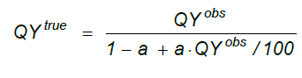
QY^{obs} = observed quantum yield
QY^{true} = true quantum yield
a = re-absorption correction factor

Table S1. Tabulated PLQY data
Sample  (Code) | PLQY (%) | Absorption (%) | Re-absorption correction (a) | Re-absorption correction PLQY (%)
BDP-PhOH 1  (C1) | 36.04029 | 67.60944754 | 0.351917212 | 46.50871433
Ph-Est-BDP 6  (C2) | 46.55592 | 45.52784497 | 0.277457649 | 54.6613664
Ph-Est-BDP-Cl 7 (C3) | 59.59526 | 40.40861537 | 0.231643763 | 65.74904565
Ph-Est-BDP-Cl₂ 8 (C4) | 63.04977 | 11.46887981 | 0.16651106 | 67.18330629

Figure S27. 2D-overlayed Solution-state emission intensity spectra of homogeneous photosensitisers in CH₃CN (1x10⁻⁷ M), measured by photon counting with a fluorospectrometer.

Figure S28. 2D-overlayed solution-state absorption intensity spectra of homogeneous photosensitisers in CH₃CN (1x10⁻⁷ M) at the excitation wavelength of 475 nm, measured by photon counting with a fluorospectrometer. Reference is 1 mL of pure CH₃CN.

Solid-State UV/Vis Absorption Spectra
Samples of solid material were ground to a powder using a mortar and pestle and DCM as lubricant to soften the resins in order to analyse the material.
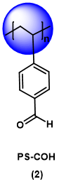
Figure S29. Solid-state absorption spectrum of formyl (0.62 mmol/g) polystyrene resins starting material (PS-COH) (2).

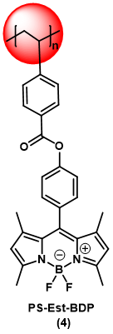
Figure S30. Solid-state absorption spectrum of PS-Est-BDP(Flow) resins (4).

Figure S31. Solid-state absorption spectrum of PS-Est-BDP(Flow) resins (4) after 96 hours of singlet oxygen (heterogeneous, flow) reaction conditions and irradiation.

Figure S32. Solid-state absorption spectrum of PS-Est-BDP(Batch) resins (5).

Figure S33. Solid-state absorption spectrum of PS-Est-BDP-Cl₂ resins (9).

Figure S34. 3D overlay of heterogeneous photosensitiser materials solid-state absorption spectra.

FT-IR Spectra

Figure S34. Transmission FT-IR spectrum of polystyrene film reference material.

Figure S35. Transmission FT-IR spectrum of formyl (0.62 mmol/g) polystyrene resins (1) starting material.
Figure S36. Transmission FT-IR spectrum of PS-Est-BDP(Flow) resins (4).

Figure S37. Transmission FT-IR spectrum of PS-Est-BDP(Flow) resins (4) after 96 hours of singlet oxygen (heterogeneous, flow) reaction conditions and irradiation.
Figure S38. Transmission FT-IR spectrum of PS-Est-BDP(Batch) resins (5).

Figure S39. Transmission FT-IR spectrum of PS-Est-BDP-Cl₂ resins (9).

Figure S40. 2D overlaid transmission FT-IR specta of heterogeneous materials. Spectra have been vertically displaced for clarity, blue boxes indicate carbonyl and aromatic regions of interest.
Figure S41. 2D overlaid transmission FT-IR specta of heterogeneous materials, expanded to show carbonyl and aromatic regions of interest. Spectra have been vertically displaced for clarity.

Single Crystal X-Ray Diffraction
Ph-Est-BDP was obtained as orange platelets and found to be the same Fdd2 space group and orthorhombic unit cell as reported by Giordani et al.[2] The Ph-Est-BDP-Cl₂ crystal molecules pack in a ‘head-to-tail’ regime with parallel-displaced π-stacking of the phenyl ester tail with either the C2 or C8 carbon of the pyrrole rings acting as the dominant interaction. Additional orthogonal halogen interactions are observed between Cl and phenyl hydrogens and weak Cl-π interactions. The Ph-Est-BDP-Cl crystal had disorder, as the chlorine atom was disordered over two sites in an 81:19 ratio. The molecules again packed in a ‘head-to-tail’ regime, but the dominant interaction was now parallel-displaced π-stacking of the BDP cores and phenyl-to-carbonyl hydrogen bonding. Both Ph-Est-BDP-Cl₂ and Ph-Est-BDP-Cl conform to a γ-stacking motif, commonly observed with crystal structures of polycyclic aromatic hydrocarbons.[4]

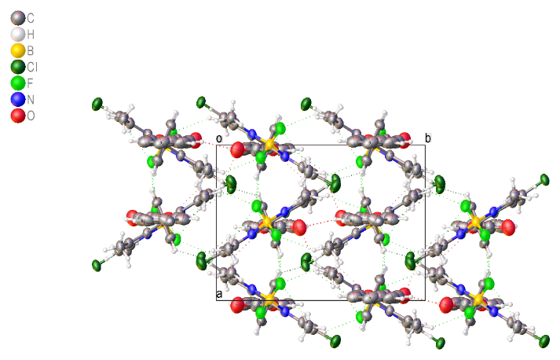
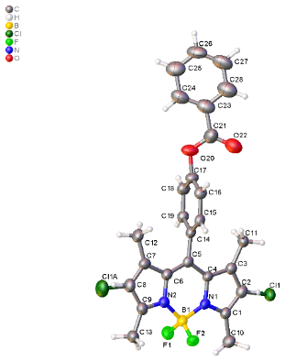
Ph-Est-BDP-Cl (7)

Figure S42. Single crystal X-ray diffraction solved structure of Ph-Est-BDP-Cl, with unit cell stacking viewed down the c axis.

Table 1 Crystal data and structure refinement for Ph-Est-BDP-Cl.
Identification code | Ph-Est-BDP-Cl
Empirical formula | C₂₆H₂₂BClF₂N₂O₂
Formula weight | 478.71
Temperature/K | 100.0
Crystal system | monoclinic
Space group | P2₁/n
a/Å | 9.8223(4)
b/Å | 13.1261(4)
c/Å | 17.6812(6)
α/° | 90
β/° | 95.747(2)
γ/° | 90
Volume/Å³ | 2268.15(14)
Z | 4
ρ_{calc}g/cm³ | 1.402
μ/mm⁻¹ | 1.866
F(000) | 992.0
Crystal size/mm³ | 0.12 × 0.1 × 0.04
Radiation | CuKα (λ = 1.54178)
2Θ range for data collection/° | 8.404 to 144.768
Index ranges | -12 ≤ h ≤ 12, 0 ≤ k ≤ 16, 0 ≤ l ≤ 21
Reflections collected | 37666
Independent reflections | 4371 [R_{int} = 0.0999, R_{sigma} = 0.0692]
Data/restraints/parameters | 4371/0/322
Goodness-of-fit on F² | 1.044
Final R indexes [I>=2σ (I)] | R₁ = 0.0867, wR₂ = 0.2235
Final R indexes [all data] | R₁ = 0.1236, wR₂ = 0.2513
Largest diff. peak/hole / e Å⁻³ | 1.28/-0.49
Experimental
Single crystals of C₂₆H₂₂BClF₂N₂O₂ [Ph-Est-BDP-Cl] were [grown by slow evaporation of acetone solvent]. A suitable crystal was selected and [mounted] on a Bruker D8Venture diffractometer. The crystal was kept at 100.0 K during data collection. Using Olex2 [1], the structure was solved with the ShelXT [2] structure solution program using Intrinsic Phasing and refined with the ShelXL [3] refinement package using Least Squares minimisation.
- Dolomanov, O.V., Bourhis, L.J., Gildea, R.J, Howard, J.A.K. & Puschmann, H. (2009), J. Appl. Cryst. 42, 339-341.
- Sheldrick, G.M. (2015). Acta Cryst. A71, 3-8.
- Sheldrick, G.M. (2015). Acta Cryst. C71, 3-8.
Crystal structure determination of [Ph-Est-BDP-Cl]
Crystal Data for C₂₆H₂₂BClF₂N₂O₂ (M =478.71 g/mol): monoclinic, space group P2₁/n (no. 14), a = 9.8223(4) Å, b = 13.1261(4) Å, c = 17.6812(6) Å, β = 95.747(2)°, V = 2268.15(14) Å³, Z = 4, T = 100.0 K, μ(CuKα) = 1.866 mm⁻¹, Dcalc = 1.402 g/cm³, 4371 reflections measured (8.404° ≤ 2Θ ≤ 144.768°), 4371 unique (R_{int} = ?, R_{sigma} = 0.0692) which were used in all calculations. The final R₁ was 0.0867 (I > 2σ(I)) and wR₂ was 0.2513 (all data).

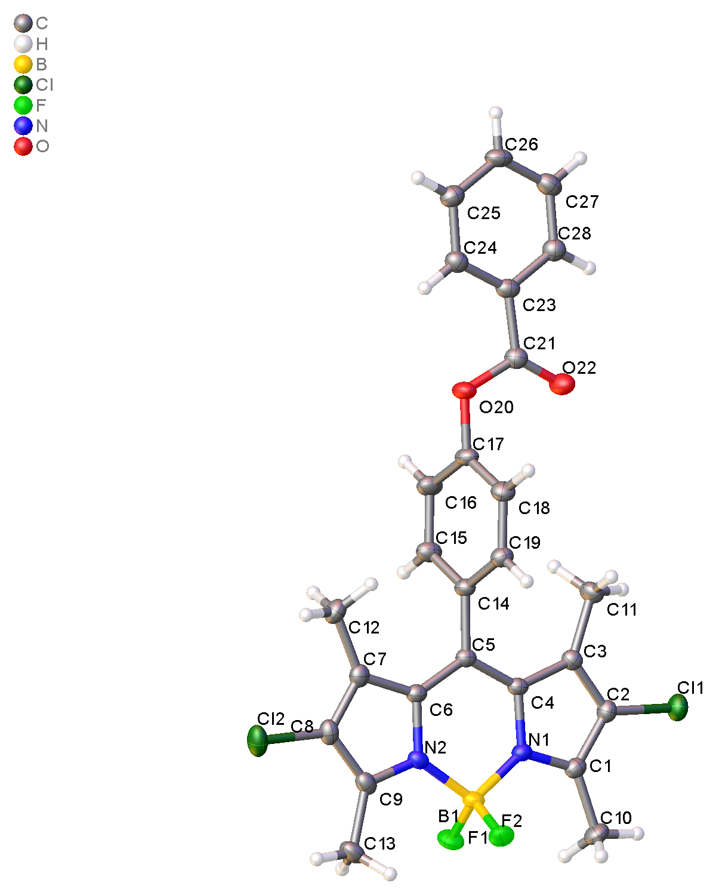
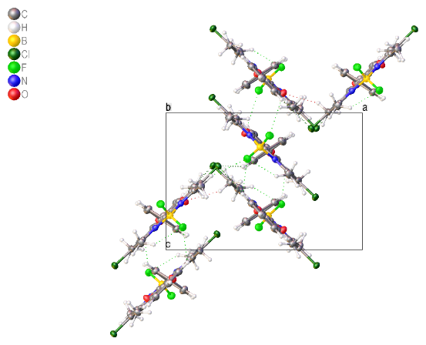
Ph-Est-BDP-Cl₂ (8)

Figure S43. Single crystal X-ray diffraction solved structure of Ph-Est-BDP-Cl₂, with unit cell stacking viewed down the b axis.

Table 1 Crystal data and structure refinement for Ph-Est-BDP-Cl2.
Identification code | Ph-Est-BDP-Cl2
Empirical formula | C₂₆H₂₁N₂O₂BF₂Cl₂
Formula weight | 513.16
Temperature/K | 100.0
Crystal system | orthorhombic
Space group | Pccn
a/Å | 13.6676(3)
b/Å | 35.7671(8)
c/Å | 9.6387(2)
α/° | 90
β/° | 90
γ/° | 90
Volume/Å³ | 4711.88(18)
Z | 8
ρ_{calc}g/cm³ | 1.447
μ/mm⁻¹ | 2.856
F(000) | 2112.0
Crystal size/mm³ | 0.5 × 0.1 × 0.08
Radiation | CuKα (λ = 1.54178)
2Θ range for data collection/° | 4.942 to 149.55
Index ranges | -15 ≤ h ≤ 17, -44 ≤ k ≤ 44, -12 ≤ l ≤ 12
Reflections collected | 62450
Independent reflections | 4820 [R_{int} = 0.0515, R_{sigma} = 0.0219]
Data/restraints/parameters | 4820/0/320
Goodness-of-fit on F² | 1.052
Final R indexes [I>=2σ (I)] | R₁ = 0.0392, wR₂ = 0.1092
Final R indexes [all data] | R₁ = 0.0442, wR₂ = 0.1140
Largest diff. peak/hole / e Å⁻³ | 0.85/-0.44
Single crystals of C₂₆H₂₁N₂O₂BF₂Cl₂ [Ph-Est-BDP-Cl2] were [grown by slow evaporation of acetone solvent]. A suitable crystal was selected and [mounted] on a 'Bruker D8Venture' diffractometer. The crystal was kept at 100.0 K during data collection. Using Olex2 [1], the structure was solved with the ShelXT [2] structure solution program using Intrinsic Phasing and refined with the ShelXL [3] refinement package using Least Squares minimisation.
- Dolomanov, O.V., Bourhis, L.J., Gildea, R.J, Howard, J.A.K. & Puschmann, H. (2009), J. Appl. Cryst. 42, 339-341.
- Sheldrick, G.M. (2015). Acta Cryst. A71, 3-8.
- Sheldrick, G.M. (2015). Acta Cryst. C71, 3-8.
Crystal structure determination of [Ph-Est-BDP-Cl2]
Crystal Data for C₂₆H₂₁N₂O₂BF₂Cl₂ (M =513.16 g/mol): orthorhombic, space group Pccn (no. 56), a = 13.6676(3) Å, b = 35.7671(8) Å, c = 9.6387(2) Å, V = 4711.88(18) Å³, Z = 8, T = 100.0 K, μ(CuKα) = 2.856 mm⁻¹, Dcalc = 1.447 g/cm³, 62450 reflections measured (4.942° ≤ 2Θ ≤ 149.55°), 4820 unique (R_{int} = 0.0515, R_{sigma} = 0.0219) which were used in all calculations. The final R₁ was 0.0392 (I > 2σ(I)) and wR₂ was 0.1140 (all data).

In-line Benchtop NMR Spectrometer
A 60 MHz benchtop NMR spectrometer (NMReady 60e, Nanalysis Corp.) was incorporated to our flow system using the flow-kit accessory and kinetics package for in-line reaction monitoring to optimise our process conditions. Reactions procedures were identical to the heterogeneous and heterogeneous flow procedures described in section S5, with the exception of using deuterated chloroform as the reaction solvent. The benchtop NMR was place in the flow system between the solution flow pump (pump A) and the T-junction, to prevent air from distorting the data collected (figure S. Data collection was performed using the kinetics experiment function, with experiments generally lasting between 1-8 hours at a time. After each experiment, the flow kit was disassembled, and the instrument was calibrated and shimmed using a built in ‘auto-shimming’ function to reduce line broadening using a solvent standard provided with the instrument. Spectra were recorded as ‘clusters’ of typically 4 scans with a 2 second relaxation time and 2048 data points, centred at 6 ppm with a range of 4 ppm (8-4 ppm).
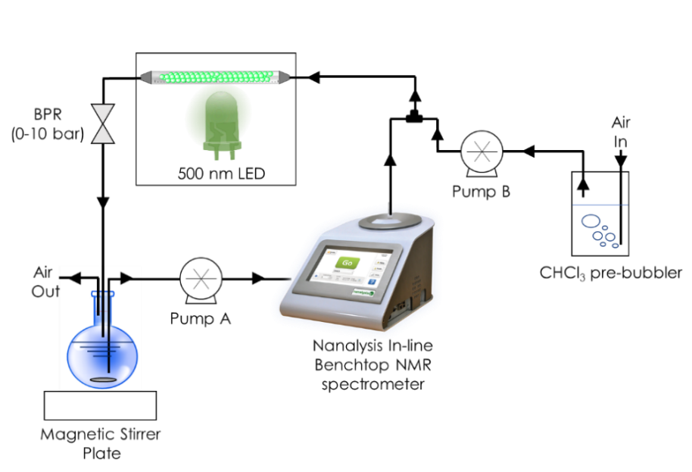
Figure S44. Heterogeneous flow photosensitisation reaction flow diagram with in-line Nanalysis Corp. benchtop NMR spectrometer.

Data was processed using MestReNova NMR processing software. Typically, raw data was apodized with an exponential function of 3.00 Hz and a sine square function of 2.00 º simultaneously. Phasing was corrected using the automatic power function setting before automatic baseline correction. The full range stacked raw data spectrum of an example homogeneous reaction before and after processing is displayed below (figure S45 & S46)

Figure S45. Homogeneous photosensitisation reaction monitored by in-line ¹H-NMR spectroscopy showing the raw collected data before apodization and phase correction. Reaction conditions: terpinene (1 mmol), CDCl₃ (15 mL), Ph-Est-BDP (1 mol%), flow (solution 1 mL/min, air 1 mL/min). four scans collected every 228.612 seconds for 160 clusters.

Figure S46. The same Homogeneous photosensitisation reaction monitored by in-line ¹H-NMR spectroscopy after apodization and phase correction specified above.

Conversion was analysed by producing integration tables of the regions from 5.75-5.25 ppm (terpinene) and 6.65-6.20 ppm (ascaridole). The two BDP sp² C-H protons signal can be observed at 6.00 ppm. Samples were periodically taken and analysed with a Bruker AVIII 300 spectrometer at 300.1 MHz for reference. An example of a sample ran on the benchtop NMR and and Bruker AVIII 300 spectrometer after processing is displayed below (figure S47 and S48). The benchtop NMR underestimates the true conversion by 9% as impurity peaks are included in the integration because of the broad signals collected at 60 MHz, however, these signals are constant and do not effect the rate of conversion obtained from kinetic runs.
Figure S47. Homogeneous photosensitisation reaction monitored by in-line ¹H-NMR spectroscopy after apodization and phase correction specified above. Reaction conditions: terpinene (1 mmol), CDCl₃ (15 mL), Ph-Est-BDP (1 mol%), flow (solution 1 mL/min, air 1 mL/min). four scans collected after 180 minutes, manually and not with a kinetics experiment. Conversion is calculated as 60.6%
Figure S48. The same Homogeneous photosensitisation reaction monitored by in-line ¹H-NMR spectroscopy after apodization and phase correction specified above. Reaction conditions: terpinene (1 mmol), CDCl₃ (15 mL), Ph-Est-BDP (1 mol%), flow (solution 1 mL/min, air 1 mL/min). four scans collected after 180 minutes, manually and not with a kinetics experiment. Conversion is calculated as 69.0%

References
1. Ali Coskun, Erhan Deniz, and & Akkaya*, E. U. Effective PET and ICT Switching of Boradiazaindacene Emission: A Unimolecular, Emission-Mode, Molecular Half-Subtractor with Reconfigurable Logic Gates. (2005). doi:10.1021/OL052020H
2. Bartelmess, J. et al. Boron dipyrromethene (BODIPY) functionalized carbon nano-onions for high resolution cellular imaging. Nanoscale 6, 13761–13769 (2014).
3. MacDougall, S. K. W., Ivaturi, A., Marques-Hueso, J., Krämer, K. W. & Richards, B. S. Ultra-high photoluminescent quantum yield of β-NaYF4: 10% Er3+ via broadband excitation of upconversion for photovoltaic devices. Opt. Express 20, A879–A887 (2012).
4. Campbell, J. E., Yang, J. & Day, G. M. Predicted energy-structure-function maps for the evaluation of small molecule organic semiconductors. J. Mater. Chem. C 5, 7574–7584 (2017).

