Supplementary Material

Enantioselective Catalytic Strecker Reaction on Cyclic (Z)-Aldimines in Flow: Reaction Optimization and
Sustainability Aspects

Antonella Ilenia Alfano,ª Andrea Sorato,^{b} Alessia Ciogli,^{b} Heiko Lange^{c,}* and Margherita Brindisi ^{a,}*
ª SPOTS-Lab – Sustainable Pharmaceutical and Organic Technology and Synthesis Laboratory, Department of Pharmacy, University of Naples Federico II, Via D. Montesano 49, 80131 Naples, Italy
^{b} Department of Drug Chemistry and Technologies, Sapienza University of Rome, P.le A. Moro 5, 00185 Rome, Italy.
^{c} VaLiCell Lab – Laboratory for the Valorisation of Lignocellulosics, Department of Earth and Environmental Sciences, University of Milano-Bicocca, Piazza della Scienza 1, 20126, Milan, Italy.

*To whom correspondence should be addressed: margherita.brindisi@unina.it , heiko.lange@unimib.it

General remarks
Unless otherwise specified, materials were purchased from commercial suppliers and used without further purification. TLC analysis was conducted using aluminum foil supported thin-layer silica gel chromatography plates (F254 indicator). Column chromatography was performed using 230–400 mesh, 60 Å pore diameter silica gel. For ¹H NMR and ¹³C NMR measurements an accurately weighed amount of analyte (about 5.0–10.0 mg) was dissolved in 600 μL of deuterated chloroform (CDCl₃) or dimethyl sulfoxide (DMSO-d₆). The mixture was transferred into a 5 mm NMR tube and the spectra were acquired on a Bruker Advance 400 MHz spectrometer by using the residual signal of the deuterated solvent as internal standard. Splitting patterns are described as singlet (s), doublet (d), triplet (t), quartet (q) and broad (br); the values of chemical shifts (δ) are given in ppm and coupling constants (J) in Hertz (Hz). NMR data were processed with MestreNova (Version 8.1.1, Mestrelab Research). ESI-MS spectra analysis was carried out on a mass spectrometer LTQ-XL.
The absolute configuration of all compounds was assigned upon comparison with previous reports. [1] Optical rotation values were measured at room temperature operating at λ = 589 nm, corresponding to the sodium D line, and were determined in a Jasco P-200 (Jasco Europe s.r.l., Cremella, Italy) polarimeter using a microcell (1 mg sensitivity) containing the compound dissolved in 1 mL of chloroform.

HPLC analysis
Two HPLC systems are used: the first one in the optimization procedure, the second during the evaluation of reaction scope. In the reaction optimization step, high performance liquid chromatography (HPLC) analyses were performed on Waters Model 510 pump equipped with a 7725i Rheodyne 20 µL injector, and a Waters 2984 UV detector. Two chiral columns (Lux® 5µm Cellulose-1 Chiral HPLC Column, 250 x 4.6 mm or Lux® 5 µm Amilose-3 Chiral HPLC Column, 250 x 4.6 mm were used) were used and the UV detection was monitored at 254 nm.

The second chromatograph consisted of a Jasco PU 980 pump equipped with a universal Rheodyne 20 µL injector and connected to a Jasco UV975 detector. Chiralpak IC 3µm (250 x 4.6 mm) was used as chiral column and detection was recorded at 254 nm.

Retention times of single enantiomer were compared with those obtained analyzing racemic mixture.
Chemical synthesis
Synthesis of starting material indolenine (15a-f) in flow and batch mode [2]
Synthesis in flow. Chemical transformations in flow were realized using a self-made flow reactor: one Waters P510 HPLC pumps were connected to a Rheodyne 9010 injection valve, equipped with a 1 mL sample loop made from PTFE tubing and an injection port for disposable syringe. The injection valve was further connected to a coiled PTFE tubing of 15 mL volume. The coil was immersed in a silicon oil bath for controlling reaction temperatures. The tubular reactor finished into a back pressure regulator (BPR), which was either spring mechanism-based (6.7 bar) or simply a PEEK capillary of defined length (1.7 bar). Product containing exiting streams were collected directly in a flask. Reagents were prepared for loading into the sample loops (SL) according to the following method: 0.25 mmol aldehyde + 0.25 mmol PhNHNH₂ ⋅ HCl in 1 mL of EtOH, heated to 50 °C for 5 min prior to loading into the SL; SL B: 1.2 equiv. HCl in 1 mL of EtOH.
Synthesis in batch. A mixture of phenylhydrazine (HCl salt, 0.25 mmol) and aldehyde (30 µL, 0.25 mmol) was treated with HCl (150 µL, 0.3 mmol). Next, the reaction mixture was gradually poured into saturated aqueous NaHCO₃ (100 mL) and extracted with EtOAc (5 × 2 mL). Combined organic extracts were washed with brine, dried with Na₂SO₄, and used without purification.
Synthesis of catalyst (8R,9S)-14b.
The synthesis of catalyst (8R,9S)-14b was performed according to literature procedures. [3-5]
Synthesis of Strecker product racemic 17 in batch (General procedure A)
To a flame dried reaction vial equipped with a magnetic stirring bar were added powdered 3 Å molecular sieves. The molecular sieves were thermally activated under vacuum for 30 min, and cooled to 10 °C under nitrogen. To the reaction vial were added spiroindolenine 15a (15 mg, 0.08 mmol), dry 1,2-dichloroethane (1.0 mL), ethyl cyanoformate 16 (9 µL, 1.1 equiv.), and methanol (5 µL, 1.1 equiv.). The resulting mixture was stirred at 10 °C for 72 h, and directly charged onto silica gel. Product 17 was isolated using petroleum ether/ethyl acetate 95:5 as eluent.
Synthesis of Strecker product 17 in batch (General procedure B)
To a flame dried reaction vial equipped with a magnetic stirring bar were added powdered 3 Å molecular sieves. The molecular sieves were thermally activated under vacuum for 30 min and cooled to 10 °C under nitrogen. To the reaction vial were added spiroindolenine 15a (15 mg, 0.08 mmol), catalyst (8R,9R)-14a, (8R,9S)-14a or (8R,9S)-14b (10 mol%), dry 1,2-dichloroethane (1.0 mL), ethyl cyanoformate 16 (9 µL, 1.1 equiv.), and methanol (5 µL, 1.1 equiv.). The resulting mixture was stirred at 10 °C for 72 h, and directly charged onto silica gel. Product 17 was isolated using petroleum ether/ethyl acetate 95:5 as eluent.
Synthesis of Strecker product 17-22 in flow (General procedure C)
Chemical transformations in flow were realized using a self-made flow reactor: a Waters P510 HPLC pump was connected to a Rheodyne 9010 injection valve, equipped with a 1 mL sample loop made from PTFE tubing and an injection port for disposable syringes. The injection valve was further connected to a coiled PTFE tubing of 25 mL volume. The coil was immersed in a water bath for controlling reaction temperatures. The tubular reactor finished into a mechanical back pressure regulator (BPR) of approx. 7 bar. Product containing exiting streams were collected directly in a flask. Crude products were purified over silica gel using petroleum ether/ethyl acetate. In detail, a solution of spiroindolenine 15a-f (0.08 mmol), ethyl cyanoformate (1.3 equiv.), the suitable catalyst (8R,9R)-14a, (8R,9S)-14a or (8R,9S)-14b (10 or 20 mol%) and methanol (1.3 equiv.) was prepared in 1,2-dichloroethane (1 mL total solution volume). The flow reactor was cooled to 10 °C using at a total flow rate of 0.2 mL/min to move the reaction mixture through the coil reactor for a residence time of 125 min.
NMR analyses
¹H NMR measurements. An accurately weighed amount of analyte (about 5.0 mg) was dissolved in 600 μL of deuterated chloroform (CDCl₃) or deuterated dimethylsulfoxide (DMSOd₆). The mixture was transferred into a 5 mm NMR tube. The spectra were acquired on a Bruker 400 MHz spectrometer using the standard Bruker zg sequence (32 scans at 20 °C). NMR data were processed with MestreNova (version 8.1.1, Mestrelab Research).
¹³C NMR measurements. An accurately weighed amount of analyte (about 5.0 mg) was dissolved in 600 μL of deuterated chloroform (chloroform-d) or deuterated dimethylsulfoxide (DMSO-d₆). The mixture was transferred into a 5 mm NMR tube. The spectra were acquired on a Bruker 400 MHz spectrometer using the standard Bruker zgpg30 sequence (3072 scans at 20 °C). NMR data were processed with MestreNova (version 8.1.1, Mestrelab Research).

Spiro[cyclohexane-1,3'-indoline]-2'-carbonitrile (rac-17)
According to general procedure A, a solution of spiroindolenine 15a (15 mg, 0.08 mmol), ethyl cyanoformate (9 µL, 1.3 equiv.) and methanol (5 µL, 1.3 equiv.) was prepared in 1,2-dichloroethane (1 mL total solution volume). Product rac-17 was isolated using petroleum ether/ethyl acetate 95:5 as eluent.
¹H NMR (700 MHz, Chloroform-d) δ 7.01-1.97 (m, 2H), 6.76 (t, J = 7.4 Hz, 1H), 6.61 (d, J = 7.9 Hz, 1H), 4.38 (s, 1H), 4.10 (s, 1H), 2.08 (d, J = 14.6 Hz, 1H), 1.90 – 1.87 (m, 1H), 1.79 (d, J = 11.0, 1H), 1.73 (d, J = 12.9 Hz, 1H), 1.65 (d, J = 10.4 Hz, 2H), 1.34- 1.25 (m, 4H).
¹³C NMR (176 MHz, Chloroform-d) δ 147.16, 135.03, 128.32, 122.88, 120.45, 119.53, 110.52, 57.12, 49.76, 35.50, 32.92, 25.36, 23.17 (2).

Spiro[cyclohexane-1,3'-indoline]-2'-carbonitrile (+)-17
According to general procedure C, a solution of spiroindolenine 15a (15 mg, 0.08 mmol), ethyl cyanoformate (9 µL, 1.3 equiv.), catalyst (R)-14a (10 mol%) and methanol (5 µL, 1.3 equiv.) was prepared in 1,2-dichloroethane (1 mL total solution volume). Product (+)-17 was isolated using petroleum ether/ethyl acetate 95:5 as a white solid in 93% yield and 95:5 e.r.. The e.r. value was determined by chiral stationary phase HPLC analysis [Lux® 5µm Amylose-3 Chiral HPLC Column, 250 x 4.6 mm], eluent: n-hexane/2-propanol 80:20, 1.0 mL/min, λ = 254 nm, tr (minor) = 15.1 min, tr (major) = 26.4 min].
[α]²⁰ = + 37.38 (c 0.3, CHCl₃). ESI-MS m/z: [M + H]⁺ 213.1.
¹H NMR (700 MHz, Chloroform-d) δ 7.03- 1.98 (m, 2H), 6.77 (t, J = 7.4 Hz, 1H), 6.61 (d, J = 7.9 Hz, 1H), 4.40 (s, 1H), 4.06 (s, 1H), 2.10 (d, J = 14.6 Hz, 1H), 1.91 – 1.88 (m, 1H), 1.81 (d, J = 11.0 Hz, 1H), 1.73 (d, J = 12.9 Hz, 1H), 1.67 (d, J = 10.4 Hz, 2H), 1.36- 1.25 (m, 4H).

Spiro[cyclohexane-1,3'-indoline]-2'-carbonitrile (-)-17

According to general procedure C, a solution of spiroindolenine 15a (15 mg, 0.08 mmol), ethyl cyanoformate (9 µL, 1.3 equiv.), catalyst (S)-14a 10 mol%) and methanol (5 µL, 1.3 equiv.) was prepared in 1,2-dichloroethane (1 mL total solution volume). Product (-)-17 was isolated using petroleum ether/ethyl acetate 95:5 as a white solid in 92% yield and 85% ee from a reaction catalyzed by XC. The e.r. value was determined by chiral stationary phase HPLC analysis [Lux® 5µm Amylose-3 Chiral HPLC Column, 250 x 4.6 mm], eluent: n-hexane/2-propanol 80:20, 1.0 mL/min, λ = 254 nm, tr (minor) = 18.9 min, tr (major) = 37.7 min].
[α]²⁰ = -43.63 (c 0.3, CHCl₃); ESI-MS m/z: [M + H]⁺ 213.1.
¹H NMR (700 MHz, Chloroform-d) δ 7.02 – 6.99 (m, 2H), 6.75 (t, J = 7.4 Hz, 1H), 6.61 (d, J = 7.9 Hz, 1H), 4.40 (s, 1H), 4.08 (s, 1H), 2.10 (d, J = 14.6 Hz, 1H), 1.91 – 1.88 (m, 1H), 1.81 (d, J = 11.0 Hz, 1H), 1.73 (d, J = 12.9 Hz, 1H), 1.67 (d, J = 10.4 Hz, 2H), 1.37- 1.25 (m, 4H).

(S)-2',3',5',6'-Tetrahydrospiro[indoline-3,4'-pyran]-2-carbonitrile (+)-18
According to general procedure C, a solution of spiroindolenine 15b (15 mg, 0.08 mmol), ethyl cyanoformate (9 µL, 1.3 equiv.), catalyst (R)-14a (10 mol%) and methanol (5 µL, 1.3 equiv.) was prepared in 1,2-dichloroethane (1 mL total solution volume). Product (+)-18 was isolated using petroleum ether/ethyl acetate 93:7 as a white solid in 82% yield and 93:7 e.r. The e.r. value was determined by chiral stationary phase HPLC analysis [Chiralpak IC 3µm column, 250 x 4.6 mm], eluent: n-hexane/2-propanol 80:20, 1.0 mL/min, UV λ = 254 nm, tr (major) = 10.7 min, tr (minor) = 14.2 min.
[α]²⁰ = + 69.52 (c 0.3, CHCl₃). ESI-MS m/z: [M + H]⁺ 215.2.
¹H NMR (400 MHz, DMSO-d₆) δ 7.18 (d, J = 7.4 Hz, 1H), 7.06 (td, J = 7.6, 1.2 Hz, 1H), 6.73 (td, J = 7.4, 0.8 Hz, 1H), 6.65 (d, J = 8.2 Hz, 2H), 4.93 (s, 1H), 3.95 (m, 1H), 3.78 – 3.65 (m, 2H), 3.50 (m, 1H), 2.25 (ddd, J = 14.4, 11.6, 4.5 Hz, 1H), 1.89 – 1.83 (m, 1H), 1.67 – 1.60 (m, 1H), 1.52 (ddd, J = 13.8, 10.8, 4.9 Hz, 1H).
¹³C NMR (101 MHz, DMSO-d₆) δ 148.92, 134.26, 128.73, 123.23, 120.36, 119.39, 110.23, 64.27, 64.11, , 56.58, 47.16, 35.39, 32.73.

tert-Butyl (S)-2-cyanospiro[indoline-3,4'-piperidine]-1'-carboxylate (+)-19
According to general procedure C, a solution of spiroindolenine 15c (22 mg, 0.08 mmol), ethyl cyanoformate (9 µL, 1.3 equiv.), catalyst (R)-14a (20 mol%) and methanol (5 µL, 1.3 equiv.) was prepared in 1,2-dichloroethane (1 mL total solution volume). Product (+)-19 was isolated using petroleum ether/ethyl acetate 96:4 as a yellowish solid in 78% yield and 94:6 e.r. The e.r. value was determined by chiral stationary phase HPLC analysis [Chiralpak IC 3µm column, 250 x 4.6 mm], eluent: n-hexane/2-propanol 80:20, 1.0 mL/min, UV λ = 254 nm, tr (minor) = 19.6 min, tr (major) = 22.2 min.
[α]²⁰ = + 85.56 (c 0.3, CHCl₃). ESI-MS m/z: [M + H]⁺ 313.2.
¹H NMR (400 MHz, Chloroform-d) δ 7.10 – 7.02 (m, 2H), 6.83 – 6.77 (m, 1H), 6.67 (d, J = 7.7 Hz, 1H), 4.44 (s, 1H), 4.05 (q, J = 7.1 Hz, 2H), 3.90 (s, 1H), 3.03 (dd, J = 17.5, 7.0 Hz, 2H), 2.12 – 2.07 (m, 2H), 1.75 (d, J = 14.0 Hz, 1H), 1.59 – 1.54 (m, 1H), 1.42 (s, 9H).
¹³C NMR (101 MHz, Chloroform-d) δ 154.75, 147.08, 133.07, 128.85, 122.99, 120.80, 118.71, 110.73, 80.04, 60.41, 56.59, 48.08, 34.60, 28.45 (3), 21.07, 14.21.

Benzyl (S)-2-cyanospiro[indoline-3,4'-piperidine]-1'-carboxylate (+)-20
According to general procedure C, a solution of spiroindolenine 15d (26 mg, 0.08 mmol), ethyl cyanoformate (9 µL, 1.3 equiv.), catalyst (R)-14a (10 mol%) and methanol (5 µL, 1.3 equiv.) was prepared in 1,2-dichloroethane (1 mL total solution volume). Product (+)-20 was isolated using petroleum ether/ethyl acetate 85:15 as yellowish solid in 48% yield and 75:25 e.r. The e.r. value was determined by chiral stationary phase HPLC analysis [Chiralpak IC 3µm column, 250 x 4.6 mm], eluent: n-hexane/2-propanol 60:40, 1.0 mL/min, UV λ = 254 nm, tr (major) = 13.6 min, tr (minor) = 16.6 min.
[α]²⁰ = + 68.24 (c 0.3, CHCl₃). ESI-MS m/z: [M + H]⁺ 348.2.
¹H NMR (700 MHz, Chloroform-d) δ 7.31 (d, J = 3.8 Hz, 4H), 7.28 – 7.24 (m, 1H), 7.07 (t, J = 7.6 Hz, 1H), 7.02 (d, J = 7.4 Hz, 1H), 6.80 (t, J = 7.5 Hz, 1H), 6.66 (d, J = 7.8 Hz, 1H), 5.10 (s, 2H), 4.43 (s, 1H), 4.13 (s, 1H), 4.11 (s, 1H), 3.98 (s, 1H), 3.10 (s, 2H), 2.11 (s, 2H), 1.76 (s, 1H), 1.57 (s, 1H).
¹³C NMR (176 MHz, Chloroform-d) δ 155.26, 147.06, 136.57, 132.84, 128.93, 128.58, 128.17, 128.03 (2), 122.98 (2), 120.84, 118.64, 110.78, 67.39 (2), 56.60 (2), 48.01, 41.16, 40.94.

(S)-3,3-Diethylindoline-2-carbonitrile (+)-21
According to general procedure C, a solution of spiroindolenine 15e (14 mg, 0.08 mmol), ethyl cyanoformate (9 µL, 1.3 equiv.), catalyst (R)-14a (10 mol%) and methanol (5 µL, 1.3 equiv.) was prepared in 1,2-dichloroethane (1 mL total solution volume). Product (+)-21 was isolated using petroleum ether/ethyl acetate 96:4 as yellow solid in 60% yield and 95:5 e.r. The e.r. value was determined by chiral stationary phase HPLC analysis [Chiralpak IC 3µm column, 250 x 4.6 mm], eluent: n-hexane/2-propanol 80:20, 1.0 mL/min, UV λ = 254 nm, tr (major) = 5.9 min, tr (minor) = 8.6 min.
[α]²⁰ = + 46.41 (c 0.3, CHCl₃). ESI-MS m/z: [M + H]⁺ 201.2.
¹H NMR (600 MHz, Chloroform-d) δ 7.03 (td, J = 7.7, 1.0 Hz, 1H), 6.92 (d, J = 7.4 Hz, 1H), 6.76 (t, J = 7.4 Hz, 1H), 6.62 (d, J = 7.8 Hz, 1H), 4.31 (s, 1H), 4.05 (s, 1H), 1.95 (dq, J = 14.9, 7.5 Hz, 1H), 1.77 (dtq J = 14.7, 7.4, 4.1 Hz, 2H), 1.67 (dq, J = 14.8, 7.5 Hz, 1H), 0.84 (dt, J = 18.1, 7.5 Hz, 6H).
¹³C NMR (151 MHz, Chloroform-d) δ 147.80, 132.34, 128.23, 123.90, 120.11, 118.91, 110.33, 58.09, 52.96, 28.67, 27.77, 8.57, 8.48.

(S)-7'-Methylspiro[cyclohexane-1,3'-indoline]-2'-carbonitrile (+)-22
According to general procedure C, a solution of spiroindolenine 15f (16 mg, 0.08 mmol), ethyl cyanoformate (9 µL, 1.3 equiv.), catalyst (R)-14a (10 mol%) and methanol (5 µL, 1.3 equiv.) was prepared in 1,2-dichloroethane (1 mL total solution volume). Product (+)-22 was isolated using petroleum ether/ethyl acetate 96:4 as yellow solid in 90% yield and 60:40 e.r. The e.r. value was determined by chiral stationary phase HPLC analysis [Chiralpak IC 3µm column, 250 x 4.6 mm], eluent: n-hexane/2-propanol 85:15, 1.0 mL/min, UV λ = 254 nm, tr (minor) = 6.6 min, tr (major) = 8.1 min.
[α]²⁰ = + 57.16 (c 0.3, CHCl₃). ESI-MS m/z: [M + H]⁺ 227.2
¹H NMR (400 MHz, Chloroform-d) δ 7.19 (s, 1H), 6.88 (t, J = 7.5 Hz, 2H), 6.72 (t, J = 7.5 Hz, 1H), 4.44 (s, 1H), 3.88 (s, 1H), 2.09 (s, 3H), 1.95 – 1.58 (m, 6H), 1.36 (t, J = 7.6 Hz, 3H), 1.20 (d, J = 9.3 Hz, 1H).
¹³C NMR (101 MHz, Chloroform-d) δ 145.59, 134.46, 129.39, 120.64, 120.35, 119.92, 119.62, 56.97, 49.99, 35.60, 33.07, 25.35, 23.14, 23.09, 16.51.

17, ¹H NMR

(+)-17, ¹H NMR

(-)-17, ¹H NMR

(+)-18, ¹H NMR

(+)-18, ¹³C NMR

(+)-19, ¹H NMR

(+)-19, ¹³C NMR

(+)-20, ¹H NMR

(+)-20, ¹³C NMR

(+)-21, ¹H NMR

(+)-21, ¹³C NMR

(+)-22, ¹H NMR

(+)-22, ¹³C NMR

A) ¹H NMR of recovered catalyst; B) ¹H NMR of commercially available catalyst.

A)

B)

(+)-17
(-)-17
(+)-18
(+)-19

(+)-20
(+)-21

(+)-22

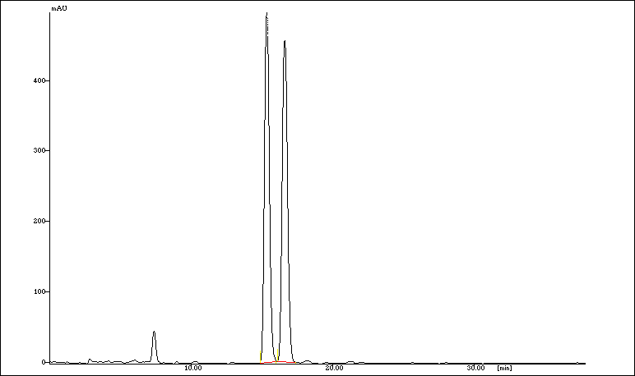
racemic
Table 1, entry 1
Peak ª | Time (min) | Area (mAU·s ) | Area (%)
1 | 15.333 | 10330.25 | 49
2 | 15.592 | 10489.50 | 51

[a]: Lux® 5µm Cellulose-1 Chiral HPLC Column, 250 x 4.6 mm was used.

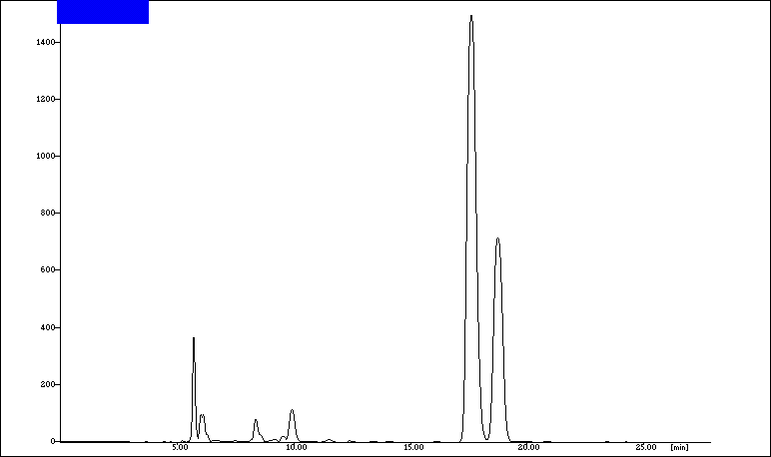
Table 1, entry 2
Peakª | Time (min) | Area (mAU·s ) | Area (%)
1 | 17.583 | 36171.25 | 70
2 | 18.725 | 16247.17 | 30

[a]: Lux® 5µm Cellulose-1 Chiral HPLC Column, 250 x 4.6 mm was used.

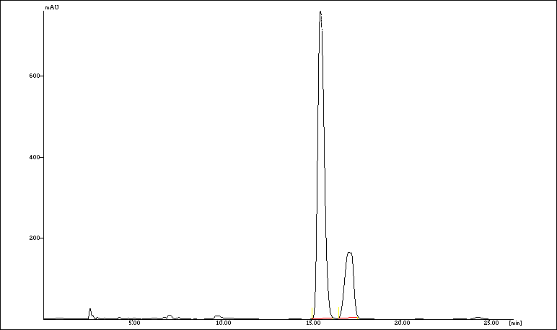
Table 1, entry 3
Peak ª | Time (min) | Area (mAU·s ) | Area (%)
1 | 15.500 | 17493.50 | 77
2 | 17.092 | 5094.50 | 23

[a]: Lux® 5µm Cellulose-1 Chiral HPLC Column, 250 x 4.6 mm was used.

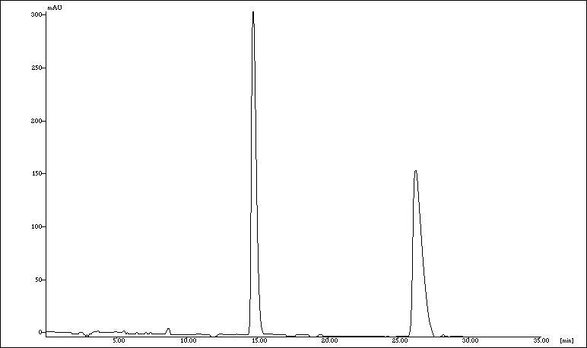
racemic
Table 1, entry 1
Peak ª | Time (min) | Area (mAU·s ) | Area (%)
1 | 14.675 | 6326.686 | 49
2 | 26.183 | 6553.256 | 51

[a]: Lux® 5µm Amylose-3 Chiral HPLC Column, 150 x 4.6 mm was used.

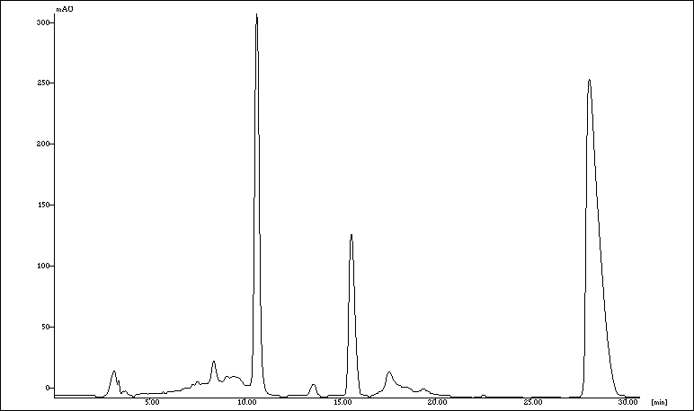
Table 2, entry 2
Peak ª | Time (min) | Area (mAU·s ) | Area (%)
1 | 15.558 | 2505.25 | 18
2 | 28.050 | 11322.04 | 82

[a] Lux® 5µm Amylose-3 Chiral HPLC Column, 150 x 4.6 mm was used.
Table 2, entry 2
Peak ª | Time (min) | Area (mAU·s ) | Area (%)
1 | 15.558 | 2505.25 | 18
2 | 28.050 | 11322.04 | 82

[a] Lux® 5µm Amylose-3 Chiral HPLC Column, 150 x 4.6 mm was used.
Table 2, entry 2
Peak ª | Time (min) | Area (mAU·s ) | Area (%)
1 | 15.558 | 2505.25 | 18
2 | 28.050 | 11322.04 | 82

[a] Lux® 5µm Amylose-3 Chiral HPLC Column, 150 x 4.6 mm was used.
Table 2, entry 2
Peak ª | Time (min) | Area (mAU·s ) | Area (%)
1 | 15.558 | 2505.25 | 18
2 | 28.050 | 11322.04 | 82

[a] Lux® 5µm Amylose-3 Chiral HPLC Column, 150 x 4.6 mm was used.
Table 2, entry 2
Peak ª | Time (min) | Area (mAU·s ) | Area (%)
1 | 15.558 | 2505.25 | 18
2 | 28.050 | 11322.04 | 82

[a] Lux® 5µm Amylose-3 Chiral HPLC Column, 150 x 4.6 mm was used.
Table 2, entry 2
Peak ª | Time (min) | Area (mAU·s ) | Area (%)
1 | 15.558 | 2505.25 | 18
2 | 28.050 | 11322.04 | 82

[a] Lux® 5µm Amylose-3 Chiral HPLC Column, 150 x 4.6 mm was used.
Table 2, entry 2
Peak ª | Time (min) | Area (mAU·s ) | Area (%)
1 | 15.558 | 2505.25 | 18
2 | 28.050 | 11322.04 | 82

[a] Lux® 5µm Amylose-3 Chiral HPLC Column, 150 x 4.6 mm was used.

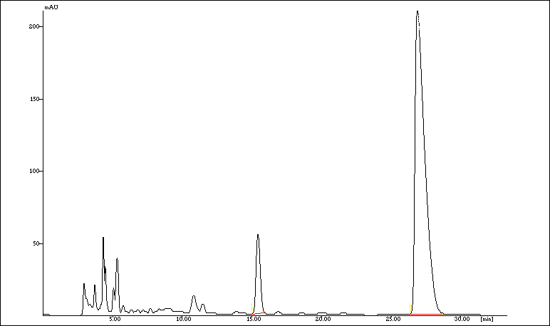
Table 3, entry 1
Peak ª | Time (min) | Area (mAU·s ) | Area (%)
1 | 15.392 | 969.08 | 9
2 | 26.850 | 9601.50 | 91

[a] Lux® 5µm Amylose-3 Chiral HPLC Column, 150 x 4.6 mm was used.
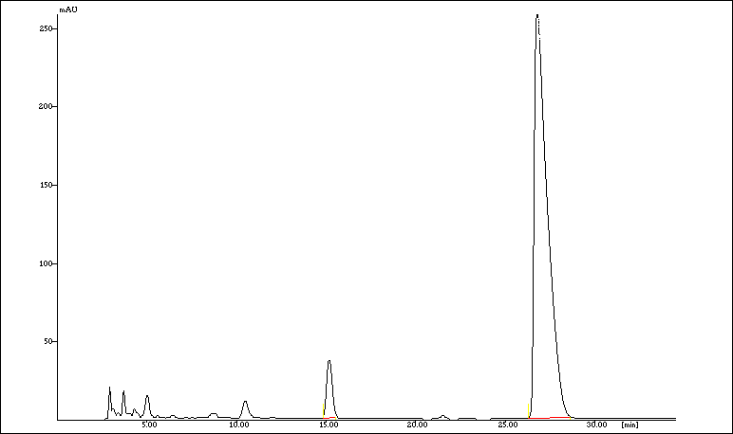
Table 3, entry 2
Peak ª | Time (min) | Area (mAU·s ) | Area (%)
1 | 15.133 | 692.75 | 5
2 | 26.750 | 12356.50 | 95

[a] Lux® 5µm Amylose-3 Chiral HPLC Column, 150 x 4.6 mm was used.

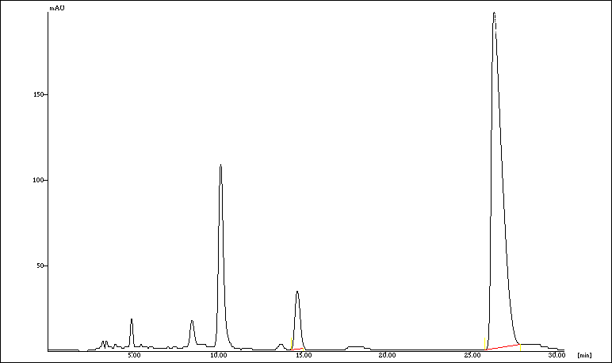
Table 3, entry 3

Peak ª | Time (min) | Area (mAU·s ) | Area (%)
1 | 14.717 | 620.25 | 7
2 | 26.367 | 8049.29 | 93

[a] Lux® 5µm Amylose-3 Chiral HPLC Column, 150 x 4.6 mm was used.

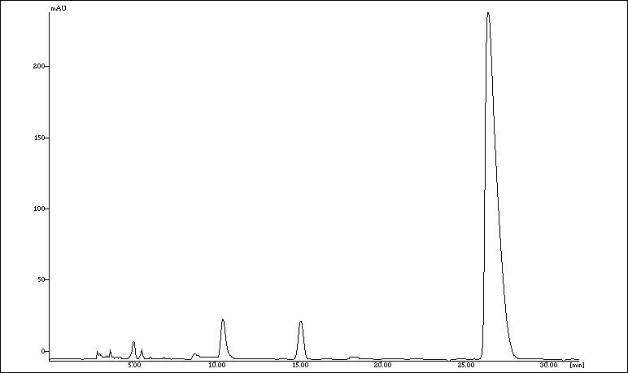
Table 3, entry 4
Peak ª | Time (min) | Area (mAU·s ) | Area (%)
1 | 15.108 | 523.250 | 5
2 | 26.417 | 11074.500 | 95

[a] Lux® 5µm Amylose-3 Chiral HPLC Column, 150 x 4.6 mm was used.

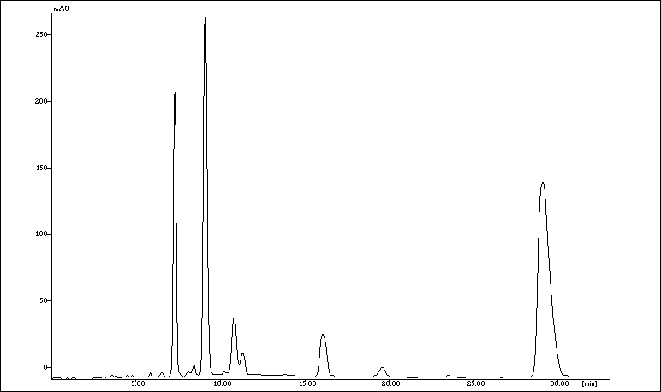
Table 3, entry 5
Peak ª | Time (min) | Area (mAU·s ) | Area (%)
1 | 16.017 | 764.00 | 10
2 | 29.050 | 6592.00 | 90

[a] Lux® 5µm Amylose-3 Chiral HPLC Column, 150 x 4.6 mm was used.

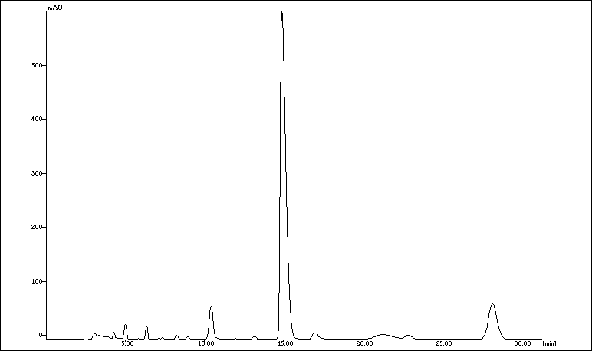
Table 3, entry 6
Peak ª | Time (min) | Area (mAU·s ) | Area (%)
1 | 14.867 | 13137.50 | 85
2 | 28.158 | 2269.50 | 15

[a] Lux® 5µm Amylose-3 Chiral HPLC Column, 150 x 4.6 mm was used.

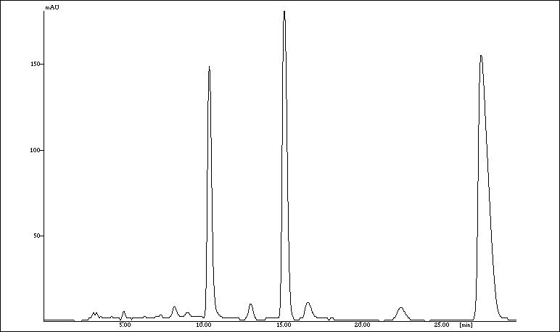
Table 3, entry 7
Peak | Time (min) | Area (mAU·s ) | Area (%)
1 | 15.150 | 3376.68 | 35
2 | 27.550 | 6244.00 | 65

[a] Lux® 5µm Amylose-3 Chiral HPLC Column, 150 x 4.6 mm was used.

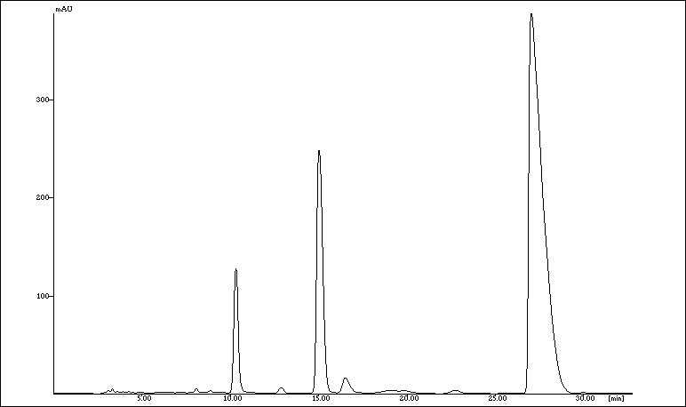
Table 3, entry 8
Peak ª | Time (min) | Area (mAU·s ) | Area (%)
1 | 14.992 | 5064.68 | 20
2 | 27.000 | 20087.00 | 80

[a] Lux® 5µm Amylose-3 Chiral HPLC Column, 150 x 4.6 mm was used.

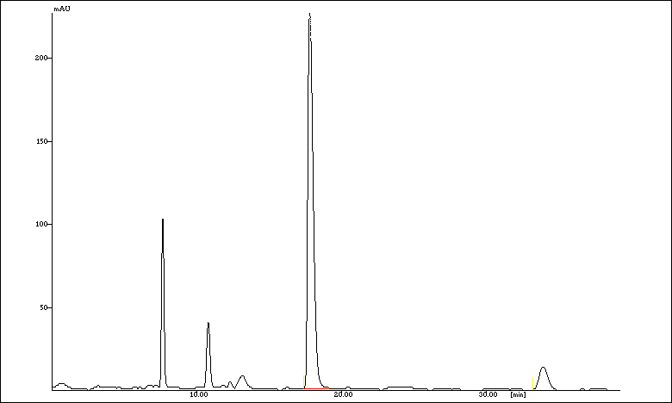
Table 3, entry 9
Peak ª | Time (min) | Area (mAU·s ) | Area (%)
1 | 18.983 | 6249.750 | 92
2 | 37.717 | 589.000 | 8

[a] Lux® 5µm Amylose-3 Chiral HPLC Column, 150 x 4.6 mm was used.

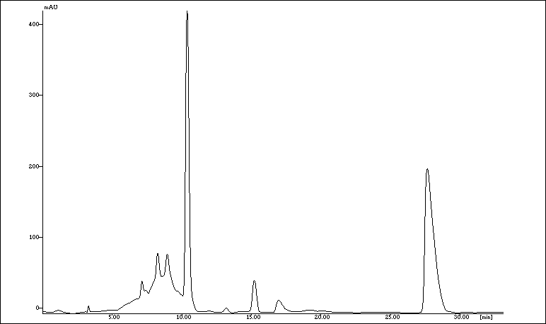
Table 4, entry 2
Peak ª | Time (min) | Area (mAU·s ) | Area (%)
1 | 15.175 | 732.75 | 8
2 | 27.600 | 8263.25 | 92

[a] Lux® 5µm Amylose-3 Chiral HPLC Column, 150 x 4.6 mm was used.

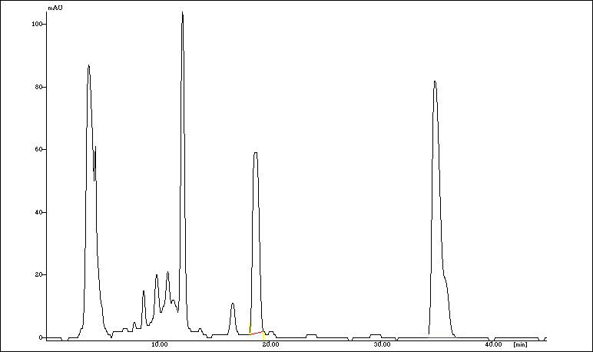
Table 4, entry 3
Peak ª | Time (min) | Area (mAU·s ) | Area (%)
1 | 18.650 | 2074.93 | 33
2 | 34.842 | 4150.00 | 67

[a] Lux® 5µm Amylose-3 Chiral HPLC Column, 150 x 4.6 mm was used.

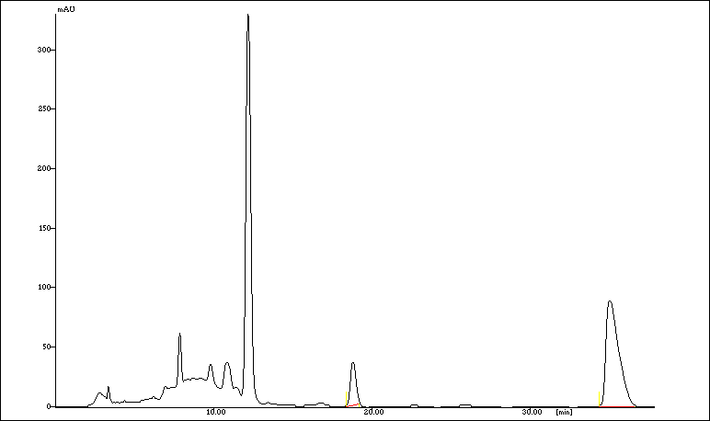
Table 4, entry 4
Peak ª | Time (min) | Area (mAU·s ) | Area (%)
1 | 18.758 | 772.00 | 14
2 | 34.983 | 4677.00 | 86

[a] Lux® 5µm Amylose-3 Chiral HPLC Column, 150 x 4.6 mm was used.

rac-18
Peak ^{[a]} | Time (min)
1 | 10.703
2 | 14.172

[a] Chiralpak IC 3µm Column, 250 x 4.6 mm was used.

(+)-18
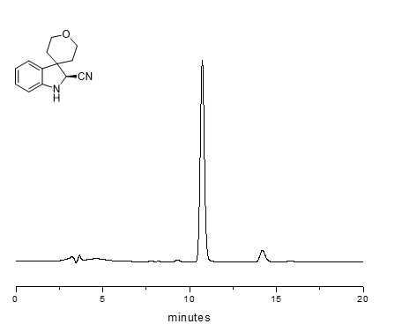
Table 5, entry 3
Peak ^{[a]} | Time (min) | Area (mAU·s ) | Area (%)
1 | 10.703 | 167423.20 | 94
2 | 14.172 | 10686.50 | 6

[a] Chiralpak IC 3µm Column, 250 x 4.6 mm was used.

rac-19
Peak ^{[a]} | Time (min)
1 | 19.570
2 | 22.206

[a] Chiralpak IC 3µm Column, 250 x 4.6 mm was used.

(+)-19

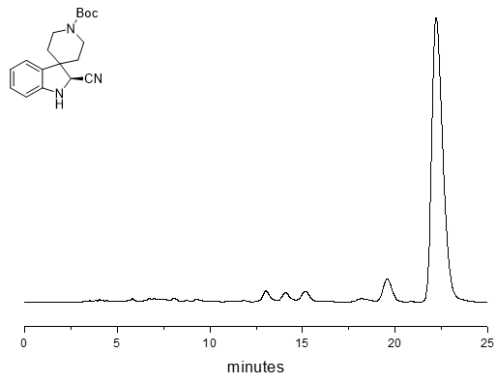
Table 5, entry 4

Peak ^{[a]} | Time (min) | Area (mAU·s ) | Area (%)
1 | 19.570 | 209278.30 | 94
2 | 22.206 | 13357.80 | 6

[a] Chiralpak IC 3µm Column, 250 x 4.6 mm was used.

rac-20
Peak ^{[a]} | Time (min)
1 | 13.587
2 | 16.604

[a] Chiralpak IC 3µm Column, 250 x 4.6 mm was used.

(+)-20
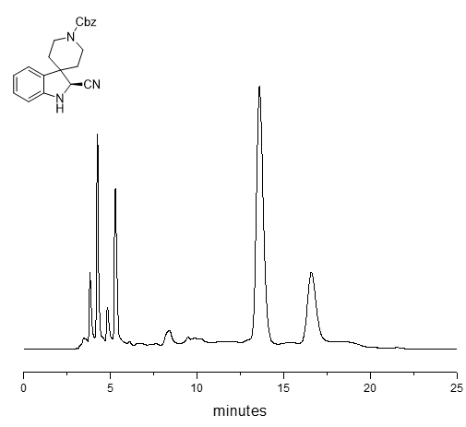
Table 5, entry 5

Peak ^{[a]} | Time (min) | Area (mAU·s ) | Area (%)
1 | 13.587 | 189278.40 | 75
2 | 16.604 | 63092.10 | 25

[a] Chiralpak IC 3µm Column, 250 x 4.6 mm was used.

rac-21
Peak ^{[a]} | Time (min)
1 | 5.885
2 | 8.361

[a] Chiralpak IC 3µm Column, 250 x 4.6 mm was used.

(+)-21
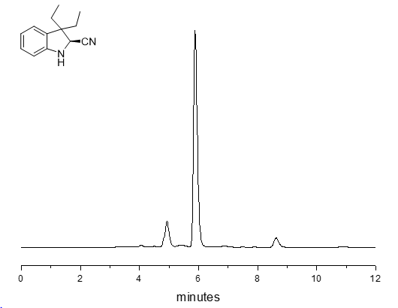
Table 5, entry 6

Peak ^{[a]} | Time (min) | Area (mAU·s ) | Area (%)
1 | 5.885 | 139111.90 | 95
2 | 8.631 | 7321.10 | 5

[a] Chiralpak IC 3µm Column, 250 x 4.6 mm was used.

rac-22
Peak ^{[a]} | Time (min)
1 | 5.593
2 | 8.071

[a] Chiralpak IC 3µm Column, 250 x 4.6 mm was used.

(+)-22
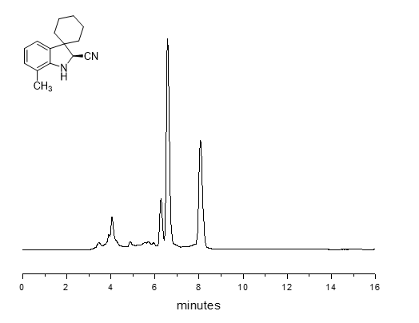
Table 5, entry 7

Peak ^{[a]} | Time (min) | Area (mAU·s ) | Area (%)
1 | 5.593 | 109351.90 | 60
2 | 8.071 | 72901.10 | 40

[a] Chiralpak IC 3µm Column, 250 x 4.6 mm was used.

References

[1] ChemComm. 2012, 48, 4899-4901
[2] React. Chem. Eng. 2020, 5, 2091
[3] Org. Lett. 2005, 7, 1967–1969
[4] Org. Lett. 2010, 12, 5450–5453
[5] J. Am. Chem. Soc. 2014, 136, 17869–17881

