SUPPORTING INFORMATION

Continuous preparation and reaction of nonaflyl azide (NfN₃) for the synthesis of organic azides and 1,2,3-triazoles

Sebastian P. Green,^{a,b} Hannah C. Broderick,ª Katherine M. Wheelhouse,^{c} Jason P. Hallett,^{b} Philip W. Miller,ª* and James A. Bullª*

ª Department of Chemistry, Imperial College London, Molecular Sciences Research Hub, White City Campus, Wood Lane, London W12 0BZ, UK.
^{b} Department of Chemical Engineering, Imperial College London, South Kensington Campus, Exhibition Road, London, SW7 2AZ, UK.
^{c} Drug Substance Development, Medicine Development and Supply, GSK Medicines Research Centre, Gunnels Wood Road, Stevenage, Hertfordshire, SG1 2NY, U.K.

*E-mail: j.bull@imperial.ac.uk; philip.miller@imperial.ac.uk

Contents
1. General Experimental Considerations 3
2. Preparation of Nonaflyl azide 4
2.1 Solvent Investigations for Nonaflyl Azide Preparation (in batch) 4
2.2 Flow synthesis of Nonaflyl azide (General flow reactor setup B) 5
2.2.1 Flow reaction with Batch Separation 5
2.3 Continuous separation of Nonaflyl azide 5
2.3.1 Membrane separators 5
2.4 Overall Process for Continuous Synthesis and Isolation of Nonaflyl Azide 8
2.4.1 with Membrane Separation 8
2.4.2 with Hybrid Gravity–Frit Separation 9
3. Preparation of Azides and triazoles 10
3.1 Batch Diazo transfer 10
3.2 Batch One-pot Diazo transfer and CuAAC reactions 12
3.3 Flow Diazo transfer 13
3.3.1 Using Heterogeneous Copper Metal 13
3.3.2 Using Homogeneous Copper Acetate 14
3.4 Flow Diazo transfer and CuAAC reactions 14
4. Characterisation Data 16
4.1 Batch Synthesis and Characterisation of Azides. 16
4.2 Batch Synthesis and Characterisation of Triazoles 17
4.3 Semi-batch array preparation of triazoles 18

General Experimental Considerations
All non-aqueous batch reactions were carried out under an inert atmosphere (argon) with flame-dried glassware, using standard techniques. Anhydrous solvents were obtained by filtration through drying columns (CH₂Cl₂, ethanol, acetonitrile, toluene, acetone) or used as supplied (methanol, diethyl ether). All water used was deionised.
Flash chromatography was performed using 230–400 mesh silica with the indicated solvent system according to standard techniques. Analytical thin-layer chromatography (TLC) was performed on precoated glass-backed silica gel plates. Visualization of the developed chromatogram was performed by UV absorbance (254 nm) and stained with aqueous potassium permanganate, or vanillin or ninhydrin solutions in ethanol if required.
Infrared spectra (ν_{max}, FTIR ATR) were recorded on an Agilent Cary 630 FTIR spectrometer and are reported in wavenumbers/reciprocal centimetres (cm⁻¹) to the nearest integer.
Nuclear magnetic resonance spectra were recorded on 400 MHz spectrometers. The frequency used to record the NMR spectra is given in each assignment and spectrum (¹H NMR at 400 MHz; ¹³C NMR at 101 MHz; ¹⁹F NMR at 377 MHz). Chemical shifts for ¹H NMR spectra are recorded in parts per million with the residual protic solvent resonance as the internal standard (CDCl₃: δ = 7.27 ppm, MeOD-d₄: δ = 3.35 ppm, MeCN-d₃: δ = 1.94 ppm). Data is reported as follows: chemical shift (multiplicity [s = singlet, d = doublet, t = triplet, q = quartet, p = pentet, m = multiplet and br = broad], integration, coupling constant (in Hz), and assignment). ¹³C NMR spectra were recorded with complete proton decoupling. Chemical shifts are reported in parts per million with the residual protic solvent resonance as the internal standard (CDCl₃: δ = 77.2 ppm, MeOD-d₄: δ = 49.0 ppm, C₆D₆: δ = 128.1 ppm). Assignments of ¹H and ¹³C spectra were based upon the analysis of δ and J values. ¹⁹F NMR spectra were recorded with complete proton decoupling. ¹⁹F NMR spectra are indirectly referenced to CFCl₃ automatically via direct measurement of the absolute frequency of the deuterium lock signal by the spectrometer hardware. Quantitative ¹H NMR analysis of samples containing ethyl or 4-methoxybenzyl azide 2 required the use of a 22 sec relaxation time and used 1,3,5-trimethoxybenzene as an internal standard. Quantitative ¹⁹F NMR analysis of samples containing nonaflyl fluoride or nonaflyl azide required the use of a 20 sec relaxation time, and used trifluorotoluene (TFT) as an internal standard. For clarity NMR spectra are displayed as follows unless this would obscure signals: ¹H NMR spectra are displayed between 10 ppm and –0.2 ppm; ¹³C NMR spectra are displayed between 210 ppm and 0 ppm; ¹⁹F NMR spectra displayed for the full sweep width as acquired.
For ¹³C NMR of the diazo compounds, the resonance for the fully substituted diazo-bearing carbon atom is often not observed due to quadrupole coupling to ¹⁴N, in which cases it is not reported.,,
IR spectra were recorded as solids or neat liquids on either a Perkin Elmer Spectrum 100 or an Agilent Cary 630 FTIR Spectrometer and are reported in wavenumbers (cm⁻¹) to the nearest integer.
Melting points were not obtained for diazo compounds or azides.
The high-resolution mass spectrometry (HRMS) analyses were performed using electrospray ion source (ESI) or pneumatically assisted electrospray (pNSI). ESI+ was performed using a Waters LCT Premier equipped with an ESI source operated in positive ion mode. The software used was MassLynx 4.1, this software does not account for the electron and all the calibrations/references are calculated accordingly, i.e. [M+H]+ is detected and the mass is calibrated to output [M+H]. pNSI was performed using an Orbitrap XL in positive ion mode. Samples are loop injected into or infused in a stream of H₂O/CH₃OH (1:1 at 50 µL min⁻¹) using an appropriate solvent for dissolution of the sample. Nebulization was pneumatically assisted by a flow of N₂ through a sheath around the capillary.
Reagents: Where the synthesis of a reagent is not given, it was commercially available. Commercial reagents were used as supplied, or purified by standard techniques where necessary. In particular, liquid amine bases such as triethylamine were distilled prior to use and stored under argon.
Safety note: Whilst no issues were encountered during the handling of the azide and diazo compounds described in this work, care should be taken when preparing and using these due to their potentially explosive nature.

Preparation of Nonaflyl azide

Determining yield and conversion in formation of NfN₃ by ¹⁹F NMR
Quantitative ¹⁹F NMR analysis of samples containing nonaflyl fluoride or nonaflyl azide required the use of a 20 sec relaxation time, and used trifluorotoluene (TFT) as an internal standard. Yields were calculated from the crude ¹⁹F NMR spectrum using the peaks specified in Figure S1. In this example, 7% impurity was obtained. The likely identity of the impurity is the perfluorosulfolane from manufacture, as NfF is supplied at 90-95% purity.
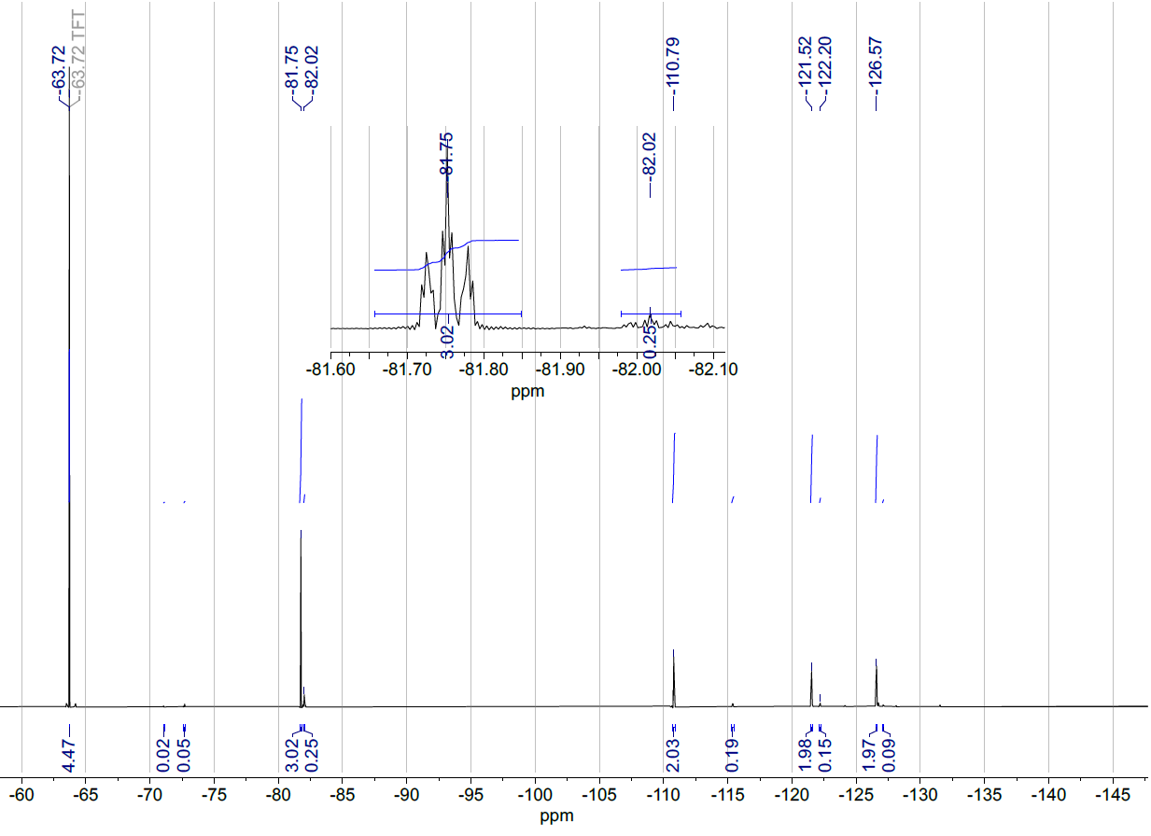
Compound | Chemical shift (ppm) | Number of ¹⁹F atoms in environment | Yield (%)
Trifluorotoluene internal standard | −63.7 | 3 | N/A
NfN₃ | −81.8 | 3 | 89
Impurity, expected to be perfluorosulfolane from NfF | −82.0 | 3 | 7

Figure S1: Example ¹⁹F NMR spectrum used to calculate yield of NfN₃.

Preparation of Nonaflyl azide in batch
General Procedure A for the Synthesis of Nonaflyl Azide
Nonafluorobutanesulfonyl fluoride (1.8 mL, 10 mmol, 1.0 equiv) was added dropwise to a stirred solution of sodium azide (716 mg, 11 mmol, 1.1 equiv) in methanol (20 mL, 0.5 M w.r.t. nonaflyl fluoride). The mixture was stirred at 25 °C for 18 h. The crude was added to a large volume of ice-water in a separating funnel (80 mL, typically 4x reaction volume). The mixture was shaken and allowed to separate for 25 min, then the bottom crude product layer was drained, dried over magnesium sulfate, and decanted to afford neat NfN₃ as a clear liquid. Caution – NfN₃ is semi-volatile and evaporates under reduced pressure. Do not concentrate below 60 mbar at 25 °C.
Shortening of Batch Reaction Time
General procedure A was followed except the reaction time was 2 h, using nonaflyl fluoride (1.8 mL, 10 mmol) and sodium azide (716 mg, 11 mmol), to afford nonaflyl azide (2.13 g, 65%).

Solvent Investigations for Nonaflyl Azide Preparation (in batch)
Solvents were screened to achieve a homogenous batch reaction mixture for the preparation of nonaflyl azide, to enable the method to be translated to flow.
Methanol and water: Nonafluorobutanesulfonyl fluoride (1.8 mL, 10 mmol, 1.0 equiv) was added dropwise to a stirred solution of sodium azide (716 mg, 11 mmol, 1.1 equiv) in methanol (20 mL). Water (6 mL) was then added. The mixture was stirred at 25 °C for 16 h. The crude was added to a large volume of ice-water in a separating funnel (80 mL). The mixture was shaken and allowed to separate for 25 min, then the bottom crude product layer was drained, dried over magnesium sulfate, and decanted to afford nonaflyl azide (1.90 g, 58%).
Acetonitrile: General procedure A was followed except the solvent was acetonitrile; using nonaflyl fluoride (1.8 mL, 10 mmol) and sodium azide (716 mg, 11 mmol), to afford 0.43 g of a clear liquid composed of 28% nonaflyl azide and 72% nonaflyl fluoride.
Water: General procedure A was followed except the solvent was water, using nonaflyl fluoride (1.8 mL, 10 mmol) and sodium azide (716 mg, 11 mmol). It was not possible to recover any significant material, and ¹⁹F NMR of the fluorous phase indicated no reaction.

Flow synthesis of Nonaflyl azide (General flow reactor setup B)
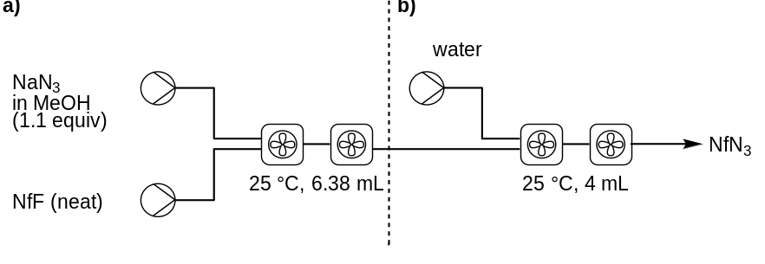
Scheme S1: Nonaflyl azide synthesis, general flow reactor setup B
The setup had two sections operated in series.
Nonaflyl azide synthesis (a): Feed lines for a solution of sodium azide in methanol, and neat nonaflyl fluoride, were connected to an fReactor module, which was connected to a second module via coiled tubing (l = 917 mm, v = 1.82 mL). The output of the second module was connected to another length of coiled tubing (l = 504 mm, v = 1.0 mL) giving a total RV of 6.38 mL.
Aqueous workup (b): The output of (a) was connected to a T-piece, with a HPLC pump primed with water connected to the other input. The output of the T-piece was connected to two fReactor modules in sequence giving a total RV of 4 mL.

Flow reaction with Batch Separation
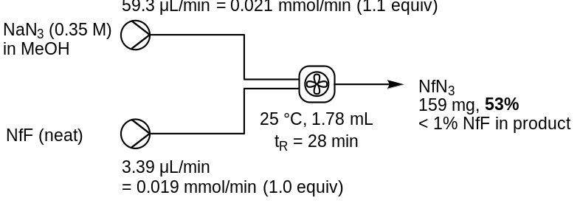
Sodium azide (159 mg, 2.45 mmol) was dissolved in methanol (total volume = 7 mL) to give a 0.35 M solution which was loaded into a syringe. A 500 μL syringe (SGE 500F-LL-GT, gas tight fixed Luer lock) was charged with nonaflyl fluoride (500 μL, 2.78 mmol). Each syringe was connected to the single fReactor module (1.78 mL). The system was primed with sodium azide solution. The nonaflyl fluoride flow rate was 3.39 μL min^{–1} (0.019 mmol min^{–1}) and the sodium azide solution flow rate was 59.3 μL min^{–1} (0.021 mmol min^{–1}, 1.1 equiv), giving an estimated total flow rate of 62.69 μL min^{–1} and residence time of 28 min. After purging for 1 h (2 RV), a sample was collected (49 min, approx 3.1 mL). The crude reaction mixture was transferred to a separating funnel containing 25 mL water chilled over ice, shaken, and allowed to separate. The fluorous lower phase was decanted and dried over magnesium sulfate to afford nonaflyl azide (159 mg, 53%).

Continuous separation of Nonaflyl azide

Membrane separator fabrication
The use of a continuous flow membrane separator, was identified as a method to isolate neat liquid nonaflyl azide. The simple membrane separators described by deMello were used as a basis for this separation., A prototype was kindly provided by deMello and coworkers (Figure S1) with an aluminium block casing, which was avoided due to safety concerns with sodium azide., A housing free separator was developed as described in Figure S2.
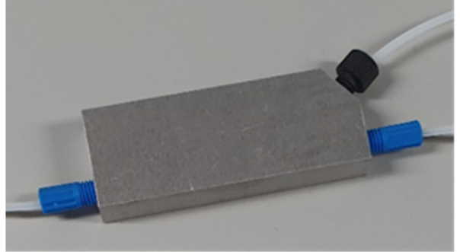
Figure S1: Prototype deMello membrane separator with aluminium casing.
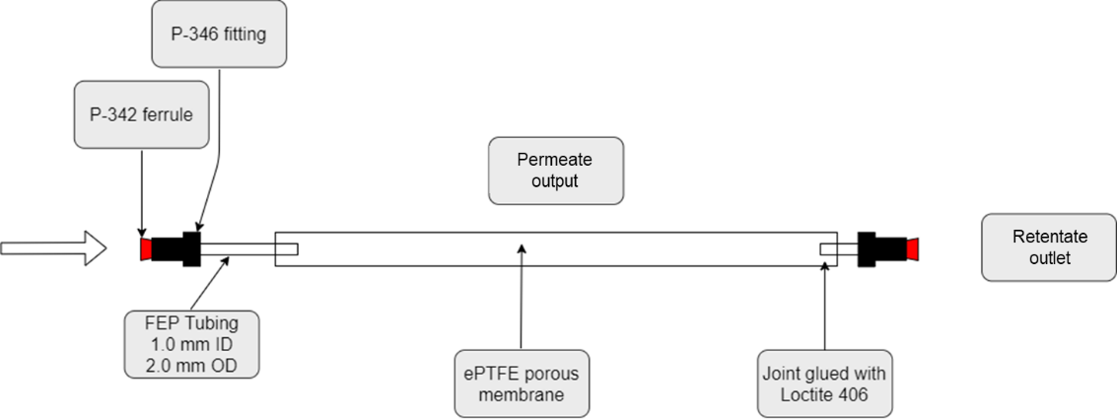
Figure S2: Schematic of fabricated housing-free separators for flow separation optimisation. ⁶
Adapted from the procedure described by deMello et al.⁶ To an approx 6 cm length of PTFE tubing (Sigma Aldrich Z69722, OD = 2 mm, ID = 1 mm), Loctite 770 primer was applied to the outer surface of the last 5 mm. The primed surface was then inserted into a 6 cm length of porous ePTFE tubing (Zeus Aeos 179978, ID = 2.11 mm, wall thickness = 0.3 mm, internodal distance 15 to 25 μm) and Loctite 406 adhesive was applied to the section of ePTFE membrane which overlapped with the PTFE tubing inside. Another approx 6 cm length of the same PTFE tubing was then attached to the other end of the ePTFE membrane in the same fashion. Appropriate fittings (P-346) and ferrules (P-363) were used to connect the inlet and retentate outlet where necessary.
The fabricated separator was found to effectively separate a 1:1 mixture of water and toluene (dyed with Sudan II orange dye, using a 5 cm length of RT with ID = 254 μm, as indicated in the original work).⁶

Flow design with nonaflyl azide isolation (Scheme S2).
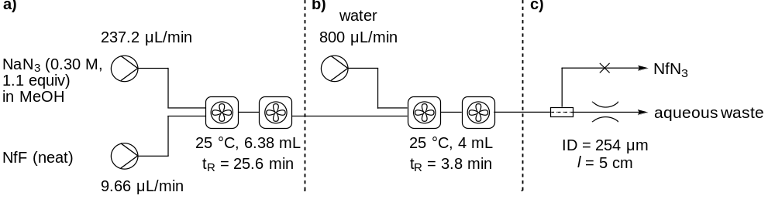
Scheme S2: Three-stage flow process to determine membrane separation conditions. a) Nonaflyl azide synthesis; b) Water ‘workup’ to induce phase separation; c) Membrane separation of fluorous phase from aqueous phase.
General flow reactor setup B (Scheme 1a) was used as a base. Flow rates were increased and a HPLC pump was used to pump water into the separation segment. A ratio of 3: 1 water/crude reaction mixture was selected to ensure enough water was present to prevent methanol crossing the membrane. The output of the synthesis segment (Scheme S2a) was connected to the water workup segment (Scheme S2b), primed with water. The fabricated membrane separator was connected with 2.5 cm of RT (ID = 254 μm). The aqueous phase immediately wetted the membrane and passed across instead of exiting the aqueous outlet, indicating the backpressure generated by either the 5 psi BPR, or 2.5 cm of RT (ID = 254 μm) was too high. Changing the RT length did not prevent eventual aqueous breakthrough. Furthermore, solid sodium fluoride had precipitated in the reactor. Gas evolution was observed, but successfully suppressed with addition of a BPR.
Several parameters were investigated to improve separation (Table S1). Increasing the reduced concentration sodium azide solution flow rate and water flow rate prevented breakthrough (Table S1, entry 3).
Table S1: Aqueous phase methanol content for separation of nonaflyl azide
Entry | NaN₃ soln.  concentration  /M | NaN₃ soln.  flow rate  /μL min^{–1} | Water  flow rate  /μL min^{–1} | MeOH content  of crude output  /% | Notes
1 | 0.30 | 237.2 | 0.8 | 22.9 | NaF precipitate observed
2 | 0.28 | 276.9 | 0.8 | 25.7 | Aqueous breakthrough
3 | 0.28 | 276.9 | 1.2 | 18.7 | Phase separation

The revised separation conditions, were used for an investigation into the optimal length and ID of RT required to separate nonaflyl azide using the membrane separators (Table S2).
Sodium azide (1.82 g, 28 mmol) was dissolved in methanol to give 100 mL of 0.28 M solution. 10 mL syringes were charged with this solution and swapped when depleted. Another syringe was charged with nonaflyl fluoride (7 mL, 39 mmol). Each syringe was connected to general flow reactor setup B (2.2, Scheme S1). The nonaflyl fluoride flow rate was 12.66 μL min^{–1} (0.070 mmol min^{–1}) and the sodium azide solution flow rate was 276.9 μL min^{–1} (0.078 mmol min^{–1}, 1.1 equiv), giving an estimated total flow rate of 289.6 μL min^{–1} and residence time of 22 min. The flow rate of water was 1.2 mL min^{–1} giving an estimated total flow rate of 1.49 mL min^{–1} and a residence time of 2.7 min. After purging for 75 min (3 RV), the fabricated membrane separator was connected with the indicated RT, giving the corresponding yield of nonaflyl azide in Table S2. After each test, the flow was briefly directed to waste using a three-way tap while the next length of RT tubing was connected to the end of the separator before flow was directed back into the separator.

Table S2: Revised process for optimisation of the length and ID of RT for membrane separation of nonaflyl azide.
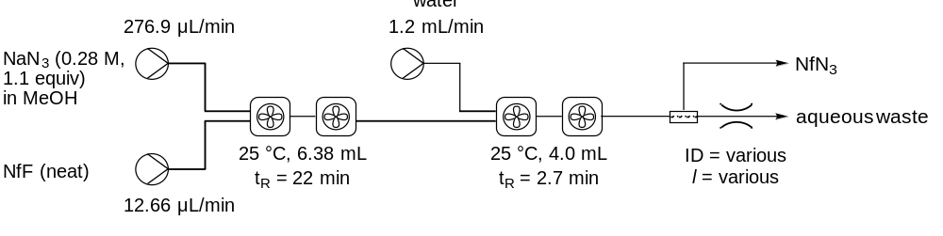
Entry | RT length  /cm | RT ID  /μm | Test time  /min | Output NfN₃  /g | Isolated Yieldª  /%
1 | 8.0 | 1,520 | 31 | - | none
2 | 5.0 | 762 | 25 | 0.284 | 50
3 | 5.0 | 508 | 20 | 0.276 | 60
4 | 7.5 | 508 | 50 | 0.578 | 54
5 | 10.0 | 508 | 45 | 0.537 | 52
6 | 15.0 | 508 | 95 | 1.162 | 53
7 | 20.0 | 508 | 45 | 0.624 | 60
8 | 21.0 | 508 | 45 | 0.765 | 74
9 | 22.5 | 508 | 49 | 1.021 ^{b} | mixed phases
10 | 25.0 | 508 | - | - ^{c} | breakthrough
11 | 30.0 | 508 | - | - ^{c} | breakthrough
ª Purity of nonaflyl azide confirmed by ¹H and ¹⁹F NMR. ^{b} Output was mostly nonaflyl azide but contained a small amount of aqueous phase. ^{c} Both phases passed through the membrane almost immediately.
Once the separation had been obtained, the yield remained fairly constant over RT length of 5 to 20 cm (Table S2 entries 2−7), peaking at 74% with 21 cm (entry 8). Longer RT led to aqueous phase breakthrough (entries 9-11).

Overall Process for Continuous Synthesis and Isolation of Nonaflyl Azide

with Membrane Separation
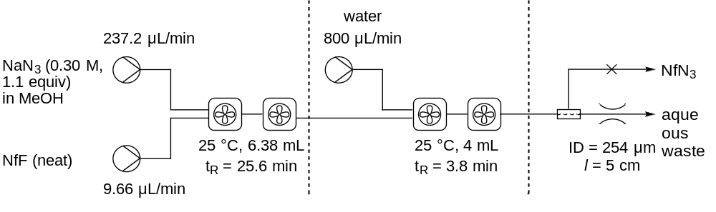
Sodium azide (1.56 g, 24 mmol) was dissolved in methanol to give 80 mL of 0.35 M solution. 10 mL syringes were charged with this solution and swapped when depleted. Another syringe was charged with nonaflyl fluoride (3.5 mL, 19.5 mmol). Each syringe was connected to general flow reactor setup B (2.2, Scheme S1). The nonaflyl fluoride flow rate was 9.66 μL min⁻¹ (0.054 mmol min^{–1}) and the sodium azide solution flow rate was 237.2 μL min⁻¹ (0.084 mmol min^{–1}, 1.1 equiv), giving an estimated total flow rate of 246.9 μL min^{–1} and residence time of 25.6 min. The flow rate of water was 800 μL min^{–1} giving an estimated total flow rate of 1.05 mL min^{–1} and a residence time of 3.8 min. After purging for 64 min (2.5 RV), the fabricated membrane separator was connected to RT of length 5 = cm and ID = 254 μm.

with Hybrid Gravity–Frit Separation
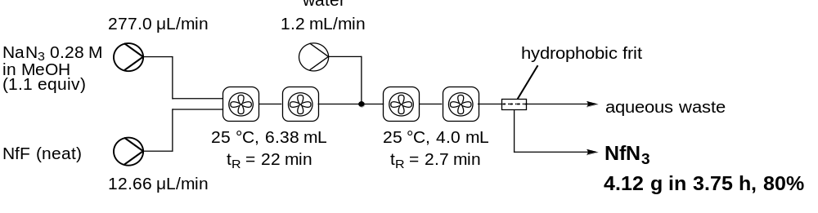
Sodium azide (1.82 g, 28.0 mmol) was dissolved in methanol to give 100 mL of 0.28 M solution and connected to a peristaltic pump. A 10 mL syringe was charged with nonaflyl fluoride (7 mL, 39.0 mmol). Both the peristaltic pump and syringe were connected to general flow reactor setup C (2.2, Scheme S1). The nonaflyl fluoride flow rate was 12.66 μL min^{–1} (0.070 mmol min^{–1}) and the sodium azide solution flow rate was 277 μL min^{–1} (0.078 mmol min^{–1}, 1.1 equiv), giving an estimated total flow rate of 289.7 μL min^{–1} and residence time of 22 min. The flow rate of water was 1.2 mL min^{–1} giving an estimated total flow rate of 1.49 mL min^{–1} and a residence time of 2.7 min. After purging for 120 min (5 RV), the output was directed onto the hydrophobic frit at the bottom of a 15 mL Biotage/IST ISOLUTE phase separator (P/N: 121-1906-D, 20 μm polyethylene frit). The feed line for a second peristaltic pump was secured at the top of the separator and set to pump at 1.5 mL min^{–1}. After approx 9 min, the separator was filled with reactor output and was periodically pumped out by the second peristaltic pump, while the frit was wetted by the product phase which began to drop from the phase separator output to afford nonaflyl azide (4.12 g in 225 min, 80%) as a clear liquid.

Nonaflyl azide, NfN₃
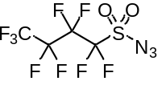Caution – NfN₃ is semi-volatile and evaporates under reduced pressure. IR(ATR)/cm⁻¹ 2147 (N=N=N), 1424, 1353, 1185, 1141, 1029, 760. ¹³C NMR (101 MHz, CDCl₃) δ 117.4 (qt, J_{C-F} = 288, 32.6 Hz, CF₃) 115.6 (tt, J_{C-F} = 303, 36.8 Hz, CF₂SO₂), 110.4 (ttm, J_{C-F} = 270, 31.1 Hz, CF₂CF₂SO₂), 108.7 (tqm, J_{CF} = 270.9, 40.1, CF₃CF₂). ¹⁹F{¹H} NMR (377 MHz, CDCl₃) δ −81.6 (CF₃), −110.1 (CF₂SO₂), −121.5 (CF₂CF₂SO₂), −126.6 (CF₃CF₂). The observed characterisation data (¹³C and ¹⁹F NMR) were consistent with that previously reported in the literature.,

Preparation of Azides and triazoles

Batch Diazo transfer
Conditions for the diazo transfer were based on those reported by Chiara and co-workers. Further optimisation reactions were undertaken to identify the highest yielding, conditions suitable for flow for the batch diazo transfer reaction. Different copper sources, both heterogeneous and homogeneous were tested (Table S3). Both copper acetate and copper metal were selected for further investigation in the flow conditions due to giving the highest conversion to the azide.
To a stirred solution of amine (0.2 mmol) in acetonitrile (1 mL, 0.2 M) was added, in sequence: nonaflyl azide (46 μL, 0.24 mmol, 1.2 equiv), triethylamine (33.5 μL, 0.24 mmol, 1.2 equiv) and copper source (0.02 mmol, 10 mol%). The copper source was one of the following: CuSO₄•5H₂O (10 mg); Cu⁰ (4 squares, 275 mg); a solution of CuSO₄•5H₂O (10 mg) in water (300 μL); Cu(OAc)₂ (3.6 mg); CuI (3.8 mg); Cu(OPiv)₂ (5.3 mg); Cu^{II} stearate (12.6 mg).The reaction mixture was stirred at 25 °C for 4 h. Sat. aq. NaHCO₃ (10 mL) and ethyl acetate (10 mL) were added. The phases were separated, and the organic extract was washed with sat. aq. NaHCO₃ (4 × 10 mL), dried over sodium sulfate, filtered, and concentrated in vacuo. The residue was purified by flash column chromatography to afford the azide product.

Table S3: Results of copper screening experiments with initial diazo transfer conditions for diazo transfer to amines.
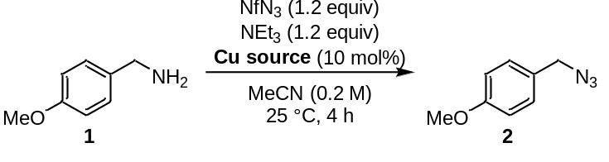
Entry | Copper source | SM 1  /% yield ª | Azide 2  /% yield ª | Total  /%
1 | CuSO₄•5H₂O | 3 | 96 | 99
2 | Cu⁰ turnings ^{b} | 2 | 97 | 99
3 | CuSO₄•5H₂O in water ^{c} | 3 | 82 | 85
4 | Cu(OAc)₂ | 2 | 100 | 102
5 | CuI | 4 | 85 | 89
6 | Cu(OPiv)₂ | 3 | 85 | 88
7 | Cu^{II} stearate | 2 | 89 | 91
ª Yields were determined by ¹H NMR spectroscopy using 1,3,5-trimethoxybenzene as an internal standard with a 22 s relaxation time. Reactions were performed on a 0.2 mmol scale. ^{b} 4x copper turnings used, total mass 275 mg. ^{c} Copper sulfate dissolved in 300 μL water, final solvent composition approximately 3:1 acetonitrile:water.

The copper acetate conditions were investigated further, to determine the effect of removing either triethylamine, the copper source, or a combination of the two on different substrates (Table S4).

Investigation into Effect of Reaction Components (Table 1)
The procedure below was followed, except in each case the given reagent (Table 1) was excluded. Where Cu⁰ was used, one square of copper metal was added (copper turnings, approx. 40 × 40 mm, 70 mg each, Sigma Aldrich product no. 61139).
To a stirred solution of amine (0.2 mmol) in acetonitrile (1 mL, 0.2 M) was added, in sequence: nonaflyl azide (46 μL, 0.24 mmol, 1.2 equiv), triethylamine (33.5 μL, 0.24 mmol, 1.2 equiv) and copper acetate (3.6 mg, 0.02 mmol, 10 mol%). The reaction mixture was stirred at 25 °C for 4 h. Sat. aq. NaHCO₃ (10 mL) and ethyl acetate (10 mL) were added. The phases were separated, and the organic extract was washed with sat. aq. NaHCO₃ (4 × 10 mL), dried over sodium sulfate, filtered, and concentrated in vacuo. The residue was purified by flash column chromatography to afford the azide product.

Table S4: Investigation into the effect of excluding different reagents from the copper acetate diazo transfer conditions.
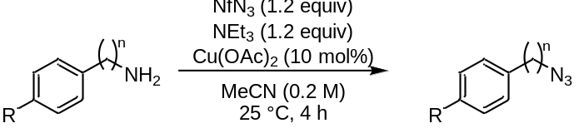
Entry | Amine | Change from given conditions | SM amine  % yield ^{a,b} | Azide  % yield ª
1 | 1 | None | - | 100
2 | 1 | No NEt₃, no Cu(OAc)₂ | - | 80
3 | 3 | None | - | 100
4 | 3 | No NEt₃ | - | 86
5 | 3 | No Cu(OAc)₂ | - | 88
6 | 3 | No NEt₃, no Cu(OAc)₂ | - | 87
7 | 5 | None | - | 100
8 | 5 | No NEt₃ | - | 97
9 | 5 | No Cu(OAc)₂ | - | 83
10 | 5 | No NEt₃, no Cu(OAc)₂ | 56 | 33
11 | 5 | Cu⁰ instead of Cu(OAc)₂ | - | 80
12 | 5 | No NEt₃, Cu⁰ instead of Cu(OAc)₂ | - | 75
13 | 7 | None | - | 100
14 | 7 | No NEt₃ | - | 87
15 | 7 | No Cu(OAc)₂ | - | 88
16 | 7 | No NEt₃, no Cu(OAc)₂ | - | 84
17 | 9 | None | - | 102
18 | 9 | No NEt₃ | - | 94
19 | 9 | No Cu(OAc)₂ | - | 106
20 | 9 | No NEt₃, no Cu(OAc)₂ | - | 95
22 | 9 | Cu⁰ instead of Cu(OAc)₂ | - | 100
23 | 9 | No NEt₃, Cu⁰ instead of Cu(OAc)₂ | - | 99
ª Yields were determined by ¹H NMR spectroscopy using 1,3,5-trimethoxybenzene as an internal standard with a 22 s relaxation time. Reactions were performed on a 0.2 mmol scale. ^{b} Amine starting material not typically observed due to aqueous NaHCO₃ workup used to quench reaction.

Benzylamines 1, 3 and 7 all gave 80−88% yield with just nonaflyl azide in the absence of base and a copper source (entries 2, 6 and 16); including either copper acetate or triethylamine did not affect the yield (entries 4−5 and 14−15) but including all the reagents boosted the yield to 100% (entries 1, 3 and 13). The aniline 5 and alkyl amine 9 also both gave quantitative yield with all reagents (entries 7 and 17), however with aniline 5, 33% yield of the azide was achieved in the absence of base and a copper source (entry 10) and 56% starting material was recovered. Using triethylamine increased the yield to 83% (entry 9), and conditions with copper acetate with or without triethylamine gave >97% yield (entries 7−8). Contrastingly, alkyl amine 9 retained excellent yield of azide without base or a copper source.

Batch One-pot Diazo transfer and CuAAC reactions
Initial conditions for the one-pot diazo transfer/CuAAC reaction, were based on a procedure reported by Chiara and co-workers, without addition of a base (Table S5).
Table S5: Optimisation of triethylamine-free one-pot diazo transfer/CuAAC.
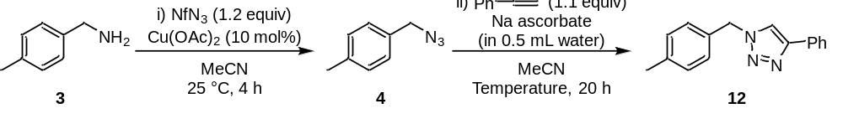
Entry | Na ascorbate  /equiv | Temperature  /°C | Further change in conditions | Azide 4  /% yield ª | Triazole 12  /% yield ª | Total  /%
1 | 1.5 | 25 | None | 6 | 78 | 84
2 | 0.5 | 25 | None | 17 | 62 | 79
3 | 0.2 | 25 | None | 66 | 16 | 82
4 | 2.0 | 25 | None | 26 | 75 | 101
5 | 1.5 | 40 | None | 1 | 84 | 85
6 | 1.5 | 50 | None | 0 | 85 | 85
7 | 2.0 | 40 | None | 17 | 79 | 96
8 | 2.0 | 50 | None | trace | 83 | 83
9 | 2.0 | 25 | 2.0 equiv alkyne | 20 | 56 | 75
10 | 2.0 | 40 | 1.3 equiv alkyne | 9 | 78 | 86
11 | 1.5 | 50 | Cu⁰ ^{b} | 0 | 86 | 86
ª Yields were determined by ¹H NMR spectroscopy using 1,3,5-trimethoxybenzene as an internal standard with a 22 s relaxation time. Reactions were performed on a 0.2 mmol scale. ^{b} 1 copper turning (approximately 70 mg) was added instead of copper acetate in the diazo transfer step.
The reaction was further investigated in the presence of triethylamine, which had given the optimal diazo transfer conditions. This promoted full conversion to form the azide, with most of the tested reactions giving high mass balance recovery. Increasing the equivalents of sodium ascorbate from Chiara’s conditions of 1.5 equiv, and increasing the alkyne loading to 1.3 equiv resulted in excellent conversion to the triazole (Table S6).

.
Table S6: Optimisation of one-pot diazo transfer/CuAAC with triethylamine.
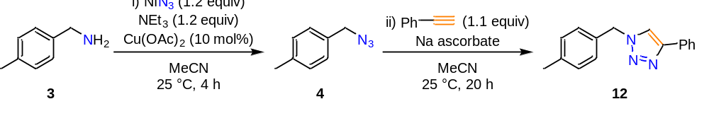
Entry | Na ascorbate  /equiv | Water ª  /mL | Temp.  /°C | Further change in conditions | Azide 4  /% yield ^{b} | Triazole 12  /% yield ^{b} | Total  /%
1 | 1.5 | 0.5 | 25 | None | 55 | 48 | 103
2 | 3.0 | 0.5 | 25 | None | 32 | 59 | 91
3 | 3.0 | 1.0 | 25 | None | 7 | 88 | 95
4 | 3.0 | 1.0 | 25 | 1.3 equiv alkyne | 29 | 71 | 101
5 | 3.0 | 1.0 | 40 | None | 2 | 81 | 82
6 | 3.0 | 1.0 | 40 | 1.3 equiv alkyne | 8 | 92 | 100
7 | 3.0 | 1.0 | 50 | 1.3 equiv alkyne | 3 | 94 | 96
8 | 3.0 | 1.0 | 40 | 1.3 equiv alkyne and Cu⁰ ^{c} | 33 | 66 | 99
ª Sodium ascorbate was dissolved in this volume of water which was added to the reaction at the start of the second step. ^{b} Yields were determined by ¹H NMR spectroscopy using 1,3,5-trimethoxybenzene as an internal standard with a 22 s relaxation time. Reactions were performed on a 0.2 mmol scale. ^{c} 1 copper turning (approximately 70 mg) was added instead of copper acetate in the diazo transfer step.

Flow Diazo transfer

Using Heterogeneous Copper Metal
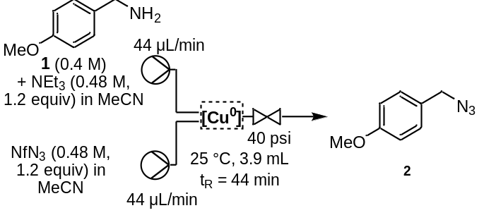
For each tested setup, the flow reactor consisted of two fReactor modules in series, with the copper turnings or copper tubing added to the modules before the reaction was set up. Where copper turnings (approx. 40 × 40 mm, 70 mg each, Sigma Aldrich product no. 61139) were used, the given number were placed inside the fReactor module prior to the experiment. Where the copper tubing (Agilent Technologies, OD = 1/8”, ID = 2.1 mm, l = 25 cm, v = 0.88 mL) was used, it was fitted between the first and second fReactor modules to give a total residence time of 54 min. The ‘no copper’ control experiment used the regular tubing and no copper turnings in either module.
4-Methoxybenzylamine 1 (523 μL, 4.0 mmol) and triethylamine (669 μL, 4.8 mmol, 1.2 equiv) were dissolved in acetonitrile to give 10 mL of 0.40 M solution w.r.t. 1 (0.48 M w.r.t. triethylamine). Nonaflyl azide (918 μL, 4.8 mmol, 1.2 equiv) was dissolved in acetonitrile to give 10 mL of 0.48 M solution. Both solutions were loaded into 10 mL syringes and connected to the given flow reactor. Both solutions had a flow rate of 44 μL min⁻¹, giving an estimated total flow rate of 88 μL min⁻¹ and a residence time of 44 min. After purging for 90 min (2 RV), samples were collected in a quench solution of sat. aq. NH₄Cl (10 mL), the phases were separated, extracted with diethyl ether (2 × 6 mL), and the organic extracts were combined, dried over sodium sulfate, filtered, and concentrated in vacuo before analysis by ¹H NMR spectroscopy using 1,3,5-trimethoxybenzene as an internal standard with a 22 sec relaxation time.

Using Homogeneous Copper Acetate
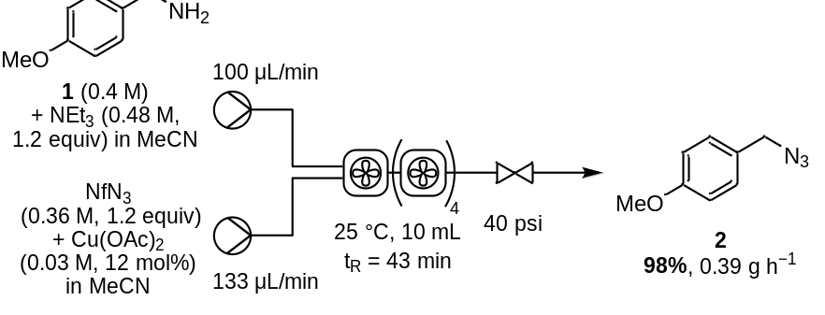
4-Methoxybenzylamine 1 (1.57 mL, 12.0 mmol) and triethylamine (2.0 mL, 14.4 mmol, 1.2 equiv) were dissolved in acetonitrile to give 30 mL of 0.40 M solution w.r.t. 1 (0.48 M w.r.t. triethylamine). Nonaflyl azide (2.75 mL, 14.4 mmol, 1.2 equiv) and copper acetate (218 mg, 1.2 mmol, 12 mol%) were dissolved in acetonitrile to give 40 mL of 0.36 M solution (0.03 M w.r.t. copper acetate). Both solutions were connected to peristaltic pumps which were connected to 5 fReactors in series. The substrate 1 solution had a flow rate of 100 μL min⁻¹, and the nonaflyl azide solution had a flow rate of 133 μL min⁻¹, giving an estimated total flow rate of 233 μL min⁻¹ and a residence time of 43 min. After purging for 90 min (2 RV), samples were collected in a quench solution, the phases were separated, extracted with CH₂Cl₂ (2 × 30 mL), and the organic extracts were combined, dried over sodium sulfate, filtered, and concentrated in vacuo before analysis by ¹H NMR spectroscopy using 1,3,5-trimethoxybenzene as an internal standard with a 22 sec relaxation time.

Flow Diazo transfer and CuAAC reactions
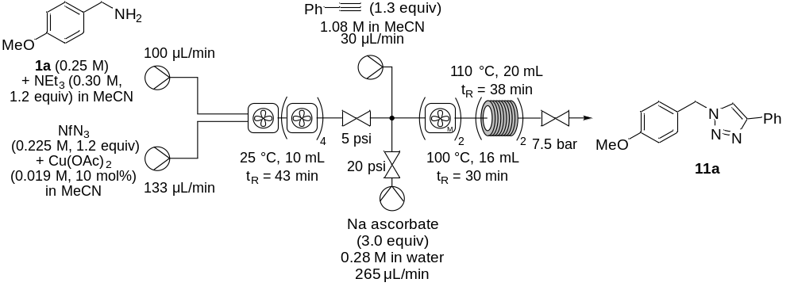
4-Methoxybenzylamine 1 (1.05 mL, 8.0 mmol) and triethylamine (1.34 mL, 9.6 mmol, 1.2 equiv) were dissolved in acetonitrile to give 32 mL of 0.25 M solution w.r.t. 1 (0.30 M w.r.t. triethylamine). Nonaflyl azide (1.73 mL, 9.0 mmol, 1.2 equiv) and copper acetate (137 mg, 0.75 mmol, 10 mol%) were dissolved in acetonitrile to give 40 mL of 0.225 M solution (0.019 M w.r.t. copper acetate). Both solutions were connected to peristaltic pumps which were connected to 5 fReactors in series. The substrate 1 solution had a flow rate of 100 μL min⁻¹, and the nonaflyl azide solution had a flow rate of 133 μL min⁻¹, giving an estimated total flow rate of 233 μL min⁻¹ and a residence time of 43 min for the first step.
Sodium ascorbate (4.21 g, 21.2 mmol) was dissolved in water to give 75 mL of 0.28 M solution, which was connected to a peristaltic pump. Phenyl acetylene (1.19 mL, 10.8 mmol) was dissolved in acetonitrile to give 10 mL of a 1.08 M solution which was loaded into a syringe. Both solutions, as well as the output of the first step, were connected to two fReactor MAXI and two Vapourtec R-1 modules in series. The sodium ascorbate solution had a flow rate of 265 μL min⁻¹ (3.0 equiv), and the alkyne solution had a flow rate of 30 μL min⁻¹ (1.3 equiv), giving an estimated total flow rate of 528 μL min⁻¹ and a residence time of 30 min for the second step.
While purging the first stage of the flow reactor, the ascorbate feed line was pumping water into the second stage at 265 μL min⁻¹. After purging the first stage for 45 min (1 RV), the ascorbate feed line was switched to ascorbate solution, and the syringe pump for the alkyne solution was started. After purging the second step flow reactor for 90 min (1.5 RV), samples were collected in a quench solution of 2:1:1 EtOAc/water/sat. aq. NaHCO₃ (40 mL), extracted with CH₂Cl₂ (2 × 50 mL), and the organic extracts were combined, dried over sodium sulfate, filtered, and concentrated in vacuo before analysis by ¹H NMR spectroscopy using 1,3,5-trimethoxybenzene as an internal standard with a 22 sec relaxation time.

Characterisation Data

Batch Synthesis and Characterisation of Azides.
General Batch Procedure C for Diazo Transfer to Amine Substrates
To a stirred solution of amine (0.2 mmol) in acetonitrile (1 mL, 0.2 M) was added, in sequence: nonaflyl azide (46 μL, 0.24 mmol, 1.2 equiv), triethylamine (33.5 μL, 0.24 mmol, 1.2 equiv) and copper acetate (3.6 mg, 0.02 mmol, 10 mol%). The reaction mixture was stirred at 25 °C for 4 h. Sat. aq. NaHCO₃ (10 mL) and ethyl acetate (10 mL) were added. The phases were separated, and the organic extract was washed with sat. aq. NaHCO₃ (4 × 10 mL), dried over sodium sulfate, filtered, and concentrated in vacuo. The residue was purified by flash column chromatography to afford the azide product.
4-Methoxybenzyl azide (2)
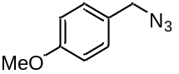General procedure C was followed using 4-methoxybenzylamine (26.0 μL). The product was purified by flash column chromatography using 3% ethyl acetate in pentane to afford 2 (32.4 mg, 99%) as a clear liquid. R_{f} = 0.40 (3% ethyl acetate in pentane). IR (ATR)/cm⁻¹ 2934, 2837, 2088 (N=N), 1610, 1511, 1463, 1241, 1174, 1031, 810, 668, 550. ¹H NMR (400 MHz, CDCl₃) δ 7.26 (d, 2H, J = 8.6 Hz, 2 × Ar-CH), 6.92 (d, 2H, J = 8.6 Hz, 2 × Ar-CH), 4.28 (s, 2H, CH₂), 3.83 (s, 3H, OCH₃). ¹³C NMR (101 MHz, CDCl₃) δ 159.8 (Ar-C_{q}-OMe), 129.9 (2 × Ar-CH), 127.6 (Ar-C_{q}), 114.4 (2 × Ar-CH), 55.5 (CH₂), 54.1 (OCH₃). The observed characterisation data (IR and ¹H) were consistent with that previously reported in the literature.,
4-Methylbenzyl azide (4)
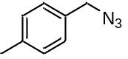General procedure C was followed using 4-methylbenzylamine (25.5 μL). The product was purified by flash column chromatography using 3% ethyl acetate in pentane to afford 4 (21.4 mg, 73%) as a clear liquid. R_{f} = 0.18 (3% ethyl acetate in pentane). IR (ATR)/cm⁻¹ 2922, 2088 (N=N), 1515, 1448, 1252, 1021, 876, 800, 753, 668, 536. ¹H NMR (400 MHz, CDCl₃) δ 7.24−7.18 (m, 4H, 4 × Ar-CH), 4.30 (s, 2H, CH₂), 2.38 (s, 3H, CH₃). ¹³C NMR (101 MHz, CDCl₃) δ 138.3 (Ar-C_{q}), 132.4 (Ar-C_{q}-Me), 129.6 (2 × Ar-CH), 128.4 (2 × Ar-CH), 54.8 (CH₂), 21.3 (CH₃). The observed characterisation data (IR, ¹H and ¹³C NMR) were consistent with that previously reported in the literature.,
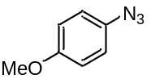1-Azido-4-methoxybenzene (6)
General procedure C was followed using p-anisidine (24.6 mg). The product was purified by flash column chromatography using 3% ethyl acetate in hexane to afford 6 (18.6 mg, 62%) as a dark brown liquid. R_{f} = 0.32 (3% ethyl acetate in hexane). IR (ATR)/cm⁻¹ 2948, 2102 (N=N), 1498, 1282, 1239, 1170, 1103, 1029, 820, 753, 626. ¹H NMR (400 MHz, CDCl₃) δ 6.99–6.95 (m, 2H, 2 × Ar-CH), 6.93–6.87 (m, 2H, 2 × Ar-CH), 3.81 (s, 3H, OCH₃). ¹³C NMR (101 MHz, CDCl₃) δ 157.1 (Ar-C_{q}-OMe), 132.4 (Ar-C_{q}-N₃), 120.1 (2 × Ar-CH), 115.2 (2 × Ar-CH), 55.7 (OCH₃). The observed characterisation data (IR, ¹H and ¹³C NMR) were consistent with that previously reported in the literature.,
4-Chlorobenzyl azide (8)
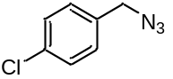General procedure C was followed using 4-chlorobenzylamine (24.3 μL). The product was purified by flash column chromatography using 3% ethyl acetate in pentane to afford 8 (31.1 mg, 93%) as a clear liquid. R_{f} = 0.13 (3% ethyl acetate in pentane). IR (ATR)/cm⁻¹ 2928, 2089 (N=N), 1596, 1491, 1407, 1246, 1089, 1016, 837, 796, 730, 677, 557, 516. ¹H NMR (400 MHz, CDCl₃) δ 7.39 (m, 2H, 2 × Ar-CH), 7.30−7.26 (m, 2H, 2 × Ar-CH), 4.35 (s, 2H, CH₂). ¹³C NMR (101 MHz, CDCl₃) δ 134.4 (Ar-C_{q}-Cl), 134.0 (Ar-C_{q}), 129.7 (2 × Ar-CH), 129.2 (2 × Ar-CH), 54.2 (CH₂). The observed characterisation data (IR, ¹H and ¹³C NMR) were consistent with that previously reported in the literature.

(3-Azidopropyl)benzene (10)
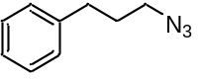General procedure C was followed using 3-phenyl-1-propylamine (28.4 μL). The product was purified by flash column chromatography using 8% ethyl acetate in hexane to afford 10 (25.1 mg, 78%) as a faint yellow liquid. R_{f} = 0.50 (8% ethyl acetate in hexane). IR (ATR)/cm⁻¹ 2925, 2085 (N=N), 1494, 1450, 1252, 743, 697, 566, 491. ¹H NMR (400 MHz, CDCl₃) δ 7.32 (m, 2H, 2 × Ar-CH), 7.26−7.19 (m, 3H, 3 × Ar-CH), 3.31 (t, 2H, J = 6.8 Hz, CH₂N₃), 2.73 (t, 2H, J = 7.6 Hz, PhCH₂), 1.94 (tt, 2H, J = 7.6, 6.8 Hz, CH₂CH₂N₃). ¹³C NMR (101 MHz, CDCl₃) δ 141.0 (Ar-C_{q}), 128.64 (2 × Ar-CH), 128.58 (2 × Ar-CH), 126.3 (Ar-CH), 50.8 (CH₂N₃), 32.9 (PhCH₂), 30.6 (CH₂CH₂N₃). The observed characterisation data (IR, ¹H and ¹³C NMR) were consistent with that previously reported in the literature.,

Batch Synthesis and Characterisation of Triazoles
General Batch Procedure D for One-Pot Diazo Transfer & CuAAC
Using general procedure C for the synthesis of azides, before any work up, phenyl acetylene (28.6 μL, 0.26 mmol, 1.3 equiv) and a solution of sodium ascorbate (119 mg, 0.6 mmol, 3.0 equiv) in water (1 mL) are added. The reaction mixture was stirred at 25 °C for 18 h or 70 °C for 2 h. Sat. aq. NaHCO₃ (10 mL) and ethyl acetate (10 mL) were added. The phases were separated, and the organic extract was washed with sat. aq. NaHCO₃ (4 × 10 mL), dried over sodium sulfate, filtered, and concentrated in vacuo. The residue was then purified by flash column chromatography to afford the triazole product.
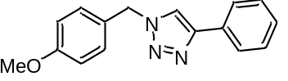1-(4-Methoxybenzyl)-4-phenyl-1H-1,2,3-triazole (11a)
General procedure D was followed, using 4-methoxybenzylamine (25.5 μL). The product was purified by flash column chromatography using 30% ethyl acetate in pentane to afford 11a (52.4 mg, 99%) as a white solid. R_{f} = 0.32 (30% ethyl acetate in pentane). IR (ATR)/cm⁻¹ 2830, 1604, 1507, 1238, 1457, 1238, 1176, 1024, 824, 759, 691. ¹H NMR (400 MHz, CDCl₃) δ 7.80 (d, 2H, J = 7.6 Hz, 2 × Ar-CH), 7.63 (s, 1H, triazole-CH), 7.40 (t, 2H, J = 7.6 Hz, 2 × Ar-CH), 7.34−7.26 (m, 3H, 3 × Ar-CH), 6.92 (d, 2H, J = 8.3 Hz, 2 × Ar-CH), 5.52 (s, 2H, CH₂), 3.82 (s, 3H, OCH₃). ¹³C NMR (101 MHz, CDCl₃) δ 160.1 (Ar-C_{q}-OMe), 148.3 (triazole-C_{q}-Ph), 130.7 (Ar-C_{q}), 129.8 (2 × Ar-CH), 128.9 (2 × Ar-CH), 128.3 (Ar-CH), 126.8 (Ar-C_{q}), 125.8 (2 × Ar-CH), 119.4 (triazole-CH), 114.7 (2 × Ar-CH), 55.5 (CH₂), 53.9 (CH₃). The observed characterisation data (IR, ¹H and ¹³C NMR) were consistent with that previously reported in the literature.,
1-(4-Methylbenzyl)-4-phenyl-1H-1,2,3-triazole (12)
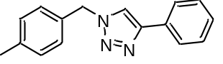General procedure D was followed using 4-methylbenzylamine (25.5 μL). The product was purified by flash column chromatography using 15% ethyl acetate in hexane to afford 12 (50.0 mg, quant.) as a white solid. R_{f} = 0.17 (15% ethyl acetate in hexane). IR (ATR)/cm⁻¹ 3377, 3295, 1461, 1349, 1193, 828, 762, 693. ¹H NMR (400 MHz, CDCl₃) δ 7.79 (d, 2H, J = 7.5 Hz, 2 × Ar-CH), 7.64 (s, 1H, triazole-CH), 7.43−7.37 (m, 2H, 2 × Ar-CH), 7.44−7.29 (m, 1H, Ar-CH), 7.24−7.19 (m, 4H, 4 × Ar-CH), 5.54 (s, 2H, CH₂), 2.37 (s, 3H, CH₃). ¹³C NMR (101 MHz, CDCl₃) δ 148.3 (triazole-C_{q}−Ph), 138.9 (Ar-C_{q}-Me), 131.7 (Ar-C_{q}), 130.6 (Ar-C_{q}), 130.0 (2 × Ar-CH), 128.9 (2 × Ar-CH), 128.3 (Ar-CH), 128.3 (2 × Ar-CH), 125.8 (2 × Ar-CH), 119.6 (triazole-CH), 54.2 (CH₂), 21.3 (CH₃). The observed characterisation data (IR, ¹H and ¹³C NMR) were consistent with that previously reported in the literature.^{23,24}
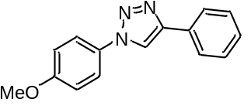1-(4-Methoxyphenyl)-4-phenyl-1H-1,2,3-triazole (13)
General procedure D was followed using p-anisidine (24.6 mg). The product was purified by flash column chromatography using 3% ethyl acetate in hexane to afford 13 (47.3 mg, 94%) as a faint brown solid. R_{f} = 0.32 (3% ethyl acetate in hexane). IR (ATR)/cm⁻¹ 3120, 1607, 1514, 1462, 1230, 1183, 1027, 826, 766, 691, 613, 541, 522. ¹H NMR (400 MHz, CDCl₃) δ 8.13 (s, 1H, triazole-CH), 7.94−7.90 (m, 2H, 2 × Ar-CH), 7.70 (dt, 2H, J = 9.0 Hz, 2.3 Hz, 2 × Ar-CH), 7.50−7.45 (m, 2H, 2 × Ar-CH), 7.40−7.35 (m, 1H, Ar-CH), 7.08−7.03 (m, 2H, 2 × Ar-CH), 3.90 (s, 3H, OCH₃). ¹³C NMR (101 MHz, CDCl₃) δ 160.0 (Ar-C_{q}-OMe), 148.3 (triazole-C_{q}-Ph), 130.6 (Ar-C_{q}), 130.5 (Ar-C_{q}), 129.0 (2 × Ar-CH), 128.5 (Ar-CH), 125.9 (2 × Ar-CH), 122.3 (2 × Ar-CH), 118.0 (triazole-CH), 114.9 (2 × Ar-CH), 55.8 (OCH₃). The observed characterisation data (IR, ¹H and ¹³C NMR) were consistent with that previously reported in the literature.
4-Phenyl-1-(3-phenylpropyl)-1H-1,2,3-triazole (14)
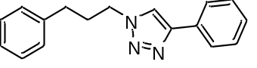General procedure D was followed using 3-phenyl-1-propylamine (28.4 μL). The product was purified by flash column chromatography using 3% ethyl acetate in hexane to afford 14 (47.6 mg, 90%) as a white solid. R_{f} = 0.54 (10% ethyl acetate in hexane). IR (ATR)/cm⁻¹ 3082, 3020, 2934, 1446, 1220, 1192, 1079, 1026, 977, 765, 745, 692, 565, 513. ¹H NMR (400 MHz, CDCl₃) δ 7.84 (d, 2H, J = 7.6 Hz, 2 × Ar-CH), 7.73 (s, 1H, triazole-CH), 7.44 (t, 2H, J = 7.6 Hz, 2 × Ar-CH), 7.37−7.29 (m, 3H, 3 × Ar-CH), 7.26−7.18 (m, 3H, 3 × Ar-CH), 4.42 (t, 2H, J = 7.3 Hz, CH₂N), 2.71 (t, 2H, J = 7.3 Hz, PhCH₂), 2.32 (tt, 2H, J = 7.3, 7.3 Hz, CH₂CH₂N). ¹³C NMR (101 MHz, CDCl₃) δ 147.9 (triazole-C_{q}-Ph), 140.2 (Ar-C_{q}), 130.8 (Ar-C_{q}), 128.9 (2 × Ar-CH), 128.7 (2 × Ar-CH), 128.6 (2 × Ar-CH), 128.2 (Ar-CH), 126.5 (Ar-CH), 125.8 (2 × Ar-CH), 119.7 (triazole-CH), 49.7 (CH₂N), 32.6 (PhCH₂), 31.8 (CH₂CH₂N). The observed characterisation data (IR, ¹H and ¹³C NMR) were consistent with that previously reported in the literature.

Semi-batch array preparation of triazoles
General procedure E for semi-batch array
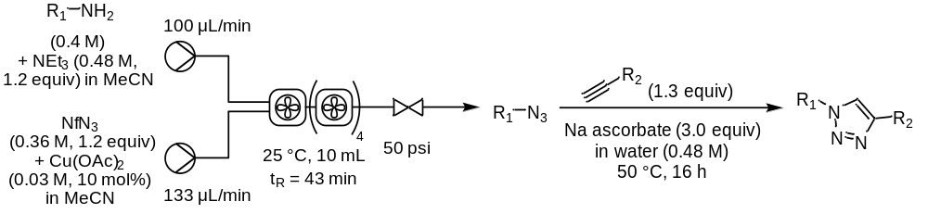
The desired amine (8.0 mmol) and triethylamine (1.34 mL, 9.6 mmol, 1.2 equiv) were dissolved in acetonitrile to give 20 mL of 0.40 M solution w.r.t. amine (0.48 M w.r.t. triethylamine). Nonaflyl azide (1.73 mL, 9.0 mmol, 1.2 equiv) and copper acetate (137 mg, 0.75 mmol, 10 mol%) were dissolved in acetonitrile to give 25 mL of 0.36 M solution (0.03 M w.r.t. copper acetate). Both solutions were connected to peristaltic pumps which were connected to 5 fReactors in series. The amine solution had a flow rate of 100 μL min⁻¹, and the nonaflyl azide solution had a flow rate of 133 μL min⁻¹, giving an estimated total flow rate of 233 μL min⁻¹ and a residence time of 43 min. Sodium ascorbate (119 mg, 0.6 mmol, 3 equiv) was dissolved in water (1 mL) four times in four separate microwave vials. Each of the tested alkynes (0.26 mmol, 1.3 equiv) was added to one of these microwave vials.
After purging the flow reactor for 90 min (2 reactor volumes), the output line of the azide reaction mixture was directed into each of the stirred microwave vials for 5 min per vial, to collect 0.2 mmol azide reaction (assuming 100% conversion from amine to azide). Each vial was then sealed and stirred at 50 °C for 16 h. The reactions were then diluted with EtOAc (10 mL) and saturated NaHCO₃ (10 mL), the layers separated and the organic phase washed with saturated aq. NaHCO₃ solution (4 × 10 mL). The organic phase was dried over sodium sulfate, filtered, and concentrated in vacuo.
1-(4-Methoxybenzyl)-4-phenyl-1H-1,2,3-triazole (11a)
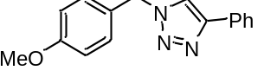General procedure E was followed using 4-methoxybenzylamine (1.05 mL, 8.0 mmol) and phenyl acetylene (29 μL, 0.26 mmol, 1.3 equiv). Purification by column chromatography on silica (20% EtOAc/pentane) afforded compound 11a as a white solid (40.0 mg, 75%). R_{f} 0.09 (20% EtOAc/pentane). ¹H NMR (400 MHz, CDCl₃) δ 7.82 (d, J = 7.6 Hz, 2H, 2 × Ar-CH), 7.65 (s, 1H, triazole-C‍H), 7.42 (dd, J = 7.6, 7.6 Hz, 2 × Ar-CH), 7.37–7.26 (m, 3 × Ar-CH), 6.94 (d, J = 8.2 Hz, 2H, 2 × Ar-CH), 5.54 (s, 2H, CH₂), 3.84 (s, 3H, OCH₃). ¹³C NMR (101 MHz, CDCl₃) δ 160.0 (Ar-C_{q}-OMe), 148.2 (triazole-C_{q}-Ph), 130.7 (Ar-C_{q}), 129.8 (2 × Ar-CH), 128.9 (2 × Ar-CH), 128.2 (Ar-CH), 126.7 (Ar-C_{q}), 125.8 (2 × Ar-CH), 119.4 (triazole-CH), 114.6 (2 × Ar-CH), 55.4 (CH₂), 53.9 (CH₃). The observed characterisation data (¹H and ¹³C NMR) was consistent with that previously reported in the literature, and obtained in this work.^{23,24}
(1-(4-Methoxybenzyl)-1H-1,2,3-triazol-4-yl)methanol (11b)
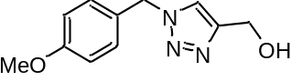General procedure E was followed using 4-methoxybenzylamine (1.05 mL, 8.0 mmol) and propargyl alcohol (15 μL, 0.26 mmol, 1.3 equiv). Purification by column chromatography on silica (100% EtOAc) afforded compound 11b as a white solid (27.9 mg, 64%). R_{f} 0.13 (100% EtOAc). IR (film)/cm⁻¹: 3432 (br, OH), 3105, 3061, 2944, 1438, 1610, 1513, 1248, 1219, 1180, 1030, 1006, 827, 845, 780, 547, 520. ¹H NMR (400 MHz, CDCl₃) δ 7.42 (s, 1H, triazole-CH), 7.23 (d, J = 8.6 Hz, 2 × Ar-CH), 6.89 (d, J = 8.6 Hz, 2H, 2 × Ar-CH), 5.44 (s, 2H, Ar-C_{q}-CH₂), 4.74 (s, 2H, CH₂OH), 3.80 (s, 3H, OCH₃). ¹³C NMR (101 MHz, CDCl₃) δ 160.1 (Ar-C_{q}-OMe),148.1 (triazole-C_{q}), 129.9 (2 × Ar-CH), 126.6 (Ar-C_{q}-CH₂), 121.5 (triazole-CH), 114.6 (2 × Ar-CH), 56.6 (Ar-CH₂), 55.5 (OCH₃), 53.9 (CH₂OH). HRMS (TOF MS ES+) m/z Calcd for C₁₁H₁₄N₃O₂ [M+H]: 220.1086; Found 220.1080. The observed characterisation data (¹H and ¹³C NMR) were consistent with that previously reported in the literature.
1-(4-Methoxybenzyl)-4-phenethyl-1H-1,2,3-triazole (11c)
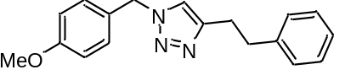General procedure E was followed using 4-methoxybenzylamine (1.05 mL, 8.0 mmol) and 4-phenyl-1-butyne (37 μL, 0.26 mmol, 1.3 equiv). Purification by column chromatography on silica (20 to 30% EtOAc/pentane) afforded compound 11c as a white solid (38.7 mg, 66%). m.p. = 89–92 °C. R_{f} 0.19 (30% EtOAc/pentane). IR (film)/cm⁻¹: 3107, 3059, 2939, 2844, 1608, 1513, 1451, 1337, 1297, 1245, 1210, 1181, 1127, 1050, 1025, 844, 823, 776, 718, 694, 670, 648, 546, 517. δ ¹H NMR (400 MHz, CDCl₃) δ 7.30–7.30 (m, 2H 2 × Ar-CH), 7.22–7.14 (m, 5H, 5 x Ar-CH), 7.03 (s, 1H, triazole-CH), 6.93–6.88 (m, 2H, 2 × Ar-CH), 5.42 (s, 2H, Ar-CH₂), 3.83 (s, 3H, OCH₃), 3.07–2.93 (m, 4H, CH₂CH₂). ¹³C NMR (101 MHz, CDCl₃) δ 159.9 (Ar-C_{q}-OMe), 147.7 (triazole-C_{q}), 141.3 (Ar-C_{q}-CH₂), 129.6 (2 × Ar-CH), 128.6 (2 × Ar-CH), 128.6 (2 × Ar-CH), 127.0 (Ar-C_{q}), 126.1 (Ar-CH), 120.8 (triazole-CH), 114.5 (2 x Ar-CH), 55.4 (OCH₃), 53.6 (Ar-CH₂), 35.7 (triazole-CH₂CH₂), 27.7 (triazole-CH₂CH₂). HRMS (TOF MS ES+) m/z Calcd for C₁₈H₂₀N₃O [M+H]: 294.1606; Found 294.1607.
1-(4-Methoxybenzyl)-1H-1,2,3-triazole-4-carboxamide (11d)
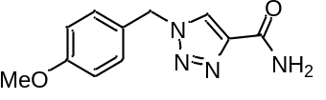General procedure E was followed using 4-methoxybenzylamine (1.05 mL, 8.0 mmol) and propiolamide (18 mg, 0.26 mmol, 1.3 equiv). Purification by column chromatography on silica (50 to 60% EtOAc/dichloromethane) afforded compound 11d as a white solid (29.1 mg, 63%). m.p. > 200 °C, no decomp observed. R_{f} 0.19 (50% EtOAc/dichloromethane). IR (film)/cm⁻¹: 3401 (br, NH), 3093, 1617 (C=O), 1512, 1245, 1031, 768, 557, 446. ¹H NMR (400 MHz, DMSO) δ 8.55 (s, 1H, triazole-CH), 7.86 (s, 1H, NHH), 7.47 (s, 1H, NHH), 7.33 (d, J = 8.5 Hz, 2H, 2 × Ar-CH), 6.92 (d, J = 8.5 Hz, 2H, 2 × Ar-CH), 5.55 (s, 2H, CH₂), 3.73 (s, 3H, OCH₃). ¹³C NMR (101 MHz, DMSO) δ 161.4 (d, J = 5.5 Hz, C=O), 159.2 (Ar-C_{q}-OMe), 143.1 (d, J = 1.9 Hz, triazole-C_{q}), 129.7 (2 × Ar-CH), 127.6 (Ar-C_{q}-CH₂), 126.3 (triazole–CH), 114.2 (2 × Ar-CH), 55.2 (CH₂), 52.6 (OCH₃). HRMS (TOF MS ES+) m/z Calcd for C₁₁H₁₃N₄O₂ [M+H]: 233.1039; Found 233.1027.
1-(2,6-Difluorobenzyl)-4-phenyl-1H-1,2,3-triazole (15a)
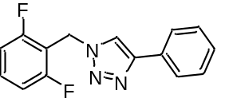General procedure E was followed using 2,6-difluorobenzylamine (0.96 mL, 8.0 mmol) and phenyl acetylene (29 μL, 0.26 mmol, 1.3 equiv). Purification by flash column chromatography (20% EtOAc/pentane) afforded 15a as a white solid (43 mg, 80%). m.p. = 163–165°C. R_{f} 0.20 (20% EtOAc/pentane). IR (film)/cm⁻¹ 3129, 1627, 1592, 1471, 1440, 1224, 1142, 1078, 1047, 1019, 799, 767, 693. ¹H NMR (400 MHz, CDCl₃) δ 7.83–7.77 (m, 3H, 2 × Ar-CH and triazole-CH), 7.44–7.28 (m, 4H, 4 × Ar-CH), 7.02–6.94 (m, 2H, 2 × Ar-CH), 5.67 (s, 2H, Ar-CH₂). ¹³C NMR (101 MHz, CDCl₃) δ 161.5 (dd, ^{1,3}J_{C-F} = 251.3, 7.0 Hz, 2 × Ar-CF), 148.2 (Ar_{(triazole)}–C_{q}), 131.6 (dd, ³J_{C-F} = 10.4, 10.4 Hz, Ar-CH), 130.5 (s, Ar-C_{q}), 128.9 (2 × Ar-CH), 128.3 (Ar-CH), 125.9 (2 × Ar-CH), 119.7 (triazole-CH), 112.3–111.7 (m, 2 × Ar-CH), 111.0 (dd, ²J_{C-F} = 18.9, 18.9 Hz, Ar-C_{q}), 41.6 (dd, ³J_{C-F} = 4.1, 4.1 Hz, CH₂). ¹⁹F NMR (377 MHz, CDCl₃) δ −114.0 Hz (2 × Ar-CF). HRMS (+ APCI) m/z calcd. For C₁₅H₂₀N₃ [M+H]: 272.0994; found: 272.0943.

(1-(2,6-Difluorobenzyl)-1H-1,2,3-triazol-4-yl)methanol (15b)
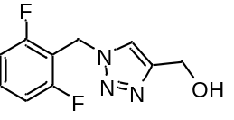General procedure E was followed using 2,6-difluorobenzylamine (0.96 mL, 8.0 mmol) and propargyl alcohol (15 μL, 0.26 mmol, 1.3 equiv). Purification by flash column chromatography (80% EtOAc/pentane) afforded 15b as a white solid (17 mg, 38%). m.p. = 113–114°C. R_{f} 0.29 (80% EtOAc/pentane). IR (film)/cm⁻¹ 3225 (br, OH), 3131, 3087, 2915, 1625, 1592, 1470, 1232, 1128, 1027, 838, 805, 783, 769, 718, 545. ¹H NMR (400 MHz, MeOD) δ 7.93 (s, 1H, triazole−CH), 7.52–7.42 (m, 1H, Ar-CH), 7.11–7.02 (m, 2H, 2 × Ar-CH), 5.70 (s, 2H, Ar-CH₂), 4.66 (s, 2H, CH₂OH). ¹³C NMR (101 MHz, MeOD) δ 162.8 (dd, ^{1,3}J_{C-F} = 249.9, 7.1 Hz, 2 × Ar-CF), 149.3 (triazole-C_{q}), 132.9 (dd, ³J_{C-F} = 10.6, 10.6 Hz, Ar-CH), 124.2 (triazole-CH), 113.0–112.6 (m, 2 × Ar-CH), 112.4 (dd, ²J_{C-F} = 19.3, 19.3 Hz, Ar-C_{q}), 56.4 (CH₂OH), 42.4 (dd, J_{C–F} = 4.2, 4.2 Hz, Ar-CH₂). ¹⁹F NMR (377 MHz, MeOD) δ −116.6 (2 × Ar-CF). The observed characterisation data (¹H and ¹³C NMR) were consistent with that previously reported in the literature.
1-(2,6-Difluorobenzyl)-4-phenethyl-1H-1,2,3-triazole (15c)
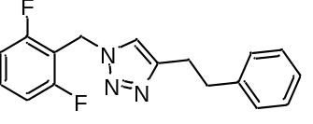General procedure E was followed using 2,6-difluorobenzylamine (0.96 mL, 8.0 mmol) and 4-phenyl-1-butyne (37 μL, 0.26 mmol, 1.3 equiv). Purification by flash column chromatography (25% EtOAc/pentane) afforded 15c as a white solid (38 mg, 64%). m.p. = 83–84 °C. R_{f} 0.27 (20% EtOAc/pentane). IR (film)/cm⁻¹ 3063, 3027, 2928, 2858, 1626, 1594, 1471, 1452, 1236, 1045, 1029, 798, 773, 750, 700, 496. ¹H NMR (400 MHz, CDCl₃) δ 7.43–7.34 (m, 1H, Ar-CH), 7.30–7.24 (m, 2H, 2 × Ar-CH), 7.23–7.14 (m, 4H, 3 × Ar-CH and triazole-CH), 7.01–6.96 (m, 2H, 2 × Ar-CH), 5.58 (s, 2H, Ar-CH₂), 3.07–2.95 (m, 4H, CH₂CH₂). ¹³C NMR (101 MHz, CDCl₃) δ 161.5 (dd, ^{1,3}J_{C-F} = 251.3, 6.9 Hz, 2 × Ar-CF), 147.6 (triazole-C_{q}), 141.2 (Ar-C_{q}), 131.4 (dd, ³J = 10.6, 10.6 Hz, Ar-CH), 128.6 (2 × Ar-CH), 128.4 (2 × Ar-CH), 126.2 (Ar-CH), 121.1 (triazole-CH), 112.3–111.6 (m, J = 19.1, 5.7 Hz, 2 × Ar-CH), 111.1 (dd, ²J = 19.0 Hz, Ar-C_{q}), 41.3 (dd, J = 4.0, 4.0 Hz, Ar-CH₂N), 35.6 (CH₂CH₂), 27.6 (CH₂CH₂). ¹⁹F NMR (377 MHz, CDCl₃) – 114.0 (2 × Ar−CF). For C₁₇H₁₆N₃F₂ [M+H]: 300.1306; found: 300.1273.
1-(2,6-Difluorobenzyl)-1H-1,2,3-triazole-4-carboxamide (15d)
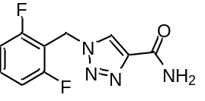General procedure E was followed using 2,6-difluorobenzylamine (0.96 mL, 8.0 mmol) and propiolamide (18 mg, 0.26 mmol, 1.3 equiv). Purification by flash column chromatography (50% EtOAc/CH₂Cl₂) afforded 15d as a white solid (28 mg, 60%). m.p. > 200 °C, no decomp observed. R_{f} 0.27 (50% EtOAc/CH₂Cl₂). IR (film)/cm⁻¹ 3391, 3136, 1652, 1624, 1471, 1596, 1557, 1471, 1388, 1235, 1034, 1010, 875, 793, 691, 642, 548, 493. ¹H NMR (400 MHz, DMSO) δ 8.56 (s, 1H, triazole-CH), 7.87 (s, 1H, NHH), 7.60–7.46 (m, 2H, NHH and Ar-CH), 7.24–7.14 (m, 2H, 2 × Ar-CH), 5.72 (s, 2H, Ar-CH₂). ¹³C NMR (101 MHz, DMSO) δ 162.1 (dd, ^{1,3}J_{C-F} = 249.4 Hz, 7.2 Hz, 2 × Ar–CF), 161.3 (C=O), 142.9 (triazole-C_{q}), 131.9 (dd, ³J_{C-F} = 10.4 Hz, Ar-CH), 126.8 (triazole-CH), 112.2–111.8 (m, 2 × Ar-CH), 111.1 (dd, ²J_{C-F} = 19.0 Hz, Ar-C_{q}), 41.2 (dd, ³J_{C-F} = 3.8 Hz, CH₂). ¹⁹F NMR (377 MHz, CDCl₃) –114.5 (2 × Ar−CF). The observed characterisation data (¹H and ¹³C NMR) were consistent with that previously reported in the literature.,
1-((1r,4r)-4-Methylcyclohexyl)-4-phenyl-1H-1,2,3-triazole (16a)
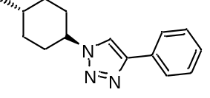General procedure E was followed using trans-4-methylcyclohexylamine (1.05 mL, 8.0 mmol) and phenyl acetylene (29 μL, 0.26 mmol, 1.3 equiv). Purification by flash column chromatography (15% EtOAc/pentane) afforded 16a as a white solid (42 mg, 87%). m.p. = 133–138°C. R_{f} 0.25 (20% EtOAc/pentane). IR (film)/cm⁻¹ 2932, 2866, 1387, 1352, 1234, 1191, 1138, 1084, 1039, 1014, 763, 694, 587, 496. ¹H NMR (400 MHz, CDCl₃) δ 7.90–7.77 (m, 3H, 2 × Ar-CH and triazole-CH), 7.47–7.39 (m, 2H, 2 × Ar-CH) 7.42–7.26 (m, 1H, Ar-CH), 4.47 (tt, J = 12.0, 3.9 Hz, 1H, NCH(CH₂)₂), 2.30–2.18 (m, 2H, NCH(CHH)₂), 1.96–1.76 (m, 4H, 2 × NCH(CHH)₂ and 2 × CHHCH(CH₃)), 1.59–1.45 (m, 1H, CH(CH₃)), 1.28–1.12 (m, 2H, 2 × CHHCH(CH₃)), 0.98 (d, J = 6.5 Hz, 3H, CH₃). ¹³C NMR 13C NMR (101 MHz, CDCl3) δ 130.7 (Ar-C_{q}), 129.0 (2 × Ar-CH), 128.3 (Ar-CH), 125.8 (2 × Ar-CH), 60.5 (NCH(CH₂)), 33.8 (2 × CH₂CH(CH₃)), 33.5 (2 × NCH(CH₂)₂), 31.8 (CH(CH₃)), 22.1 (CH₃). HRMS (TOF–ES+) m/z calcd. For C₁₅H₂₀N₃ [M+H]: 242.1657; found: 242.1649. Note, triazole signals in ¹³C could not be identified due to low intensity peaks.
trans-Product stereochemistry was assigned based on the presence of H_{ax}–H_{ax} splitting patterns observed for proton signals at the two stereocenters.
(1-((1r,4r)-4-Methylcyclohexyl)-1H-1,2,3-triazol-4-yl)methanol (16b)
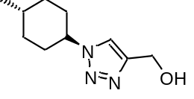General procedure E was followed using trans-4-methylcyclohexylamine (1.05 mL, 8.0 mmol) and propargyl alcohol (15 μL, 0.26 mmol, 1.3 equiv). Purification by flash column chromatography (80% EtOAc/pentane) afforded 16b as a white solid (18 mg, 46%). m.p. = 98–104°C. IR (film)/cm⁻¹ 3315 (br, OH), 2946, 2930, 2865, 1452, 1378, 1234, 1196, 1142, 1047, 1016, 805. ¹H NMR (400 MHz, CDCl₃) δ 7.92 (br s, 1H, triazole–CH), 4.93 (br s, 2H, CH₂OH), 4.44 (t, J = 12.0 Hz, 1H, NCH(CH₂)₂), 3.32 (br s, 1H, OH) 2.20 (d, J = 11.9 Hz, 2H, NCH(CHH)₂), 1.90 (d, J = 13.4 Hz, 2H, 2 × CHHCH(CH₃)), 1.85–1.72 (m, 2H, 2 × NCH(CHH)₂), 1.55–1.42 (m, 1H, CH(CH₃)), 1.23–1.09 (m, 2H, CHHCH(CH₃)), 0.96 (d, J = 6.4 Hz, 3H, CH₃). ¹³C NMR (126 MHz, CDCl₃) δ 60.9 (NCH(CH₂)), 55.7 (CH₂OH), 33.7 (2 × CH₂CH(CH₃)), 33.3 (2 × NCH(CH₂)₂), 31.6 (CH(CH₃)), 21.9 (CH₃). HRMS (TOF–ES+) m/z calcd. For C₁₀H₁₈N₃O [M+H]: 196.1450; found: 196.1445. Note there is 9% impurity present in this sample which could not be removed. Triazole peaks in ¹³C could not be identified due to low intensity peaks.
1-((1r,4r)-4-Methylcyclohexyl)-4-phenethyl-1H-1,2,3-triazole (16c)
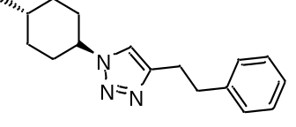General procedure E was followed using trans-4-methylcyclohexylamine (1.05 mL, 8.0 mmol) and 4-phenyl-1-butyne (37 μL, 0.26 mmol, 1.3 equiv). Purification by flash column chromatography (15 to 20% EtOAc/pentane) afforded 16c as a white solid (14 mg, 26%), m.p. = 97–109°C. R_{f} 0.29 (20% EtOAc/pentane). IR (film)/cm⁻¹ 3063, 3124, 3027, 2944, 2926, 2863, 1603, 1545, 1496, 1452, 1237, 1215, 1140, 1052, 828, 730, 697, 670. ¹H NMR (400 MHz, CDCl₃) δ 7.31–7.27 (m, 2H, 2 × Ar-CH), 7.23–7.20 (m, 1H, Ar-CH), 7.20–7.16 (m, 2H, 2 × Ar-CH), 7.12 (s, 1H, triazole-CH), 4.36 (tt, J = 12.1, 3.9 Hz, 1H, NCH(CH₂)₂), 3.09–3.03 (m, 2H, CHHCHHPh), 3.03–2.98 (m, 2H, CHHCHHPh), 2.20–2.13 (m, 2H, NCH(CHH)₂), 1.92–1.85 (m, 2H, 2 × CHHCH(CH₃)), 1.78–1.67 (m, 2H, NCH(CHH)₂), 1.53–1.42 (m, 1H, CH(CH₃)), 1.20–1.10 (m, 2H, 2 × CHHCH(CH₃)), 0.96 (d, J = 6.5 Hz, 3H, CH₃). ¹³C NMR (126 MHz, CDCl₃) δ 146.5 (triazole-C_{q}), 141.2 (Ar-C_{q}), 128.6 (2 × Ar-CH), 128.5 (2 × Ar-CH), 126.3 (Ar-CH), 119.1 (triazole-CH), 60.3 (NCH(CH₂)), 35.7 (CH₂CH₂Ph or CH₂CH₂Ph), 33.8 (2 × CH₂CH(CH₃)), 33.4 (2 × NCH(CH₂)₂), 31.8 CH(CH₃), 27.5 (CH₂CH₂Ph or CH₂CH₂Ph), 22.1 (CH₃). HRMS (TOF–ES+) m/z calcd. For C₁₇H₂₄N₃ [M+H]: 270.1970; found: 270.1980.
1-((1r,4r)-4-Methylcyclohexyl)-1H-1,2,3-triazole-4-carboxamide (16d)
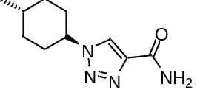General procedure E was followed using trans-4-methylcyclohexylamine (1.05 mL, 8.0 mmol) and propiolamide (18 mg, 0.26 mmol, 1.3 equiv). Purification by flash column chromatography (80% EtOAc/pentane) afforded 16d as a white solid (21 mg, 39%). ¹H NMR (400 MHz, DMSO-d₆) δ 8.58 (s, 1H, triazole-CH), 7.82 (s, 1H, NHH), 7.44 (s, 1H, NHH), 4.48 (tt, J = 11.6, 3.8 Hz, 1H, NCH(CH₂)₂), 2.10–2.01 (m, 2H, NCH(CHH)₂), 1.90–1.73 (m, 4H, 2 × NCH(CHH)₂ and 2 × CHHCH(CH₃)), 1.52–1.38 (m, 1H, CH(CH₃)), 1.21–1.04 (m, 2H, 2 × CHHCH(CH₃)), 0.91 (d, J = 6.5 Hz, 3H, CH₃). ¹³C NMR (101 MHz, DMSO-d₆) δ 161.7 (C=O), 142.7 (triazole-C_{q}), 124.7 (triazole-CH), 59.4 (NCH(CH₂)₂), 33.2 (2 × CH₂CH(CH₃)), 32.5 (2 × (NCH(CH₂)₂), 31.0 (CH(CH₃)), 21.9 (CH₃). HRMS (TOF–ES+) m/z calcd. For C₁₀H₁₇N_{4O} [M+H]: 209.1402; found: 209.1400.

¹H and ¹³C NMR Spectra of Selected Compounds
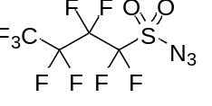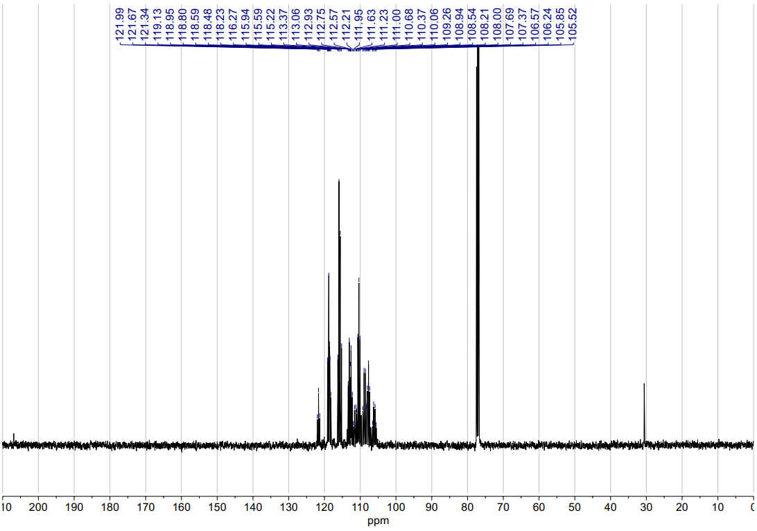
NfN₃
¹³C NMR (101 MHz, CDCl₃)
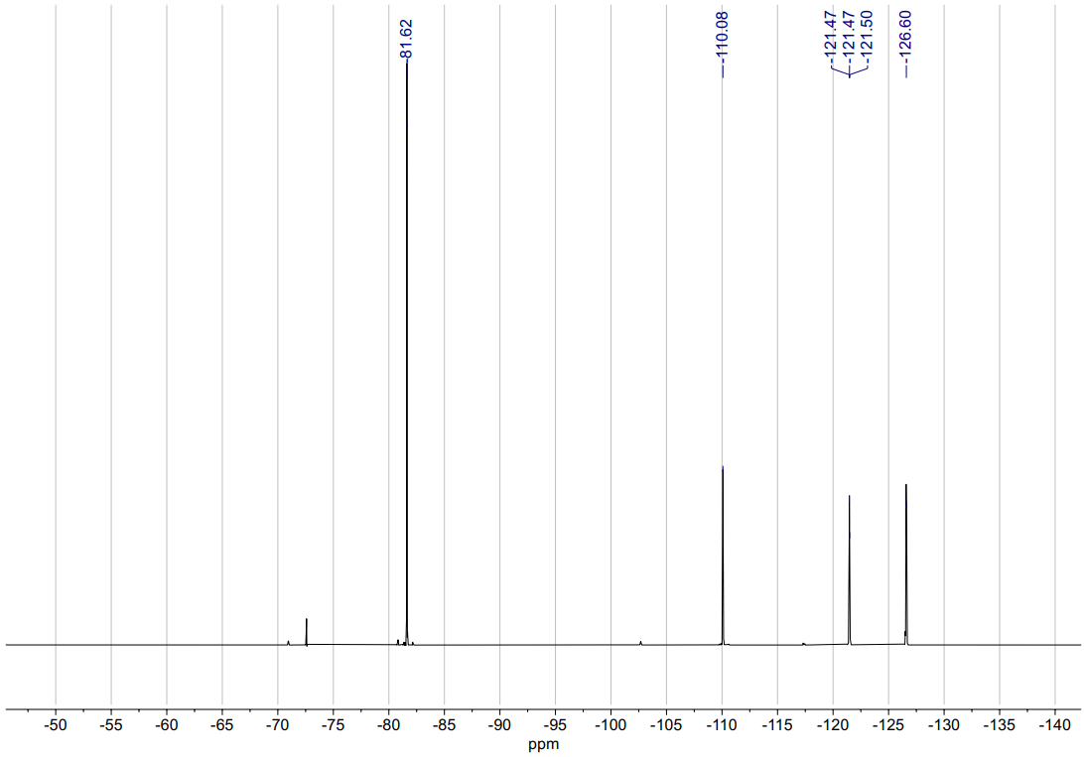
NfN₃
¹⁹F NMR (377 MHz, CDCl₃)
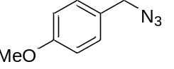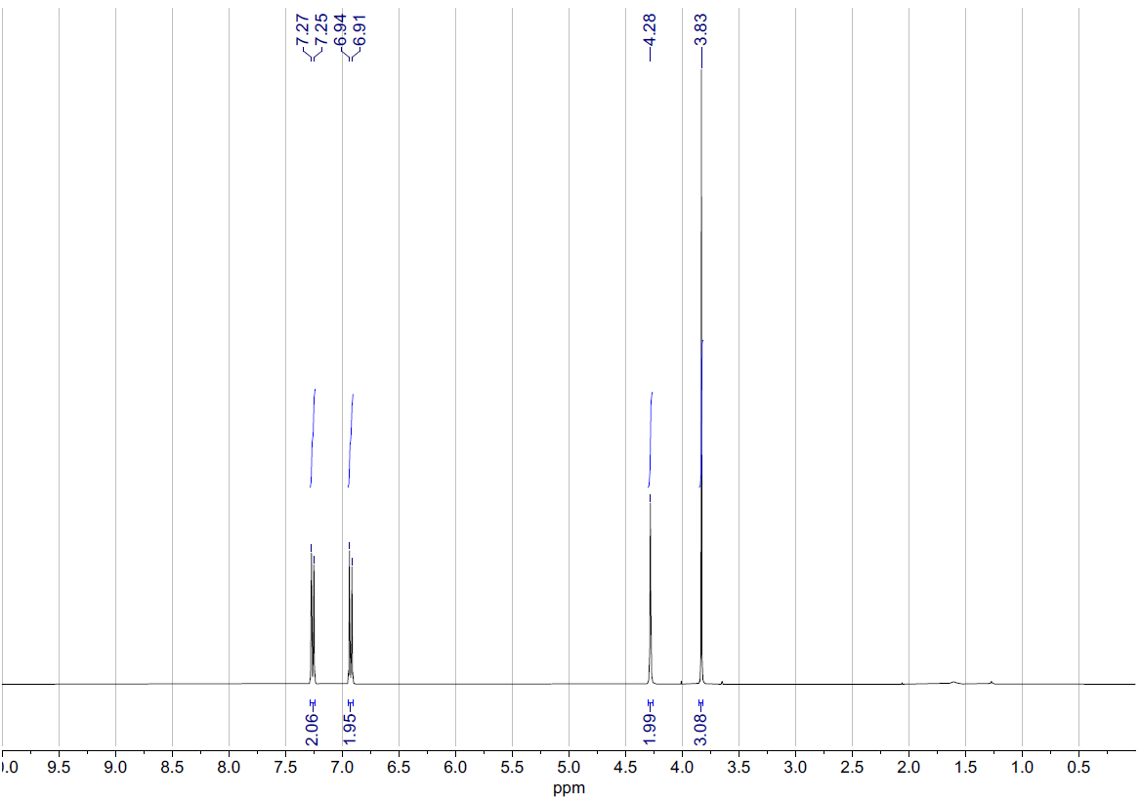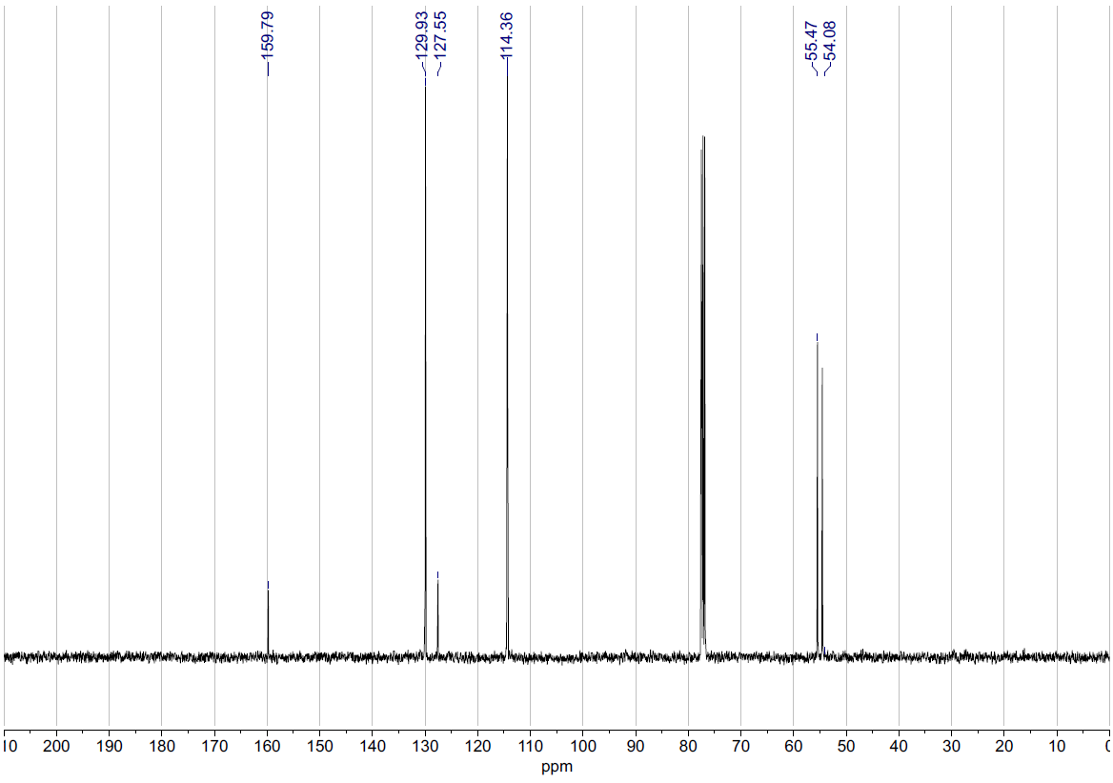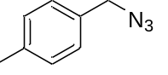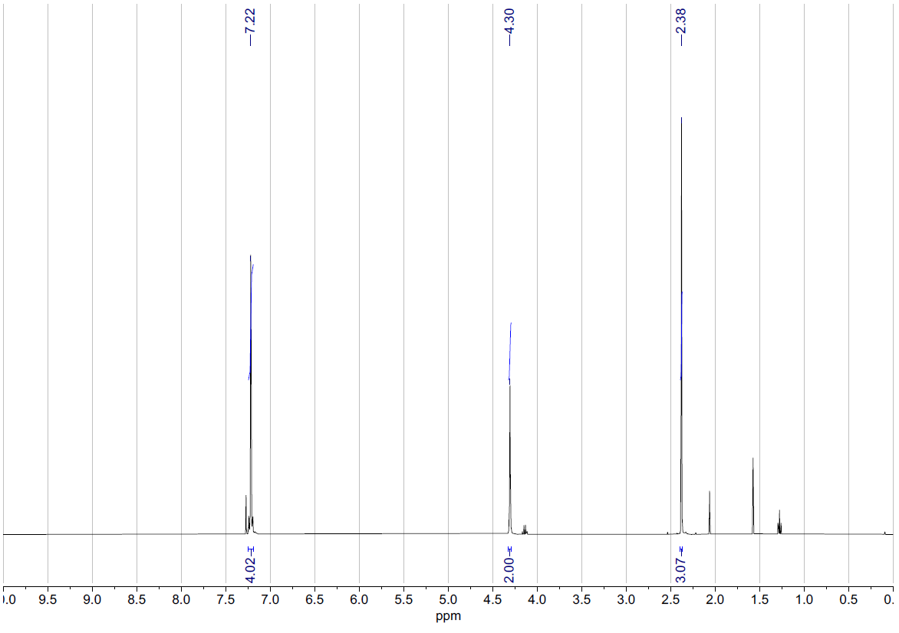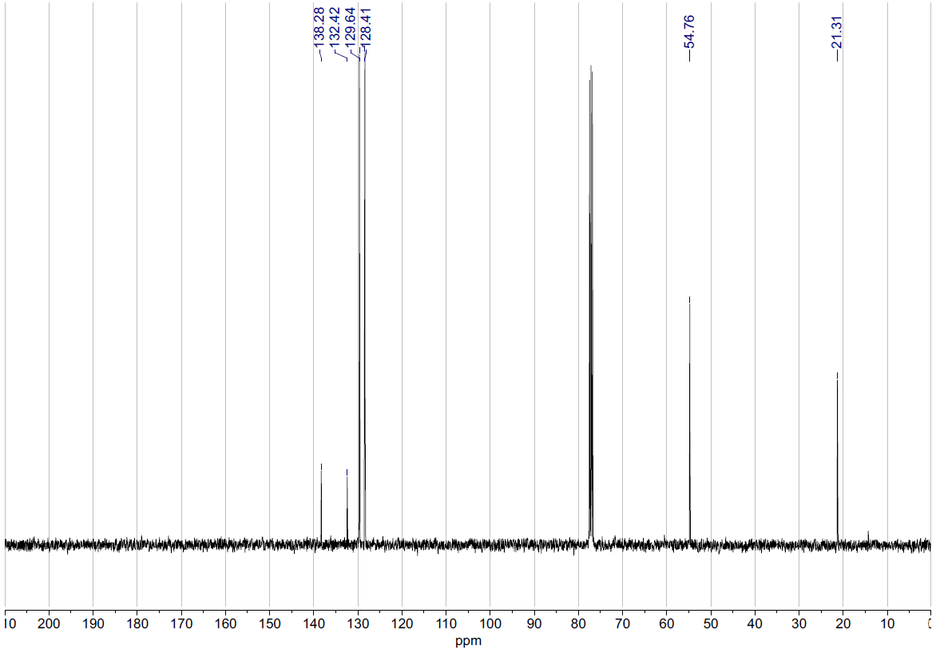
2
¹H NMR (400 MHz, CDCl₃)
2
¹³C NMR (101 MHz, CDCl₃)

4
¹H NMR (400 MHz, CDCl₃)

4
¹³C NMR (101 MHz, CDCl₃)

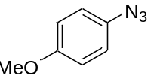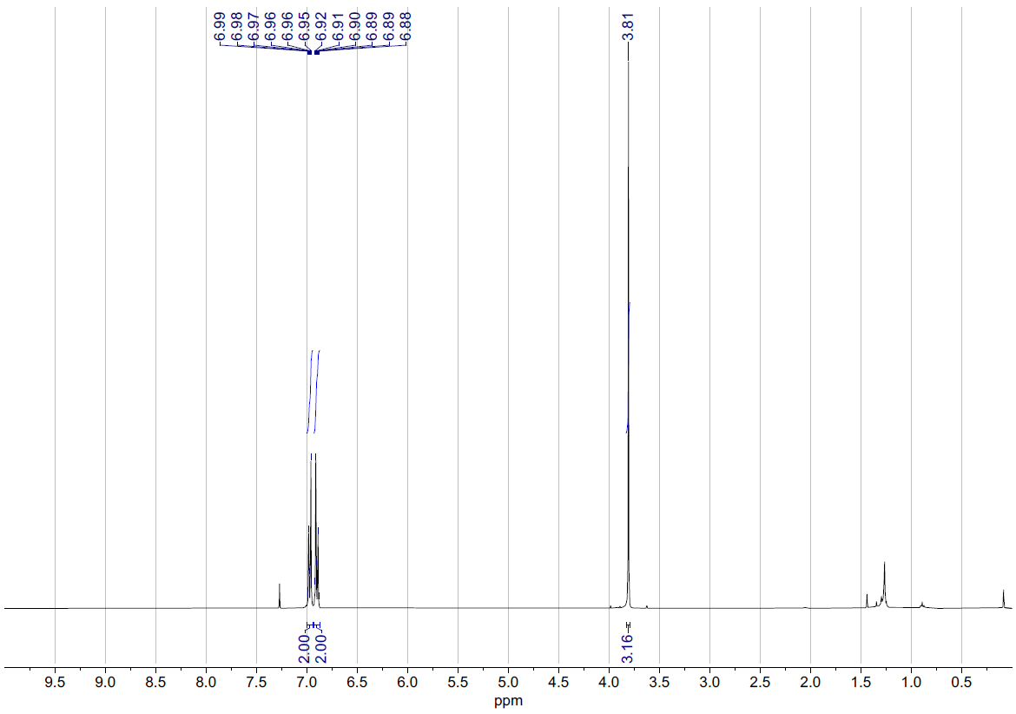
6
¹H NMR (400 MHz, CDCl₃)

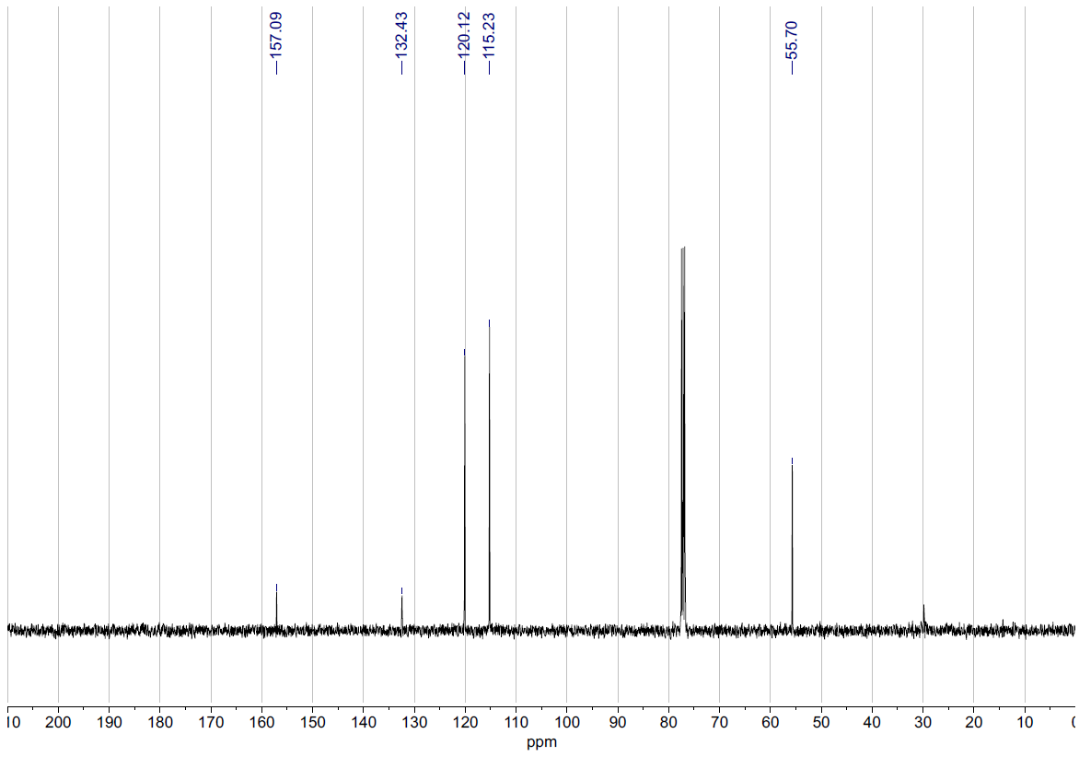
6
¹³C NMR (101 MHz, CDCl₃)

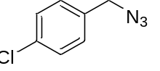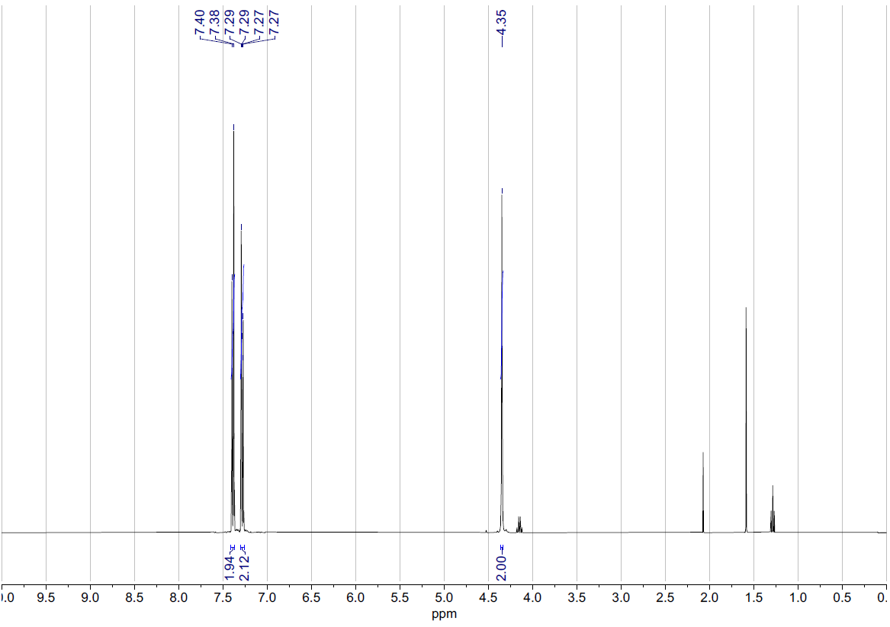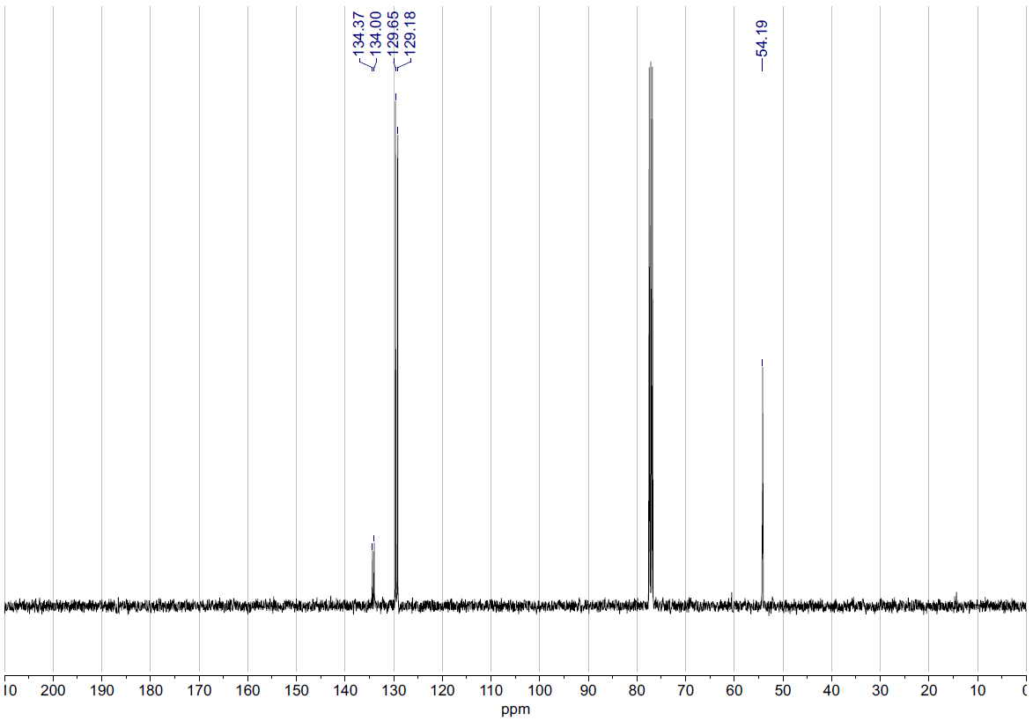
8
¹H NMR (400 MHz, CDCl₃)

8
¹³C NMR (101 MHz, CDCl₃)

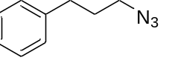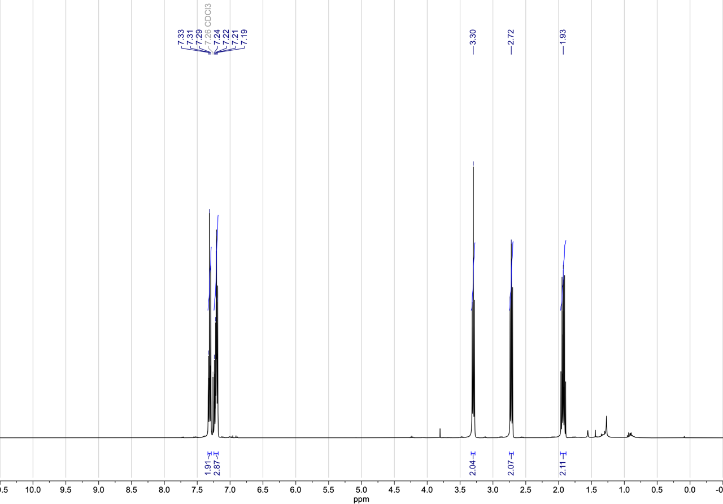
10
¹H NMR (400 MHz, CDCl₃)

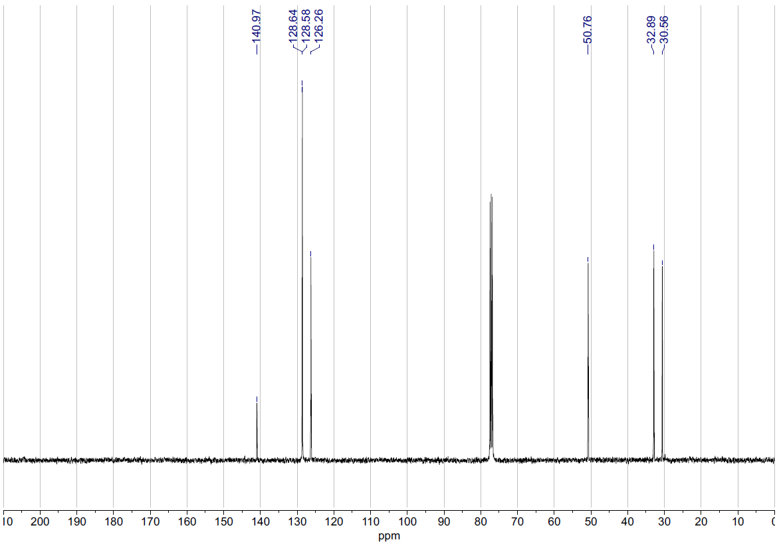
10
¹³C NMR (101 MHz, CDCl₃)
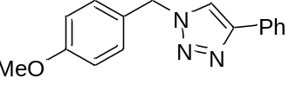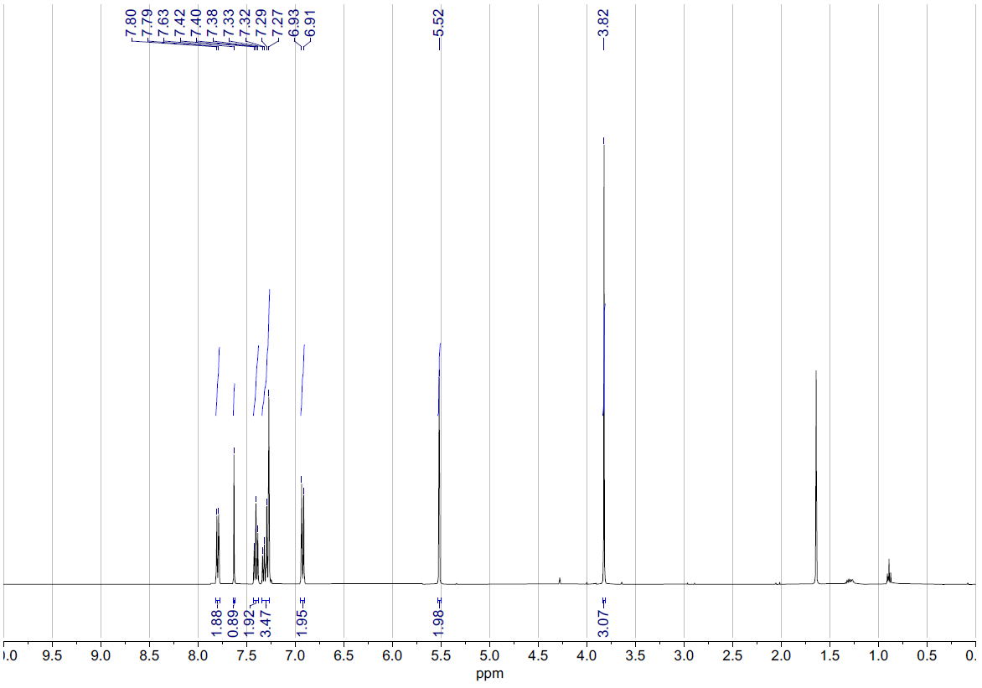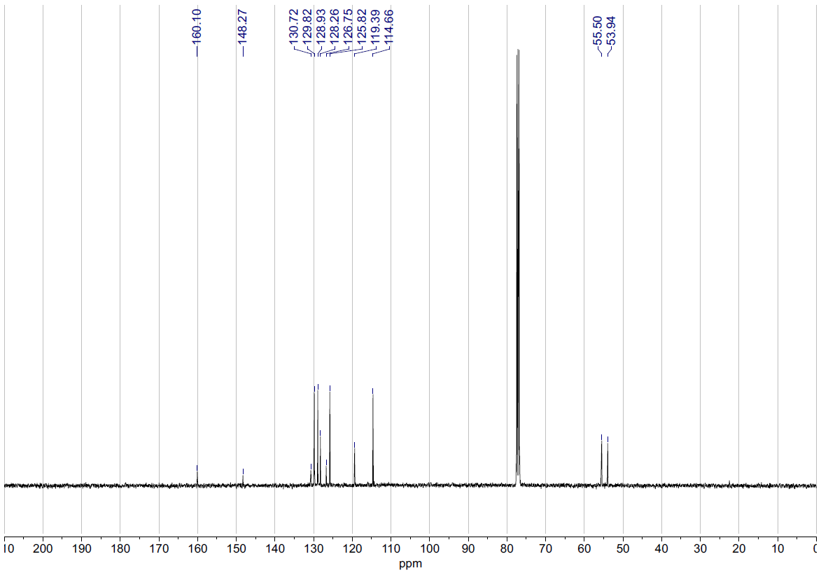
11a (batch prep)
¹³C NMR (101 MHz, CDCl₃)

11a (batch prep)
¹H NMR (400 MHz, CDCl₃)

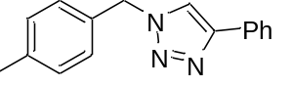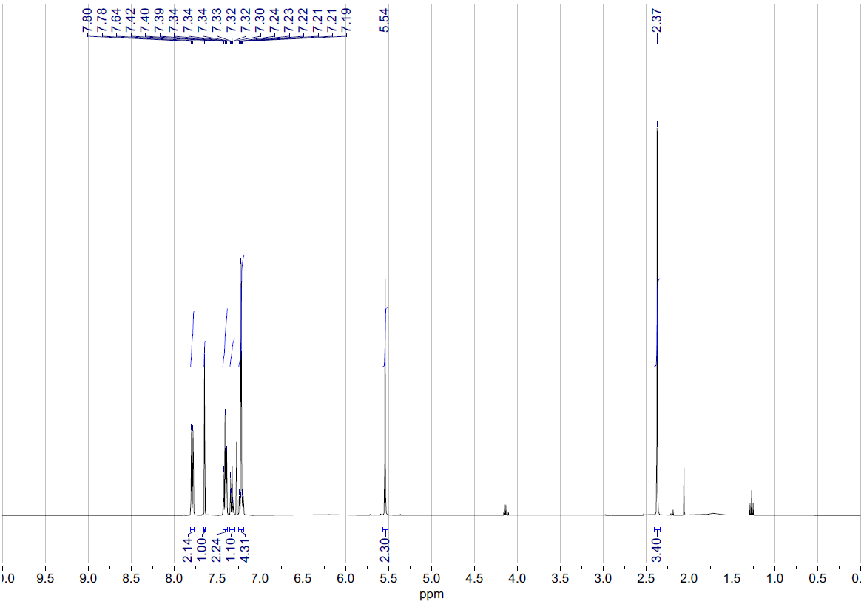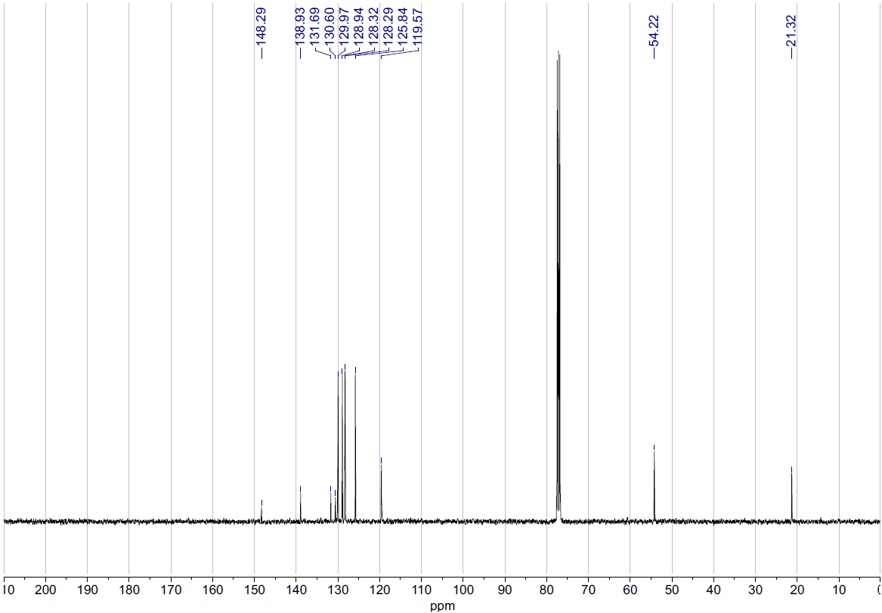
12
¹H NMR (400 MHz, CDCl₃)

12
¹³C NMR (101 MHz, CDCl₃)
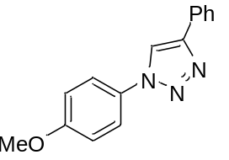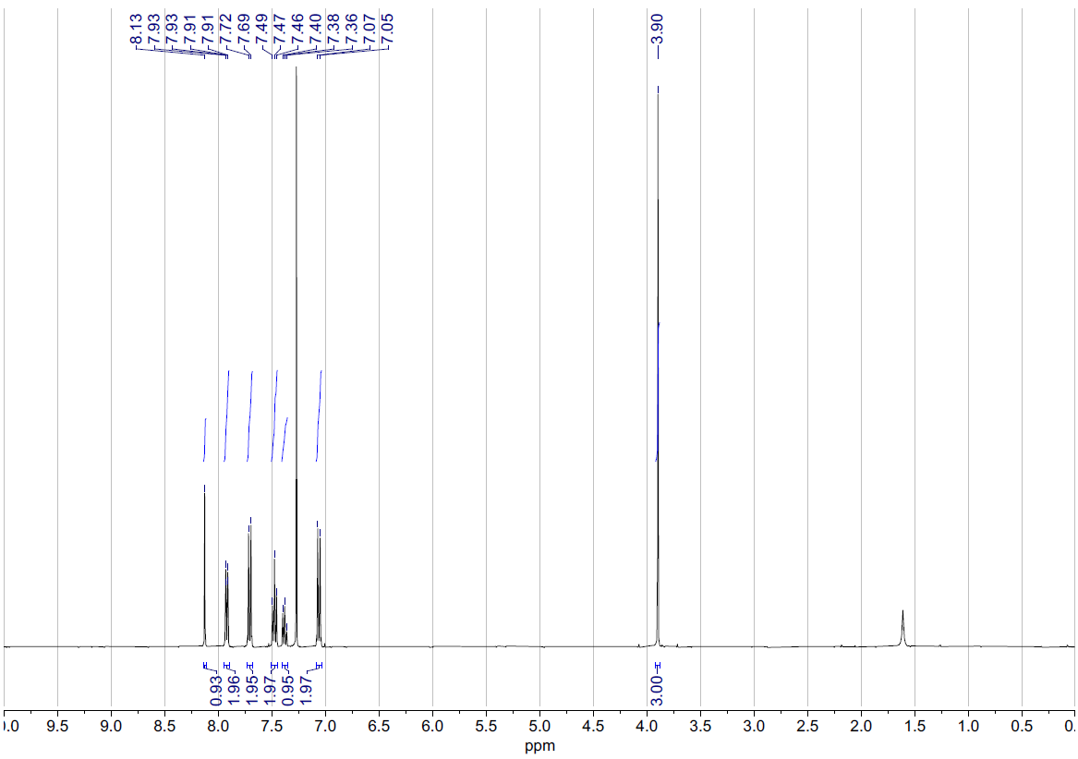
13
¹H NMR (400 MHz, CDCl₃)

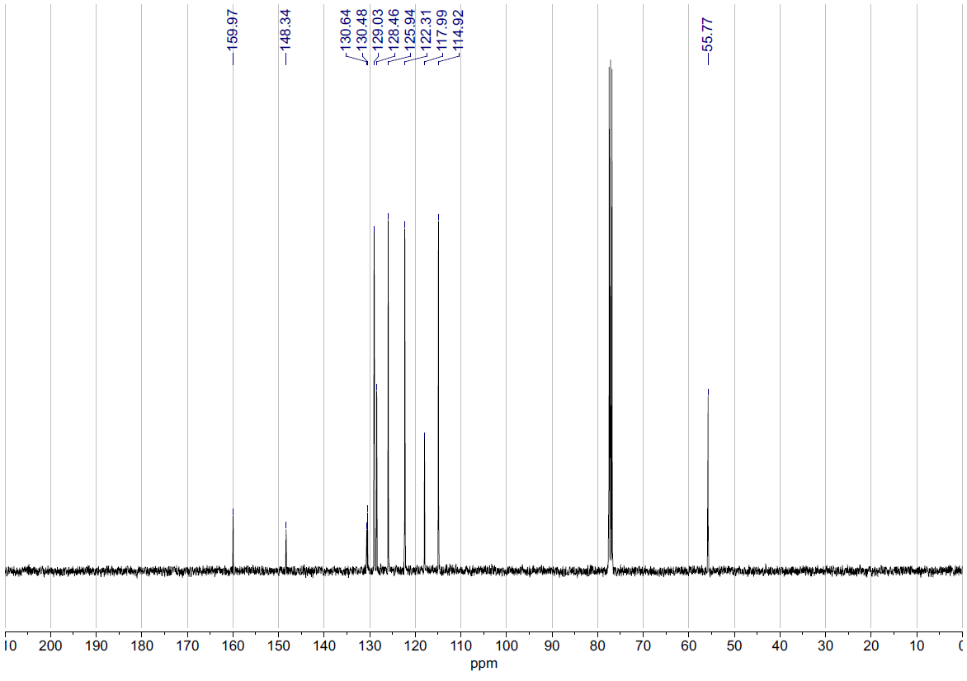
13
¹³C NMR (101 MHz, CDCl₃)

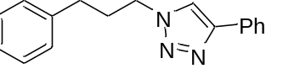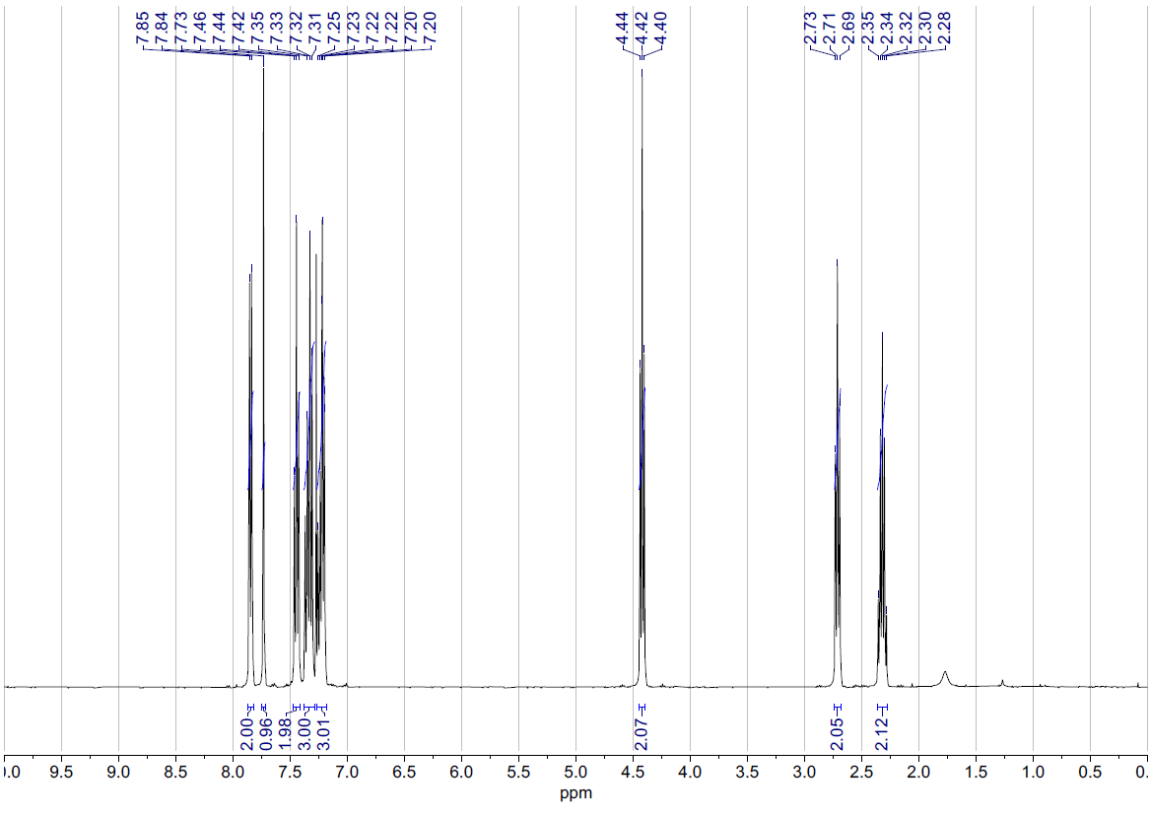
14
¹H NMR (400 MHz, CDCl₃)

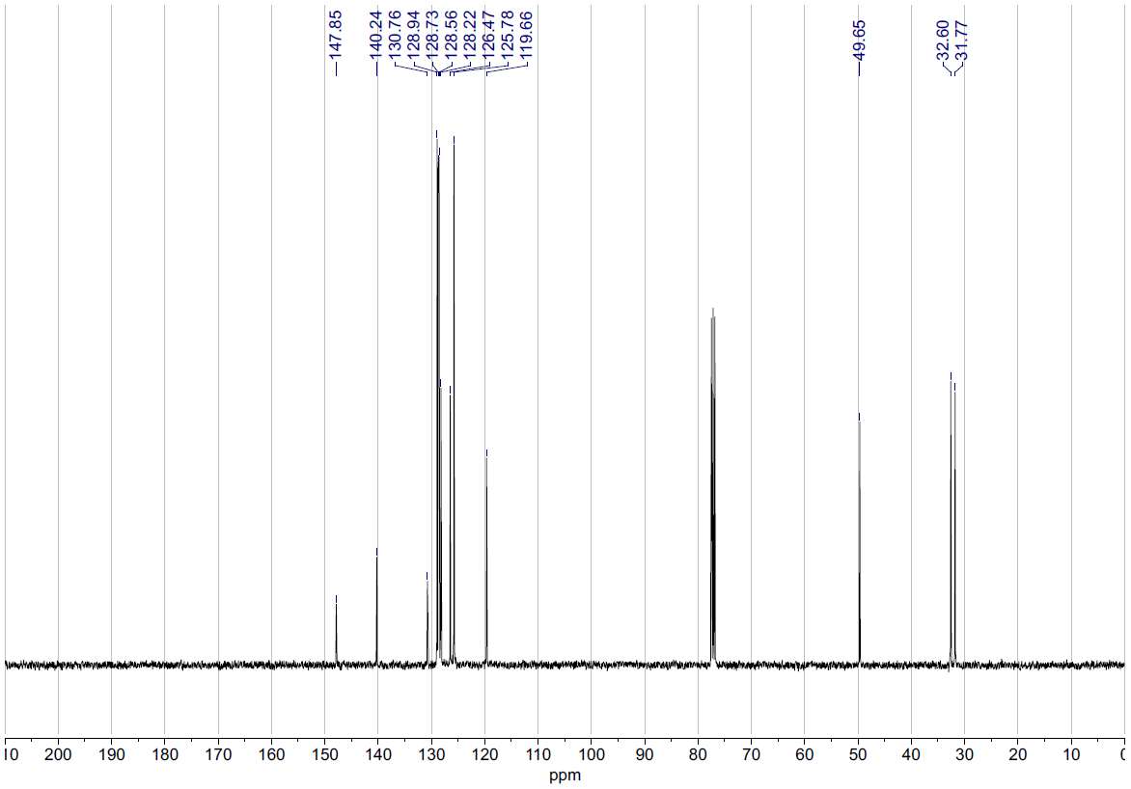
14
¹³C NMR (101 MHz, CDCl₃)
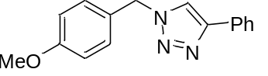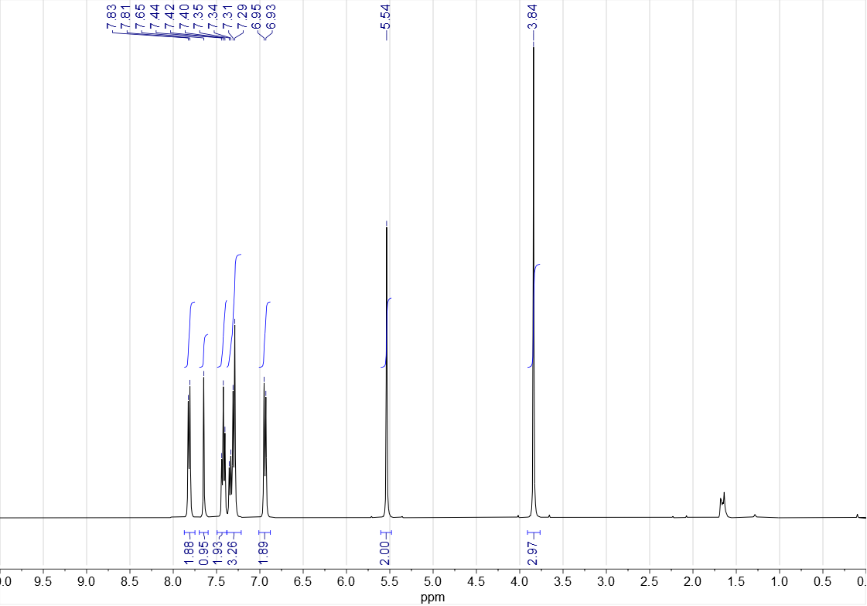
11a semi-batch preparation
¹H NMR (400 MHz, CDCl₃)
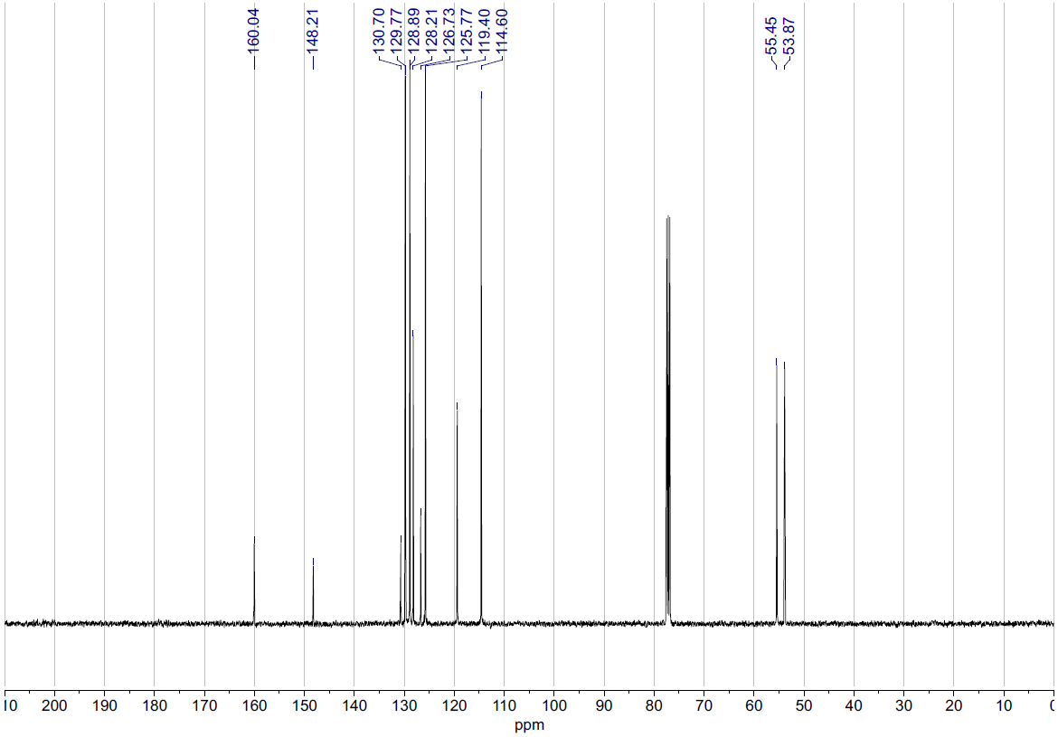
11a semi-batch preparation
¹³C NMR (101 MHz, CDCl₃)
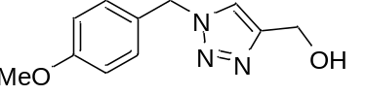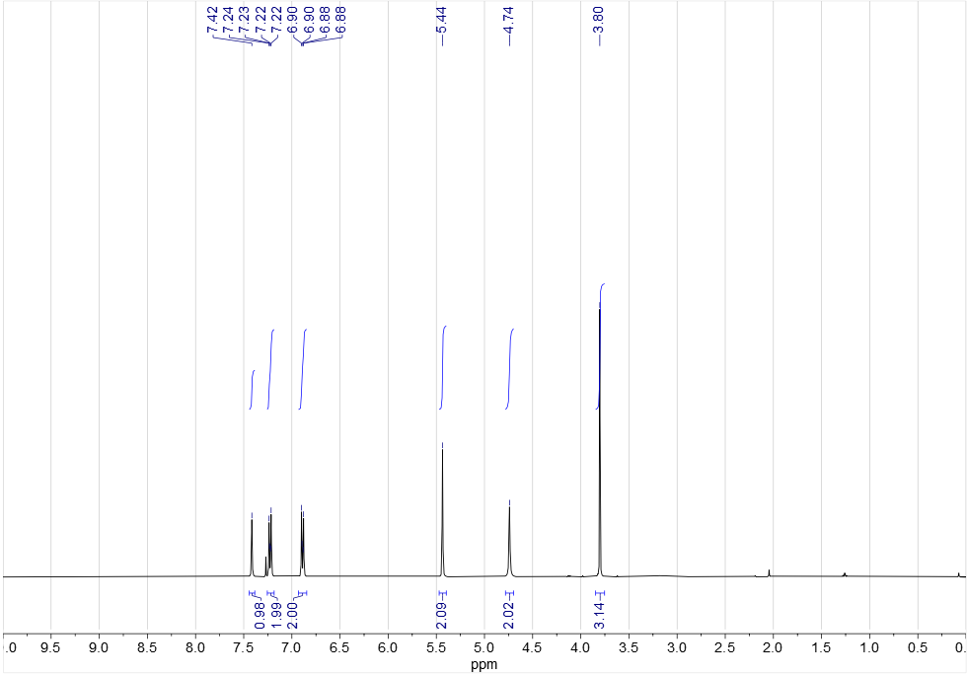
11b
¹H NMR (400 MHz, CDCl₃)
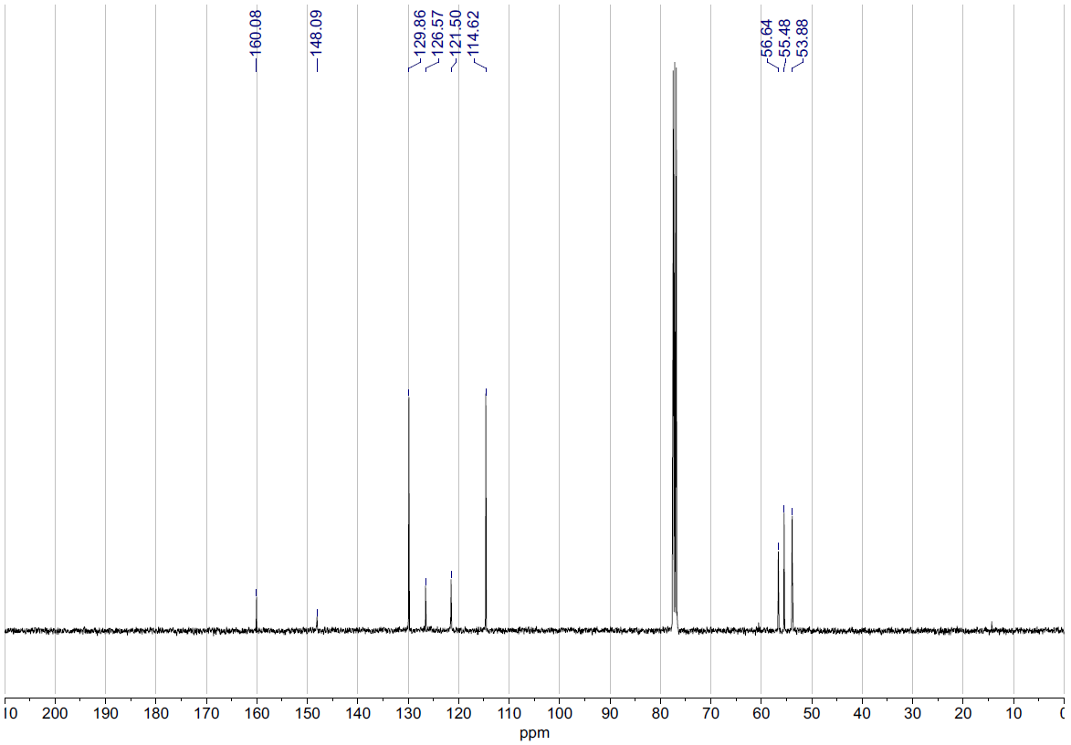
11b
¹³C NMR (101 MHz, CDCl₃)
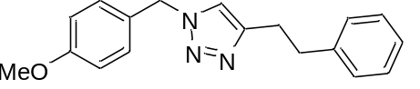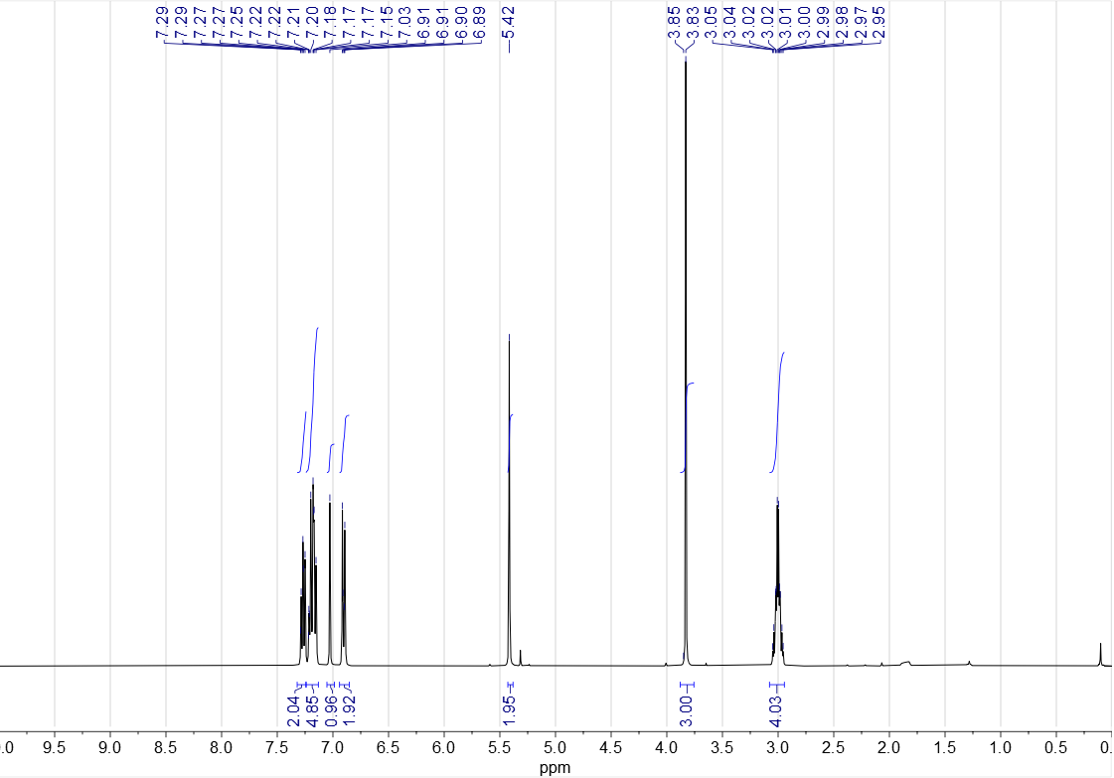
11c
¹H NMR (400 MHz, CDCl₃)
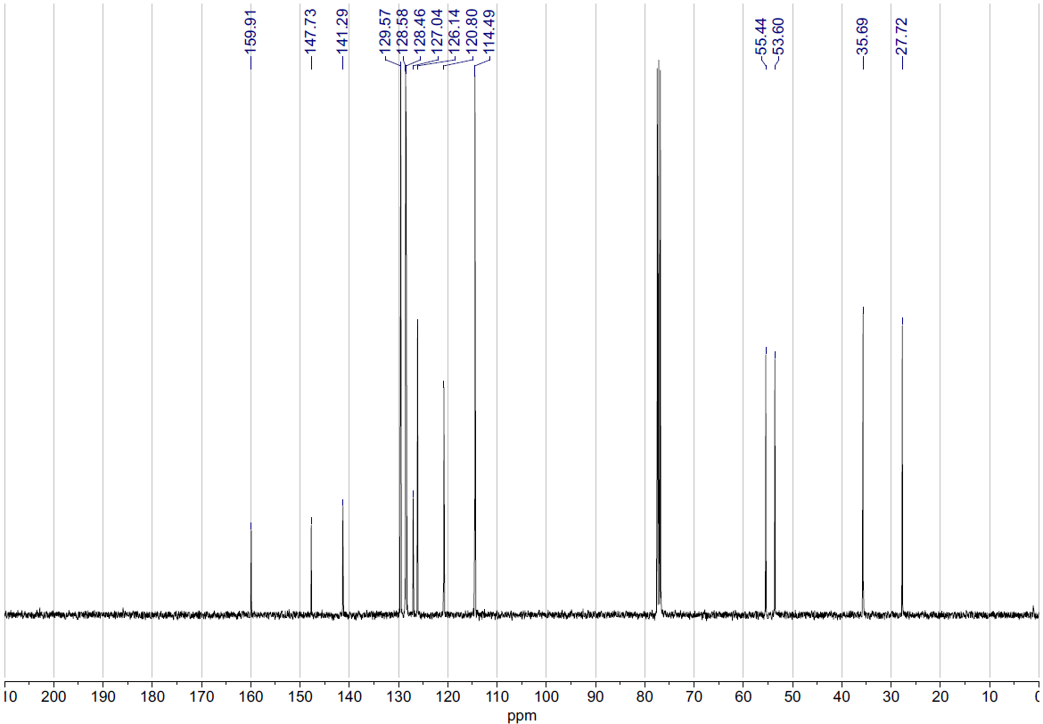
11c
¹³C NMR (101 MHz, CDCl₃)
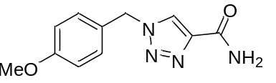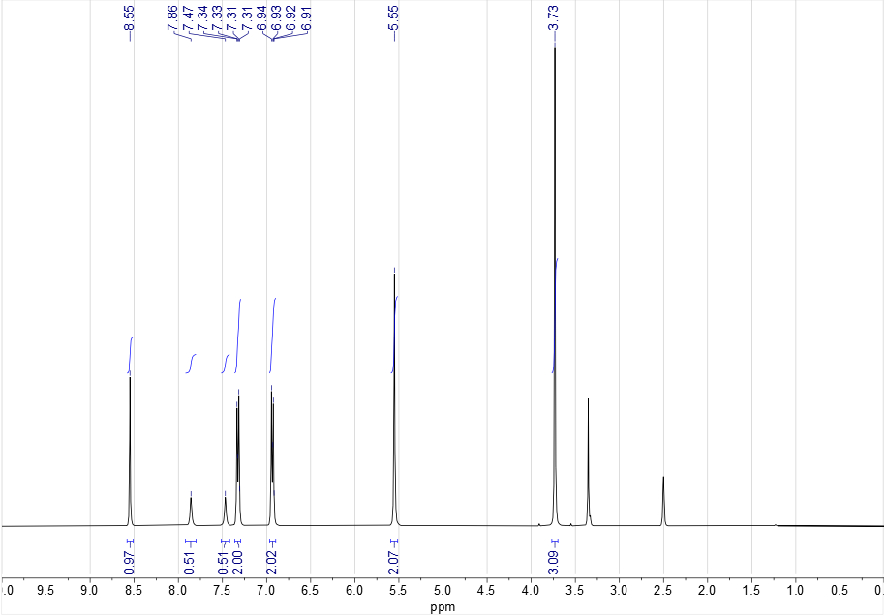
11d
¹H NMR (400 MHz, DMSO-d₆)
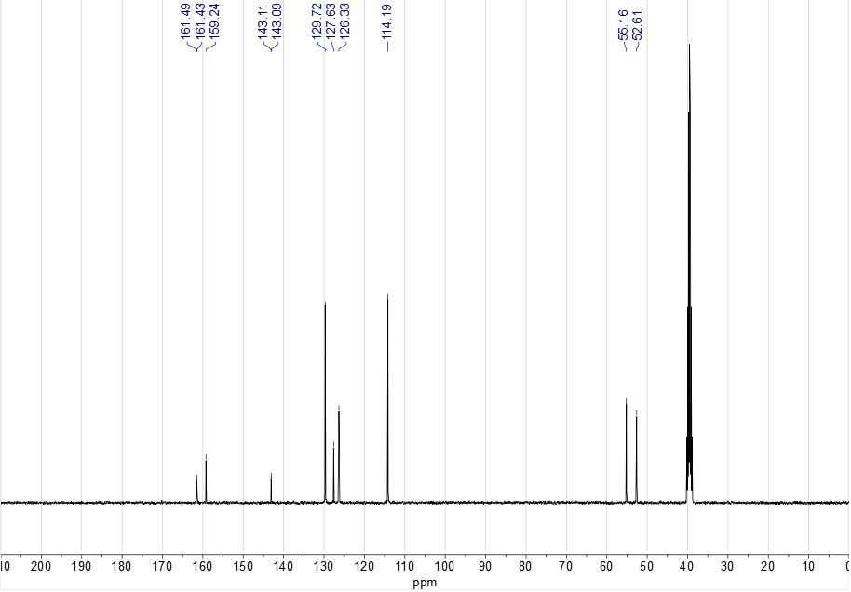
11d
¹³C NMR (101 MHz, DMSO-d₆)

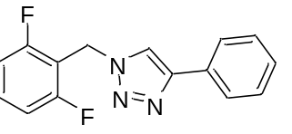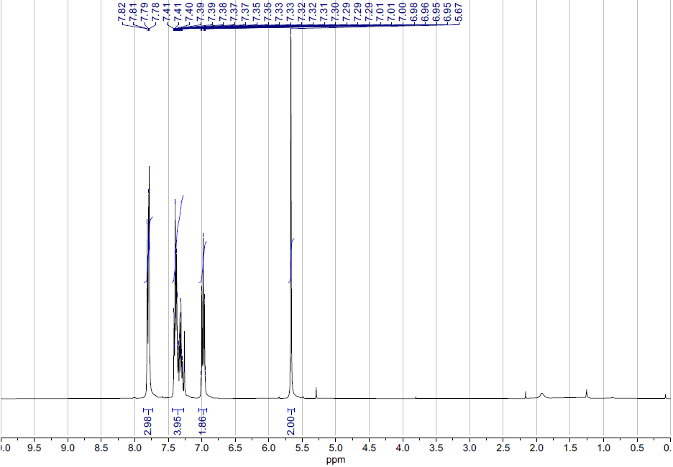
15a
¹H NMR (400 MHz, CDCl₃)

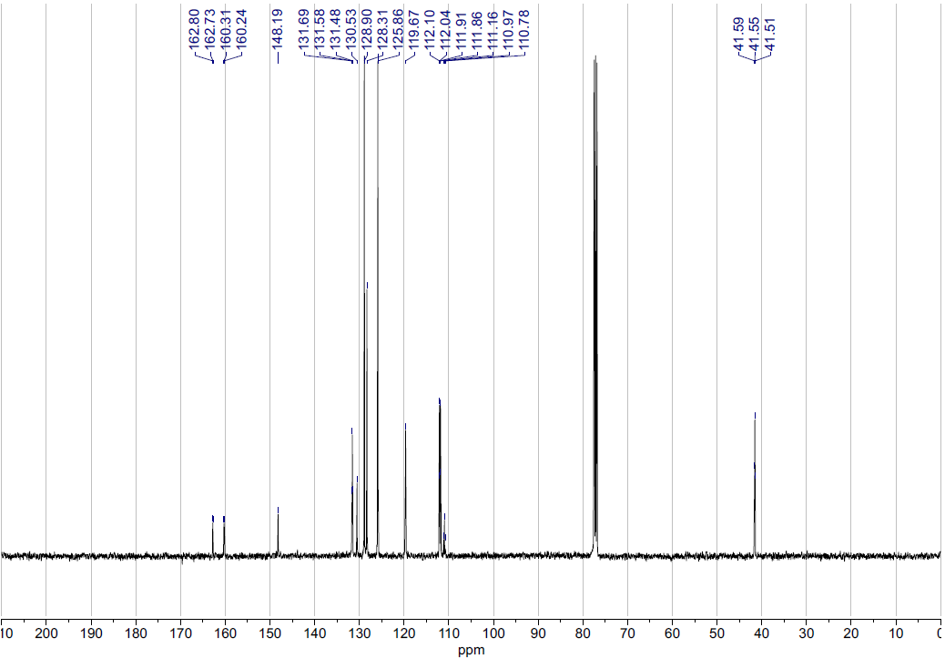
15a
¹³C NMR (101 MHz, CDCl₃)

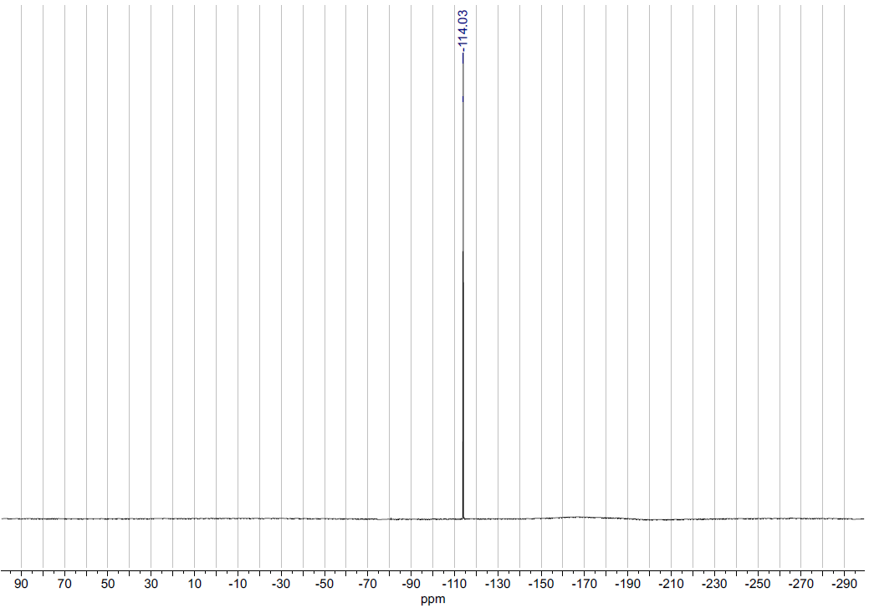
15a
¹⁹F NMR (377 MHz, CDCl₃)

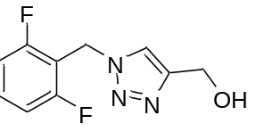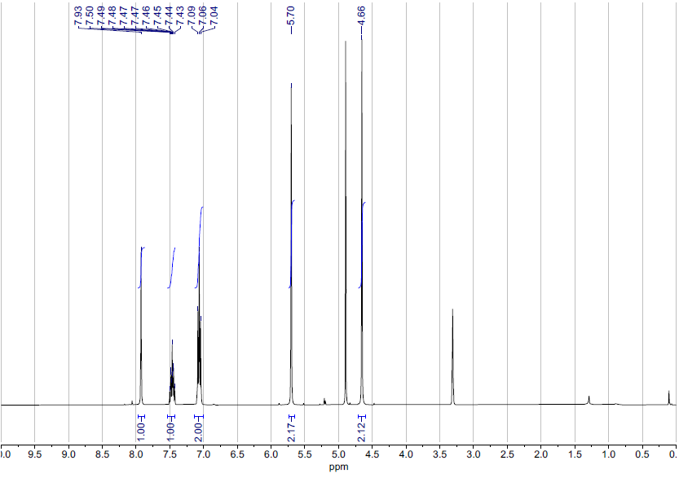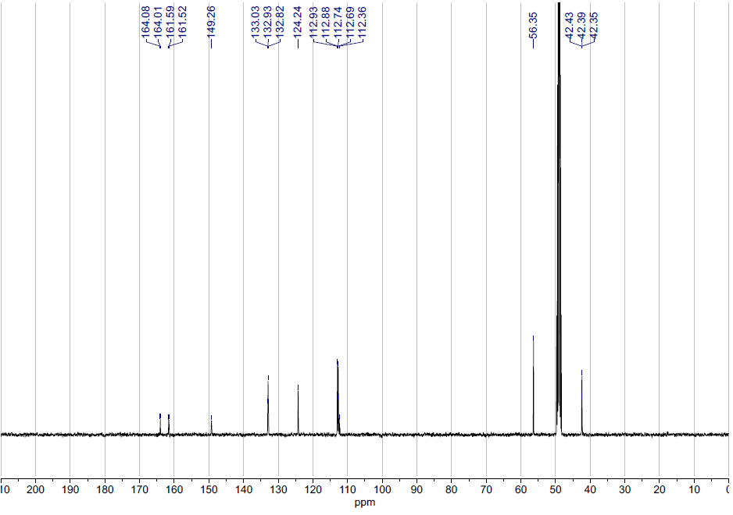
15b
¹³C NMR (101 MHz, MeOD)
15b
¹H NMR (400 MHz, MeOD)

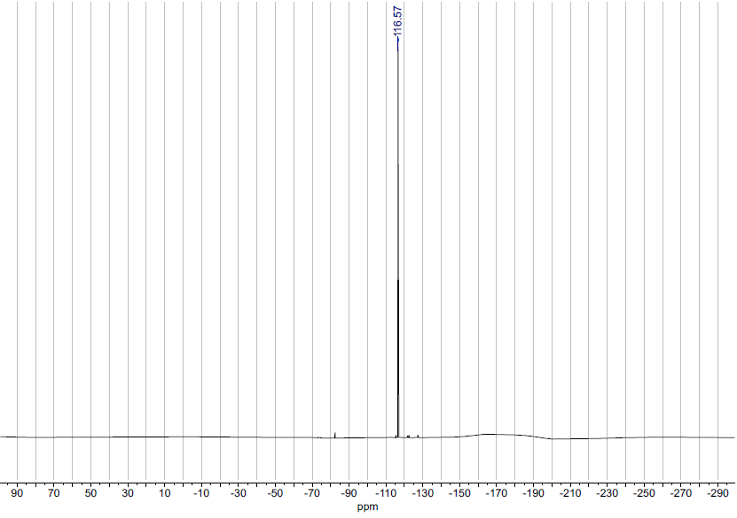
15b
¹⁹F NMR (377 MHz, MeOD)

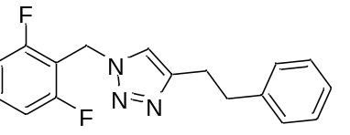
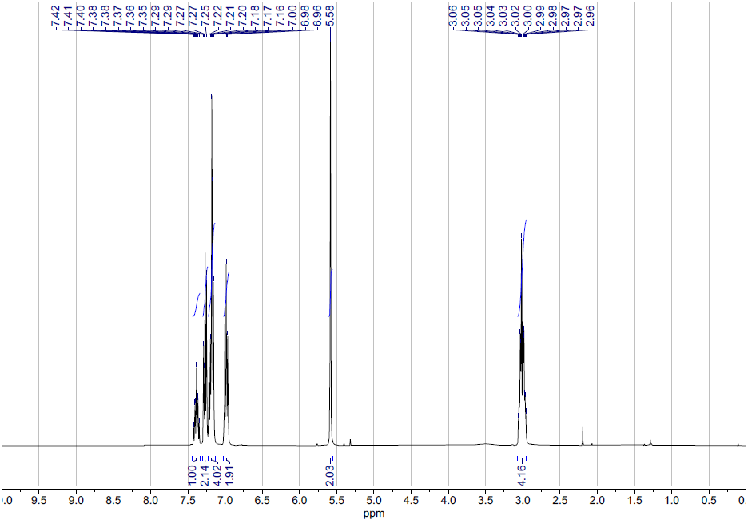
15c
¹H NMR (400 MHz, CDCl₃)
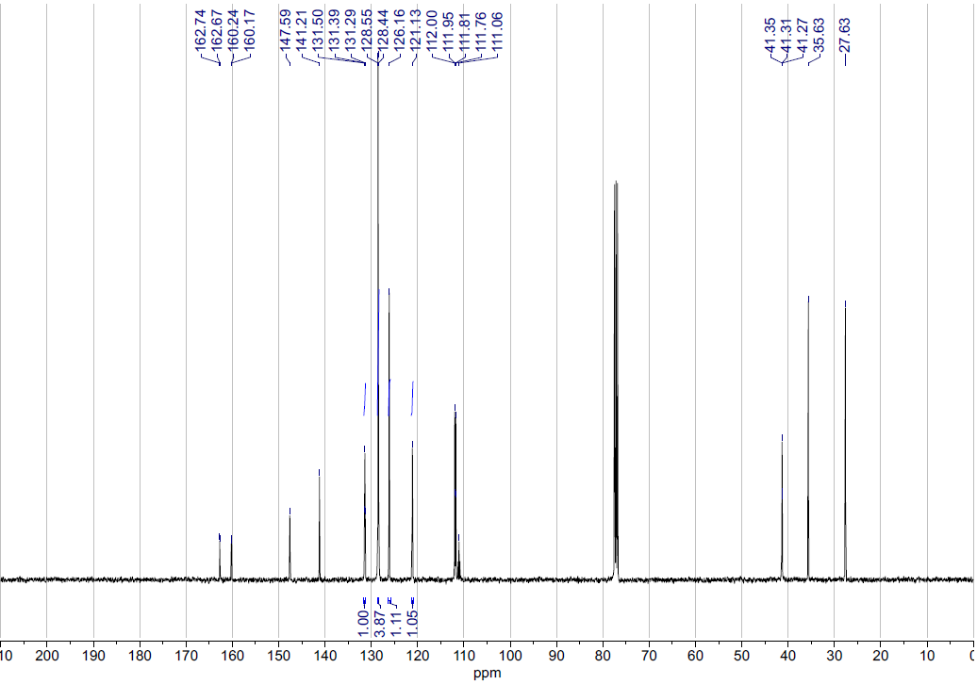
15c
¹³C NMR (101 MHz, CDCl₃)
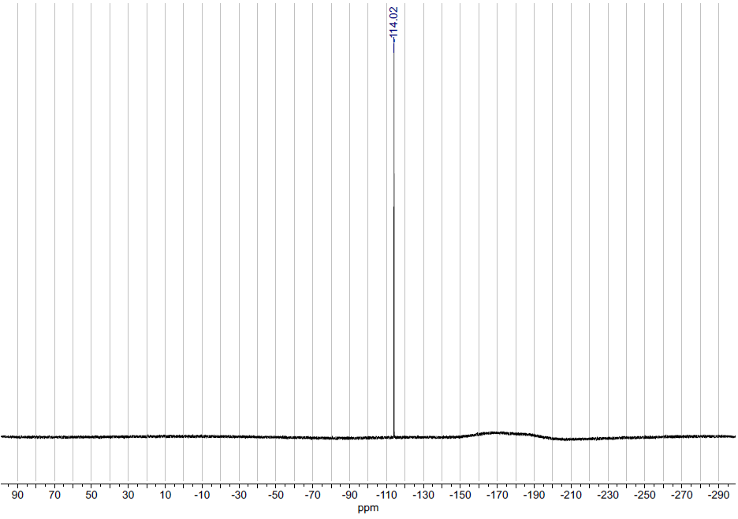
15c
¹⁹F NMR (377 MHz, CDCl₃)

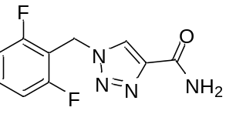
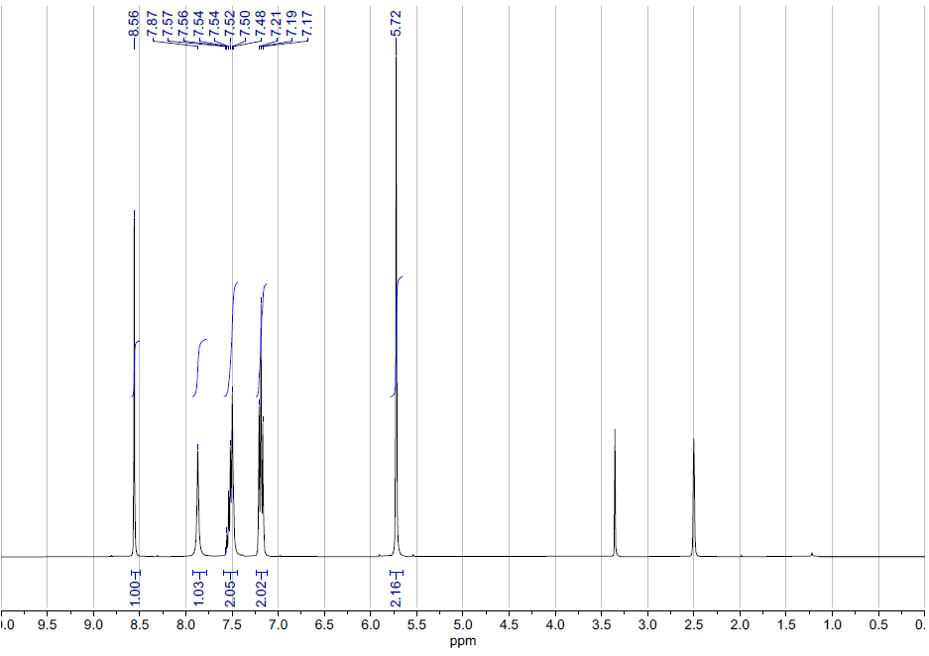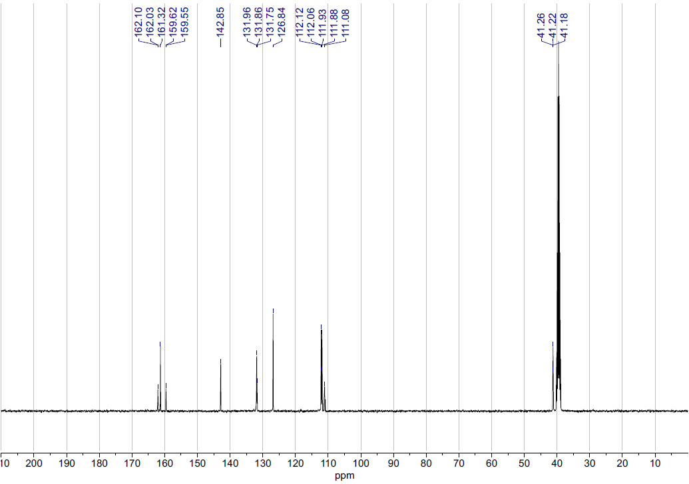
15d
¹³C NMR (101 MHz, DMSO-d₆)
15d
¹H NMR (400 MHz, DMSO-d₆)
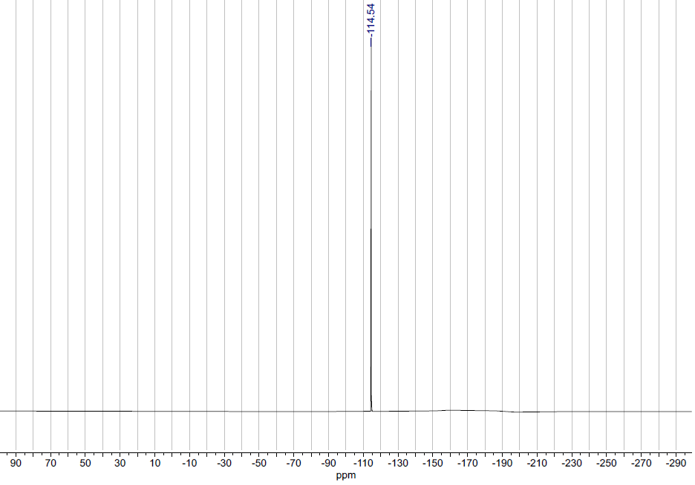
15d
¹⁹F NMR (377 MHz, DMSO-d₆)

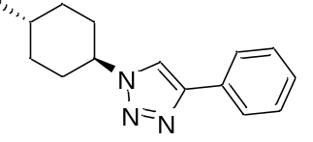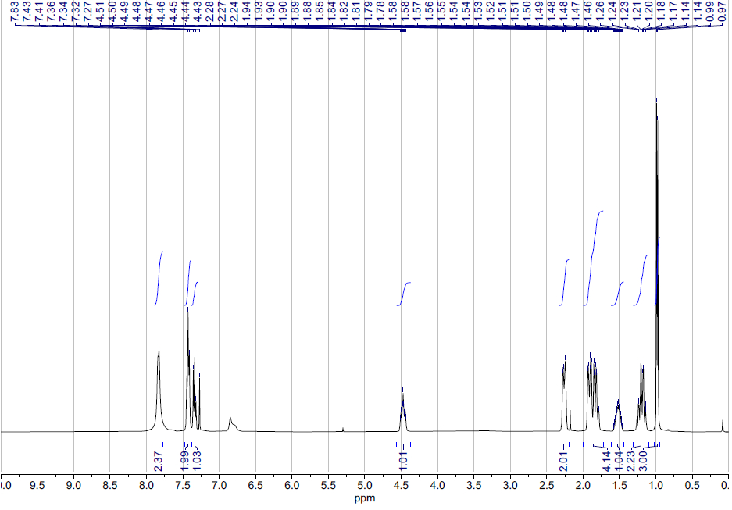
16a
¹H NMR (400 MHz, CDCl₃)
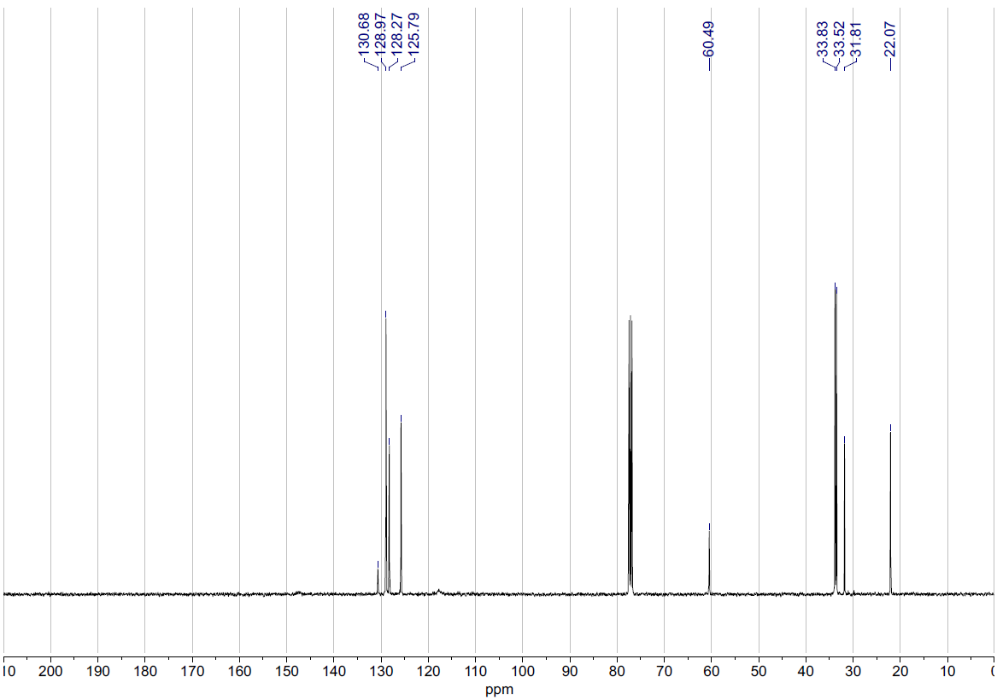
16a
¹³C NMR (101 MHz, CDCl₃)
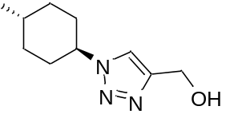
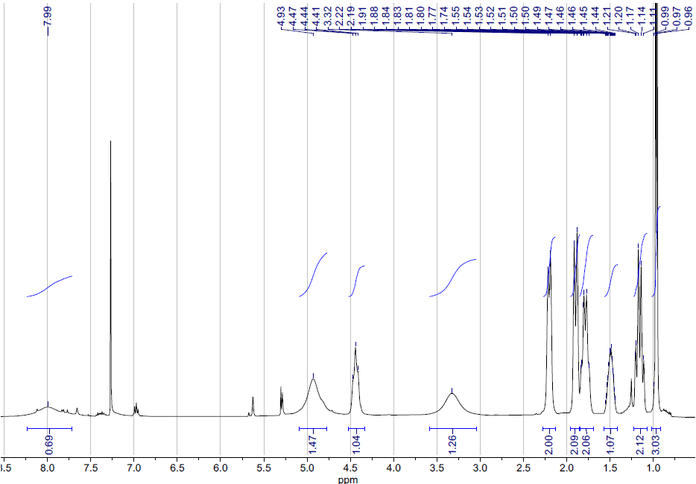
16b
¹H NMR (400 MHz, CDCl₃)
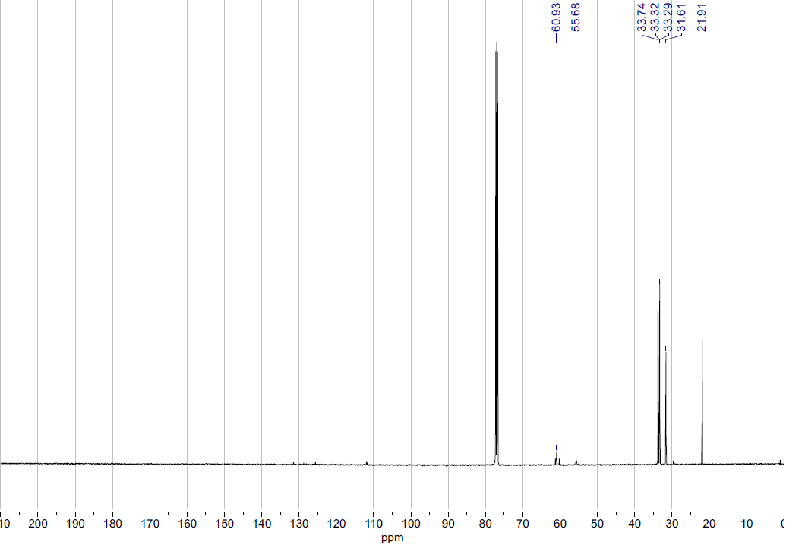
16b
¹³C NMR (126 MHz, CDCl₃)
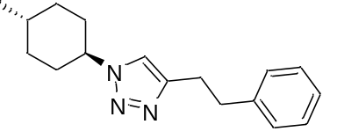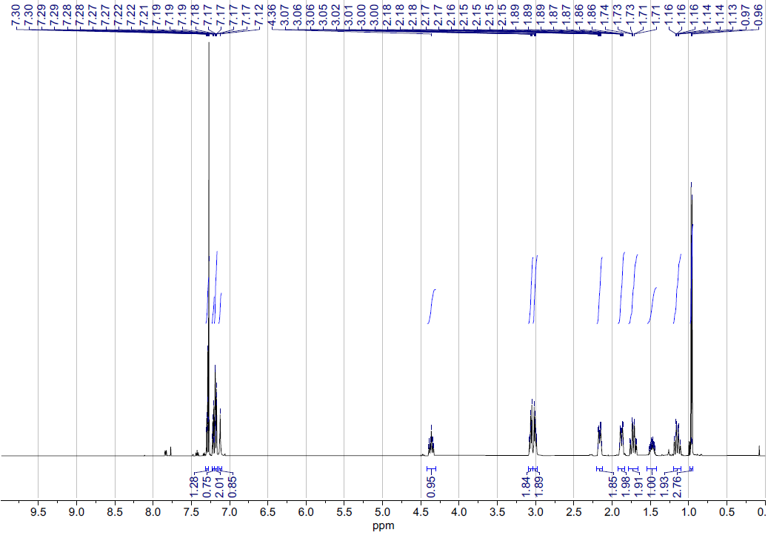
16c
¹H NMR (500 MHz, CDCl₃)
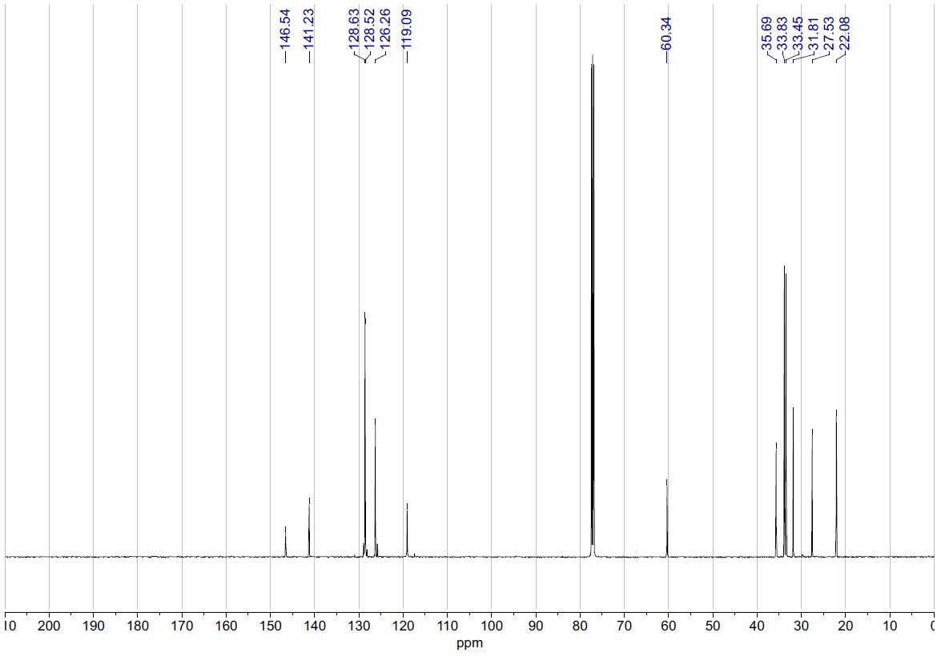
16c
¹³C NMR (126 MHz, CDCl₃)
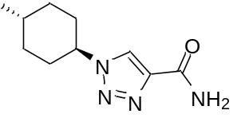
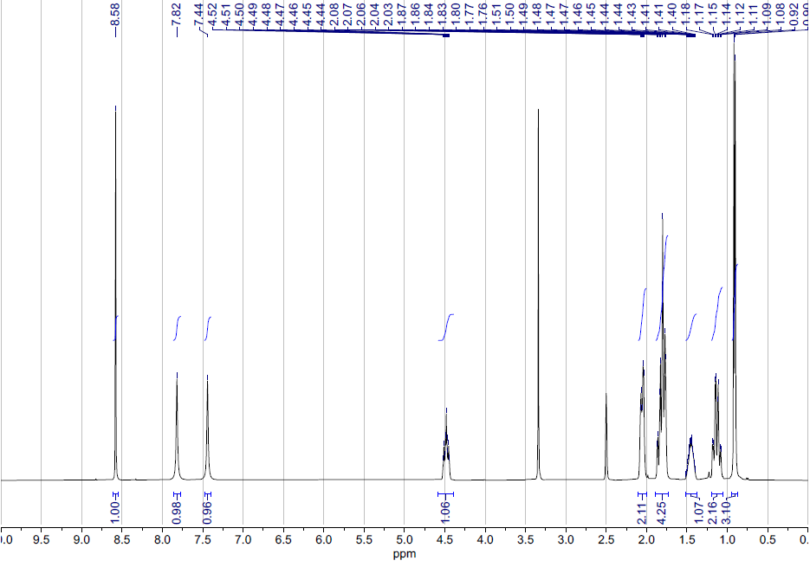
16d
¹H NMR (400 MHz, DMSO-d₆)
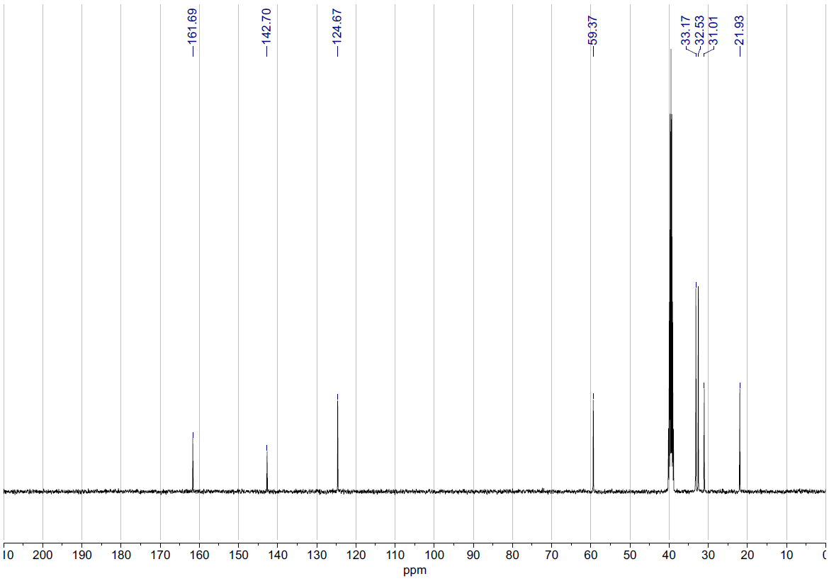
16d
¹³C NMR (101 MHz, DMSO-d₆)

References ) R. O. Duthaler, H. G. Foerster, J. D. Roberts, J. Am. Chem. Soc., 1978, 100, 4974–4979.
) W. Runge,J. Firl, Z. Naturforsch. 1976, 31, 1515–1518.
) R. E Wasylishen, B. A. Pettitt, Can. J. Chem. 1979, 57, 1274–1278.
) J. G. Kralj, H. R. Sahoo, K. F. Jensen, Lab Chip, 2007, 7, 256–263.
) K. Wang, G. Luo, Chem. Eng. Sci. 2017, 169, 18–33.
) T. W. Phillips, J. H. Bannock, J. C. deMello, Lab Chip 2015, 15, 2960–2967.
) A. J. Harvie, J. O. Herrington, J. C. deMello, React. Chem. Eng. 2019, 4, 1579–1588.
) H. D. Fair, R. F. Walker, Energetic Materials, Volume 2: Technology of the Inorganic Azides; Plenum Press: New York, USA, 1977.
) H. D. Fair, R. F. Walker, Energetic Materials, Volume 2: Technology of the Inorganic Azides; Plenum Press: New York, USA, 1977.
) S.-Z. Zhu, J. Chem. Soc. Perkin Trans. 1 1994, 113, 2077–2081.
) A. Budinská, J. Václavík, V. Matoušek, P. Beier, Org. Lett. 2016, 18, 5844–5847.
) J. L. Chiara, J. R. Suárez, Adv. Synth. Catal. 2011, 353, 575–579
) J. R. Suárez, B. Trastoy, M. E. Pérez-Ojeda, R. Marín-Barrios, J. L. Chiara, Adv. Synth. Catal. 2010, 352, 2515–2520.
) C. A. M. Afonso, Synth. Commun. 1998, 28, 261–276.
) S. Chakraborty, B. Mishra, M. Neralkar, S. Hotha, J. Org. Chem. 2019, 84, 6604–6611.
) S. Oae, N. Yamada, K. Fujimori, O. Kikuchi, Bull. Chem. Soc. Jpn. 1983, 56, 248–256.
) C. Büll, T. Heise, N. van Hilten, J. F. A. Pijnenborg, V. R. L. J. Bloemendal, L. Gerrits, E. D. Kers-Rebel, T. Ritschel, M. H. den Brok, G. J. Adema, T. J. Boltje, Angew. Chem. Int. Ed. 2017, 56, 3309–3313.
) L. Di Nunno, A. Scilimati, Tetrahedron, 1986, 42, 3913–3920.
) D. Chang, D. Zhu, L. Shi, J. Org. Chem. 2015, 80, 5928–5933.
) K. E. Elson, I. D. Jenkins, W. A. Loughlin, Org. Biomol. Chem. 2003, 1, 2958–2965.
) R. M. Moriarty, R. C. Reardon, Tetrahedron 1970, 26, 1379–1392.
) L. Benati, G. Bencivenni, R. Leardini, D. Nanni, M. Minozzi, P. Spagnolo, R. Scialpi, G. Zanardi, Org. Lett., 2006, 8, 2499–2502.
) S. T. Abu-Orabi, M. A. Atfah, I. Jibril, F. M. Mari’i, A. A.-S. Ali, J. Heterocycl. Chem. 1989, 26, 1461–1468.
) Y. M. A. Yamada, S. M. Sarkar, Y. Uozumi, J. Am. Chem. Soc. 2012, 134, 9285–9290.
) Z.-J. Cai, X.-M. Lu, Y. Zi, C. Yang, L.-J. Shen, J. Li, S.-Y. Wang, S.-J. Ji, Org. Lett. 2014, 16, 5108–5111.
) J. H. Song, P. Choi, S. E. Lee, K. H. Jeong, T. Kim, K. S. Kang, Y. S. Choi, J. Ham, Eur. J. Org. Chem. 2013, 28, 6249–6253.
) H. Song, N. J. Rogers, V. Brabec, G. J. Clarkson, J. P. C. Coverdale, H. Kostrhunova, R. M. Phillips, M. Postings, S. L. Shepherd and P. Scott, Chem. Commun., 2020, 56, 6392–6395.
) R. P. Jadhav, A. A. Patil, V. D. Bobade, Indian J. Chem. Sect. B, 2020, 59, 716–723.
) J. Gómez-CarpinteroJorge, J. Domingo Sánchez, J. Francisco González and J. Carlos Menéndez, J. Org. Chem. 2021, 86, 20, 14232–14237.
) D. R. Meena, R. N. Rao, B. Maiti, and K. Chanda, Res. Chem. Intermed, 2017, 43, 4711–4717.

