Supporting Information:
Best practice approach for temperature measurement in flow chemistry based on CFD simulation
Vanessa Nuredin,ª Lisa Schulz,^{a,b} Norbert Kockmann,^{b} and Thorsten Röder^{a,}*
ª Institute of Chemical Process Engineering, Mannheim University of Applied Sciences, 68163 Mannheim
(Germany)
^{b} Laboratory of Equipment Design, Department of Biochemical and Chemical Engineering, TU Dortmund University, 44227 Dortmund (Germany)
* Correspondence: t.roeder@hs-mannheim.de

Content
TEMPERATURE MEASUREMENT TECHNIQUES IN MICROTECHNOLOGY 2
MATERIAL PROPERTIES 2
PT100 SIMULATION LENGTH 3
MESH 4
ENERGY BALANCE 5
TEMPERATURE AND VELOCITY PROFILE AT MEASUREMENT SECTION 6
VARIATION OF TEMPERATURE AND FLUID 9
PRESSURE DROP STUDY 11
ABBREVIATIONS & SYMBOLS 12
REFERENCES 12

TEMPERATURE MEASUREMENT TECHNIQUES IN MICROTECHNOLOGY
Thermocouple probes, resistance thermometers, infrared thermography or fluorescence thermography are just some examples often used in microtechnology. Infrared thermography is particularly suitable for measuring surfaces. Here, the temperature of the surface is determined via radiated energy by using infrared bands. However, this method is not suitable for fluids. For fluorescence thermography a fluorescent dye is added to the fluid. The relationship between fluorescence intensity and temperature is then used to verify the temperature. Thermocouple probes use the voltage between two electrical conductors to determine the temperature change. They measure precisely and with short response times but are also sensitive to interference and deliver spatially lower resolutions. Resistance thermometers reflect the change of temperature based on changes in electrical conductivity. Like thermocouple probes, they measure precisely and quickly but also, they are less susceptible to interference and changes [1].

MATERIAL PROPERTIES
Table S1 summarizes the material properties used in the CFD simulation.

Table S1. List of material properties at 20 °C used in the simulation.
Material | Thermal conductivity λ [W m⁻¹ K⁻¹] | Specific heat capacity $C_{p}$  [J K⁻¹ kg⁻¹] | Density ρ [kg m⁻³] | Dynamic viscosity μ [Pa·s]
Platin | 71.6 | 133 | 21450 | /
Steel | 44.5 | 475 | 7850 | /
DMF | 0.20 | 2030 | 944 | 0.00086
Ethanol | 0.17 | 2404 | 808 | 0.0012

PT100 SIMULATION LENGTH
Figure S1 shows the temperature of the T-piece and the Pt100 in a 2D simulation. The red line depicts the region of the temperature profile inside the Pt100. The temperature gradient approaches a plateau at a Pt100 length of 32 mm. Therefore, a Pt100 simulation length of 35 mm is sufficient.
Fig. S1 2D simulation for the estimation of the necessary Pt100 length. Inlet temperature of the fluid: 90 °C, environmental temperature: 40 °C, flow rate: 16.6 mL min⁻¹.

MESH
The free tetrahedral mesh was generated by the COMSOL Multiphysics® software (element size: extra fine) [2]. Figure S2 shows examples of the mesh applied in this work for selected regions within the T-piece and along the Pt100 sensor.
Fig. S2 Three selected regions of the fluid flow mesh.

ENERGY BALANCE
A closed energy balance is especially important in this study for comparing simulated and experimental temperature values. Therefore, an energy balance study was performed. For a closed energy balance, the input heat $Q_{in}$ should equal the sum of heat removal over the T-piece $Q_{loss}$ and the output heat $Q_{out}$ as shown in Figure S3.
Fig. S3 Energy balance with input heat $Q_{in}$, heat removal $Q_{loss}$ and output heat $Q_{out}$.

Table S2 presents the results of the energy balance for the different flow rates. The different heat values, taken from the CFD simulation, are listed with the deviation from a closed energy balance (< 2%).

Flow rate  [mL min⁻¹] | $$Q_{in}$$  [W] | $$Q_{out}$$  [W] | $$Q_{loss}$$  [W] | Deviation from closed energy balance  [%]
5.0 | 10.5 | 8.2 | 2.2 | 1.1
16.6 | 35.2 | 32.1 | 2.6 | 1.5
20.0 | 42.0 | 38.8 | 2.6 | 1.4
34.0 | 71.4 | 67.9 | 2.7 | 1.2
50.0 | 105.6 | 101.8 | 2.8 | 1.0
Table S2. Energy balance with input heat $Q_{in}$, heat removal $Q_{loss}$ and output heat $Q_{out}$ for different flow rates.

TEMPERATURE AND VELOCITY PROFILE AT MEASUREMENT SECTION
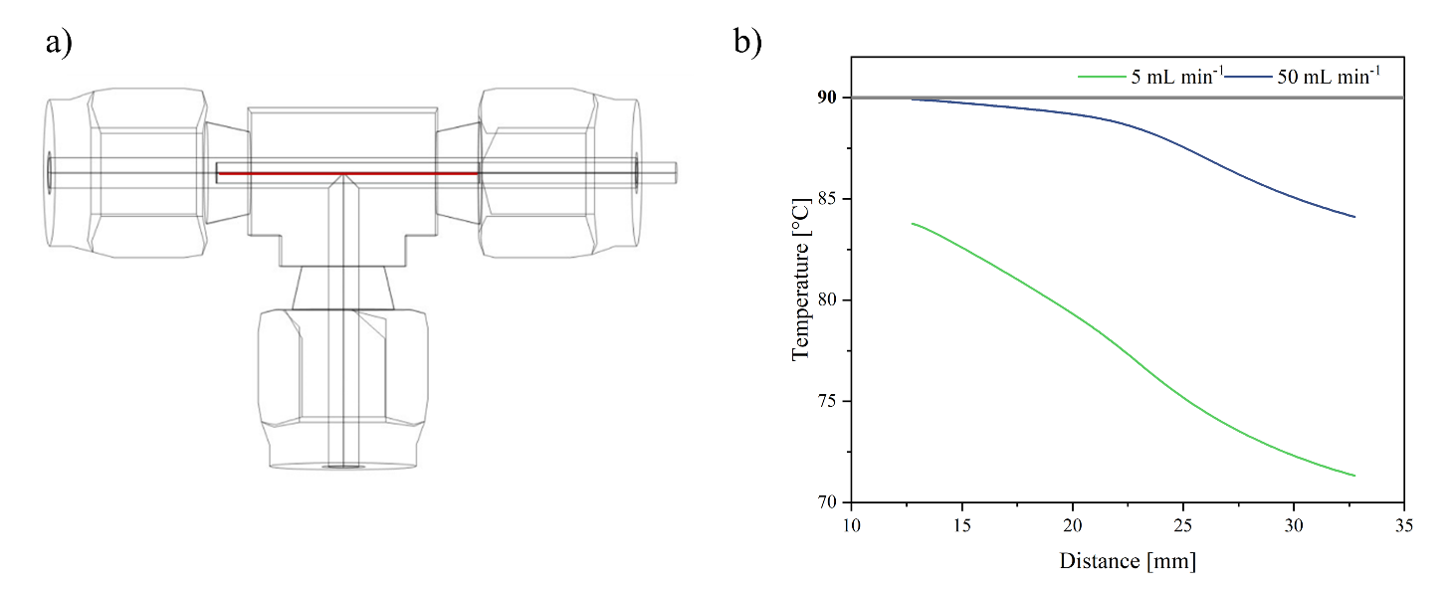
Figure S4 depicts the study of the temperature profile in the Pt100 measuring section. This measuring section is shown in Figure S4a as red line. Flow rates of 5 and 50 mL min⁻¹ are simulated. The resulting temperature profiles are shown in Figure S4b.
Fig. S4a) Measuring section in the Pt100 (red line). b) Temperature profile in the measuring section for the lowest (5 mL min⁻¹) and highest (50 mL min⁻¹) flow rate at an inlet temperature of the fluid of 90 °C and an environmental temperature of 20 °C.
Please note, that a higher flow rate results in a smaller temperature gradient in the simulation, while the temperature at the lowest flow rate of 5 mL min⁻¹ covers a rather wide range. Since the simulated temperature is averaged, the results must be more precise at higher flow rates.

Figure S5 shows a comparison of the temperature profiles across the measurement section inside the Pt100. The side-on and head-on positions, the use of insulation, and the highest and lowest simulated flow rates are plotted. It can be seen that the temperature in the measurement section of the Pt100 in the head-on position is lower than the corresponding temperature in the side-on position, especially without the use of insulation. Additionally, it becomes evident that the temperature deviation in both positions is smaller at higher flow rates.
Figure S6 shows three velocity profiles in different sections through the T-piece. Figure S6a presents the undisturbed flow profile in front of the Pt100. Figure S6b shows the profile in the annular gap between Pt100 and T-piece. A section in the dead volume of the T-piece is shown in Figure S6c.

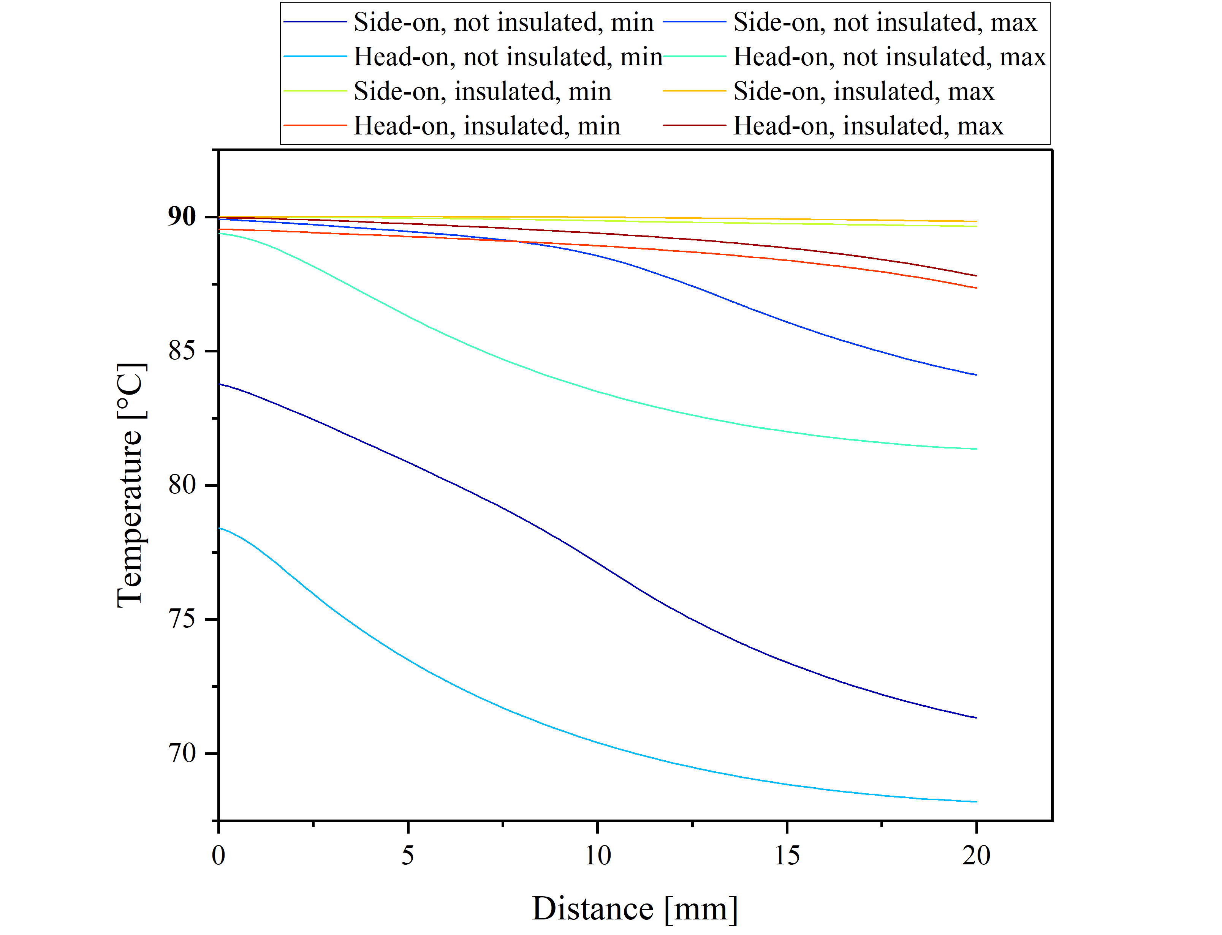
Fig. S5 Temperature profiles for side-on and head-on Pt100 positions, insulated and not insulated for the maximal flow rate of 50 mL min⁻¹ and minimal flow rate of 5 mL min⁻¹, respectively. Inlet temperature of the fluid: 90 °C, environmental temperature: 20 °C.
Fig. S6 Velocity profile at different positions inside the T-piece at a flow rate of 16.6 mL min⁻¹. a) Before the Pt100, b) through the Pt100 and c) through the Pt100 in dead volume.

A fully developed laminar flow can be seen in all three cross sections. The velocities do not vary much between Figure S6b and 6c. However, the fluid velocity in Figure 6a is, as expected, much lower.
Figure 7 displays the temperature profile at the outlet of the T-piece for all simulated flow rates.
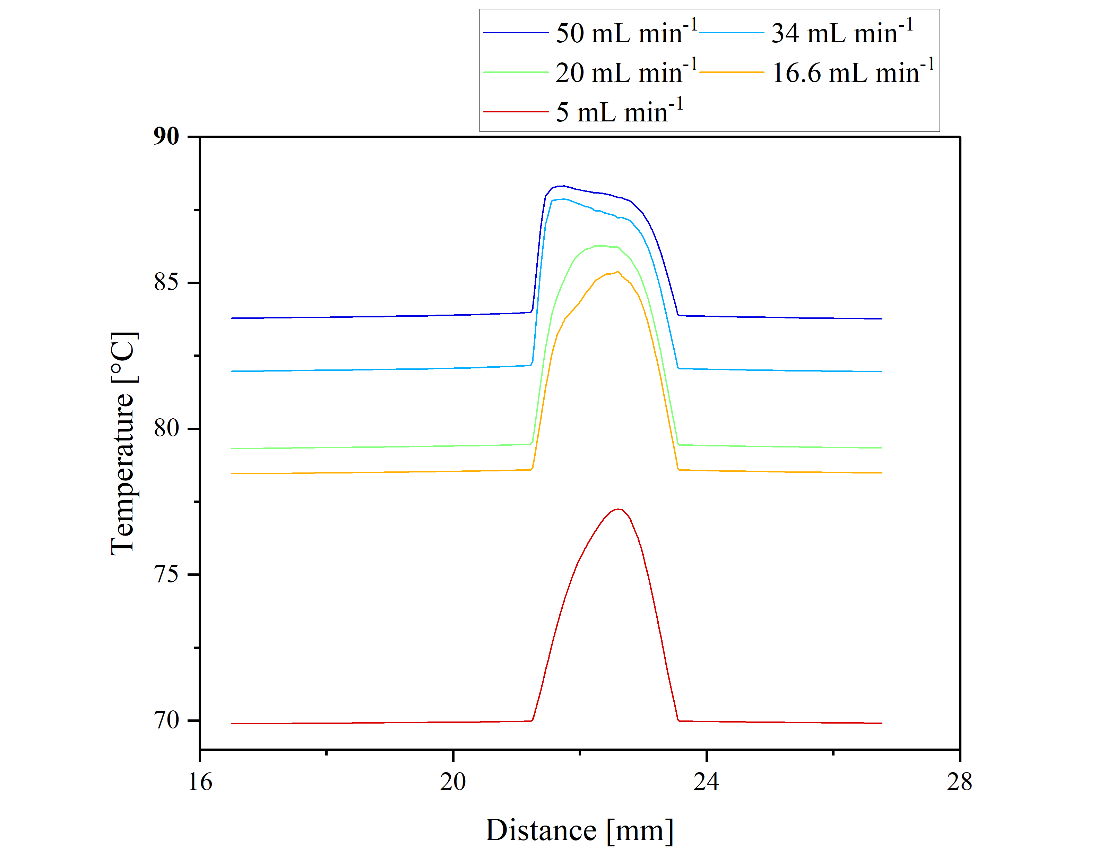
Fig. S7 Temperature profile at the outlet of the T-piece (side-on, without insulation) for all simulated flow rates. Inlet temperature of the fluid: 90 °C, environmental temperature: 20 °C.

Note that the temperature profiles of the higher flow rates are not symmetrical, which is probably caused by the inserted Pt100 sensor.

VARIATION OF TEMPERATURE AND FLUID
As there was experimental data for two other inlet fluid temperatures, simulations were performed for 80 °C and 100 °C. These simulations, together with the already presented one at 90 °C, are compared with the experimental data of modules 1 and 4 in Figure S8.
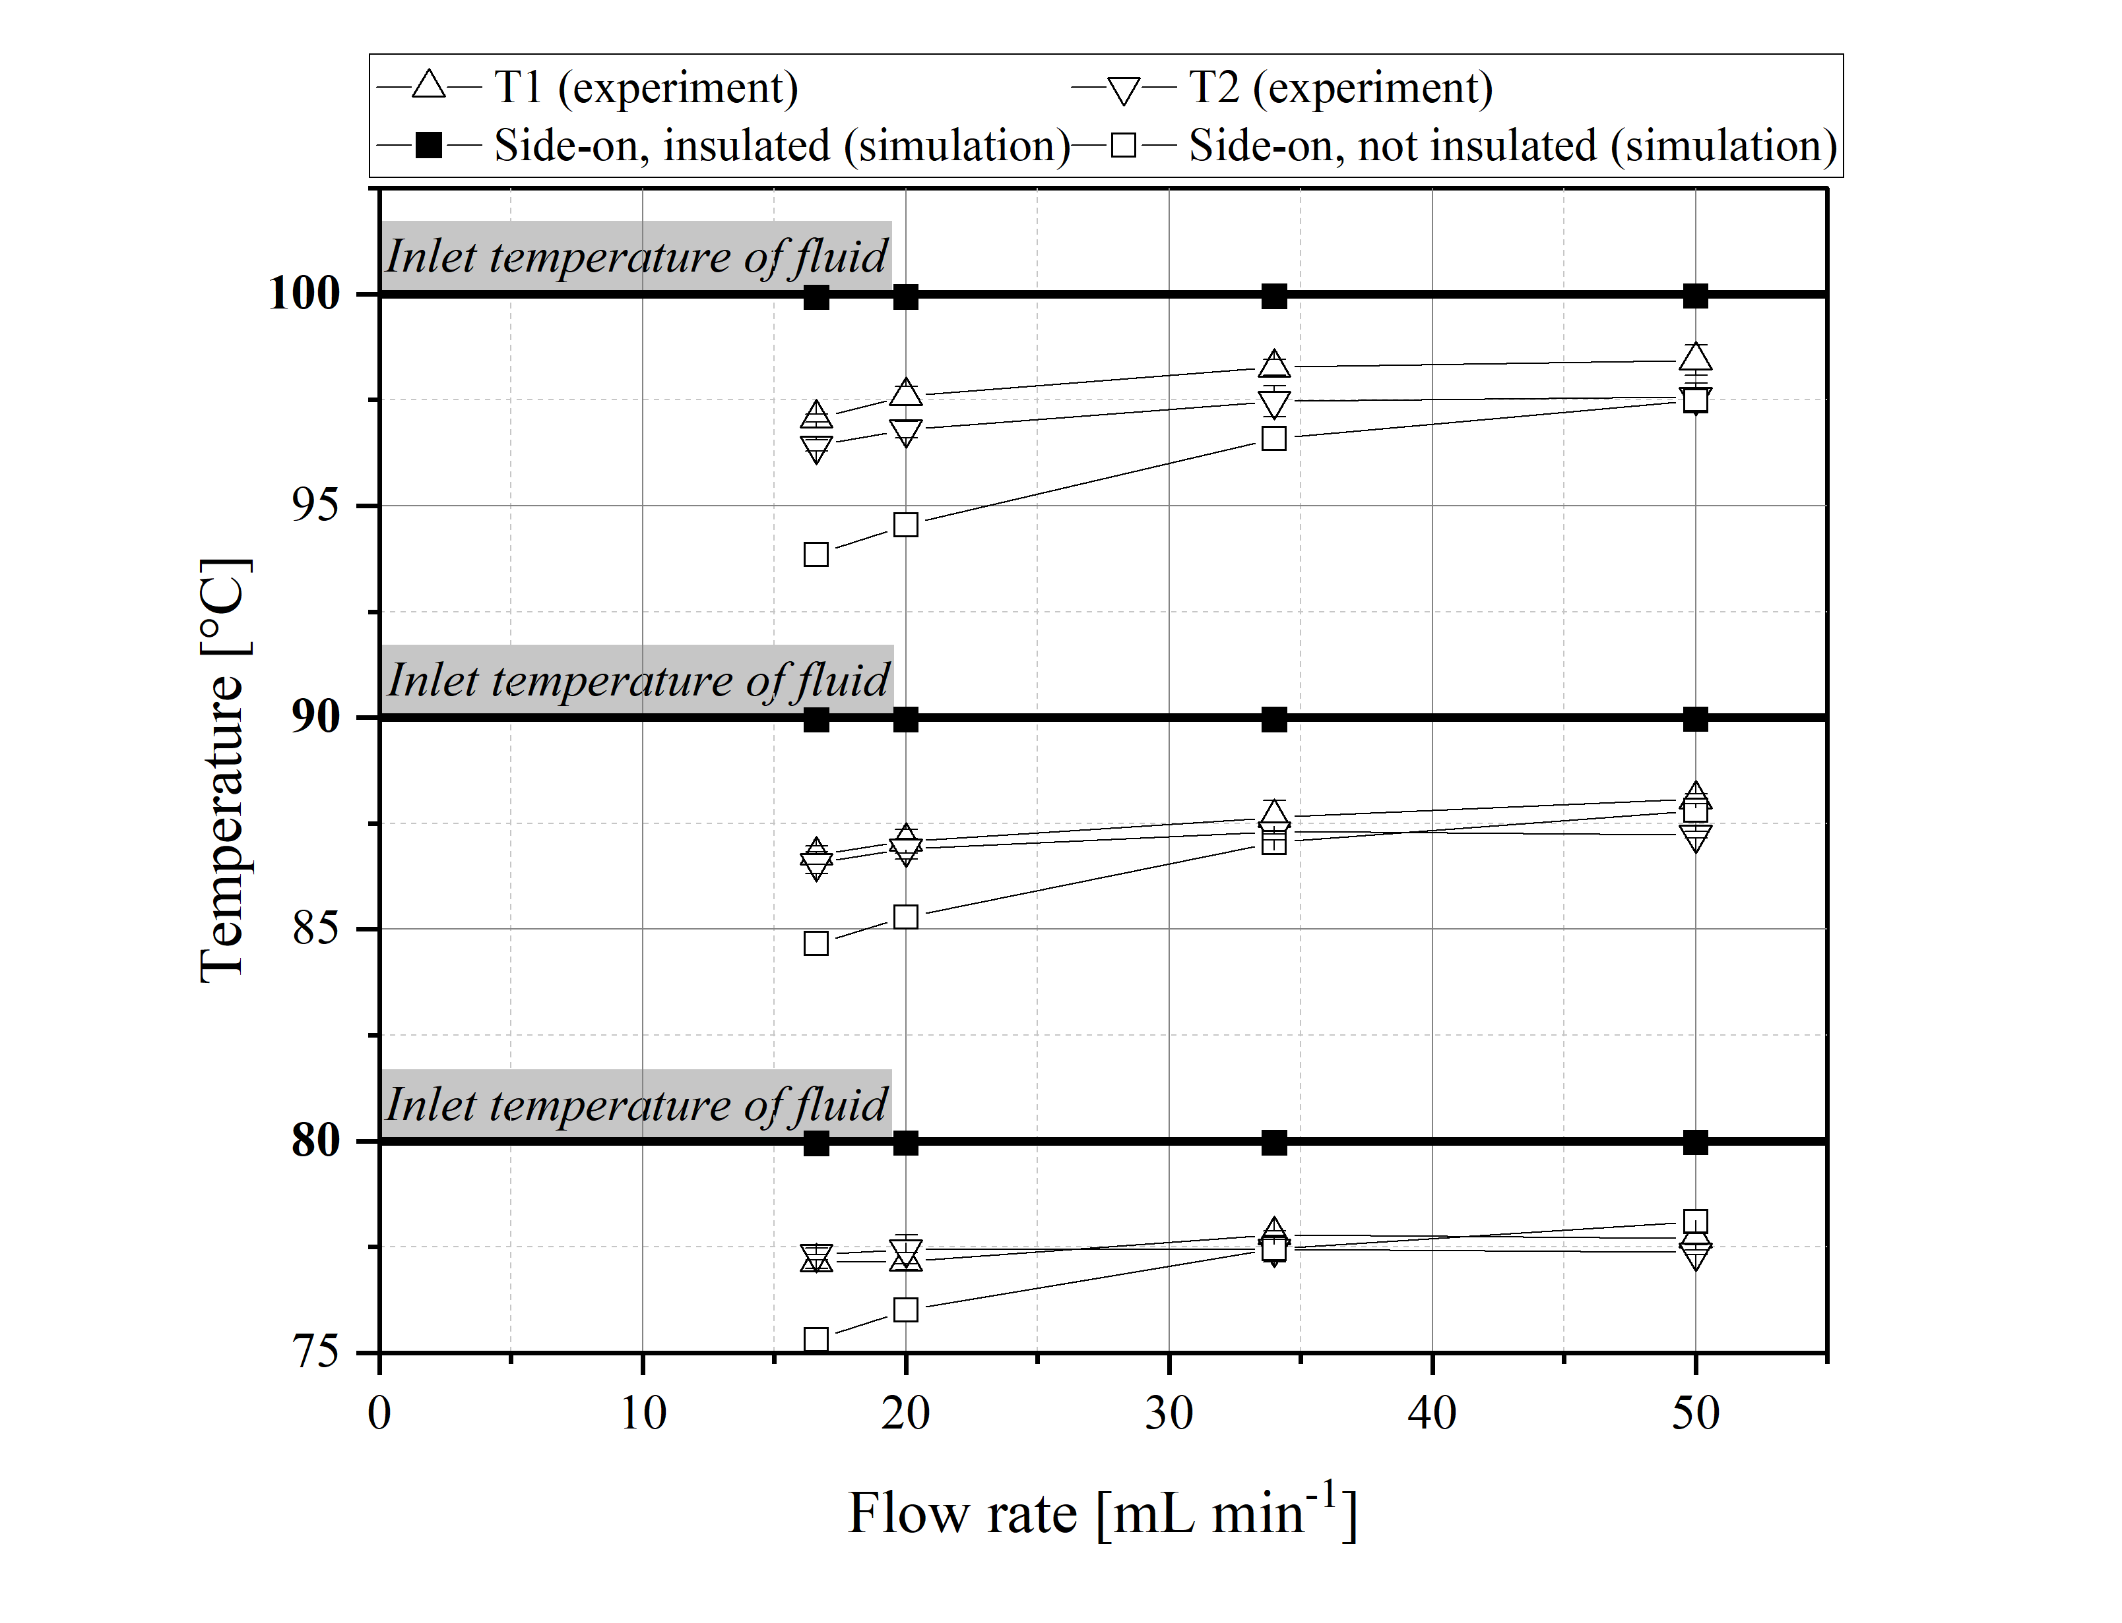
Fig. S8 Comparison of simulation and experimental results for inlet temperatures of the fluid of 80, 90 and 100 °C for different flow rates. The data points are connected with lines for better visualisation.
Figure S8 shows that the effect of decreasing temperature at lower flow rates is almost the same in the range of 80 to 100 °C. The measured temperature values are close to the temperature values obtained by simulation with a not insulated T-piece. The difference between experiment and simulation is slightly higher for 100 °C inlet fluid temperature than for 80 °C, since the heat transfer from the T-piece to the environment increases with increasing temperature.
To compare different solvents, a simulation with ethanol is also performed. This simulation and the simulation with DMF as fluid are shown in Figure S9.
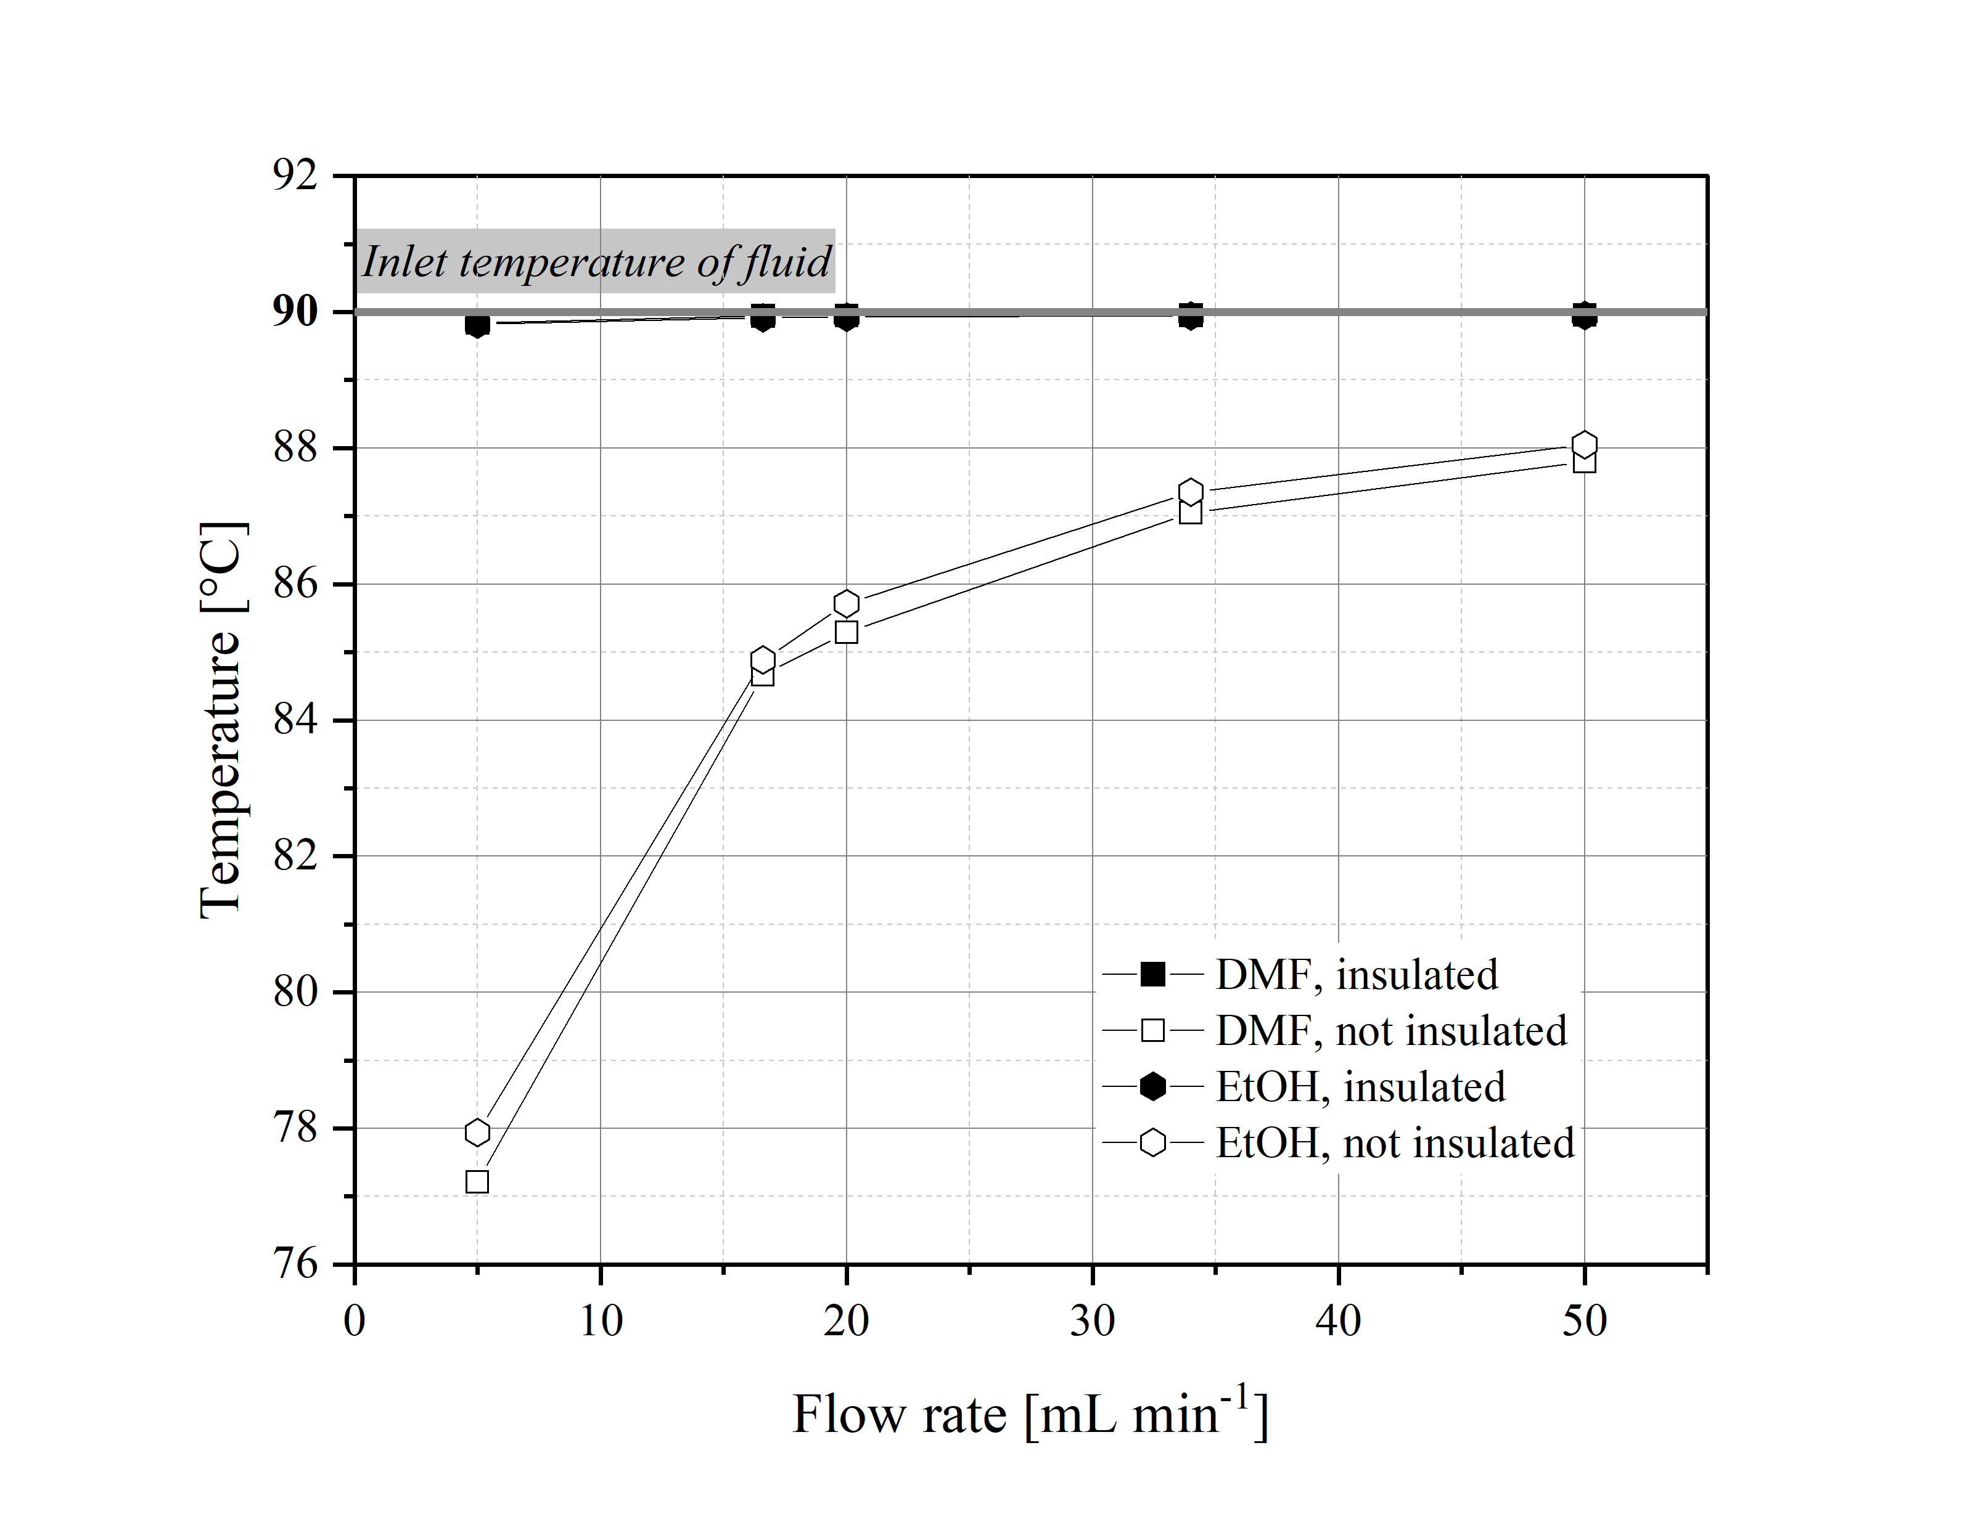
Fig. S9 Simulated temperature profile for side-on setting without insulation with DMF (dimethylformamide) and EtOH (ethanol) as solvent for different flow rates. Inlet and environmental temperature are given with 90 °C and 20 °C, respectively. The data points are connected with lines for better visualisation.
Ethanol shows the same behavior as dimethylformamide. The temperature loss is higher at lower flow rates. It can also be seen that the temperature of EtOH is always slightly higher than the temperature of DMF. This should be due to the lower heat capacity of DMF (2030 J K⁻¹ kg⁻¹) in comparison to the heat capacity of EtOH (2404 J K⁻¹ kg⁻¹).

PRESSURE DROP STUDY
The pressure drop versus flow rate is shown in Figure S10. The side-on and head-on positions of the Pt100 in the T-piece are presented.
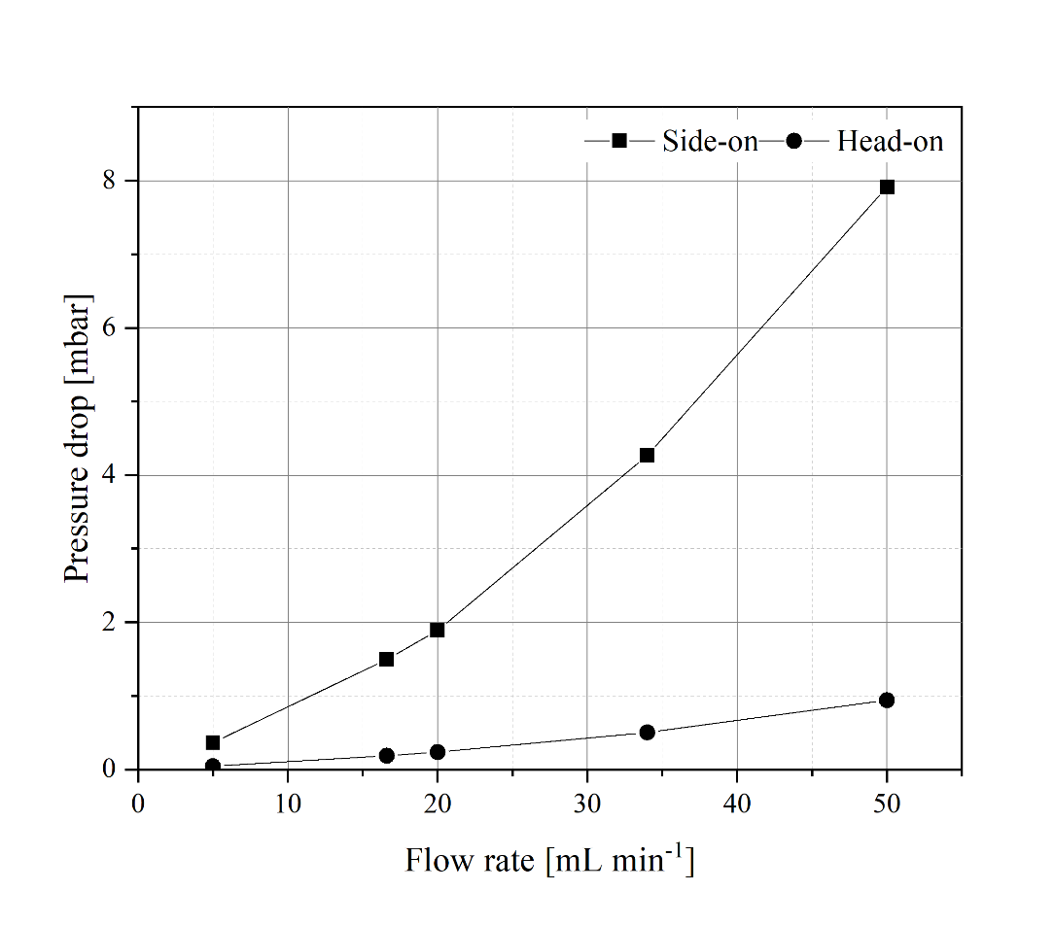
Fig. S10 Pressure drop applied over different flow rates for side-on and head-on Pt100 position. The data points are connected with lines for better visualisation.
The pressure drop increases almost quadratically with increasing flow rate in side-on and head-on position. The greater increase in pressure drop in the head-on position may be due to the smaller cross section that the fluid must pass through. The longer distance between inlet and outlet in the side-on position cloud also be a reason for the smaller increase in pressure difference.
Additionally, distinct pressure profiles are evaluated for the four different orientations of the Pt100 in the T-piece. Figure S11 illustrates the pressure profiles and pressure drops for the four different orientations of the Pt100 at a flow rate of 16.6 mL min⁻¹.
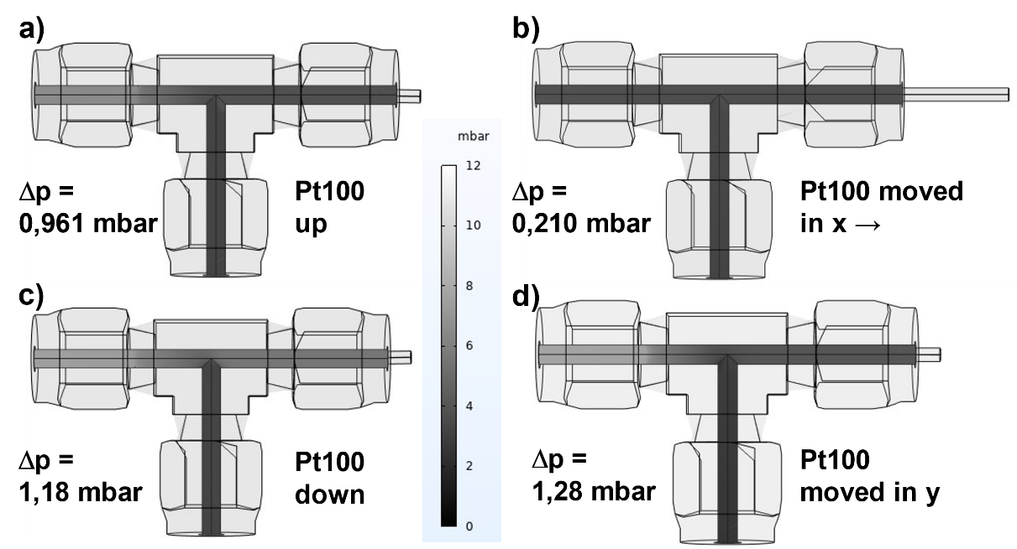
Fig. S11 Pressure profile for different orientation positions of the Pt100 at a flow rate of 16.6 mL min⁻¹ . a) Pt100 moved upwards. b) Pt100 moved in x-direction. c) Pt100 moved downwards. d) Pt100 moved in y-direction.

ABBREVIATIONS & SYMBOLS
$C_{p}$: Specific heat capacity
CFD: Computational fluid dynamics
DMF: Dimethylformamide
EtOH: Ethanol
Pt100: Platinum resistance thermometer with a resistance of 100 Ω
Δp: Pressure drop
$Q_{in}$: Heat input
${\dot{Q}}_{loss}$: Heat removal rate
$Q_{loss}$: Heat removal
$Q_{out}$: Heat output
ρ: Density
λ: Thermal conductivity
μ: Dynamic viscosity

REFERENCES
1. Li D (2015) Encyclopedia of Microfluidics and Nanofluidics. Springer New York, New York, NY
2. COMSOL Multiphysics® v. 6.2. www.comsol.com. COMSOL AB, Stockholm, Sweden

