Supplementary Information (SI):

Journal of Paleolithic Archaeology

Lithic technology and chronology of Initial Upper Paleolithic assemblages at Tor Fawaz, southern Jordan

Seiji Kadowaki ^{a,}*, Toru Tamura ^{b,}, Risako Kida ^{c}, Takayuki Omori ^{d}, Lisa A. Maher ^{e}, Marta Portillo ^{f}, Masato Hirose ^{c}, Eiki Suga ^{c}, Sate Massadeh ^{g}, and Donald O. Henry ^{h}

ª Nagoya University Museum, Nagoya University, Furo-cho, Chikusa-ku, Nagoya 464-8601, Japan
^{b} Geological Survey of Japan, AIST, Central 7, 1-1-1 Higashi, Tsukuba, Ibaraki 305-8567, Japan
^{c} Graduate School of Environmental Studies, Nagoya University, Furo-cho, Chikusa-ku, Nagoya 464-8601, Japan
^{d} The University Museum, The University of Tokyo, Hongo 7-3-1, Bunkyo, Tokyo 113-0033, Japan
^{e} Department of Anthropology, University of California, Berkeley, 232 Kroeber Hall, Berkeley, CA, 94720-3710, USA
^{f} Department of Archeology and Anthropology, Archaeology of Social Dynamics (2017SGR 995), Institució Milà i Fontanals, Spanish National Research Council (CSIC), Egipcíaques, 15, Barcelona, 08001, Spain
^{g} Department of Antiquities, Jordan, Jebal Amman, Third Circle, Abdel Moneim Street, Building No. 21, Jordan
^{h} Department of Anthropology, University of Tulsa, Tulsa, Oklahoma 74104, USA

* Corresponding author.
E-mail address: kadowaki@num.nagoya-u.ac.jp (S. Kadowaki).

Online Resource Text 1
Preliminary measurements of quartz OSL
The single-aliquot regenerative-dose (SAR) protocol was used to determine the equivalent dose (D_{e}) of quartz grains using the OSL response to a test dose to monitor and correct for sensitivity changes (Murray and Wintle, 2000). OSL measurements were made at 125 °C with a stimulation time of 20 s. The OSL intensity was determined by integrating the signal for initial 0.5 s subtracted by the average during the last 5 s of signal. To determine D_{e}, four regeneration points were measured including 0 Gy and a replicate of the first regeneration point, which was used to check whether the sensitivity correction procedure was performing adequately. D_{e} values of three aliquots were averaged in each case.
Dose recovery test and preheat plateau test were carried out on sample OSL-34 (gsj17391) (Table 1) by changing the preheat temperature from 160 to 260 °C in 20 °C increments. A 160 °C cutheat for the OSL response to the test dose was used for all samples. As a result of the tests, unfavorable quartz OSL characteristics for dating were observed; the dose recovery ratio considerably varies in relation to the preheat temperature and even outside the acceptable range (within 1.0±0.1) for preheat 160 and 220 ºC, and D_{e} was also variable, showing no plateau (Online Resource Fig. 3). These results suggest the influence of serious sensitivity changes of the quartz OSL, hindering the robust determination of preheat temperature and estimate of D_{e}. Thus, the quartz OSL was not further investigated for age determination.

Reference
Murray, A.S., Wintle, A.G., 2000. Luminescence dating of quartz using an improved singlealiquot regenerative-dose protocol. Radiat. Meas. 32, 57–73.

Online Resource Figure 1
Sediment block sample MM6 comes from the transition between Layer C upper and Layer C lower of the east section of the 1994 Trench at Tor Fawaz (upper left). Six thin section slides (right) were produced from the sediment block, with slides 1–3 from Layer C upper and slides 4–6 from Layer C lower (lower left).

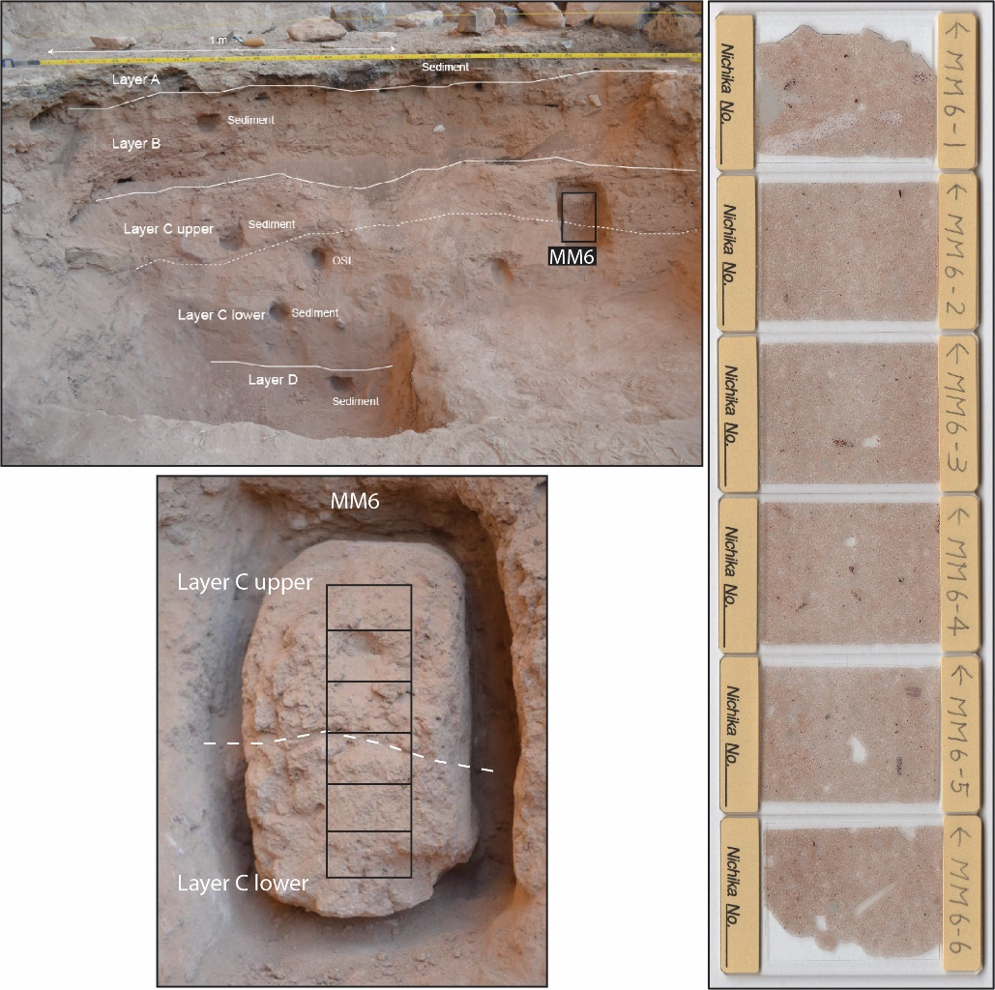

Online Resource Figure 2
Sediment block sample MM12 intersects Layer B and Layer C lower from the east section of Unit 6 at Tor Fawaz (upper left). Six thin section slides (right) were produced from the sediment block, with slides 1–3 from Layer B and slides 3–6 from Layer C (lower left). Note the more laminated/layered appearance of slides 1–3 in both the sediment block and the thin sections.

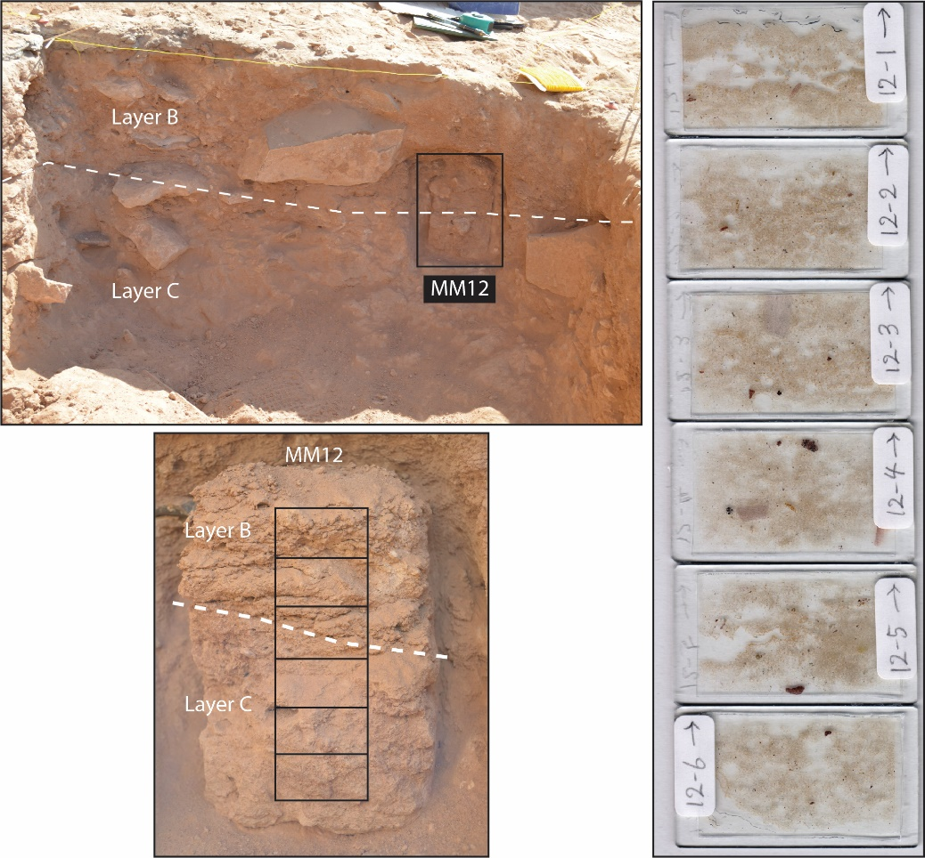

Online Resource Figure 3
Results of the dose recovery test (A) and preheat plateau test (B) on OSL of quartz grains extracted from sample gsj17384. Acceptable range of the dose recovery and recycling ratios is shaded. Error bars show the standard deviation.

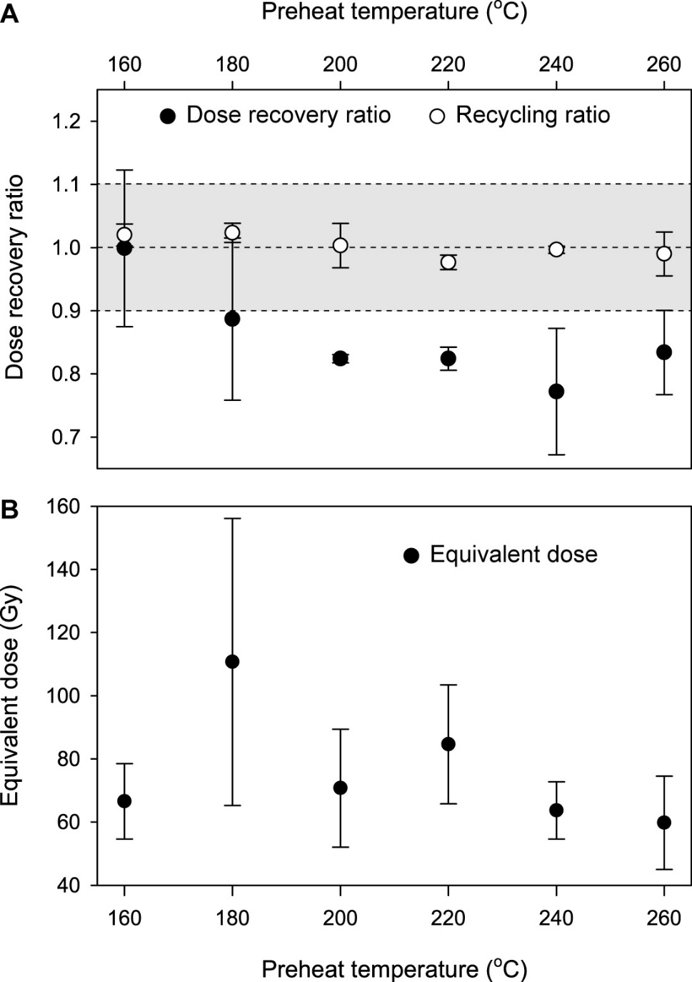

Online Resource Figure 4
Results of dose recovery (A) and preheat plateau (B) tests on Qtz OSL of sample OSL-34 (gsj17391).

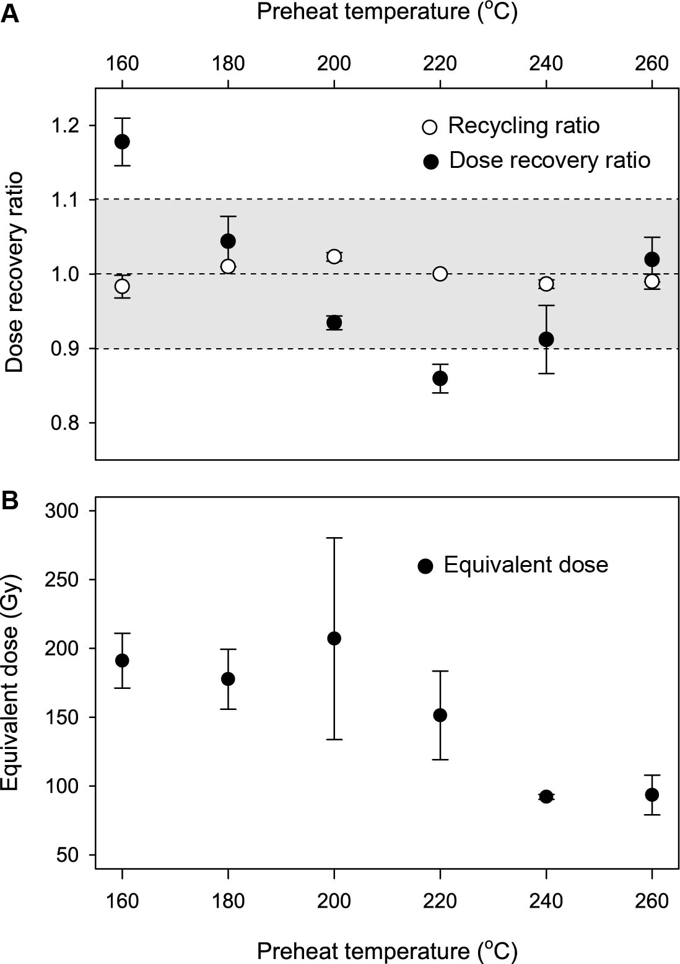

Online Resource Figure 5
Decay curve of natural K-feldspar pIRIR_{50/150} signal and dose-response curve (inset) measured on sample OSL-34 (gsj17391). The intersection of the natural pIRIR intensity with the dose-response curve and the corresponding equivalent dose is highlighted with red dashed lines.

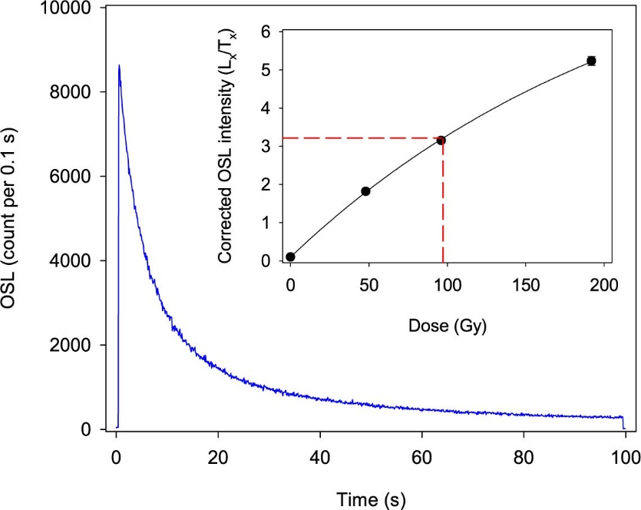

Online Resource Table 1
Summary of the pIRIR_{50/150} single-aliquot regenerative dose protocol used in this study.

Step | post-IR IRSL (50ºC/150ºC) | Signal
1 | Preheat at 180ºC for 60 s
2 | IR stimulation at 50ºC for 100 s
3 | IR stimulation at 150ºC for 100 s | Lx
4 | Test dose
5 | Preheat at 180ºC for 60 s
6 | IR stimulation at 50ºC for 100 s
7 | IR stimulation at 150ºC for 100 s | Tx
8 | Dose and return to step 1

