Analyzing trends in material culture evolution – a case study of Gravettian points from Lower Austria and Moravia

Andreas Maier^{1*}, Robin John¹, Florian Linsel², Georg Roth³, Walpurga Antl-Weiser⁴, Lisa Bauer⁵, Norbert Buchinger⁶, Levin Cavak¹, Helen Hoffmann¹, Janos Puschmann¹, Marcel Schemmel¹, Viola C. Schmid^{6,7,8,9}, Ulrich Simon^{10**}, Roswitha Thomas⁶

¹ Institute of Prehistoric Archeology, University of Cologne, Bernhard-Feilchenfeld-Str. 11, 50969 Köln, Germany
² Institute of Computer Science, Martin-Luther-Universität Halle-Wittenberg, Von-Seckendorff-Platz 1, 06120 Halle, Germany
³ Institut für Prähistorische Archäologie, Freie Universität Berlin, Fabeckstr. 23-25, 14195 Berlin, Germany
⁴ Department of Prehistory, Naturhistorisches Museum, Burgring 7, 1010 Wien, Austria
⁵ Institute of Prehistoric Archeology, Friedrich-Alexander-University Erlangen-Nürnberg, Kochstraße 4/16, 91054 Erlangen, Germany
⁶ Research group Quaternary Archaeology, Austrian Archaeological Institute, Austrian Academy of Sciences, Hollandstraße 11+13, 1020 Wien, Austria
⁷ Human Origins Group, Faculty of Archaeology, Leiden University, Einsteinweg 2, 2333 CC Leiden, Netherlands
⁸ Department of Early Prehistory and Quaternary Ecology, University of Tübingen, Burgsteige 11, 72070 Tübingen, Germany
⁹ Équipe AnTET - Anthropologie des Techniques, des Espaces et des Territoires au Pliocène et au Pléistocène, University Paris Nanterre, 21 allée de l'Université, 92023 Nanterre Cedex, France
¹⁰ Schleswig, Germany

* a.maier@uni-koeln.de, ORCID: 0000-0002-5021-3341
** ORCID: 0000-0002-0195-467X

SUPPLEMENTARY MATERIAL

Content:

1. Radiocarbon data and chronological attribution of the assemblages
2. PyREnArA - program procedure
3. Pearson coefficients of the parameters
4. Shape analysis – results and tables
5. RDA analysis – results and tables
6. Retouch
7. Typology as canonical variable
8. Location as canonical variable
9. Within-cluster variance
10. Artifacts from Krems-Wachtberg and Jarošov-Podvršťa.
11. References for drawings/photographs
12. References

Tab. s1. Radiocarbon data and chronological attribution of the assemblages

Assembalge | M | S | Lab.-Nr. | AMS | BP | Std | calBP | Std | P | wBP | wStd | WCalBP | wStd | Chron | References
Aggsbach, a | ch |  | GrN-1327 | CON | 22670 | 100 |  |  |  |  |  |  |  |  | Vogel & Zagwijn, 1967
Aggsbach, b (main) | ch |  | GrN-1354 | CON | 25760 | 170 | 30049 | 141 |  |  |  |  |  | 30 | Vogel & Zagwijn, 1967
Aggsbach, c | ch |  | GrN-2513 | CON | 26800 | 200 |  |  |  |  |  |  |  |  | Vogel & Zagwijn, 1967
Dolni Vestonice I | ch |  | Ly-1999 | CON | 19640 | 540 |  |  |  |  |  |  |  |  | Oliva, 2000
Dolni Vestonice I | ch |  | GrN-11004 | CON | 20270 | 210 |  |  |  |  |  |  |  |  | Oliva, 2000
Dolni Vestonice I | ch |  | Ly-1303 | CON | 22250 | 570 |  |  |  |  |  |  |  |  | Oliva, 2000
Dolni Vestonice I | b | H | OxA-8292 | AMS | 22840 | 200 |  |  |  |  |  |  |  |  | Svoboda et al., 2018
Dolni Vestonice I | ch |  | GrN-6857 | CON | 25790 | 320 | 30038 | 400 | * |  |  |  |  |  | Svoboda et al., 2018
Dolni Vestonice I | ch |  | GrN-1286 | CON | 25820 | 170 | 30120 | 136 | * |  |  |  |  |  | Svoboda et al., 2018
Dolni Vestonice I | ch |  | GrN-18189 | CON | 25950 | 630 | 30132 | 640 | * |  |  |  |  |  | Svoboda et al., 2018
Dolni Vestonice I | ch |  | GrN-10524 | CON | 26430 | 190 | 30660 | 241 | * |  |  |  |  |  | Svoboda et al., 2018
Dolni Vestonice I | ch |  | GrN-18188 | CON | 27250 | 590 | 31417 | 567 | * |  |  |  |  |  | Svoboda et al., 2018
 |  |  |  |  |  |  |  |  | 3.3 | 26092 | 114 | 30388 | 218 | 30.4
Dolni Vestonice I | ch |  | GrN-6859 | CON | 27790 | 370 |  |  |  |  |  |  |  |  | Svoboda et al., 2018
Dolni Vestonice |  |  | GrN-2902 | CON | 28340 | 390 |  |  |  |  |  |  |  |  | Svoboda et al., 2018
Dolni Vestonice I | ch |  | GrN-6860 | CON | 29180 | 460 |  |  |  |  |  |  |  |  | Svoboda et al., 2018
Dolni Vestonice I | ch |  | GrN-18187 | CON | 29300 | 750 |  |  |  |  |  |  |  |  | Svoboda et al., 2018
Dolni Vestonice I | ch |  | GrN-11189 | CON | 31700 | 1000 |  |  |  |  |  |  |  |  | Svoboda et al., 2018
Dolni Vestonice I | ch |  | GrN-6858 | CON | 32850 | 660 |  |  |  |  |  |  |  |  | Svoboda et al., 2018
Jarosov II | b | M | GrA-24741 | AMS | 22330 | 130 |  |  |  |  |  |  |  |  | Škrdla et al, 2006
Jarosov II | b | M | GrA-20495 | AMS | 23120 | 200 |  |  |  |  |  |  |  |  | Jöris et al., 2010
Jarosov II |  |  | GrA-9613 | AMS | 25110 | 240 | 29445 | 298 | a |  |  |  |  |  | Škrdla, 2001
Jarosov II |  |  | GrA-9604 | AMS | 25780 | 250 | 30032 | 282 | a |  |  |  |  |  | Škrdla, 2001
Jarosov II |  |  | GrA-15137 | AMS | 26220 | 390 | 30490 | 355 | a |  |  |  |  |  | Škrdla, 2001
Jarosov II |  |  | GrN-17191 | CON | 26340 | 180 | 30596 | 234 | a |  |  |  |  |  | Škrdla, 2001
 |  |  |  |  |  |  |  |  | ª0.1 | 25901 | 119 | 30160 | 106 | 30.2
Jarosov II |  |  | VERA-758 | AMS | 26900 | 200 | 31041 | 117 | b |  |  |  |  |  | Jöris et al., 2010
Jarosov II |  |  | VERA-757 | AMS | 27200 | 200 | 31302 | 163 | b |  |  |  |  |  | Jöris et al., 2010
Jarosov II |  |  | VERA-759 | AMS | 27200 | 200 | 31302 | 163 | b |  |  |  |  |  | Jöris et al., 2010
 |  |  |  |  |  |  |  |  | ^{b}47.2 | 27100 | 115 | 31163 | 56 | 31.2
Kranawetberg AH3 | ch |  | GrA-28183 | AMS | 24780 | 140 |  |  |  |  |  |  |  |  | Antl-Weiser et al., 2010
Kranawetberg AH3 | ch |  | GrA-28184 | AMS | 25640 | 160 |  |  |  |  |  |  |  |  | Antl-Weiser et al., 2010
Kranawetberg AH3 | ch |  | GrA-28185 | AMS | 25010 | 150 |  |  |  |  |  |  |  |  | Antl-Weiser et al., 2010
Kranawetberg AH4 |  |  | GrA-9062 | AMS | 25220 | 250 | 29526 | 285 | * |  |  |  |  |  | Antl-Weiser et al., 2010
Kranawetberg AH4 | ch |  | GrA-9063 | AMS | 24620 | 230 | 28849 | 231 | * |  |  |  |  |  | Antl-Weiser et al., 2010
Kranawetberg AH4 | ch |  | GrA-9065 | AMS | 24930 | 240 | 29242 | 330 | * |  |  |  |  |  | Antl-Weiser et al., 2010
Kranawetberg AH4 | ch |  | GrA-9066 | AMS | 24830 | 230 | 29092 | 260 | * |  |  |  |  |  | Antl-Weiser et al., 2010
Kranawetberg AH4 | ch |  | VERA-364 | AMS | 25300 | 90 | 29565 | 222 | * |  |  |  |  |  | Antl-Weiser et al., 2010
Kranawetberg AH4 |  |  | VERA-366 | AMS | 25450 | 90 | 29694 | 221 | * |  |  |  |  |  | Antl-Weiser et al., 2010
 |  |  |  |  |  |  |  |  | 0.3 | 25266 | 56 | 29533 | 203 | 29.5
Milovice I, G | ch |  | GrN-14824 | CON | 25220 | 280 | 29520 | 302 |  |  |  |  |  |  | Svoboda, 2011
Milovice I, G | ch |  | GrN-22105 | CON | 25570 | 170 | 29752 | 250 |  |  |  |  |  |  | Svoboda, 2011
Milovice I, G | t | M | Poz-99606 | AMS | 25770 | 210 | 30039 | 208 | * |  |  |  |  |  | Wilczýnski et al., 2020
Milovice I, G | t | M | Poz-99610 | AMS | 25880 | 220 | 30210 | 213 | * |  |  |  |  |  | Wilczýnski et al., 2020
Milovice I, G | t | M | Poz-99607 | AMS | 24900 | 200 | 29177 | 274 | * |  |  |  |  |  | Wilczýnski et al., 2020
Milovice I, G | t | M | Poz-99608 | AMS | 26010 | 230 | 30369 | 276 | * |  |  |  |  |  | Wilczýnski et al., 2020
 |  |  |  |  |  |  |  |  | 0.2 | 25555 | 86 | 29857 | 129 | 29.9
Pavlov I | ch |  | GrN-1325 | CON | 25020 | 150 |  |  |  |  |  |  |  |  | Svoboda et al., 2016
Pavlov I | ? |  | GrN-22304 | CON | 25160 | 170 |  |  |  |  |  |  |  |  | Svoboda et al., 2016
Pavlov I | ch |  | GrA-192 | AMS | 25530 | 110 |  |  |  |  |  |  |  |  | Svoboda et al., 2016
Pavlov I | ? |  | GrN-22305 | CON | 25800 | 290 |  |  |  |  |  |  |  |  | Svoboda et al., 2016
Pavlov I | ch |  | Beta-359288 | AMS | 25810 | 130 |  |  |  |  |  |  |  |  | Svoboda et al., 2016
Pavlov I | ch |  | Gin-104 | AMS | 26000 | 350 | 30343 | 361 | * |  |  |  |  |  | Svoboda et al., 2016
Pavlov I | ch |  | GrN-20391 | CON | 26170 | 450 | 30436 | 402 | * |  |  |  |  |  | Svoboda et al., 2016
Pavlov I | ch |  | Beta-388400 | AMS | 26180 | 110 | 30470 | 217 | * |  |  |  |  |  | Svoboda et al., 2016
Pavlov I | ch |  | Beta-359291 | AMS | 26340 | 140 | 30601 | 209 | * |  |  |  |  |  | Svoboda et al., 2016
Pavlov I | ch |  | Beta-359287 | AMS | 26400 | 140 | 30648 | 214 | * |  |  |  |  |  | Svoboda et al., 2016
Pavlov I | ? |  | GrN-22303 | CON | 26400 | 310 | 30613 | 302 | * |  |  |  |  |  | Svoboda et al., 2016
Pavlov I |  |  | Beta-388403 | AMS | 26420 | 120 | 30666 | 208 | * |  |  |  |  |  | Svoboda et al., 2016
Pavlov I | ch |  | KN-1286 | CON | 26580 | 460 | 30691 | 380 | * |  |  |  |  |  | Svoboda et al., 2016
Pavlov I | ch |  | GrN-1272 | CON | 26620 | 230 | 30761 | 260 | * |  |  |  |  |  | Svoboda et al., 2016
Pavlov I | ch |  | GrN-19539 | CON | 26650 | 230 | 30779 | 258 | * |  |  |  |  |  | Svoboda et al., 2016
Pavlov I | ch |  | GrN-4812 | CON | 26730 | 250 | 30825 | 258 | * |  |  |  |  |  | Svoboda et al., 2016
 |  |  |  |  |  |  |  |  | 48.4 | 26373 | 55 | 30629 | 171 | 30.6
Pavlov I | ch |  | Beta-388397 | AMS | 26920 | 130 |  |  |  |  |  |  |  |  | Svoboda et al., 2016
Pavlov I | ch |  | Beta-388402 | AMS | 26990 | 120 |  |  |  |  |  |  |  |  | Svoboda et al., 2016
Pavlov I | ch |  | Beta-359289 | AMS | 27050 | 130 |  |  |  |  |  |  |  |  | Svoboda et al., 2016
Pavlov I | ch |  | Beta-388406 | AMS | 27410 | 120 |  |  |  |  |  |  |  |  | Svoboda et al., 2016
Pavlov I | ch |  | Beta-359285 | AMS | 27520 | 150 |  |  |  |  |  |  |  |  | Svoboda et al., 2016
Pavlov I | ch |  | Beta-388405 | AMS | 27570 | 130 |  |  |  |  |  |  |  |  | Svoboda et al., 2016
Pavlov I | ch |  | Beta-388401 | AMS | 27660 | 130 |  |  |  |  |  |  |  |  | Svoboda et al., 2016
Pavlov I | ch |  | Beta-359293 | AMS | 28560 | 160 |  |  |  |  |  |  |  |  | Svoboda et al., 2016
Pavlov I | ch |  | Beta-388398 | AMS | 28580 | 140 |  |  |  |  |  |  |  |  | Svoboda et al., 2016
Pavlov I | ch |  | Beta-359292 | AMS | 28630 | 170 |  |  |  |  |  |  |  |  | Svoboda et al., 2016
Pavlov I |  |  | Beta-388404 | AMS | 28710 | 120 |  |  |  |  |  |  |  |  | Svoboda et al., 2016
Pavlov I | ch |  | Beta-359286 | AMS | 28860 | 170 |  |  |  |  |  |  |  |  | Svoboda et al., 2016
Pavlov I | ch |  | Beta-359294 | AMS | 32540 | 240 |  |  |  |  |  |  |  |  | Svoboda et al., 2016
Pavlov I | ch |  | Beta-388399 | AMS | 33230 | 220 |  |  |  |  |  |  |  |  | Svoboda et al., 2016
Petrkovice | ch |  | GrN-19540 | CON | 20790 | 270 |  |  |  |  |  |  |  |  | Svoboda, 2008
Petrkovice | ch |  | GrA-35446 | AMS | 21790 | 110 |  |  |  |  |  |  |  |  | Svoboda, 2008
Petrkovice | ch |  | GrA-35447 | AMS | 21970 | 110 |  |  |  |  |  |  |  |  | Svoboda, 2008
Petrkovice | ch |  | GrA-35449 | AMS | 22260 | 110 |  |  |  |  |  |  |  |  | Svoboda, 2008
Petrkovice | ch |  | GrA-891 | AMS | 23370 | 160 | 27556 | 147 |  |  |  |  |  | < 27.5 | Svoboda, 2008
Predmosti Ib |  |  | GrA-32641 | AMS | 24340 | 120 |  |  |  |  |  |  |  |  | Svoboda, 2013
Predmosti Ib | b |  | GrN-6852 | CON | 26320 | 240 | 30574 | 270 | * |  |  |  |  |  | Svoboda, 2013
Predmosti Ib | b | M | OxA-17653 | AMS | 26730 | 140 | 30964 | 110 | * |  |  |  |  |  | Svoboda, 2013
Predmosti Ib | b |  | GrA-32583 | AMS | 26780 | 140 | 30997 | 99 | * |  |  |  |  |  | Svoboda, 2013
Predmosti Ib | b |  | GrN-6801 | CON | 26870 | 250 | 30985 | 176 | * |  |  |  |  |  | Svoboda, 2013
 |  |  |  |  |  |  |  |  | 34.5 | 26713 | 86 | 30981 | 80 | 30.9
Krems-Wachtberg, AH4.4 | ch |  | VERA-4532 | AMS | 26840 | 220 | 30982 | 152 | * |  |  |  |  |  | Einwögerer et al., 2014
Krems-Wachtberg, AH4.4 | ch |  | VERA-3941 | AMS | 26870 | 220 | 31006 | 143 | * |  |  |  |  |  | Einwögerer et al., 2014
Krems-Wachtberg, AH4.4 | ch |  | VERA-4536 | AMS | 26980 | 210 | 31103 | 113 | * |  |  |  |  |  | Einwögerer et al., 2014
Krems-Wachtberg, AH4.4 | ch |  | VERA-3938 | AMS | 27000 | 220 | 31124 | 126 | * |  |  |  |  |  | Einwögerer et al., 2014
Krems-Wachtberg, AH4 | ch |  | VERA-3935 | AMS | 27220 | 230 | 31324 | 181 | *
 |  |  |  |  |  |  |  |  | 78.1 | 26978 | 98 | 31112 | 50 | 31.1
Krems-Wachtberg, AH4 | ch |  | VERA-3937 | AMS | 28240 | 270 |  |  |  |  |  |  |  |  | Einwögerer et al., 2014
Willendorf II, 9 / B1 | b | M | GrA-5005 | AMS | 23180 | 120 |  |  |  |  |  |  |  |  | Haesaerts et al., 1996
Willendorf II, 9 / B1 | b |  | GrN-21898 | CON | 23860 | 270 |  |  |  |  |  |  |  |  | Haesaerts et al., 1996
Willendorf II, 9 / B1 | b |  | GrN-22208 | CON | 24370 | 290 |  |  |  |  |  |  |  |  | Haesaerts et al., 1996
Willendorf II, 9 / B1 | b |  | GrA-5006 | AMS | 24910 | 150 | 29116 | 178 |  |  |  |  |  | 29.1 | Haesaerts et al., 1996
Willendorf II, 8a / B1 | ch |  | GrA-893 | AMS | 23200 | 140 | 27474 | 142 | * |  |  |  |  |  | Haesaerts et al., 1996
Willendorf II, 8a / B1 | ch |  | GrA-493 | AMS | 23400 | 190 | 27568 | 159 | * |  |  |  |  |  | Haesaerts et al., 1996
Willendorf II, 8a / B1 | ch |  | GrA-494 | AMS | 23670 | 120 | 27820 | 91 | * |  |  |  |  |  | Haesaerts et al., 1996
 |  |  |  |  |  |  |  |  | 3.7 | 23458 | 82 | 27621 | 118
Willendorf II, 8 / B2 | b |  | GrA-917 | AMS | 22180 | 190 |  |  |  |  |  |  |  |  | Haesaerts et al., 1996
Willendorf II, 8 / B2 | ch |  | GrA-894 | AMS | 24710 | 180 |  |  |  |  |  |  |  |  | Haesaerts et al., 1996
Willendorf II, 8 / B2 | ch |  | GrN-17801 | CON | 25230 | 320 | 29518 | 328 | * |  |  |  |  |  | Haesaerts et al., 1996
Willendorf II, 8 / B2 | b |  | GrN-21690 | CON | 25400 | 170 | 29626 | 260 | * |  |  |  |  |  | Haesaerts et al., 1996
Willendorf II, 8 / B2 | b |  | GrN-20767 | CON | 25440 | 170 | 29648 | 262 | * |  |  |  |  |  | Haesaerts et al., 1996
Willendorf II, 8 / B2 | ch |  | GrN-17802 | CON | 25660 | 350 | 29857 | 413 | * |  |  |  |  |  | Haesaerts et al., 1996
 |  |  |  |  |  |  |  |  | 83.7 | 25421 | 107 | 29653 | 239 | 29.6
Willendorf II, 8 / B2 | ch |  | GrN-11191 | CON | 25800 | 800 |  |  |  |  |  |  |  |  | Haesaerts, 1990
Willendorf II, 7 / B3 | ch |  | GrA-491 | AMS | 23830 | 200 | 28063 | 241 | * |  |  |  |  |  | Nigst et al., 2008
Willendorf II, 7 / B3 | ch |  | GrA-492 | AMS | 23990 | 130 | 28153 | 220 | * |  |  |  |  |  | Nigst et al., 2008
 |  |  |  |  |  |  |  |  | 50.2 | 23942 | 109 | 28089 | 188
Willendorf II, 6 / B4 | ch |  | GrA-1016 | AMS | 26150 | 110 | 30445 | 222 |  |  |  |  |  | 30.5 | Haesaerts et al., 1996
Willendorf II, 6 / B4 | ch |  | GrN-20768 | CON | 26500 | 480 | 30638 | 394 |  |  |  |  |  |  | Haesaerts et al., 1996
Willendorf II, 6 / B4 | ch |  | GrN-17803 | CON | 27600 | 480 | 31820 | 546 |  |  |  |  |  |  | Haesaerts et al., 1996
Willendorf II, 6 / B4 |  |  | GrA-895 | AMS | 27620 | 230 | 31540 | 217 |  |  |  |  |  |  | Haesaerts et al., 1996
Willendorf II, 5 / C2 | humus |  | GrN-11194 | CON | 23830 | 190 |  |  |  |  |  |  |  |  | Haesaerts, 1990
Willendorf II, 5 / C2 | ch |  | GrN-11193 | CON | 30500 | 900 | 34914 | 891 | * |  |  |  |  |  | Haesaerts, 1990
Willendorf II, 5 / C2 | ch |  | GrA-218 | AMS | 27270 | 290 | 31363 | 212 | * |  |  |  |  |  | Haesaerts et al., 1996
 |  |  |  |  |  |  |  |  | 0.1 | 27574 | 276 | 31534 | 238 | 31.5
Willendorf II, 5 / C2 | ch |  | H-246-231 | CON | 32000 | 3000 |  |  |  |  |  |  |  |  | Felgenhauer, 1959

2. PyREnArA - Program procedure
PyREnArA can be accessed following this link: https://doi.org/10.5281/zenodo.7534188 (John et al. 2023). This chapter stepwise guides through the procedure and the functions of the program PyREnArA (Fig. S2.1). It combines the computer-based recording of morphological properties as well as retouch position and quality of artifact drawings and photos with a statistical evaluation of the recorded properties.
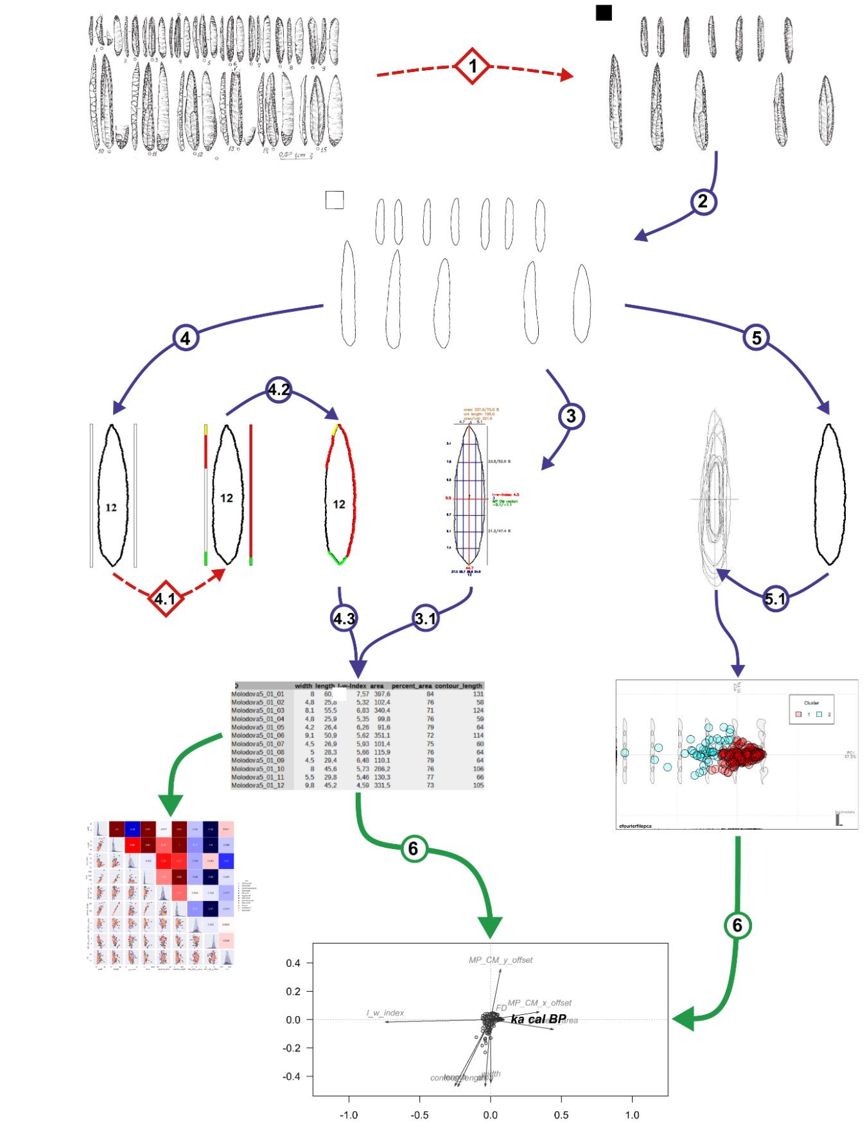
Fig. s2.1 PyREnArA. Stepwise overview of the program procedure and functions. Red dashed lines with square labels: steps that need to be done by hand; blue solid lines with circular labels: automated steps; the outline color of the images indicate the programming language: red/blue = Python, green = R; original image: (Nuzhnyi, 2009, 165: Fig. 4)
2.1 Preparation and modification of the image (Fig. 1: Step 1)
Any photos or drawings of artifacts, individually or in groups on plates can be used in PyREnArA. For uploading an image into PyREnArA, all depicted artifacts must have the same scale and a reference object. The reference object serves as scale for all metric measurements. It is a black square with an edge length of 1 cm relative to the image scale and must be placed in the upper left corner. This is easily done in any image editing program. If the image contains objects not to be recorded (incomplete pieces, scales, etc.), they must be erased. Make sure that only a single dorsal view of each artifact is left in the image (Fig. S2.2, right). Smaller objects, such as arrows or artifact numberings usually will be ignored by the program and therefore do not necessarily need to be removed. However, in case of low resolution, removal is advised. In case of pixel-noise due to resizing poor quality images, the image background should be knocked out, while avoiding alterations of the artifact contours, particularly gaps.

Fig. s2.2 Preparation and modification of images. Left: original image from literature (Nuzhnyi, 2009, 165: Fig. 4); right: processed image with the reference object

2.2 Program-intern image processing (Fig. 1: Step 2)
First, the program creates a new folder in the directory, where it later stores the obtained data and figures. Second, the uploaded image is resized to reduce computing time (and converted to a grey-scale image, so photos can be handled too). The background is set to the NoData value zero. For all operations, black pixels contain data values whereas white ones have NoData values, hence the image is binary. The threshold of white and black is set automatically after Otsu (1979). Third, using the threshold image, the program finds the contours of the artifacts, around which minimum bounding rectangles are fitted. Each artifact is re-oriented with its longest extent placed vertically. In case of lithic points, the program assures that the angle between the tip and its most distant point is zero (Fig. S2.3). In doing so, artifact alignment and therefore subsequent measurements are standardized. In case the artifacts are not detected and rotated correctly, it may be necessary to repeat the import procedure with an altered version.
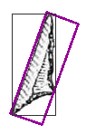

Fig. s2.3 Left: Alignment of an artifact. Violet: tilted minimum area rectangle that will be turned upright; grey: current minimum area rectangle; right: rotated outline image (Nuzhnyi, 2009, 165: Fig. 4)

2.3 Metrical investigation (Fig. 1: Step 3)
Size measurement
When all objects are identified and re-oriented, the program sets points to approximate the detected shapes. The reference object provides the number of pixels per centimeter, which in turn, divided by the actual size in millimeters, returns a translation quotient.
Contour length and area
A built-in function of OpenCV returns the length of the contour as a pixel count which, divided by the reference quotient, results in the length in millimeters. Another built-in function measures the area covered by the artifact. Using the square number of the reference quotient, it returns the area in square millimeters. The area of the bounding box is calculated in this manner as well. Using both area values, a relative coverage area in percentage is obtained. This value is used to distinguish between artifact shapes, especially regarding their pointedness.
Widths, length, and length-width index.
The widest extent of an artifact is obtained by starting in the top left and top right corner of the respective bounding box. Searches for the artifact pixels closest to both sides of the bounding box, the widest part of the artifact is determined by finding the smallest distance between the contour lines and the box’s sides. The longest extent is found accordingly, starting in the upper and lower left corner of the bounding box (Fig. S2.4). Both spatial parameters are divided by the translation quotient to calculate the maximum width and length in millimeters. Dividing the maximum length by the maximum width, the length-width index is determined.
Further measurements of extent
The axes of the widest and longest extents provide the reference for further measurements (Fig. S2.4). The axis of the widest extent divides the artifact into a lower and upper part and each part is subdivided into three zones of equal distance. Where the boundaries between the zones intersect with the artifact’s contour, artifact width is measured. The axis of the longest extent divides the artifact into a left and right part, which are also subdivided into three zones, respectively. Where the section boundaries intersect the artifact’s counter, the length is measured. In addition, the length of the upper and lower part and the width of the left and right side are measured. In total, six widths measurements in addition to the widest part and four lengths measurements in addition to longest part are recorded. The four points of the widest and longest extent plus the 12 points of the zones are subsequently used as “checkpoints” (n=16). If the area of an artifact exceeds or is equal to 85% of the bounding box, widths are measured in five zones starting from the lowest. For length measurements, three zones are defined (16 checkpoints).
Midpoint difference
Inspired by L. Grosman´s work on Lower Paleolithic hand axes and Neolithic masks (Grosman, 2016), PYENARA also calculates the difference between the geometrical center (MP) and the center of mass (CM) of each of the contours. The geometric center describes the middle point of the artifacts bounding box, the center of mass is the point where the artifact is in balance. The offset between both points is measured in horizontal (x) and vertical (y) direction (Fig. S2.4). The output is a vector containing both values.
Angle measurements
Using the set of the 16 checkpoints, the shape of the artifact can roughly be simplified. The advantage of using the checkpoints is their overall comparability. On each of these points, the angle between the two neighboring reference points is measured. The resulting 16 angles get obtained. The eighth point usually marks the tip of the artifact, if there is one. The angle data is stored in a separate csv file in the main directory of the site.
The metrical data is saved as a separate csv-file within the folder directory (Fig. 1: Step 3.1). One figure, which depicts most of the metrical data, is saved to the folder directory (Fig. 4).
Fig. s2.4 Metrical parameters of a single artifact: red = max. width and length and length-width index; blue = other widths and lengths; violet = position of widest and longest part; grey = absolute and relative length of upper and lower part/width of left and right part; brown = area (in mm2 and percentage), contour length and area to contour length ratio; green = vector between MP and CM (green = MP, dark red = CM), golden = checkpoints. Metrical data in mm. (Artifact: Nuzhnyi, 2009, 165: Fig. 4, no. 15)

2.4 Retouch analysis (Fig. 1: Step 4)
The recording of retouch and their quantitative and qualitative properties needs to be done by the researcher. The program exports the image of each outline and adds on each side two “retouch bars”. In the inner bars, the user can insert the kind and the length of each retouch alongside the lateral flanks. The outer ones are determined for surface retouch. The left one depicts the dorsal, the right one the ventral surface. The color coding is as follows: red with an RGB value of (255, 0, 0) represents a dorsal retouch, green (0, 255, 0) a ventral retouch, yellow (0, 255, 255) a bifacial edge retouch, blue (0, 0, 255) a backing retouch and violet (255, 0, 255) a surface retouch. Unretouched parts are left blank (Fig. S2.5). To simplify this step, a legend in the upper left corner contains the kind of retouch (cf. Inizan et al., 1999) and its associated color, which can be picked and filled in the boxes (Fig. 1: Step 4.1).
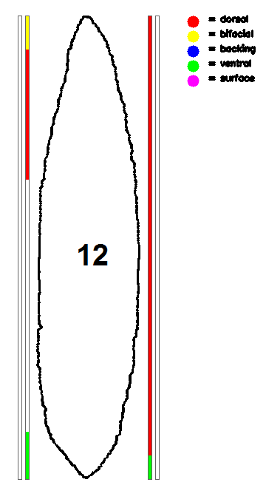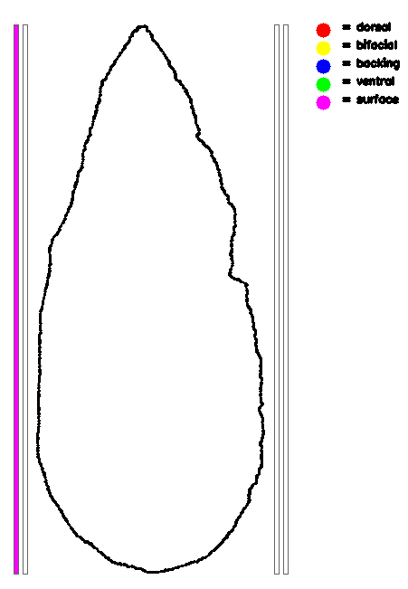
Fig. s2.5 Colored bars for retouch analysis. Left artifact: Nuzhnyi, 2009, 165: Fig. 4, no. 15; Right artifact: fictional surface retouched point

The thus-colored images are again uploaded into the program, where for each of the colored sections the associated part of the contour is identified. By iterating through the color bars, the oblique points on the artifacts are determined and merged to form a curve. Using an OpenCV built-in function, the length of the curvature is calculated. Also, the artifact is split into a left and a right side using the most distant points in length of the artifact so that the lateral length of each side can be calculated too. To obtain the relative length of the retouch in comparison to the respective lateral length, the lengths are divided. For positional arguments, the most distal and most basal point of the retouch are compared to the most distal and most basal point of the artifacts. If the most distal point has a similar position while the most basal point is not of the same position as the center point of the artifact, the retouch is considered to be a “tip retouch” (Fig. S2.6). “Basal retouch” is treated similarly but using the most basal point of the artifact. If the most distal point of the retouch equals the most distal point of the contour while the most basal equals the most basal, the retouch is considered to be a “lateral retouch”. If the most basal point of the retouch is below the geometrical center point of the artifact, the retouch is named “tip and medial”. Oppositely, the retouch is referred to as “basal and medial”. Lastly, if the most distal and most basal points of the retouch do not reach the values of the most distal and most basal point of the artifact, the retouch is considered to be “medial” (Fig 1: Step 4.2). Apart from the metrical analysis surface retouch is treated in the same way. Currently it is not possible to return the absolute and relative size of the surface that is retouched.
The obtained data is then saved to a separate csv file within the folder directory (Fig. 1: Step 4.3). A figure, depicting the obtained retouch data is saved to the main directory (Fig. S2.6).

Fig. s2.6 Retouch detection shows an altered image of artifact 12 (Artifact: Nuzhnyi, 2009, 165: Fig. 4, no. 15) and the fictional surface retouched artifact

2.5 Shape analysis (Fig. 1: Step 5)
The program automatically creates a folder in the directory and stores the images of every artifact outline separately. These images can in a further step be used in shape analysis of the artifacts.
Besides recording metric properties and retouch information, PyREnArA also allows for the analysis of shape, often referred to as geometric morphometrics (GMM). In GMM the shape of an object can be described as the combination of all information that is "invariant under translation, rotation, and isotropic rescalings" (Small, 1996). Based on the works of Thompson (1945), GMM is used in modern biology to estimate the structural change of species according to their topology. With the establishment of a user-friendly programming language, like R and Python (e.g., Claude, 2008), the field of GMM gained publicity, and the community grew. Today, GMM is also used in archaeological analyses (e.g., Hoggard et al., 2019; Falcucci et al., 2022).

In GMM closed outline methods with two different data sources are commonly used: the use of landmarks and pseudo-/semilandmarks (Claude, 2008, 5) or outlines of images, which are afterwards translated to landmarks (Bonhomme et al., 2014, 2017). Landmarks could be automatically detected or subjectively chosen by the researcher. A semilandmark lays in the space between two landmarks and is not based on a detectable feature. The outlines could be extracted from scanned drawings or digital sketches from photos. An orthographic overview image can also be used to detect the outline of an object. The shape of an object can be described either with a semilandmark analysis, an Eigenshape function (Claude, 2008: 229–231), or a Fourier-based approach (ibid.: 221–229).

The approximated model of the outline will be translated, sized and rotated. This procedure is comparable to the Generalised Procrustes Analysis (GPA) (Claude, 2008: 156–166). Procrustes is a figure of the Greek mythology who first catches, then cuts and finally stretches people to fit the size of an iron bed. However, in the end, the heroic Theseus forced him to build his bed. GPA is a method of size, scale, and translation normalization (Caple et al., 2017: 1683). In a GPA, a set of several objects will be translated into a common centroid. After that, these objects will be scaled to the same centroid size, and in the last step, these objects will be turned until the sum of the squared distances between their landmarks is the lowest value possible (Mitteroecker et al., 2013).

In this study we decided to choose a Fourier-based approach because it has certain benefits, such as the objects can be compared even if they do not have the same number of landmarks or size. In an Elliptic Fourier Analysis (EFA), the outline of an object will be represented approximately by deriving a chain code from its quantized image (Szeliski, 2011: 244–250). Each segmented line could have one of eight orientations with a specific length. This chain code will be translated into an infinite series of trigonometric functions, also called harmonics. For a 2-dimensional object like an outline, four Fourier coefficients are defined, each two describing one dimension. Each additional elliptical Fourier function, harmonic, refines the outline model, which converges stepwise towards the original outline. The more harmonics are included in an outline model; the smaller is the average error. The precision of this error has natural/ technical restrictions, e.g., the resolution of the image. The number of harmonics should be adjusted to reach a harmonic power of 99 %, or the sum of errors is not tremendously decreasing. Every picture has its natural threshold, for which the number of harmonics will not add more detail.

After performing the GPA and EFA, several statistical tests can be applied to the resulting data: a principal component analysis (PCA) (Claude, 2008: 106–111), a cluster analysis (CA) (hierarchical) (ibid.: 155), a discriminant analysis (DA) (ibid.: 156, fig. 7), a MANOVA / Procrustes ANOVA, regression-based modelling (Linear/ Multiple) and a mean shape examination. We decided to first estimate the difference by calculating a PCA and second to use a hierarchical clustering algorithm. The performed ward.d2 method was applied. For finding the optimal number of clusters of our investigated object we decided to apply the silhouette approach to our dataset. The resulting graph shows the quality of a clustering. After performing the PCA and a CA, we could separate into distinctive groups, which are not following a temporal, cultural or spatial pattern.

For our approach, we decided to separate our starting dataset according to their GMM-group and then to perform a cultural-temporal selection of one specific tool type, namely “projectile points”.

2.6 Redundancy Analysis (RDA) (Fig. 1: Step 6)
The Redundancy Analysis (RDA) is a direct extension of multiple regression, as it models the effect of an explanatory matrix X (n x p) on a response matrix Y (n x m). In our research, we include the aforementioned parameters as X to try to explain the chronological development as Y.

Redundancy analysis is used as a two-step process (Legendre and Legendre, 2012; Roth, 2022). The first step is a multiple regression, where each object in Y is regressed on the explanatory variables in X, which results in a matrix of fitted values Yfit. In the second step, RDA applies a principal components analysis (PCA) on the fitted matrix Yfit to reduce dimensionality, i.e., to obtain the eigenvalues and eigenvectors. We then obtain a matrix Z which contains the canonical axes, which correspond to linear combinations of the explanatory variables in the space of X. The linearity of the combinations of the X variables is a fundamental property of RDA. In the analysis of community composition, these canonical axes are interpreted as complex environmental gradients.

3. Pearson coefficients of the parameters

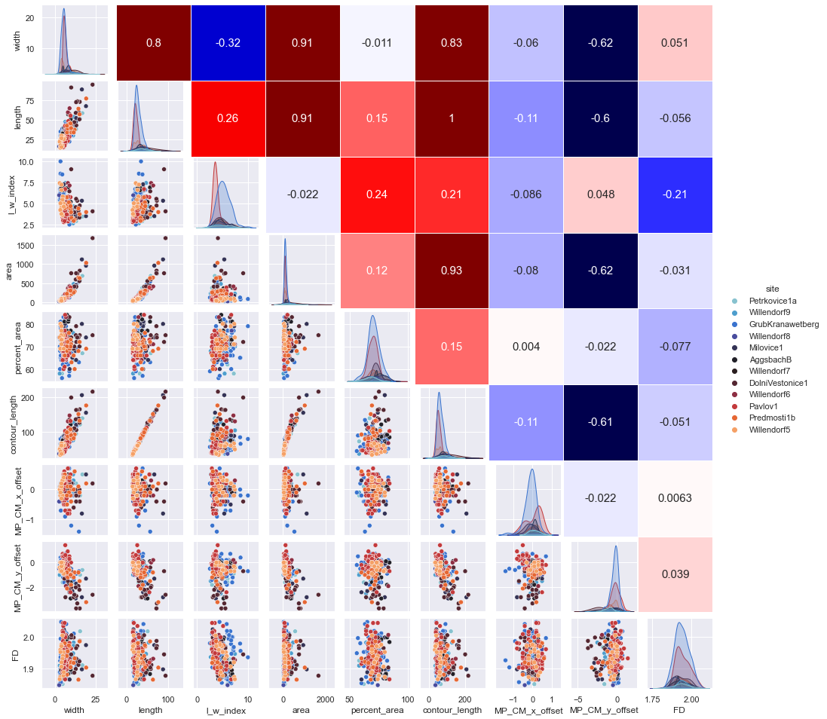

Fig. s3.1: Pearson correlation coefficients. The sites in the legend are given in chronological order with the oldest at the bottom.

4. Shape analysis – results and tables

Fig. s4.1. GMM silhouette bar indicating that a subdivision of the dataset into three clusters is statistically most reasonable

Fig. s4.2. Comparison of the mean shapes of clusters 1, 2 and 2.

5. RDA analysis – results and tables

Tab. s5.1: Permutation test for RDA of the entire dataset and individually for cluster 1, 2 and 3 for the entire period as well as before and after 30 ka cal BP with 999 permutations

ALL | Df | Variance | F | Pr(>F)
Cluster 1+2
Model | 1 | 0.085113872 | 2.530057681 | 0.057
Residual | 265 | 8.914886128 | NA | NA
Cluster 1
1 | 1 | 0.174339918 | 1.422270288 | 0.205
2 | 72 | 8.825660082 | NA | NA
Cluster 2
1 | 1 | 0.239960704 | 3.94454183 | 0.011
2 | 144 | 8.760039296 | NA | NA
Cluster 3
1 | 1 | 0.427412632 | 2.243613 | 0.075
2 | 45 | 8.572587368 | NA | NA
> 30 ka
Cluster 1+2
Model | 1 | 0.656240782 | 8.7302048 | 0.001
Residual | 111 | 8.343759218 | NA | NA
Cluster 1
1 | 1 | 0.432832763 | 1.717757288 | 0.137
2 | 34 | 8.567167237 | NA | NA
Cluster 2
1 | 1 | 1.541335358 | 8.266012389 | 0.001
2 | 40 | 7.458664642 | NA | NA
Cluster 3
1 | 1 | 0.58685836 | 2.301913685 | 0.056
2 | 33 | 8.41314164 | NA | NA
≤ 30 ka
Model | 1 | 0.129984579 | 2.227465801 | 0.069
Residual | 152 | 8.870015421 | NA | NA
Cluster 1
1 | 1 | 0.814892773 | 3.58408742 | 0.017
2 | 36 | 8.185107227 | NA | NA
Cluster 2
1 | 1 | 0.287353269 | 3.364079175 | 0.032
2 | 102 | 8.712646731 | NA | NA
Cluster 3
1 | 1 | 1.774878747 | 2.456538354 | 0.108
2 | 10 | 7.225121253 | NA | NA

Tab. s5.2: RDA and OCA values of the entire dataset and individually cluster 1 and 2 for the entire period as well as before and after 30 ka cal BP

ALL
Cluster 1+2+3 | RDA | PC1 | PC2 | PC3 | PC4 | PC5 | PC6 | PC7 | PC8 | PC9 | RDA% | Pr(>F)
Eigenvalue | 0.0851 | 4.1841 | 1.4809 | 0.9992 | 0.9172 | 0.7311 | 0.5036 | 0.0639 | 0.0331 | 0.0018
Proportion Explained | 0.0095 | 0.4649 | 0.1645 | 0.1110 | 0.1019 | 0.0812 | 0.0560 | 0.0071 | 0.0037 | 0.0002 | 0.95 | 0.057
Cumulative Proportion | 0.0095 | 0.4744 | 0.6389 | 0.7499 | 0.8518 | 0.9331 | 0.9890 | 0.9961 | 0.9998 | 1.0000
Cluster 1
Eigenvalue | 0.1743 | 4.5405 | 1.6313 | 0.8634 | 0.7639 | 0.5605 | 0.4164 | 0.0441 | 0.0044 | 0.0011
Proportion Explained | 0.0194 | 0.5045 | 0.1813 | 0.0959 | 0.0849 | 0.0623 | 0.0463 | 0.0049 | 0.0005 | 0.0001 | 1.94 | 0.205
Cumulative Proportion | 0.0194 | 0.5239 | 0.7051 | 0.8011 | 0.8859 | 0.9482 | 0.9945 | 0.9994 | 0.9999 | 1.0000
Cluster 2
Eigenvalue | 0.2400 | 4.1660 | 1.2831 | 1.0086 | 0.8933 | 0.7715 | 0.5684 | 0.0459 | 0.0209 | 0.0022
Proportion Explained | 0.0267 | 0.4629 | 0.1426 | 0.1121 | 0.0993 | 0.0857 | 0.0632 | 0.0051 | 0.0023 | 0.0002 | 2.67 | 0.011
Cumulative Proportion | 0.0267 | 0.4896 | 0.6321 | 0.7442 | 0.8434 | 0.9292 | 0.9923 | 0.9974 | 0.9998 | 1.0000
Cluster 3
Eigenvalue | 0.4274 | 4.0333 | 1.6030 | 1.1106 | 0.7231 | 0.5983 | 0.4510 | 0.0326 | 0.0167 | 0.0041
Proportion Explained | 0.0475 | 0.4481 | 0.1781 | 0.1234 | 0.0803 | 0.0665 | 0.0501 | 0.0036 | 0.0019 | 0.0005 | 4.8 | 0.075
Cumulative Proportion | 0.0475 | 0.4956 | 0.6737 | 0.7971 | 0.8775 | 0.9440 | 0.9941 | 0.9977 | 0.9995 | 1.0000
> 30 ka
Cluster 1+2+3
Eigenvalue | 0.6562 | 3.9953 | 1.3261 | 1.0708 | 0.8144 | 0.6359 | 0.4321 | 0.0506 | 0.0174 | 0.0012
Proportion Explained | 0.0729 | 0.4439 | 0.1473 | 0.1190 | 0.0905 | 0.0707 | 0.0480 | 0.0056 | 0.0019 | 0.0001 | 7.3 | 0.001
Cumulative Proportion | 0.0729 | 0.5168 | 0.6642 | 0.7832 | 0.8736 | 0.9443 | 0.9923 | 0.9979 | 0.9999 | 1.0000
Cluster 1
Eigenvalue | 0.4328 | 4.7920 | 1.5859 | 0.7991 | 0.6355 | 0.4077 | 0.3040 | 0.0405 | 0.0014 | 0.0010
Proportion Explained | 0.0481 | 0.5324 | 0.1762 | 0.0888 | 0.0706 | 0.0453 | 0.0338 | 0.0045 | 0.0002 | 0.0001 | 4.8 | 0.137
Cumulative Proportion | 0.0481 | 0.5805 | 0.7567 | 0.8455 | 0.9161 | 0.9615 | 0.9952 | 0.9997 | 0.9999 | 1.0000
Cluster 2
Eigenvalue | 1.5413 | 2.8645 | 1.3426 | 1.0314 | 0.9368 | 0.7569 | 0.4936 | 0.0187 | 0.0132 | 0.0008
Proportion Explained | 0.1713 | 0.3183 | 0.1492 | 0.1146 | 0.1041 | 0.0841 | 0.0548 | 0.0021 | 0.0015 | 0.0001 | 17.1 | 0.001
Cumulative Proportion | 0.1713 | 0.4895 | 0.6387 | 0.7533 | 0.8574 | 0.9415 | 0.9964 | 0.9984 | 0.9999 | 1.0000
Cluster 3
Eigenvalue | 0.5869 | 3.9162 | 1.5501 | 1.1438 | 0.8378 | 0.5607 | 0.3550 | 0.0318 | 0.0141 | 0.0036
Proportion Explained | 0.0652 | 0.4351 | 0.1722 | 0.1271 | 0.0931 | 0.0623 | 0.0394 | 0.0035 | 0.0016 | 0.0004 | 6.5 | 0.056
Cumulative Proportion | 0.0652 | 0.5003 | 0.6726 | 0.7997 | 0.8928 | 0.9551 | 0.9945 | 0.9980 | 0.9996 | 1.0000
≤ 30 ka
Cluster 1+2+3
Eigenvalue | 0.1300 | 4.1009 | 1.3490 | 1.0762 | 0.9627 | 0.7458 | 0.5345 | 0.0672 | 0.0313 | 0.0026
Proportion Explained | 0.0144 | 0.4557 | 0.1499 | 0.1196 | 0.1070 | 0.0829 | 0.0594 | 0.0075 | 0.0035 | 0.0003 | 1.4 | 0.069
Cumulative Proportion | 0.0144 | 0.4701 | 0.6200 | 0.7396 | 0.8465 | 0.9294 | 0.9888 | 0.9962 | 0.9997 | 1.0000
Cluster 1
Eigenvalue | 0.8149 | 3.7721 | 1.5493 | 1.1528 | 0.7261 | 0.5543 | 0.4054 | 0.0200 | 0.0045 | 0.0006
Proportion Explained | 0.0905 | 0.4191 | 0.1721 | 0.1281 | 0.0807 | 0.0616 | 0.0450 | 0.0022 | 0.0005 | 0.0001 | 9.1 | 0.017
Cumulative Proportion | 0.0905 | 0.5097 | 0.6818 | 0.8099 | 0.8906 | 0.9522 | 0.9972 | 0.9994 | 0.9999 | 1.0000
Cluster 2
Eigenvalue | 0.2874 | 4.1221 | 1.3310 | 1.0766 | 0.8377 | 0.7259 | 0.5283 | 0.0731 | 0.0149 | 0.0030
Proportion Explained | 0.0319 | 0.4580 | 0.1479 | 0.1196 | 0.0931 | 0.0807 | 0.0587 | 0.0081 | 0.0017 | 0.0003 | 3.2 | 0.032
Cumulative Proportion | 0.0319 | 0.4899 | 0.6378 | 0.7575 | 0.8505 | 0.9312 | 0.9899 | 0.9980 | 0.9997 | 1.0000
Cluster 3
Eigenvalue | 1.7749 | 3.1741 | 1.5640 | 1.0656 | 1.0072 | 0.3021 | 0.0881 | 0.0165 | 0.0065 | 0.0011
Proportion Explained | 0.1972 | 0.3527 | 0.1738 | 0.1184 | 0.1119 | 0.0336 | 0.0098 | 0.0018 | 0.0007 | 0.0001 | 19.7 | 0.108
Cumulative Proportion | 0.1972 | 0.5499 | 0.7237 | 0.8421 | 0.9540 | 0.9875 | 0.9973 | 0.9992 | 0.9999 | 1.0000

6. Retouch

Fig. s6.1: Percent values of projectiles retouched on the dorsal and ventral side as well as on both sides. Assemblages are listed from old (left) to young (right). No temporal trend is discernible

Fig. s6.2: Percent values of projectiles retouched on the left and right side. Assemblages are listed from old (left) to young (right). No temporal trend is discernible

Fig. s6.3: Percent values of projectiles retouched at the tip, medial part and base as well as mean length of retouch. Assemblages are listed from old (left) to young (right). No temporal trend is discernible
7. Typology as canonical variable

Table s7.1 Permutation test for RDA of the with typological information as canonical variable and 999 permutations
ALL | Df | Variance | F | Pr(>F)
Model | 1 | 0.506516138015836 | 158.035.005.134.913 | 0.001
Residual | 265 | 849.348.386.198.417 | NA | NA

Table s7.2 RDA and OCA values of the entire dataset
ALL
 | RDA | PC1 | PC2 | PC3 | PC4 | PC5 | PC6 | PC7 | PC8 | PC9
Eigenvalue | 0.5065 | 0.3845 | 0.1401 | 0.1004 | 0.9033 | 0.7643 | 0.4872 | 0.0560 | 0.0284 | 0.0014
Proportion Explained | 0.0562 | 0.4273 | 0.1557 | 0.1116 | 0.1003 | 0.0849 | 0.0541 | 0.0062 | 0.0031 | 0.0001
Cumulative Proportion | 0.0562 | 0.4836 | 0.6393 | 0.7510 | 0.8513 | 0.9363 | 0.9904 | 0.9966 | 0.9998 | 1

Fig. s7.1: RDA of the entire dataset. X-axis: RDA, y-axis: first PCA-axis Triplot shows 48.3 of total variance
8. Location as canonical variable

Tab. s8.1 Permutation test for RDA of the with site location as canonical variable and 999 permutations
ALL | Df | Variance | F | Pr(>F)
Model | 1 | 0.441871284708929 | 136.824.175.404.896 | 0.001
Residual | 265 | 855.812.871.529.107 | NA | NA

Table s8.2 RDA and OCA values of the entire dataset
ALL
 | RDA | PC1 | PC2 | PC3 | PC4 | PC5 | PC6 | PC7 | PC8 | PC9
Eigenvalue | 0.4418 | 0.3964 | 0.1344 | 0.1001 | 0.9227 | 0.7396 | 0.4993 | 0.0559 | 0.0279 | 0.0014
Proportion Explained | 0.0490 | 0.4405 | 0.1493 | 0.1113 | 0.1025 | 0.0821 | 0.0554 | 0.0062 | 0.0031 | 0.0001
Cumulative Proportion | 0.0490 | 0.4895 | 0.6389 | 0.7503 | 0.8528 | 0.9350 | 0.9905 | 0.9967 | 0.9998 | 1

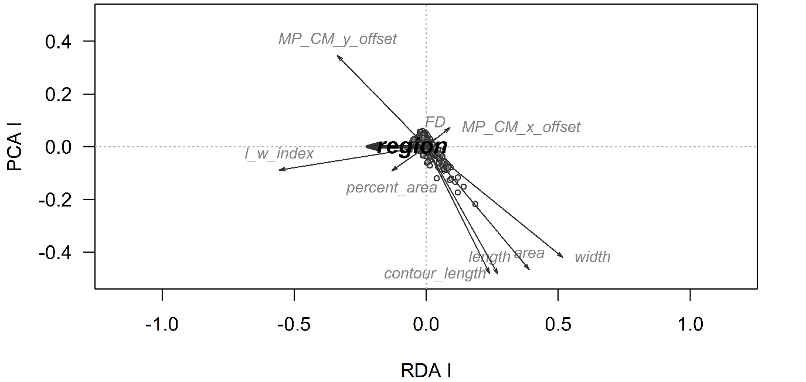
Fig. s7.1: RDA of the entire dataset. X-axis: RDA, y-axis: first PCA-axis Triplot shows 49 of total variance

9. Within-cluster variance

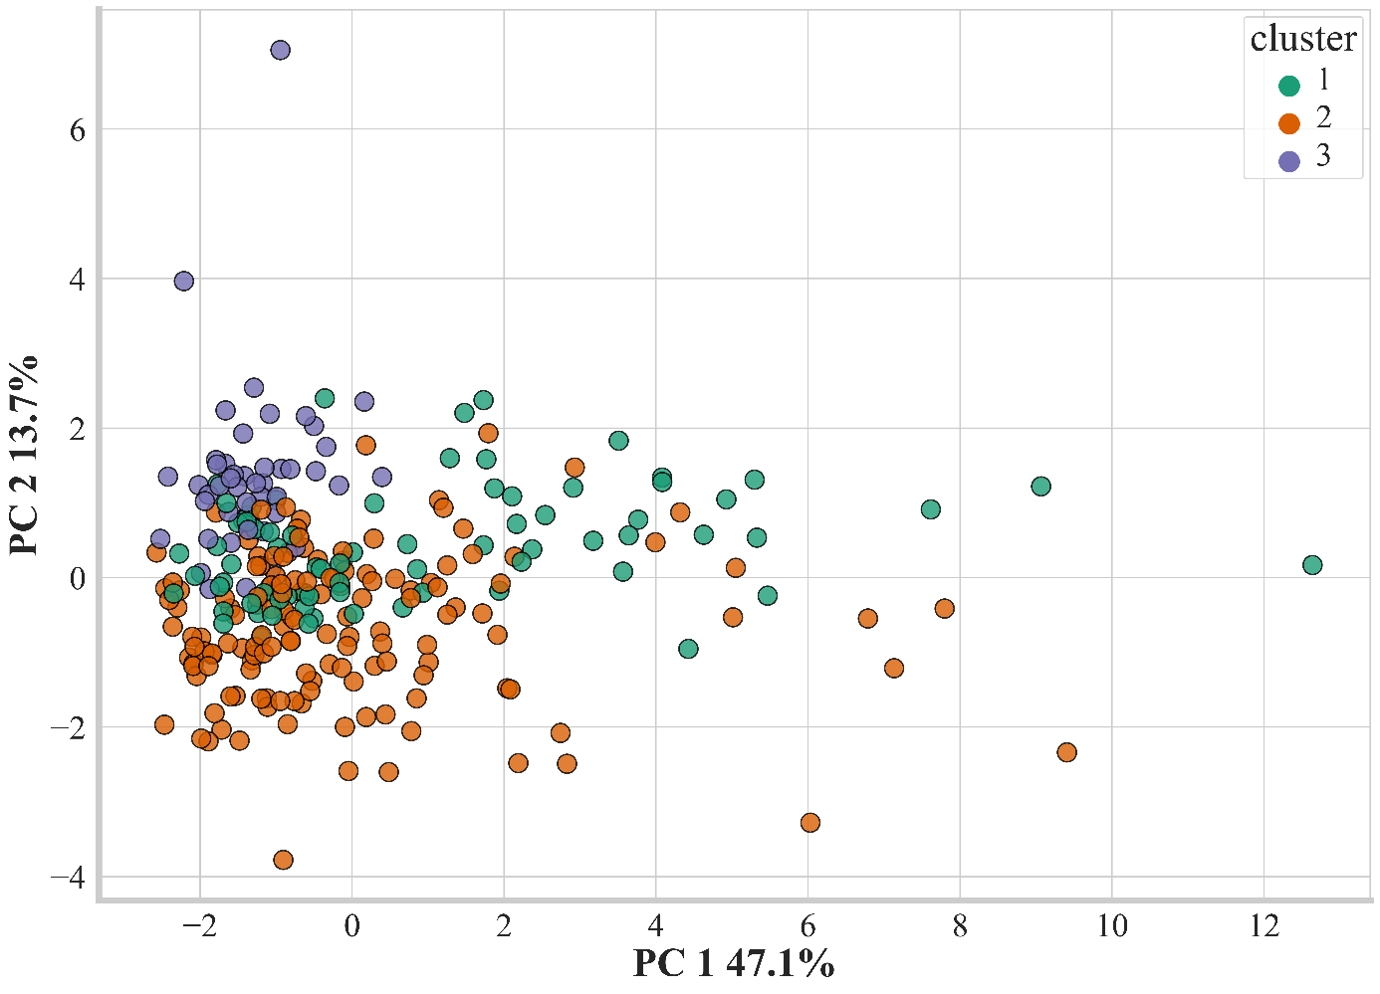
Fig. s9.1 PCA-Plot with different rotation than in Fig. 1 for better visualization of within-cluster variance

10. Artifacts from Krems-Wachtberg and Jarošov-Podvršťa.

Fig. s10.1: Lithic projectiles from Krems-Wachtberg (after Simon et al., 2014; Thomas & Ziehaus, 2014; Thomas et al., 2016)

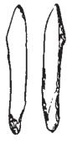
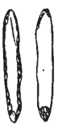
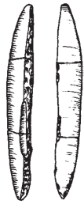
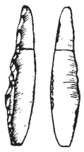

Fig. s10.2: Lithic projectiles from Jarošov-Podvršťa (after Škrdla et al., 2005)

11. References for drawings/photographs

Aggsbach
Otte, M. (1981). Le Gravettien en Europe Centrale (Dissertationes Archaeologicae Gandenses 20). De Tempel.

Dolní Věstonice
Klíma, B. (1963). Dolní Věstonice: výzkum tábořiště lovců mamutů v letech 1947-1952 (Unter-Wisternitz. Die Erforschung des Lagerplatzes der Mammutjäger 1947-1952). Nakl. Československé akademie věd.

Grub/Kranawetberg
Photographs by Walpurga Antl-Weiser.

Jarošov II
Škrdla, P., Nývltova-Fišákova, M. & Nyvlt, D. (2006). Jarošov II settlement cluster. Results of the 2005 excavation. Archeologické rozhledy, LVIII, 207–236.

Krems Wachtberg
Simon, U., Händel, M., Einwögerer, T. & Neugebauer-Maresch, C. (2014). The archaeological record of the Gravettian open air site Krems-Wachtberg. Quaternary International, 351, 5-13.
Thomas, R. & Ziehaus, J. (2014). Spatial and chronological patterns of the lithics of hearth 1 at the Gravettian site Krems-Wachtberg. Quaternary International, 351, 134–145.
Thomas, R. Brandl, M. & Simon, U. (2016). The Gravettian lithic industry at Krems-Wachtberg (Austria). Quaternary International, 406, 106–119.

Milovice I
Polanská, M. (2018). Questionnement sur la diversité du Pavlovien morave par l'étude technologique des gisements de Milovice I, Pavlov I, Pavlov VI, Dolni Vestonice II-WS, Predmostí Ib (République tchèque) (Doctoral dissertation, Paris 1).

Pavlov 1
Svoboda J. (Ed.) (1994). Pavlov I – Excavations 1952-1953. ERAUL 66. Liège

Petrkovice
Novák, M. (2008). Flint and radiolarite assemblages: technology and typology. In J. Svoboda (Ed.), Petrkovice. On Shouldered Points and Female Figurines, The Dolní Věstonice Studies, 15, (pp. 70–142). Brno.

Predmostí
Absolon, K., & Klíma, B. (1977). Predmostí: ein Mammutjägerplatz in Mähren. Fontes Archaeologiae Moravicae Brno, 8.

Willendorf
Felgenhauer F. (1959). Willendorf in der Wachau. Monographie der Paläolith-Fundstellen I-VII. Mitteilungen der Prähistorischen Kommission der Österreichischen Akademie der Wissenschaften VIII-IX. Vienna.
Moreau, L. (2010). Geißenklösterle. The Swabian Gravettian in its European context: Geißenklösterle. Das schwäbische Gravettien im europäischen Kontext. Quartär, 57, 79–93.
Moreau L. (2012). Le Gravettien ancien d’Europe centrale revisité: mise au point et perspectives, L’Anthropologie, 116(5), 609–638.
Otte, M. (1981). Le Gravettien en Europe Centrale (Dissertationes Archaeologicae Gandenses 20). De Tempel.
12. References

Antl-Weiser, W., Fladerer, F. A., Nigst, P. R. & Verpoorte, A. (2010). Grub/Kranawetberg (Lower Austria) – Insights into a Gravettian Micro-region in Eastern Austria. In Ch. Neugebauer-Maresch / L. Owen (eds), New aspects of the Central European Upper Palaeolithic – Methods, Chronology, Technology and Subsistence. Symposium by the Prehistoric Commission of the Austrian Academy of Sciences, Vienna, November 9-11, 2005. Mitteilungen der Prähistorischen Kommission 72 (Wien 2010) 231-143.
Bonhomme, V., Picq, S., Gaucherel, C. & Claude, J. (2014). Momocs: Outline analysis using R. Journal of Statistical Software, 56, 1–24.
Bonhomme, V., Forster, E., Wallace, M., Stillman, E., Charles, M., & Jones, G. (2017). Identification of inter-and intra-species variation in cereal grains through geometric morphometric analysis, and its resilience under experimental charring. Journal of Archaeological Science, 86, 60–67.
Caple, J., Byrd, J., & Stephan, C. N. (2017). Elliptical Fourier analysis: Fundamentals, applications, and valuefor forensic anthropology. International Journal of Legal Medicine, 131(6), 1675–1690.
Claude, J. (2008). Rfunctions1 (R functions for geometric morphometrics). In: Claude, J. 2008 Morphometrics with R. DOI: 10.13140/RG.2.2.24525.36324
Einwögerer, T., Händel, M., Simon, U., Masur, A. & Neugebauer-Maresch, C. (2014). Upper Palaeolithic occupation in the Wachtberg area of Krems: The evidence of surveys, sections and core samples. Quaternary International, 351, 50–66. https://doi.org/10.1016/j.quaint.2014.01.011.
Falcucci, A., Karakostis, F. A., Göldner, D. & Peresani, M. (2022). Bringing shape into focus: Assessing differences between blades and bladelets and their technological significance in 3D form. Journal of Archaeological Science: Reports, 43, 103490.
Felgenhauer F. (1959). Willendorf in der Wachau. Monographie der Paläolith-Fundstellen I-VII. Mitteilungen der Prähistorischen Kommission der Österreichischen Akademie der Wissenschaften VIII-IX. Vienna.
Grosman, L. (2016). Reaching the Point of No Return: The Computational Revolution in Archaeology. Annual Review of Anthropology, 45(1), 129–145. DOI:10.1146/annurev-anthro-102215-095946
Haesaerts, P. (1990). Nouvelles recherches au gisement de Willendorf (Basse Autriche), Bulletin de l’Institut Royal des Sciences Naturelles de Belgique. Sciences de la Terre, 60, 1990, 203–218.
Haesaerts, P., Damblon, F., Bachner, M. & Trnka, G. (1996). Revised stratigraphy and chronology of the Willendorf II sequence, Lower Austria. Archaeologica Austriaca, 80, 25–42.Hussain, S. T. & Riede, F. (2019). On the current taxonomic crisis in Palaeolithic and Mesolithic archaeology – Report on the 1st CLIOARCH Workshop at Sandbjerg Manor, Denmark, November 27-29, 2019, Archäologische Informationen, 42, 1–4.
Hoggard, C. S., McNabb, J., and Cole, J. N. (2019). The Application of EllipticFourier Analysis in Understanding Biface Shape and Symmetry through theBritish Acheulean. Journal of Paleolithic Archaeology, 2, 115–133.
Inizan, M. L. (1999). Technology and Terminology of Knapped Stone. Nanterre: GREP.
Jöris, O., Neugebauer-Maresch, C., Weninger, B. & Street, M. (2010). The Radiocarbon Chronology of the Aurignacian to Mid-Upper Palaeolithic Transition along the Upper and Middle Danube. In Ch. Neugebauer-Maresch / L. Owen (eds), New aspects of the Central European Upper Palaeolithic – Methods, Chronology, Technology and Subsistence. Symposium by the Prehistoric Commission of the Austrian Academy of Sciences, Vienna, November 9-11, 2005. Mitteilungen der Prähistorischen Kommission 72 (Wien 2010) 101-138.
Legendre, P., & Legendre, L. (2012). Numerical ecology. 3rd edition. Elsevier.
Mitteroecker, P., Gunz, P. & Windhager, S. (2013). A brief Review of Shape, Form, and Allometry in Geometric Morphometrics, with Applications to Human Facial Morphology. Hystrix, 24, 59–66.
Nigst, P. R., Viola, B., Haesaerts, P., Blockley, S., Damblon, F., Franck, C., Fuchs, M., Götzinger, M.,
Hambach, U., Mallol, C., Moreau, L., Niven, L., Richards, M., Richter, D., Zöller, L., Trnka, G., &
Hublin, J.-J. (2008). New research on the Aurignacian of central Europe: a first note on the 2006
fieldwork at Willendorf II. Quartär, 55, 9–15.
Nuzhnyi, D. Y. (2009). The industrial variability of the eastern Gravettian assemblages of Ukraine. Quartär, 56, 159–174.
Oliva, M. (2000). Dolní Věstonice I – une révision de la stratigraphie culturelle. Anthropologie, 38(3), 283–290.
Otsu N. (1979). A threshold selection method from gray-level histograms. IEEE Trans. Sys. Man. Cyber. 9, 1, p. 62–66. doi:10.1109/TSMC.1979.4310076
Simon, U., Händel, M., Einwögerer, T. & Neugebauer-Maresch, C. (2014). The archaeological record of the Gravettian open air site Krems-Wachtberg. Quaternary International, 351, 5-13.
Škrdla, P., Nývltova-Fišákova, M. & Nyvlt (2006). Jarošov II settlement cluster. Results of the 2005 excavation. Archeologické rozhledy, LVIII, 207–236.
Škrdla, P. (2001). Jarosov II. Gravettien - pavlovien. Sidliste. Zachranny vyzkum. Ulozeni: AU AV CR Brno. Přehled výzkumů, 42, 122–126.
Small, C. G. (1996). The Statistical Theory of Shape. Springer Series in Statistics. New Yok: Springer.
Svoboda, J. (2008). Formation of the archaeological layers, structure of the site and features. In J Svoboda (Ed.), Petřkovice. On shouldered points and female figurines. DVS 15, (pp. 31–45). Institute of Archaeology Brno.
Svoboda, J. (2011). Concluding remarks. In J. Svoboda (Ed.), Pavlov. Excavations 2007-2011. The Dolní Věstonice Studies 8 (pp. 257–266). Institute of Archaeology Brno.
Svoboda, J. (2013). Location and history of Předmostí, spatial structure and overall stratigraphy. In J. Svoboda (Ed.), Předmostí. DVS 19, (pp. 9–18). Institute of Archaeology Brno.
Svoboda, J., Novák, M., Sázelová, S. & Demek, J. (2016). Pavlov I: A large Gravettian site in space and time. Quaternary International, 406, 95–105. https://doi.org/10.1016/j.quaint.2015.09.015.
Svoboda, J., Novák, M., Sázelová, S., Hladilová, Š., Škrdla, P. (2018). Dolní Věstonice I. Excavations 1990-1993. Přehled výzkumů, 59, 35–67.
Szeliski, R. (2011). Computer vision. Algorithms and Applications. Texts in Computer Science. London.
Thomas, R. & Ziehaus, J. (2014). Spatial and chronological patterns of the lithics of hearth 1 at the Gravettian site Krems-Wachtberg. Quaternary International, 351, 134–145.
Thomas, R. Brandl, M. & Simon, U. (2016). The Gravettian lithic industry at Krems-Wachtberg (Austria). Quaternary International, 406, 106–119.
https://doi.org/10.1016/j.quaint.2015.09.073.
Thompson, D. A. W. (1945). On Growth and Form. Cambridge.
Vogel, J. G. & Zagwijn, W. H. (1967). Groningen Radiocarbon Dates VI. Radiocarbon, 9, 63–106.
Wilczyński, J., Goslar, T., Wojtal, P., Oliva, M., Göhlich, U. B., Antl-Weiser, W., Šída, P., Verpoorte, A. & Lengyel, G. (2020). New Radiocarbon Dates for the Late Gravettian in Eastern Central Europe. Radiocarbon, 62, 243–59.

