Supplementary Information

Reconstructing skills and strategies of hominins during the early Acheulean: Behavioral flexibility in handaxe production at Olduvai Gorge (Tanzania)

Kumar Akhilesh¹, Susana Rubio-Jara^{2,3}, Joaquín Panera^{2,3}, Manuel Santonja³, Alfredo Pérez-González³, Manuel Domínguez-Rodrigo^{3,4,5}; Patricia Bello-Alonso^{6,7}; Shanti Pappu^{1,8}
Corresponding author: Joaquín Panera
Email jpanera@ucm.es

- Sharma Centre for Heritage Education, 4 School Road, Sholinganallore, Chennai 600119, Tamil Nadu, India.
- Departamento de Prehistoria, Historia Antigua y Arqueología. Facultad de Geografía e Historia, Universidad Complutense de Madrid, Profesor Aranguren s/n Edificio B, 28040 Madrid, Spain
- Institute of Evolution in Africa (IDEA), University of Alcalá (UAH), Covarrubias 36, 28010 Madrid, Spain.
- Área de Prehistoria, Departamento de Historia y Filosofía. Universidad de Alcalá, Alcalá de Henares, Spain
- Department of Anthropology, Rice University, 6100 Main St., Houston, TX 77005-1827.
- GEAAT, Grupo de Estudos de Arqueoloxía, Antigüidade e Territorio. Universidade de Vigo, Facultade de Historia. Campus As Lagoas, 32004, Ourense, Spain.
- TraCEr, Monrepos Archaeological Research Centre and Museum for Human Behavioural Evolution, RGZM, Mainz, Germany
- Visiting Professor, SIAS, Krea University, 5655, Central Expressway, Sri City, Andhra Pradesh 517646 India

Table S1: Data recording formats before and during the experiments.
- Data recorded for the slabs  - Experiment Number  - Slab Number  - Raw Material  - Length (mm)  - Breadth (mm)  - Thickness (mm)  - Weight (g)  - Shape of the slab  - Number of slab edges  - Number of penetrative structures (PTPS)  - Number of joints  - Location of joints in relation to each other  - Features of each face  - Photo number  - Notes | - Data recorded for the hammerstones  - Hammerstone Number  - Shape  - Raw material  - Length (mm)  - Breadth (mm)  - Thickness (mm)  - Weight (g)
Attributes recorded for Anvils  - Anvil Number  - Raw material  - Length (mm)  - Breadth (mm)  - Thickness (mm)  - Weight (g)  Attributes recorded for Waste Flakes  - Flake Number  - State (complete/broken)  - Length (mm)  - Breadth (mm)  - Thickness (mm)  - Weight (g)Reduction phase (cortex >2/3, cortex 1/3-2/3, cortex < 1/3, decortical)  - Organization of the dorsal surface:  (numbers of scars and polarity: unipolarity, bipolarity and multipolarity)  We have differentiated these polarities of scars as follows:  a. unipolarity, when dorsal faces have scars with a single polarity following the flake’s technological axis;  b. bipolarity, with at least one scar whose polarity does not coincide with the technological axis; and  c. multipolarity, when dorsal faces with two or more scars do not coincide with the technological axes.  - Striking platforms  - Butts  - Type of fractures | Attributes recorded for Handaxes  - Handaxe Experiment Number  - State (complete/broken)  - Raw material NS Quartzite grain size (fine, medium, coarse)  - Length (mm)  - Breadth (mm)  - Thickness (mm)  - Weight (g)  - Weight of the waste products arising from free-hand percussion (g)  - Weight of the waste products arising from bipolar knapping (g)
Data recorded during knapping (in addition to photographic records)
- Date
- Experiment Number
- Slab Number
- Flake Number
- Hammerstone Number
- Striking Platform Face/Edge: This was recorded to mark the location from where the flake was struck
Freehand (FHP) or Bipolar Percussion (BP)

Table S2: Metrical Dimensions of complete handaxes made on NSQ slabs at the TKLF site
 | L (mm) | B (mm) | T (mm) | Weight (g)
N | 45 | 45 | 44 | 45
Mean | 232.40 | 112.24 | 50.59 | 1669.02
Median | 242 | 113 | 47.5 | 1750
Minimum | 97 | 53 | 30 | 219
Maximum | 327 | 166 | 79 | 3115
Std. Deviation | 49.48 | 21.88 | 11.16 | 616.65

Table S3. Metrical Dimensions of the complete experimental handaxes (marked Exp.) compared with the archaeological (TKLF) complete handaxes made on NSQ slabs. Bifaces of all size ranges from TKLF are included here.

 | L (mm)  Exp. |  | L (mm)  TKLF |  | B (mm)  Exp. |  | B (mm)  TKLF |  | T (mm)  Exp. |  | T (mm)  TKLF |  | Weight (g)  Exp. |  | Weight (g)  TKLF
N | 15 | 45 |  | 15 |  | 45 |  | 15 |  | 44 |  | 15 |  | 45
Mean | 241.12 | 232.40 |  | 133.11 |  | 112.24 |  | 44.75 |  | 50.59 |  | 1915.67 |  | 1669.02
Median | 244.00 | 242 |  | 133.10 |  | 113 |  | 46.00 |  | 47.5 |  | 1748.00 |  | 1750
Minimum | 213 | 97 |  | 112 |  | 53 |  | 36 |  | 30 |  | 1380 |  | 219
Maximum | 289 | 327 |  | 160 |  | 166 |  | 55 |  | 79 |  | 2488 |  | 3115
Std. Deviation | 21.624 | 49.48 |  | 15.397 |  | 21.88 |  | 5.195 |  | 11.16 |  | 389.281 |  | 616.65

Table S4. Total weight (kg) in TKLF by chaîne opératoire phase and raw material (NSQ= Naibor Soit Quarzite, VR= Volcanic Rocks, nNSQ= no Naibor Soit Quarzite).
 | NSQ | VR | nNSQ | Gneiss | Total
Acquisition phase | 0.8 | 78.8 | 0.2 | 3.4 | 83.2
Production phase (flakes) | 40.2 | 4.0 | 0.04 | 0.02 | 44.3
Production phase (cores) | 170.1 | 20.1 | 2.3 | 0.7 | 193.2
Façonnage | 104.3 | 11.7 | 0 | 0 | 116.0
Shatter | 57.1 | 0.5 | 0.05 | 0 | 57.6
Total | 372.5 | 115.1 | 2.6 | 4.1 | 494.3

Table S5. Metrical dimensions of complete hammerstones on volcanic rocks at TKLF.
 | L (mm) | B (mm) | T (mm) | Weight (g)
N | 57 | 57 | 56 | 56
Mean | 91.59 | 74.87 | 57.5 | 568.98
Median | 90 | 73 | 58.83 | 460.5
Minimum | 52 | 37 | 27 | 64
Maximum | 132 | 120 | 98 | 1786
Std. Deviation | 19.95 | 18.67 | 17.44 | 403.71

Fig. S1. Handaxes on slabs at TKLF: A and B. Handaxes with bilateral and bifacial shaping; C and D. Handaxes with one edge with bifacial reduction and the other edge unifacial; E-H. Handaxes with bifacial reduction along the apical third to shape the point, and basal area with two natural backs or natural back and knapping back (E). Drawings by R. Rojas-Mendoza. Modified from Santonja et al., 2018.

Fig. S2. Handaxes on slabs and reduction sequence at TKLF: A. Handaxe with bilateral and bifacial shaping and A1. Diacritic diagram showing the shaping sequence and the chronological order of flake removals; B. Handaxe with one edge with bifacial reduction and the other edge unifacial, and B1. Diacritic diagram; C. Handaxe with bifacial reduction along the apical third to shape the point, and basal area with two natural backs; D. Handaxe with bifacial reduction along the apical third and basal area with a natural back and knapping back. Drawings by R. Rojas-Mendoza. Modified from Santonja et al., 2018.

Additional Information

Spatial Distribution of Flakes: It was observed that in all experiments the maximum concentration of debitage fell right at the knapper’s feet i.e. maximum at the junction between A1, B1 and A2 (Fig. S3), at a distance of maximum up to 50 cm with sparse flakes <1 cm distributed upto B2.

Fig.S3. Spatial Distribution of Flakes. Maximum concentration of pieces at the junction between A1, B1 and A2, lying at the feet of the knapper.
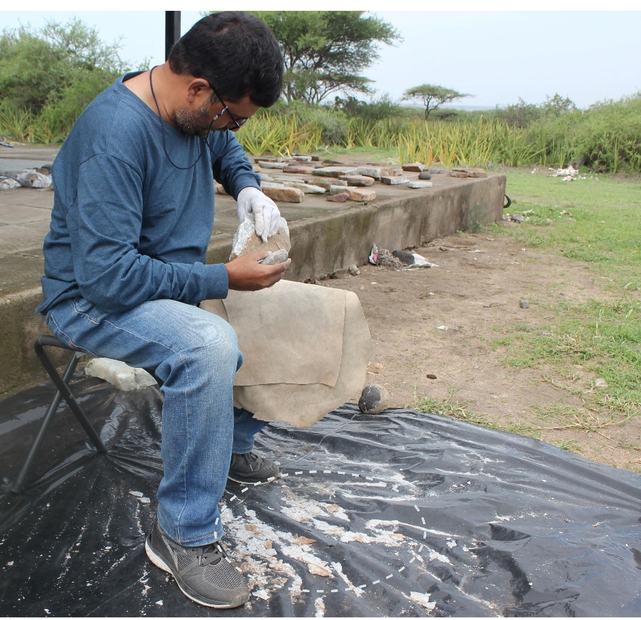

Fig S4. Lengths and widths of the experimental flakes: A comparative analysis of flake dimensions across six experimental series reveals a consistent pattern: flake widths are significantly greater than their lengths. This finding is supported by Wilcoxon signed-rank tests conducted for each experiment, all yielding p-values < 0.001, thereby rejecting the null hypothesis of equal or greater length. Boxplot visualizations reinforce this pattern, showing that in every case the median width exceeds the median length (S4). Additionally, a separate boxplot of the difference between width and length (W−L) per experiment confirms that these values are consistently positive. Together, the statistical tests and graphical analyses provide robust evidence of a morphological tendency toward broader-than-long flakes.

Fig. S4a. Box plot of the lengths and widths of the experimental flakes.

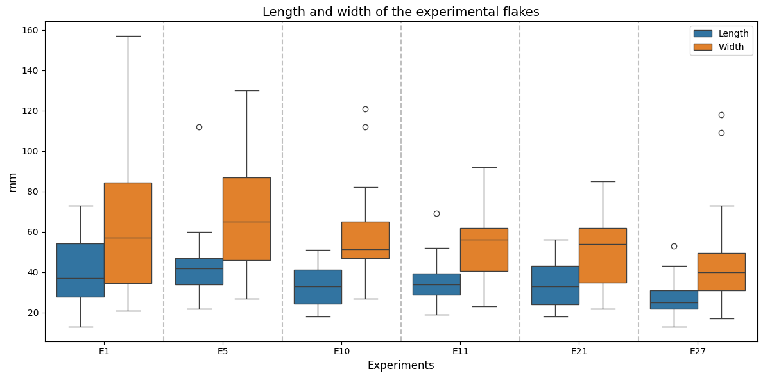

Fig. S4b. Box plot with the difference between width and length (W−L) of the experimental flakes.

