Supplementary Appendix

Preparing for future pandemics: frailty associates with mortality in hospitalised older people during the entire COVID-19 pandemic, a Dutch multicentre cohort study.

European Geriatric Medicine

Authors
Bas F.M. van Raaij, Raymond Noordam, Rosalinde A.L. Smits, Veerle M.G.T.H. van der Klei, Steffy W.M. Jansen, Carolien M.J. van der Linden, Harmke A. Polinder-Bos, Julia Minnema, Lisanne Tap, Jessica M. van der Bol, Esther M.M. van de Glind, Hanna C. Willems, Floor J.A. van Deudekom, Rikje Ruiter, Barbara C. van Munster, Sarah H.M. Robben, Henrike J. Schouten, Dennis G. Barten, Jacinta A. Lucke, Geeske M.E.E. Peeters, Stella Trompet, Yvonne M. Drewes, Frederiek van den Bos, Jacobijn Gussekloo, Simon P. Mooijaart, on behalf of the COOP study group.
Contents
Appendix 1. List of participating hospitals . . . . . . . . . . . . . . . . . . . . . . . . . . . . . . . . . . . . . . . . . . . . . . . . . . . . | 3
Appendix 2. Number of inclusions per hospital for each pandemic wave . . . . . . . . . . . . . . . . . . . . . . . . . . . | 4
Appendix 3. Comparison of patients with a recorded frailty status and patients with a missing frailty status . . . . . . . . . . . . . . . . . . . . . . . . . . . . . . . . . . . . . . . . . . . . . . . . . . . . . . . . . . . . . . . . . . . . . . . . . . . . . . . . . . | 5
Appendix 4. The association of frailty with in-hospital mortality stratified by COVID-19 wave of patients admitted to one of four hospitals included in all waves . . . . . . . . . . . . . . . . . . . . . . . . . . . . . . . . . . . . . . . . . . | 6
Appendix 5. The associations of frailty with indicators of disease severity stratified by COVID-19 wave . . | 7
Appendix 6. Differences in patients characteristics based on frailty stratified by COVID-19 wave . . . . . . . | 9

Appendix 1. List of participating hospitals

Hospital | Location
Alrijne | Leiderdorp
Amsterdam University Medical Center | Amsterdam
Catharina Hospital | Eindhoven
Deventer Hospital | Deventer
Elisabeth-TweeSteden | Tilburg
Erasmus Medical Center | Rotterdam
Gelre | Apeldoorn and Zutphen
Isala | Zwolle
Leiden University Medical Center | Leiden
Maasstad Hospital | Rotterdam
Medical Center Leeuwarden | Leeuwarden
OLVG | Amsterdam
Reinier de Graaf | Delft
Spaarne | Haarlem
St. Jansdal | Harderwijk
University Medical Center Groningen | Groningen
VieCuri Medical Center | Venlo
Zaans Medical Center | Zaandam
ZGT | Almelo

Appendix 2. Number of inclusions per hospital for each pandemic wave
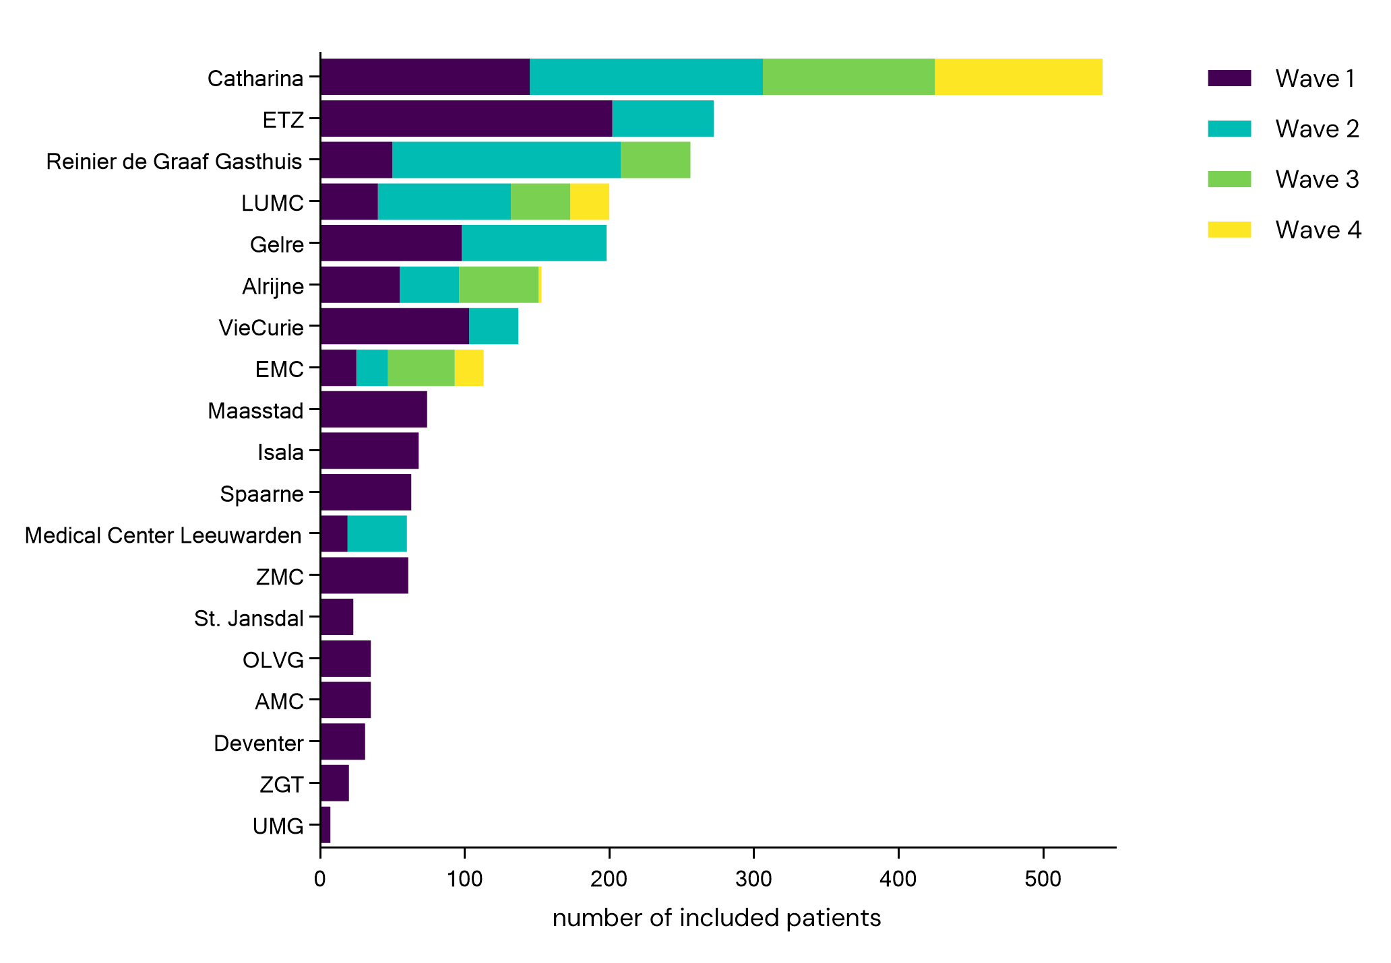

Appendix 3. Comparison of patients with a recorded frailty status and patients with a missing frailty status.

Characteristic | Clinical frailty scale
Characteristic | Assessed (N=2362) | Missing (N=705)
Age, years | 79 [75-84] | 78 [74-83]
Sex, men | 1421 (60) | 440 (62)
BMI, kg/m² | 26.9 ±5.0 | 27.3 ± 4.9
Living situation
Home | 2075 (90) | 598 (91)
Nursing home | 220 (10) | 47 (7)
Other | 24 (1) | 12 (2)
Vaccinated* | 290 (77) | 47 (71)
Comorbidities
CCI, total score (0-33) | 2 [1-3] | 2 [1-3]
Lung disease | 661 (28) | 211 (30)
Diabetes with medication | 727 (31) | 222 (32)
Hypertension | 1297 (55) | 389 (55)
Myocardial infarction | 409 (17) | 146 (21)
Dementia | 220 (9) | 32 (5)
Smoking status
Never | 742 (43) | 225 (45)
Former | 815 (48) | 244 (49)
Active | 159 (9) | 28 (6)
Data are mean ± SD, median [IQR] or n (%). BMI=body mass index. CCI=charlson comorbidity index.
Lung disease includes asthma, chronic obstructive pulmonary disease, interstitial lung disease and lungcancer.

* Vaccinated is defined as a patient who self-reportedly received at least one dose of a COVID-19 vaccine prior to admission.

Number of missing values:
Clinicial frailty status assessed: 2 sex, 440 BMI, 43 living situation, 99 vaccinated, 383 CCI, 3 diabetes with medication, 2 myocardial infarction, 2 dementia, 646 smoking status.
Clinical frailty status missing: 139 BMI, 48 living situation, 30 vaccinated, 109 CCI, 2 hypertension, 208 smoking status.
Appendix 4. The association of frailty with in-hospital mortality stratified by COVID-19 wave of patients admitted to one of four hospitals included in all waves.

 | First wave |  |  |  | Second wave |  |  |  | Third wave |  |  |  | Fourth wave |  |  |  | P-value for interaction
 | Fit  (N=124) | Pre-frail (N=64) | Frail  (N=77) |  | Fit  (N=125) | Pre-frail (N=79) | Frail  (N=112) |  | Fit  (N=91) | Pre-frail (N=92) | Frail  (N=78) |  | Fit  (N=44) | Pre-frail (N=54) | Frail  (N=67) |  | P-value for interaction
In-hospital mortality, n (%) | 40 (32) | 18 (28) | 45 (58)** |  | 16 (13) | 20 (25)* | 40 (36)** |  | 15 (17) | 18 (20) | 23 (30)* |  | 5 (11) | 6 (11) | 17 (25) |  | 0.423
Comparisons with fit patients: * p value < 0.05, ** p-value <0.001
Appendix 5. The associations of frailty with indicators of disease severity stratified by COVID-19 wave.

 | First wave |  |  |  | Second wave |  |  |  | Third wave |  |  |  | Fourth wave |  |  |  | P-value for interaction
 | Fit  (N=519) | Pre-frail (N=304) | Frail  (N=331) |  | Fit  (N=313) | Pre-frail (N=196) | Frail  (N=224) |  | Fit  (N=110) | Pre-frail (N=106) | Frail  (N=93) |  | Fit  (N=44) | Pre-frail (N=54) | Frail  (N=67) |  | P-value for interaction
DSBA, days | 7  [5-11] | 7**  [3-11] | 4**  [2-7] |  | 7  [4-10] | 5*  [2-8] | 4**  [1-7] |  | 7  [4-10] | 5*  [1-8] | 3**  [1-7] |  | 3  [1-9] | 3  [0-8] | 3  [1-6] |  | 0.063
Temp, °C | 37.8±1.1 | 37.7±1.1 | 37.6±1.1 |  | 37.8±1.1 | 37.8±1.0 | 37.7±1.0 |  | 37.7±1.0 | 37.6±1.0 | 37.7±1.1 |  | 37.2±1.2 | 37.2±1.1 | 37.1±1.5 |  | 0.835
RR, breaths/min | 20  [18-26] | 22  [18-25] | 20  [18-25] |  | 21  [18-27] | 22  [18-26] | 21  [18-27] |  | 20  [16-26] | 20  [16-25] | 22  [18-28] |  | 18  [14-21] | 20*  [16-25] | 20  [16-24] |  | 0.878
SBP, mmHg | 139±23 | 137±23 | 139±24 |  | 139±25 | 137±24 | 138±28 |  | 141±27 | 138±25 | 139±27 |  | 145±30 | 140±30 | 143±33 |  | 0.851
SBOT, % | 92  [89-95] | 93  [89-95] | 94  [88-96] |  | 93  [90-96] | 94  [91-97] | 94  [90-97] |  | 93  [90-95] | 94  [89-96] | 93  [90-95] |  | 95  [91-97] | 95  [92-98] | 95  [92-97] |  | 0.741
Oxygen therapy, L/min | 3  [2-5] | 3  [2-4] | 2*  [0-4] |  | 2  [0-5] | 2*  [0-4] | 2  [0-4] |  | 3  [1-6] | 2  [0-5] | 2  [0-5] |  | 0  [0-3] | 2  [0-4] | 1  [0-3] |  | 0.695
Haemoglobin, mmol/L | 8.4±1.2 | 8.0±1.2** | 7.7±1.2** |  | 8.2±1.2 | 8.0±1.3 | 7.8±1.2** |  | 8.3±1.1 | 8.0±1.2 | 8.0±1.3 |  | 8.0±1.3 | 7.7±1.3 | 7.4±1.8* |  | 0.108
Thrombocytes, 10⁹/L | 221±113 | 207±85 | 209±88 |  | 206±91 | 205±109 | 212±84 |  | 209±90 | 221±93 | 211±129 |  | 240±97 | 214±75 | 229±78 |  | 0.232
Leucocytes,  10⁹/L | 7.9±4.7 | 8.8±12.1 | 8.4±7.3 |  | 7.3±3.7 | 7.4±8.6 | 7.6±3.9 |  | 7.8±3.7 | 9.4±13.4 | 9.0±5.8 |  | 9.5±4.6 | 9.1±4.8 | 9.5±4.0 |  | 0.725
Lymphocytes, 10⁹/L | 0.90  [0.60-1.40] | 1.00*  [0.64-1.60] | 0.94*  [0.58-1.62] |  | 0.78  [0.51-1.10] | 0.80  [0.52-1.10] | 0.79  [0.60-1.01] |  | 0.88  [0.60-1.20] | 0.83  [0.55-1.20] | 0.80  [0.53-1.04] |  | 1.10  [0.57-1.51] | 0.72  [0.40-1.12] | 0.93  [0.51-1.33] |  | 0.114
CRP, mg/L | 94  [49-152] | 76*  [38-138] | 63**  [31-111] |  | 79  [43-149] | 67*  [30-116] | 62**  [25-111] |  | 84  [37-159] | 77  [37-140] | 53  [27-111] |  | 54  [16-130] | 55  [16-100] | 33  [12-95] |  | 0.380
LDH, U/L | 335  [258-439] | 306  [248-423] | 296**  [235-388] |  | 332  [258-436] | 291*  [241-379] | 288**  [229-362] |  | 341  [252-444] | 287*  [232-369] | 284  [223-416] |  | 249  [185-319] | 243  [195-334] | 254  [210-315] |  | 0.689
Creatinin, µmol/L | 89  [75-112] | 99**  [76-142] | 92  [70-140] |  | 89  [72-120] | 106**  [84-147] | 102*  [76-139] |  | 94  [72-122] | 112*  [83-138] | 98  [70-134] |  | 94  [71-119] | 96  [72-142] | 99  [71-141] |  | 0.695
Sodium, mmol/L | 135±4 | 136±5 | 137±6** |  | 135±4 | 136±4 | 137±5* |  | 134±5 | 137±5* | 136±4 |  | 136±4 | 137±4 | 138±5 |  | 0.427
Comparisons with fit patients: * p value < 0.05, ** p-value <0.001.

Data are mean ± SD or median [IQR]. DSBA=duration of symptoms before admission. Temp=body temperature. RR=respiratory rate. SBP=systolic blood pressure. SBOT=saturation before oxygen therapy. CRP=c-reactive protein. LDH= lactic acid dehydrogenase.

Reference values for laboratory findings:
Haemoglobin 8.5-11.0; Thrombocytes 150-400; Leucocytes 4.00-10.00; Lymphocytes 1.00-3.50; CRP <5.0; LDH <248; creatinin 64-104; Sodium 136-145.

Number of missing values:
First wave: 119 DSBA, 55 Temp, 70 RR, 58 SBP, 362 SBOT, 124 oxygen therapy, 10 haemoglobin, 94 thrombocytes, 64 leucocytes, 188 lymphocytes, 65 CRP, 219 LDH, 60 creatinin, 13 sodium.
Second wave: 52 DSBA, 17 Temp, 30 RR, 12 SBP, 148 SBOT, 42 oxygen therapy, 16 haemoglobin, 25 thrombocytes, 27 leucocytes, 107 lymphocytes, 18 CRP, 88 LDH, 12 creatinin, 20 sodium.
Third wave: 23 DSBA, 10 Temp, 11 RR, 2 SBP, 110 SBOT, 25 oxygen therapy, 6 haemoglobin, 11 thrombocytes, 5 leucocytes, 41 lymphocytes, 5 CRP, 36 LDH, 2 creatinin, 8 sodium.
Fourth wave: 28 DSBA, 4 Temp, 17 RR, 41 SBOT, 7 oxygen therapy, 2 haemoglobin, 3 thrombocytes, 2 leucocytes, 32 lymphocytes, 5 CRP, 35 LDH, 1 creatinin, 3 sodium
Appendix 6. Differences in patients characteristics based on frailty stratified by COVID-19 wave.

Characteristic | First wave |  |  |  | Second wave |  |  |  | Third wave |  |  |  | Fourth wave
Characteristic | Fit  (N=519) | Pre-frail (N=304) | Frail  (N=331) |  | Fit  (N=313) | Pre-frail (N=196) | Frail  (N=224) |  | Fit  (N=110) | Pre-frail (N=106) | Frail  (N=93) |  | Fit  (N=44) | Pre-frail (N=54) | Frail  (N=67)
Age, years | 76  [73-81] | 79  [75-84]** | 82  [78-87]** |  | 77  [73-82] | 80  [75-86]** | 83  [78-87]** |  | 77  [73-81] | 80  [75-85]** | 80  [76-86]** |  | 76  [74-82] | 80  [75-83] | 82  [77-87]**
Sex, men | 359 (69) | 174 (57)** | 156 (47)** |  | 203 (65) | 124 (63) | 119 (53)* |  | 76 (69) | 67 (63) | 51 (55)* |  | 33 (75) | 29 (54)* | 30 (45)*
BMI, kg/m² | 26.9±4.1 | 28.1±5.5* | 26.8±4.9 |  | 26.7±4.7 | 27.2±4.9 | 26.7±5.8 |  | 26.6±4.5 | 27.0±5.6 | 26.4±6.3 |  | 26.1±4.0 | 25.7±5.1 | 26.5±6.2
Living situation
Home | 501 (99) | 279 (95)** | 228 (70)** |  | 303 (97) | 186 (95) | 152 (68)** |  | 108 (100) | 98 (95)* | 72 (80)** |  | 43 (100) | 50 (93) | 55 (87)*
Nursing home | 1 (0) | 13 (4)** | 89 (27)** |  | 8 (3) | 6 (3) | 70 (31)** |  | 0 (0) | 5 (5)* | 18 (20)** |  | 0 (0) | 3 (6) | 7 (11)*
Other | 4 (1) | 2 (1)** | 9 (3)** |  | 1 (0) | 3 (2) | 3 (1)** |  | 0 (0) | 0 (0)* | 0 (0)** |  | 0 (0) | 1 (2) | 1 (2)*
Vaccinatedª | NA | NA | NA |  | NA | NA | NA |  | 66 (70) | 79 (86)* | 67 (82) |  | 16 (70) | 25 (76) | 37 (74)
Comorbidities
CCI, total score | 1 [0-2] | 2 [1-3]** | 2 [1-3]** |  | 1 [0-2] | 2 [1-3]** | 2 [1-3]** |  | 1 [0-3] | 2 [1-3] | 2 [1-3]* |  | 2 [1-2] | 2 [1-4] | 2 [1-3]
Lung disease | 102 (20) | 103 (34)** | 92 (28)* |  | 84 (27) | 55 (28) | 72 (32) |  | 20 (18) | 39 (37)* | 37 (40)** |  | 16 (36) | 20 (37) | 21 (31)
Diabetes with medication | 133 (26) | 106 (35)* | 121 (37)** |  | 76 (24) | 71 (36)* | 84 (37)* |  | 33 (30) | 32 (30) | 28 (30) |  | 9 (21) | 13 (24) | 21 (31)
Hypertension | 254 (49) | 193 (64)** | 198 (60)* |  | 160 (51) | 110 (56) | 120 (53) |  | 59 (54) | 65 (61) | 60 (65) |  | 15 (34) | 26 (48) | 37 (55)*
Myocardial infarction | 76 (15) | 67 (22)* | 54 (16) |  | 45 (14) | 45 (23)* | 41 (18) |  | 17 (16) | 19 (18) | 23 (25) |  | 7 (16) | 5 (9) | 10 (15)
Dementia | 1 (0) | 16 (5)** | 94 (28)** |  | 4 (1) | 12 (6)* | 65 (29)** |  | 1 (1) | 4 (4) | 16 (17)** |  | 0 (0) | 1 (2) | 6 (9)
Smoking status
Never | 152 (42) | 84 (40) | 112 (48)* |  | 86 (39) | 47 (36) | 68 (42) |  | 49 (56) | 35 (42) | 36 (47)* |  | 22 (56) | 19 (40) | 32 (51)
Former | 178 (49) | 107 (51) | 94 (40)* |  | 125 (56) | 78 (59) | 80 (50) |  | 33 (38) | 44 (52) | 24 (32)* |  | 12 (31) | 18 (38) | 22 (35)
Active | 30 (8) | 18 (9) | 29 (12)* |  | 11 (5) | 7 (5) | 13 (8) |  | 5 (6) | 5 (6) | 16 (21)* |  | 5 (13) | 11 (23) | 9 (14)
Comparisons with fit patients: * p value < 0.05, ** p-value <0.001.

Data are mean ± SD, median [IQR] or n (%). BMI=body mass index. CCI=charlson comorbidity index. NA=not applicable.
Lung disease includes asthma, chronic obstructive pulmonary disease, interstitial lung disease and lungcancer.

a. Vaccinated is defined as a patient who self-reportedly received at least one dose of a COVID-19 vaccine prior to admission (vaccinations were introduced after the second wave).

Number of missing values:
First wave: 2 sex, 246 BMI, 28 living situation, 180 CCI, 3 diabetes with medication, 2 myocardial infarction, 2 dementia, 350 smoking status.
Second wave: 125 BMI, 2 living situation, 117 CCI, 219 smoking status.
Third wave: 60 BMI, 8 living situation, 40 vaccinated, 60 CCI, 62 smoking status.
Fourth wave: 9 BMI, 5 living situation, 59 vaccinated, 26 CCI, 15 smoking status.

