SUPPLEMENTARY MATERIAL
Supplementary Table 1. General characteristics of the residents included in the first registration in the 34 nursing homes who initiated the first audit registration and those who completed the whole study.
Characteristics | All the nursing homes | Those who completed the study | P value
Number of nursing homes | 34 | 23
Number of infections / registrations | 1505 | 1003
Age, year, mean (SD) | 85.8 (8.4) | 86.4 (8.2) | .069
Age groups, n (%)
<70 years | 83 (5.5) | 49 (4.9) | .182
70-80 years | 264 (17.6) | 146 (14.6) | .182
81-90 years | 668 (44.4) | 459 (45.8) | .182
>90 years | 489 (32.5) | 348 (34.7) | .182
Gender, n (%)
Men | 463 (30.8) | 291 (29.0) | .375
Women | 1041 (69.2) | 711 (71.0) | .375
Previous duration of symptoms, mean of days (SD) | 2.5 (3.9) | 2.4 (4.2) | .810
Type of infection, n (%)
Urinary tract infection | 719 (47.8) | 475 (47.4) | .095
Respiratory tract infection | 533 (35.5) | 392 (39.1) | .095
Skin infection | 154 (10.2) | 79 (7.9) | .095
Another infection | 97 (6.5) | 57 (5.7) | .095
Antibiotic prescribing rate, n (%) | 1328 (88.2) | 886 (88.3) | .992
Indication for antibiotic therapy, n (%)
Initiation of treatment | 1246 (82.8) | 819 (81.7) | .498
Prophylaxis | 43 (2.9) | 37 (3.7) | .296
Continuation | 62 (4.1) | 42 (4.2) | 1.000
Unknown | 5 (0.3) | 3 (0.3) | 1.000
Not given | 147 (9.8) | 107 (10.7) | .506
Antibiotic taken during the previous 15 days, n (%)
Yes | 259 (17.2) | 169 (16.8) | .857
No | 1212 (80.5) | 812 (81.0) | .831
Unknown | 9 (0.6) | 8 (0.8) | .728
Where the antibiotic course was initiated, n (%)
Nursing home | 1173 (77.9) | 783 (78.1) | .980
Hospital | 151 (10.0) | 94 (9.4) | .633
Health care center | 13 (0.9) | 10 (1.0) | .897
Unknown | 2 (0.1) | 1 (0.1) | 1.000
No antibiotic initiated | 121 (8.0) | 90 (9.0) | .452
Duration of the antibiotic course, mean of days (SD) | 6.8 (6.4) | 7.0 (7.5) | .423
Allergy to penicillin, n (%) | 42 (2.8) | 22 (2.2) | .424
Perception of antibiotic demand, n (%)
Yes | 700 (46.5) | 395 (39.4) | <.001
No | 747 (49.6) | 559 (55.7) | .003
Unknown | 31 (2.1) | 28 (2.8) | .294
Referral to hospital, n (%) | 191 (12.7) | 128 (12.8) | 1.000
SD=Standard deviation.

Supplementary Table 2. General characteristics of the residents with urinary tract infections from the nursing homes that completed the two registration audits.
Characteristics | Total | First registration | Second registration | P value
Number or registrations / infections | 772 | 475 | 297
Catheter indwelling residents, n (%) | 46 (6.0) | 30 (6.3) | 16 (5.4) | .708
Mean prior symptom duration, days, n (SD) | 2.3 (3.2) | 2.5 (3.6) | 1.9 (2.5) | .016
General signs and symptoms, n (%)
Fever | 98 (12.7) | 50 (10.5) | 48 (16.2) | .029
Shaking chills | 62 (8.0) | 37 (7.8) | 25 (8.4) | .860
Confusion | 419 (54.3) | 253 (53.3) | 166 (55.9) | .523
Joint and muscle pains | 37 (4.8) | 18 (3.8) | 19 (6.4) | .140
No general symptoms | 273 (35.4) | 165 (34.7) | 108 (36.4) | .702
Urinary tract signs and symptoms, n (%)
Dysuria | 180 (23.3) | 93 (19.6) | 87 (29.3) | .003
Urgency | 57 (7.4) | 25 (5.3) | 32 (10.8) | .007
Frequency | 66 (8.5) | 28 (5.9) | 38 (12.8) | .001
Incontinence | 29 (3.8) | 19 (4.0) | 10 (3.4) | .798
Back or flank pain | 58 (7.5) | 41 (8.6) | 17 (5.7) | .177
Gross hematuria | 56 (7.3) | 39 (8.2) | 17 (5.7) | .249
Foul-smelling urine | 375 (48.6) | 226 (47.6) | 149 (50.2) | .531
Murky urine | 324 (42.0) | 192 (40.4) | 132 (44.4) | .304
None of the above | 178 (23.1) | 112 (23.6) | 66 (22.2) | .728
Diagnosis, n (%)
Cystitis | 586 (75.9) | 359 (75.6) | 227 (76.4) | .855
Pyelonephritis | 22 (2.8) | 12 (2.5) | 10 (3.4) | .645
Other urinary tract infections | 131 (17.0) | 78 (16.4) | 53 (17.8) | .679
Urine testing, n (%)
Urinary dipstick | 633 (82.0) | 398 (83.8) | 235 (79.1) | .122
Urine culture | 147 (19.0) | 84 (17.7) | 63 (21.2) | .263
No testing | 21 (2.7) | 11 (2.3) | 10 (3.4) | .518
Antibiotic treatment, n (%) | 727 (94.2) | 446 (93.9) | 281 (94.6) | .798
Duration of the antibiotic course, days, mean (SD) | 7.0 (12.7) | 6.8 (9.3) | 7.2 (16.7) | .729
Antibiotic given, n (%)
Penicillin V | 0 (0.0) | 0 (0.0) | 0 (0.0) | NA
Amoxicillin | 3 (0.4) | 2 (0.4) | 1 (0.3) | 1.000
Amoxicillin and clavulanate | 72 (9.3) | 43 (9.1) | 29 (9.8) | .839
Macrolide or clindamycin | 2 (0.3) | 1 (0.2) | 1 (0.3) | 1.000
Cephalosporin | 166 (21.5) | 95 (20.0) | 71 (23.9) | .232
Fosfomycin | 298 (38.6) | 179 (37.7) | 119 (40.1) | .558
Nitrofurantoin | 59 (7.6) | 38 (8.0) | 21 (7.1) | .739
Trimethoprim + sulfamethoxazole | 27 (3.5) | 16 (3.4) | 11 (3.7) | .964
Quinolone | 83 (10.8) | 54 (11.4) | 29 (9.8) | .561
Another antibiotic | 29 (3.8) | 23 (4.8) | 6 (2.0) | .070
No antibiotics | 45 (5.8) | 29 (6.1) | 16 (5.4) | .798
NA=Not available; SD=Standard deviation.

Supplementary Table 3. General characteristics of the residents with respiratory tract infections from the nursing homes that completed the two registration audits.
Characteristics | Total | First registration | Second registration | P value
Number or registrations / infections | 762 | 392 | 370
Mean prior symptom duration, days, n (SD) | 2.2 (2.0) | 2.2 (1.9) | 2.14 (2.0) | .741
General signs and symptoms, n (%)
Fever | 173 (22.7) | 90 (23.0) | 83 (22.4) | .931
Shaking chills | 117 (15.4) | 58 (14.8) | 59 (15.9) | .734
Confusion | 155 (20.3) | 85 (21.7) | 70 (18.9) | .391
Joint and muscle pains | 52 (6.8) | 26 (6.6) | 26 (7.0) | .943
No general symptoms | 403 (52.9) | 197 (50.3) | 206 (55.7) | .154
Respiratory tract signs and symptoms, n (%)
Cough | 532 (69.8) | 252 (64.3) | 280 (75.7) | .001
Rhinorrhea | 213 (28.0) | 102 (26.0) | 111 (30.0) | .253
Otorrhea | 5 (0.7) | 2 (0.5) | 3 (0.8) | .948
Odynophagia | 83 (10.9) | 42 (10.7) | 41 (11.1) | .963
Tonsillar exudate | 17 (2.2) | 15 (3.8) | 2 (0.5) | .005
Tender cervical glands | 27 (3.5) | 19 (4.8) | 8 (2.2) | .071
Dyspnea | 278 (36.5) | 143 (36.5) | 135 (36.5) | 1.000
Increase in sputum volume | 337 (44.2) | 157 (40.1) | 180 (48.6) | .021
Purulent sputum | 107 (14.0) | 52 (13.3) | 55 (14.9) | .595
Bronchospasm | 93 (12.2) | 54 (13.8) | 39 (10.5) | .210
None of the above | 31 (4.1) | 15 (3.8) | 16 (4.3) | .870
Diagnosis, n (%)
Common cold | 184 (24.1) | 87 (22.2) | 97 (26.2) | .226
Acute otitis media | 5 (0.7) | 2 (0.5) | 3 (0.8) | .948
Acute sinusitis | 0 (0.0) | 0 (0.0) | 0 (0.0) | NA
Acute pharyngitis | 39 (5.1) | 22 (5.6) | 17 (4.6) | .636
Acute tonsillitis | 10 (1.3) | 8 (2.0) | 2 (0.5) | .134
Acute bronchitis | 139 (18.2) | 77 (19.6) | 62 (16.8) | .349
Pneumonia | 114 (15.0) | 66 (16.8) | 48 (13.0) | .164
COPD exacerbation | 47 (6.2) | 26 (6.6) | 21 (5.7) | .691
Bronchoaspirative respiratory tract infection | 74 (9.7) | 39 (9.9) | 35 (9.5) | .916
Influenza, n (%) | 29 (3.8) | 18 (4.6) | 11 (3.0) | .328
COVID-19 infection, n (%) | 11 (1.4) | 7 (1.8) | 4 (1.1) | .609
Other respiratory tract infections, n (%) | 88 (11.5) | 26 (6.6) | 62 (16.8) | <.001
Tests performed, n (%)
Rapid antigen detection test | 4 (0.5) | 2 (0.5) | 2 (0.5) | 1.000
C-reactive protein rapid test | 26 (3.4) | 10 (2.6) | 16 (4.3) | .251
Chest X-ray | 61 (8.0) | 23 (5.9) | 38 (10.3) | .035
COVID-19 test | 136 (17.8) | 95 (24.2) | 41 (11.1) | <.001
No testing | 541 (71.0) | 250 (63.8) | 291 (78.6) | <.001
Antibiotic treatment, n (%) | 538 (70.6) | 306 (78.1) | 232 (62.7) | <.001
Duration of the antibiotic course, days, mean (SD) | 6.8 (1.7) | 6.7 (1.7) | 6.8 (1.6) | 0.538
Antibiotic given, n (%)
Penicillin V | 0 (0.0) | 0 (0.0) | 0 (0.0) | NA
Amoxicillin | 26 (3.4) | 10 (2.6) | 16 (4.3) | .251
Amoxicillin and clavulanate | 247 (32.4) | 132 (33.7) | 115 (31.1) | .492
Macrolide or clindamycin | 43 (5.6) | 25 (6.4) | 18 (4.9) | .455
Cephalosporin | 88 (11.5) | 47 (12.0) | 41 (11.1) | .780
Fosfomycin | 9 (1.2) | 8 (2.0) | 1 (0.3) | .054
Nitrofurantoin | 0 (0.0) | 0 (0.0) | 0 (0.0) | NA
Trimethoprim + sulfamethoxazole | 4 (0.5) | 4 (1.0) | 0 (0.0) | .148
Quinolone | 99 (13.0) | 62 (15.8) | 37 (10.0) | .023
Another antibiotic | 35 (4.6) | 22 (5.6) | 13 (3.5) | .226
No antibiotics | 224 (29.4) | 86 (21.9) | 138 (37.3) | <.001
COPD=Chronic obstructive pulmonary disease; NA=Not available; SD=Standard deviation.

Supplementary Table 4. Percentage of hygiene elements implemented in the two registrations in the nursing homes that provided with information.
Characteristics | Total | First audit | Second audit | P value
Number of nursing homes | 40 | 20 | 20
Hand hygiene, n (%)
Hand sanitizer is hanging beside the resident's front door | 12 (30.0) | 5 (25.0) | 7 (35.0) | .730
Hand sanitizer is hanging beside the care center's front door | 3 (7.5) | 1 (5.0) | 2 (10.0) | 1.000
Always wash hands before and after meeting with residents | 39 (97.5) | 19 (95.0) | 20 (100.0) | 1.000
None of the above | 0 (0.0) | 0 (0.0) | 0 (0.0) | NA
Hygiene resources at the nursing home, n (%)
Materials for resident hygiene accessible at strategic points | 38 (95.0) | 19 (95.0) | 19 (95.0) | 1.000
Materials for room cleaning accessible at strategic points | 37 (92.5) | 19 (95.0) | 18 (90.0) | 1.000
Availability of clean/disinfected cloths accessible | 28 (70.0) | 14 (70.0) | 14 (70.0) | 1.000
Accessible trash bins | 37 (92.5) | 19 (95.0) | 18 (90.0) | 1.000
Accessible laundry bins for changing bed linens and towels | 32 (80.0) | 17 (85.0) | 15 (75.0) | .693
None of the above | 0 (0.0) | 0 (0.0) | 0 (0.0) | NA
Protective equipment, n (%)
Three sizes of gloves are available in the residents' toilets | 39 (97.5) | 20 (100.0) | 19 (95.0) | 1.000
Waterproof front aprons available for washing residents | 22 (55.0) | 10 (50.0) | 12 (60.0) | .751
Availability of masks | 38 (95.0) | 20 (100.0) | 18 (90.0) | .468
Availability of eye protection | 24 (60.0) | 13 (65.0) | 11 (55.0) | .747
None of the above | 0 (0.0) | 0 (0.0) | 0 (0.0) | NA
Specific hygiene resources, n (%)
Availability of wet wipes for changing diapers | 20 (50.0) | 10 (50.0) | 10 (50.0) | 1.000
Availability of hygiene materials, e.g. soapy sponges | 40 (100.0) | 20 (100.0) | 20 (100.0) | NA
Waterproof aprons and disposable gloves for perineal care | 28 (70.0) | 14 (70.0) | 14 (70.0) | 1.000
None of the above | 0 (0.0) | 0 (0.0) | 0 (0.0) | NA
Professional hygiene management, n (%)
I always wash my hands before and after attending residents | 36 (92.3) | 18 (90.0) | 18 (94.7) | 1.000
I keep my nails short and clean and remove hand jewelry | 30 (76.9) | 14 (70.0) | 16 (84.2) | .501
None of the above, n (%) | 1 (2.6) | 1 (5.0) | 0 (0.0) | 1.000
Resident and family hygiene management, n (%)
Residents are encouraged to wash their hands | 37 (94.9) | 19 (95.0) | 18 (94.7) | 1.000
We educate family members to wash their hands frequently | 22 (56.4) | 10 (50.0) | 12 (63.2) | .613
None of the above | 2 (5.1) | 1 (5.0) | 1 (5.3) | 1.000
Perineal care, n (%)
Perineal care is always performed in bed | 12 (30.8) | 4 (20.0) | 8 (42.1) | .251
Thorough perineal care is performed at least once a day | 38 (97.4) | 20 (100.0) | 18 (94.7) | .979
Used perineal cleaning towels are not reused for other tasks | 30 (76.9) | 15 (75.0) | 15 (78.9) | 1.000
None of the above | 0 (0.0) | 0 (0.0) | 0 (0.0) | NA
Diaper changing, n (%)
The smallest suitable diaper for the resident's size is chosen | 15 (38.5) | 8 (40.0) | 7 (36.8) | 1.000
The diaper is chosen according to the resident's incontinence | 19 (79.2) | 8 (66.7) | 11 (91.7) | .315
Diapers are changed at least 3 times a day | 35 (89.7) | 19 (95.0) | 16 (84.2) | .560
Diaper changing is done according to a fixed schedule | 22 (56.4) | 11 (55.0) | 11 (57.9) | 1.000
Diaper changing is individualized for each resident | 31 (79.5) | 16 (80.0) | 15 (78.9) | 1.000
None of the above | 0 (0.0) | 0 (0.0) | 0 (0.0) | NA
NA=Not available.

Supplementary Fig. 1. Registration form used during the two registration periods.
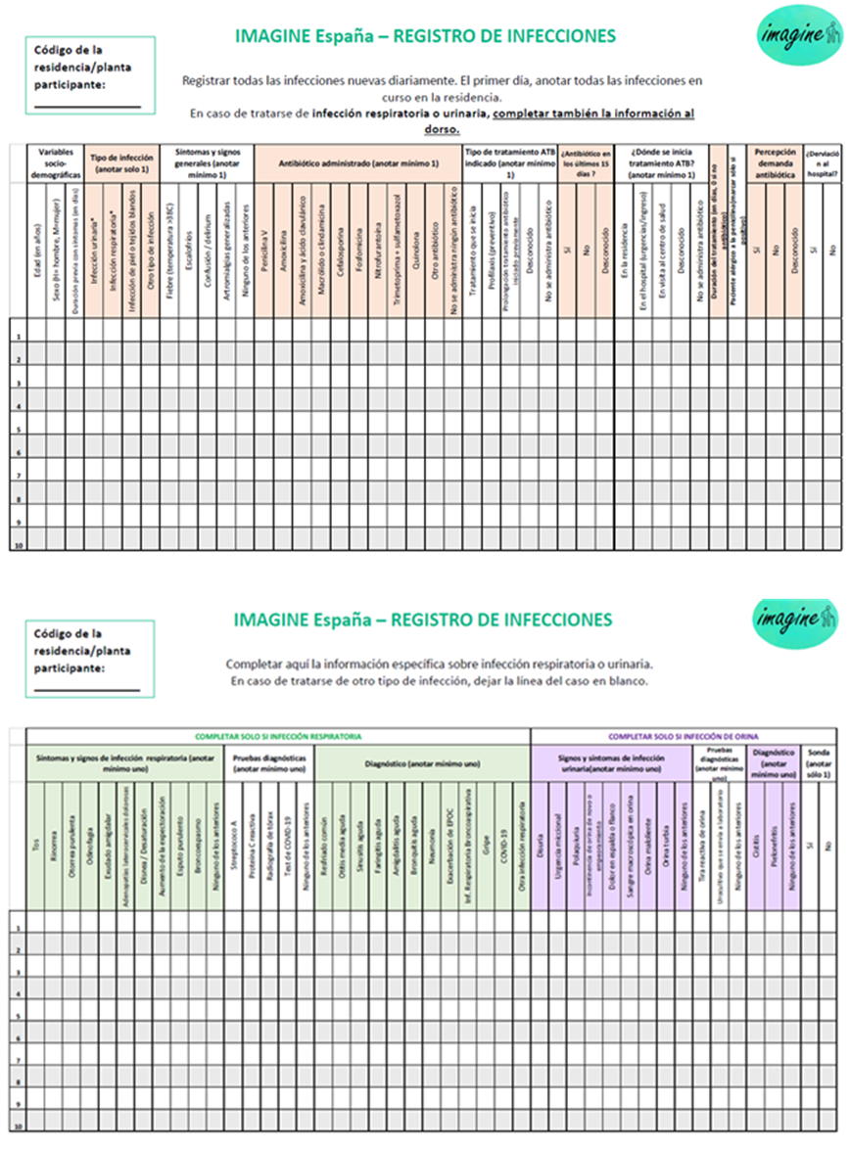

Supplementary Fig. 2. Definition of potentially inappropriate antibiotic used in this study.
Appropriateness of antibiotic use

Urinary tract infections
Respiratory tract infections

Antibiotic use is warranted
Potentially inappropriate antibiotic use
Potentially inappropriate antibiotic use
Antibiotic use is warranted

  - Otitis (with otorrhea)
- Amoxicillin 5-7d
  - Sinusitis (with fever, shaking chills or >10 days with symptoms)
- Amoxicillin 5-7d
  - Pharyngitis/Tonsillitis (with StrepA test)
- Penicillin V 7-10d
  - Pneumonia
- Amoxicillin and clavulanate 5-7d
  - COPD exacerbation (with purulent sputum)
- Amoxicillin and clavulanate 5-7d
  - Bronchoaspirative respiratory infection
- Amoxicillin and clavulanate 5-7d
  - <2 lower urinary tract infection signs and symptoms*
  - 1 lower urinary tract infection sign and symptom* or flank pain without (fever/shaking chills OR confusion/poor general status)
  - Cystitis
- Nitrofurantoin 5-7d
- Fosfomycin 1d
  - Pyelonephritis
- Cephalosporin 7d
  - Common cold
  - Otitis (without otorrhea and fever)
  - Sinusitis (without fever, shaking chills or >10 days with symptoms)
  - Pharyngitis/Tonsillitis (without StrepA test)
  - Acute bronchitis
  - COPD exacerbation (without purulent sputum)
  - Influenza
  - COVID

*Dysuria, frequency, urgency, urinary incontinence, suprapubic pain or low abdominal pain, urethral purulence or pain, and/or swelling or tenderness of the testes, epididymis, or prostate. Characteristics of the urine, such as foul-smelling urine, gross hematuria and/or cloudy urine are not included.

