Perceived educational needs in geriatric medicine of professionals: a multinational multilingual open online survey
Giulia Ogliari¹*, Marina Kotsani²*, Athanase Benetos³, Nenad Bogdanovic⁴, Sylvie Bonin-Guillaume⁵, Rui Buzaco⁶, Sofia Duque^{7,8}, Anne Wissendorff Ekdahl⁹, Rachael Frost¹⁰, Anna Marie Herghelegiu^{11,12}, Meltem Koca¹³, Anastassia Kossioni¹⁴, Evrydiki Kravvariti¹⁵, Jurate Macijauskiene¹⁶, Nicolas Martínez-Velilla^{17,18}, Tahir Masud¹⁹, Tajana Pavic²⁰, Karolina Piotrowicz²¹, Regina Roller-Wirnsberger²², Sumru Savas²³, Luca Soraci²⁴, George Soulis², Michael Vassallo²⁵, Tamar Yellon^{26,27}, Mirko Petrovic²⁸ and Collaborators of the global summary paper of the PROGRAMMING survey on educational needs²⁹
*equally contributed to this manuscript
Journal: European Geriatric Medicine
Corresponding author: Giulia Ogliari, Giulia Ogliari, MD, PhD, National Institute for Health and Care Research (NIHR) Health Determinants Research Collaboration (HDRC) Leicestershire, Leicestershire County Council, County Hall, Leicester Road, Glenfield, Leicestershire, LE3 8RA, United Kingdom. ORCID 0000-0001-8273-3619 Email: Giulia.Ogliari1@nottingham.ac.uk or giulietta.ogliari@gmail.com or giulia.ogliari@virgilio.it

Supplementary Fig. 1 Overall knowledge of professionals by country of work

Figure notes: displayed countries are limited to those with at least 10 respondents. Abbreviations: n: number; SD: standard deviation

Supplementary Fig. 2 Overall knowledge of professionals by EU-27 country of work
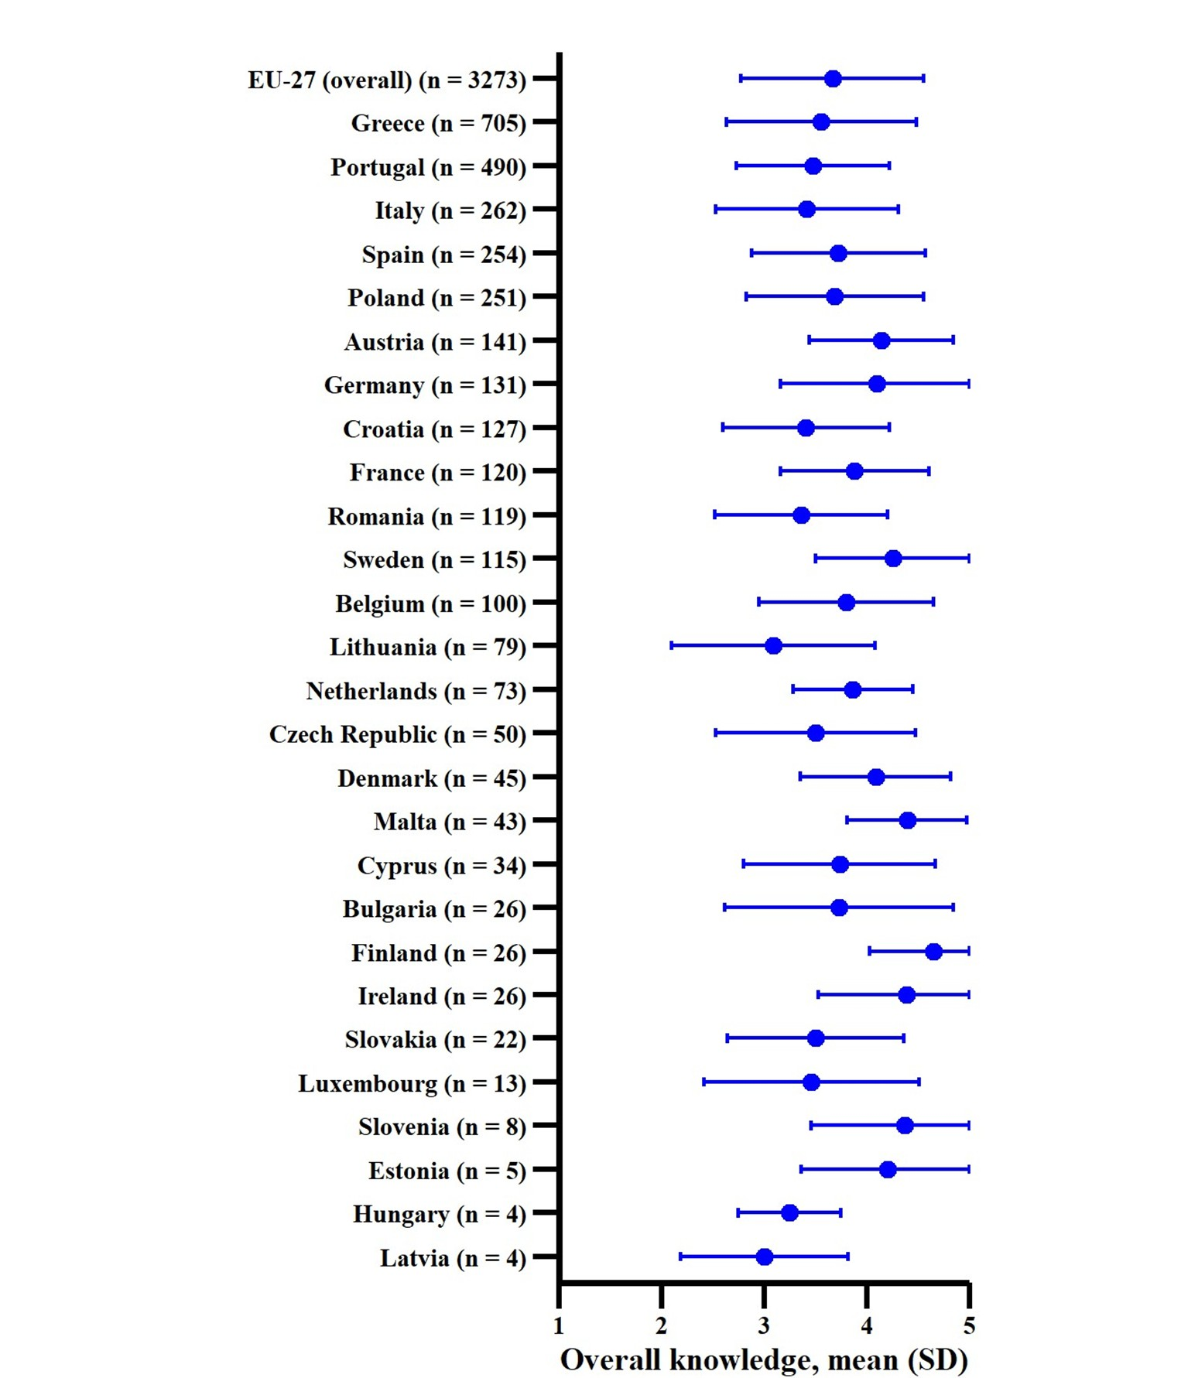
Abbreviations: n: number; SD: standard deviation
Supplementary Fig. 3 Distributions of professionals’ responses on their perceived knowledge, relevance and interest, respectively, in topics and skills related to the care of older people, as based on the five options (from very low to very high)
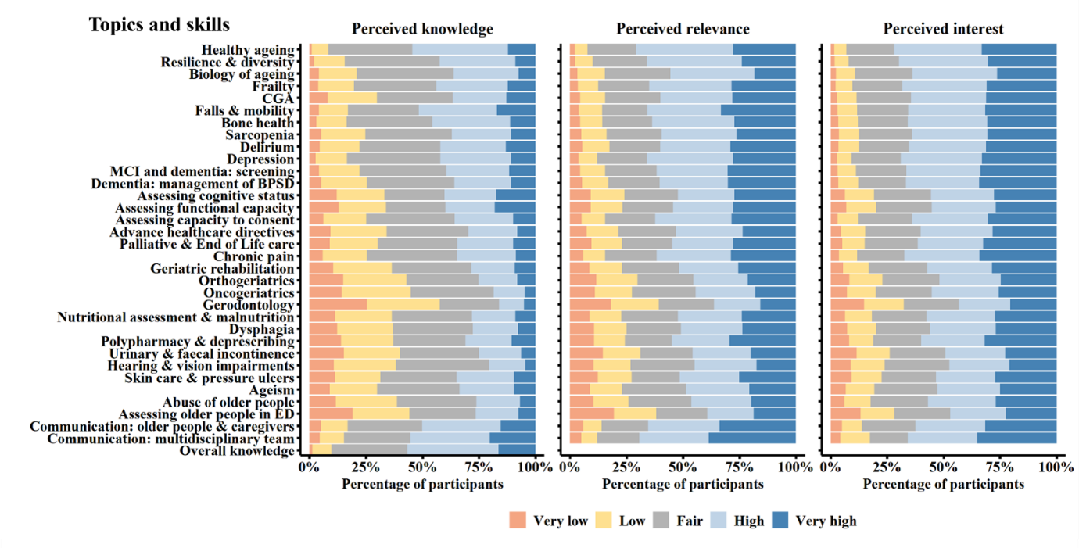

Supplementary Figure 4 Fig. 5 Standardized Z scores for global topic scores among professionals working outside Türkiye
Abbreviations: BPSD: behavioural and psychiatric symptoms of dementia; CGA: Comprehensive Geriatric Assessment; ED: Emergency Department; MCI: mild cognitive impairment; Q: quartile

