Improving Diabetes Management in Older Adults with Cancer: A Quality Improvement Project to Enhance Monitoring During Steroid-Based Systemic Anti- Cancer Therapy

Journal of European Geriatric Medicine

Author names: Evelyne Liuu; Rose Evans; Gitanjali Amaratunga; Sarah Compton; Alexandros Georgiou; Tania Kalsi; Yuk-Fun Liu; James Maguire; Clare Nottage; Hannah L. Rush; Carly Welch

Affiliations and e-mail address of the corresponding author:
ª Department of Ageing and Health, 9th Floor North Wing, St Thomas’ Hospital, Westminster Bridge, London, SE1 7EH, United Kingdom
^{b} Department of Twin Research & Genetic Epidemiology, 3rd Floor D Block South Wing, St Thomas’ Campus, King’s College London, London, SE1 7EH, United Kingdom
^{c} University of Poitiers, INSERM 1402, CHU Poitiers, Centre d’Investigation Clinique, Laboratoire MOVE, department of geriatrics, 2 rue de la Miletrie, 86000 Poitiers, France
evelyne.liuu@univ-poitiers.fr

Supplementary data 1: GOLD enhanced monitoring pathway
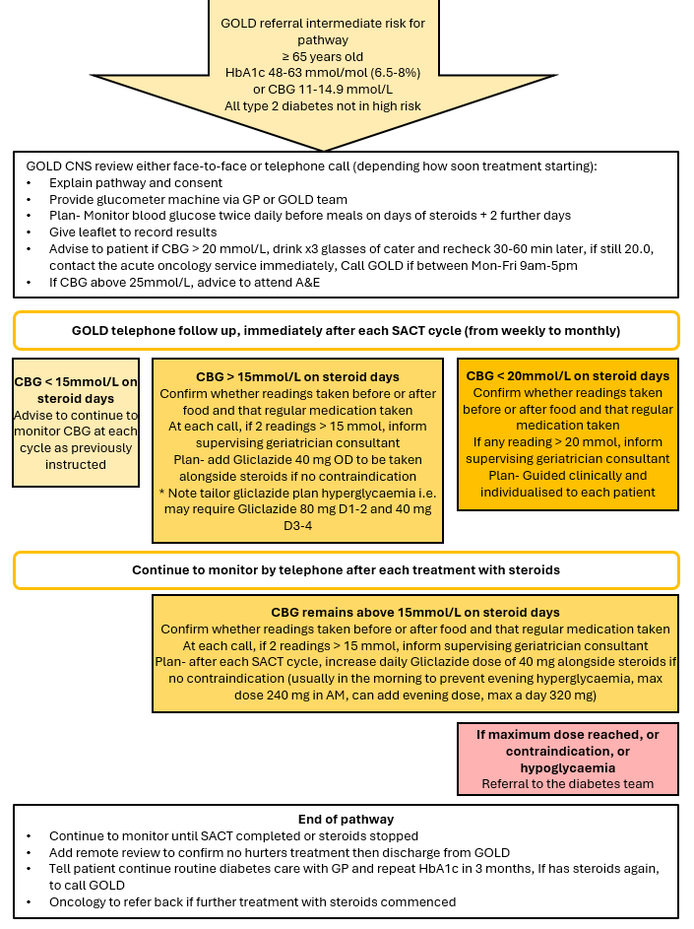Abbreviations: CBG, capillary blood glucose in mmol/L; GOLD, geriatric oncology liaison development; CNS, clinical nurse specialist; GP, general practitioner; A&E, accident and emergency department; SACT, systemic anticancer therapy; OD, once a day; AM, in the morning.

Supplementary data 2: Association among clinical and biological characteristics and frailty level (according to CFS categories) in the GOLD patients
Variables | FIT  CFS 1-2  (n=16) | PREFRAILTY  CFS 3-4  (n=64) | FRAILTY  CFS 5-9  (n=17) | P-value
CFS, median [Q1;Q3] | 2.00 [2.00;2.00] | 3.00 [3.00;4.00] | 5.00 [5.00;6.00] | <0.001
Age in years, median [Q1;Q3] | 74.0 [70.8;79.2] | 74.0 [69.8;80.0] | 76.0 [70.0;78.0] | 0.97
Sex female, n (%) | 4 (25%) | 26 (41%) | 9 (53%) | 0.26
Metastatic status, n (%) | 6 (38%) | 27 (45%) | 7 (41%) | 0.85
Pre-existing diabetes, n (%) | 10 (62%) | 53 (83%) | 14 (82%) | 0.19
Social isolation, n (%) | 0 (0%) | 4 (6%) | 2 (12%) | 0.48
Dependency in ADL, n (%) | 0 (0%) | 1 (2%) | 10 (59%) | <0.001
Timed get up and go test (sec), median [Q1;Q3] | 10.2 [9.0;10.7] | 13.3 [11.5;17.3] | 20.1 [13.4;29.1] | <0.001
History of falls, n (%) | 0 (0%) | 6 (9%) | 7 (41%) | 0.002
Cognitive impairment, n (%) | 1 (6%) | 13 (21%) | 7 (44%) | 0.05
Low mood, n (%) | 1 (6%) | 10 (16%) | 7 (44%) | 0.02
Malnutrition, n (%) | 6 (38%) | 26 (41%) | 13 (81%) | 0.01
Other holistic interventions, n (%) | 9 (56%) | 55 (86%) | 16 (94%) | 0.01
HbA1c at GOLD clinic (mmol/L), median [Q1;Q3] | 50.5 [48.0;55.2] | 51.0 [47.0;56.0] | 51.0 [48.0;60.0] | 0.94
Random CBG in GOLD clinic (mmol/L), median [Q1;Q3] | 8.00 [6.00;9.07] | 7.90 [6.80;10.40] | 8.70 [7.40;9.72] | 0.67
All CBG readings (mmol/L), median [Q1;Q3] | 9.36 [8.08;11.36] | 8.54 [7.73;9.97] | 9.98 [7.84;10.96] | 0.32
Glucose AM readings (mmol/L), median [Q1;Q3] | 7.71 [7.33;8.72] | 7.40 [6.93;8.21] | 8.32 [6.86;9.53] | 0.56
Glucose PM readings (mmol/L), median [Q1;Q3] | 11.70 [9.91;12.20] | 10.07 [8.46;10.80] | 11.05 [8.83;12.53] | 0.14
Highest glucose reading (mmol/L), mean ± SD | 17.34 ± 5.24 | 15.67 ± 4.60 | 17.07 ± 5.86 | 0.44
Number of cancer treatment cycles, median [Q1;Q3] | 3 [1;4] | 3 [1;5] | 3 [1;6] | 0.58
Any change in cancer treatment plan during CBG monitoring, n (%) | 7 (47%) | 30 (49%) | 8 (47%) | 0.98
Any change in steroid regimens during CBG monitoring, n (%) | 3 (20%) | 13 (22%) | 5 (29%) | 0.76
New diabetes medication intervention needed, n (%) | 6 (43%) | 19 (33%) | 5 (33%) | 0.75

Abbreviations: ADL=activities in daily living; AM=morning time; CBG=capillary blood glucose; CFS=clinical frailty scale; GOLD=geriatric oncology liaison development; PM=evening time; SD=standard deviation.

Supplementary data 3: Association among clinical and biological characteristics and steroid-induced hyperglycaemia in the GOLD patients who underwent a comprehensive geriatric assessment (n=102)

Variables | Steroid-induced hyperglycaemia  (n=30) | No Steroid-induced  hyperglycaemia  (n=62) | P-value
Age in years, mean ± SD | 73.9 ± 5.6 | 75.5 ± 5.9 | 0.23
Sex female, n (%) | 19 (63%) | 20 (32%) | 0.005
Metastatic status, n (%) | 11 (37%) | 24 (41%) | 0.67
Pre-existing diabetes, n (%) | 26 (87%) | 45 (73%) | 0.13
CFS, median [Q1;Q3] | 3.00 [3.00;4.00] | 3.00 [3.00;4.00] | 1.00
Social isolation, n (%) | 1 (3%) | 3 (5%) | 1.00
Dependency in ADL, n (%) | 3 (10%) | 9 (15%) | 0.74
Timed get up and go test (sec), median [Q1;Q3] | 12.6 [10.3;16.3] | 13.9 [11.2;19.9] | 0.26
History of falls, n (%) | 5 (17%) | 8 (13%) | 0.75
Cognitive impairment, n (%) | 2 (7%) | 16 (26%) | 0.04
Low mood, n (%) | 5 (17%) | 12 (20%) | 0.78
Malnutrition, n (%) | 13 (45%) | 28 (46%) | 0.92
Other holistic interventions, n (%) | 24 (80%) | 50 (82%) | 0.82
HbA1c at GOLD clinic (mmol/mol), median [Q1;Q3] | 54 [48;60] | 50 [45;55] | 0.05
HbA1c at GOLD clinic (%), median [Q1;Q3] | 7.1 [6.6;7.6] | 6.7 [6.3;7.2] | 0.05
Random CBG in GOLD clinic (mmol/L), median [Q1;Q3] | 8.90 [6.90;11.00] | 7.90 [6.50;9.75] | 0.16
All CBG readings (mmol/L), mean ± SD | 10.85 ± 2.03 | 8.28 ± 1.18 | <0.001
Glucose AM readings (mmol/L), mean ± SD | 9.21 ± 2.28 | 7.41 ± 1.20 | <0.001
Glucose PM readings (mmol/L), mean ± SD | 12.61 ± 2.61 | 9.28 ± 1.57 | <0.001
Highest glucose reading (mmol/L), mean ± SD | 20.68 ± 4.21 | 13.47 ± 2.96 | <0.001
Number of cancer treatment cycles, median [Q1;Q3] | 4 [2;6] | 3 [1;5] | 0.07
Any change in cancer treatment plan during CBG monitoring, n (%) | 17 (57%) | 32 (54%) | 0.83
Any change in steroid regimens during CBG monitoring, n (%) | 14 (47%) | 9 (15%) | 0.001

Abbreviations: ADL=activities in daily living; AM=morning time; CBG=capillary blood glucose; CFS=clinical frailty scale; EGS=comprehensive geriatric assessment; GOLD=geriatric oncology liaison development; PM=evening time; SD=standard deviation.
Restricted to patients who underwent a comprehensive geriatric assessment (n=102).

Supplementary data 4: Univariate analysis of overall survival in the GOLD patients (n=126)
Variables | Univariate analysis  HR (95% CI), p-value
Age in years  Gender (Male vs Female)  Metastatic status (Y vs N)  Pre-existing diabetes (Y vs N)  CFS (per unit)  Social isolation (Y vs N)  Dependency in ADL (Y vs N)  Timed Get up and Go (per second)  History of falls (Y vs N)  Cognitive impairment (Y vs N)  Low mood (Y vs N)  Malnutrition (Y vs N)  Geriatric interventions other than DP (Y vs N)  HbA1c at GOLD clinic (per mmol/L)  Random CBG in GOLD clinic (per unit)  CBG readings (per unit)  CBG AM readings (per unit)  CBG PM readings (per unit)  Highest CBG reading (per unit)  Diabetes medication intervention | 1.01 (0.96-1.07), p =0.59  1.78 (0.86-3.69), p = 0.12  2.43 (1.23-4.8), p =0.01  0.80 (0.41-1.57), p =0.51  1.28 (0.97-1.69), p = 0.08  3.34 (1.15-9.68), p = 0.03  1.71 (0.71-4.71), p = 0.23  1.04 (0.98-1.09), p = 0.17  1.78 (0.72-4.37), p = 0.21  0.62 (0.24-1.59), p = 0.32  1.11 (0.46-2.69), p = 0.81  3.00 (1.45-6.20), p = 0.001  2.53 (0.88-7.30), p = 0.09  1.02 (0.99-1.05), p = 0.12  1.05 (0.95-1.15), p = 0.35  1.12 (0.92-1.37), p = 0.27  1.10 (0.90-1.35), p = 0.34  1.01 (0.84-1.20), p = 0.92  0.98 (0.89-1.07), p =0.60  1.22 (0.57-2.61), p = 0.60

Abbreviations: ADL= activities in daily living; AM= morning time; CBG=Capillary Blood Glucose; CFS=clinical frailty scale; CI= confidence interval; DP= diabetes pathway; GOLD=geriatric oncology liaison development; HR=hazard ratio; PM=evening time

