Supplementary Information
Fooling with facts:
Quantifying anchoring bias through a large-scale experiment

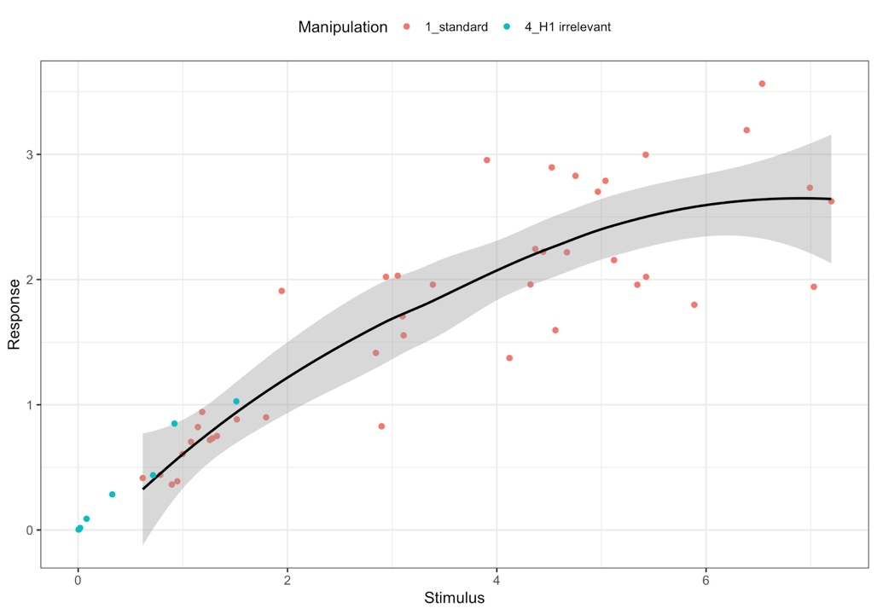
Supplementary Figure 1. Response vs. stimulus based on 42 standard questions and 8 questions with an irrelevant anchor in the control group. Points coloured according to manipulation. LOESS curve fitted to standard anchoring questions for reference.
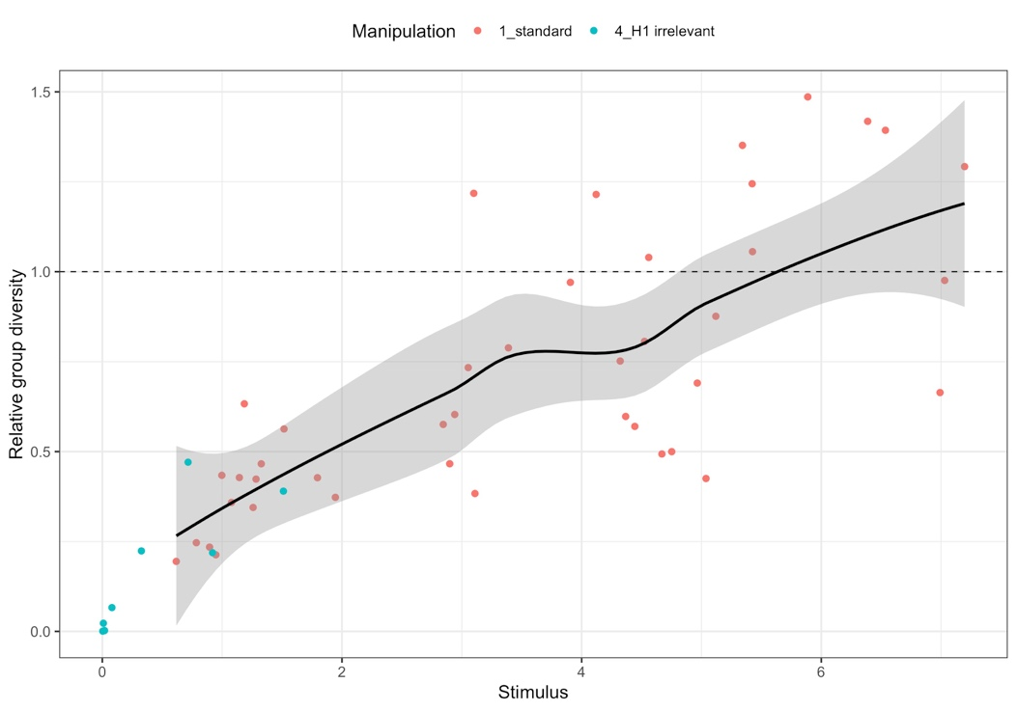
Supplementary Figure 2. Relative group diversity vs. stimulus based on 42 standard questions and 8 questions with an irrelevant anchor in the control group. Points coloured according to manipulation. LOESS curve fitted to standard anchoring questions. The line at y = 1 indicates the equal ratio of the treatment to the control group’s standard deviation.
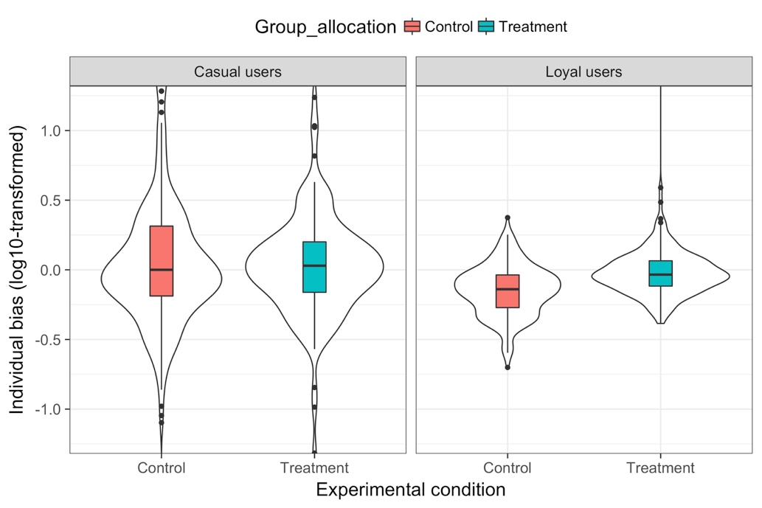
Supplementary Figure 3. Individual bias (log10-transformed) vs. experimental condition, distinguished by the level of activity during the experiment.
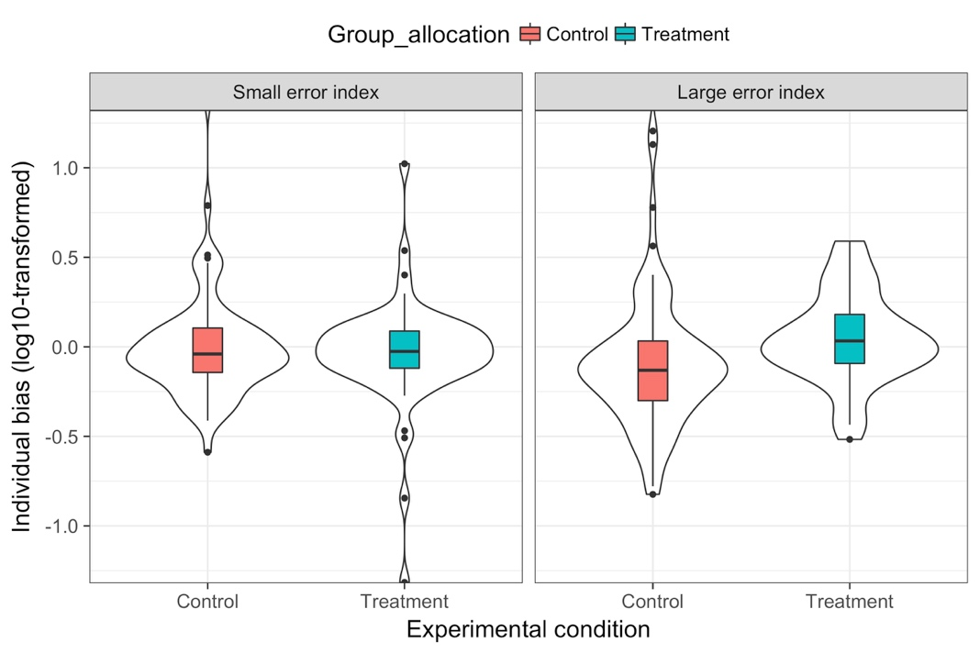
Supplementary Figure 4. Individual bias (log10-transformed) vs. experimental condition, distinguished by previous performance on the app.

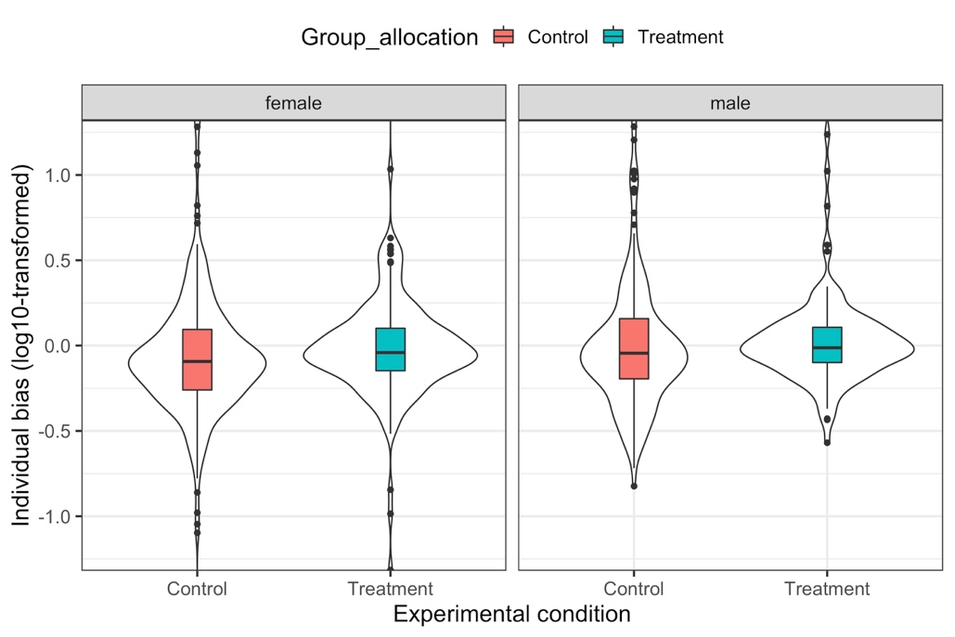
Supplementary Figure 5. Individual bias (log10-transformed) vs. experimental condition, separated by gender.

Supplementary Table 1. Overview of all experimental questions.
 |  |  |  | Control Group | Experimental Group
# | Type of question | Event name | Question | Hint 1 | Hint 2 - Group A | Hint 2 - Group B | Result
1 | Standard | Apple WWDC | Apple's Worldwide Developers Conference will take place next week in San Jose where exciting new software and devices may be presented! What will the starting price be in US $ of the device that is announced last during Apple’s WWDC 2018? | Current starting price of Apple’s iPhone 8: 699 USD | Current starting price of Apple’s Watch Series 3 (Cellular): 399 USD | Current starting price of Apple’s MacBook Air: 999 USD | 0 USD
2 | Standard | Apple WWDC | Investors will look closely at Apple's WWDC to see what's in store for consumers during the next months. What will Apple’s closing stock price be on the first day of the WWDC on June 4th? | Average opening stock price during past 3 days: 187.51 USD | Highest stock price yesterday: 188.23 USD | Lowest stock price yesterday: 186.14 USD | 191.83 USD
3 | Standard | Apple WWDC | Aaaaand cut! In HH:MM, how long will this year's WWDC keynote address be? | Scheduled length of WWDC 2018 keynote: 2:00 | Length of WWDC 2017 keynote: 2:19 | Length of WWDC 2016 keynote: 2:03 | 2:15 h
4 | Standard | Apple WWDC | What will the temperature be in San Jose at the start of the keynote (Monday, 10 am PDT) in °F? | Temperature last Monday at 10 am in San Jose: 73 | Forecast temperature high on Monday: 79 | Forecast temperature low on Monday: 57 | 66°F
5 | PTF-prediction | Apple WWDC | During the last couple of years, Tim Cook welcomed several speakers of the company to the stage to introduce new software features or products. How many different people will present during the keynote this year? | Number of people on stage during WWDC 2016: 10 | Number of people on stage during WWDC 2017: 12 | PTF's prediction: 8 | 9 people
6 | PTF-prediction | Little Big Town concert | At the beginning of June the band Little Big Town opened the 2018 CMT Music Awards with the first live performance of their new single "Summer Fever". Now that it's summer, do you also have "that flip-flop attitude" they're singing about? How many views will the official video of "Summer Fever" on the VEVO YouTube channel have by next Wednesday (June 18)? | Number of views this Wednesday: 234,700 | PTF's prediction: 534,700 | PTF's prediction: 384,700 | 346,060 views
7 | PTF-prediction | Little Big Town concert | Little Big Town will be playing at the Country Summer Music Festival this weekend in Santa Rosa, CA. Hopefully it'll be sunny - but we're sure the band manages to fire the crowd up either way with their new single "Summer Fever"! In F°, what will the temperature be in Santa Rosa at 1 PM on Sunday? | Temperature last Sunday at 1 PM: 78°F | PTF's prediction: 82 °F | PTF's prediction: 74 °F | 67 °F
8 | PTF-prediction | Ottawa Craft and Beer Festival | Over 250 craft, import, and domestic beers will be presented at Ottawa's Beer Fest this weekend. The entry fee covers 10 drink tickets and a sampling cup. What will the weather be like at 1 PM in Ottawa, Ontario, on Sunday? | Temperature last Sunday at 1 PM: 68°F | PTF's prediction: 76°F | PTF's prediction: 60°F | 84 °F
9 | PTF-prediction | Sugarland - new music video | Although the American country singers "Sugarland" released their song "Babe" back in April, the corresponding music video aired just a couple of days ago. Taylor Swift went back to her old country-roots when co-writing this song. How many views will the video get on Sugerland's VEVO channel on YouTube by next Thursday? | Number of views last Thursday: 4,206,205 | PTF's prediction: 5,006,710 | PTF's prediction: 5,807,215 | 7,219,035 views
10 | PTF-prediction | U.S. Open Golf | The U.S. Open Golf Championship is partnering with some well-known companies during the tournament: American Express, Deloitte, Lexus, and Rolex. What will the closing stock price be in USD of American Express (AXP) at the NYSE on Tuesday? | Closing stock price AXP last Tuesday: 100.73 USD | PTF's prediction: 99.23 USD | PTF's prediction: 102.23 USD | 97.14 USD
11 | PTF-prediction | Sotheby's auction I | The weather in London can be incredibly unpredictable! Luckily, the Sotheby's Impressionist and Modern Art Evening Sale takes place inside, so no need to worry about the weather. In °C, what will the temperature be like on Tuesday at 1 PM in London? | Temperature at 1 PM last Tuesday: 16°C | PTF's Prediction: 20°C | PTF's prediction: 24°C | 23 °C
12 | PTF-prediction | Sotheby's auction I | Sotheby's is on Instagram and Snapchat! For more information on their latest exhibitions, have a look at Sotheby's accounts! How many Instagram likes will their last post on Monday (June 18) get by Tuesday evening? | Average # likes for pics posted on Mondays in June: 3,078 | PTF's prediction: 2,228 | PTF's prediction: 3,928 | 3,110 likes
13 | PTF-prediction | Sotheby's auction I | The auction house Sotheby's was founded in 1744 and has its headquarters in New York, NY. It has salesrooms all over the world: NY, London, Paris, Hong Kong. Did you know it's the oldest company listed on the New York Stock Exchange? In USD, what will Sotheby's (BID) closing stock price be at the NYSE on Tuesday (June 26)? | Closing stock price BID last Tuesday: 59.06 USD | PTF's prediction: 60.31 USD | PTF's prediction: 57.81 USD | 55.84 USD
14 | PTF-prediction | World Cup Other | There are a number of sponsors supporting the holding of this year's FIFA World Cup - McDonald's is one of them. Have you noticed McDonald's FIFA World Cup Fantasy game online where you create your own team? What will McDonald's (MCD) closing stock price be at the NYSE on Friday? | Closing stock price last Wednesday: 166.58 USD | PTF's prediction: 163.48 USD | PTF's prediction: 169.68 USD | 164.55 USD
15 | PTF-prediction | World Cup Other | Anyone travelling to Russia to see a game of the World Cup live? Apart from the FIFA World Cup, Russia has many interesting cities that are worth a visit: Moscow, Saint Petersburg, .... What will $1 USD be worth in Russian Rubles tomorrow at noon ET? | Last Wednesday's exchange rate on OFX: 62.3800 RUB | PTF's prediction: 62.6615 RUB | PTF's prediction: 62.0985 RUB | 63.4662 RUB
16 | PTF-prediction | Royal Ascot | Royal Ascot - the famous British Horseracing Event - will take place from June 19 to 23. Did you know 1,200 kg of Cornish Clotted Cream will be consumed by the spectators during that time? How many times will the letter "a" be used in Royal Ascot's last tweet (@Ascot) on the final race day (Saturday, 23rd)? | # letter "a" used by @Ascot in last tweet last Saturday: 6 | PTF's prediction: 10 times | PTF's prediction: 14 times | 5 times
17 | Standard | On this day | A well-known British royal was born on June 21 in 1982: Prince William, Duke of Cambridge will be turning 36 today! We hope he'll enjoy the day with his wife, Catherine, and the kids George, Charlotte, and Louis.  How many words will the last tweet tweeted (incl. retweets) by @RoyalFamily by end of day Thursday contain? | # words in @RoyalFamily last tweet last Thursday: 28 | # words in shortest tweet during past 2 days: 10 | # words in longest tweet during past 2 days: 46 | 31 words
18 | Standard | Taylor Swift in London | We hope it won't rain on the day of the first Taylor Swift concert in London - but judging by the "rain show alert" post on Instagram after her Chicago show this "special effect" made the show even more magical!  In °C, what will the temperature be at 9 AM on London on Friday (June 22)? | Temperature last Friday at 9 AM: 16°C | Forecast low for Friday: 11°C | Forecast high for Friday: 20°C | 15 °C
19 | Standard | Taylor Swift in London | According to the set list from her first concert in Glendale, Arizona, the show will start with Taylor Swift's hit "... Ready For It". Even of you can't make it to one of her concerts, you can watch the music video of that song and many more on YouTube.  How many daily views will Taylor Swift's YouTube VEVO channel have on Monday (June 25)? | Daily average # views past 30 days: 4,951,760 | Smallest # of daily views during last 14 days: 4,623,075 | Largest # of daily views during last 14 days: 5,583,663 | 4,723,825 views
20 | Standard | Big Five Marathon | Pretoria is one of the larger cities very close to the Entabeni Game Reserve where the Big Five marathon will take place. Did you know that Pretoria is South Africa's executive capital?  In °F, what will the temperature be like at 11 AM in Pretoria on Saturday? | Temperature at 11 AM last Saturday: 60°F | Forecast low for Saturday: 50°F | Forecast high for Saturday: 68°F | 67 °F
21 | Standard | Big Five Marathon | Have you ever imagined running next to rhinos, zebras, antelopes, and giraffes? Well, you can: at the Big Five Marathon that is taking place on Saturday in South Africa! We bet that's going to be a very adventurous sport event!  How many runners will finish this year's Big 5 marathon? | Average number of finishers during last 5 years: 126 | Highest # of finishers during the last 5 years: 152 | Lowest # of finishers during the last 5 years: 101 | 127 racers
22 | Standard | Big Five Marathon | Need some extra motivation to run faster? Well, if a lion chases you, you'd better hurry up!  In HH:MM, what will the finishing time be of the runner coming in 80th place at the Big Five Marathon? | Average time of finishers 2017:  05:46 h | Finishing time of runner in 60th place 2017: 05:34 h | Finishing time of runner in 100th place 2017: 06:13 h | 06:14 h
23 | Standard | FORMULA 1 Pirelli Grand Prix De France 2018 | The Formula 1 Pirelli Grand Prix de France will take place at the Circuit Paul Ricard on Sunday, June 24. The French Grand Prix is one of the oldest motor races in the world! It's already been 10 years since the last French Grand Prix took place, so we're excited for the results!  In °C, what will the weather be like in Marseille, France, at 11 AM on Monday? | Temperature at 11 AM last Monday: 25°C | Temperature high last Monday: 30°C | Temperature low last Monday: 20°C | 24°C
24 | Standard | FORMULA 1 Pirelli Grand Prix De France 2018 | In Formula 1, a lot of the races are frequently sponsored by large companies. For the upcoming GP de France, the Italian-based company Pirelli is the sponsor. Pirelli is a producer and supplier of tires.  In EUR to 2 decimal places, what will Pirelli's (PIRC.MI) stock price be at 1 PM on Tuesday on the Milan Stock Exchange? | Stock price at 2 PM last Tuesday: 7.33 EUR | Stock price low last Tuesday: 7.19 EUR | Stock price high last Tuesday: 7.33 EUR | 7.25 EUR
25 | Standard | City of Vancouver | The City of Vancouver has an official Twitter account. If you're a Vancouver resident, it might be worthwhile checking out the account regularly as useful information and the latest news is announced here on a daily basis.  How many words will the last tweet tweeted by end of day Wednesday by @CityofVancouver contain? | # words in @CityofVancouver tweet last Wednesday: 47 | # words in shortest tweet during past 2 days: 3 | # words in longest tweet during past 2 days: 45 | 29 words
26 | Standard | IMVDb | On IMVDb - the Internet Music Video Database - you can discover the latest music video releases of your favorite bands or rewatch the best music videos from the past years.  In MM:SS, what will be the length of the newest YouTube video that is published by Thursday evening (if multiple, average will be taken)? | Average length of new music videos last Thursday: 3:57 mins | Length of longest video in past 5 days: 4:30 mins | Length of shortest video in past 5 days: 2:31 mins | 3:37 mins
27 | Standard | Celine Dion World Tour | Céline Dion's 2018 World Tour will kick off on Tuesday at the Tokyo Dome in Japan! This will be her first concert in Asia since her tour in 2008.  How many songs will Céline Dion play during the first concert of her Céline Dion Live 2018 tour in Tokyo on June 26? | Average # songs played during 2017 tour: 23 | # songs in longest concert in 2017 tour: 28 | # songs in shortest concert in 2017 tour: 21 | 19 songs
28 | Standard | Auction:  Sotheby's Contemporary Art Day Auction | Interested in buying an artwork at one of Sotheby's auctions? It's likely you'll have to dig deep into your pockets - for some pieces the estimated prices are only available upon request!  To the 4th decimal place, how many USD can you buy with 1 GBP on Thursday at 1 PM London time? | Last Thursday's exchange rate at 1 PM London time: 1.3215 | Exchange rate low last Thursday: 1.3101 | Exchange rate high during last Thursday: 1.3271 | 1.3094 USD
29 | Standard | Ed Sheeran concert | Did you notice Ed Sheeran album's have very interesting short names? His latest album has the name ÷ (divide) and previous ones are called + (plus) and x.  What will be the absolute difference in subscribers on EdSheeran's official YouTube channel on Sunday compared to Saturday? | Daily change last Sunday (absolute): 24,844 | Lowest daily absolute change past 14 days: 20,929 | Highest daily absolute change past 14 days: 29,287 | 28,210 subscribers
30 | Standard | Ed Sheeran concert | This week, Ed Sheeran plays three concerts in The Netherlands and Belgium as part of his current world tour. He'll be coming to North America in August and there are still tickets available!  In °F, what will the temperature be in Amsterdam, Netherlands, at noon on Saturday, June 30? | Temperature last Saturday at noon in Amsterdam: 61°F | Forecast high for Saturday: 81°F | Forecast low for Saturday: 56°F | 73 °F
31 | Standard | Elon Musk Birthday | Elon Musk is celebrating his birthday this week: he was born on June 28 in 1971. He is a forward-thinking businessman known for his companies SpaceX, Tesla, Inc. and his latest project, Hyperloop, a high-speed transportation system.  In USD, what will Tesla's (TSLA) stock price be at the Nasdaq Stock Market next Tuesday (July 3) at 1 PM? | TSLA's stock price last Tuesday at 1 PM: 334.34 USD | TSLA's stock price low last Tuesday: 326.00 USD | TSLA's stock price high last Tuesday: 343.55 USD | 310.86 USD
32 | Standard | Box Office Mojo | Have you been to the movies lately? Jurassic World 2, Incredibles 2, Ocean's 8, and Solo: A Star Wars Story are some of the films that have been popular during the last month.  In USD, how much money will the Top 10 films gross next Monday according to Box Office Mojo? | Top 10 gross last Monday: 30,407,642 USD | Highest gross amount Top 10 last 5 Mondays: 42,991,006 USD | Lowest gross amount Top 10 last 5 Mondays: 10,973,333 USD | 24,575,462 USD
33 | Standard | Formula 1 Eyetime Großer Preis von Österreich | In Formula 1, minimising the time spent for pit stops is essential in order for a driver not to lose his position in the race. On the Formula 1 website a pit stop is even compared to a ballet performance...  To the closest second, how much time will the the Formula 1 Austrian Grand Prix winner spend on pit stops? | Average pit stop time all racers last GP: 26.34 secs | Total pit stop time of winner in Australian GP: 21.79 secs | Total pit stop time of winner in Bahrain GP: 24.52 secs | 21.21 secs
34 | Standard | Canada Day | It's July 1 which means it's Canada Day! 🇨🇦🎂 Did you know there is a Twitter account specifically dedicated for Canada? Check it out!  How many words will the last tweet tweeted by @Canada by end of day Monday contain? | # words in @Canada's last tweet last Monday: 38 | # words in longest tweet during last 10 tweets: 43 | # words in shortest tweet during last 10 tweets: 11 | 11 words
35 | Irrelevant anchor in control group | Montreal en Arts | The Mtl en Arts festival takes place until the end of this week. This is already the 19th time this event is taking place in Montréal! Did you know this is the largest open-air exhibition of art in Eastern Canada?  How many times will the last post by Tuesday evening on Mtl en Art's FB page be liked (incl. other reactions) within 24 hours? | Number of people following Mtl en Arts FB page: 8,379 | Lowest number of reactions last 10 posts: 4 | Highest number of reactions last 10 posts: 73 | 37 reactions
36 | Irrelevant anchor in control group | World UFO Day | On July 2 it's World UFO Day! On this day, people all over the world are on the lookout for unidentified flying objects (UFOs). Have you ever spotted something unusual in the sky?  How many upvotes will the last post posted by Tuesday evening in the r/UFOs subreddit on Reddit get within 24 hours? | Number of subscribers to r/UFOs: 101,000 subscribers | Highest number of upvotes last 10 posts: 107 | Lowest number of upvotes last 10 posts: 0 | 0 upvotes
37 | Irrelevant anchor in control group | Paris Fashion Week | The Haute Couture Fashion Week takes place in Paris from July 1 to 5. The next big Fashion shows in New York, London, Milan, and Paris will take place in September when the Spring/Summer 2019 collections will be shown.  How many times will the letters V, O, U, G, and E appear in the last tweet tweeted by @VogueParis by Tuesday evening? | Number of tweets overall last Tuesday: 42 | Lowest number of V, O, U, G & E letters in last 10 tweets: 32 times | Highest number of V, O, U, G & E letters in last 10 tweets: 7 times | 18 times
38 | Standard | Wimbledon | It's time for Strawberries and Cream: The Championships, Wimbledon, start on July 2nd. During last year's matches, more than 150,000 merchandise items were sold. Among those were a whopping 8,882 umbrellas and 1,334 panama hats.  In °C, what will the weather be like at 11 AM on Thursday in Wimbledon? | Temperature last Thursday at 11 AM in Wimbledon: 18°C | Lowest temperature last Thursday: 12°C | Highest temperature last Thursday: 27°C | 24 °C
39 | Standard | Fourth of July | May the fourth be with you! This day in 1776, the United States of America adopted the Declaration of Independence. The famous Macy's 4th of July Fireworks in New York City are annually televised on NBC - or, if you're in NYC, you can watch them live from the East River.  In USD to 2 decimal places, what will Macy's (M) stock price be at 1 PM on Thursday on the NYSE? | Macy's stock price last Thursday at 1 PM: 38.14 USD | Macy's stock price high last Thursday: 38.62 USD | Macy's stock price low last Thursday: 37.51 USD | 36.76 USD
40 | Standard | IMVDb | You can check out the most popular music videos that have been released in the last five days on IMVDb.com! Right now, the song Narcos by Migos leads the list. It's followed by Charli XCX's new video for 5 In The Morning.  In MM:SS, what will be the length of the newest YouTube video that is published by Sunday evening? | Length of last Sunday's video: 3:41 mins | Length of shortest video in past 5 days: 2:27 mins | Length of longest video in past 5 days: 5:37 mins | 3:48 mins
41 | Standard | World Cup: Brazil vs. Belgium | On the official 2018 FIFA World Cup Russia homepage you can find plenty of interesting facts about each team and each game. Did you know that for each game a Man of the Match is chosen?  How many passes between players (for both teams, incl. incomplete) will be recorded during the Brazil vs. Belgium match on Friday? | # passes between players during Croatia vs. Nigeria game: 850 | # passes between players during Iran vs. Morocco game: 627 | # passes between players during Saudi Arabia vs. Egypt game: 1012 | 927 passes
42 | Irrelevant anchor in control group | Ironman 70.3 Muskoka | The Ironman 70.3 Muskoka Canada takes place on Sunday in Huntsville, ON, close to the Great Lakes. Did you know that the 70.3 stands for the 70.3 miles (113 km) that is covered by the athletes via swimming, cycling, and running? This is half the distance of a regular Ironman.  In HH:MM, what will be the finishing time of the racer coming in 45th place at the 70.3 Muskoka Ironman? | Time of winner of last 70.3 in Mont-Tremblant, QC, Canada: 03:41 h | Finishing time of racer coming in 30th place at last 70.3 in Norway: 04:52 h | Finishing time of racer coming in 60th place at last 70.3 in Norway: 05:19 h | 04:38 h
43 | Standard | On this day | 24 years ago on July 5, Amazon.com was founded by Jeff Bezos. The company has its headquarters in Seattle, Washington. Did you know the logo includes an arrow which indicates everything "from a to z" is available at Amazon.com?  In USD, what will be Amazon.com's (AMZN) stock price at the NasdaqGS next Tuesday at noon? | Stock price last Tuesday at noon: 1,704.54 USD | Amazon's stock price low last Tuesday: 1,692.48 USD | Amazon's stock price low high Tuesday: 1,725.00 USD | 1,747.06 USD
44 | Standard | MTL Challenge Dragon Boat | Beat the heat 🔥! Watch the MTL Challenge Dragon Boat race in the Olympic Basin in Montréal this weekend! In addition to the exciting races you'll also be able to see live performances from artists from China and Montréal at the Chinese Cultural Festival.  In MM:SS, what will be the finishing time of the 10th boat in the 2000m Community Mixed Final A race on Sunday? | Average time in mixed 2000m in 2017: 10:41 mins | Finishing time of boat in 5th place in same race 2017: 10:30 mins | Finishing time of boat in 15th place in same race 2017: 11:07 mins | 11:29 mins
45 | Standard | Tour de France | This year's Tour der France will start on Saturday and finish on the 29th of July. After each of the 21 stages, differently colored jerseys are given to certain racers, depending on their performance during the day. The overall leader wears a yellow jersey.  In °C, what will the temperature be in Paris on Monday at 10 AM? | Temperature in Paris last Monday at 10 AM: 22°C | Forecast high for next Monday: 28°C | Forecast low for next Monday: 18°C | 21 °C
46 | Irrelevant anchor in control group | Formula 1 Rolex British Grand Prix | The Formula 1 2018 Rolex British Grand Prix takes place this weekend at the Silverstone Circuit. The racers will do 52 laps, each being 5.891 km long.  What will be the average speed of the person who finishes 10th in the British Grand Prix on Sunday during his fastest lap? | Number of cars racing in the Grand Prix: 20 | Speed (average) of first finisher of last British GP (fastest lap): 234.03 secs | Speed (average) of last finisher of last British GP (fastest lap): 227.20 secs | 226.89 secs
47 | Standard | Montreux Jazz Festival | The Montreux Jazz Festival currently takes place in the French part of Switzerland. This world-famous festival has featured many star musicians in the past. This year, Elton John will perform!  To the 4th decimal place, how many CHF can you buy with 1 CAD on Tuesday at 1 PM? | Last Tuesday's exchange rate at 1PM: 0.7551 CHF | Exchange rate high, last Tuesday: 0.7569 CHF | Exchange rate low, last Tuesday: 0.7528 CHF | 0.7562 CHF
48 | Irrelevant anchor in control group | Flight statistics | Going on vacation? Getting to your dream holiday location can be a hassle sometimes when flights are delayed, cancelled or baggage is lost.  How many flights will be delayed in the Asia-Pacific area next Wednesday? | Global total delayed flights last Wednesday: 21,994 | Delayed flights in North America last Wednesday: 4,457 flights | Delayed flights in Europe last Wednesday: 7,381 flights | 7,853 flights
49 | Standard | MoMA photography | Going back in time! Historic photographs that have been on exhibition in the Museum of Modern Art (MoMA) New York are now up for sale at Christie's. In many photos you can discover how New York's skyline developed over the 20th century!  In USD, what will be the final sale price of the most expensive photo in the auction? | Mean price prediction for 5 most expensive photos: 13,000 USD | Christie's low price prediction for most expensive photo: 12,000 USD | Christie's high price prediction for most expensive photo: 18,000 USD | 100,000 USD
50 | Standard | Tim McGraw & Faith Hill Soul2Soul Tour | After playing 80 extremely successful concerts in 2017, Tim McGraw & Faith Hill are on the road again to continue their Soul2Soul World Tour. The two singers not only have an incredible chemistry on stage but also off stage!  How many daily views will the TimandFaithVEVO channel on YouTube have on Wednesday? | Daily views last Wednesday: 29,418 | Lowest # of daily views during last 14 days: 25,754 | Highest # of daily views during last 14 days: 32,253 | 30,963 views
51 | Standard | Croatia vs. England | The third last match in this year's World Cup (there's still the Third Place Play-Off happening on the 14th) will take place in Moscow in Russia's largest football stadium. Croatia will meet England for the 8th time.  How many passes between players (for both teams, incl. incomplete) will be recorded during the Croatia vs. England match on Wednesday? | # passes during Panama vs. Tunisia game: 910 | # passes during Uruguay vs. Saudi Arabia game: 1,111 | # passes during Senegal vs. Colombia game: 712 | 1101 passes
52 | Standard | Flight NYC to Moscow | Fancy seeing the World Cup final live? Moscow is definitely worth a visit with its various sights: It is famous for The Red Square at the heart of the city, the Kremlin, St. Basil's Cathedral, and more. There's a a lot to explore!  In HH:MM, how long will it take flight AFL101 to fly from New York JFK to Moscow on Thursday? | Flight duration, last Thursday: 08:14 h | Longest flight duration during 10-day period:  08:30 h | Shortest flight duration during 10-day period:  7:52 h | 08:16 h
53 | Standard | Festival d'été de Québec | Summer time - festival time! The Festival d’été de Québec 2018 takes place from July 5-15. Stars such as The Weeknd, Neil Young, Shawn Mendes, the Foo Fighters, Lorde and many more will perform! The company Bell is one of the major sponsors of this Festival.  In CAD to 2 decimal places, what will Bell's (BCE) stock price be at noon on Thursday? | Stock price at noon last Thursday: 53.43 CAD | Stock price high last Thursday: 53.80 CAD | Stock price low last Thursday: 53.22 CAD | 55.87 CAD
54 | Irrelevant anchor in control group | Film release | A couple of exciting films are being released this month: Mission Impossible - Fallout, Mamma Mia: Here We Go Again, and Skyscraper.  In Mio. USD, how much will the Top 12 movies gross during the upcoming weekend (July 13-15)? | Gross value highest grossing film last weekend: 76.0 Mio. EUR | Top 12 lowest gross value during last 5 weekends: 112.3 Mio. USD | Top 12 highest gross value during last 5 weekends: 271.3 Mio. USD | 157.3 Mio. USD
55 | Irrelevant anchor in control group | Friday the 13th | The weekend is almost there! This week, Friday is not just any Friday but Friday the 13th. Did you know that the 13th of a month falls at least once on a Friday every year but not more than three times?  How many upvotes will the last post on Friday in the subreddit r/IsTodayFridayThe13th receive within 24 hours? | Number of subscribers to the subreddit: 25.200 | Lowest number of upvotes last 10 posts: 510 | Highest number of upvotes last 10 posts: 628 | 77,000 upvotes
56 | Standard | Trump visit UK (July 12-15) | President Trump will embark on his first official visit to the UK from Thursday onwards for four days. He's scheduled to attend a dinner at Winston Churchill's birthplace and meet with the Queen at Windsor Castle.  How many words will the last tweet tweeted by @realDonaldTrump by end of day Friday contain? | # words in @realDonaldTrump's last tweet last Friday: 38 | # words in his shortest tweet during last 10 tweets: 9 | # words in his longest tweet during last 10 tweets: 49 | 0 words
57 | Standard | FB App anniversary | The Facebook for iPhone app launched 10 years ago on July 10, 2008. It took Facebook one year to develop the app after previously only offering a mobile version of its website for people's smartphone browser. How times have changed!  In USD to 2 decimal places, what will Facebook's (FB) stock price be at 3 PM on Tuesday at the NasdaqGS? | Last Tuesday's stock price at 3 PM:  203.55 USD | Stock price low last Tuesday: 202.26 USD | Stock price high last Tuesday: 204.91 USD | 208.93 USD
58 | Standard | Flight cancellations | Imagine you've got somewhere exciting to go... and your flight gets cancelled! There can be multiple reasons for that: Staff is on strike, the aircraft is not available, or the weather conditions prevent planes from flying. How annoying!  How many flights will get cancelled in the Asia-Pacific region next Tuesday? | Flight cancellations in the United States last Tuesday: 326 | Flight cancellations in Europe last Tuesday: 231 | Flight cancellations in North America last Tuesday: 380 | 744 flights
59 | Standard | Twitter birthday | On July 15 in 2006, Twitter was "born". Can you believe people have been tweeting for 12 years now? Did you know that the first tweet from space was sent in 2009?  In USD to 2 decimal places, what will Twitter's (TWTR) stock price be at the NYSE at noon on Wednesday? | Stock price at noon last Wednesday:  43.74 USD | Stock price low last Wednesday: 42.22 USD | Stock price high last Wednesday: 44.10 USD | 43.12 USD
60 | Standard | World Cup final | The final game in the World Cup takes place this weekend in which France meets Croatia. It will be played in Russia's capital Moscow in the Luzhniki Stadium, which is not only the biggest stadium in Russia but also one of the largest in the whole of Europe!  In °C, what will the temperature be like at 9 AM on Thursday in Moscow? | Temperature at 9 AM in Moscow last Thursday: 22°C | Temperature low last Thursday: 16°C | Temperature high last Thursday: 26°C | 21 °C
61 | Standard | Flight time Toronto to Paris | City of love! France is one of the teams playing in the World Cup final match on Sunday. Its capital, Paris, is definitely worth a visit (think Eiffeltower, Notre-Dame, and Louvre!). There's something for everyone: lots of cafés, shopping opportunities, and museums.  In HH:MM, how long will it take flight AC880 to fly from Toronto Pearson to Paris CDG on Thursday? | Flight duration, last Thursday: 06:36 h | Longest flight duration during 10-day period: 06:51 h | Shortest flight duration during 10-day period: 06:23 h | 07:04 h
62 | Standard | BBC Proms | The BBC proms - the world's greatest classical music festival - have begun! The word proms stands for "promenade concerts". These concertsy are informal and inexpensive and the audience stands to listen (promming).  How many words will the last tweet tweeted by @bbcproms by end of day Thursday contain? | # words in @bbcproms's last tweet last Thursday: 20 | # words in longest tweet during last 10 tweets: 34 | # words in shortest tweet during last 10 tweets: 6 | 14 words

