Supplementary Materials

Table S1. Examples of prototypical tweets of vaccine-referencing clusters
Cluster | Tweets | Tweeter | # of RTs | Original
Pro-vaccine | It is not acceptable for NHK to create its own vaccination schedule. | Taro Kono (COVID vaccine minister) | 77,663 | うあー、NHK、勝手にワクチン接種のスケジュールを作らないでくれ。デタラメだぞ。
Pro-vaccine | While some argue that young people do not require vaccinations as they are less likely to experience severe symptoms, in Japan, “serious illness” is defined as a condition requiring a ventilator or intensive care. Many people in their 30s and 40s experience moderate illness, and I have witnessed several such cases. To help individuals understand the severity of the disease, I have created a slide illustrating the difference between “mild” and “moderate” illness. As an American Board Certified Internist, I emphasize the importance of getting vaccinated. | American Board Certified Internist | 62,010 | 「若者は重症化しないからワクチンは必要ない」と言う人がいます。日本の「重症」の定義は人工呼吸器や集中治療が必要な状態です。30代、40代でも中等症になる方はそれなりにいて、僕も多く診てきました。軽症や中等症といってもピンとこない方もいるので、スライドを作ってみました。
Pro-vaccine | I am excited to be receiving my first vaccine next week and to become fully protected. | Anonymous | 46,689 | 来週1回目のワクチン受けるので取り急ぎ準備した ワクワク
Policy-criticism | When I learned that the primary contractor who received the order for the COCOA (Covid-19 Contact-Confirming Application) also received the order for the vaccination management system, I strongly felt that it was a foregone conclusion. | Anonymous | 14,779 | COCOA受注した一次請けがワクチン接種管理システムも受注してると聞いて、もう始まる前から終わってる感がすごいしてきたな……。
Policy-criticism | While watching a recorded NHK special, I learned that the researcher at Kagoshima University who published a paper on the world’s most remarkable drug against Covid-19 is a non-regular employee whose contract expires in March. He doesn’t know if he will continue to be employed and has to work part-time as a pharmacist on weekends to make ends meet. Given this situation, I’m not sure how Japan can produce a vaccine. | Anonymous | 13,588 | 録画してたNHKスペシャル見てたら、世界でもっとも注目されたコロナに効く薬の論文を発表した、鹿児島大学の研究者が非正規雇用で、3月に契約期間が切れて今後も雇用が続くかわからないし、週末は薬剤師のバイトしないと食べていけないと言ってて、こんなんじゃ日本でワクチンなんか出来るわけないな…
Policy-criticism | I was impressed by how quickly Sumida-ku (an administrative ward in Tokyo) handled the transfer of benefits and the distribution of vaccination coupons. Their competence was quite helpful. Once things settle down, I hope the media will cover the source of their efficiency. | Light novel and science fiction writer | 9,074 | マジで墨田区、給付金の振り込みもワクチン接種券も激早だったし、有能すぎてびっくりする。たすかる。落ち着いたら、その対応力の源が何だったのか、取材してほしい。
Anti-vaccine | Only those of you who say you won’t get the new corona vaccine no matter what, please like and RT this tweet! | Anonymous | 6,765 | 何があっても新型コロナワクチンは打たないと言う方だけ、このツイートにいいねとRTお願いします！
Anti-vaccine | I will never forget how several hospitals turned my mother away after she became ill from the vaccine. She cried beside herself and begged for help, not only experiencing physical pain but emotional pain as well. We urgently need an outpatient clinic for vaccine adverse reactions and aftereffects! Please spread the word by using the hashtag #vaccineadversereactions and RT! | Anonymous | 6,959 | 自分は忘れない。ワクチン接種後、母親が体調崩してから、診察拒否対応をした数件の病院を！ 必死にお願いする自分の横で母親は泣いていました。 肉体的苦痛に加えて精神的苦痛も！ ワクチン副反応・後遺症外来の早期設置を！今すぐに！ #ワクチン副反応 #RT拡散希望
Anti-vaccine | I urge families who have lost loved ones due to vaccination to keep a copy of their medical records, including the death certificate. Without medical records in five years, such as if the hospital no longer exists, it will be impossible to seek justice. The lack of medical records has prevented Type C trials from being addressed. | Anonymous | 6,015 | 今、ワクチン接種が原因で亡くなったかもしれないご遺族は、カルテのコピーを死亡診断書も含め、手元に保管することをお勧めします。5年後、病院がなくなるなど、カルテがなくなれば、裁判すらできなくなります。カルテがないC型裁判は、カルテがないため救済されていません。

Figure S1: Comparison of machine learning algorithms for classifying the High and Low Groups
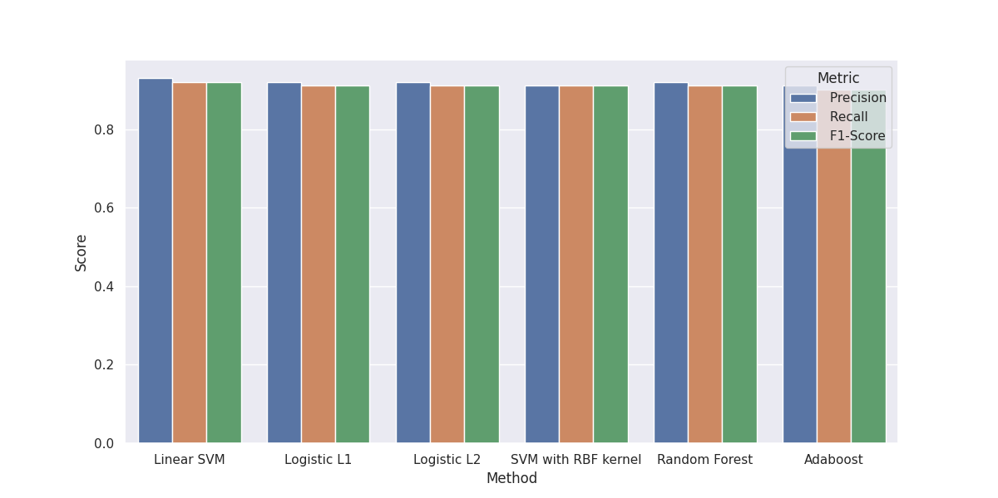
Note: We trained a classifier utilizing multiple machine learning algorithms to classify the High and Low groups. Six algorithms were employed for creating the classifier: Linear support vector machine (SVM), Logistic Regression with L1 regularization and L2 regularization, SVM with RBF kernel, Random Forest, and Adaboost. We conducted a performance comparison among these algorithms, and as depicted in the figure, no statistically significant disparities in performance (Precision/Recall/F-value) were observed. Consequently, we selected the linear SVM due to its lower computational complexity and facilitation of feature weight comparison.

Figure S2: Sensitivity analyses on the parameters to create feature sets

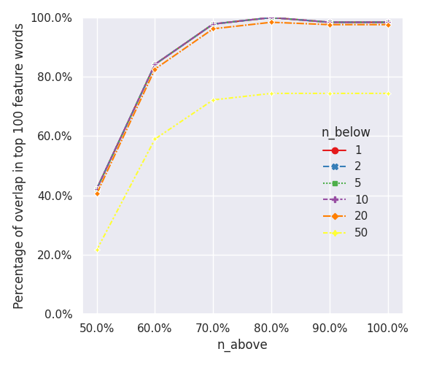
Note: We conducted a comparison of feature sets obtained by varying two parameters, namely “no_below” and “no_above.” The definitions of these parameters are as follows:
no_below: Words appearing less frequently than the specified threshold “no_below” across the entire corpus are excluded from the feature set.
no_above: Words appearing in a proportion of documents greater than or equal to the given threshold “no_above” across the entire corpus are excluded from the feature set.
To assess the impact of parameter variations, we compared the overlap in the top 100 feature words for each document, using the reference set obtained with no_below = 10 and no_above = 0.8. Note that, in Figure S2, the lines indicating that the values of n_below are 1, 2, 5, and 10 overlap and appear to be a single line. Figure S2 illustrates that the range of values for no_below (1, 2, 5, 10, and 20) exhibits relatively stable outcomes, suggesting that no_below = 10 is a reasonable cut-off value. Furthermore, stability is achieved when setting no_above to 0.7 or higher. Consequently, we can reasonably conclude that selecting no_below = 10 and no_above = 0.8 (i.e., 80%) yields robust results with high stability.
Figure S3. Proportions of pro- and anti-vaccine information spreading accounts in the friend list as of Dec 2021
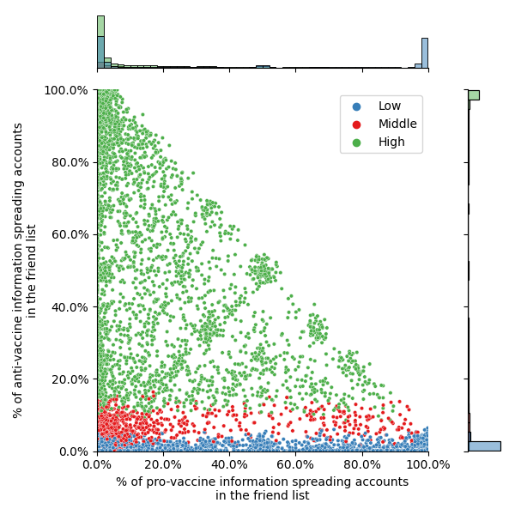
Note: Figure S3 displays the proportions of accounts spreading anti-vaccine information and accounts spreading pro-vaccine information among the friends of 150,000 accounts classified into three levels of anti-vaccine sentiment (“Low,” “Middle,” and “High”) as outlined in Table 2 (Dec 2021). Most of the High group accounts (green dots) are concentrated on the left side of the graph, indicating that they do not follow many accounts of pro-vaccine information spreaders on their friend lists.

