Enhancing Tokenization Accuracy with Dynamic Patterns: Cumulative Logic for Segmenting User-Generated Content in Logographic Languages

Supplementary Material 1: Detailed Tokenizer Performance Comparison

This supplementary material provides comprehensive visual results and detailed analysis of our tokenizer performance evaluation. We present extensive comparisons between Jieba, PyCantonese, and our proposed tokenizer trained with three progressive datasets (period 1, period 1+2, and period 1+2+3).

Domain-Specific Terms Recognition
Figure S1 illustrates the extent to which each tokenizer correctly segmented the terms and expressions listed in S1 (689 domain-specific terms from the political discourse dataset). Compared to conventional tokenizers, our proposed method with all three periods’ cumulative learning captured most terms and novel expressions within the sociopolitical research context.
[INSERT FIGURE S1 HERE]

As shown in Figure S1, our proposed tokenizer achieved accuracy rates consistently above 90% when trained on the full cumulative dataset (period 1+2+3), representing a substantial improvement over Jieba (20-35%) and PyCantonese (40-55%). The cumulative learning effect is evident in the performance differential between period 1 (50-65%) and periods 1+2 and 1+2+3 (>90%). This improvement was particularly pronounced during the early months (May-July 2019) when cumulative learning showed the greatest gains, and maintained throughout the later months as the political discourse evolved.
Figure S2 shows similar results for dataset D2 (469 COVID-19 pandemic-related terms). Our proposed tokenizer recognized significantly more pandemic-related terms, achieving accuracy rates consistently between 85-90% when fully trained (period 1+2+3), compared to Jieba and PyCantonese which both performed poorly (15-35%).

[INSERT FIGURE S2 HERE]

The pattern in Figure S2 shows that even with just period 1 training, our model (40-55%) substantially outperformed conventional tokenizers. As more data was incorporated through periods 1+2 and 1+2+3, performance improved further to 85-90%, demonstrating the value of cumulative learning. This was particularly evident during April-July 2020, when pandemic discourse intensified following the initial outbreak period. Terms like “跳舞群組” (dancing group) and “健康碼” (health code) were correctly identified as single meaningful units rather than being fragmented into individual characters or common words.

Named Entity Recognition Performance
Figures S3 and S4 display the performance of the three tokenizers in recognizing 1,235 personal names and 504 place names across both datasets.

[INSERT FIGURE S3 HERE]

It is observed that our proposed tokenizer in accumulative periods was adept at distinguishing most personal names. For personal name recognition in the political discourse dataset (left panel of Figure S3), our proposed tokenizer with periods 1+2 and 1+2+3 consistently outperformed both Jieba and PyCantonese, achieving accuracy rates of 75-90% compared to 40-60% for PyCantonese and 45-60% for Jieba.
For instance, the multiple-character institution name “衞生防護中心 (health protection center)” has been correctly recognized as one single token, rather than inaccurately as “衞生防護 (health protection),” “防護中心 (protection center),” or three separate commonly seen 2-characters words in Chinese, i.e., “衞生 (health),” “防護 (protection),” “中心 (center).”
Jieba and PyCantonese both exhibited several segmentation errors when recognizing uncommon surnames in Chinese. For example, the compound surname “林鄭” was erroneously split into two separate characters “林 (Lam)” and “鄭 (Cheng)”, which lost the originally identical meaning in the research context. This would be particularly problematic when such names blended into the vast array of tokens as input for subsequent NLP procedures.
For place name recognition (right panel of Figure S3), PyCantonese exhibited better performance compared to the other tokenizers (75-90% accuracy), primarily due to its extensive built-in dictionary, which includes a comprehensive collection of existing place names in Hong Kong. Our proposed model achieved 70-80% accuracy after cumulative learning, while Jieba ranged from 55-75%.
Comparatively, the proposed model in this study excelled at identifying compound names after accumulative learning, which provide more precise information about places and locations that might not be included in the test vocabulary. For instance, “旺角 (Mongkok)” and “太古 (Taikoo)” are two well-known areas in Hong Kong, and their names were already listed in the test vocabulary. Consequently, PyCantonese can correctly recognize them owing to its incorporated ‘local knowledge’. On the other hand, our proposed tokenizer segmented more detailed tokens, such as “旺角東 (Mongkok East)” and “太古站 (Taikoo MTR Station)”, which were the exact terms discussed by the netizens in the original online discussions (raw data).

[INSERT FIGURE S4 HERE]

In the pandemic dataset (Figure S4), similar patterns emerged. For personal name recognition (left panel), our proposed tokenizer with periods 1+2 and 1+2+3 achieved the highest accuracy (80-90%), outperforming both PyCantonese (65-85%, with notable decline after May) and Jieba (which showed declining performance from 65% to around 50% by year-end).
For place name recognition in the pandemic dataset (right panel), PyCantonese again performed best (80-90%) due to its pre-existing dictionary, while our proposed tokenizer with periods 1+2 and 1+2+3 achieved 70-80% accuracy, and Jieba maintained a relatively stable 65-70%. Our model demonstrated particular strength in recognizing compound location terms related to the pandemic, such as specific hospital names that emerged during the public health crisis.
These detailed comparisons across different entity types and contexts demonstrate the robust adaptability of our proposed cumulative learning approach to tokenization, particularly for emergent terms and compound entities in dynamic social media discourse.

Figure S1
The average accuracy of domain-specific terms matching per month for entries in D₁ with Jieba, PyCantonese, and our proposed tokenizer trained with three sub-datasets.
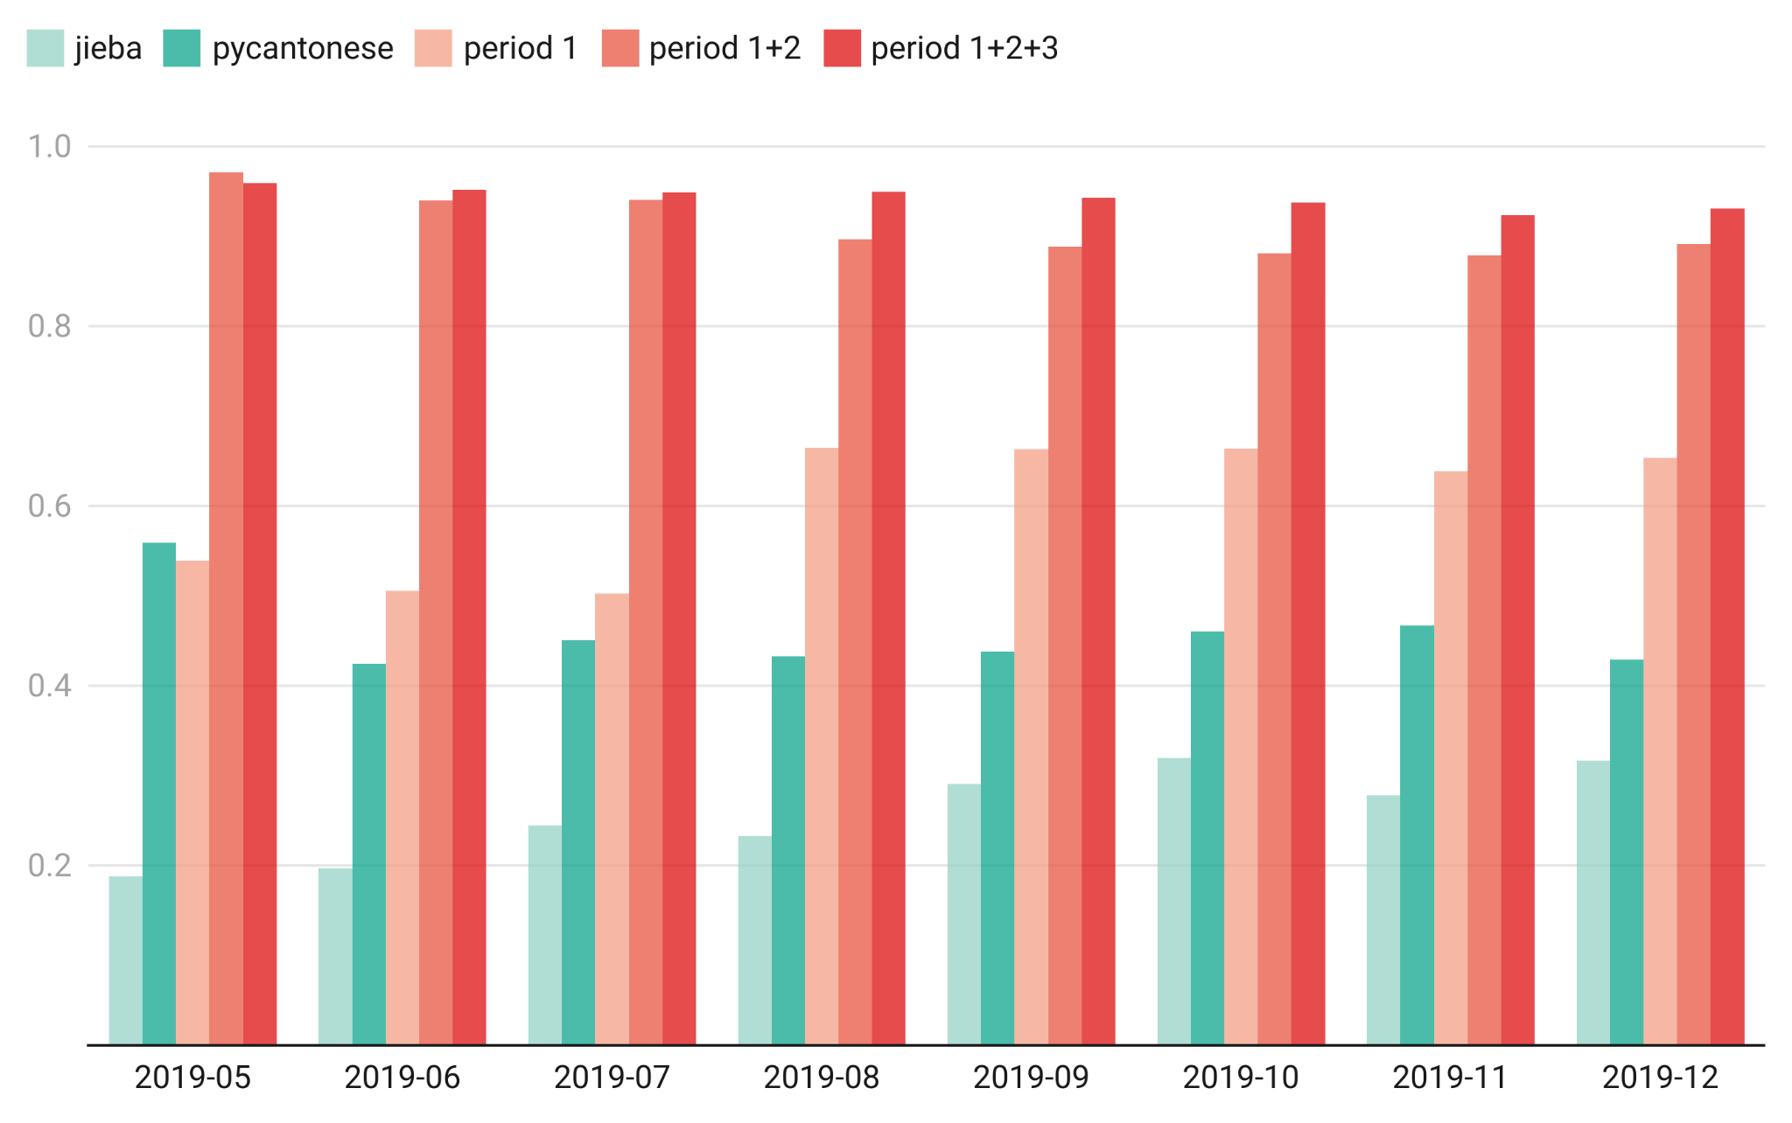

Figure S2
The average accuracy of domain-specific terms matching per month for entries in D₂ with Jieba, PyCantonese, and our proposed tokenizer trained with three sub-datasets.
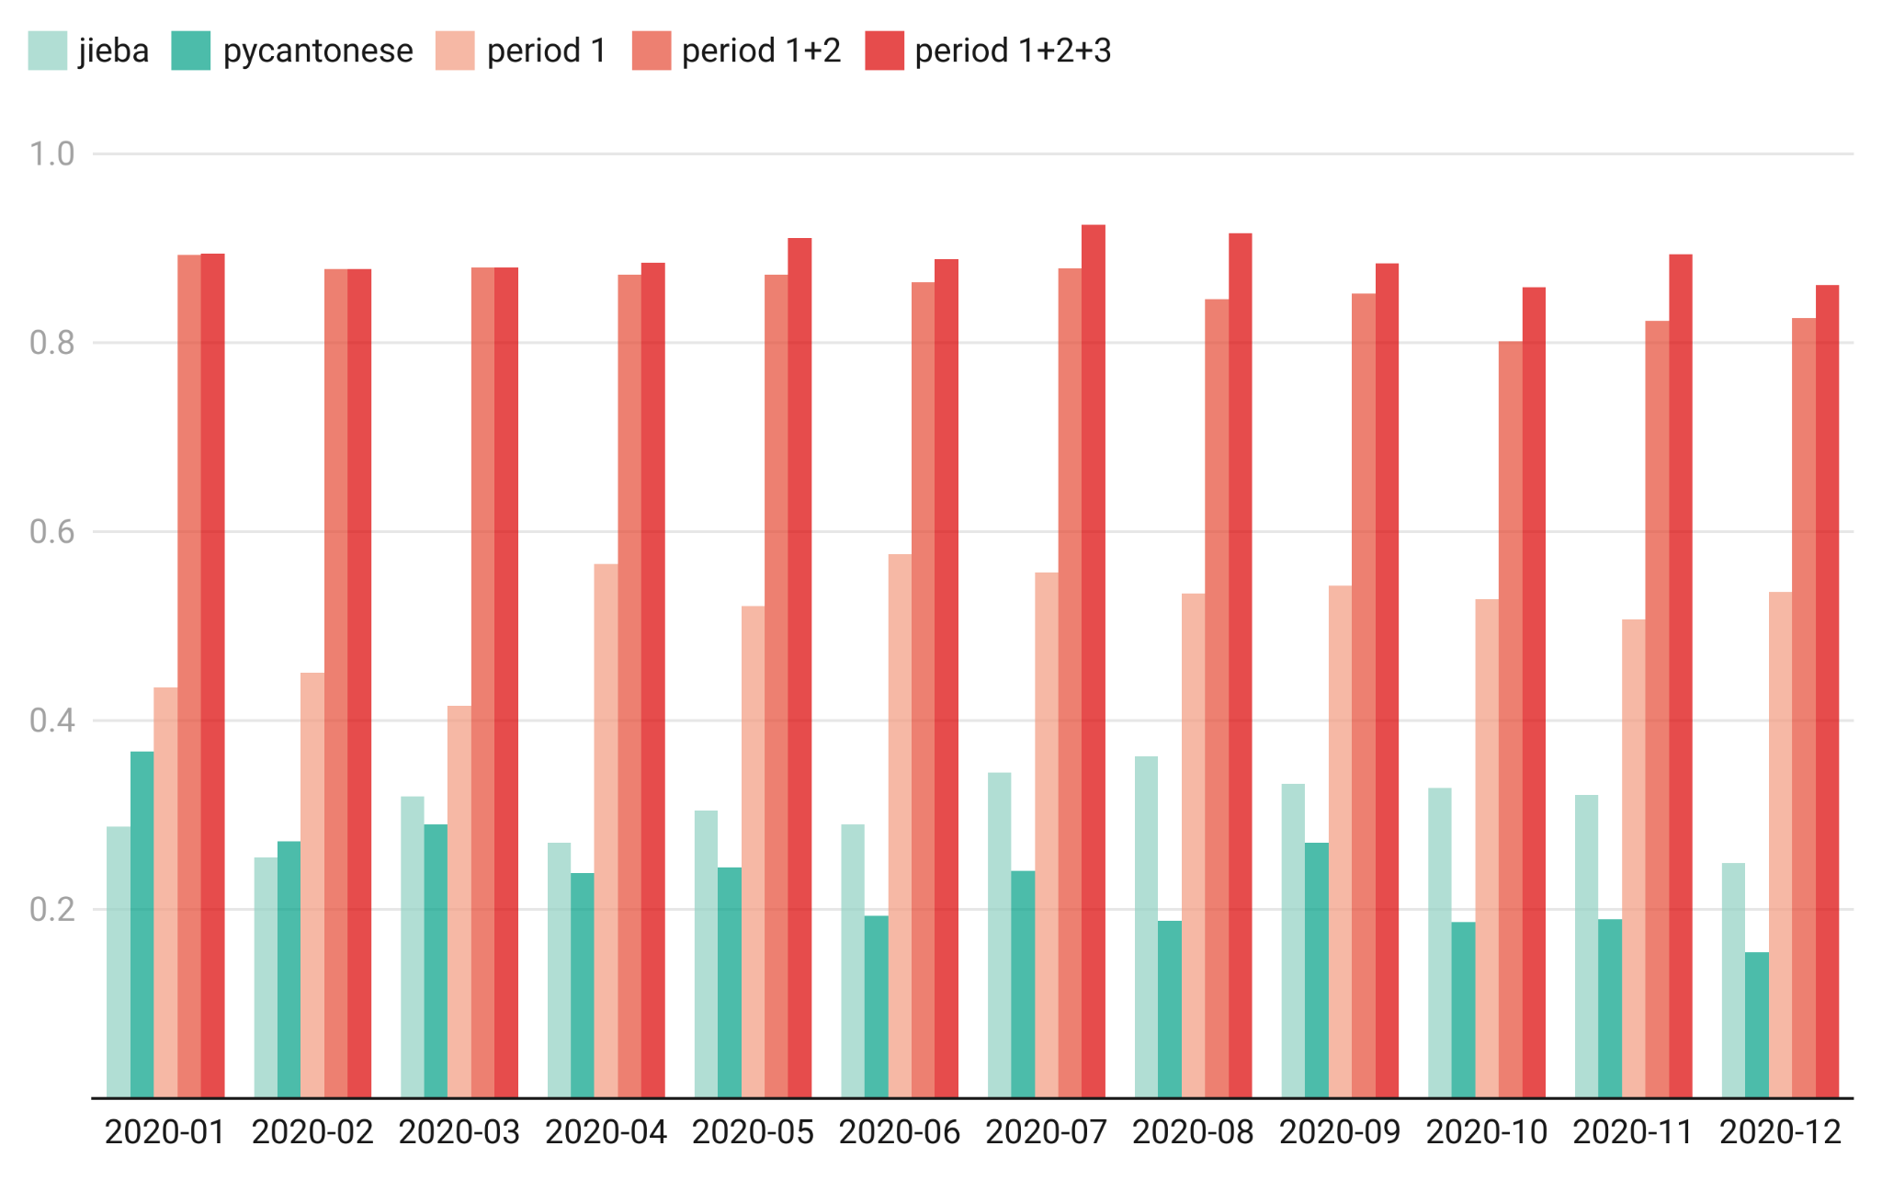

Figure S3
The average accuracy of personal name and place name matching per month for entries in D₁ with Jieba, PyCantonese, and our proposed tokenizer trained with three sub-datasets.
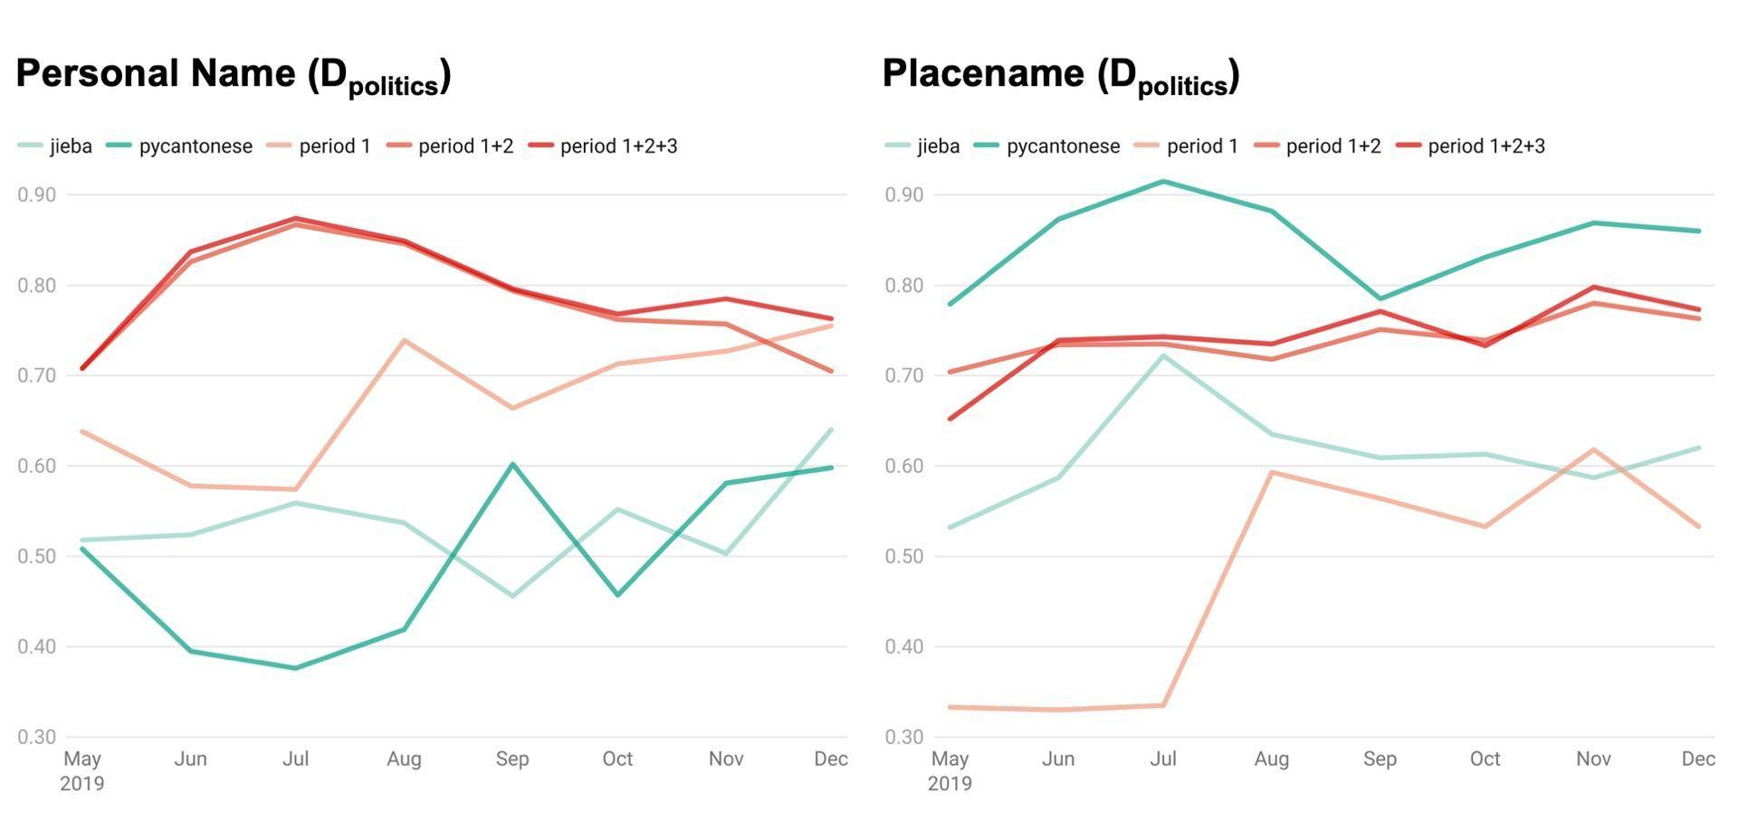

Figure S4
The average accuracy of personal name and place name matching per month for entries in D₂ with Jieba, PyCantonese, and our proposed tokenizer trained with three sub-datasets.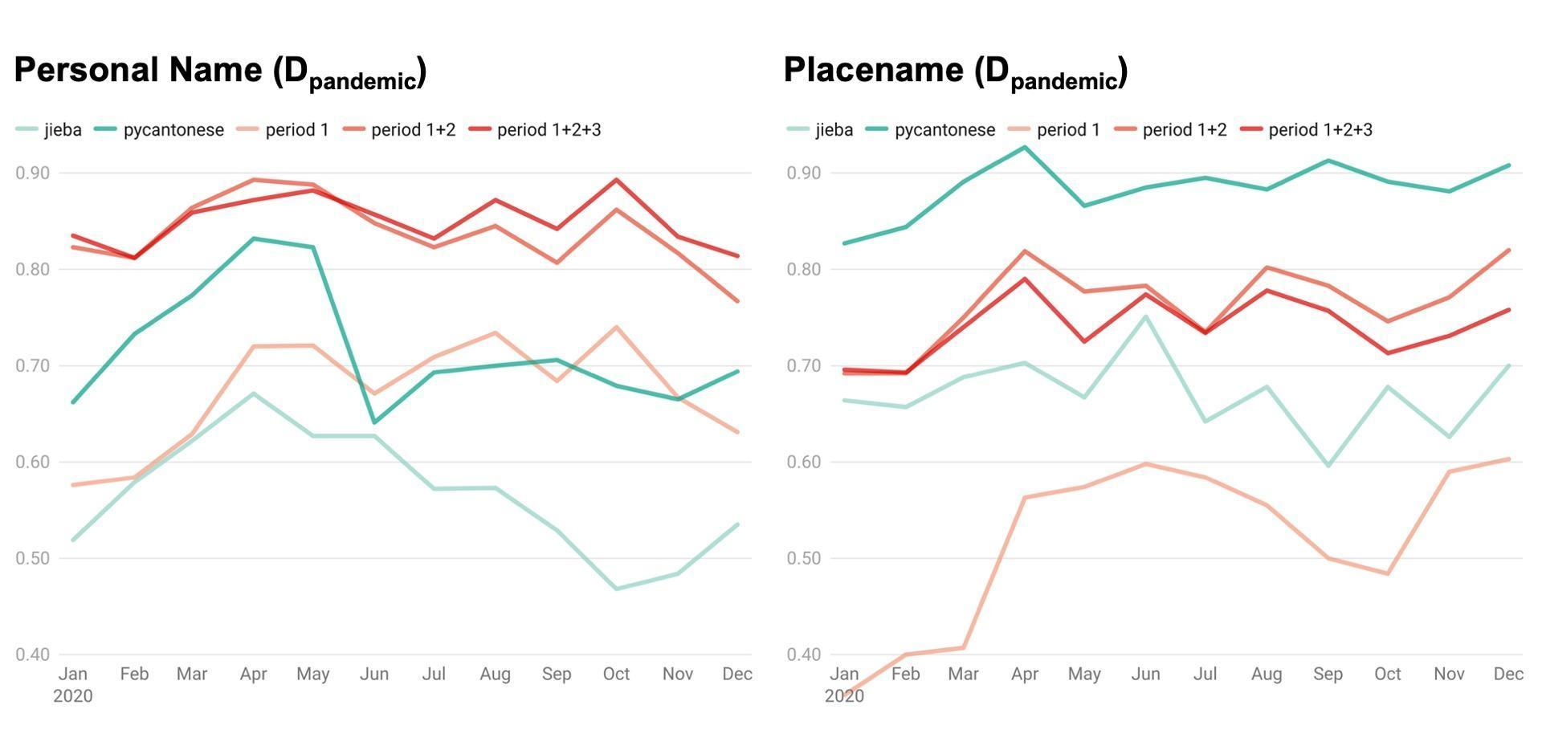

Supplementary Material 2: Word-Intrusion Evaluation of Tokenization Effects on Topic-Model Coherence

The word-intrusion paradigm (Chang et al., 2009) was used to test how segmentation quality shapes the interpretability of LDA topics extracted from LIHKG protest (D_{politics}) and pandemic (D_{pandemic}) corpora. The task is label-free, providing a direct measure of semantic coherence that is highly sensitive to tokenization errors.

Text preparation and topic modeling. After the cleaning pipeline described in Model Implementation, each corpus was tokenized in two ways—(i) the baseline Jieba tokenizer and (ii) the cumulative, period-aware tokenizer whose dictionary aggregates the period 1+2+3 vocabulary. The resulting streams were converted to bag-of-words matrices and modeled with Latent Dirichlet Allocation (Blei et al., 2003). The number of topics was fixed at k = 35, where held-out perplexity flattened and Cv coherence (Röder et al., 2015) peaked. Hyper-parameters (α = 50⁄k, β = 0.01) and random seeds were identical across runs; each of the four models (Jieba-politics, cumulative-politics, Jieba-pandemic, cumulative-pandemic) was trained for 3,000 collapsed-Gibbs iterations (1,000 burn-in).

Intrusion-set construction. For every one of the 35 topics in each model, we extracted the five highest-probability words. An intruder ωk was selected that appeared among the top ten words of at least one other topic but contributed ≤ 0.1 % probability to the current topic. The six-word list was shuffled so that position provided no cue. Evaluating every topic yielded 35 × 4 = 140 intrusion tests.

Human judgment and model precision. Eight Cantonese-English bilingual volunteers (four postgraduate linguistics students and four communication-science researchers) were recruited and compensated with retail vouchers. Each subject received a web interface that displayed one six-word list at a time and was instructed to click “the word that does not belong with the others.” Lists were presented in random order; no time limit was imposed, and the full session lasted about 25 minutes. Inter-annotator agreement on duplicated control items averaged κ = 0.71, indicating substantial consistency.
For each topic k we compute:
$$MPk = ∑s\frac{1\left(is,k = ωk\right)}{S}$$
where is,k is the word chosen by subject s, and S is the number of subjects.

Findings. Across all topics the cumulative tokenizer markedly increased precision. In the protest corpus mean precision rose from 0.44 with Jieba to 0.86 with the cumulative tokenizer; in the pandemic corpus it rose from 0.59 to 0.74. Figure S5 illustrates the distributions: in both domains the entire inter-quartile range of the cumulative tokenizer lies above the Jieba median, and the upper whisker is shorter, signaling fewer incoherent topics. A Wilcoxon signed-rank test on the 35 paired topics confirms significance (V_{politics} = 630, p < .001; V_{pandemic} = 466, p < .001).

Interpretation. Splitting multi-character expressions such as “逃犯條例” (Fugitive Offenders Ordinance/Extradition Bill) into “逃犯/條例” (fugitive/ordinance) dilutes topical signal and makes intruder detection harder. By continually absorbing high-frequency collocations, the cumulative tokenizer preserves such compounds and sharpens topic boundaries; human precision therefore rises. The larger gain in the protest corpus reflects its richer inventory of emergent slogans, whereas pandemic discourse, although still improved, contains fewer novel multi-word expressions and so shows a smaller but meaningful lift. These findings demonstrate that tokenization choices propagate directly to topic-model interpretability: an adaptive, period-aware tokenizer yields LDA topics that align far better with human semantic judgments.

Figure S5
The model precision distributions comparing Jieba and the proposed tokenizer across political and pandemic corpora.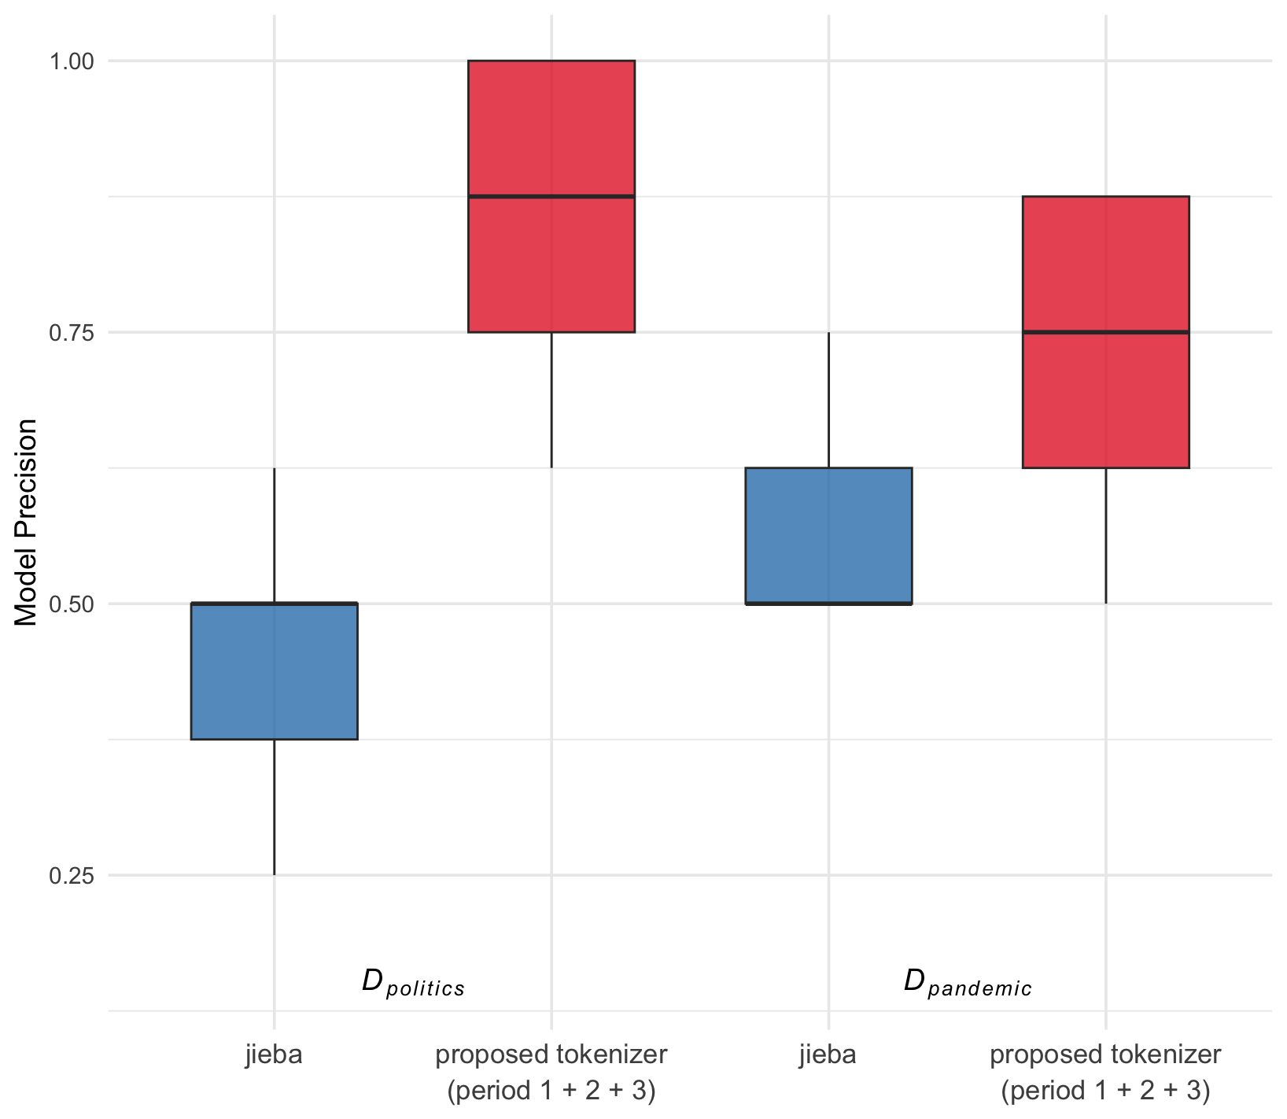

References
Blei, D. M., Ng, A. Y., & Jordan, M. I. (2003). Latent dirichlet allocation. The Journal of Machine Learning Research, 3, 993–1022.
Chang, J., Boyd-Graber, J., Gerrish, S., Wang, C., & Blei, D. (2009). Reading tea leaves: How humans interpret topic models. In Neural Information Processing Systems, 32, 296.
Röder, M., Both, A., & Hinneburg, A. (2015). Exploring the space of topic coherence measures. Proceedings of the Eighth ACM International Conference on Web Search and Data Mining, 399–408.

