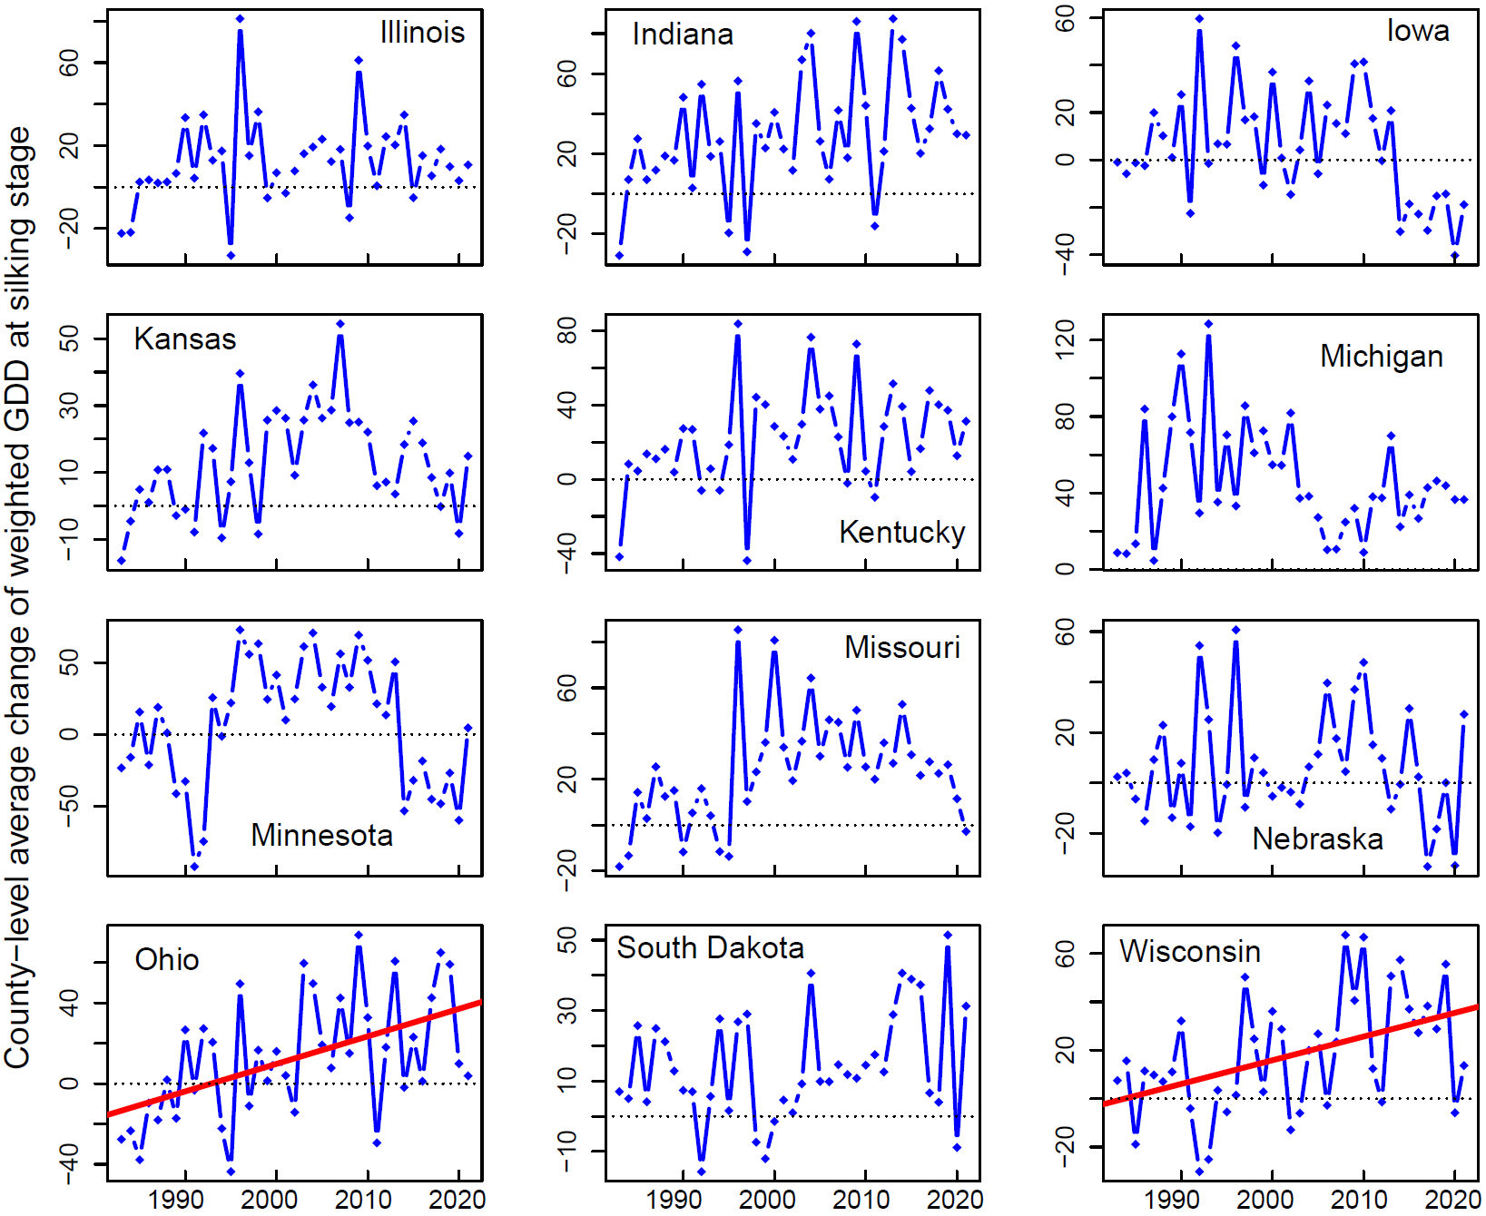
Figure S1. County-level average change in cumulative GDD at silking stage from 1983 to 2021 for each of the 12 states. The red lines represent significant temporal trends at p < 0.01 level.

Table S1. Summary of changes in cumulative GDD of silking stage. The values in the parentheses of the second and third columns are corresponding average of the changes.
State | Number of years with positive change in county-level average GDD | Number of years with negative change in county-level average GDD | Coefficient (R²) of temporal trend of GDD change (p-value < 0.01)
Illinois | 32 (18.1) | 7 (-15.0) | N/A
Indiana | 35 (35.6) | 4 (-23.8) | N/A
Iowa | 21 (21.9) | 18 (-14.2) | N/A
Kansas | 30 (19.1) | 9 (-6.5) | N/A
Kentucky | 33 (29.2) | 6 (-18.3) | N/A
Michigan | 39 (45.2) | 0 | N/A
Minnesota | 24 (35.8) | 15 (-39.0) | N/A
Missouri | 33 (29.8) | 6 (-11.9) | N/A
Nebraska | 23 (19.5) | 16 (-12.3) | N/A
Ohio | 26 (28.7) | 13 (-20.0) | 1.37 (0.24)
South Dakota | 34 (17.7) | 5 (-9.1) | N/A
Wisconsin | 29 (27.8) | 10 (-11.3) | 0.98 (0.19)

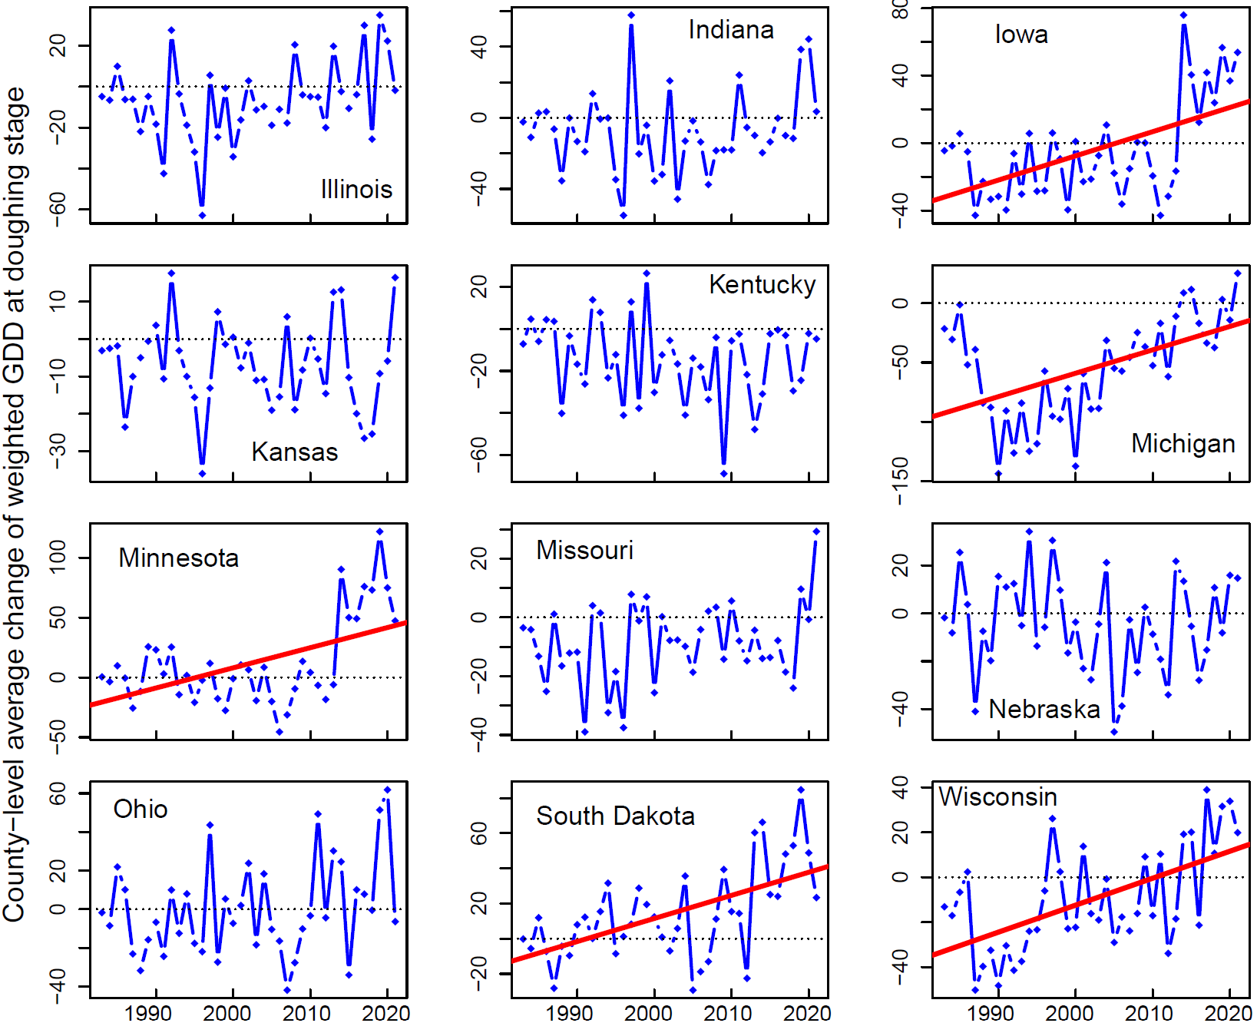
Figure S2. County-level average change in cumulative GDD at doughing stage from 1983 to 2021 for each of the 12 states. The red lines represent significant temporal trends at p < 0.01 level.

Table S2. Summary of changes in cumulative GDD of doughing stage. The values in the parentheses of the second and third columns are corresponding average of the changes.
State | Number of years with positive change in county-level average GDD | Number of years with negative change in county-level average GDD | Coefficient (R²) of temporal trend of GDD change (p-value < 0.01)
Illinois | 9 (19.2) | 30 (-15.1) | N/A
Indiana | 9 (23.2) | 30 (-16.9) | N/A
Iowa | 15 (24.8) | 24 (-23.1) | 1.43 (0.29)
Kansas | 9 (8.6) | 30 (-11.5) | N/A
Kentucky | 7 (10.4) | 32 (-19.8) | N/A
Michigan | 4 (12.1) | 35 (-62.8) | 1.97 (0.25)
Minnesota | 21 (34.6) | 18 (-15.7) | 1.68 (0.25)
Missouri | 11 (6.5) | 28 (-14.6) | N/A
Nebraska | 15 (16.2) | 24 (-17.2) | N/A
Ohio | 16 (23.7) | 23 (-16.2) | N/A
South Dakota | 27 (26.1) | 12 (-12.9) | 1.31 (0.31)
Wisconsin | 13 (18.4) | 26 (-24.1) | 1.20 (0.32)

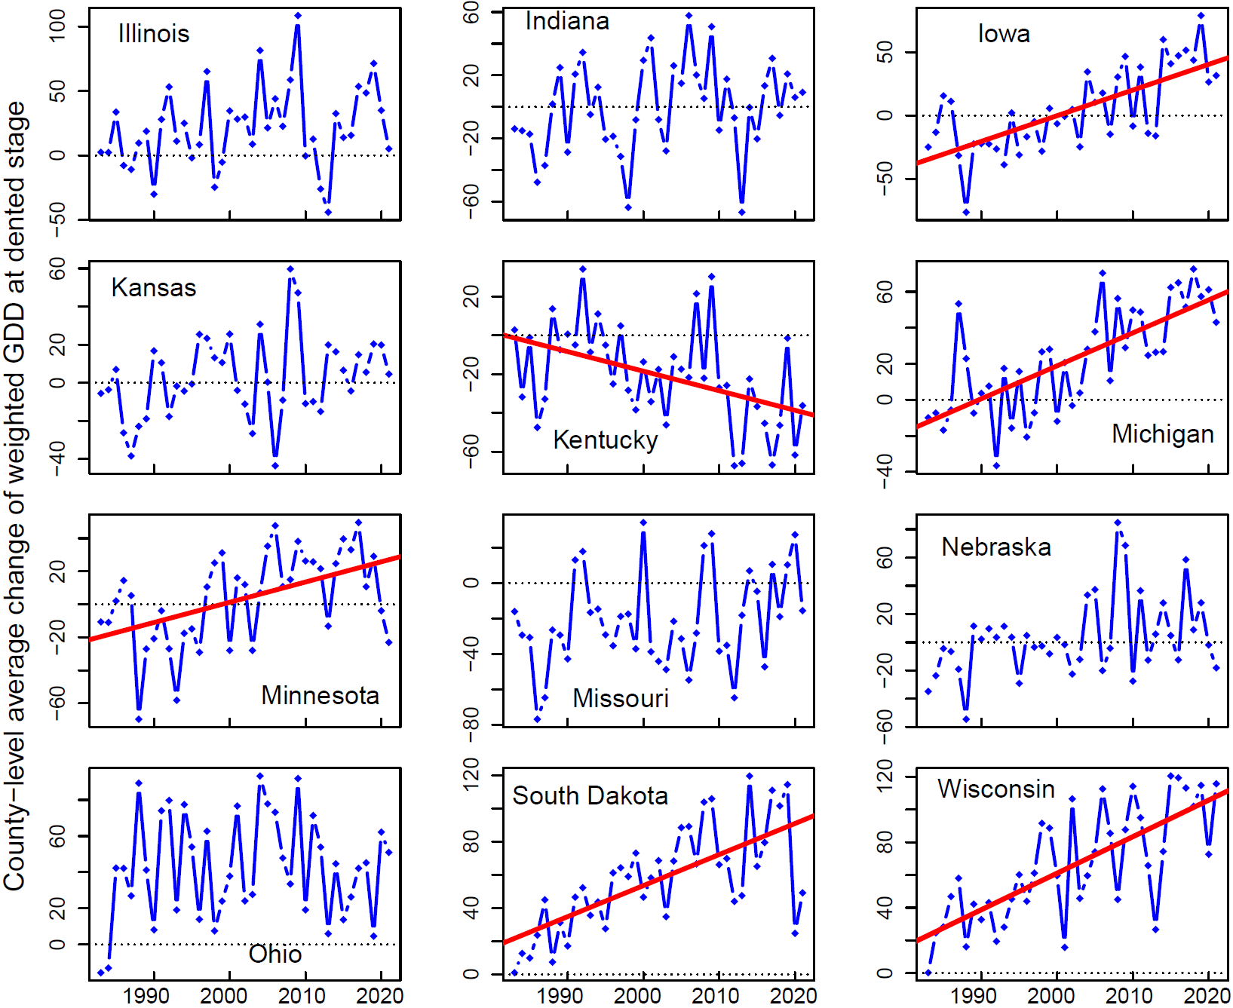
Figure S3. County-level average change in cumulative GDD at dented stage from 1983 to 2021 for each of the 12 states. The red lines represent significant temporal trends at p < 0.01 level.

Table S3. Summary of changes in cumulative GDD of dented stage. The values in the parentheses of the second and third columns are corresponding average of the changes.
State | Number of years with positive change in county-level average GDD | Number of years with negative change in county-level average GDD | Coefficient (R²) of temporal trend of GDD change (p-value < 0.01)
Illinois | 30 (32.8) | 9 (-16.8) | N/A
Indiana | 19 (23.2) | 20 (-22.8) | N/A
Iowa | 19 (31.6) | 20 (-22.2) | 2.03 (0.48)
Kansas | 20 (18.9) | 19 (-14.5) | N/A
Kentucky | 8 (14.9) | 31 (-29.6) | -1.01 (0.18)
Michigan | 28 (36.5) | 11 (-13.0) | 1.83 (0.50)
Minnesota | 23 (23.0) | 16 (-24.1) | 1.23 (0.23)
Missouri | 9 (18.8) | 30 (-33.2) | N/A
Nebraska | 19 (23.4) | 20 (-16.0) | N/A
Ohio | 37 (45.6) | 2 (-14.3) | N/A
South Dakota | 39 (57.2) | 0 | 1.87 (0.45)
Wisconsin | 39 (65.6) | 0 | 2.23 (0.53)

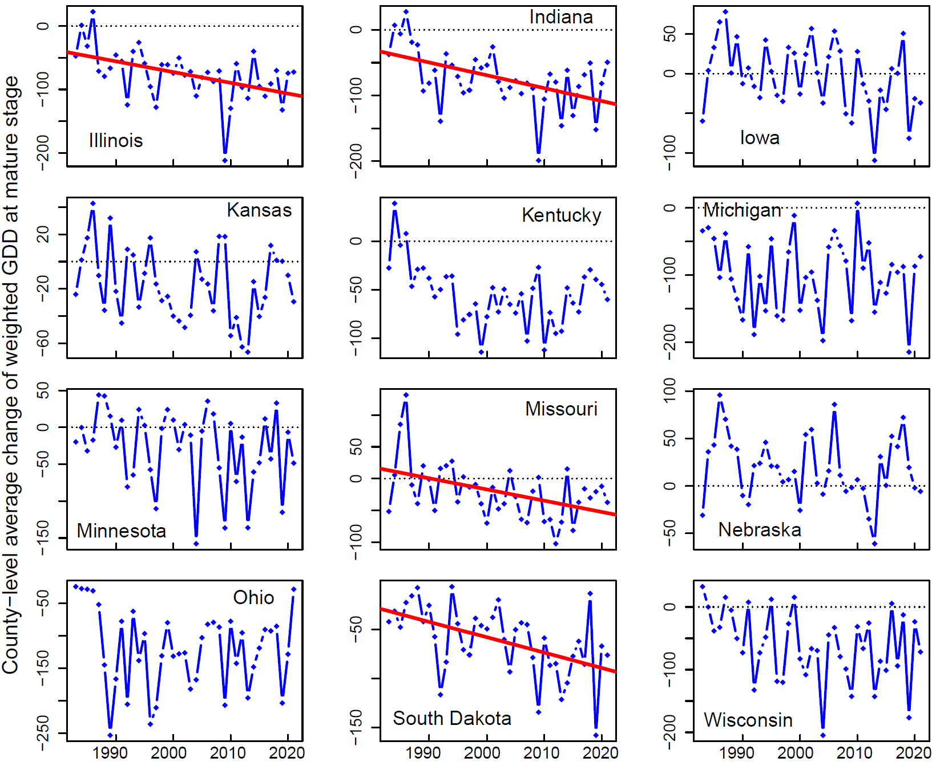
Figure S4. County-level average change in cumulative GDD at mature stage from 1983 to 2021 for each of the 12 states. The red lines represent significant temporal trends at p < 0.01 level.

Table S4. Summary of changes in cumulative GDD of mature stage. The values in the parentheses of the second and third columns are corresponding average of the changes.
State | Number of years with positive change in county-level average GDD | Number of years with negative change in county-level average GDD | Coefficient (R²) of temporal trend of GDD change (p-value < 0.01)
Illinois | 2 (12.0) | 37 (-80.6) | -1.70 (0.21)
Indiana | 2 (17.3) | 37 (-77.9) | -1.96 (0.23)
Iowa | 21 (29.0) | 18 (-40.6) | N/A
Kansas | 13 (14.0) | 26 (-32.0) | N/A
Kentucky | 2 (23.3) | 37 (-58.7) | N/A
Michigan | 1 (6.6) | 38 (-101.9) | N/A
Minnesota | 14 (20.0) | 25 (-54.0) | N/A
Missouri | 11 (30.8) | 28 (-40.7) | -1.77 (0.19)
Nebraska | 27 (34.7) | 12 (-17.4) | N/A
Ohio | 0 | 39 (-119.5) | N/A
South Dakota | 0 | 39 (-61.1) | -1.56 (0.24)
Wisconsin | 6 (14.7) | 33 (-75.2) | N/A

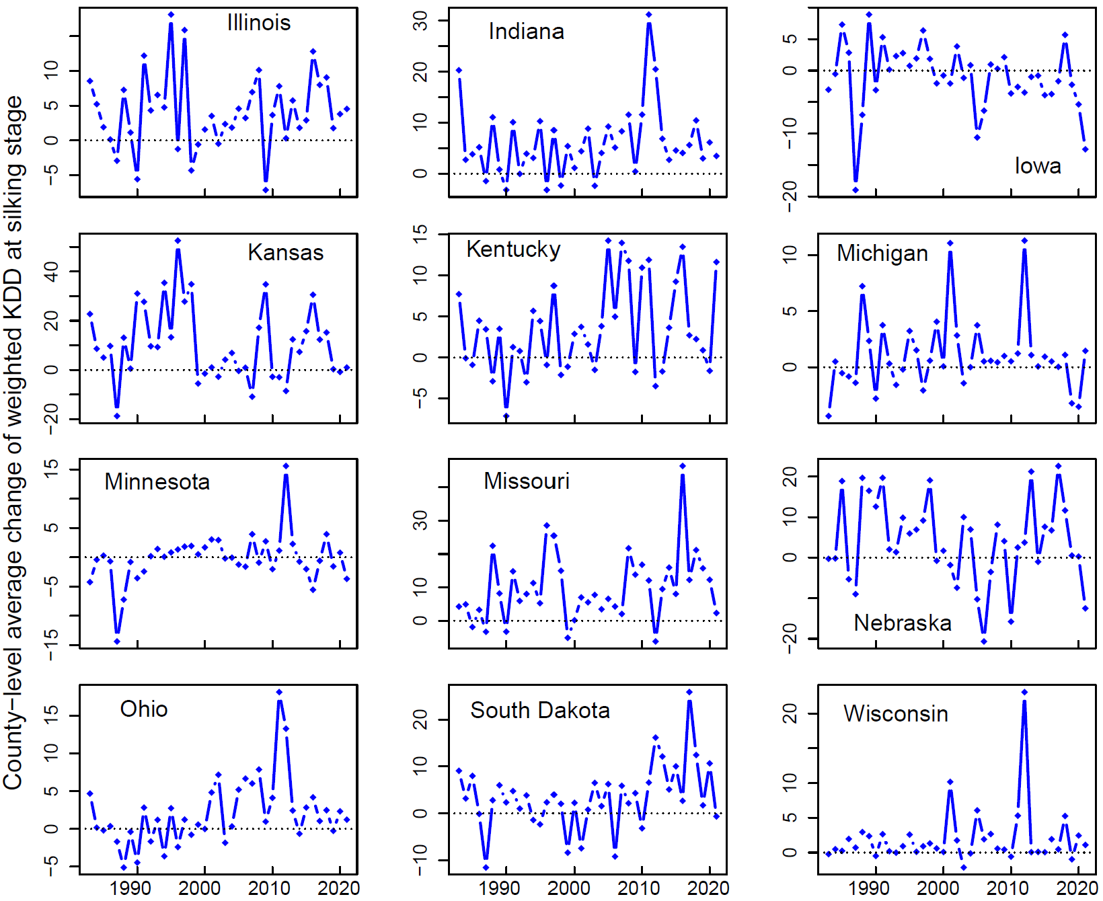
Figure S5. County-level average change in cumulative KDD at silking stage from 1983 to 2021 for each of the 12 states.

Table S5. Summary of changes in cumulative KDD of silking stage. The values in the parentheses of the second and third columns are corresponding average of the changes.
State | Number of years with positive change in county-level average KDD | Number of years with negative change in county-level average KDD | Coefficient (R²) of temporal trend of KDD change (p-value < 0.01)
Illinois | 32 (5.7) | 7 (-3.2) | N/A
Indiana | 33 (7.5) | 6 (-2.1) | N/A
Iowa | 17 (3.2) | 22 (-4.4) | N/A
Kansas | 29 (15.9) | 10 (-5.5) | N/A
Kentucky | 26 (6.3) | 13 (-2.2) | N/A
Michigan | 28 (2.2) | 11 (-2.0) | N/A
Minnesota | 19 (2.4) | 20 (-2.7) | N/A
Missouri | 34 (11.8) | 5 (-4.0) | N/A
Nebraska | 26 (9.6) | 13 (-6.8) | N/A
Ohio | 26 (4.0) | 13 (-1.8) | N/A
South Dakota | 30 (6.1) | 9 (-4.9) | N/A
Wisconsin | 32 (2.5) | 7 (-0.6) | N/A

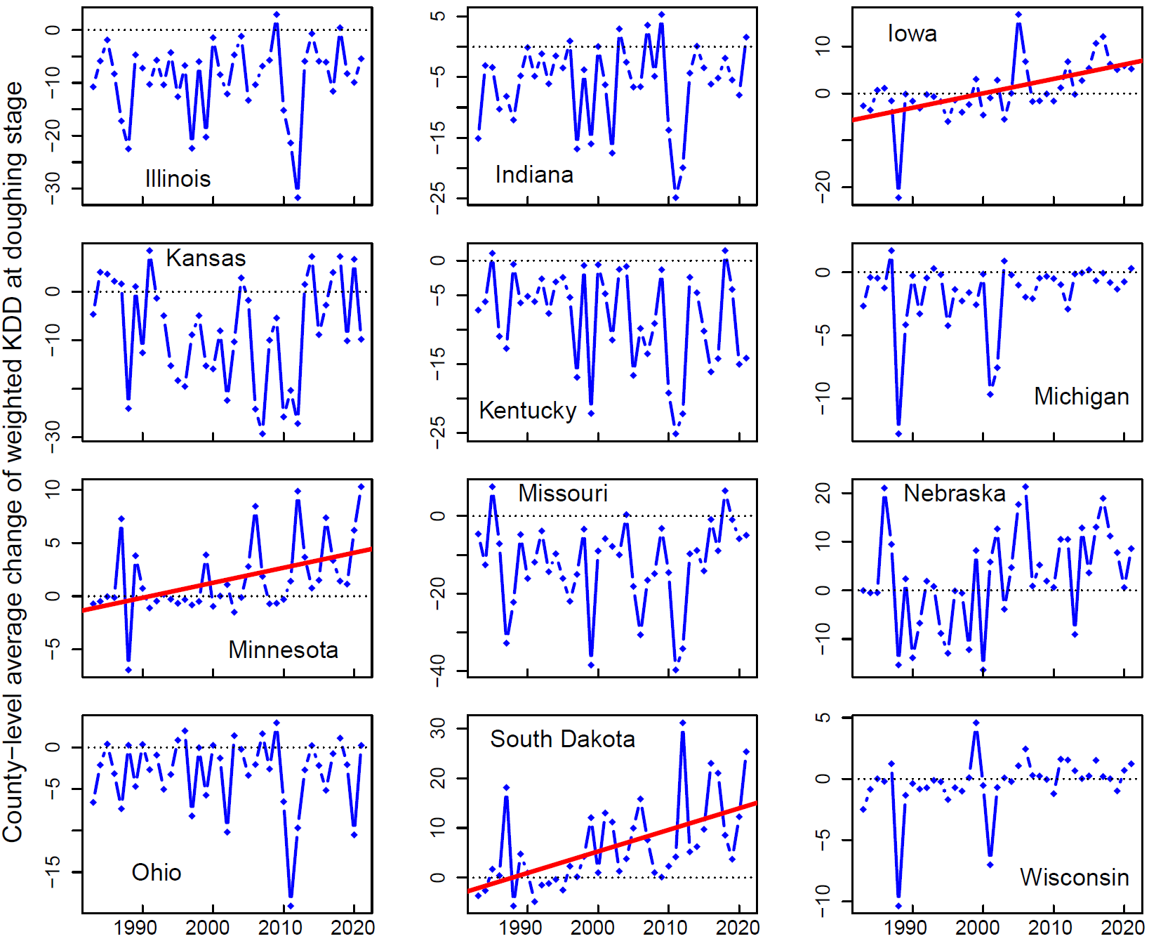
Figure S6. County-level average change in cumulative KDD at doughing stage from 1983 to 2021 for each of the 12 states. The red lines represent significant temporal trends at p < 0.01 level.

Table S6. Summary of changes in cumulative KDD of doughing stage. The values in the parentheses of the second and third columns are corresponding average of the changes.
State | Number of years with positive change in county-level average KDD | Number of years with negative change in county-level average KDD | Coefficient (R²) of temporal trend of KDD change (p-value < 0.01)
Illinois | 2 (1.7) | 37 (-9.8) | N/A
Indiana | 7 (2.1) | 32 (-7.8) | N/A
Iowa | 17 (5.5) | 22 (-3.1) | 0.31 (0.30)
Kansas | 12 (4.2) | 27 (-13.4) | N/A
Kentucky | 2 (1.3) | 37 (-9.0) | N/A
Michigan | 5 (0.7) | 34 (-2.0) | N/A
Minnesota | 21 (3.7) | 18 (-0.9) | 0.14 (0.19)
Missouri | 3 (4.8) | 36 (-13.7) | N/A
Nebraska | 25 (8.5) | 14 (-7.2) | N/A
Ohio | 12 (1.0) | 27 (-4.7) | N/A
South Dakota | 31 (8.4) | 8 (-2.8) | 0.43 (0.31)
Wisconsin | 19 (0.9) | 20 (-1.6) | N/A

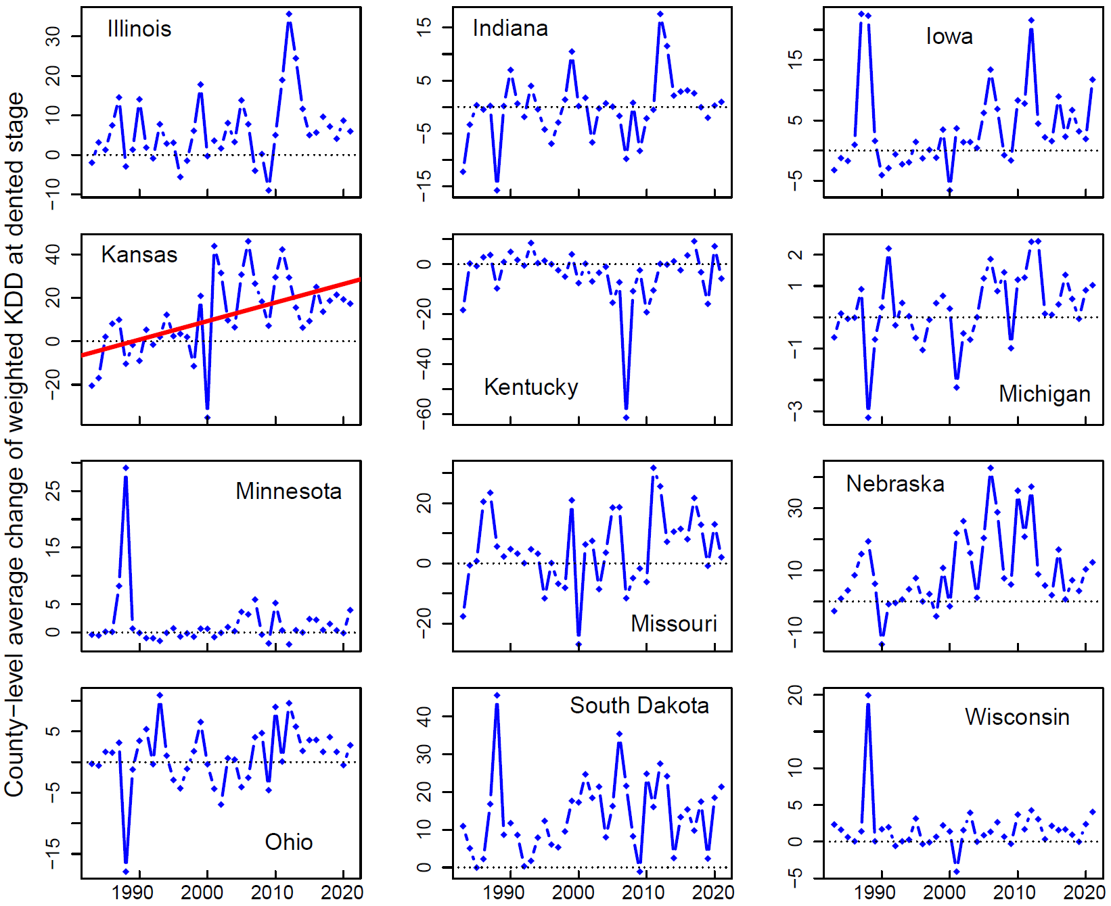
Figure S7. County-level average change in cumulative KDD at dented stage from 1983 to 2021 for each of the 12 states. The red line represents significant temporal trend at p < 0.01 level.

Table S7. Summary of changes in cumulative KDD of dented stage. The values in the parentheses of the second and third columns are corresponding average of the changes.
State | Number of years with positive change in county-level average KDD | Number of years with negative change in county-level average KDD | Coefficient (R²) of temporal trend of KDD change (p-value < 0.01)
Illinois | 31 (8.4) | 8 (-3.3) | N/A
Indiana | 21 (3.3) | 18 (-4.4) | N/A
Iowa | 26 (6.4) | 13 (-2.3) | N/A
Kansas | 31 (17.3) | 8 (-13.3) | 0.85 (0.29)
Kentucky | 17 (2.9) | 22 (-9.6) | N/A
Michigan | 25 (0.9) | 14 (-0.8) | N/A
Minnesota | 23 (3.1) | 16 (-0.7) | N/A
Missouri | 27 (10.7) | 12 (-8.8) | N/A
Nebraska | 32 (12.7) | 7 (-3.5) | N/A
Ohio | 24 (3.7) | 15 (-3.5) | N/A
South Dakota | 37 (14.5) | 2 (-0.6) | N/A
Wisconsin | 32 (2.3) | 7 (-0.8) | N/A

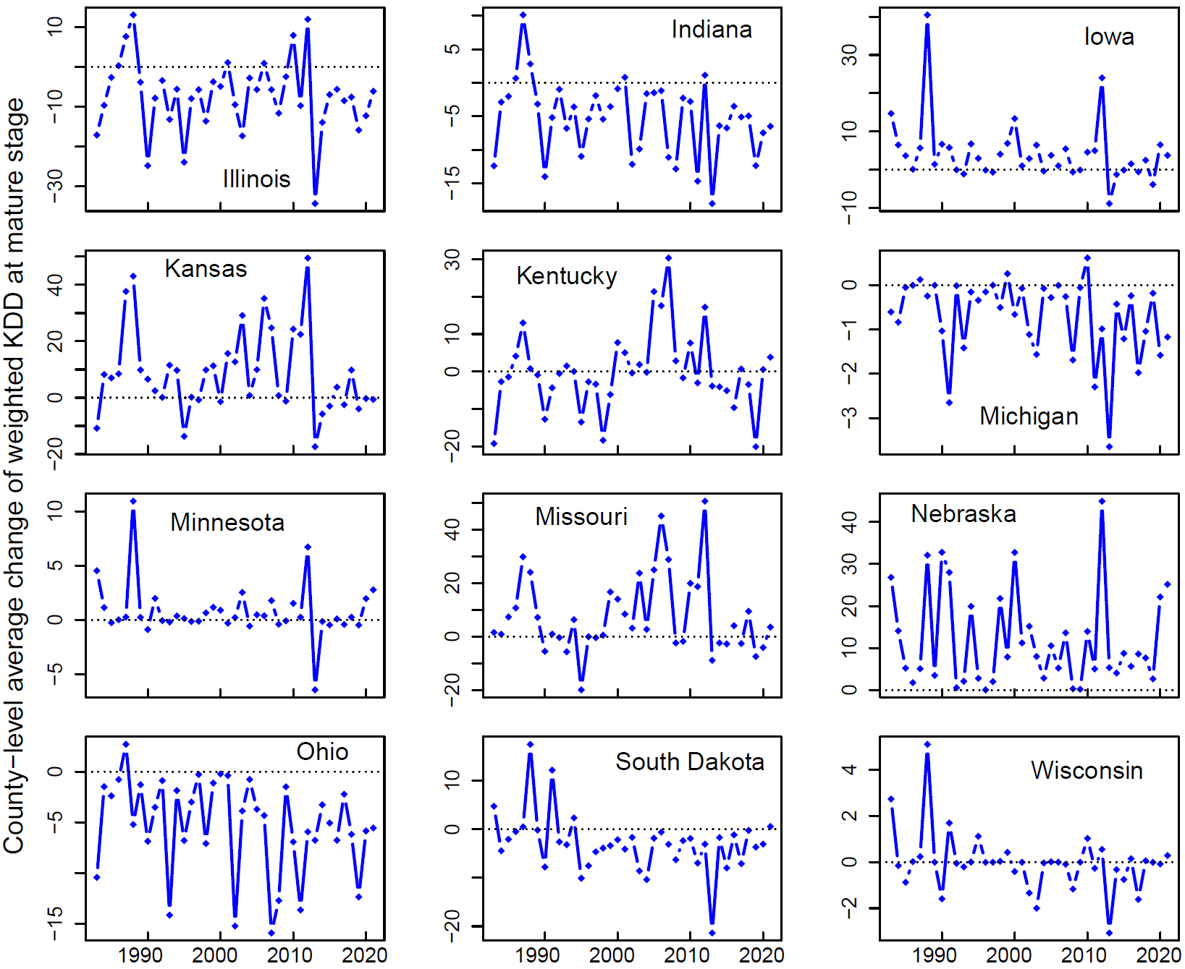
Figure S8. County-level average change in cumulative KDD at mature stage from 1983 to 2021 for each of the 12 states.

Table S8. Summary of changes in cumulative KDD of mature stage. The values in the parentheses of the second and third columns are corresponding average of the changes.
State | Number of years with positive change in county-level average KDD | Number of years with negative change in county-level average KDD | Coefficient (R²) of temporal trend of KDD change (p-value < 0.01)
Illinois | 7 (6.1) | 32 (-10.1) | N/A
Indiana | 5 (3.1) | 34 (-6.5) | N/A
Iowa | 27 (6.9) | 12 (-1.5) | N/A
Kansas | 27 (15.0) | 12 (-5.1) | N/A
Kentucky | 17 (8.0) | 22 (-6.3) | N/A
Michigan | 3 (0.3) | 36 (-0.8) | N/A
Minnesota | 24 (1.7) | 15 (-0.7) | N/A
Missouri | 25 (14.6) | 14 (-4.6) | N/A
Nebraska | 39 (11.8) | 0 | N/A
Ohio | 1 (2.7) | 38 (-5.4) | N/A
South Dakota | 6 (6.3) | 33 (-4.5) | N/A
Wisconsin | 15 (0.9) | 24 (-0.6) | N/A

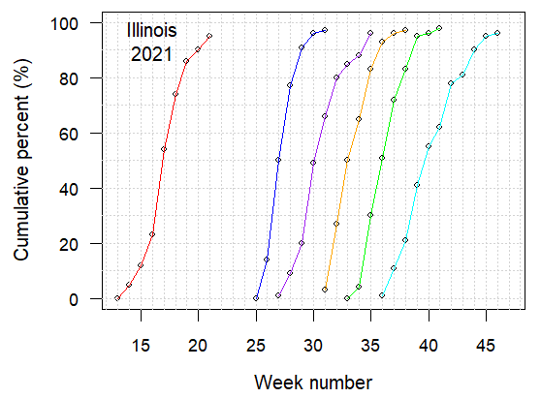 | 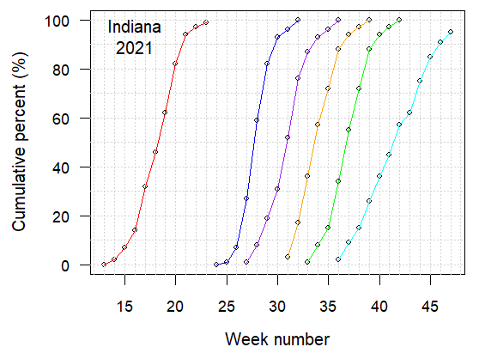
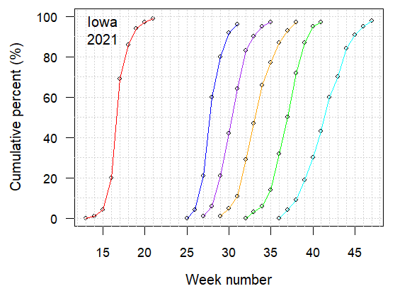 | 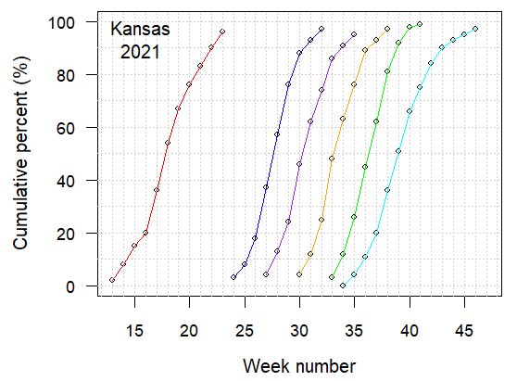
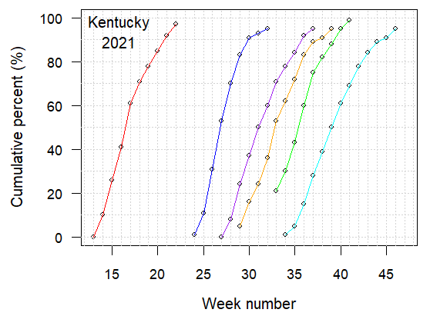 | 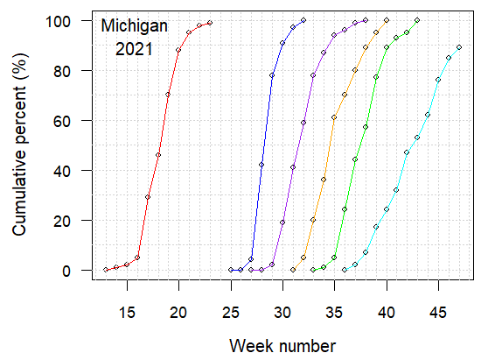
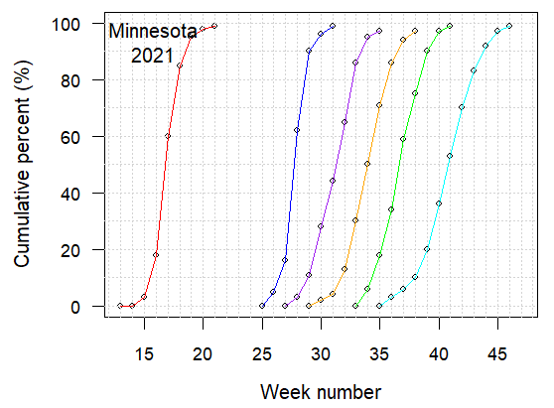 | 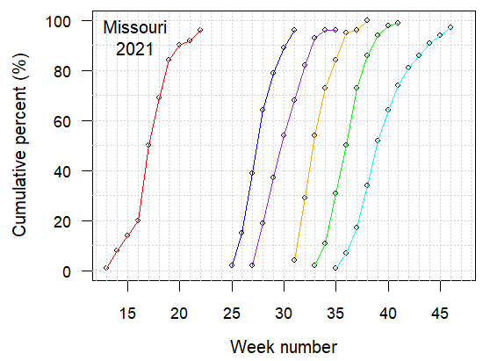
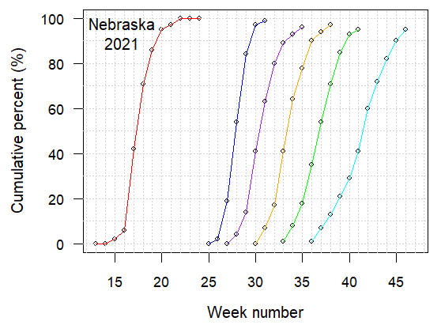 | 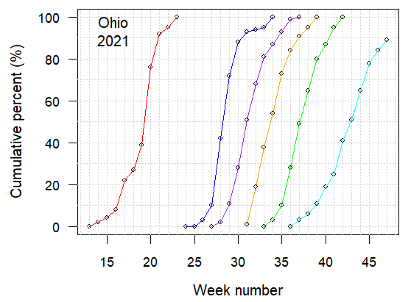
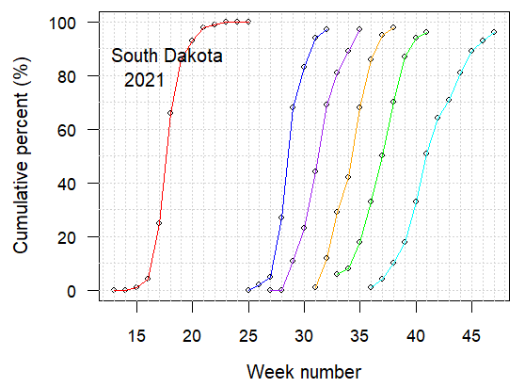 | 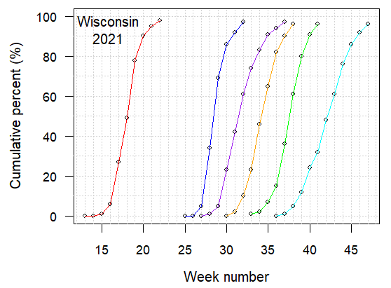
Figure S9. Corn development data of each state in the year 2021. The six curves (from left to right) represent the six growing stages of planted, silking, doughing, dented, mature, and harvested.
Table S9. Number of counties with full record of corn yield for the study period 1982-2021 in each state.
State | Number of counties with full record of corn yield for the period 1982-2021
Illinois | 44
Indiana | 38
Iowa | 65
Kansas | 7
Kentucky | 25
Michigan | 22
Minnesota | 41
Missouri | 8
Nebraska | 37
Ohio | 43
South Dakota | 11
Wisconsin | 41

