Detailed RT and Accuracy Analysis
This section reports the results of linear mixed model analyses of the logarithm of RT assuming Gaussian error and of accuracy assuming binomial error with a probit link function. Note that these analyses operate on individual trial data, which results in greater power than methods that average over trials, and also large degrees of freedom. As expected for Experiment 1, accuracy was significantly less for speed (70.5%) than accuracy (77.4%) instructions, χ²(1) = 79.4, p < .001, and RT was significantly faster (0.54s vs. 0.76s), F(1,11088) = 4203, p < .001. The same was true for Experiment 2 for both accuracy (65% vs. 72.5%), χ²(1) = 163, p < .001, and RT (0.66s vs. 0.85s), F(1,23377) = 4465, p < .001. The relative speed of correct and error responses was also affected as expected. The interaction between instructions and response accuracy was significant in Experiment 1, with errors 0.02s faster than corrects under speed emphasis and 0.033s slower under accuracy emphasis, F(1,11084) = 47.7, p < .001. Again the same was true for Experiment 2, with errors 0.058s faster under speed-emphasis and 0.011s slower under accuracy-emphasis, F(1,23372) = 83.6, p < .001.

In terms of Experiment 1 post-error effects, there was a significant interaction in RT between response instructions and last trial (i.e., correct vs. error), with 0.018s post- error slowing under speed emphasis and 0.18s post-error speeding under accuracy emphasis, F(1,11080) = 27.4, p < .001. The same was true for Experiment 2, but with 0.014s slowing and 0.048s speeding, F(1,23269) = 164, p < .001. In terms of accuracy, for Experiment 1 neither the effect of last trial nor its interaction with instructions approached significance. For Experiment 2 accuracy was significantly lower after an error (67.3%) than after a correct (69.2%) response, χ²(1) = 10, p = .002, but the interaction with speed versus accuracy emphasis was not, χ²(1) = .09, p = .77.

Finally, we examined the effect of last-response confidence in Experiment 2. Responses were slower when the last trial received a low-confidence rating (0.771s vs. 0.757s), F(1,23373) = 10.7, p = .001, and this effect interacted with instructions, being negligible for speed emphasis but 0.021s under accuracy emphasis, F(1,2356) = 17.1, p < .001. Differences between correct and error speed were also larger after a low than high confidence response, F(1,23354) = 6.15, p = .01. However, no interactions of last trial accuracy with last-trial confidence were significant in mean RT. Although the main effect of last confidence rating on accuracy did not achieve significance, it did interact significantly with post error/correct and instructions, although only just, χ²(1) = 4.2, p = .04. Under speed emphasis, accuracy was 4.2% higher after a correct high confidence response than after a correct low confidence response whereas the difference was reversed by 0.5% after an error. Under accuracy emphasis there was little difference in either case (respectively 1.3% and 1.9% favouring post-correct).

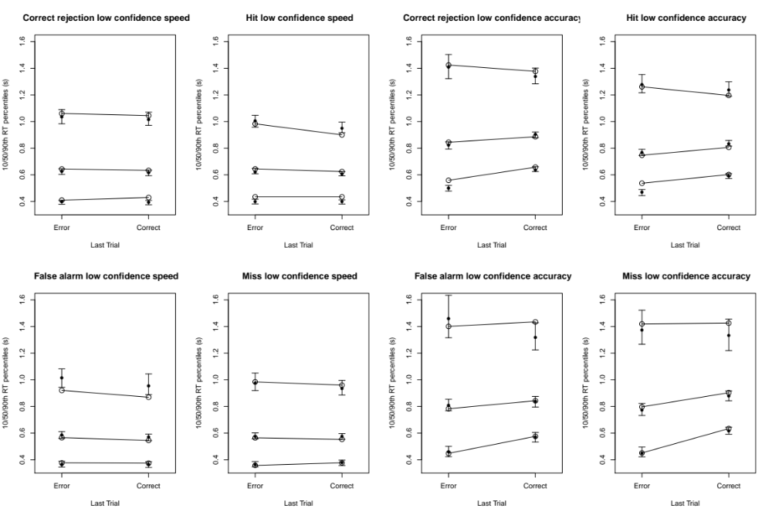
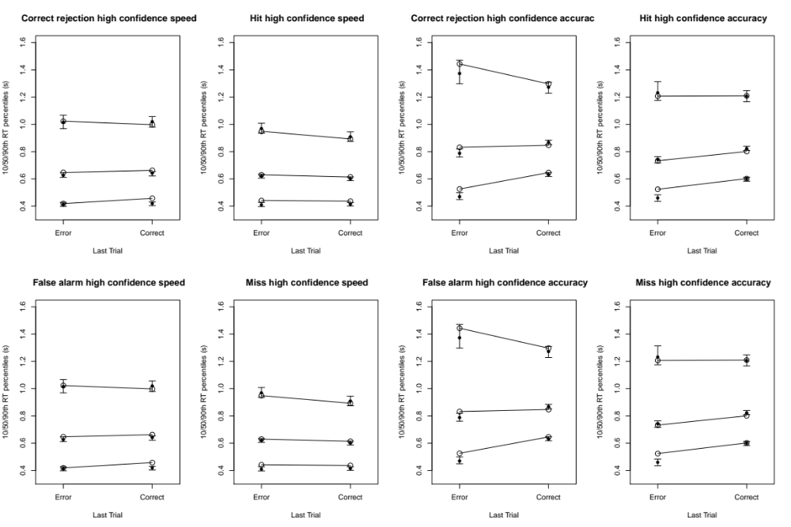

Figure S1. LBA confidence model fits to RT distribution in Experiment 2 for new and old test items, speed vs. accuracy instructions and last-trial confidence (panels) and by last trial accuracy (x-axis). Observed values are given by large circles and joined by lines. Fits are indicated by solid points (posterior medians) with 95% credible intervals.

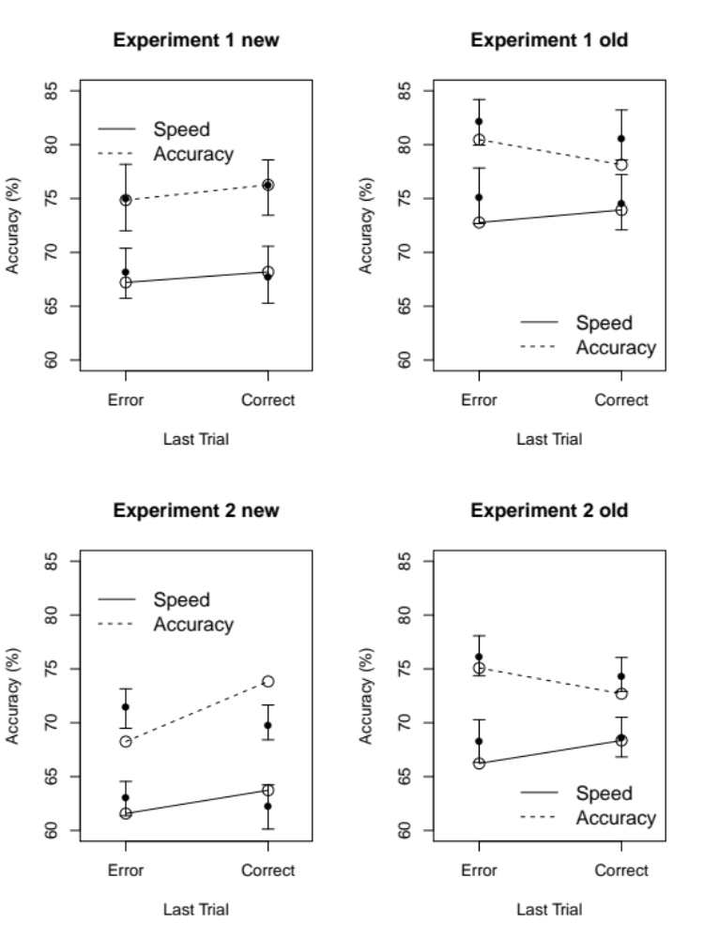

Figure S2. DDM fits to accuracy for new and old stimuli in Experiments 1 and 2 (panels) and speed vs. accuracy instructions (lines). Observed values are given by large circles and joined by lines. Fits are indicated by solid points (posterior medians) with 95% credible intervals.

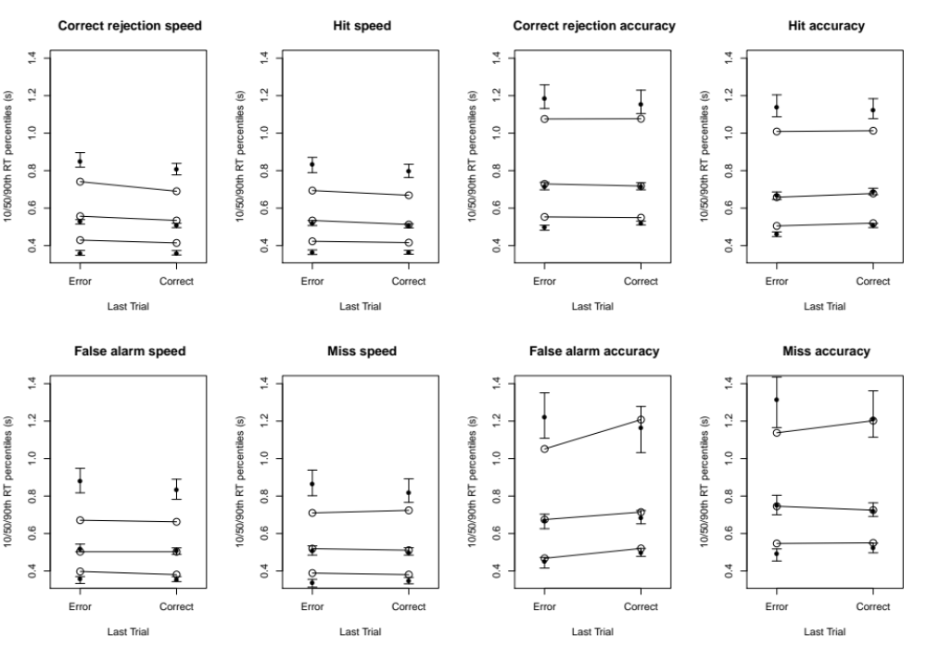
(a)
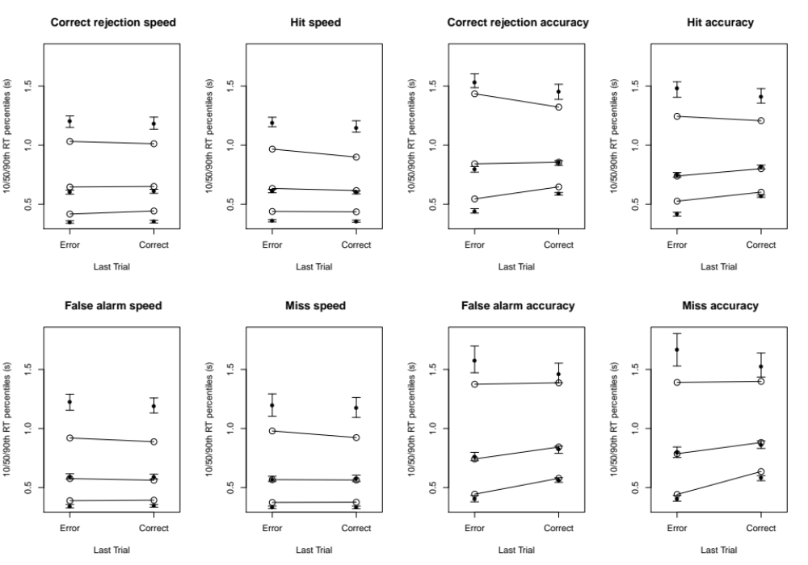
(b)
Figure S3. DDM fits to RT distribution fits to RT distribution represented by 10th, 50th and 90th percentiles (a) Experiment 1, (b) Experiment 2 broken down by responses to new items (correct rejections and false alarms) and old items (hits and misses) and speed vs. accuracy instructions (panels). Observed values are given by large circles and joined by lines. Fits are indicated by solid points (posterior medians) with 95% credible intervals.

Table S1. Experiment 2 speed and accuracy emphasis condition post-correct minus post-error RT (milliseconds) posterior predictive means for the full model (M), versions of the full model with effects removed by averaging over post-correct and post-error values leaving only the effect(s) of: non-decision time (N), threshold (T)mean rate (R), rate quality (Ql), rate quantity (Qn), mean rate and non-decision time (RN), threshold and non-decision time (TN) and threshold and mean rate (TR).

 | M | N | T | R | Ql | Qn | RN | TN | TR
Speed | -16 | -7 | 34 | -65 | -4 | -62 | -72 | 26 | -9
Accuracy | 35 | 55 | 181 | -336 | -2 | -337 | -277 | 239 | -24

Table S2. Experiment 2 speed and accuracy emphasis condition post-correct minus post-error accuracy (%)posterior predictive means for the full model (M), versions of the full model with effects removed by averaging over post-correct and post-error values leaving only the effect(s) of: non-decision time (N), threshold (T), mean rate (R), rate quality (Ql), rate quantity (Qn), mean rate and non-decision time (RN), threshold and non-decision time (TN) and threshold and mean rate (TR).

 | M | N | T | R | Ql | Qn | RN | TN | TR
Speed | 2.1 | -0.2 | 0.2 | 2.4 | 1.9 | 0.5 | 2.4 | -0.2 | 2.0
Accuracy | 2.9 | 0.2 | 1.2 | 2.2 | -0.6 | 3.1 | 2.3 | 1.2 | 3.0

Table S3. Experiment 2 speed and accuracy emphasis condition post-correct minus post-error RT (milliseconds) after a low confidence response posterior predictive means for the full model (M), versions of the full model with effects removed by averaging over post-correct and post-error values leaving only the effect(s) of: non-decision time (N), threshold (T), mean rate (R), rate quality (Ql), and rate quantity (Qn.

 | M | T | R | Ql | Qn
Speed | -20 | -2 | -42 | -12 | -47
Accuracy | 32 | 272 | -415 | -23 | -418

Table S4. Experiment 2 speed and accuracy emphasis condition post-correct minus post-error RT (milliseconds) after a high confidence response posterior predictive means for the full model (M), versions of the full model with effects removed by averaging over post-correct and post-error values leaving only the effect(s) of: non-decision time (N), threshold (T), mean rate (R), rate quality (Ql), and rate quantity (Qn.

 | M | T | R | Ql | Qn
Speed | -9 | 30 | -51 | 0 | -42
Accuracy | 39 | 310 | -458 | 26 | -487

Table S5. Experiment 2 speed and accuracy emphasis condition post-correct minus post-error accuracy (%) after a low confidence response posterior predictive means for the full model (M), versions of the full model with effects removed by averaging over post-correct and post-error values leaving only the effect(s) of: non-decision time (N), threshold (T), mean rate (R), rate quality (Ql), and rate quantity (Qn).

 | M | T | R | Ql | Qn
Speed | -0.7 | -0.8 | -0.4 | -0.7 | -0.6
Accuracy | 2.0 | 1.7 | 1.6 | -0.5 | 2.5

Table S6. Experiment 2 speed and accuracy emphasis condition post-correct minus post-error accuracy (%) after a low confidence response posterior predictive means for the full model (M), versions of the full model with effects removed by averaging over post-correct and post-error values leaving only the effect(s) of: non-decision time (N), threshold (T), mean rate (R), rate quality (Ql), and rate quantity (Qn).

 | M | T | R | Ql | Qn
Speed | 3.8 | 0.5 | 3.7 | 3.8 | 0.9
Accuracy | 3.3 | 1.6 | 2.8 | -0.5 | 3.5

Model and parameter recovery
We simulated data with the same design as the experiment based on the posterior median parameters for the selected LBA and DDM models (see “makeSimData.R” scripts in the LBAdata, LBAcdata and DDMdata subdirectories of the ModelRecovery directory on the OSF site) then fit that data with all variants of both the DDM and LBA using the same hierarchical methods as in our analysis of the experimental data (for the LBA see scripts in the LBAfit and DDMfit subdirectories of the LBAdata subdirectory, for the DDM see scripts in the LBAfit and DDMfit subdirectories of the DDMdata subdirectory, and for the LBAc see scripts in the LBAcfit subdirectory) . Table S5 shows fits of the LBA model to data simulated from the LBA select the correct model for both experiments. Table S6 shows fits of the DDM model to data simulated from the DDM select the correct model for both experiments. Tables S7 and S8 show results of miss-specified-model fits. Table S7 shows that fits of the DDM to data simulated from the LBA select the correct model variants. Table S8 shows that fits of the LBA to data simulated from the DDM select the incorrect variants.

Table S5. LBA fit DIC model selection results (smaller values preferred), where the minimum value is subtracted from every value, so a 0 entry indicates the selected model. Fits were to data simulated from the posterior median parameters of the winning LBA model (Experiment 1 = N, Experiment 2 = TRN). For model variants an effect of last trial on threshold is indicated by a T, mean rate by an R and non-decision time by an N.

Experiment | T | TN | TR | TRN | N | R | RN
1 | 69 | 77 | 253 | 227 | 0 | 252 | 202
2 | 398 | 122 | 36 | 0 | 306 | 1158 | 133

Table S6. DDM fit DIC model selection results (smaller values preferred), where the minimum value is subtracted from every value, so a 0 entry indicates the selected model. Fits were to data simulated from the posterior median parameters of the winning DM model (TN). For model variants an effect of last trial on threshold is indicated by a T, mean rate by an R and non-decision time by an N.

Experiment | T | TN | TR | TRN | N | R | RN
1 | 1055 | 0 | 130 | 102 | 166 | 1280 | 219
2 | 2439 | 0 | 2560 | 215 | 393 | 2906 | 486

Table S7. DDM fit DIC model selection results (smaller values preferred), where the minimum value is subtracted from every value, so a 0 entry indicates the selected model. Fits were to data simulated from the posterior median parameters of the winning LBA model (Experiment 1 = N, Experiment 2 = TRN). For model variants an effect of last trial on threshold is indicated by a T, mean rate by an R and non-decision time by an N.

Experiment | T | TN | TR | TRN | N | R | RN
1 | 693 | 56 | 790 | 145 | 0 | 870 | 99
2 | 2166 | 35 | 2144 | 0 | 254 | 2645 | 175

Table S8. LBA fit DIC model selection results (smaller values preferred), where the minimum value is subtracted from every value, so a 0 entry indicates the selected model. Fits were to data simulated from the posterior median parameters of the winning DDM model (TN). For model variants an effect of last trial on threshold is indicated by a T, mean rate by an R and non-decision time by an N.

Experiment | T | TN | TR | TRN | N | R | RN
1 | 458 | 38 | 414 | 27 | 97 | 1070 | 0
2 | 1107 | 27 | 493 | 0 | 297 | 2191 | 99

Table S9. LBA fit DIC model selection results (smaller values preferred), where the minimum value is subtracted from every value, so a 0 entry indicates the selected model. Fits were to data simulated from the posterior median parameters of the winning (TR) LBA model for data from Experiment 2 broken down by last-trial confidence. For model variants an effect of last trial on threshold is indicated by a T, mean rate by an R and non-decision time by an N.

TR | TRN | TN | RN | T | N | R
0 | 35 | 210 | 293 | 428 | 702 | 1360

Using the results from Figure S4 shows recovery results (posterior median parameters for each participant) for the six types of LBA parameters for fits of the selected LBA-model variant to data generated from that variant for Experiment 1. Recovery is largely unbiased (i.e., parameters occur equally often above and below the identity line) and are linearly related and fairly precisely related to true values (i.e., true vs. recovered correlations are generally high). Figure S4 shows the analogous results for Experiment 2. There is more evidence of bias, with overestimation of start-point noise and rate parameters and underestimation of thresholds for lower values, and overestimation for higher values but correlations are high in all cases. Figures S6 and S7 show analogous results for the DDM. In Experiment 1 the recovery of start-point noise is very poor and there was strong shrinkage of the rate standard deviation estimates (i.e., they cluster around the group mean) but recovery of the other parameters is very good. The same pattern is evident for Experiment 2 except that rate standard deviation recovery is somewhat improved. Figure S8 shows results for the fits selected LBA model to Experiment 2 data broken down by last-trial confidence. Correlations are high, and rate-parameter recovery does not show bias, but there is some overestimation bias in start point noise and non-decision time, and underestimation of thresholds.
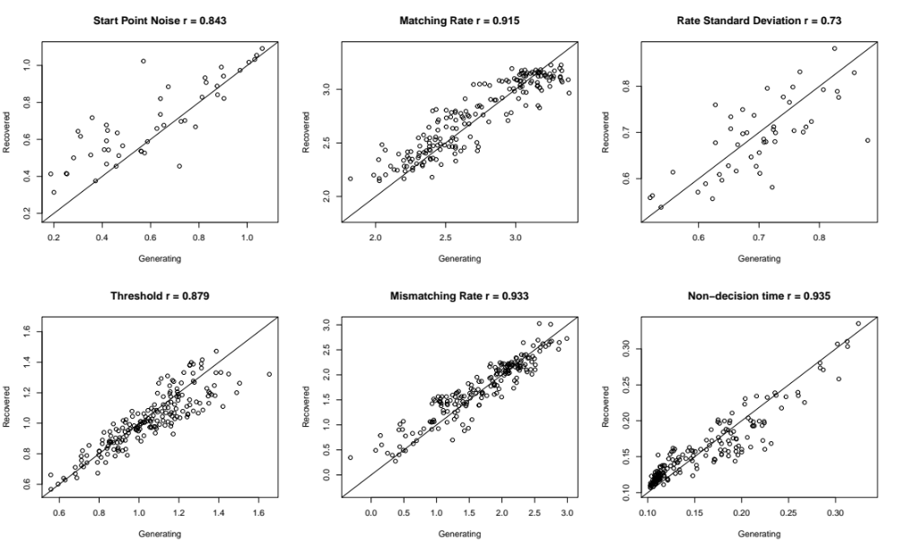
Figure S4. Recovery results (posterior median parameters for each participant) for the six types of LBA parameters for fits of the selected LBA-model variant to data generated from that variant for Experiment 1.
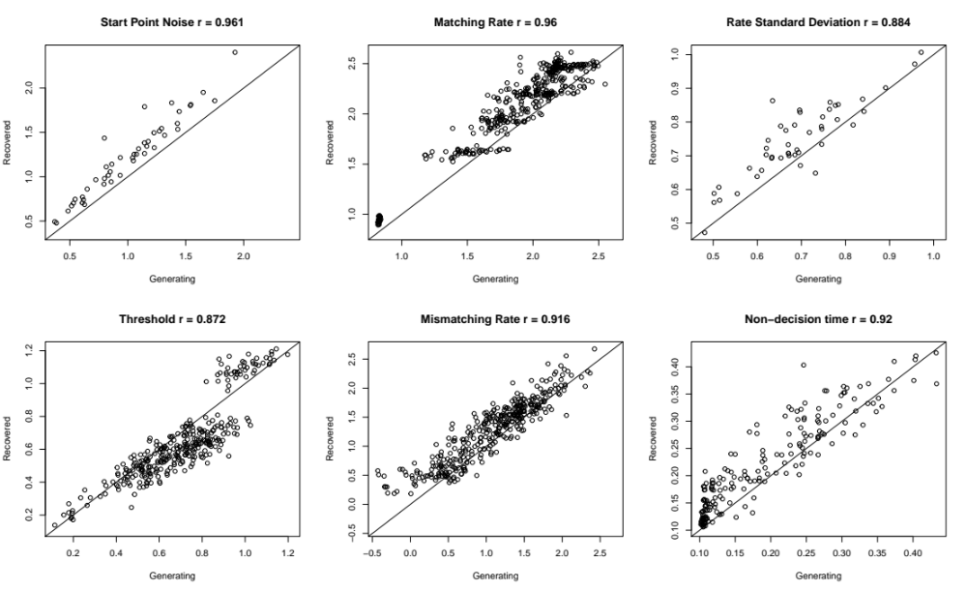
Figure S5. Recovery results (posterior median parameters for each participant) for the six types of LBA parameters for fits of the selected LBA-model variant to data generated from that variant for Experiment 2.
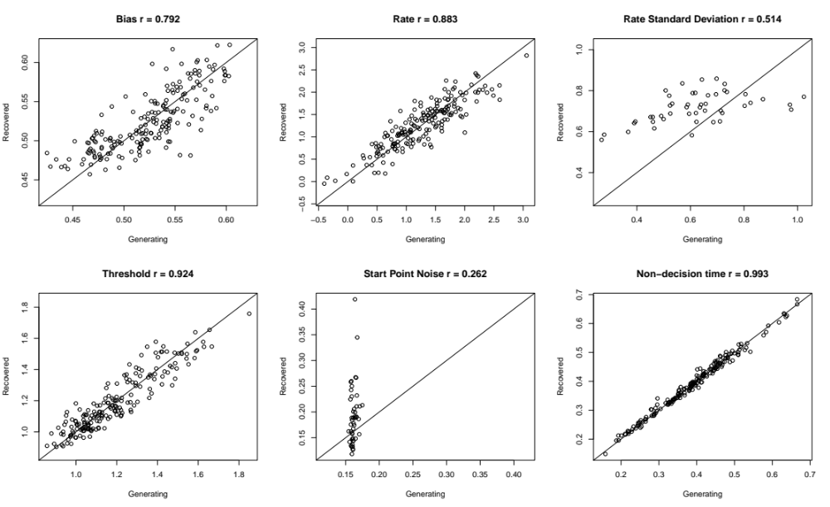
Figure S6. Recovery results (posterior median parameters for each participant) for the six types of DDM parameters for fits of the selected DDM-model variant to data generated from that variant for Experiment 1.

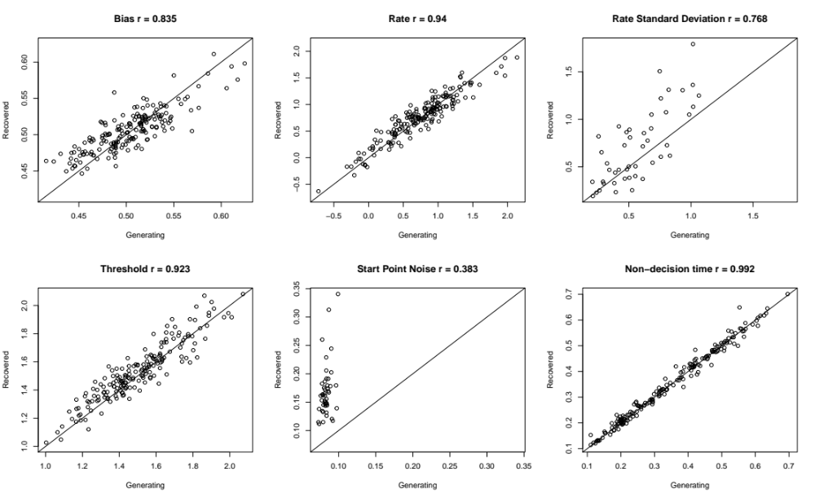
Figure S7. Recovery results (posterior median parameters for each participant) for the six types of DDM parameters for fits of the selected DDM-model variant to data generated from that variant for Experiment 1.
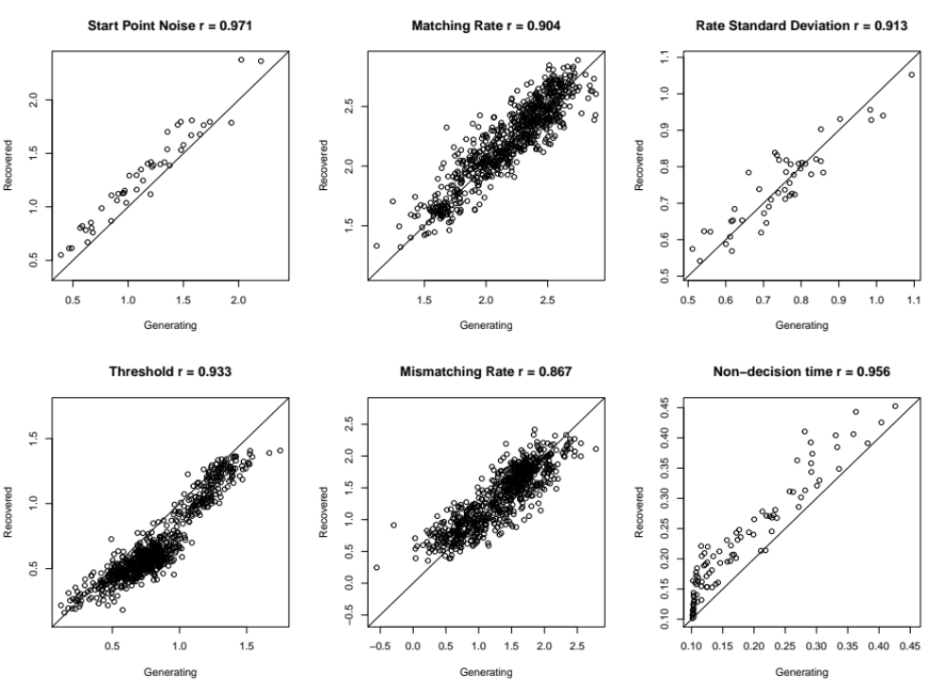
Figure S8. Recovery results (posterior median parameters for each participant) for the six types of LBA parameters for fits of the selected LBA-model variant to data generated from that variant for Experiment 2 broken down by last-trial confidence.

Non-robust data fits
We fit all model variants for the DDM and LBA, and models with no last-trial effect, to the full (i.e., non-robust) data set. The best models were always the most complex.

Table S10. LBA fit DIC model selection results (smaller values preferred), where the minimum value is subtracted from every value, so a 0 entry indicates the selected model. Fits were to non-robust data. For model variants an effect of last trial on threshold is indicated by a T, mean rate by an R and non-decision time by an N. The TRN model had an absolute DIC for Experiment 1 of -13436 and for Experiment 2 51832.

Experiment | TRN | TR | BN | RN | T | R | N | None
1 | 0 | 297 | 182 | 379 | 338 | 616 | 336 | 845
2 | 0 | 450 | 836 | 921 | 1650 | 3505 | 1262 | 4671

Table S11. DDM fit DIC model selection results (smaller values preferred), where the minimum value is subtracted from every value, so a 0 entry indicates the selected model. Fits were to non-robust data. For model variants an effect of last trial on threshold is indicated by a T, mean rate by an R and non-decision time by an N. The TRN model had an absolute DIC for Experiment 1 of 2290 and for Experiment 2 71393.

Experiment | TRN | TR | BN | RN | T | R | N | None
1 | 0 | 2602 | 24 | 278 | 2626 | 2783 | 253 | 2754
2 | 0 | 9011 | 344 | 444 | 9310 | 10076 | 847 | 10280

Parameter and Model Recovery
The model recovery study examined the ability of DIC to select the data generating model based on data simulated from the selected LBA and DDM models for each experiment. We first simulated data from the posterior median parameters of the selected LBA and DDM model variants for each experiment (see “makeSimData.R” scripts in the LBAdata and DDMdata subdirectories of the ModelRecovery directory on the OSF site). We then fit the LBA data with all 7 variants of LBA and DDM to the simulated LBA (see scripts in the LBAfit and DDMfit subdirectories of the LBAdata subdirectory), and finally all 7 variants of LBA and DDM (see LBAfit and DDMfit subdirectories of the DDMdata subdirectory).

Table S7 presents DIC values for fits of the LBA to simulated LBA data (obtained using the summaryLBA.R script in the LBAdata subdirectory). For both experiments the correct model was selected.

Table S7. Relative DIC (i.e., DIC minus the smallest DIC in each row) for fits of LBA model variants (T = threshold, R = rate, N = non-decision time) to data simulated from the selected LBA model variant in each experiment (N for Experiment 1 and TRN for Experiment 2).

 | T | TN | TR | TRN | N | V | RN
Experiment 1 | 69 | 77 | 253 | 227 | 0 | 252 | 202
Experiment 2 | 398 | 122 | 36 | 0 | 306 | 1158 | 133

Table S8 presents DIC values for fits of the DDM to the simulated DDM data (obtained using the summaryDDM.R script in the DDMdata subdirectory). For both experiments the correct model was selected.

Table S8. Relative DIC (i.e., DIC minus the smallest DIC in each row) for fits of DDM model variants (T = threshold, R = rate, N = non-decision time) to data simulated from the selected DDM model variant in each experiment (TN for both Experiments 1 and 2).

 | T | TN | TR | TRN | N | V | RN
Experiment 1 | 1055 | 0 | 1130 | 102 | 166 | 1280 | 219
Experiment 2 | 2439 | 0 | 2560 | 215 | 393 | 2906 | 486

We also examined miss-specified fits. Table S9 presents DIC values for fits of the DDM to the simulated LBA data (obtained using the summaryLBA.R script in the LBAdata subdirectory). The “correct” variant (in the sense of having the same parameter types as the data generating LBA model) was selected for both experiments.

Table S9. Relative DIC (i.e., DIC minus the smallest DIC in each row) for fits of DDM model variants (T = threshold, R = rate, N = non-decision time) to data simulated from the selected LBA model variant in each experiment (N for Experiment 1 and TRN for Experiment 2).

 | T | TN | TR | TRN | N | V | RN
Experiment 1 | 693 | 56 | 790 | 145 | 0 | 870 | 99
Experiment 2 | 2166 | 35 | 2144 | 0 | 254 | 2645 | 175

Finally, Table S10 presents DIC values for fits of the DDM to the simulated LBA data (obtained using the summaryDDM.R script in the DDMdata subdirectory). The “correct” model was not selected in either experiment, although in both cases the non-decision time effect was selected.
Table S10. Relative DIC (i.e., DIC minus the smallest DIC in each row) for fits of LBA model variants (T = threshold, R = rate, N = non-decision time) to data simulated from the selected DDM model variant in each experiment (TN for both Experiments 1 and 2).

 | T | TN | TR | TRN | N | V | RN
Experiment 1 | 458 | 38 | 414 | 27 | 97 | 1070 | 0
Experiment 2 | 1107 | 27 | 493 | 0 | 297 | 2191 | 99

The true model fits were also used to assess parameter recovery. Figures S10 and S11 show recovery for each LBA parameter type for Experiments 1 and 2 respectively. In both cases all types of generating parameters were strongly corelated with recovered parameters, indicating good recovery in an ordinal sense. Recovery in an absolute sense is excellent for all but the start-point noise parameter (with some over-estimation bias of smaller generating values) in the simpler 18 parameter model for Experiment 1. With the more complicated 30 parameter model for Experiment 2 some over-estimation is evident for all but the threshold parameter, which is somewhat underestimated expect for larger generating values, which are overestimated.

Figure S10. Parameter recovery for the selected LBA model for Experiment 1. Quantity is the average of accumulation rates over accumulators. Quality is the rate for the accumulator that matches the stimulus minus the rate for the accumulator that mismatches the stimulus. Rate parameters are broken down by whether the stimulus is old (previously studied) or new (not studied). See Table 3 for definitions of non-decision time, start-point noise, threshold and accumulation rate parameters.
Figure S11. Parameter recovery for the selected LBA model for Experiment 2. Quantity is the average of accumulation rates over accumulators. Quality is the rate for the accumulator that matches the stimulus minus the rate for the accumulator that mismatches the stimulus. Rate parameters are broken down by whether the stimulus is old (previously studied) or new (not studied). See Table 3 for definitions of non-decision time, start-point noise, threshold and accumulation rate parameters.

For the 18 parameter DDM model of Experiment 1 correlations are much lower for the two trial-to-trial variability parameters, particular start-point noise. For the remaining parameters correlations are much higher and there is little evidence of bias. The pattern for Experiment 2 model (which also has 18 parameters) is similar, although the correlations for trial-to-trial variability parameters are somewhat improved.

Figure S12. Parameter recovery for the selected DDM model for Experiment 1. Quantity is the average of accumulation rates over accumulators. Quality is the rate for the accumulator that matches the stimulus minus the rate for the accumulator that mismatches the stimulus. Rate parameters are broken down by whether the stimulus is old (previously studied) or new (not studied). See Table 3 for definitions of non-decision time, start-point noise, threshold and accumulation rate parameters.

Figure S13. Parameter recovery for the selected DDM model for Experiment 2. Quantity is the average of accumulation rates over accumulators. Quality is the rate for the accumulator that matches the stimulus minus the rate for the accumulator that mismatches the stimulus. Rate parameters are broken down by whether the stimulus is old (previously studied) or new (not studied). See Table 3 for definitions of non-decision time, start-point noise, threshold and accumulation rate parameters.

