Supplement A, Table S1
Table S1
Sampling Diagnostics of the Fits in Analysis of Parameter Recovery
Simulating Model | Fitting Model | Number of Iterations | Number of Subjects | Number of Trials | $${\hat{R}}_{max}$$ | $${\hat{ESS}}_{min}$$
Kalman SMEP | Kalman SMEP | 2000 | 150 | 300 | 1.0088 | 997
Kalman SMEP | Kalman SMEP | 2000 | 64 | 100 | 5.79 | 2
Kalman SMEP | Kalman SMEP + Bounds | 3000 | 64 | 100 | 1.0077 | 407
Kalman SMEP | Kalman SMEP | 3000 | 64 | 150 | 1.012 | 418
Kalman SMEP | Kalman SMEP | 2000 | 64 | 200 | 1.034 | 117
Kalman SMEP | Kalman SMEP | 3000 | 64 | 200 | 1.030 | 136
Kalman SMEP | Kalman SMEP | 3000 | 64 | 250 | 1.0037 | 1512
Kalman SMEP | Kalman SMEP | 2000 | 64 | 300 | 1.0084 | 1239
Kalman SMEP | Kalman SMEP | 3000 | 64 | 300 | 1.0037 | 1743
Kalman SMEP | Kalman SMEP | 2000 | 64 | 500 | 1.0072 | 1197
Note. Kalman SMEP means Kalman Filter Model with Softmax decision rule, exploration bonus and perseveration bonus; Bounds marks the case in which the range of possible values of $φ$ was restricted to -10 $<φ<$ 20 and the range of $ρ$ was restricted to -20 $<ρ<$ 40; the iterations were in each case half warmup and half sampling; ${\hat{R}}_{max}$ the maximum $\hat{R}$ estimated for a parameter in the corresponding fit, indicating how well the chains merged; ${\hat{ESS}}_{min}$ is the minimum $\hat{ESS}$ estimated for a parameter in the corresponding fit, indicating the efficiency and accuracy of the fit.

Supplement B: Figure S1
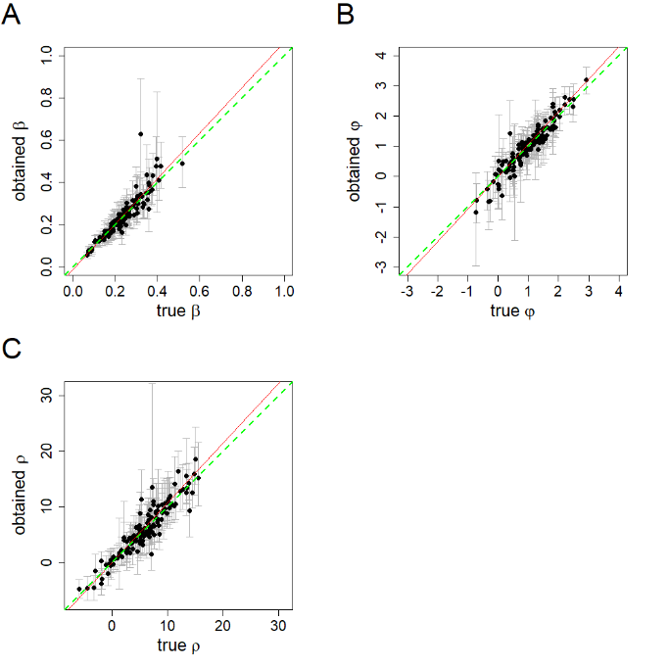
Figure S1: Parameter recover scatter plots for a gamma(2,4) prior on beta: this figure is similar to Figure 2, the difference is that we used gamma (2,4) as prior in the fitting process of $β$ instead of uniform (0,3). $β$ is the softmax parameter; $φ$ is the exploration bonus parameter; $ρ$ is the perseveration parameter; the scatterplots show the correlation of the true values, i.e., the input values to the simulation, and the recovered values obtained in the fitting process; the mean of the posterior values are depicted as dots, the whiskers show the range of the 95% HDI; the red lines are the actual linear regression lines; the green lines show the linear regression lines for a perfect parameter recovery.

Supplement C: Figure S2

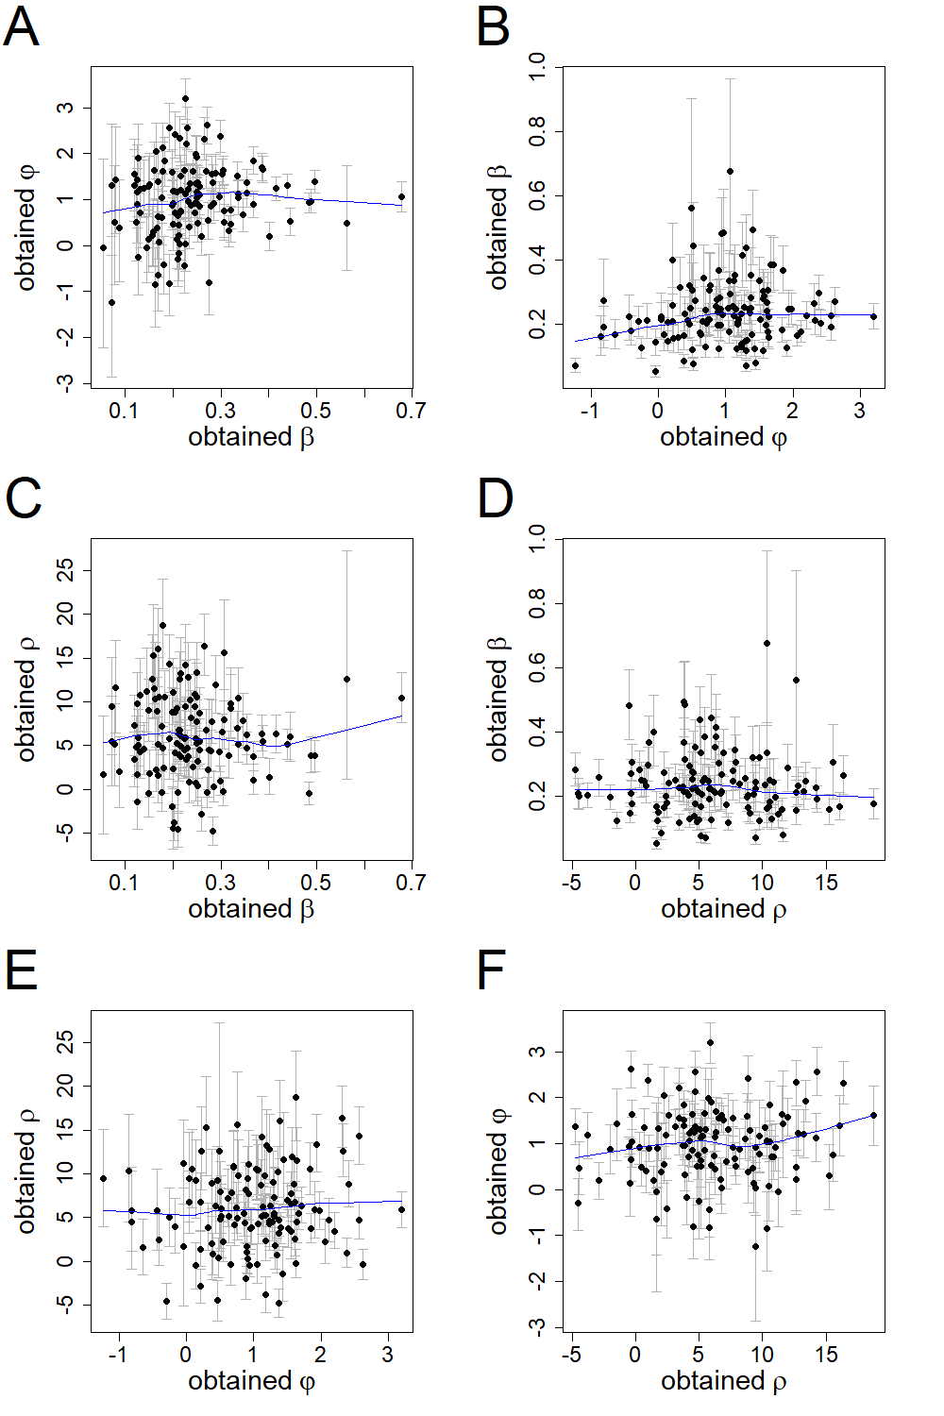
Figure S2 Interdependence of the Recovered Free Parameter Values of the Kalman SMEP Model: $β$ is the softmax parameter; $φ$ is the exploration bonus parameter; $ρ$ is the perseveration parameter; the scatterplots show the correlation of the different recovered parameters; the mean of the posterior values is depicted as dot the whiskers show the range of the 95% HDI; the locally weighted scatterplot smoothing (LOWESS) lines of the relationships are depicted in blue

Supplement D: Table S2
Table S2
Comparison of loo Estimates for the Entire Datasets
Model used to fit | Model used to generate
Model used to fit | 1 | 2 | 3 | 4 | 5
1. Kalman SMEP | -0.6081ª | -0.7430 | -0.7845 | -0.2616 | -0.3402
2. Kalman SME | -0.6476 | -0.7413ª | -0.7825 | -0.2596 | -0.3378
3. Kalman SM | -0.6753 | -0.7531 | -0.7801ª | -0.3497 | -0.4126
4. Delta SM | -0.6866 | -0.7621 | -0.7929 | -0.2230ª | -0.3109
5. Diff Delta SM | -0.6837 | -0.7617 | -0.7926 | -0.2235 | -0.3036ª
Note. Model Names: SM: softmax; E: exploration bonus; P: perseveration, Diff Delta: Delta rule with differential learning rates for positive and negative prediction errors. The goodness-of-fit was compared using Pareto smoothed importance sampling leave-one-out cross validation: the cells contain the estimated loo measure for the entire fit, divided through the number of subjects and number of trials.
ª the best fitting model of the column.

