Supplementary Materials

Model parameters
Table 1. All excitation and inhibition model parameters of the AROM+
Excitation parameter α
Layer | Feature | Letter | Orthographic | Associative | Response
Feature | 0 | .005 | 0 | 0 | 0
Letter | 0 | 0 | .07 | 0 | 0
Orthographic | 0 | .3 | 0 | .09 | 0
Associative | 0 | 0 | 0 | .03 | 1
Response | 0 | 0 | 0 | 0 | 0
Inhibition parameter γ
Layer | Feature | Letter | Orthographic | Associative | Response
Feature | 0 | -.15 | 0 | 0 | 0
Letter | 0 | 0 | -.04 | 0 | 0
Orthographic | 0 | 0 | -.21 | 0 | 0
Associative | 0 | 0 | 0 | -.04 | 0
Response | 0 | 0 | 0 | 0 | β
Note: β parameter of the LCA was estimated from data

Table 2. Decay parameters
Layer | AROM
Feature | .00
Letter | .07
Orthographic | .07
Associative | .07
Response | κ
Note: κ parameter of the LCA was estimated from data

Table 3. Spearman correlations between model parameters
 | β | ξ | $$ρ_{New}$$ | $$ρ_{Old}$$ | NDT | $$θ_{New-High}$$ | $$θ_{New-Low}$$ | $$θ_{Old-High}$$ | $$θ_{Old-Low}$$
κ | -.02 | -.33 | .01 | .16 | -.11 | .16 | .05 | -.08 | .23
β |  | -.10 | .15 | -.19 | -.15 | -.13 | -.45* | .22 | -.01
ξ |  |  | -.50** | .33 | .03 | 0 | .11 | -.22 | -.10
$ρ_{New}$ |  |  |  | -.21 | .05 | -.18 | -.21 | .10 | -.12
$ρ_{Old}$ |  |  |  |  | .16 | 0 | .16 | -.09 | .04
NDT |  |  |  |  |  | -.09 | -.04 | -.27 | -.20
$θ_{New-High}$ |  |  |  |  |  |  | .22 | -.01 | .10
$θ_{New-Low}$ |  |  |  |  |  |  |  | .03 | .11
$θ_{Old-High}$ |  |  |  |  |  |  |  |  | .50**
Note: * p<.05, ** p <.01

Figure 1. The left plot displays the effects of the resting levels and spreading activation in the four experimental conditions. The average activations of the semantic layer units are shown. The average was calculated over participants and items. The distance between blue and orange lines reflects the effect of higher resting levels for Old words. The differences between solid and dashed lines reflect the effect of spreading activation. The right plot shows the input to the Old response unit in the decision layer. That is, the values from the left are plotted after the sigmoid transformation has been applied. The patterns of activation from the semantic layer are preserved, but scaled so that the input for the LCA is positive. Both plots show that semantic many associates lead to a higher semantic activation.

N400 linear mixed effects model regression tables

Table 4. Random effects
Groups | Name | Variance | SD
ID: Stimulus | Intercept | .4024 | .6343
ID | Intercept | .1125 | .3354
 | Residual | .2084 | .4565
Number of obs.: 10911, groups: ID: Stimulus, 3637; ID, 29

Table 5. Fixed effects regression coefficients
Fixed Effect | β | ${SE}_{β}$ | t
Intercept | .012 | .065 | .177
D1 (Frontal vs. mean of Central and Posterior) | -.068 | .007 | -9.682
D2 (Central vs. mean of Posterior and Frontal) | -.108 | .007 | -15.376
Orthographic activation (Ortho) | -.010 | .013 | -.757
AMSS | .093 | .014 | 6.842
Criterion | .007 | .017 | .407
Ortho: AMSS | -.010 | .014 | -.701
Ortho: Criterion | .017 | .013 | 1.261
AMSS: Criterion | .013 | .016 | .832
D1: Ortho | -.009 | .007 | -1.258
D2: Ortho | .003 | .007 | .469
D1: AMSS | .023 | .007 | 3.331
D2: AMSS | .005 | .007 | .706
D1: Criterion | .046 | .007 | 6.153
D2: Criterion | -.005 | .007 | -.703
Ortho: AMSS: Criterion | -.010 | .013 | -.791
D1: Ortho: AMSS | .002 | .007 | .239
D2: Ortho: AMSS | .001 | .007 | .169
D1: Ortho: Criterion | .006 | .007 | .844
D2: Ortho: Criterion | .002 | .007 | .331
D1: AMSS: Criterion | .006 | .007 | .873
D2: AMSS: Criterion | -.002 | .007 | -.339
D1: Ortho: AMSS: Criterion | .010 | .007 | 1.364
D2: Ortho: AMSS: Criterion | -.003 | .007 | -.460
Note: rlmer formula:
Amplitude ~ EEG Region*Ortho*AMSS* Criterion + (1|ID) + (1|ID:Stimulus);
D1, D2: dummy variables 1 and 2

N400 linear mixed effects model without mean orthographic activation

Table 6. ANOVA style main and interaction effects
Effect | df | F-value | p - value
Intercept | (1, 28.769) | .013 | .9092
EEG Region | (2, 7266.000) | 193.662 | <.0001
AMSS | (1, 3632.618) | 28.561 | <.0001
Criterion | (1, 3410.987) | .231 | .6306
EEG Region: AMSS | (2, 7266.000) | 5.325 | .0049
EEG Region: Criterion | (2, 7266.000) | 10.475 | <.0001
AMSS: Criterion | (1, 3493.075) | 1.080 | .2987
EEG Region: AMSS: Criterion | (2, 7266.000) | .950 | .3866
Notes:
rlmer formula: Amplitude ~ EEG Region * AMSS * Criterion + (1|ID) + (1|ID:Stimulus);
p-values were obtained using the Kenward-Roger approximation. Significant F-values are marked in bold

Table 7. Random effects of the regression model
Groups | Name | Variance | SD
ID: Stimulus | Intercept | .4022 | .6342
ID | Intercept | .1124 | .3353
 | Residual | .2086 | .4568
Number of obs: 10911, groups: ID: Stimulus, 3637; ID, 29

Table 8. Fixed effects regression coefficients
Fixed Effect | β | $${SE}_{β}$$ | t
Intercept | .011 | .065 | .169
D1 (Frontal vs. mean of Central and Posterior) | -.068 | .007 | -9.654
D2 (Central vs. mean of Posterior and Frontal) | -.108 | .007 | -15.408
AMSS | .092 | .014 | 6.812
Criterion | .006 | .017 | .352
D1: AMSS | .023 | .007 | 3.206
D2: AMSS | .005 | .007 | .761
D1: Criterion | .046 | .007 | 6.223
D2: Criterion | -.005 | .007 | -.728
AMSS: Criterion | .015 | .016 | .902
D1: AMSS: Criterion | .007 | .007 | .980
D2: AMSS: Criterion | -.002 | .007 | -.334
Note: rlmer formula: Amplitude ~ EEG Region*AMSS* Criterion + (1|ID) + (1|ID:Stimulus)
D1, D2: dummy variables 1 and 2

N400 linear mixed effects model summary for measures of orthographic and associative activation from the last seven processing cycles
Table 9. Main and interaction effects for the N400 linear mixed effects model
Effect | df | F-value | p - value
Intercept | (1, 28.784) | .0186 | .8925
EEG Region | (2, 7258.000) | 187.807 | <.0001
Orthographic activation (Ortho) | (1, 3602.660) | .952 | .3292
AMSS | (1, 3628.430) | 32.682 | <.0001
Criterion | (1, 3427.030) | .097 | .7560
EEG Region: Ortho | (2, 7258.000) | 2.372 | .0933
EEG Region: AMSS | (2, 7258.000) | 4.726 | .0089
Ortho: AMSS | (1, 3602.340) | 1.333 | .2483
EEG Region: Criterion | (2, 7258.000) | 10.469 | <.0001
Ortho: Criterion | (1, 3602.360) | .999 | .3174
AMSS: Criterion | (1, 3481.760) | 1.178 | .2778
EEG Region: Ortho: AMSS | (2, 7258.000) | .669 | .5125
EEG Region: Ortho: Criterion | (2, 7258.000) | .954 | .3851
EEG Region: AMSS: Criterion | (2, 7258.000) | 1.008 | .3651
Ortho: AMSS: Criterion | (1, 3602.100) | .075 | .7835
EEG Region: Ortho: AMSS: Criterion | (2, 7258.000) | .658 | .5181
Notes:
rlmer formula: Amplitude ~ EEG Region * Ortho * AMSS * Criterion + (1|ID) + (1|ID:Stimulus);
p-values were obtained using the Kenward-Roger approximation. Significant F-values are marked in bold.

EEG preprocessing
We first reduced the sampling rate to 250 Hz and then removed line noise at 50Hz using the CleanLine plug-in for EEGLAB. Next, the data were high pass filtered using a 1Hz threshold. We then decomposed the data using independent component analysis as implemented in the EEGLAB infomax picard routine. The extracted components were then applied to the unfiltered data and labeled using the ICLabel EEGLAB plug-in. After labelling, components identified as eye, muscle or line noise were inspected and removed from the data. We also inspected the components classified as other to identify further noise sources and remove them. The cleaned data were then filtered using a band-pass filter keeping frequencies 0.1 and 30Hz. Next steps were performed in ERPLAB. First, epochs were defined, extracted, and visually inspected for any residual artifacts. If needed channels were interpolated using EEGLAB routines (in total three channels in two subjects).

ERP plots and mean N400 amplitudes

Figure 2. ERPs for the analyzed electrodes.

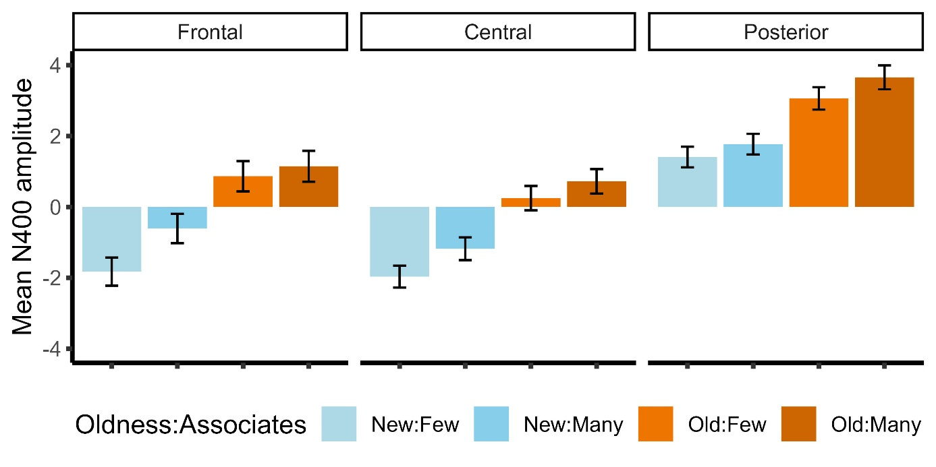
Figure 3. Mean N400 amplitudes and standard errors of the mean for each experimental condition (Oldness: Number of associates) for each EEG region.

AROM+ with a single criterion
The only difference compared to the model in the main text is that there is only one criterion.
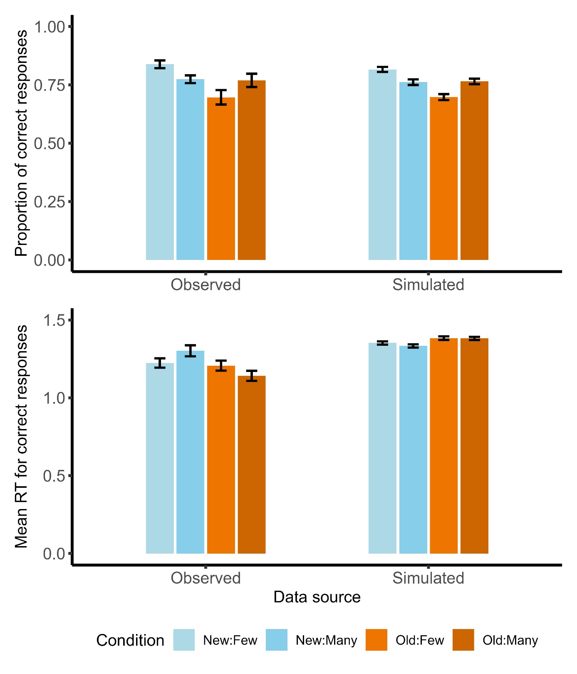
Figure 4. Performance (means and standard errors) in the four experimental conditions (Oldness: Number of associates) from behavioral and simulated data. a: average proportion of correct responses (hits and correct rejections). b: average response times in seconds for correct responses (hits and correct rejections). While the single response criterion model can capture accuracy, it fails to reproduce response times.

