Supporting Information

Self-healing and polymer welding of soft and stiff epoxy thermosets via silanolates

Amelia A. Putnam-Neeb^{1,2}, Jordan M. Kaiser^{1,3}, Amber M. Hubbard^{1,2}, Dayton P. Street^{1,2}, Matthew B. Dickerson¹, Dhriti Nepal¹, and Luke A. Baldwin¹*

¹Materials and Manufacturing Directorate, Air Force Research Laboratory, Wright Patterson Air Force Base, Ohio, 45433, United States.
²National Research Council Research Associate, Air Force Research Laboratory, Wright Patterson Air Force Base, Ohio, 45433, United States.
³UES, Inc. Dayton, Ohio, 45432, United States.

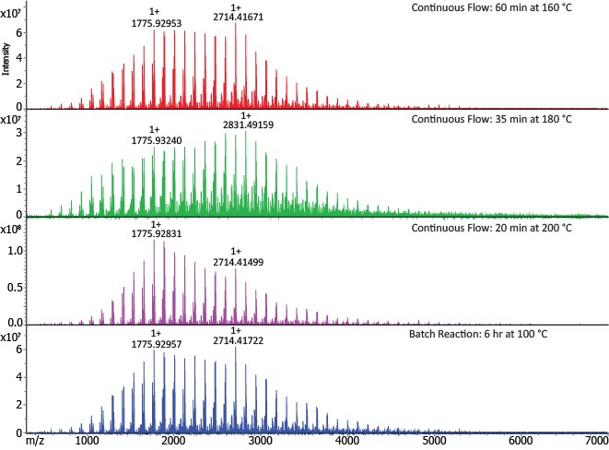
Figure S1: MALDI-TOF MS spectra of different flow conditions compared to the batch synthesis for the oligomerization of AMS to make PAMS. The continuous flow parameters of 160 °C and a 60 min retention time (top spectrum) yielded a product similar to that of the batch reaction conditions (bottom spectrum). The PAMS synthesized by flow gave a molecular weight of 1500 – 2000 g mol⁻¹, or about 11-19 repeating siloxane units.

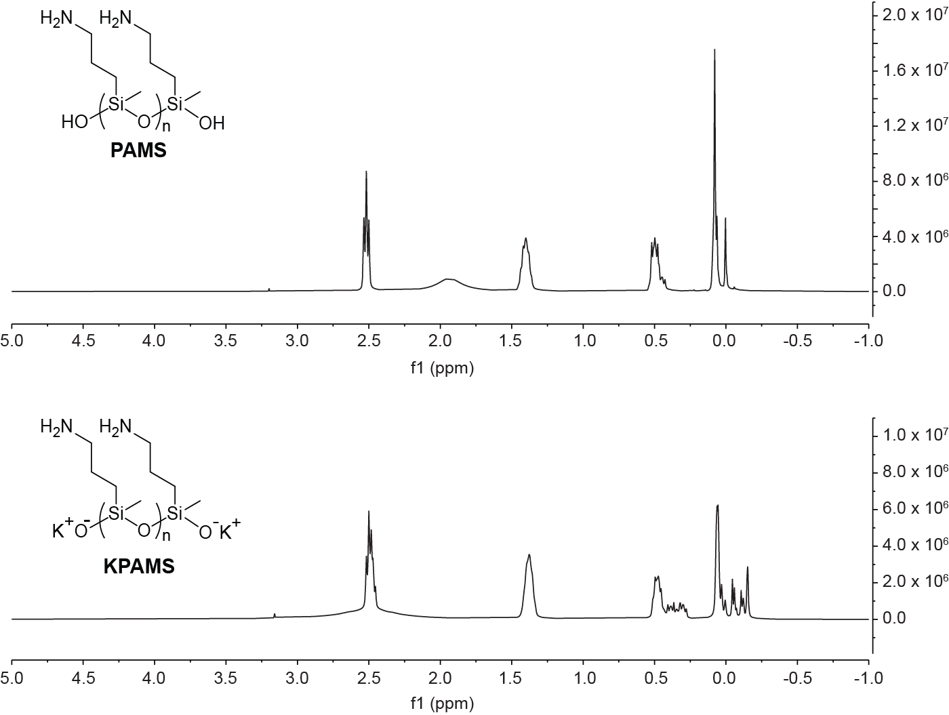
Figure S2: Nuclear magnetic resonance (NMR) spectra of PAMS (top) and KPAMS (bottom). ¹H NMR was recorded using a Bruker Avance 400 MHz spectrometer with DMSO-d₆ solvent.

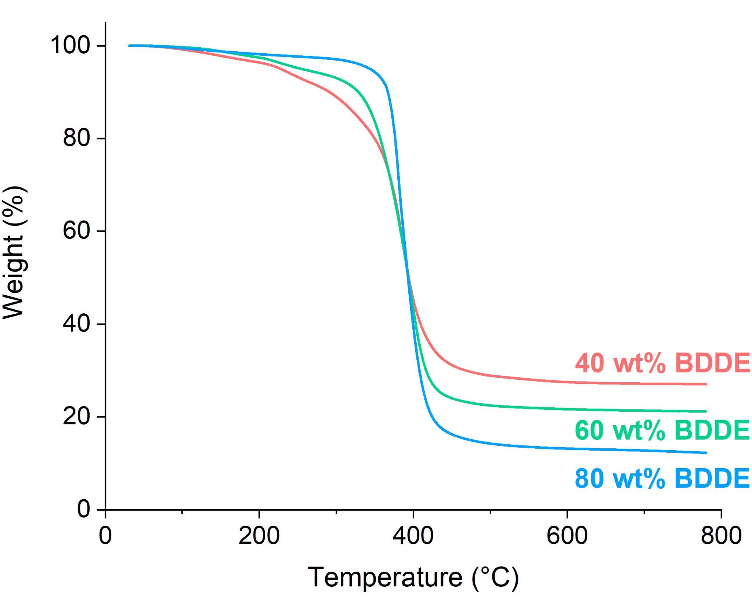
Figure S3: Thermogravimetric analysis (TGA) of all KPAMS-BDDE formulations. The end weight after decomposition is highest with less BDDE as a result of the residual potassium content from increasing concentration of KPAMS.

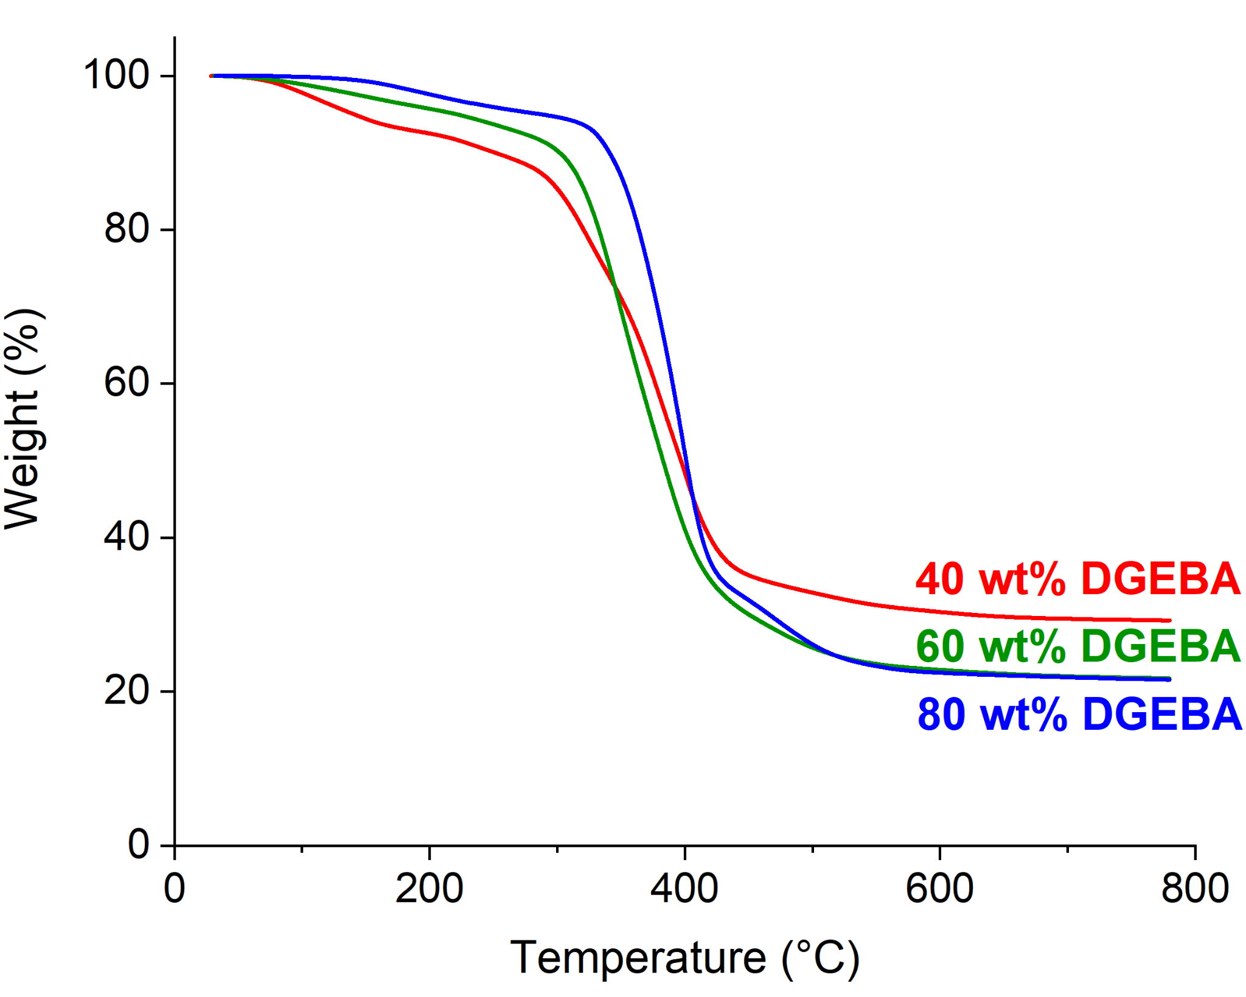
Figure S4: Thermogravimetric analysis (TGA) of all KPAMS-DGEBA formulations.

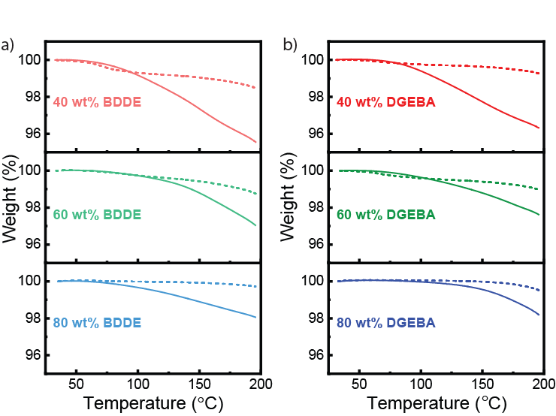
Figure S5: Cyclic TGA of each formulation of a) KPAMS-BDDE and b) KPAMS-DGEBA. For each experiment, TGA was performed twice using the same sample, heating to 200 °C both times to determine if water was removed. In each plot, the first cycle is denoted by a solid line, and the second cycle is shown as a dashed line. Final mass loss for each cycle is tabulated in Table S1.

Table S1: Final mass loss for cyclic TGA experiments for all adaptable network formulations.
Adaptable network composition | Final Mass Loss
Adaptable network composition | 1st Cycle | 2nd Cycle
40 wt% BDDE | 4.449% | 1.521%
60 wt% BDDE | 2.958% | 1.247%
80 wt% BDDE | 1.945% | 0.2788%
40 wt% DGEBA | 3.680% | 0.7308%
60 wt% DGEBA | 2.376% | 1.031%
80 wt% DGEBA | 1.807% | 0.4767%
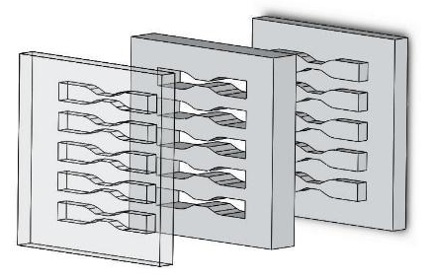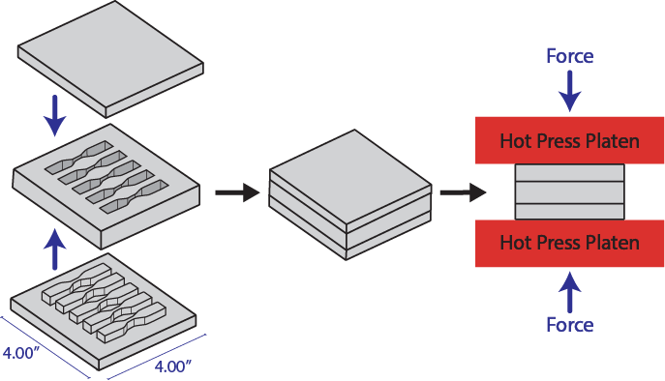
Figure S6: Drawing of the 3-piece aluminum mold used for self-healing and welding of adaptable network dogbone specimens (top). The mold consisted of a single female piece and two male pieces to fit on each end. Fractured dogbones were placed in the wells of the mold, which was then placed in a hot press (bottom) to weld under 5 MPa of pressure at 110 °C for 45 min.

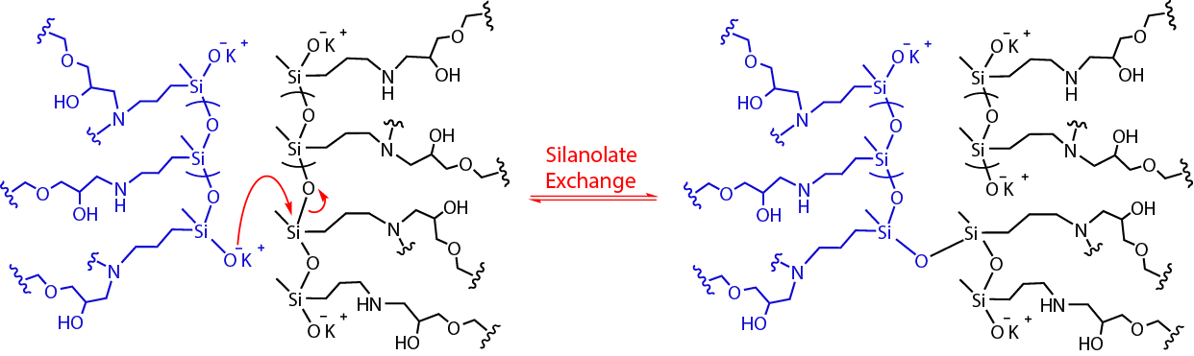
Figure S7: Primary exchange mechanism of silanolate adaptable networks.

Table S2: Thermal properties of KPAMS-BDDE networks. Thermal characterization from DSC and DMA was repeated in triplicate, and error is reported as one standard deviation.
BDDE  content | T_{d}  (5%) | Gel Fraction | T_{g}  (DSC) | T_{g}  (Eʹ) | T_{g}  (tan δ)
40 wt% | 222 °C | 0.63 | -7 ± 1 °C | 10 ± 5 °C | 20 ± 6 °C
60 wt% | 253 °C | 0.88 | 11.1 ± 0.9 °C | 24 ± 2 °C | 34 ± 3 °C
80 wt% | 343 °C | 0.94 | -7 ± 1 °C | 12 ± 1 °C | 23 ± 1 °C

Table S3: Stoichiometric ratios of amine to epoxide groups within each formulation used for KPAMS-BDDE networks. A formulation with 59.73 wt% BDDE would give an exact 2:1 epoxide:amine ratio.
BDDE  content | Epoxide | Amine
40 wt% | 1.00 | 1.11
60 wt% | 2.02 | 1.00
80 wt% | 5.39 | 1.00

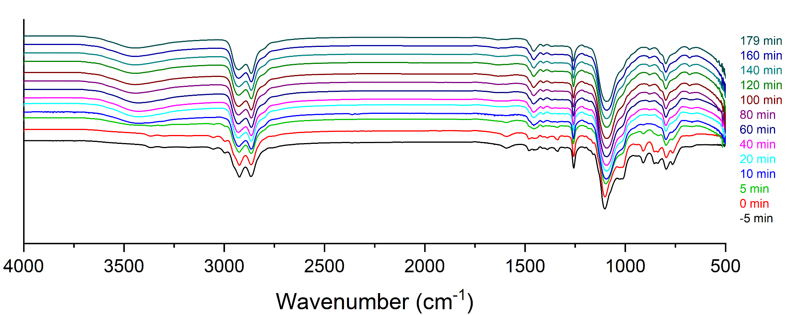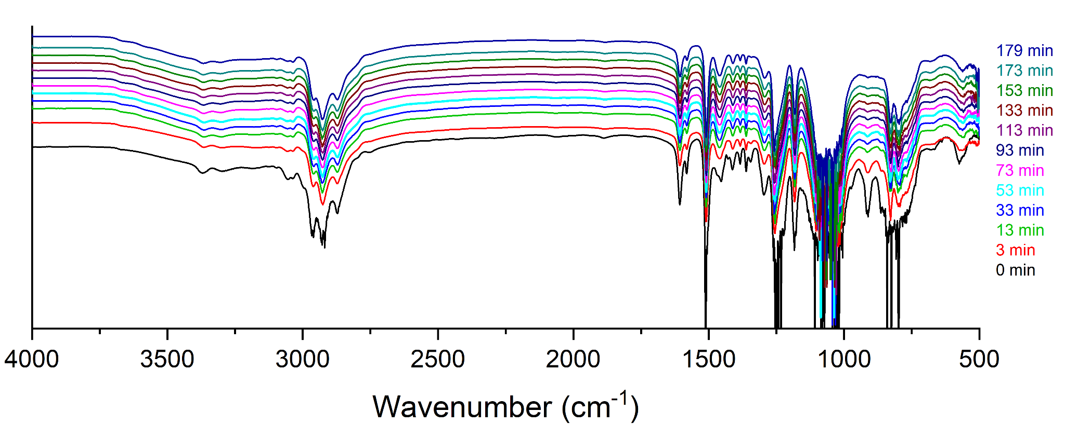
b)
a)
Figure S8: In situ FT-IR of a) KPAMS-BDDE and b) KPAMS-DGEBA synthesis with 60 wt% diepoxide crosslinker. The epoxide groups (914 cm⁻¹) of the DGEBA were reacted away over the 180 min cure time. For BDDE, epoxide groups were mostly exhausted within the first ~10 min. An additional FT-IR spectrum of KPAMS-BDDE was included from before the reaction was heated to 80 °C to show the reaction of epoxy groups.

Table S4: Thermal properties of KPAMS-DGEBA formulations. Thermal characterization from DSC and DMA was repeated in triplicate, and error is reported as one standard deviation.
DGEBA  content | T_{d}  (5%) | Gel  Fraction | T_{g}  (DSC) | T_{g}  (Eʹ) | T_{g}  (tan δ)
40 wt% | 138 °C | 0.62 | 6 ± 1 °C | 19 ± 4 °C  81 ± 4 °C | 29 ± 4 °C  85 ± 4 °C
60 wt% | 218 °C | 0.97 | 4 ± 1 °C  103 ± 2 °C | 7 ± 1 °C  92 ± 1 °C | 15 ± 5 °C  111 ± 1 °C
80 wt% | 289 °C | 1.02 | 91.7 ± 0.8 °C | 97 ± 3 °C | 110 ± 3 °C

Table S5: Stoichiometric ratios of amine to epoxide groups within each formulation used for KPAMS-DGEBA networks. A formulation with 68.41 wt% DGEBA would give an exact 2:1 epoxide:amine ratio.
DGEBA content | Epoxide | Amine
40 wt% | 1.00 | 1.62
60 wt% | 1.39 | 1.00
80 wt% | 3.69 | 1.00

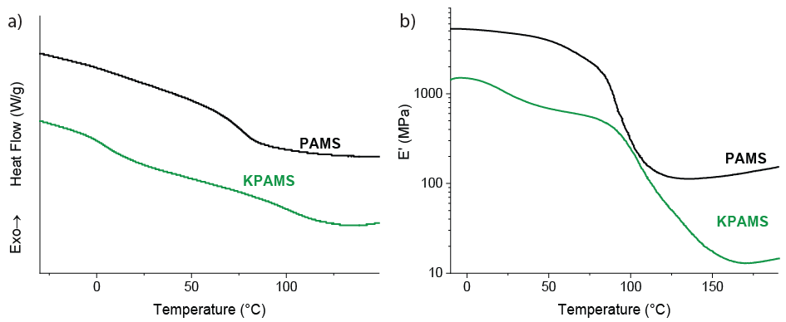
Figure S9: Representative a) DSC and b) DMA results of 60 wt% DGEBA with 40 wt% KPAMS (green) or PAMS (black) as a control without dynamic bonding. The single T_{g} shown in the PAMS-DGEBA network (74.64 ± 0.06 °C from DSC) suggests a more uniform distribution of the polysiloxane. The silanolate-containing KPAMS-DGEBA has two T_{g} values present, indicating poor mixing between the starting materials.

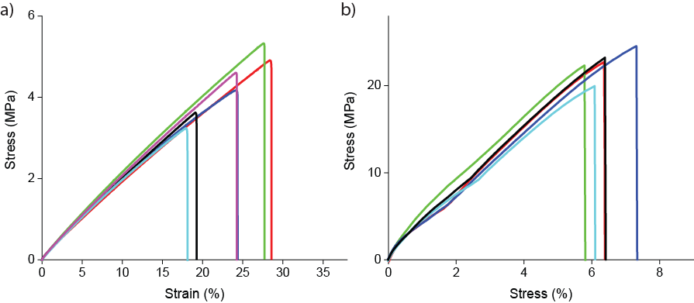
Figure S10: Pristine samples of a) 60 wt% BDDE and b) 60 wt% DGEBA. The dogbone specimens were then healed and retested, and a representative sample (black trace) is shown in Fig. 6 with multiple healing iterations.

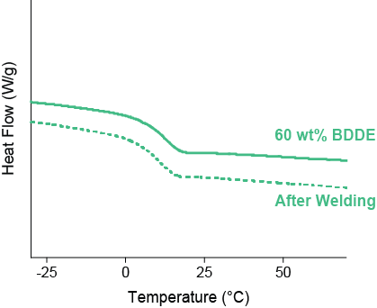
Figure S11: DSC curves of a 60 wt% BDDE sample before and after a self-healing/welding cycle (110 °C, 5 MPa, 45 min). The similar T_{g} in both experiments indicates that the self-healing properties were not a result of additional curing within the material.

