Supplementary material

Electrospun polymeric nanohybrids with outstanding pollutants adsorption and electroactivity for water treatment and sensing devices
Roberto Scaffaro, Andrea Maio, Michele Gammino
Department of Engineering, University of Palermo, Viale delle Scienze, ed. 6, 90128 Palermo (Italy).
*Corresponding author: roberto.scaffaro@unipa.it
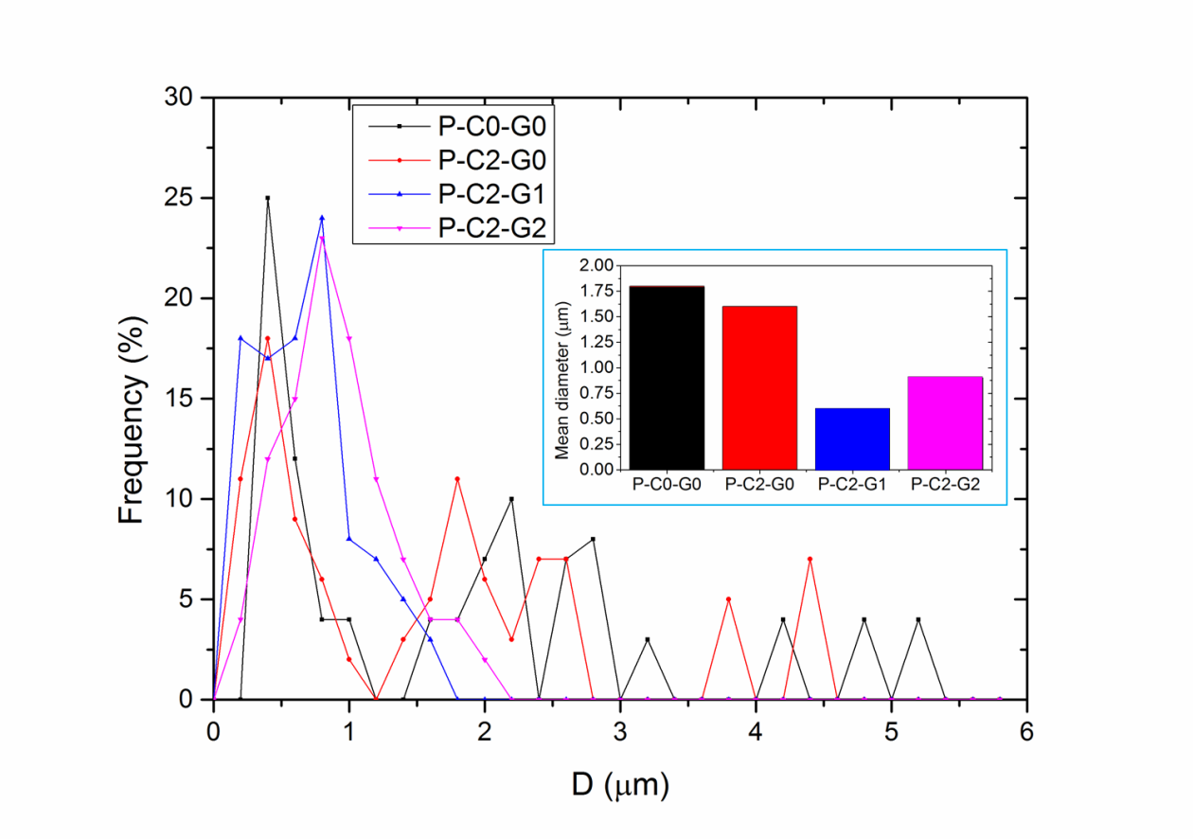
Figure S1. Diameter size distribution of fibres in the samples prepared, along with mean fibre diameters (inset).
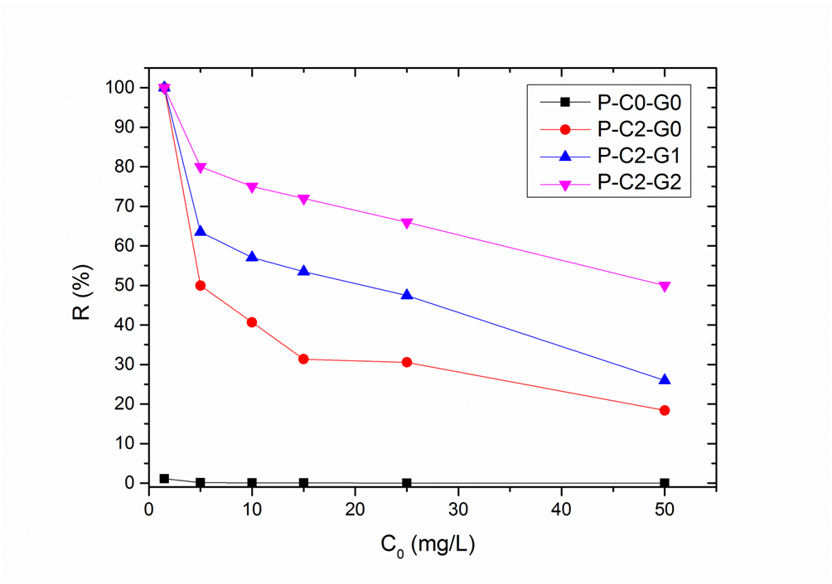
Figure S2. Removal efficiency (R%) plotted as a function of initial concentration of MB (C₀)

Table S1 Fitting results of PSO and PFO models
Sample | PFO |  |  | PSO
Sample | q₁ (mg/g) | k₁ (min⁻¹) | R² | q₂ (mg/g) | k₂ (g/mg min) | R²
P-C0-G0 | 5.598 | 0.0056 | 0.9839 | 5.704 | 3.82 10⁻³ | 0.99976
P-C2-G0 | 78.417 | 0.0035 | 0.9919 | 97.182 | 1.82 10⁻⁵ | 0.8986
P-C2-G1 | 182.898 | 0.0025 | 0.9162 | 186.220 | 8.83 10⁻⁵ | 0.9995
P-C2-G2 | 291.667 | 0.0050 | 0.9453 | 294.118 | 1.63 10⁻⁴ | 0.9999

Table S2 Fitting results of Elovich and IPD models
Sample | Elovich |  |  | IPD
Sample | α (mg/g min) | β (g/mg) | R² | k_{IPD} (mg/g min^{0.5}) | C_{IPD} (mg/g) | R²
P-C0-G0 | 0.237545 | 0.738902 | 0.70264 | (I) 0.91  (II) 0.05386  (III) 1.3E-4 | -3.24 | 1  0.9799  1
P-C2-G0 | 9.248779 | 0.019927 | 0.76052 | (I) 0.66675  (II) 7.53509  (III) 0.0335 | 0 | (I) 0.9976  (II) 0.995  (III) 1
P-C2-G1 | 17.51155 | 0.064293 | 0.95899 | (I) 3.5347  (II) 0.3864 | 77.02 | (I) 0.9813  (II) 1
P-C2-G2 | 41.72895 | 0.025858 | 0.98284 | (I) 8.6444  (II) 0.0178 | 145.93 | (I) 0.95599  (II) 1

Sensing performance
The following script (SCRIPT-1) was used to monitor the adsorption of MB molecules onto sorbent materials. Specifically, SCRIPT-1 will turn on the LED connected to digital pin 9 and keep it continuously lit as long as the Arduino is powered, as illustrated in Fig. S2.
SCRIPT-1:
// Configuring the digital pin to which the LED is connected.
const int pinLED = 9;
void setup() {
// Set the LED pin as an output
pinMode(pinLED, OUTPUT);
}
void loop() {
// Light-on the LED
digitalWrite(pinLED, HIGH);
}
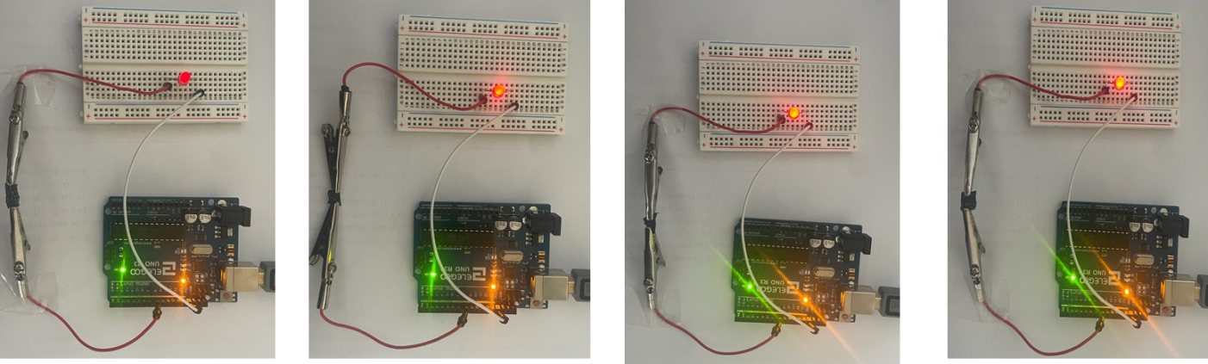
Figure S3. Progressive increase in the brightness of analog LED 9 as conductivity rises due to the growing amount of MB adsorbed by the material.
Arduino reads data from the pressure sensor and sends the read values to the computer through the serial port. Subsequently, we used a data visualization software, such as the Serial Plotter software in the Arduino IDE, to display the time-voltage graph. Note that each measure lasts 12 minutes.
With the following script (SCRIPT-2), Arduino sends a series of data to the computer: the time elapsed in seconds, and voltage values. Each signal is recorded as voltage read from the pressure sensor. Each data point is separated by a tab (\t), and each line ends with a new line character (\n).
SCRIPT-2
// Configuring the analog pin to which the pressure sensor is connected
const int pinSensPr = A0;
void setup() {
// Start serial communication with the computer
Serial.begin(9600);
}
void loop() {
// Read the value from the sensor
int ValRead = analogRead(pinSensor);
// Convert the value read in millivolts (considering 5V as a reference voltage)
float tension_mV = (ValRead * 5000.0) / 1023.0;
// send the data to the computer
Serial.print(millis() / 1000.0); // Send the elapsed time in seconds
Serial.print("\t");
Serial.println(tension_mV); // Send the value of tension in mV
// Delay to avoid excessively frequent measurements
delay(1000);
}

