Supporting information
Highly-efficient Sustainable Ionic Thermoelectric Materials using Lignin-Derived Hydrogels
Muhammad Muddasar ^{1,2}, Nicolás Menéndez ², Ángela Quero², Mohammad A. Nasiri³, Andrés Cantarero³, Jorge García-Cañadas⁴, Clara Gómez², Maurice N. Collins ^{1,5,} *, and Mario Culebras ^{2*}
¹ Stokes Laboratories, School of Engineering, Bernal Institute, University of Limerick, Limerick, Ireland.
² Institute of Material Science, (ICMUV) University of Valencia, PO Box 22085, E46071, Valencia, Spain.
³ Institute of Molecular Science (ICMol), Universitat de Valencia, PO Box 22085, E46071, Valencia, Spain
⁴ Department of Industrial Systems Engineering and Design, Universitat Jaume I, Campus Del Riu Sec, Castelló de la Plana 12006, Spain
⁵ SFI Centre for Advanced Materials and BioEngineering Research, Ireland.
*Corresponding author.
E-mail: Mario.Culebras@uv.es and Maurice.Collins@ul.ie

Experimental section
Table S1: Summary of precursors for lignin-derived hydrogels
 | Lignin (g) | PVA (g) | DI water (mL) | NaOH (g) | Wt.% of lignin in synthesized hydrogels  (%)
TcB3 | 0.3 | 0.8 | 10 | 0.5 | 27.2
TcB6 | 0.6 | 0.8 | 10 | 0.5 | 42.8
TcB9 | 0.9 | 0.8 | 10 | 0.5 | 52.9

Material characterizations
The structural morphology of lignin-based hydrogels was characterized by scanning electron microscopy (SEM) using a Hitachi SU-4800 (Hitachi High-Technologies Corporation, Tokyo, Japan). The accelerating voltage during SEM observation was 10 kV. The samples were cut using a sharp blade, positioned on an SEM stub in the desired orientation, and sputtered with gold before analysis. Fourier-Transform Infrared Spectroscopy (FTIR) was used for the structural analysis of the lyophilized samples. FTIR was performed using an Agilent Cary 630 FTIR spectrophotometer (Agilent Technologies) in transmittance mode. A total of 32 scans were conducted per test in a range between 4000–650 cm⁻¹. Swelling tests of all the hydrogel samples were conducted at room temperature in water and KOH electrolyte. Prior to testing, gels were dried overnight in a vacuum oven with the temperature set at 60 ˚C. Prior to immersing the gels in water, their dry weight was recorded using a weighing scale. Then, the gels were placed in the water bath, their weight was measured periodically over the course of 48 h. Before each weighing, the gels were dried on blotting paper to remove any surface water from the gels. The % swelling of the gels was calculated using equation 1:
% swelling = $\frac{W_{s}- W_{d}}{W_{d}} ×100$ (1)
where $W_{s}$ is the weight of the sample at each time point and $W_{d}$ is the dry weight of the sample.

Ionic thermoelectrical testing
Prior to testing, the freeze-dried hydrogels were immersed in electrolytic solutions for 48 hours. These infiltrated hydrogels were encapsulated between two stainless steel plates and sealed with epoxy for ionic thermoelectric testing. This encapsulation method significantly reduces water loss and maintains long-term stability, particularly at elevated temperatures, within these ionic thermoelectric hydrogels. Another potential encapsulation approach involves the use of polymer coatings, which entail applying a protective layer over the hydrogels to prevent water evaporation [1]. The Seebeck coefficient of the infiltrated lignin-derived hydrogels was measured using a laboratory-made apparatus. The apparatus consists of two Peltier cells acting as heater and cooler, two k-type thermocouples to monitor the applied temperature gradient, and a voltmeter (Keithley, 2400) to monitor the induced voltage difference. The samples with known geometry were placed on the apparatus with either end contacting a Peltier cell, a thermocouple, and a voltage contact. The Seebeck coefficient (S) of the samples was calculated using $S=∆V/∆T$ , where ΔT is the temperature difference, and ΔV is the open circuit voltage difference.

Electrochemical testing
Electrochemical AC impedance spectroscopy (EIS) was used to characterize the ionic resistance of the hydrogels. an IVIUM potentiostat was employed at open circuit potential to perform EIS measurements with a 10 mV AC applied voltage while sweeping the frequency from 1 Hz to 100 kHz. Hydrogels with radius of ≈6.5 mm and thickness of ≈5 mm were sandwiched between stainless steel electrodes, and the experiments were carried out at room temperature. The ionic resistance R was obtained from the intercept of the impedance response on the abscissa, and the ionic conductivity ($σ_{i})$ can be obtained using $σ_{i}=\frac{d}{A∙R}$ ,where A is the contact area between the sample and the electrodes, and d is the sample thickness.

Thermal conductivity testing
The thermal conductivity of the dry and wet hydrogels was measured in a homemade set-up. Two surface thermocouple self-adhering of Omega company were used to measure the temperature difference between the hot and cold parts, and an FHF04 heat flux sensor (Hukseflux Thermal Sensors BV) with an accuracy of 10.88 μV W⁻¹ m² was used to measure the heat flux through the sample. The heat flux was monitored by the voltage changes detected by the sensor and recorded by an Agilent 344420A digital multimeter, the heat flux sensor measures the temperature. The hot part was kept at a constant temperature simulating the body temperature (308 K) using an Omega model CN7500 temperature controller connected to the Peltier TEC1-12706 and a Pt100 temperature sensor. Besides, for the simulation of ambient temperature (cold part), a Peltier ATS-TEC30-36-017 was used. The heat flux, Q, was determined according to the equation 2 provided by Hukseflux for the particular sensor:
$Q=\frac{V}{s\left(1+0.002\left(T-20\right)\right)}$ (2)

where $V$ is the output voltage obtained by the heat flux sensor, $s$ is the sensor sensitivity, and $T$ the absolute temperature. The thermal conductivity, κ, of the hydrogels was calculated from the following equation 3:
$Q=-κ \frac{ΔT}{Δx}$ (3)
where Q is the previously obtained heat flux value, $ΔT$ is the temperature difference across the sample, and $Δx$ is the distance of heat transfer (the thickness of the sample) [2]. All samples were tested at a pressure of 10 kPa. All the presented data have about ± 5% uncertainty. The fabricated ionic thermoelectric supercapacitor undergoes CV testing at 10 mV/sec scan rate along with EIS testing in the frequency range of 100 kHz to 10 mHz, using IVIUM potentiostat. The current density (I.D), power density (P.D), and energy density were calculated using following equations reported in recent studies [3-5].
$I.D= \frac{V}{RA}$ (4)

$P.D= {I.D}^{2} ×R$ (5)

$E.D= \int{\frac{P.D}{dt}}$ (6)

Where:
V = Voltage (V)
R = resistance (external load) (Ω)
A = area (m²)

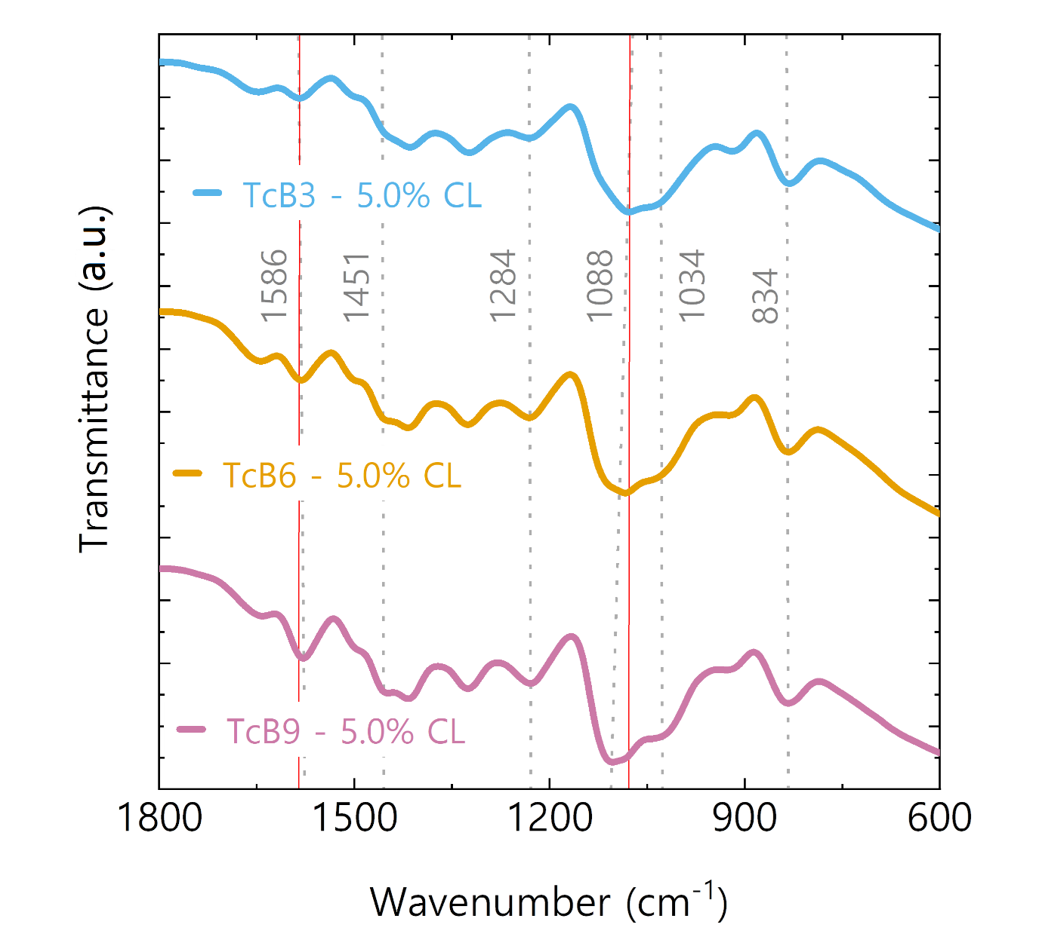
Figure S1: FTIR spectra of hydrogels with different lignin concentrations, fingerprint region (1800 cm⁻¹ – 600 cm⁻¹)

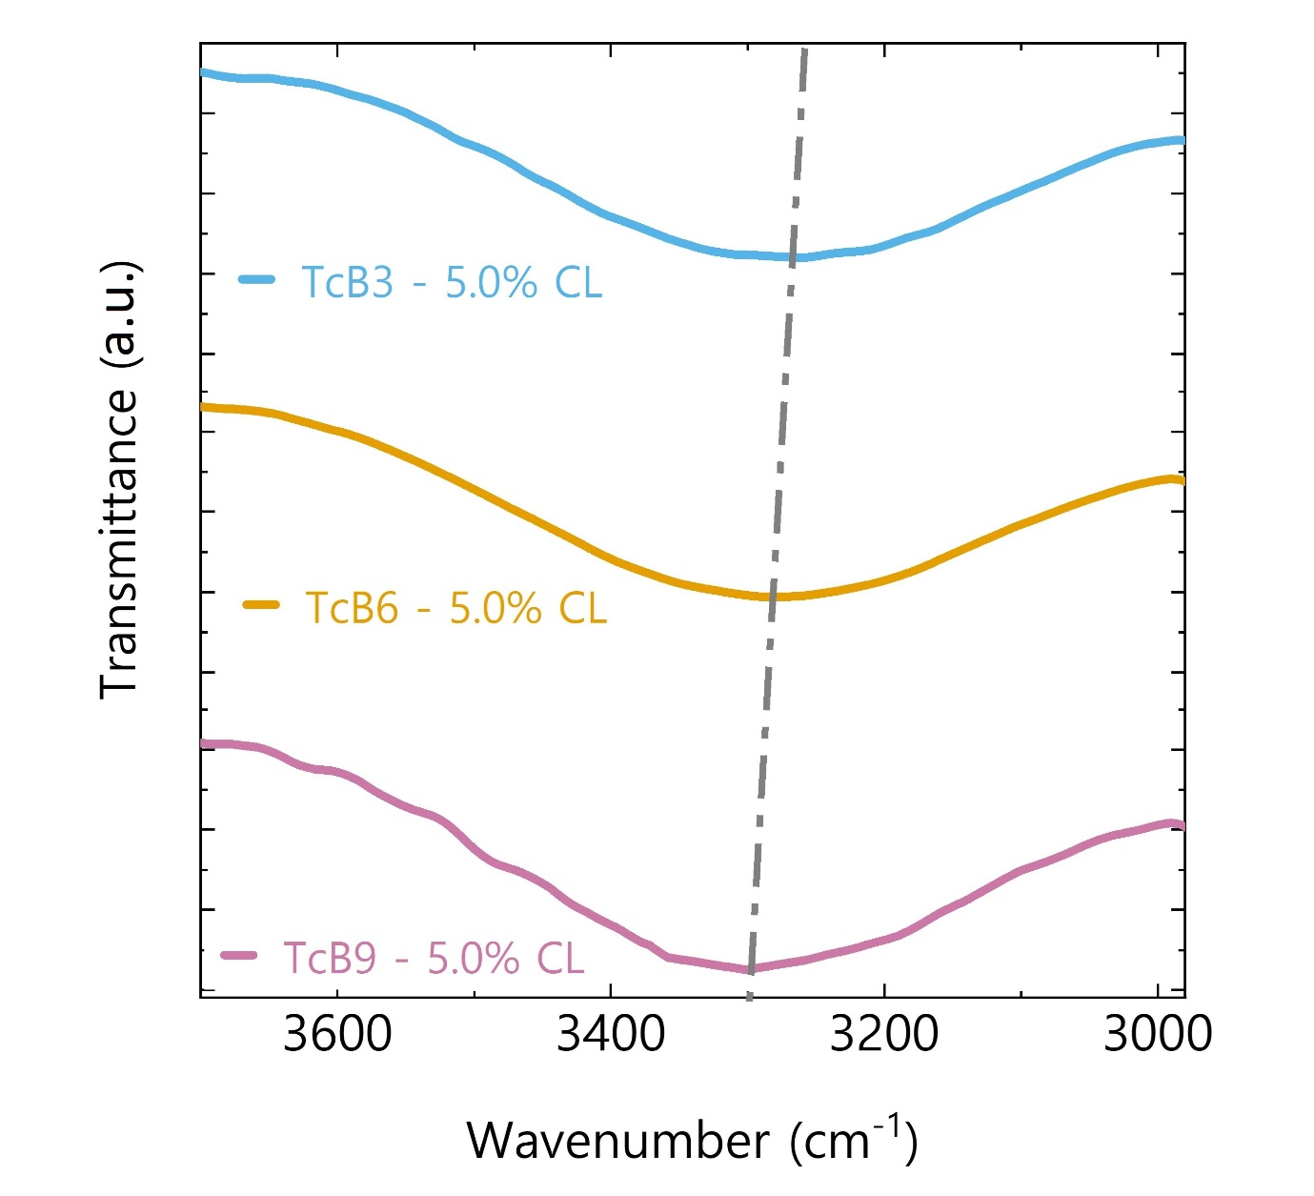
Figure S2: FTIR spectra of hydrogels with different lignin concentrations, zoomed in hydroxyl group region (3700-3000 cm⁻¹)

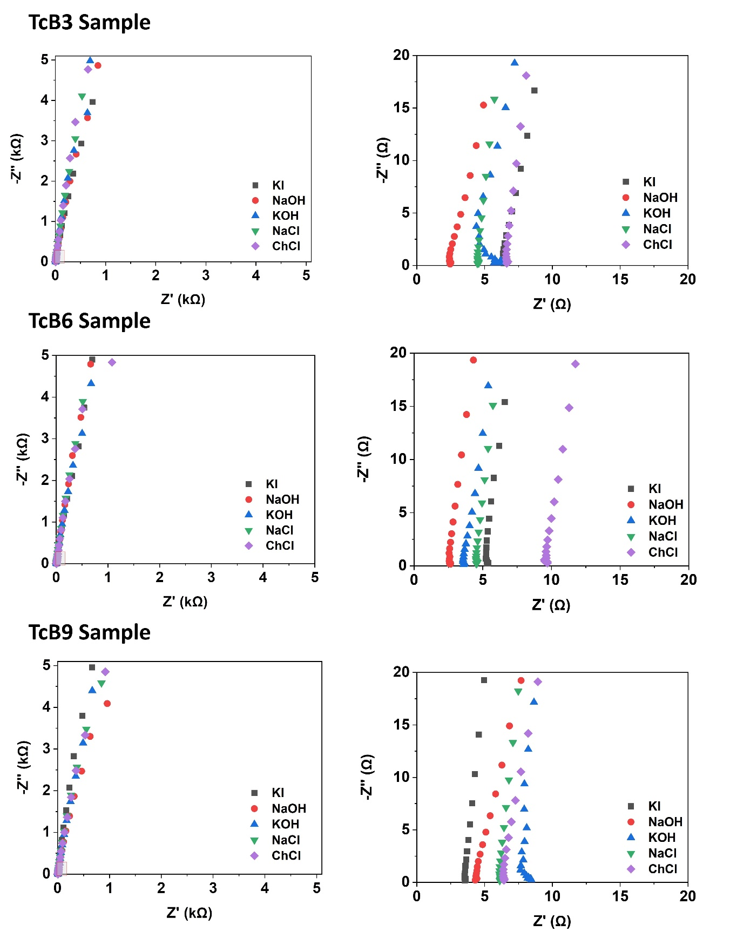
Figure S3: Nyquist plots of lignin-derived hydrogels (TcB3, TcB6, TcB9) infiltrated with various electrolytes (1 M) (left: full plot; right: zoomed plot)

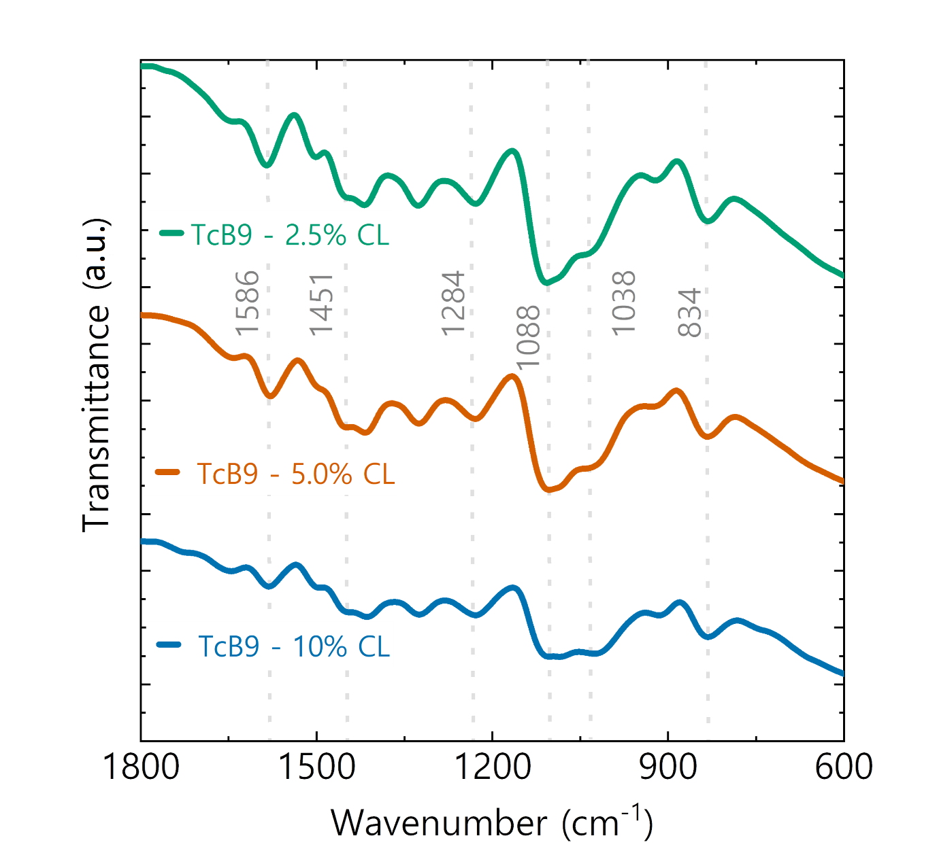
Figure S4: FTIR spectra of hydrogels with different crosslinker concentration, fingerprint region (1800 cm⁻¹ – 600 cm⁻¹)
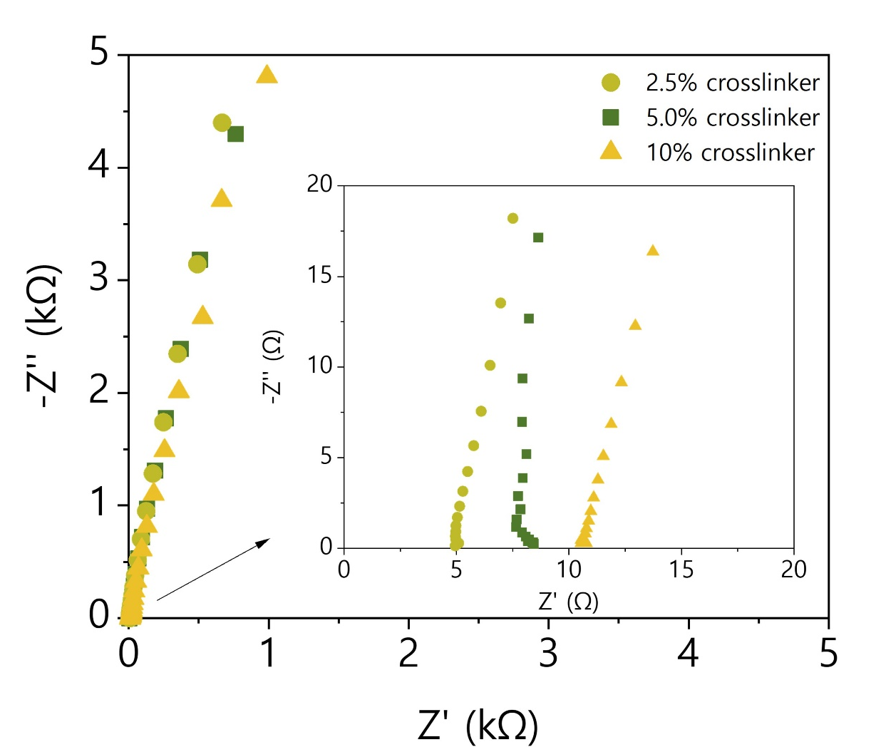
Figure S5: Nyquist plot of TcB9 hydrogels with various crosslinker concentration (steep slope showing fast ion migration)

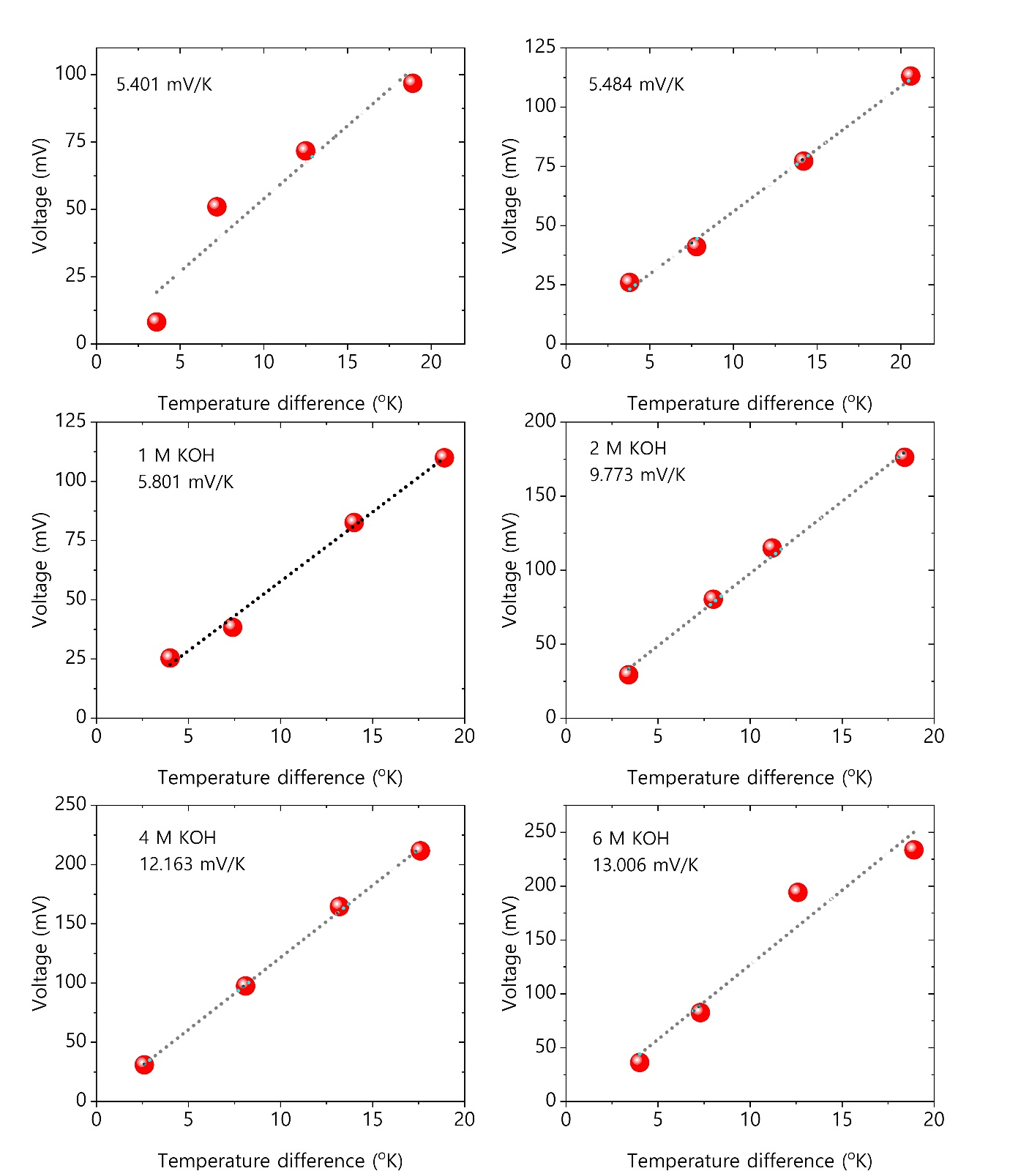
Figure S6: linear fit of the open circuit voltage vs. temperature difference for all TcB9 – 2.5% CL samples infiltrated with various KOH concentrations.
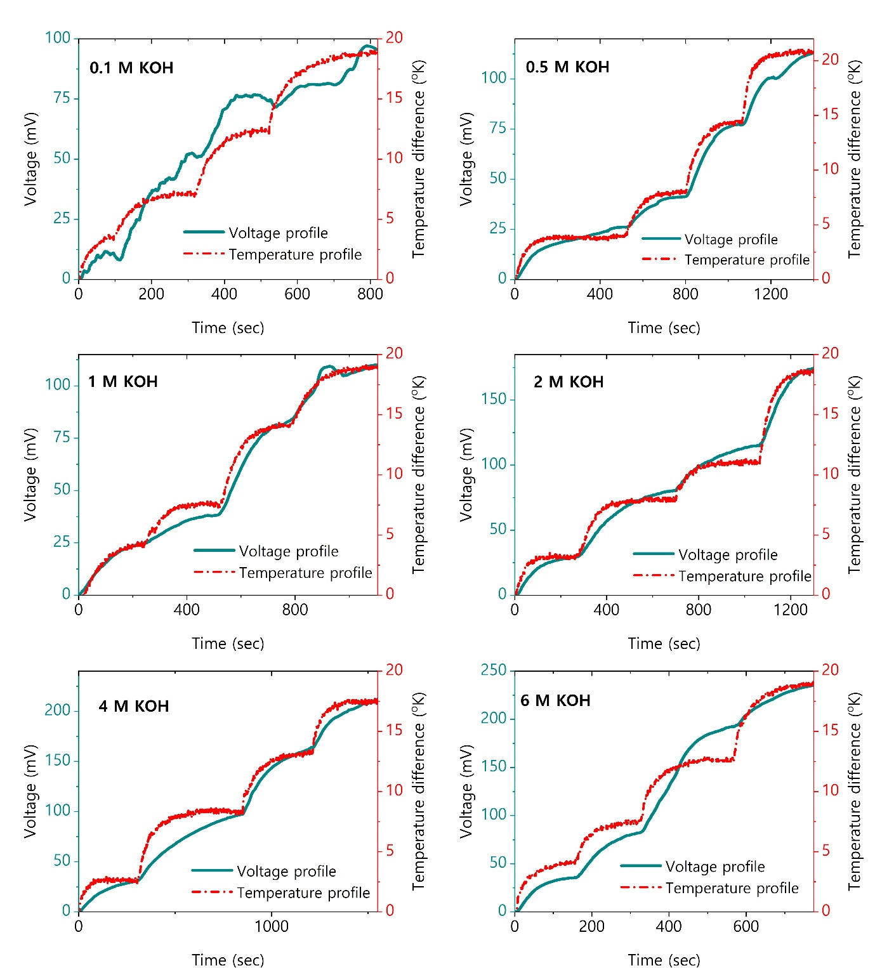
Figure S7: Voltage and temperature profile of all TcB9 – 2.5% CL samples infiltrated with various KOH concentrations.

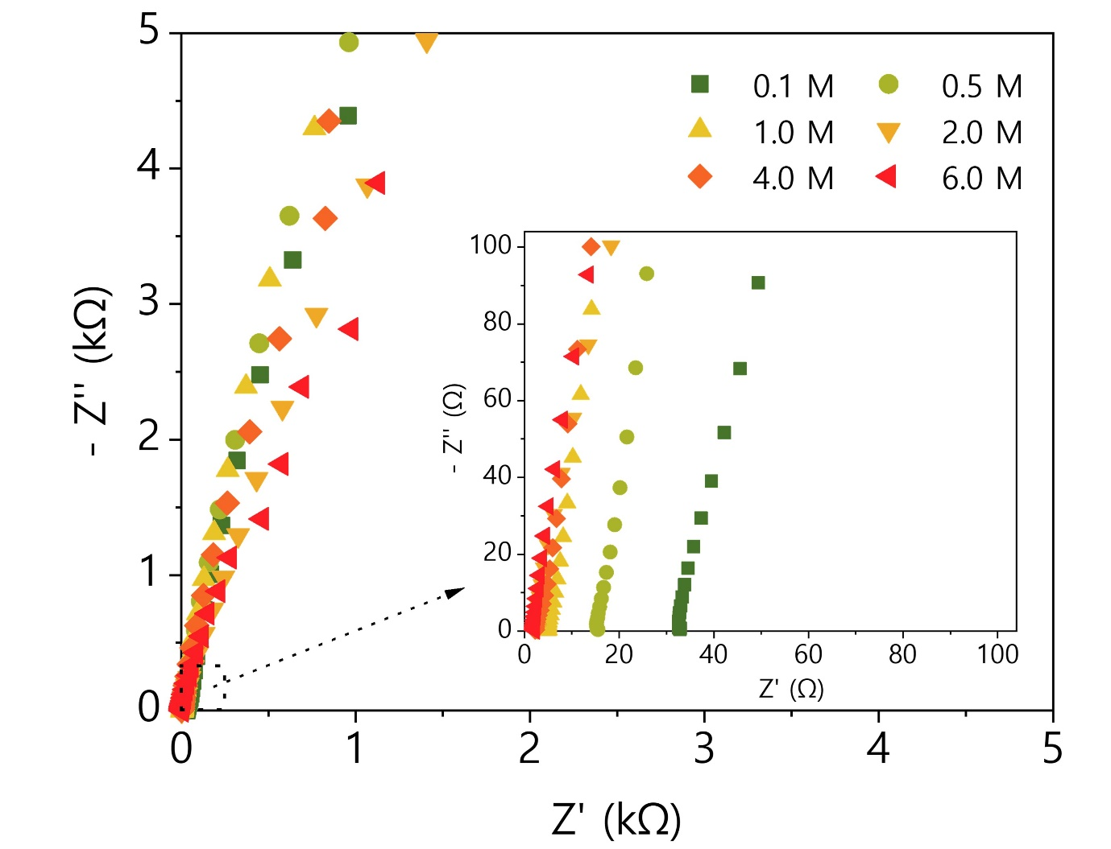
Figure S8: Nyquist plot of TcB9 – 2.5% CL hydrogels infiltrated with various KOH concentrations (0.1M – 6.0 M)

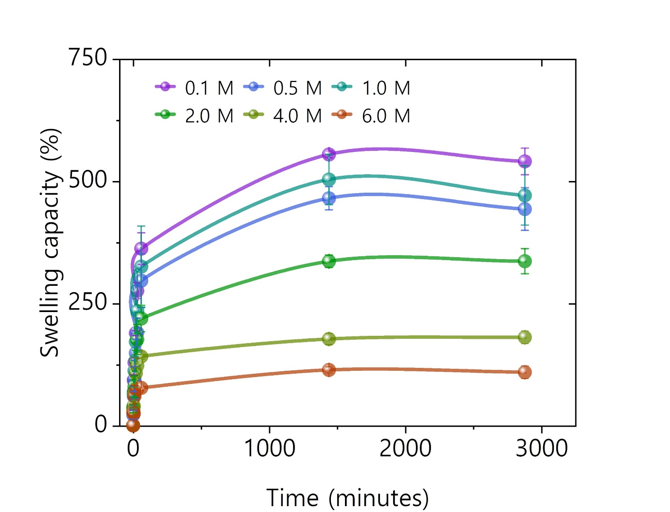
Figure S9: Swelling capacity of hydrogels infiltrated with various KOH concentrations (0.1M – 6.0 M)
Thermal stability analysis
Thermal stability analysis was performed on freeze-dried lignin hydrogels to assess their capacity to endure high temperatures. The results demonstrated that the hydrogels were mostly stable and had no significant weight loss till 200°C (Figure S10). This observation underscores the suitability of these hydrogels for low-grade thermal energy harvesting applications. Notably, the quality of encapsulation is crucial for stability maintenance, particularly given the hydrogels' aqueous nature. With optimized encapsulation techniques, these hydrogels present a promising avenue for efficient low-grade waste energy harvesting.
Figure S10: Thermal stability analysis of hydrogels (TGA curves)

Performance comparison with pure PVA hydrogel
A pure PVA hydrogel is synthesized using a specific weight percentage of polyvinyl alcohol (PVA) determined based on the composition of the original TcB9-2.5%CL hydrogel. In comparing the thermoelectric properties of TcB9-2.5%CL hydrogel and pure PVA hydrogel in a 4M KOH solution, several crucial parameters were examined. TcB9-2.5%CL hydrogel exhibited a significantly higher Seebeck coefficient (12.2 mV/K) compared to pure PVA hydrogel (5.77 mV/K), signifying its superior ability to generate thermal voltage from temperature gradients. Furthermore, TcB9-2.5%CL hydrogel demonstrated a lower thermal conductivity (0.307 W/mK) in contrast to pure PVA hydrogel (0.424 W/mK), indicating reduced heat dissipation, lower mismatch losses, and enhanced thermoelectric efficiency. The power factor of TcB9-2.5%CL hydrogel (3330.8 µW/mK²) was substantially higher than that of pure PVA hydrogel (807.1 µW/mK²), highlighting its superior capacity to convert heat differentials into electrical power. Notably, the figure of merit for TcB9-2.5%CL hydrogel (3.12) far exceeded that of pure PVA hydrogel (0.57), underscoring its overall enhanced thermoelectric performance. These findings emphasize the significant thermoelectric potential of TcB9-2.5%CL hydrogel, positioning it as a promising candidate for efficient thermoelectric energy conversion applications.

Table S2: Ionic thermoelectric properties of lignin hydrogels in different electrolytes (1 M
Ionic thermoelectric properties | TcB9-2.5% hydrogel  (4M KOH) | Pure PVA hydrogel  (4M KOH)
Seebeck coeffeicient (mV/K) | 12.2 | 5.77
Ionic conductivity (mS/cm) | 225.2 | 242.4
Thermal conductivity (W/mK) | 0.307 | 0.424
Power factor (µW/mK²) | 3330.8 | 807.1
Figure of merit | 3.12 | 0.57

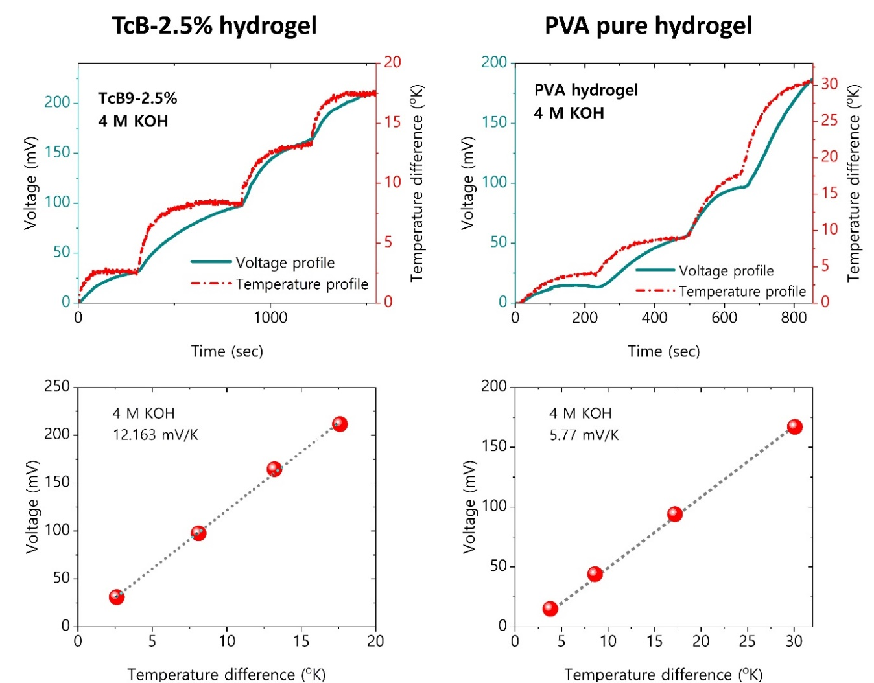
Figure S11: Ionic thermoelectric performance comparison of TcB9-2.5% and pure PVA hydrogel

TcB9-2.5% C.L infiltrated with 4M KOH electrolyte was subjected to ionic conductivity testing under different temperatures to examine the effect of temperature variation on its ionic conductivity and ionic thermoelectric properties. At lower temperatures, the molecular mobility within the hydrogel is restricted, resulting in a lower ion transport efficiency, hence the initial conductivity of 225.3 mS/cm at room temperature. As the temperature increases, the polymer chains within the hydrogel experience enhanced flexibility and increased free volume, facilitating the mobility of the KOH ions. This phenomenon aligns with the Arrhenius equation, where the conductivity is exponentially dependent on temperature due to increased kinetic energy and ion mobility. Consequently, at 60 ºC, the hydrogel exhibited a significantly heightened conductivity of 258.5 mS/cm, confirming the temperature-sensitive nature of the hydrogel's ionic conductivity (Figure S12).
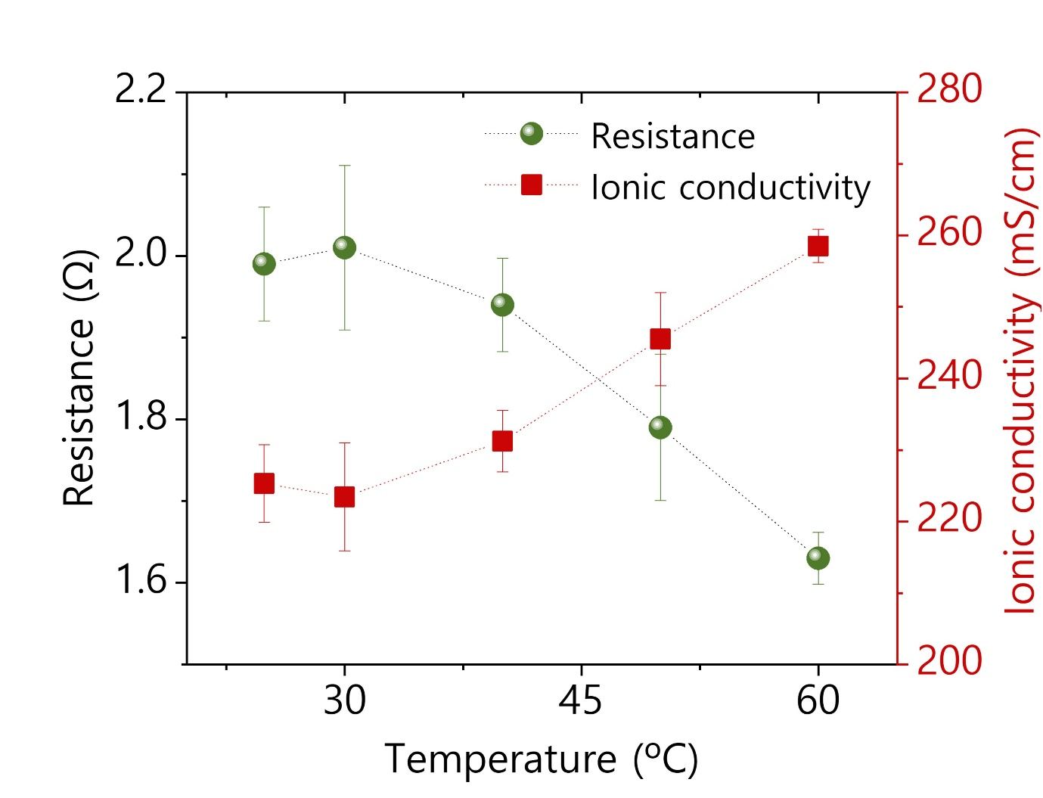
Figure S12: Resistance and ionic conductivity of TcB9-2.5% (4 M KOH) vs. temperature

The same hydrogel composition underwent compression cycling at a strain level of 58.3% for each cycle, and this process was repeated up to 1000 cycles. In our tests, the ionic conductivity consistently stayed between 200-225 mS/cm, showing stability without significant variations. Consequently, the relative change in ionic conductivity remained close to 1 (Figure S13), indicating minimal alterations during the tests. This finding indicates that subjecting the hydrogel to repetitive compression did not notably affect its ability to conduct ions.
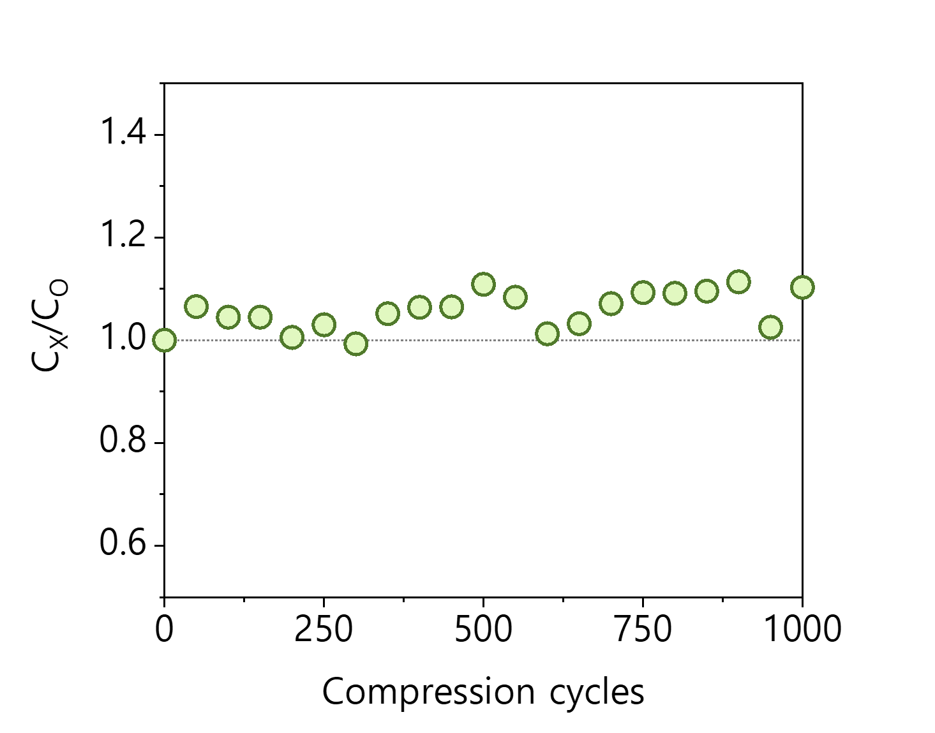
Figure S13: Effect of compression cycles on ionic conductivity of TcB9-2.5% (4 M KOH): Normalized ionic conductivity change.

The thermal voltage response of the hydrogel under compression was investigated, and the outcomes are depicted in Figure S14. Initially, without compression, the hydrogel exhibited a consistent open circuit voltage of approximately 95 mV. Upon complete deformation of the hydrogel and allowing time for stabilization, the output voltage persisted at around 62% of its initial performance level. This observation suggests that even after significant deformation, the hydrogel retains a substantial portion of its thermal voltage output, indicating a notable degree of stability in its thermal response.
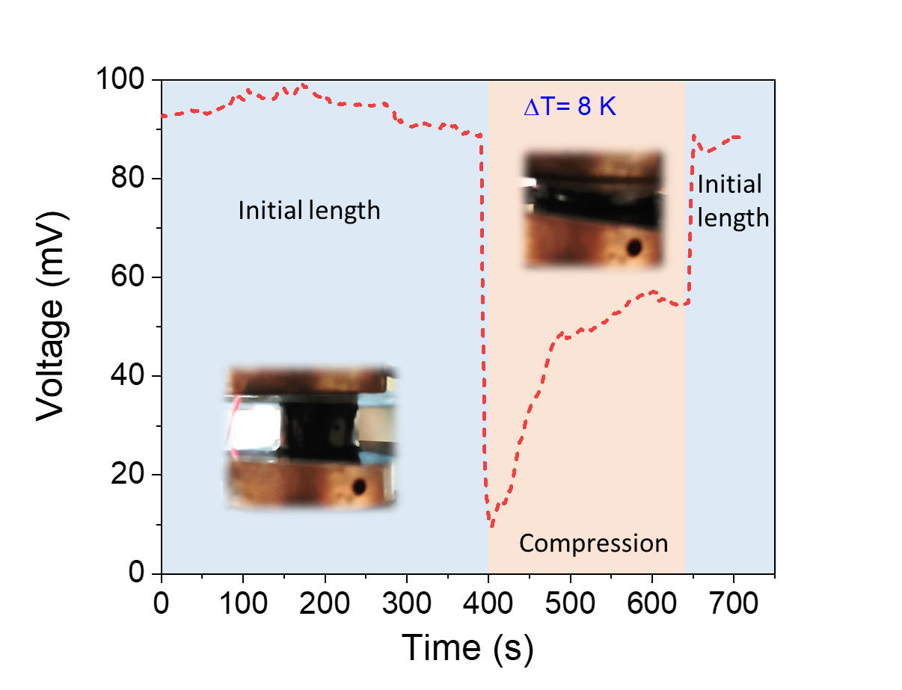
Figure S14: Voltage response of TcB9-2.5% (4 M KOH) vs compression
The first stage is where cations and anions move toward different electrodes under applied temperature gradient (≈1.9 K), resulting in an increase in the voltage during the charging process until saturation (≈17.6 mV). That loss in Seebeck coefficient is attributed to high R_{ct} value. When an external load (1 KΩ) is connected to the ionic-thermoelectric supercapacitor, electrons flow through the circuit to balance the accumulated charge, thereby charging both electrodes. (iii) The ions diffuse back to their original states after the temperature difference is removed and the external circuit is disconnected. However, the electrons remain at the electrodes, causing a negative voltage. (iv) Finally, the external circuit is reconnected and the accumulated electrons on the electrode flow through the load again but this time in the opposite direction. It is therefore called reverse electron working or discharging cycle.
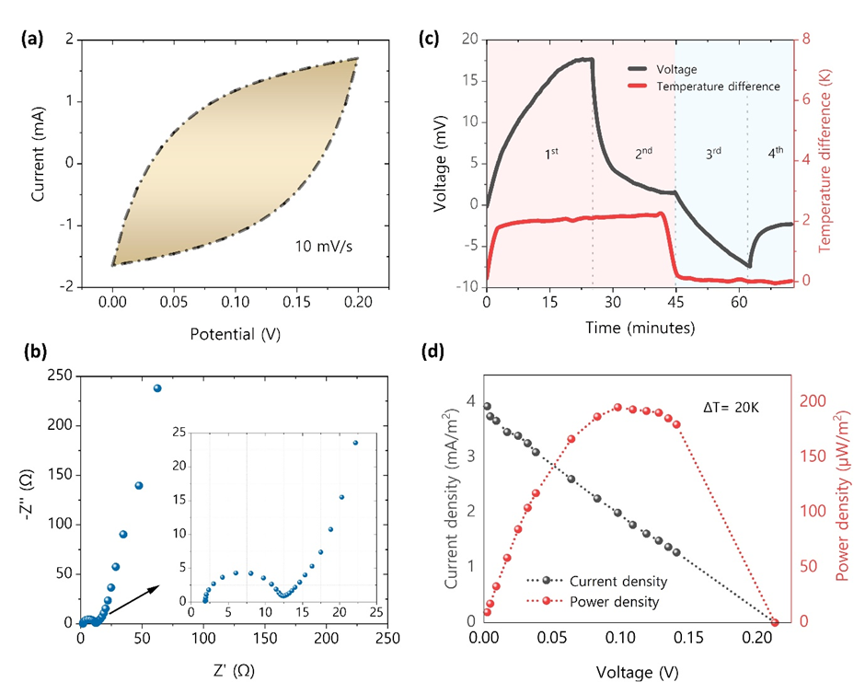
Figure S15: Ionic thermoelectric supercapacitor performance; (a) CV curve of the device with porous carbon electrodes, (b) Nyquist plot, (c) voltage and temperature gradient profile, and (d) I-V-P cruve at 20K temperature difference

Table S3: Ionic thermoelectric properties of lignin hydrogels in different electrolytes (1 M)
Sample | Seebeck coefficient (mV/K) | S.D (±) | Ionic conductivity (mS/cm) | S.D (±) | Power factor [(µW/m K²]
TcB3 – 5.0% CL
KOH | 2.326 | 0.136 | 55.922 | 3.241 | 30.255
NaOH | 1.702 | 0.036 | 98.458 | 8.412 | 29.140
KI | 0.592 | 0.048 | 38.051 | 4.231 | 1.326
NaCl | 0.420 | 0.133 | 54.469 | 2.214 | 0.959
ChCl | 0.399 | 0.045 | 37.062 | 6.432 | 0.588
TcB6 – 5.0% CL
KOH | 2.513 | 0.260 | 64.142 | 5.421 | 40.532
NaOH | 1.484 | 0.068 | 113.849 | 6.412 | 25.072
KI | 0.965 | 0.041 | 55.922 | 5.210 | 5.213
NaCl | 0.412 | 0.033 | 53.984 | 3.123 | 0.917
ChCl | 0.581 | 0.041 | 25.407 | 2.531 | 0.855
TcB9 – 5.0% CL
KOH | 3.480 | 0.621 | 48.102 | 12.159 | 58.251
NaOH | 1.304 | 0.037 | 65.692 | 2.421 | 11.168
KI | 0.676 | 0.148 | 67.896 | 1.124 | 3.102
NaCl | 0.484 | 0.045 | 45.755 | 6.412 | 1.072
ChCl | 0.667 | 0.011 | 38.352 | 5.120 | 1.674

Table S4: Ionic thermoelectric properties of lignin hydrogels with different crosslinker ratios
Sample | Seebeck coefficient (mV/K) | S.D (±) | Ionic conductivity (mS/cm) | S.D (±) | Power factor (µW/mK²) | S.D (±)
2.5% crosslinker | 5.801 | 0.957 | 61.502 | 5.235 | 206.965 | 22.210
5.0% crosslinker | 3.480 | 0.621 | 48.102 | 12.159 | 58.251 | 11.421
10% crosslinker | 3.037 | 0.061 | 35.631 | 2.409 | 32.632 | 2.409

Table S5: Ionic thermoelectric properties of lignin hydrogels in various KOH concentrations
Sample  (TcB9 – 2.5% CL) | Seebeck coefficient (mV/K) | S.D (±) | Ionic conductivity (mS/cm) | S.D (±) | Thermal conductivity (W/mK) | S.D (±)
0.1 M | 5.401 | 0.109 | 15.63 | 5.423 | 0.381 | 0.013
0.5 M | 5.484 | 0.225 | 33.260 | 7.5323 | 0.432 | 0.010
1.0 M | 5.801 | 0.957 | 61.503 | 5.235 | 0.383 | 0.012
2.0 M | 9.773 | 0.311 | 182.478 | 8.523 | 0.342 | 0.009
4.0 M | 12.161 | 0.446 | 225.227 | 15.421 | 0.307 | 0.033
6.0 M | 13.006 | 0.671 | 226.423 | 9.124 | 0.294 | 0.005

Table S6: Power factor and figure of merit of lignin hydrogels in various KOH concentrations
Sample  (TcB9 – 2.5% CL) | Power factor (µW/mK²) | S.D (±) | Figure of Merit | S.D (±)
0.1 M | 45.595 | 11.209 | 0.034 | 0.005
0.5 M | 100.029 | 14.321 | 0.066 | 0.003
1.0 M | 206.965 | 22.217 | 0.155 | 0.023
2.0 M | 1742.877 | 34.216 | 1.463 | 0.050
4.0 M | 3330.888 | 44.231 | 3.124 | 0.078
6.0 M | 3831.110 | 45.325 | 3.749 | 0.067

Table S7: Comparison of this study with previous studies
Materials | Ionic conductivity  (mS/cm) | Seebeck coefficient  (mV/k) | Power factor  (µW/mK² ) | Figure of Merit  (ZT_{i} ) | Ref.
PEO/NaOH | 8.13 × 10⁻² | 10 | -- |  | [6]
PEDOT:PSS/PSSH | 291 | 16.2 | 7610 at 80% humidity | -- | [7]
WPU/EMIM:DCA | 8.4 | 34.5 | 999 at 90% humidity | 1.31 | [4]
PVA/NaI | 51.5 | 42.8 | 9433 | ≈ 5.01 | [8]
PVA/NaOH | 71.2 | 1 | -- | -- | [9]
Polyquaternium-10/NaOH | 30 | 24.17 | 1752 | -- | [10]
PEGDA, 2-HEA/EMIM⁺TFSI– | 0.376 | 38.9 | 54.5 | -- | [11]
PAA-PEO-NaCl ionic hydrogels | 0.45 | 3.26 | 0.252 | 0.21 | [12]
PEDOT:PAAMPSA:PA | 309.8 | 21.9 | 14858 | 12.3 | [13]
Cellulose/PEO/NaOH | 20 | 24 | 1,150 | ≈ 0.69 | [14]
EMIM:DCA/Gelatin | 4.2 | 22.1 | 205 | -- | [15]
PVA–chitosan/Ch₂Cl | 40.5 | 28.4 | 3266 | 2.42 | [16]
PVA/SA/PEG hydrogel | 31.4 | 66.7 | 13960 | -- | [17]
PAM/CMC Hydrogel | 18.4 | 11.58 | 198.2 | 0.11 | [18]
Lignin/PVA/KOH | 226.48 | 13.01 | 3,831 | 3.75 | This work

References:
1. Hu, Y., et al., Cellulose ionic conductor with tunable Seebeck coefficient for low-grade heat harvesting. Carbohydrate Polymers, 2022. 292: p. 119650.
2. Serrano-Claumarchirant, J.F., et al., Textile-based Thermoelectric Generator Produced Via Electrochemical Polymerization. Advanced Materials Interfaces. n/a(n/a): p. 2202105.
3. Qian, Q., et al., Great Enhancement in the Thermopower of Ionic Liquid by a Metal-Organic Framework. Advanced Functional Materials, 2023. 33(37): p. 2303311.
4. Fang, Y., et al., Stretchable and Transparent Ionogels with High Thermoelectric Properties. Advanced Functional Materials, 2020. 30(51): p. 2004699.
5. Han, C.-G., et al., Giant thermopower of ionic gelatin near room temperature. Science, 2020. 368(6495): p. 1091-1098.
6. Zhao, D., et al., Ionic thermoelectric supercapacitors. Energy & Environmental Science, 2016. 9(4): p. 1450-1457.
7. Kim, B., et al., Robust High Thermoelectric Harvesting Under a Self-Humidifying Bilayer of Metal Organic Framework and Hydrogel Layer. Advanced Functional Materials, 2019. 29(7): p. 1807549.
8. He, Y., et al., Role of Ions in Hydrogels with an Ionic Seebeck Coefficient of 52.9 mV K–1. The Journal of Physical Chemistry Letters, 2022. 13(20): p. 4621-4627.
9. Kim, S.L., J.-H. Hsu, and C. Yu, Thermoelectric effects in solid-state polyelectrolytes. Organic Electronics, 2018. 54: p. 231-236.
10. Han, Y., et al., Ultrasensitive Flexible Thermal Sensor Arrays based on High-Thermopower Ionic Thermoelectric Hydrogel. Advanced Science. n/a(n/a): p. 2302685.
11. Park, T.H., et al., Ionoelastomer electrolytes for stretchable ionic thermoelectric supercapacitors. Nano Energy, 2023. 114: p. 108643.
12. Fu, M., et al., Highly Stretchable, Resilient, Adhesive, and Self-Healing Ionic Hydrogels for Thermoelectric Application. Advanced Functional Materials, 2023: p. 2306086.
13. Kim, D.-H., et al., Self-healable polymer complex with a giant ionic thermoelectric effect. Nature Communications, 2023. 14(1): p. 3246.
14. Li, T., et al., Cellulose ionic conductors with high differential thermal voltage for low-grade heat harvesting. Nature Materials, 2019. 18(6): p. 608-613.
15. Le, Q., H. Cheng, and J. Ouyang, An ionic thermoelectric capacitor with continuous power generation for heat harvesting. Chemical Engineering Journal, 2023. 469: p. 143828.
16. Chen, B., et al., Giant Negative Thermopower Enabled by Bidirectionally Anchored Cations in Multifunctional Polymers. ACS Applied Materials & Interfaces, 2023. 15(20): p. 24483-24493.
17. Hsiao, Y.-C., et al., Stretchable polyvinyl alcohol and sodium alginate double network ionic hydrogels for low-grade heat harvesting with ultrahigh thermopower. Materials Today Energy, 2023. 37: p. 101383.
18. Zhou, Z., et al., Flexible hydrogel with a coupling enhanced thermoelectric effect for low-grade heat harvest. Materials Today Sustainability, 2023. 21: p. 100293.

