MECHANISMS OF MERCURY REMOVAL FROM WATER WITH HIGHLY EFFICINT MXENE AND SILVER CRYOGEL COMPOSITE FILTERS
Chingis Daulbayev^{1,2}, Armanbek Nursharip¹, Zhandos Tauanov^{3,4}, Rosa Busquets⁵, Alzhan Baimenov^{1,3*}

¹National Laboratory Astana, Nazarbayev University, Nur-Sultan, Kazakhstan
²Institute of Nuclear Physics, Almaty, Kazakhstan
³Al Farabi Kazakh National University, Almaty, Kazakhstan
⁴Satbayev University, Almaty, Kazakhstan
⁵School of Life Sciences, Pharmacy and Chemistry, Kingston University, Penrhyn road, KT1 2EE, Kingston upon Thames, Greater London, UK

*Corresponding author: alzhan.baimenov@nu.edu.kz

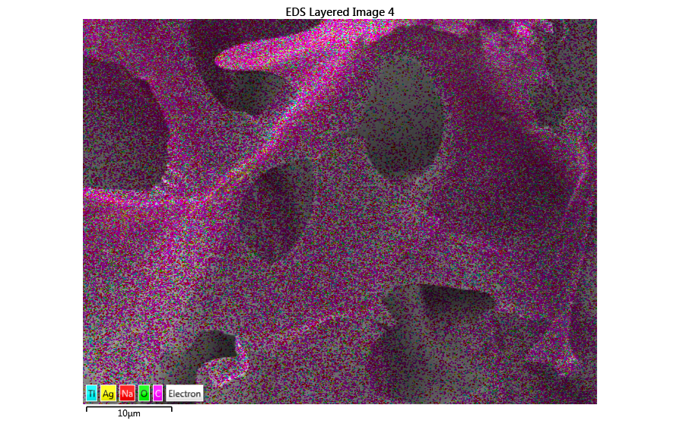 | 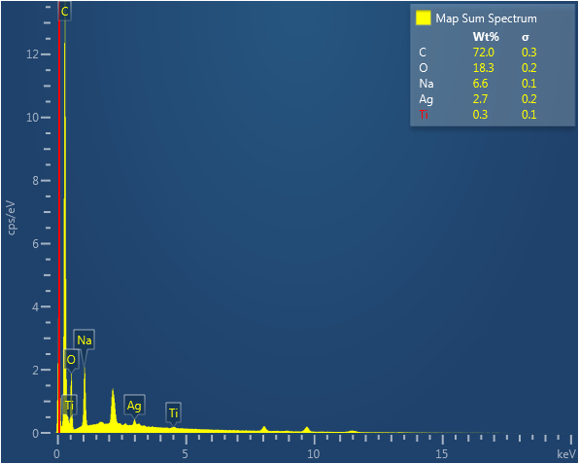
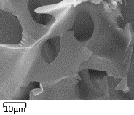 | 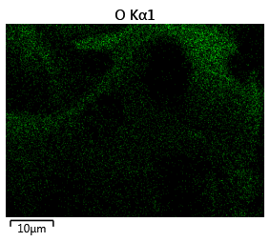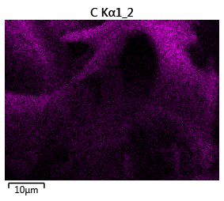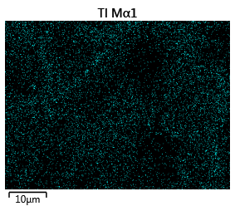 | 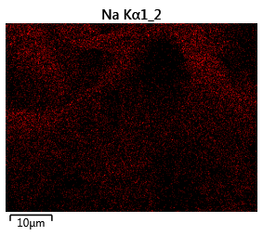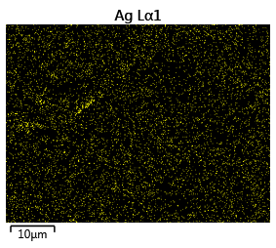

Figure S1. EDX mapping of MXene/Ag/PEI

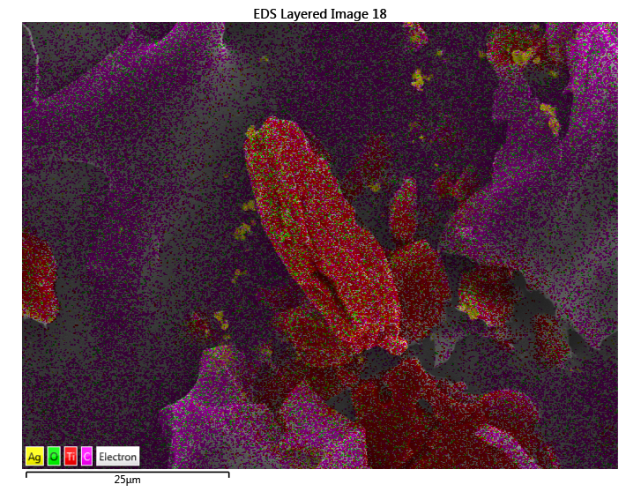 | 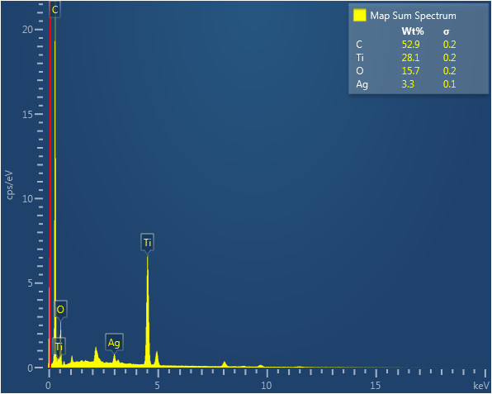
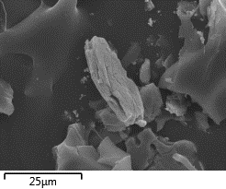 | 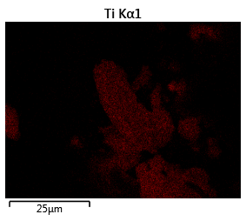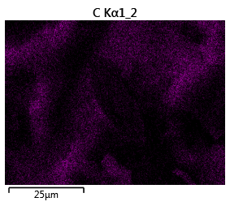 | 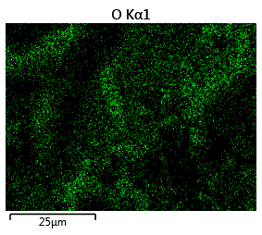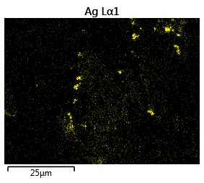

Figure S2. EDX mapping of MXene/Ag

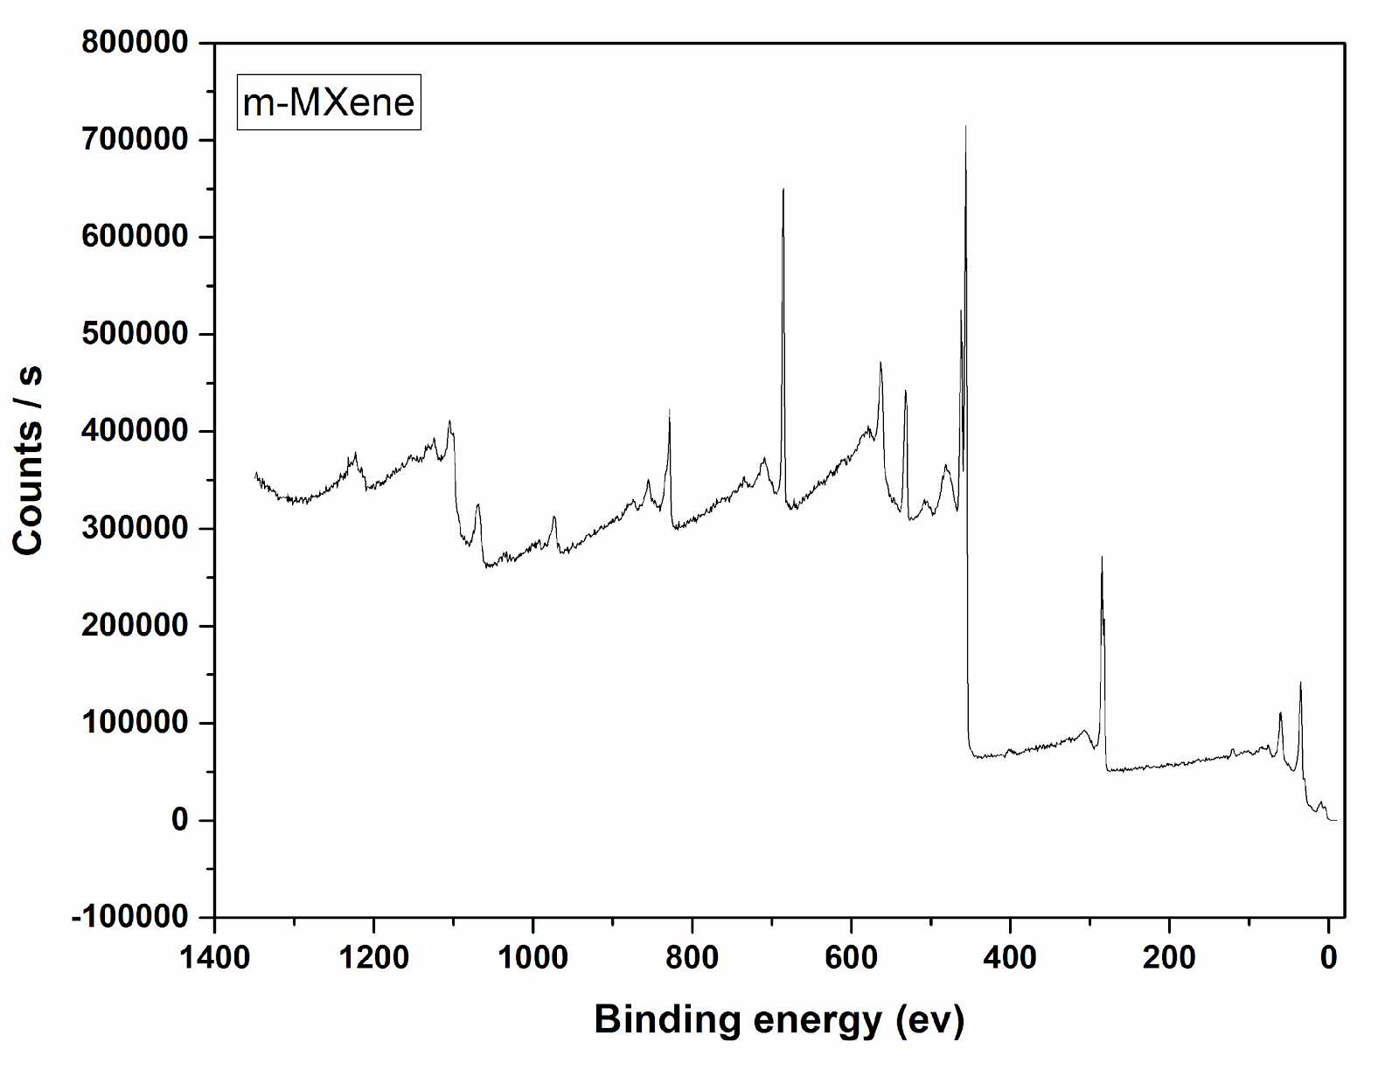 | 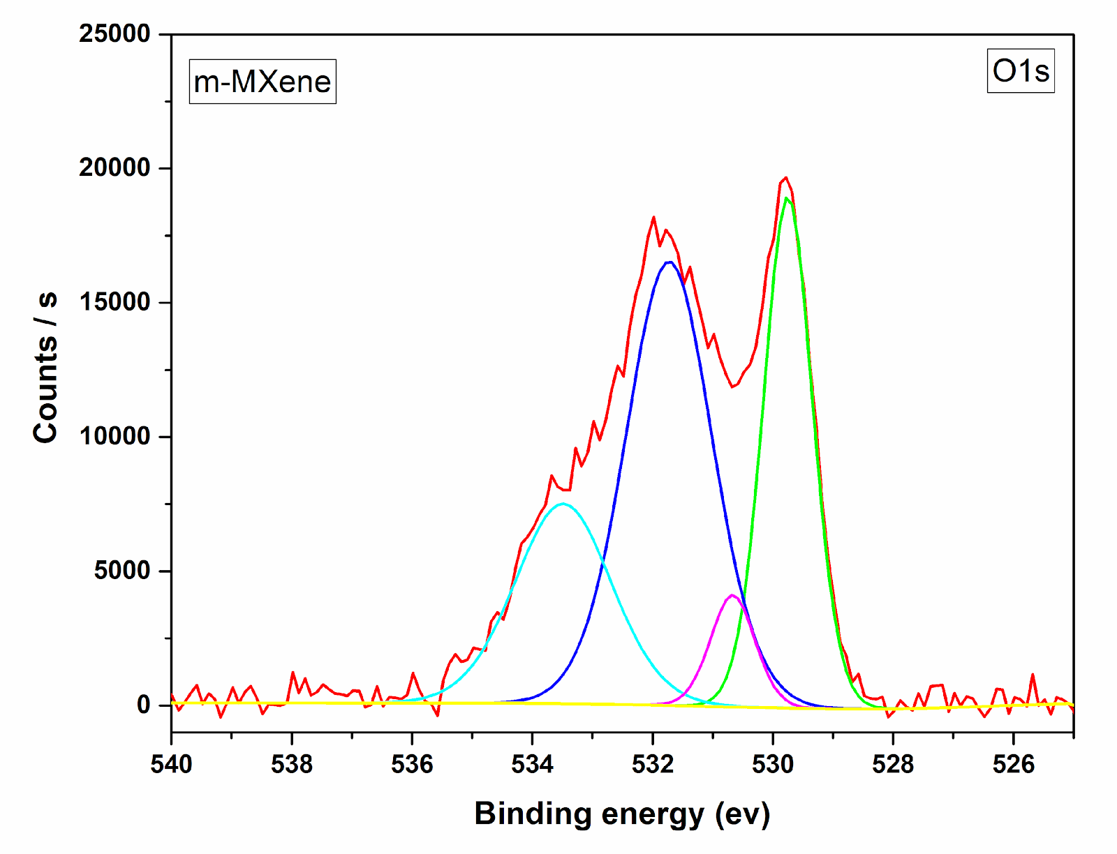
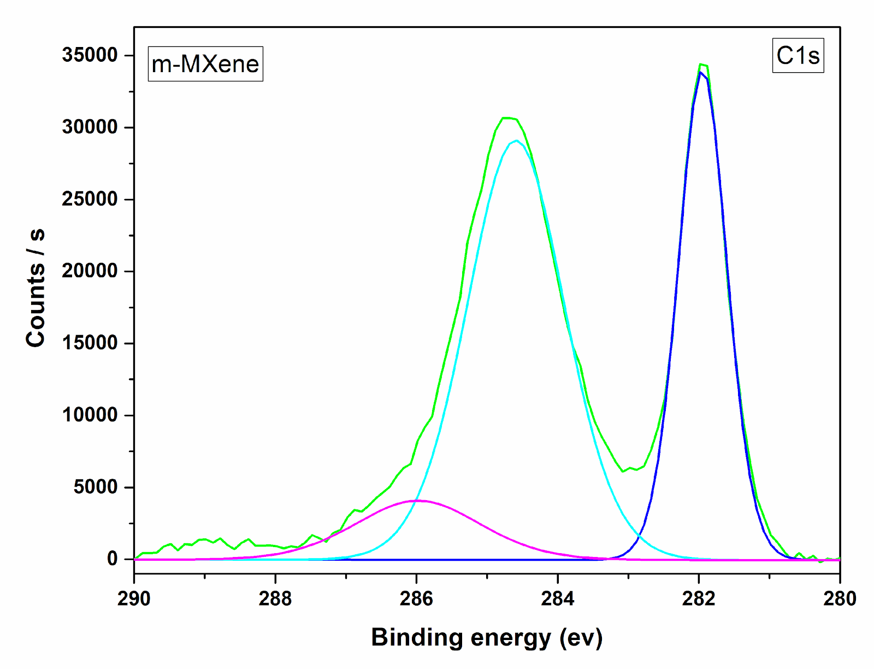 | 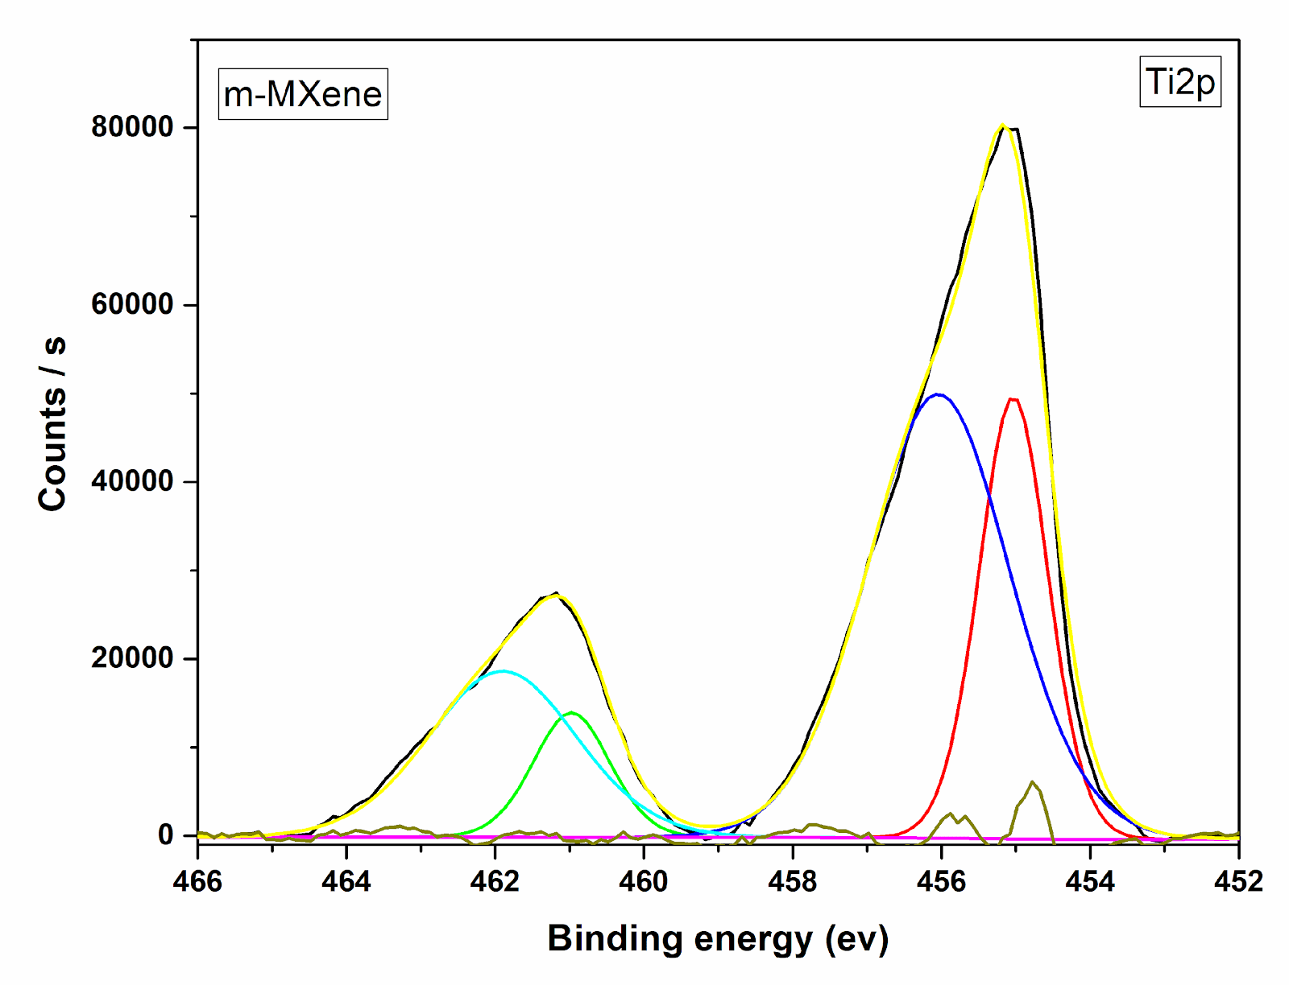

Figure S3. High-resolution XPS spectra of MXene

Figure S4. Zeta potential vs. pH values for PEI, PEI/MXene and PEI/MXene@Ag samples

Element | Line | Mass% | Atom%
C | K | 77.02±0.03 | 85.39±0.04
O | K | 13.69±0.04 | 11.39±0.03
Na | K | 0.40±0.01 | 0.23±0.00
Mg | K | 1.00±0.01 | 0.55±0.00
Al | K | 0.23±0.00 | 0.12±0.00
Si | K | 0.20±0.00 | 0.10±0.00
S | K | 0.62±0.01 | 0.26±0.00
Ca | K | 4.13±0.02 | 1.37±0.01
Fe | K | 1.21±0.02 | 0.29±0.00
Cu | K | 1.50±0.03 | 0.31±0.01
Total |  | 100.00 | 100.00
Map_001_wholespectrum |  | Fitting ratio 0.0135
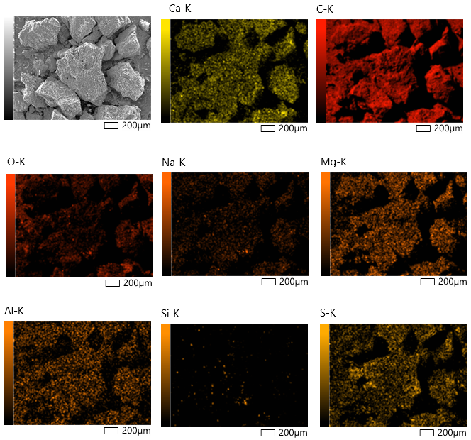

Figure S5. SEM/EDS mapping images and elemental composition of commercial activated carbon
Element | Line | Mass% | Atom%
C | K | 68.00±0.04 | 75.38±0.05
O | K | 27.13±0.06 | 22.58±0.05
Al | K | 0.21±0.00 | 0.11±0.00
S | K | 4.65±0.02 | 1.93±0.01
Total |  | 100.00 | 100.00
Map_003_wholespectrum |  | Fitting ratio 0.0331
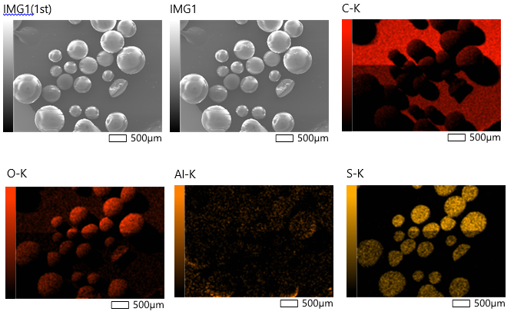

Figure S6. SEM/EDS mapping images and elemental composition of commercial ion-exchange resin

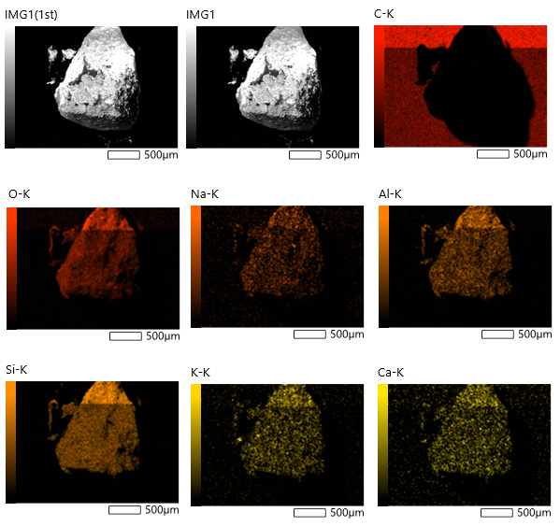
Element | Line | Mass% | Atom%
C | K | 57.83±0.04 | 67.05±0.04
O | K | 32.17±0.05 | 28.01±0.05
Na | K | 0.46±0.01 | 0.28±0.00
Al | K | 1.65±0.01 | 0.85±0.00
Si | K | 7.16±0.02 | 3.55±0.01
K | K | 0.45±0.01 | 0.16±0.00
Ca | K | 0.29±0.01 | 0.10±0.00
Total |  | 100.00 | 100.00
Map_004_wholespectrum |  | Fitting ratio 0.0203

Figure S7. SEM/EDS mapping images and elemental composition of commercial zeolite Y

A
B
C
Figure 8. XPS spectra of PEI/MXene@Ag for Ag3d a) before and b) after mercury adsorption; c) Hg 4f after the adsorption

